ACHA6013 – CW1 Independent Inquiry
James Hungin 2000718

When I wrote my personal statement as part of my application to get into this university I referenced the great Enzo Ferrari, utilizing the quote [1] “Race cars are neither beautiful nor ugly, they become beautiful when they win”. I recall discovering this quote and it unsettling me as I found myself disagreeing with the view of a man I idolized and yet it prompted me to ask the question, what indeed makes a car beautiful? This is a surprisingly layered question given the metamorphosis the automotive industry is currently undergoing what a car is and can be now seems to be the question on everyone’s mind. Is there even still a place for styling and artistry in an automotive capacity?
Beauty is possibly the most subjective quality known to mankind and quantifying such a thing is an inordinate task, yet we know it must exist in an automotive sense or the passion we share amongst the wider automotive community would be non-existent, ironic given the widespread dispute over whether a car can be considered art.
In order to answer these questions, I must first ask and subsequently answer the questions what is art? What does art mean to me? And finally, can a car truly be a work of art? I firmly believe that there is no single definition for what art can be and in my experience, there can be vast deviance in what it means to people and can influence people. I however speak on no one’s behalf and to me art is the most wonderful thing we as a species have, it wants for nothing yet has the capability to be effortlessly provocative, inspired and yet it inspires, beautiful and ugly or perhaps neither. The function of art will be debated until the sun stops fusing Hydrogen nuclei with some arguing art can have no purpose other than itself but if that were true then would we still be able to find beauty in the function of objects or would the inspiration art brings us be as impactful as the last several thousand years shown it to be and would it not be more gratifying to see your own work of art to achieve a higher function than to simply be. I defy anyone to look at the flat 6 engine fitted to the Singer 911 DLS aside from the car and not regard it as a wonderful piece of sculpture that just so happens to be able to rev to an ear splitting 9300 RPM. For myself though art is in everything regardless of how mundane because everything you see around you has a story to tell in which is held the thoughts and feelings of everyone involved in it’s creation; the outstanding thing about artists is their ability to utilise these thoughts and feelings to create pieces that are emotive and manipulative, pushing the boundaries of what we as a species are capable of and helping us reassess the way we live our lives.
Of course what makes something beautiful is entirely dependent on the one who perceives the object in question and again it can be ironic how some find beauty in imperfection. Francis Bacon once said [2] “There is no exquisite beauty without some strangeness in the proportion”. Bacon surely accounting for the human element leading us to reflect on ourselves and examine our own imperfections and assess how it is indeed the foibles in our lives that distinguish us from the rising tide of artificial intelligence and constant homogenization. It’s the niggles that humanize art and make it relatable. The irony comes from the idea that one admires something that truly is exquisite and flawless and gives us something to aspire to and drives us to strive for perfection; otherwise we resign ourselves to settle for mediocrity instead of celebrating those who go above and beyond to achieve genuine perfection for breaking the mould. I find beauty comes from graceful organic forms furnished with sophisticated and meticulous detailing and unlike Bacon, I rather like conventional proportions.
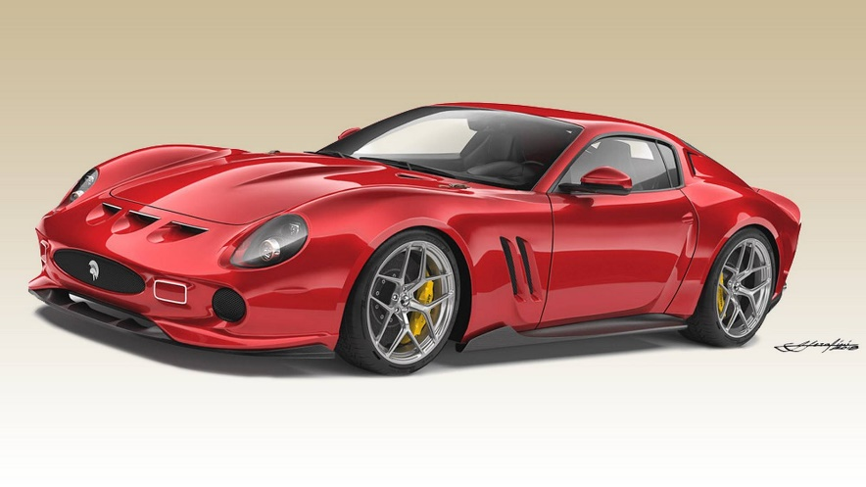
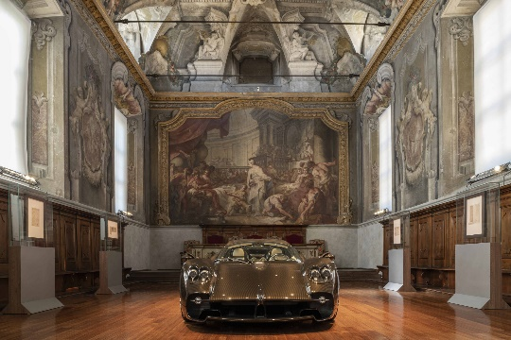
Bearing all this in mind, I must now address the idea of a car being considered a work of art. [3] “We are therefore dealing here with a humanized art, and it is possible that the Deesse marks a change in the mythology of cars.” (Barthes, 1957). Upon laying eyes on the Citroën DS for the first time at the Paris Salon de l’Automobile in 1955, Philosopher Roland Barthes was compelled to write a composition waxing lyrical about the sculpture of the new Citroën strung up on a pylon in order to show off the pure, undisturbed form. Or in the case of the Pagani Utopia [4] “It is not the case for Horacio to compare himself to the Florentine genius but of following his path: Leonardo constantly combined technical inspiration with his love of beautiful shapes. Horacio Pagani is an artist, the car is his preferred way of expressing himself. When he draws something, however beautiful it is, the shape he creates is the result of the function it will perform. For him, a shape cannot be elegant if it is technically incorrect. And when the technical difficulty has been overcome, its beauty can be found in its solution.” (Puyal, 2022). Further emphasizing my earlier point that art is all around us and can be found in more areas than simply what is put in front of us, and if one such as Horacio Pagani can emulate the great Leonardo Da Vinci in his work than defy anyone to agree that an automobile is a form of art. For those who prefer a more down to earth basis, in 2019 after Italian coachbuilding company “Ares” attempted to produce a revival of Ferrari’s famed 250 GTO but were unsuccessful after a panel of Italian judges in Bologna declared the historic road racer to be a masterpiece and a work of art in the same guise as a piece by Da Vinci or Picasso and is not to be replicated or reproduced.
[6]
[5]
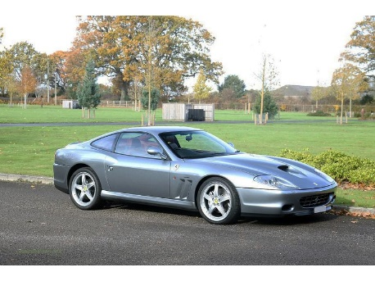
It Is my firm belief that an automobile can and should be regarded as a work of art for the level of passion and creativity that goes into designing a vehicle, the artistic skill required to sketch and develop an idea and the wonderful collaborative effort needed to take a car from ideation to production. Not to mention the sculpture of the bodywork and especially the way these things possess and excite those of us in the motoring world.
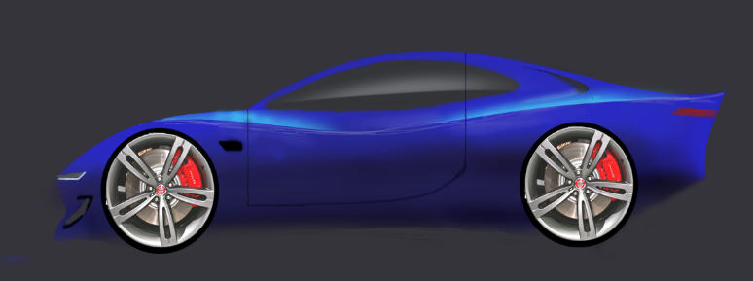
Unbridled passion for the motoring world is what drives me to get out of bed in the morning. Undoubtedly stemming from witnessing Michael Schumacher rewriting the history books of Formula 1 and fortunately having been exposed to so many wonderful cars and automotive events during my formative years; my father having bought a Ferrari 575M Maranello finished in Grigio Titanio over a full Bordeaux leather interior which to my three year old eyes was the most spectacular thing in the world. This has only been exacerbated over the years as I have been privileged to have attended events such as the Goodwood Festival of Speed in multiple years, the Monaco Grand Prix in 2013 and 2015, The Concours d’Elegance at Hampton Court Palace and was even invited to the Ferrari factory in Maranello for the unveiling of the 812 GTS and F8 Spider at Universo Ferrari, though the event was behind closed doors and before the cars had even been revealed to the public. When I was 16 I got my first true taste of automotive design when I spent two weeks in the Jaguar Land-Rover design department in Coventry under the tutelage of Ian Callum. There I was able to experience aspects of the industry clay modelling, interior and exterior sketching, DVA, studio engineering and alias modelling. I believe this was the moment that set me on the path to studying automotive and transport design, it truly felt like the natural step forward in my personal development.
[7]
Reflecting on why I chose to pursue automobile design, I once again find myself pondering what does make a car beautiful, a question which now feels even more difficult to answer once adjusted for the level of artistry and sculpture involved in the creation of a car. Through my methodologies and design processes I strive to bring a sense of neo classicalism to an ever expanding society that is acquiescing to conformity and homogenization. I take great inspiration from the lifestyle and culture of the 1950’s and ‘60’s. I envision a life surrounded by vivid colours, timeless curvaceous styling, a golden age of music, an unrivalled sense of joy all under the guise of the desire to achieve greater heights than anything that had come before, [8] “We choose to go to the moon. We chose to go to the moon. We choose to go to the moon in this decade and do the other things not because they are easy, but because they are hard. Because that goal will serve to organize and measure the best of our energies and skills” (Kennedy, 1962). It is my ambition to create unique and distinctive pieces that allow my unparalleled passion to shine through. When creating something in which one is expected to spend several hours at a time, it must be a place you should not only enjoy being in but makes you look forward to the journey ahead. This should be achieved through the stimulation of all senses; picture yourself opening the nicely weighted doors and immersing yourself in an opulent cabin that causes joy to emanate as you lower yourself into the ergonomically designed seat trimmed with the finest aniline leather and marvel at the tactile feeling of analogue switches and dials to bring the car to life. Next revel in the aural pleasure from a wonderful surround sound speaker system and inhale the natural aromas from premium materials such as Brazilian Rosewood lining the dashboard. Your eyes will be drawn to the sophisticated details adorning the interior such as stitching and other accentuating features. All of these features melding together to produce a scintillating feeling, and that’s before you even start driving which is sure to be a visceral thrill-ride.
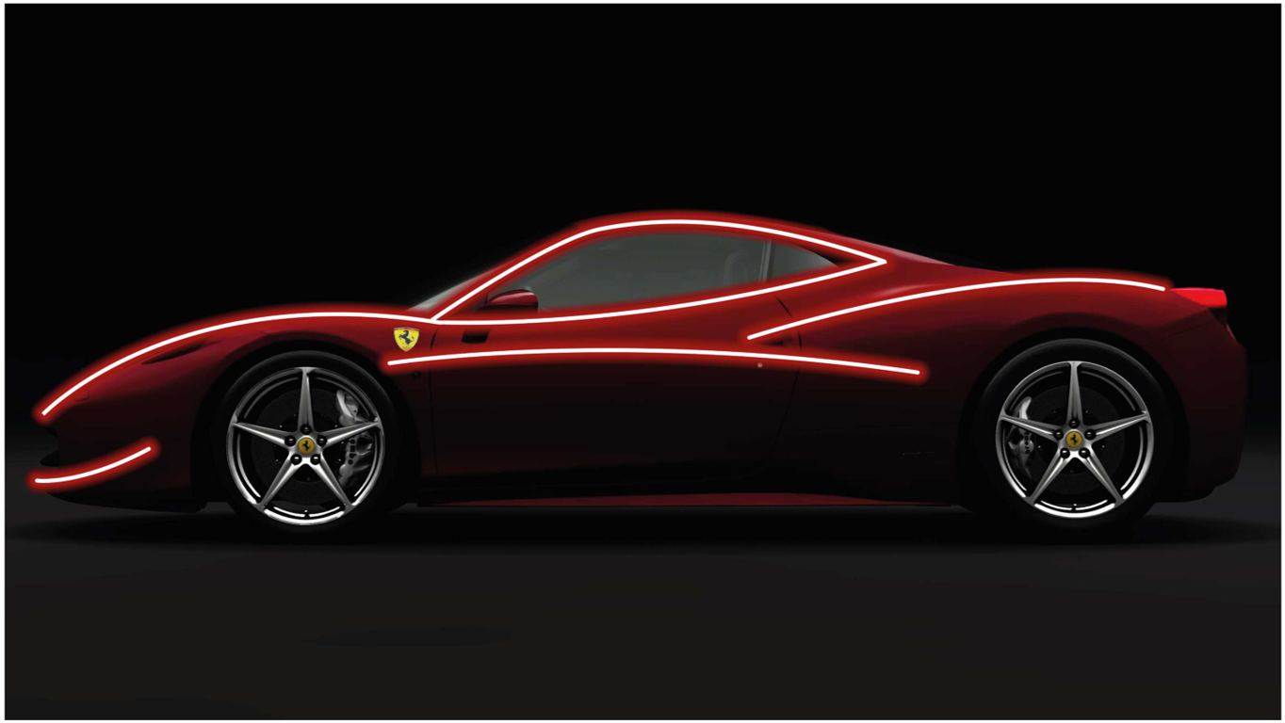
My tastes and design ideologies when it comes to cars tend to align with Pininfarina’s in the pursuit of beauty and elegance, “Design shapes the world” being their mantra. Pininfarina are noted for sophisticated and forward-thinking designs but never straying from core principles and their long standing relationship with Ferrari, until recently helped build both brands into the powerhouses they are today Pininfarina designs tend to have very traditionally correct proportions and seamless bodywork with flowing lines that stretch the length and width of the car. I believe in refined, unbroken curves that are allowed room to breathe and bodywork cut with sharp and distinctive lines that tie the whole thing together but above all, the profile must be clean, pure and free from any sort of fuss. I really appreciate it when style and creativity are allowed to take centre stage, but it should never be a compromise and nothing superfluous should be allowed to permeate. Whilst aesthetics are of great importance I find it just as gratifying to understand the reasoning behind design decisions in regards to functionality and engineering. I find it fascinating to watch the symbiosis between designers and engineers in full effect as they lock horns to produce the best possible outcome; or as Pininfarina would put it, [9] “This quest for the right equilibrium between emotions and reasons”. I also find my ideals align with the thoughts of Colin Chapman and Gordon Murray, [10] “Simplify then add lightness” Chapman would say. These two icons went head-to-head at the crucible of motorsport yet they shared similar ideals and thoughts about how a performance car should be constructed, as simply as possible aiming to minimize the weight for the sake of uncompromised performance. This is evident when you see road cars from Lotus and Gordon Murray Automotive, my personal favourite being the GMA T.33.
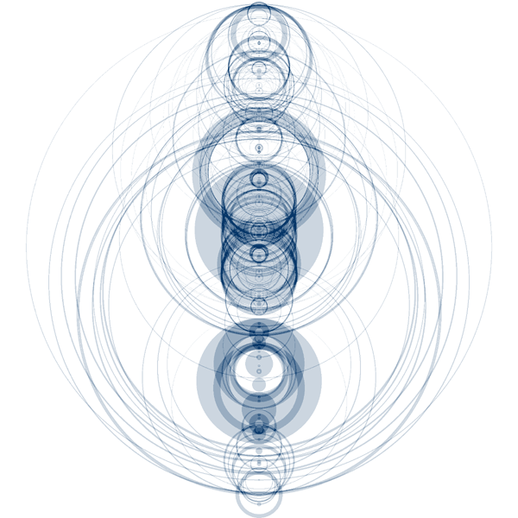
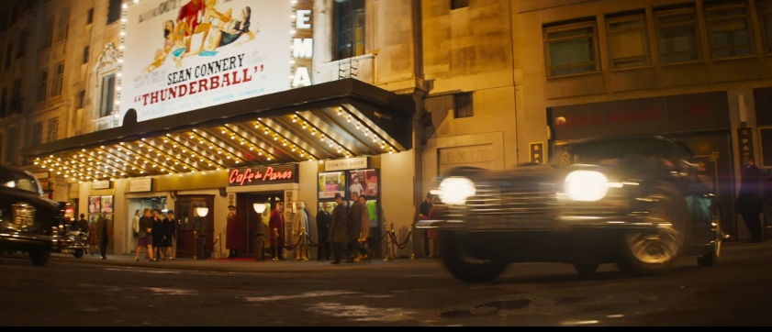
I often begin my ideation phase by immersing myself in the subject matter and doing my due diligence in regards to research into legacy and brand values. I follow this up by recusing myself to focus on inspiration. Music and film have been of paramount importance to my inspiration and are also a source of comfort for me. I thoroughly enjoy losing myself to a story told through the medium of film but I also find myself looking elsewhere into things such as the cinematography, lighting, hues and camerawork all of which could very easily be immersion breaking but when done correctly can transport you and enables you to place yourself where a protagonist may go. Edgar Wright’s “Last Night in Soho” resonated with me particularly strongly. Music simply means the world to me and has the uncanny ability to be infinitely relatable. There is a time and a place for every song in existence and I pride myself on being able to venture into unknown genres in order to find the perfect song for the perfect time. Music is a friend in a time of solace, the life of the party, a distraction from the mundane. Music is just the most empathetic entity and to suggest that it cannot dictate the form of something, even a car is folly. Auditory-visual synaesthesia is the sensation of being able to visually experience shapes and colours as a direct result of aural stimuli. To those who experience such a thing often find great pleasure, amplifying the musical experience and can even be a bonus creatively. [12] “The Shape of Song” (Wattenberg, 2001) may prove to be a more literal and tangible analogy that posits what a song might look actually look like through an “Arc Diagram” that highlights and links repeated sections on sheet music forming a graceful, interconnected network of curves showcasing the shape of a given song and “Reflect the full range of musical forms” as is the case of Beethoven’s Moonlight Sonata shown here…
[11]
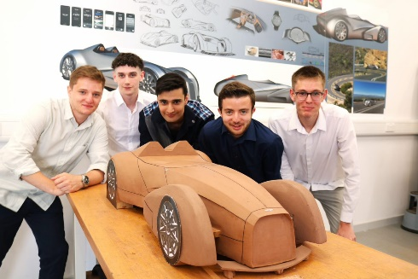
After my initial research and inspiration phase I then move on to a brainstorming phase aiming to get as many thumbnail sketches out on paper as possible in a limited time as I attempt to liberate the subconscious and channel whatever emotions, thoughts and feelings are bubbling under the surface after phase one. From then on it is simply a case of finding my favourites among my works to take forward. Having recently completed a project with Morgan, I find myself more confident in my sketchwork and understand now that it is more important that and idea is able to be conveyed rather than the way it is dressed up. Seeing how Morgan have religiously stuck with the same design thinking for over 70 years now is admirable and it proves that in some cases the old ways really are the best. That’s why I will always start a project with a pencil and a sheet of A3 paper. The Morgan project also helped me to better understand the value of developing a design idea collaboratively as opposed to trying to handle everything alone. I was very pleased with the final product, the development of which helped me to better understand where my skillset lay as I have a new found appreciation for clay modelling that I wish to carry forward into my next project. The clay helped me visualize the design in 3 dimensions in a way that sketches and virtual models just couldn’t. This was down to the way that surfaces are formed and I believe the sculpting gave me a greater understanding of how a body is put together.
I took the Morgan project deeply to heart and now as I have begun work on my final year major project I find myself trying new techniques to enhance my work such as augmenting my sketchwork on an iPad and I believe my graphical work has improved exponentially; all in the name of making a car as aesthetically pleasing as possible. One possible reason for the project being such a success can be attributed to the essence of competition and the dynamic found between two rival teams, and now I wonder just how influential the spirit of competitiveness can be?
Spite is an underrated tool that when used properly can spur you on to achieve greater heights than you could imagine. For example we simply would not have Lamborghini and Ferrari may not have produced such stellar road cars if Enzo Ferrari and Ferruccio Lamborghini had not had such great distain for one another. Lamborghini was in the tractor business and upon completing a sale would take his customers for rides in his Ferrari 250 GT. After having burned out the clutch on his Ferrari, Lamborghini discovered that the clutch in question was in fact the same unit used in some of his tractors. Lamborghini confronted Ferrari who took this as a great insult and suggested Ferruccio stick to tractors at which point Lamborghini vowed to create a sports car of his own to vanquish Ferrari’s and Automobili Lamborghini was born. Perhaps it is a primal thing, the idea of wanting to out-do one another for the sake of achievement, it is a tried and tested formula for success that dates back millennia. It fuels us in the automotive world and let to the creation of motorsport. The first recorded motor race came in 1895 in France, a run from Paris to Bordeaux and back to Paris. Motorsport is unique in the way that requires harmony between man and machine and when that unity is achieved it resonates on a deep emotional level that is exceptional in it’s way of drawing out adrenaline and excitement across all flavours under the overarching moniker.
I feel like not enough people appreciate the scale of the direct impact that motorsport has on our daily lives. The cars and the roads form the infrastructure of our cities and carve through our landscapes and are interspersed into our daily lives and yet so much critical technology and learning about how to build a car and develop these infrastructures is derived from the world of motorsport. Tyres are the medium through which a drivers inputs are transferred and the contact patch is partially responsible for a vehicles dynamic capabilities and behaviour on the road; the compounds of these tyres are pioneered by companies such as Pirelli and Michelin for use in motorsport to optimize performance, as a consequence are extremely capable on the public roads allowing for greater levels of traction and safety in the cars we daily drive. Pirelli have now produced what they call a “Cyber Tyre” which has sensors embedded within that take readings in real time to understand road conditions, grip levels and tyre performance all in the name of optimizing a cars capabilities and enhancing safety on public roads. Survival cells and monocoques were developed in Formula 1 to cocoon an occupant in the event of a collision and have led the development race for safer chassis. Paddle operated gearboxes, regenerative braking in hybrid systems, telemetry, aerodynamics, suspension, braking performance and steering geometry were all developed or refined in the realms of motorsport and are now considered staples of the motoring world. Combining elements like these you then begin to understand how to piece a car together in the most efficient way possible, finding elegant engineering solutions to real world problems that are beautiful in their own way.
Bearing all of this in mind, it is now finally time to directly address the key questions posed at the start of this piece: “What makes a car beautiful?” and “Is there still a place for beauty in our modern motoring world?”.
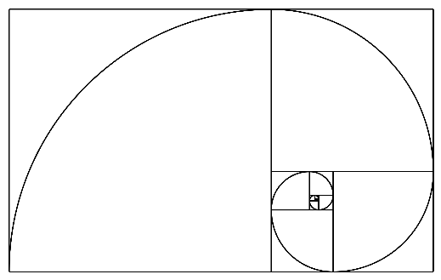
The motor car is an extension of ourselves and a face that we display to the public when driving. It is also an entity unto which we project thoughts and feelings, humanizing these machines. We also celebrate the idiosyncrasies associated with our vehicles as if they were people and when we finally part with them, a feeling of melancholy engulfs us as if we’ve lost a dear friend. What in fact makes a car beautiful is in the outward appearance, yes; a pretty face to show to the world and bodywork with sensual curves, striking graphics and memorable, meticulous detailing. All of the above are true, especially when those curves follow the laws of natural beauty as laid out by the “Golden Spiral” [13].
The golden spiral is the term given to the shape formed when applying the logarithmic ratio expressed as the Greek letter φ (Phi) and is constructed by using numbers in the Fibonacci sequence. This spiral uses mathematics to help give us a grounded understanding of proportions and also makes sense of the way natural shapes are formed, for example the pattern in which sunflower seeds are grown given how the flower must turn is determined by the golden spiral. The proportions of the Mona Lisa can be attributed to the golden spiral.
When applying the same thinking to the shape of a car we begin to understand what makes it beautiful, but to suggest the beauty of such a thing is purely aesthetic, especially given all I have already written would be completely superficial. Consider the humane qualities pertinent in our cars, despite being able to consider a car as a piece of art, the beauty of such a thing cannot be judged by the same metrics. The beauty of our cars comes from the aesthetics yes, but critically it comes from the artistry and hard work that goes into its creation, the stories that led to its inception would we hold Lamborghini’s in such high esteem if they hadn’t been born out of spite? Furthermore, what enhances the beauty of our vehicles are the emotional ties we hold as we care for them and maintain them as if they were our own flesh and blood. Beauty can also be found in the way a car executes a specific function; a Land Rover is a wonderful thing but can only truly be appreciated once you’ve strayed off of the beaten track and exploited it’s off road capabilities, upon which the car will have accumulated dirt and grime that some would argue (ironically) only seems to enhance the aesthetic appeal for it shows it has been used as its maker intended, only to then be taken home and hosed down like the family dog after having rolled around in the mud! “It (The Mclaren 650S GT3) looks miles better covered in crap from the Spa 24 hours” (Harris, 2019) [14]
If you’re technically minded, the beauty comes from the way the car is put together. Mechanical and engineering sculpture should nut be underestimated, even if it is simply finding individual parts aesthetically pleasing or seeing how those parts work cohesively to produce something greater than their sum and functioning at an exceptional level.
Most importantly the beauty in a car can be found in the experiences one has alongside their mechanical partner. Every family road trip, B-road blast, drag race, lap around Silverstone, commute to work, shopping run, dropping the kids off at school. Every dent, every punctured tyre, every worn brake pad are all just chapters in an unfolding story that are opportunities to invite more characters and helps bring people together. When you understand all of that, take a step back the next time you look at your car and appreciate the forms in the bodywork, run your hands along the creases in the bodywork and discern how the light is reflected in the surfaces, all of which will be deliberate and done for a reason. Next take a moment to marvel at the blood, sweat and tears that have been put into the car and be thankful for all it gives you because no matter what you drive, I whole heartedly believe in the beaty of cars and car ownership. To me that is what makes a car beautiful.
And now to the case of looking to the future; something I have been guilty of struggling with in the past and there is an argument to be made that my tastes and sensibilities have held me back but I’m not here to wax lyrical or write a requiem to the motor car, but to consider where the industry is headed and if there is still a place for beauty in terms of the automobile.
The internal combustion engine is now seen as a relic and is becoming ostracized as more and more communities begin embracing alternative powertrains in the pursuit of a brighter and greener tomorrow. The very idea of what a motor car can be is in question and new legislation threatens to take away that which many of us hold dear and in some cases it is simply no longer possible to create shapes and forms that many did in fact consider to be beautiful. Should we see a rise in autonomous vehicles then we may see a new range of vehicles all intended to move as one, potentially in their own roads to segregate them from human driven vehicles and eliminate the humane element of risk from the scenario. These vehicles however would need to be identical down to the last minute detail and I have no doubt would restrict the creativity and reduce driving to a purely functional endeavour. The way of looking at this from a designer’s perspective is to embrace that new challenges are emerging in regards to the way cars are owned and used as well as what powers them. This presents an opportunity for designers to have a blank sheet of paper to envisage what the cars of the future may look like and be as conceptual as possible. Yet if the industry tends towards standardised parts and systems, finding ways to customize and distinguish yourself will become vital. For instance if there should ever be a modular chassis and battery system popularized across the industry then we may well see a return to old fashioned coachbuilding because why should you settle for a basic platform that is the same as everybody else’s when you can have something bespoke and tailored to your tastes but still conforms to the societies ideals about mobility.
If anything, beauty in cars should now be more important than ever because it is something worth holding on to and reminds us why we love motoring and in a world that tends towards disorder and societies strive for conformity, those who dare to be different should be rewarded for showing creativity and allowing their tastes to be expressed on the road. Not only do I believe there is still a place for beauty in our forward thinking, environmentally conscious world, I strongly believe it is something we cannot afford to lose and must cling on to with every fibre of our beings.
I began this piece with a quote from Enzo Ferrari, I man for whom I bear a great deal of respect and upon being asked about his greatest victories, he responded “That which is yet to be won, the one which I have not yet achieved” [15]. What we can take from this is that we as a species must honour our heritage, yes, but also to accept that just because something seems good, doesn’t mean we should ever stop innovating. Timeless beauty will endure throughout the ages and can always serve as inspiration, but we should never lose sight of the fact that our greatest victories, are yet come.


James A S Hungin – 2000718

References

[1] Enzo Ferrari, 1898-1988, https://quotefancy.com/quote/1184964/Enzo-Ferrari-Race-cars-are-neither-beautiful-nor-ugly-They-become-beautiful-when-they-win
[2] Francis Bacon, 1561-1626, http://www.diptyqueparis-memento.com/en/the-beautiful/
[3] Roland Barthes, 1957, La Nouvelle Citroën – Mythologies, http://www.citroenet.org.uk/passenger-cars/michelin/ds/32.html
[4] Robert Puyal, 2022, Pagani Utopia, https://www.pagani.com/pagani-utopia/
[5] Pagani Utopia image, 2022, https://www.carscoops.com/2022/09/pagani-shows-off-utopia-at-milan-museum-next-to-original-da-vinci-drawings/
[6] Dany Bahar sketch, 2018, https://uk.motor1.com/news/267893/ares-design-ferrari-250-gto/
[7] Ferrari 575M Maranello image, 2018, https://www.clinkardcars.co.uk/
[8] john F. Kennedy, 1962, Rice Stadium speech https://www.rev.com/blog/transcripts/john-f-kennedy-jfk-moon-speech-transcript-we-choose-to-go-to-the-moon
[9] Pininfarina, Philosophy, https://pininfarina.it/en/automotive/
[10] Colin Chapman, 1928-1982, https://www.classicdriver.com/en/article/genius-colin-chapman-simplify-then-add-lightness%E2%80%9D
[11] Edgar Wright, 2021, Last Night in Soho, https://www.artstation.com/artwork/03XOmY
[12] Martin Wattenberg, 2001, The Shape of Song, http://www.visualcomplexity.com/vc/project.cfm?id=371
[13] Golden Spiral image, https://symbolsage.com/golden-spiral-meaning/
[14] Chris Harris, 2019, Mclaren Senna vs 650S GT3, https://www.youtube.com/watch?v=x-kK2cWDcWU
[15] Enzo Ferrari, 1898-1988, http://www.quoteswise.com/enzo-ferrari-quotes.html#:~:text=%5BOn%20the%20most%20important%20race,I%20have%20not%20yet%20achieved.&text=%5BOn%20which%20Ferrari%20model%20he,is%20yet%20to%20be%20built.

