Shaun Davies
1903572
Worksheet 2

Contents
Worksheet 2 2
1. Screen Captures 2
2. Observational Tasks 25
2.1 DNS 25
2.2 Critical Roles/Features within an Enterprise Network 26
2.3 Levels of Access/Roles 27
2.4 AGDLP & AGUDLP 27
References 28

Worksheet 2

Screen Captures

To ensure that Server 1 IP is statically defined the user navigated to the Network Status and selected the properties option for PrivateNet1. They were then able to select the TCP/IPV4 option and the IP was statically defined as per the below screen capture and no DNS was setup.
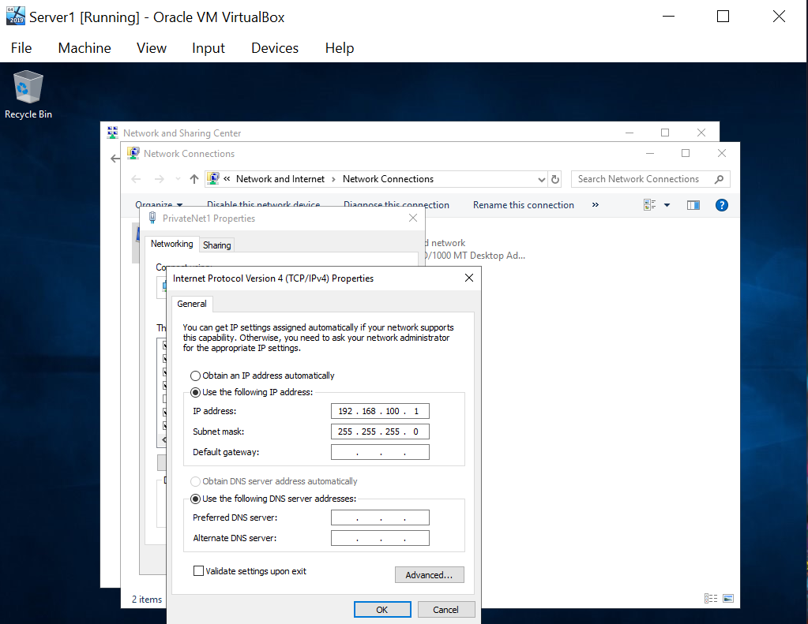

They then navigated to the Firewall and checked the status of the firewall which was off, as per the below.
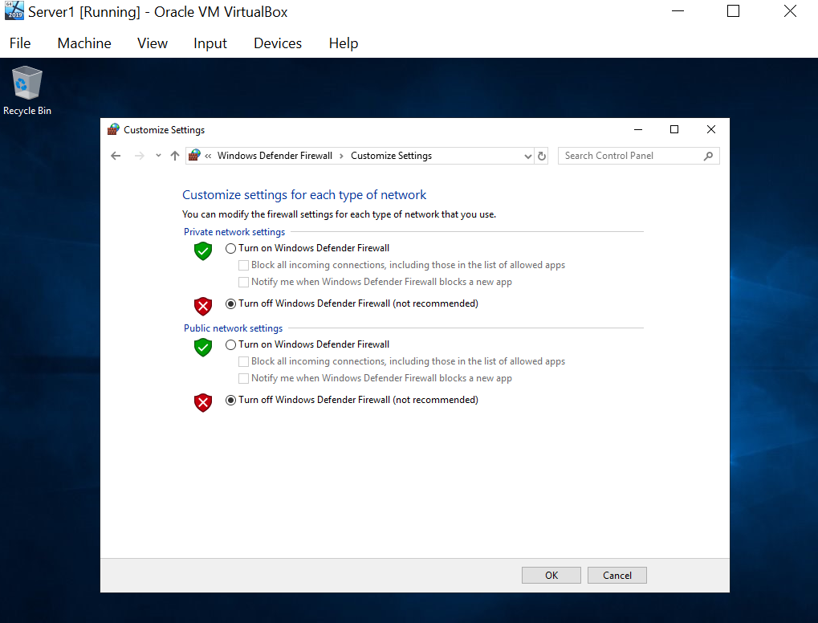
After confirming the above the user searched for ‘This PC’ and selected properties in order to change the name of the PC to DC1-NWT.
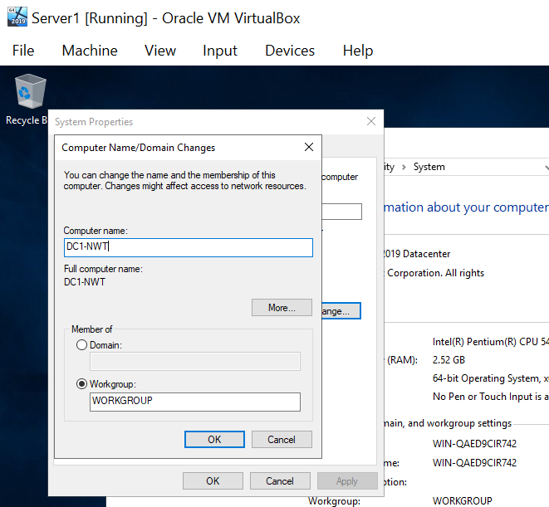
Server 1 was the restarted in order for the changes to take effect as can be seen below.
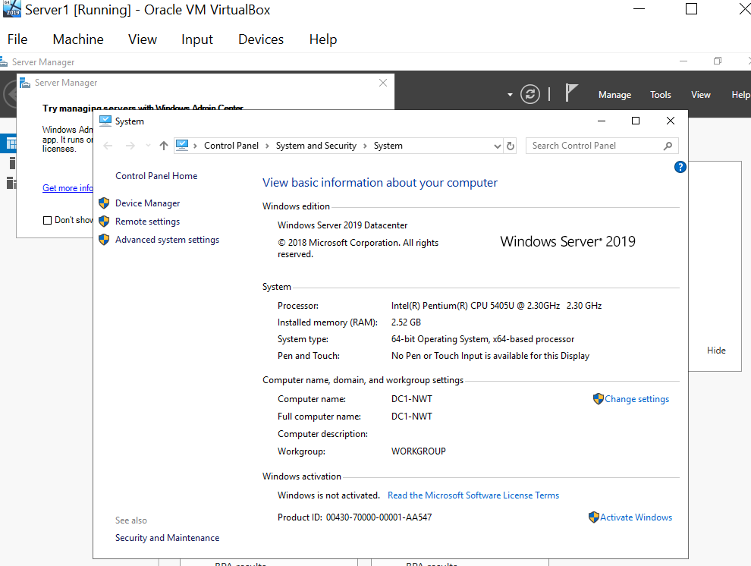

The user then began to setup the Active Directory, firstly selecting Server Manager and ensuring pre-requisite tasks had been completed.
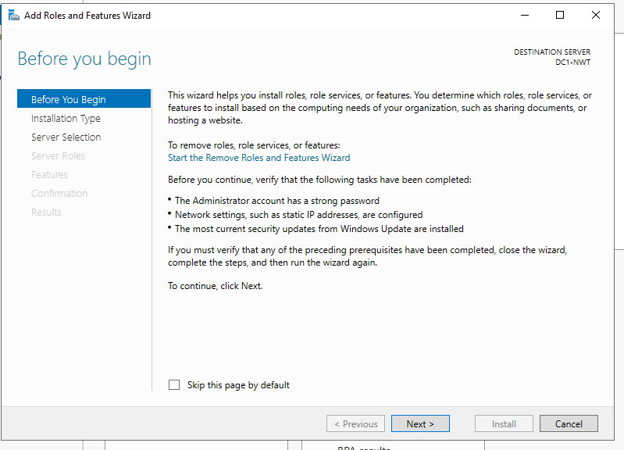
The user then selected the installation type as per the below.
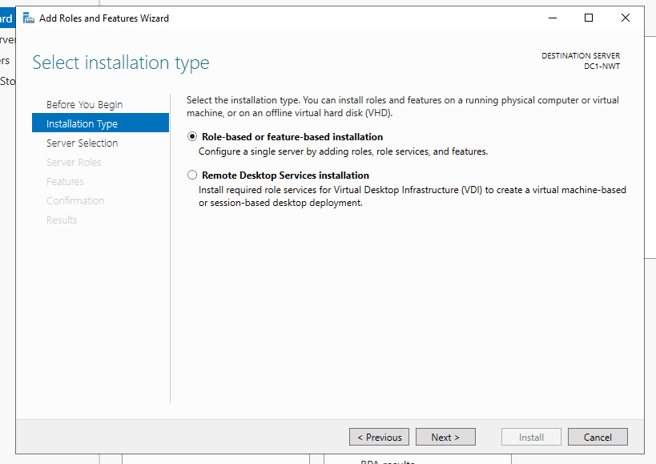
Server 1 (DC1-NWT) was then chosen.
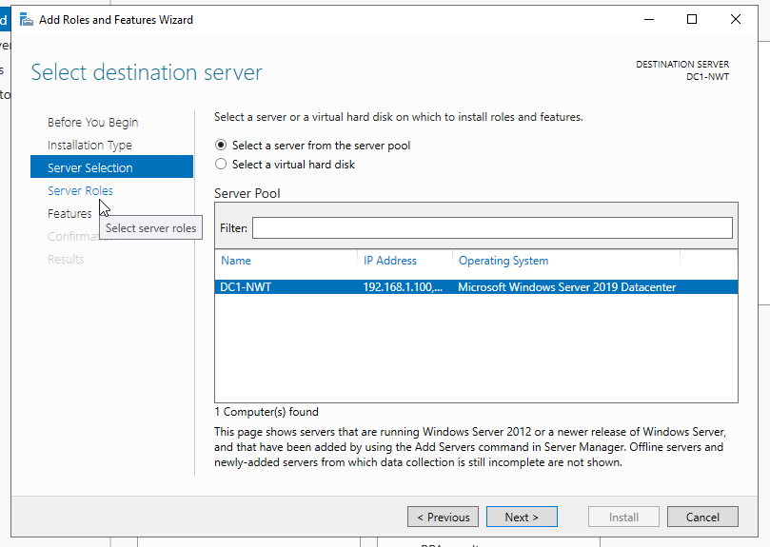
The user then selected The active directory domain services and used the default features. The user then read the summary of what the AD DS does.
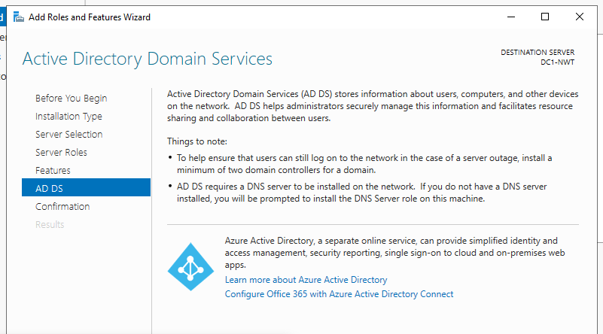
The installation process for the AD DS was then commenced.
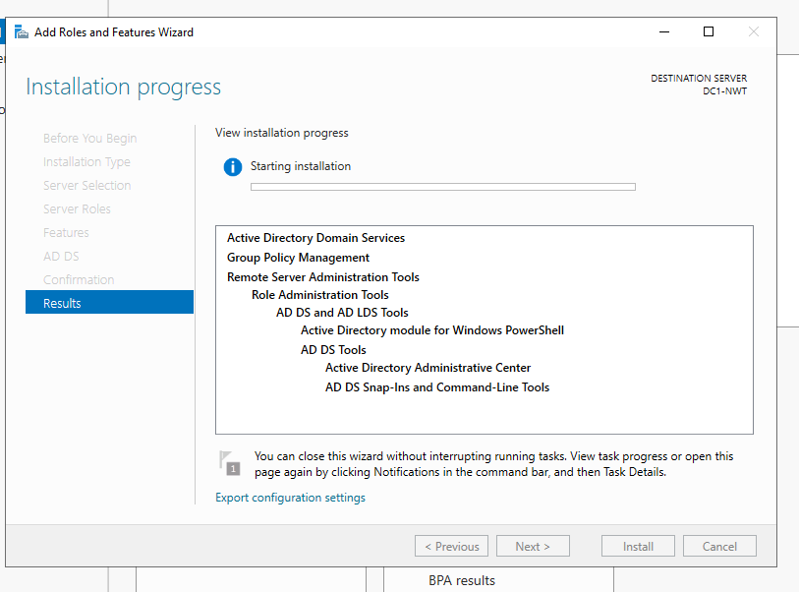
Following installation the server was then promoted to a domain controller.
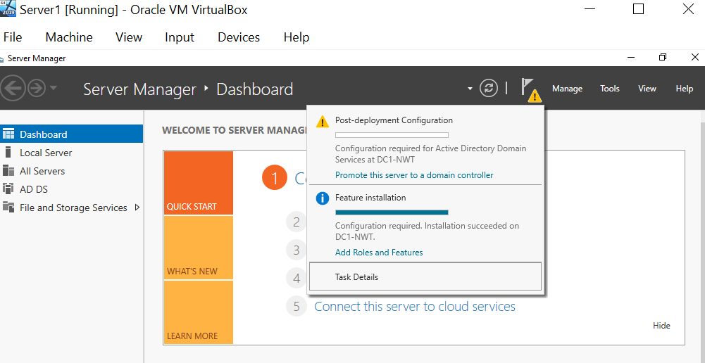
This then allowed the user to create a new forest and assign the domain name of nwtraders.msft.
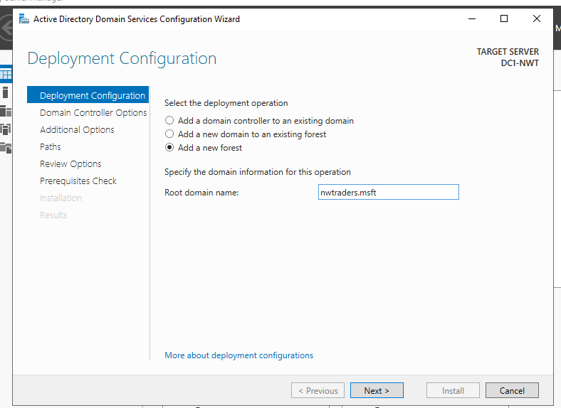
The user insured that Windows User 2016 was selected for both the Forest Functional level and the Domain functional level and specified the controller capabilities ensuring DNS and Global catalogue were selected. The password N3tW0rk1 was then assigned.
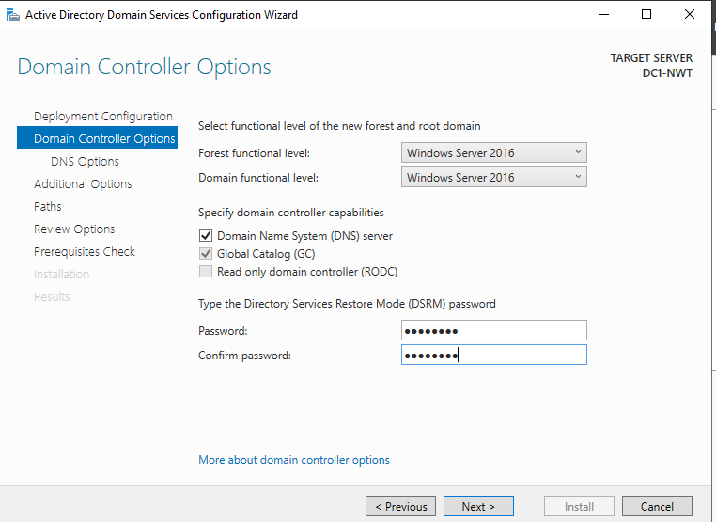
The locations of the Database folder, SYSVOL and LogFiles was noted as per the below screen capture.
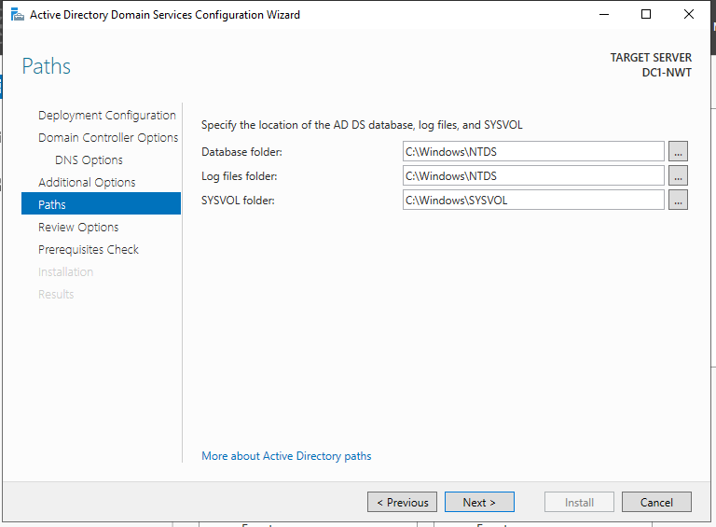
Following installation the server was rebooted. The user was then prompted for the Administrator account for NWTRADERS they had setup at the login screen.
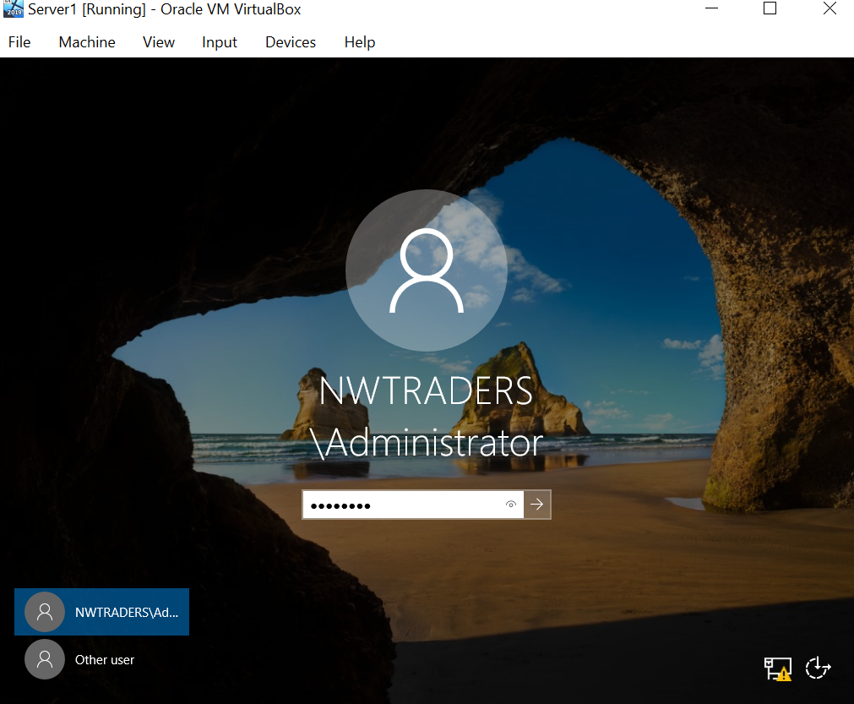

The user then faced complications due to the password not being recognized. The password had been correctly entered and clarified within this document. The previous admin password of ‘P@ssw0rd’ would not work either. The user then decided to remove the server and begin the setup again. Following this on entering the N3tW0rk1 password, this was not recognized, however P@ssw0rd was correct.

The user then continued with the task and navigated to the Active Directory Users and Computers.
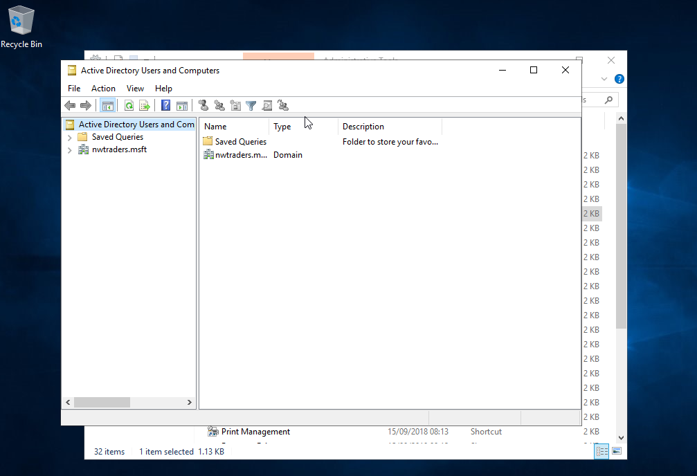

The user then selected the Domain Controllers Window which verified that DC1-NWT is the domain controller, this is shown below.
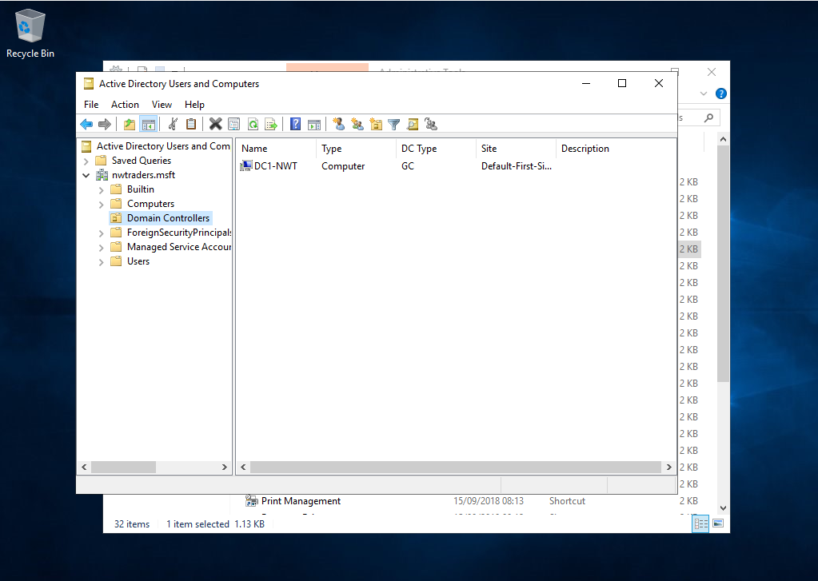

The Users container was selected and the objects were assorted by Type.
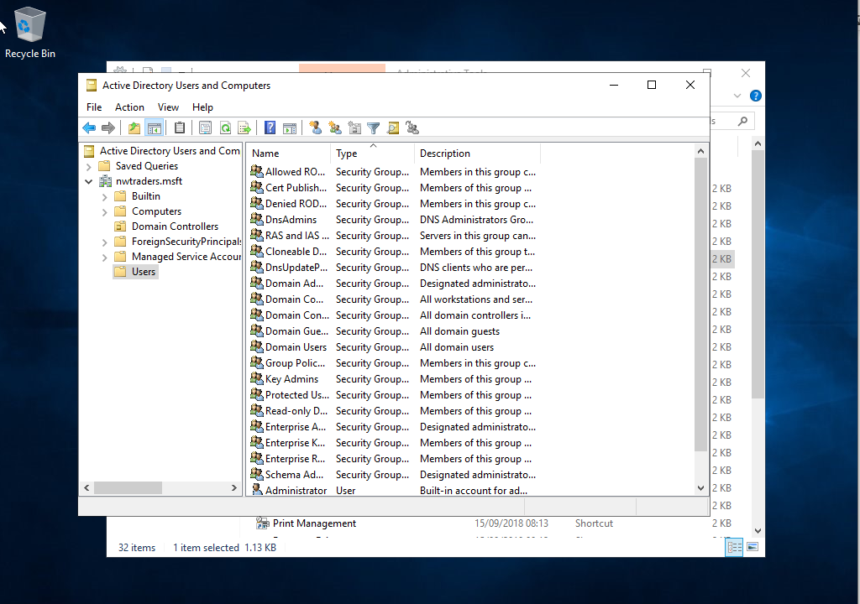

The domain admin account the user created is listed as the only member of the Domain Admins Group.
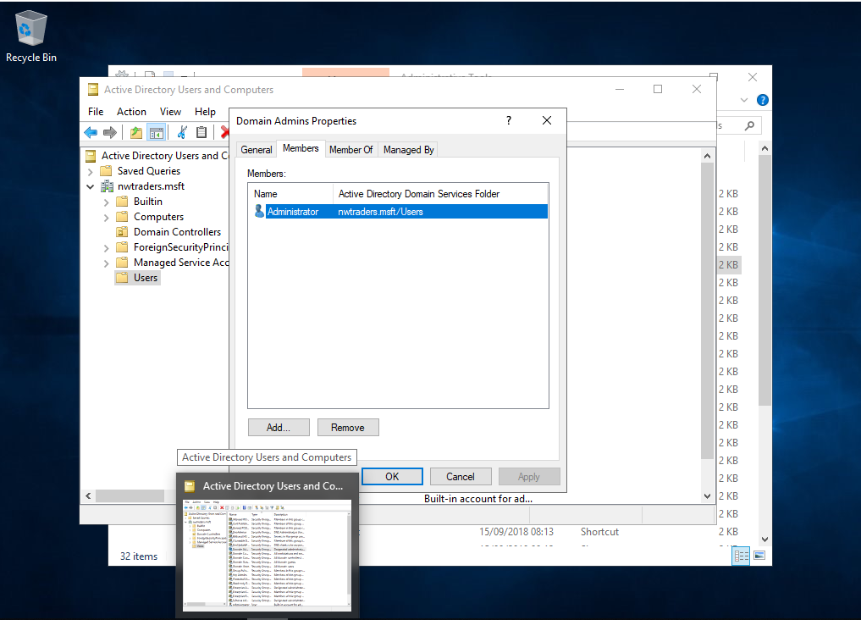

In order to create a failsafe admin account, the user firstly has to create a new user.
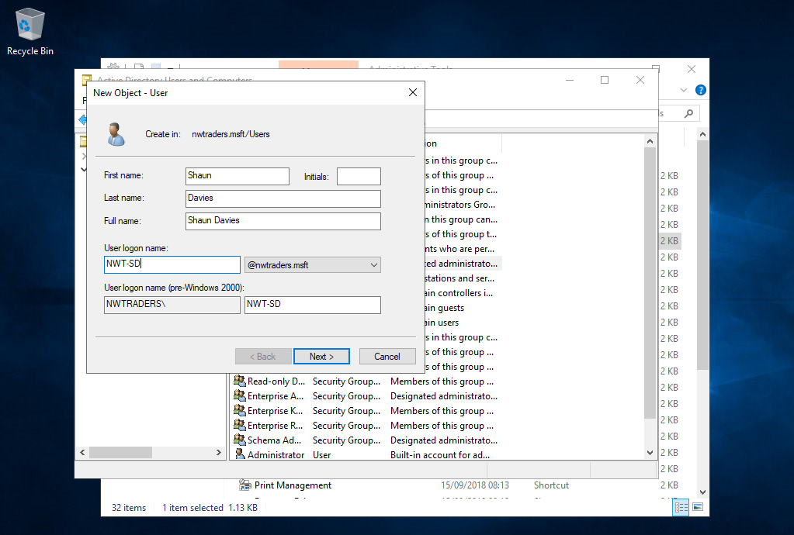

The user details are as follows.
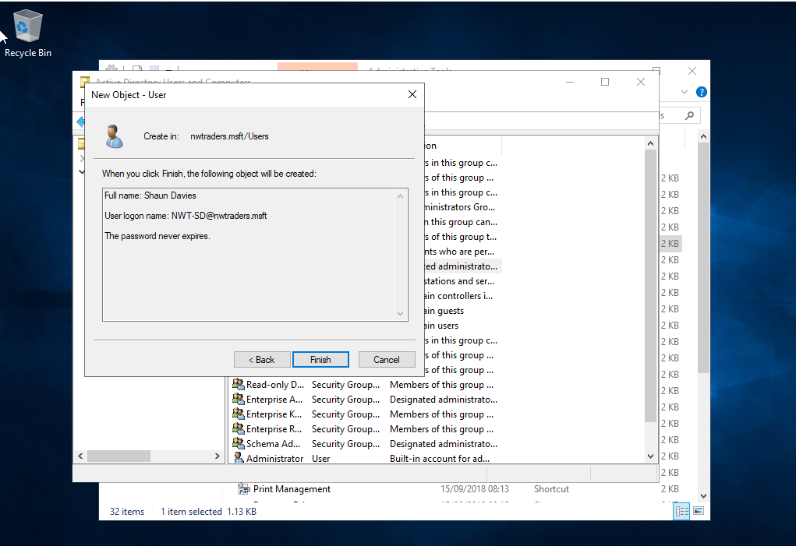

The new user is then added to the Domain admins group.
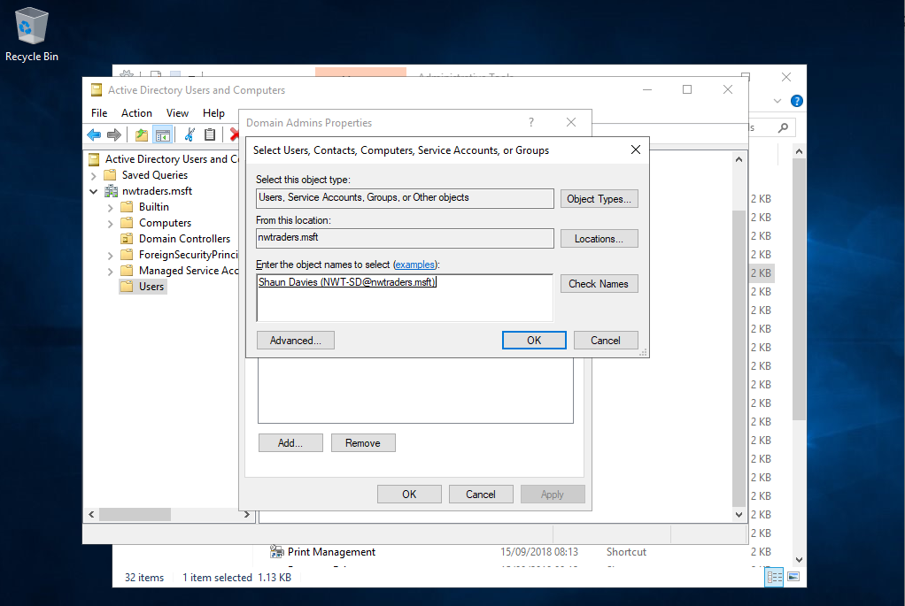

During Task 4, the user created another new user in order to demonstrate enforcing policy options and to control objects.
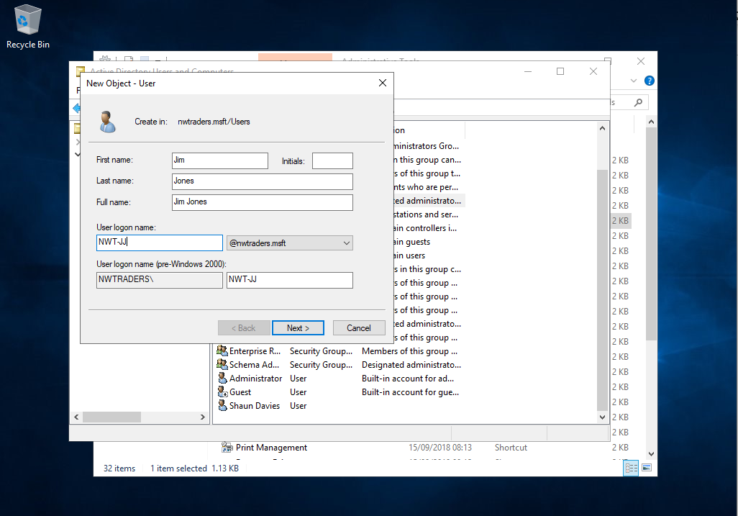
The new user resides in the Domain Users group.
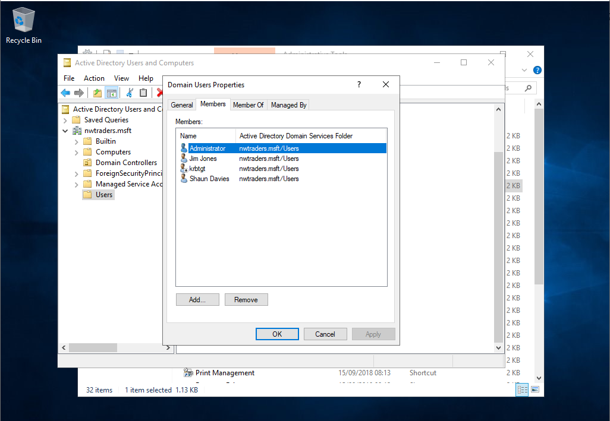

The users logon hours were set Between 08:00 and 17:00 hrs Monday to Friday with logon denied between 13:00 and 14:00 hrs between Monday and Friday.
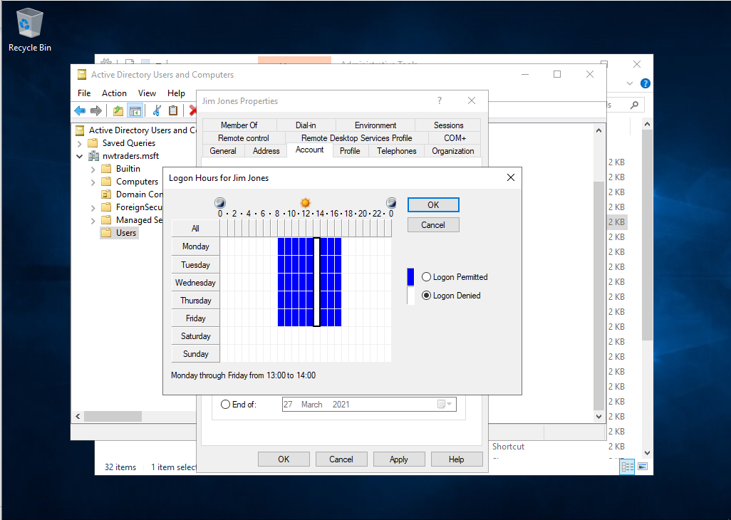

The user clarified that there are no computer accounts created for Client 1 or Client 2.
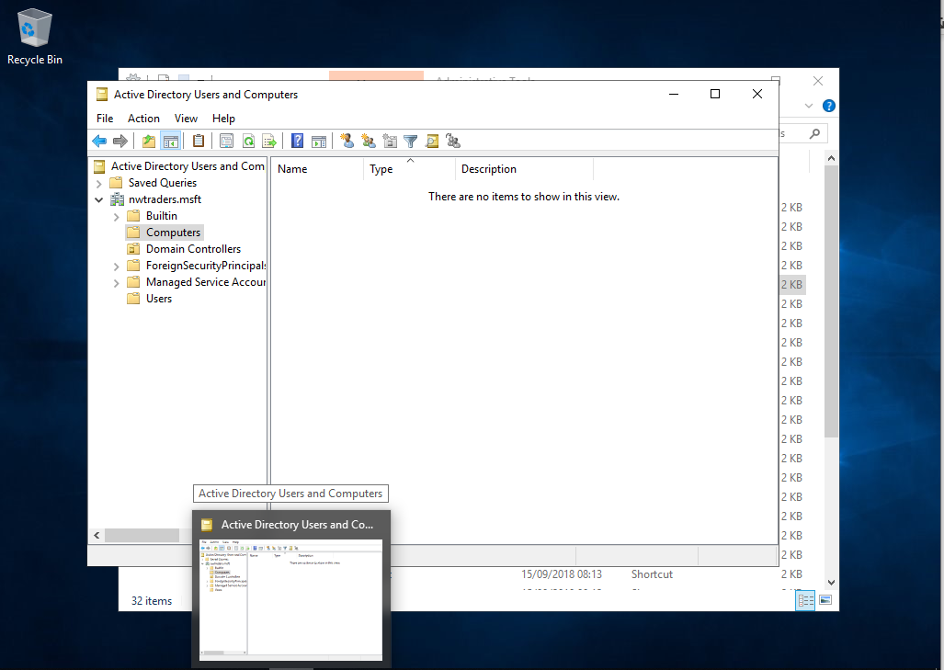

The user then created a new computer named WS1-NWT.
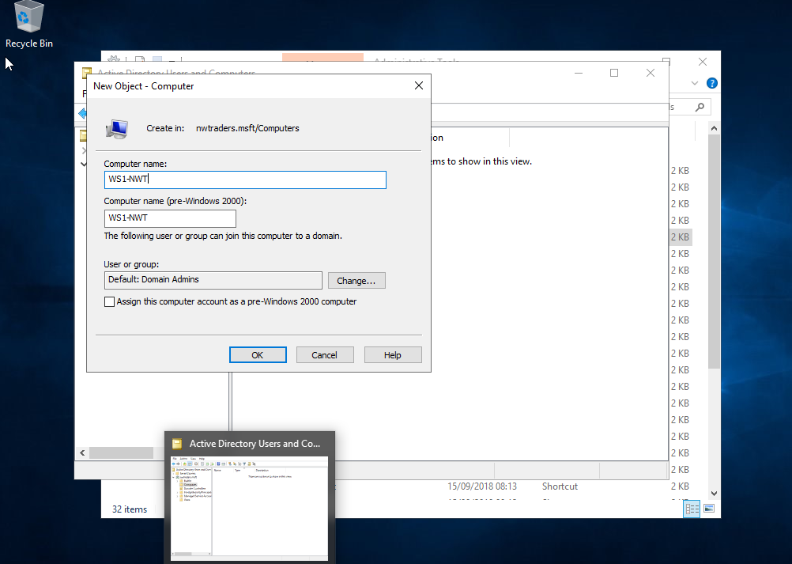

Client 1 was powered on and the PC name was changed to WS1-NWT.
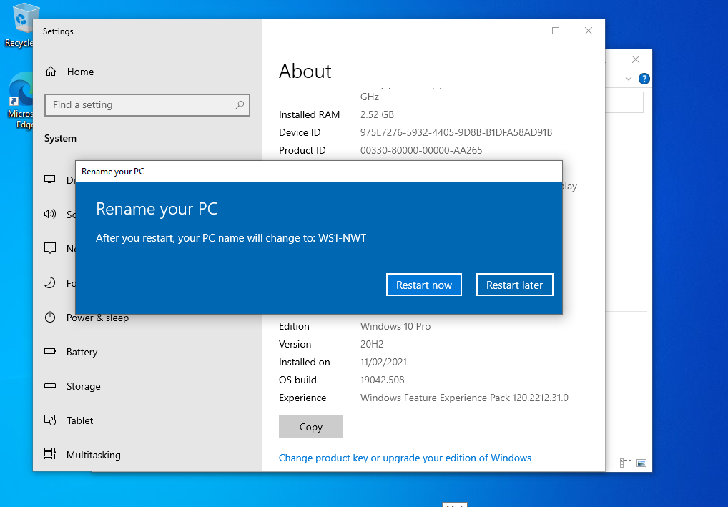

To ensure the client is connected to the DNS server running on Server 1 the user changes the IP address configuration. PrivateNet1 is given the preferred DNS server IP of 192.168.100.1.
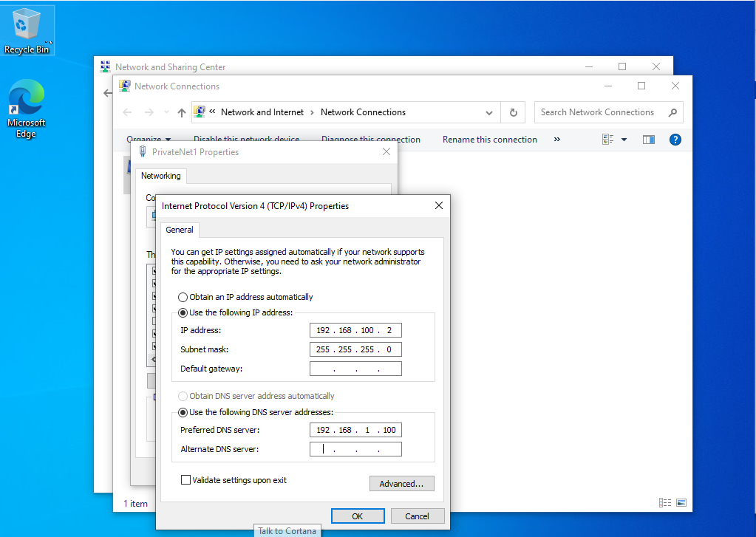

The client domain membership is set to nwtraders.msft.
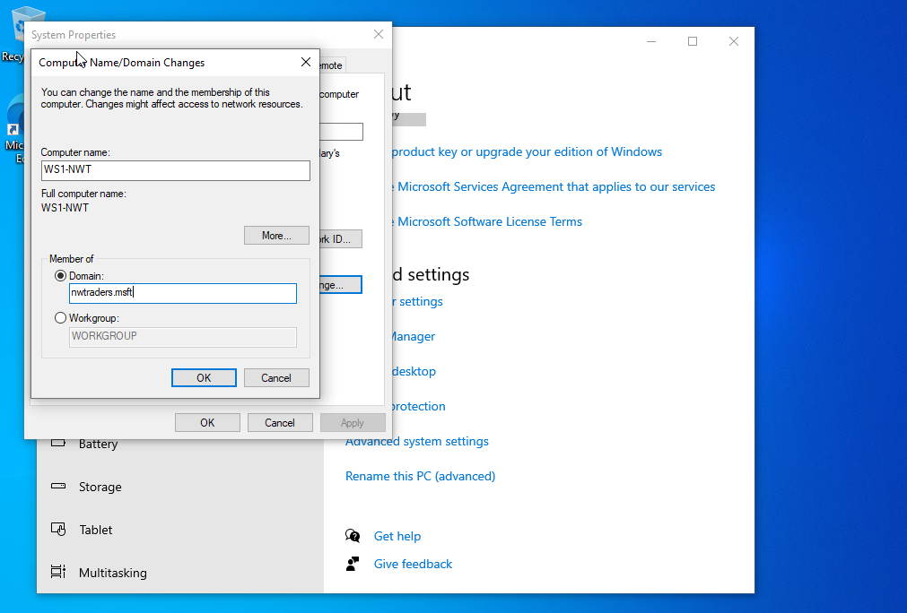
The user is welcomed to the nwtraders.msft domain.
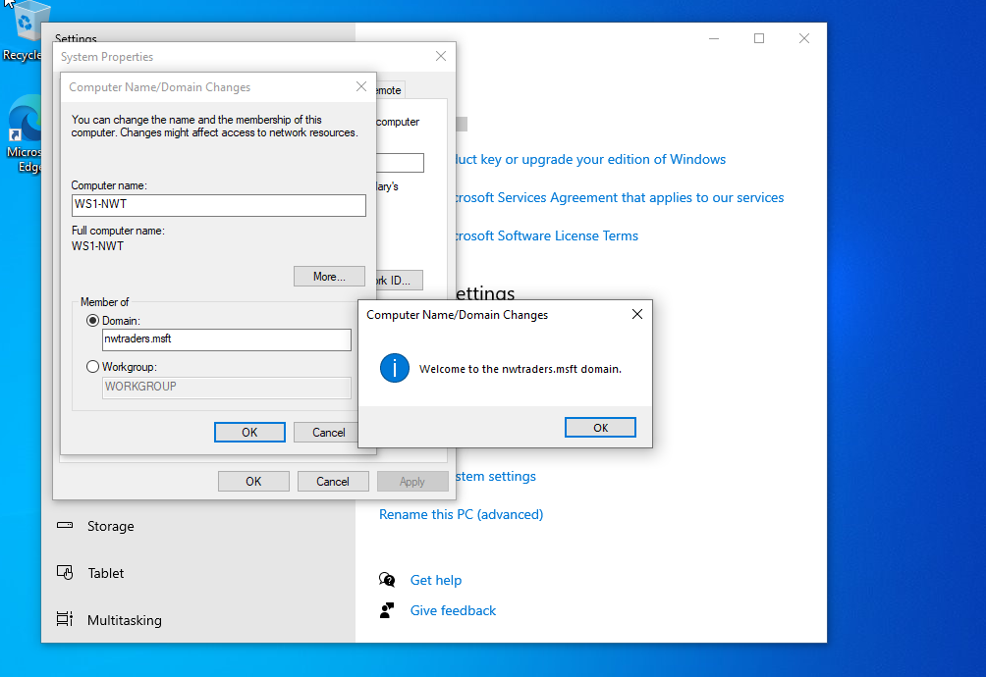

Client 1 shows as connected to the nlwtraders domain and the non-admin account is used to login.
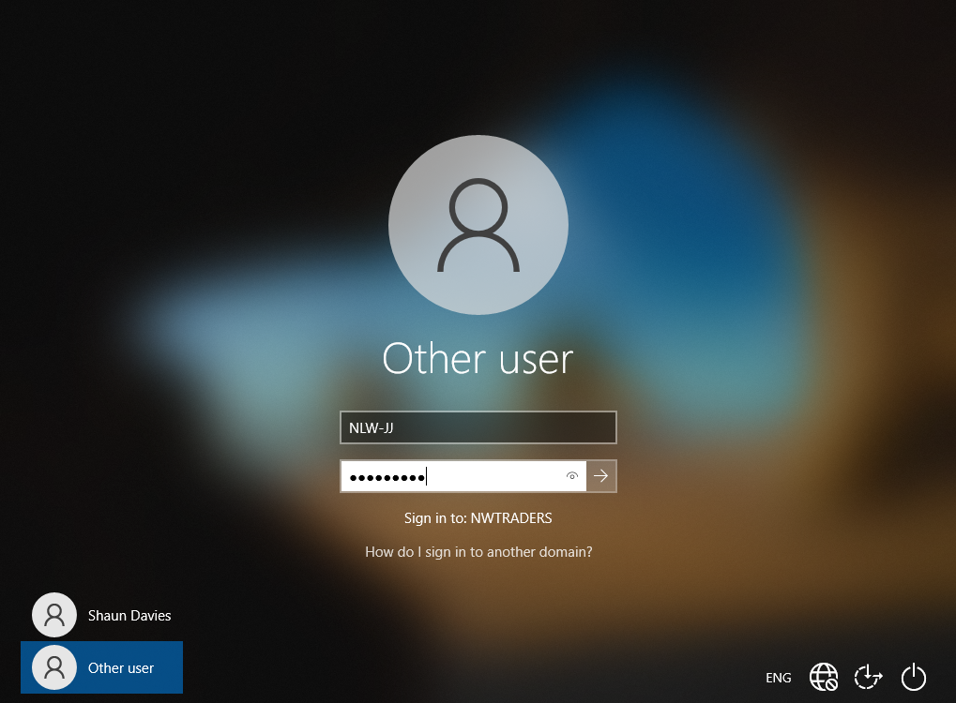

The user verified the connection to the network by displaying the user details that appear when the mouse cursor is over the person icon, which shows Jim Jones, the non-admin account. The user then confirmed that the Jim Jones account could not logon to the server as can be seen below.
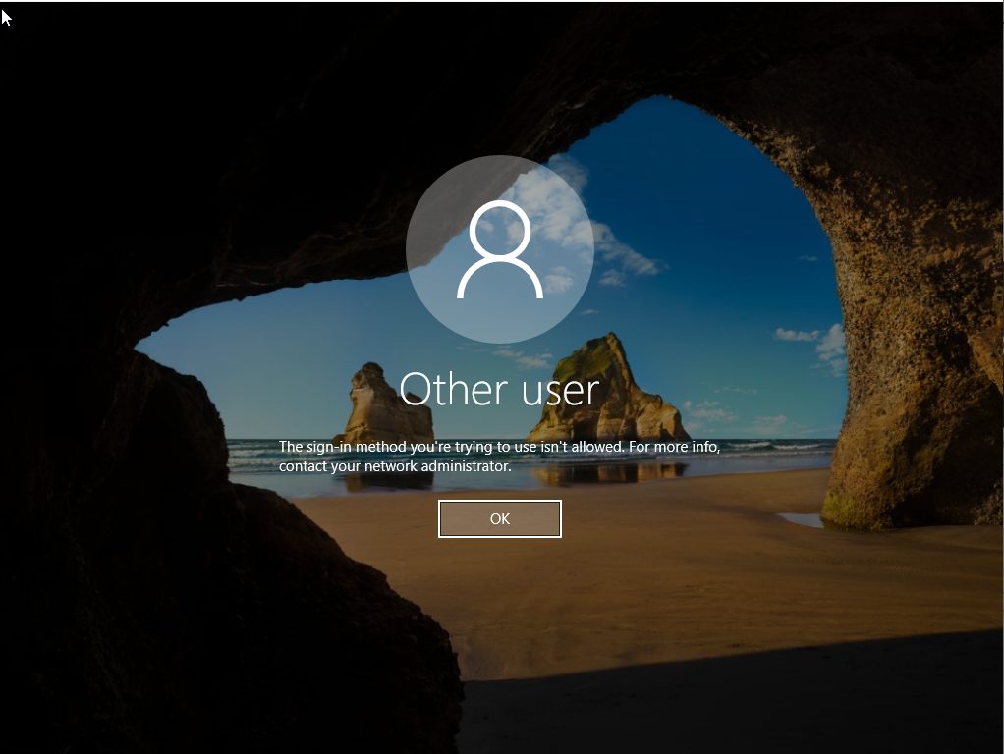

Observational Tasks

DNS

DNS which stands for Domain Name System is the name given to the collection of databases which are used to translate hostnames such as www.nwtraders.msft to an IP address. This makes enables the use of the internet far easier as this enables users to navigate to where they want to go on the internet using language which is easier to understand and remember. Without DNS, users would have to enter IP addresses which would become impossible to memorize. [1]
The DNS server translates the human language, www.awebsite.uk, to computer language, the IP address. The OS of the host will remember those IP addresses by caching the information in order that it does not have to constantly have to ask the DNS server. [1]

The below illustration demonstrates the DNS server.
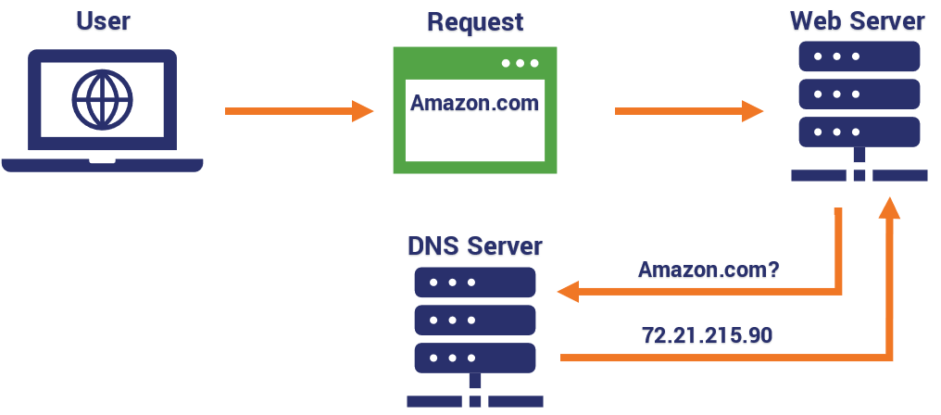 [2]

An Active Directory cannot be installed without a DNS because an AD cannot resolve the user requests into IP addresses without it. The Active Directory will hold information on what resources are available to the user on its network but will utilise the DNS to resolve the requests that follow from the user. The AD organizes the available resources for its network. [3]

Critical Roles/Features within an Enterprise Network

An active directory is not the only critical role/feature of an enterprise network, there are many features which make an enterprise network more efficient.
File sharing is one of the most important features, it allows a server to share its resources with a large number of its users. This allows the administrator to allocate a part of the server or individual folders to be shared with users, in order for them to store information. The administrator will delegate what folders are shared and who has access in order to effectively control what is being shared and that only those who need access, have it. The server allows the administrator to determine what size/portion of the servers file system is shared.
Security services is another vital role within an enterprise network as there are multiple threats to a network which are regularly exploited. The server must provide some security services in order for it to offer some protection. The administrator can establish policies such as password policies. This will allow the administrator to set particular restrictions which promote secure passwords, such as certain length, expiry periods, mixture of characters and numbers etc. Digital certificates can also be utilized in order to confirm the user is who they claim to be and that the files they are using/uploading are genuine. [4]

Levels of Access/Roles

Creating different levels of access within a network increases the protection against security breaches. By ensuring users have the appropriate access for their needs this prevents all users accidentally or purposefully sabotaging the network. It also allows delegation of certain admin rights to certain users. For example a DHCP (Dynamic Host Configuration Protocol) Admin can be created, this would then allow a user to maintain the DHCP with such tasks as creating, deleting and activating a server scope (a range of IP addresses a DHCP server is permitted to distribute). [5]
Having more than one Domain Administrator allows for shared responsibility of the network in order to effectively manage the access requirements, security and overall maintenance of the network. It also allows for any human error such as an admin forgetting their password or being locked out of their account etc.

AGDLP & AGUDLP

ADDLP which stands for Accounts, Global groups, Domain Local groups and Permissions is an efficient way of assigning permissions/resources to a group of users rather than individually. The administrator would firstly need to create the user Accounts, then the necessary Global group is created, and the user accounts are added to that group. The administrator then creates the Domain Local group which contains the necessary resources required for the users within the group. Then the Global group is added to the Domain group and the administrator applies the relevant permissions for the resource. [6]
By doing this it allows admins to easily add multiple Global groups to the Domain group which also allows Global groups from other domains to also be added. This allows for any files that all the users need access, to be shared once rather than to each user individually. It also allows users to belong to multiple groups with different permissions, as different roles will need the same and differing permissions. This is key to successfully managing a network as it reduces the task for the administrator. [6]
AGUDLP is the same principle accept that the U stands for Universal groups. This means that the Global groups are nested within the Universal groups which are placed on the main domain.
The author believes that utilizing AGDLP is absolutely necessary in successfully managing a network. Without the use of groups then the amount of admin tasks would be endless and would prevent the efficient maintenance of the network due to the admin being protracted with tasks relating to users.
To effectively utilise groups the network engineer should plan for the implementation of groups and what permissions are needed at different levels throughout the user roles. This will allow quick allocation of users into groups and groups into the relevant domains with the relevant permissions.

References

[1] | T. Fisher, “What is DNS (Domain Name System)?,” Lifewire, 27 Nov 2019. [Online]. Available: https://www.lifewire.com/what-is-dns-domain-name-system-2625855. [Accessed 04 Mar 2021].
[2] | P. Nohe, “What is a DNS leak?,” Hashed out by the ssl store, 23 Apr 2019. [Online]. Available: https://www.thesslstore.com/blog/what-is-a-dns-leak/. [Accessed 04 Mar 2021].
[3] | Server Brain, “The difference between DNS and AD Domains,” Server Brain, 02 Mar 2021. [Online]. Available: https://www.serverbrain.org/active-directory-security-2003/the-difference-between-dns-and-ad-domains.html. [Accessed 04 Mar 2021].
[4] | D. Lowe, “Networking For Dummies, 11th Edition,” in Netwroking For Dummies, New Jersey, John Wiley & Sons, Inc, 2016, pp. 180-183.
[5] | D. Lowe, “Understanding DHCP,” in Networking For Dummies, 11th Edition, New Jersey, John Wiley & Sons, Inc, 2016, pp. 82-84.
[6] | T. Fenner, “AGDLP reduces account management, permissions management headaches,” Tech Target, 21 May 2007. [Online]. Available: https://searchwindowsserver.techtarget.com/tip/AGDLP-reduces-account-management-permissions-management-headaches. [Accessed 04 Mar 2021].

