

Student Name : Yaxesh Nimeshbhai Ghoghari

Student ID : 2532567

Module Name : Marketing Management

Module Code : LCMB7024

Lecturer’s Name : Laila Maazouz

Portfolio: Brand development

Term 1

Table of Contents

Element 1: Brand Extension Poster Presentation 3
1.1 Introduction 4
1.2 Brand Extension Overview 4
1.3 Market Appeal & Emerging Trends 4
1.4 Alignment with Sustainability Goals 4
Element 2: STDP Analysis (Segmentation, Targeting, Differentiation, Positioning) 4
2.1 Market Segmentation Strategy 4
2.2 Targeting Strategy 6
2.3 Differentiation Strategy 7
2.4 Positioning Strategy 7
Element 3: Element 3: Marketing Mix (7Ps) – Amazon Smart Pet Care Belt 9
3.1 Product 9
3.2 Price 10
3.3 Place 11
3.4 Promotion 11
3.5 People 12
3.6 Process 12
3.7 Physical Evidence 13
Element 4: Reflection 13
References 15

Element 1: Brand Extension Poster Presentation

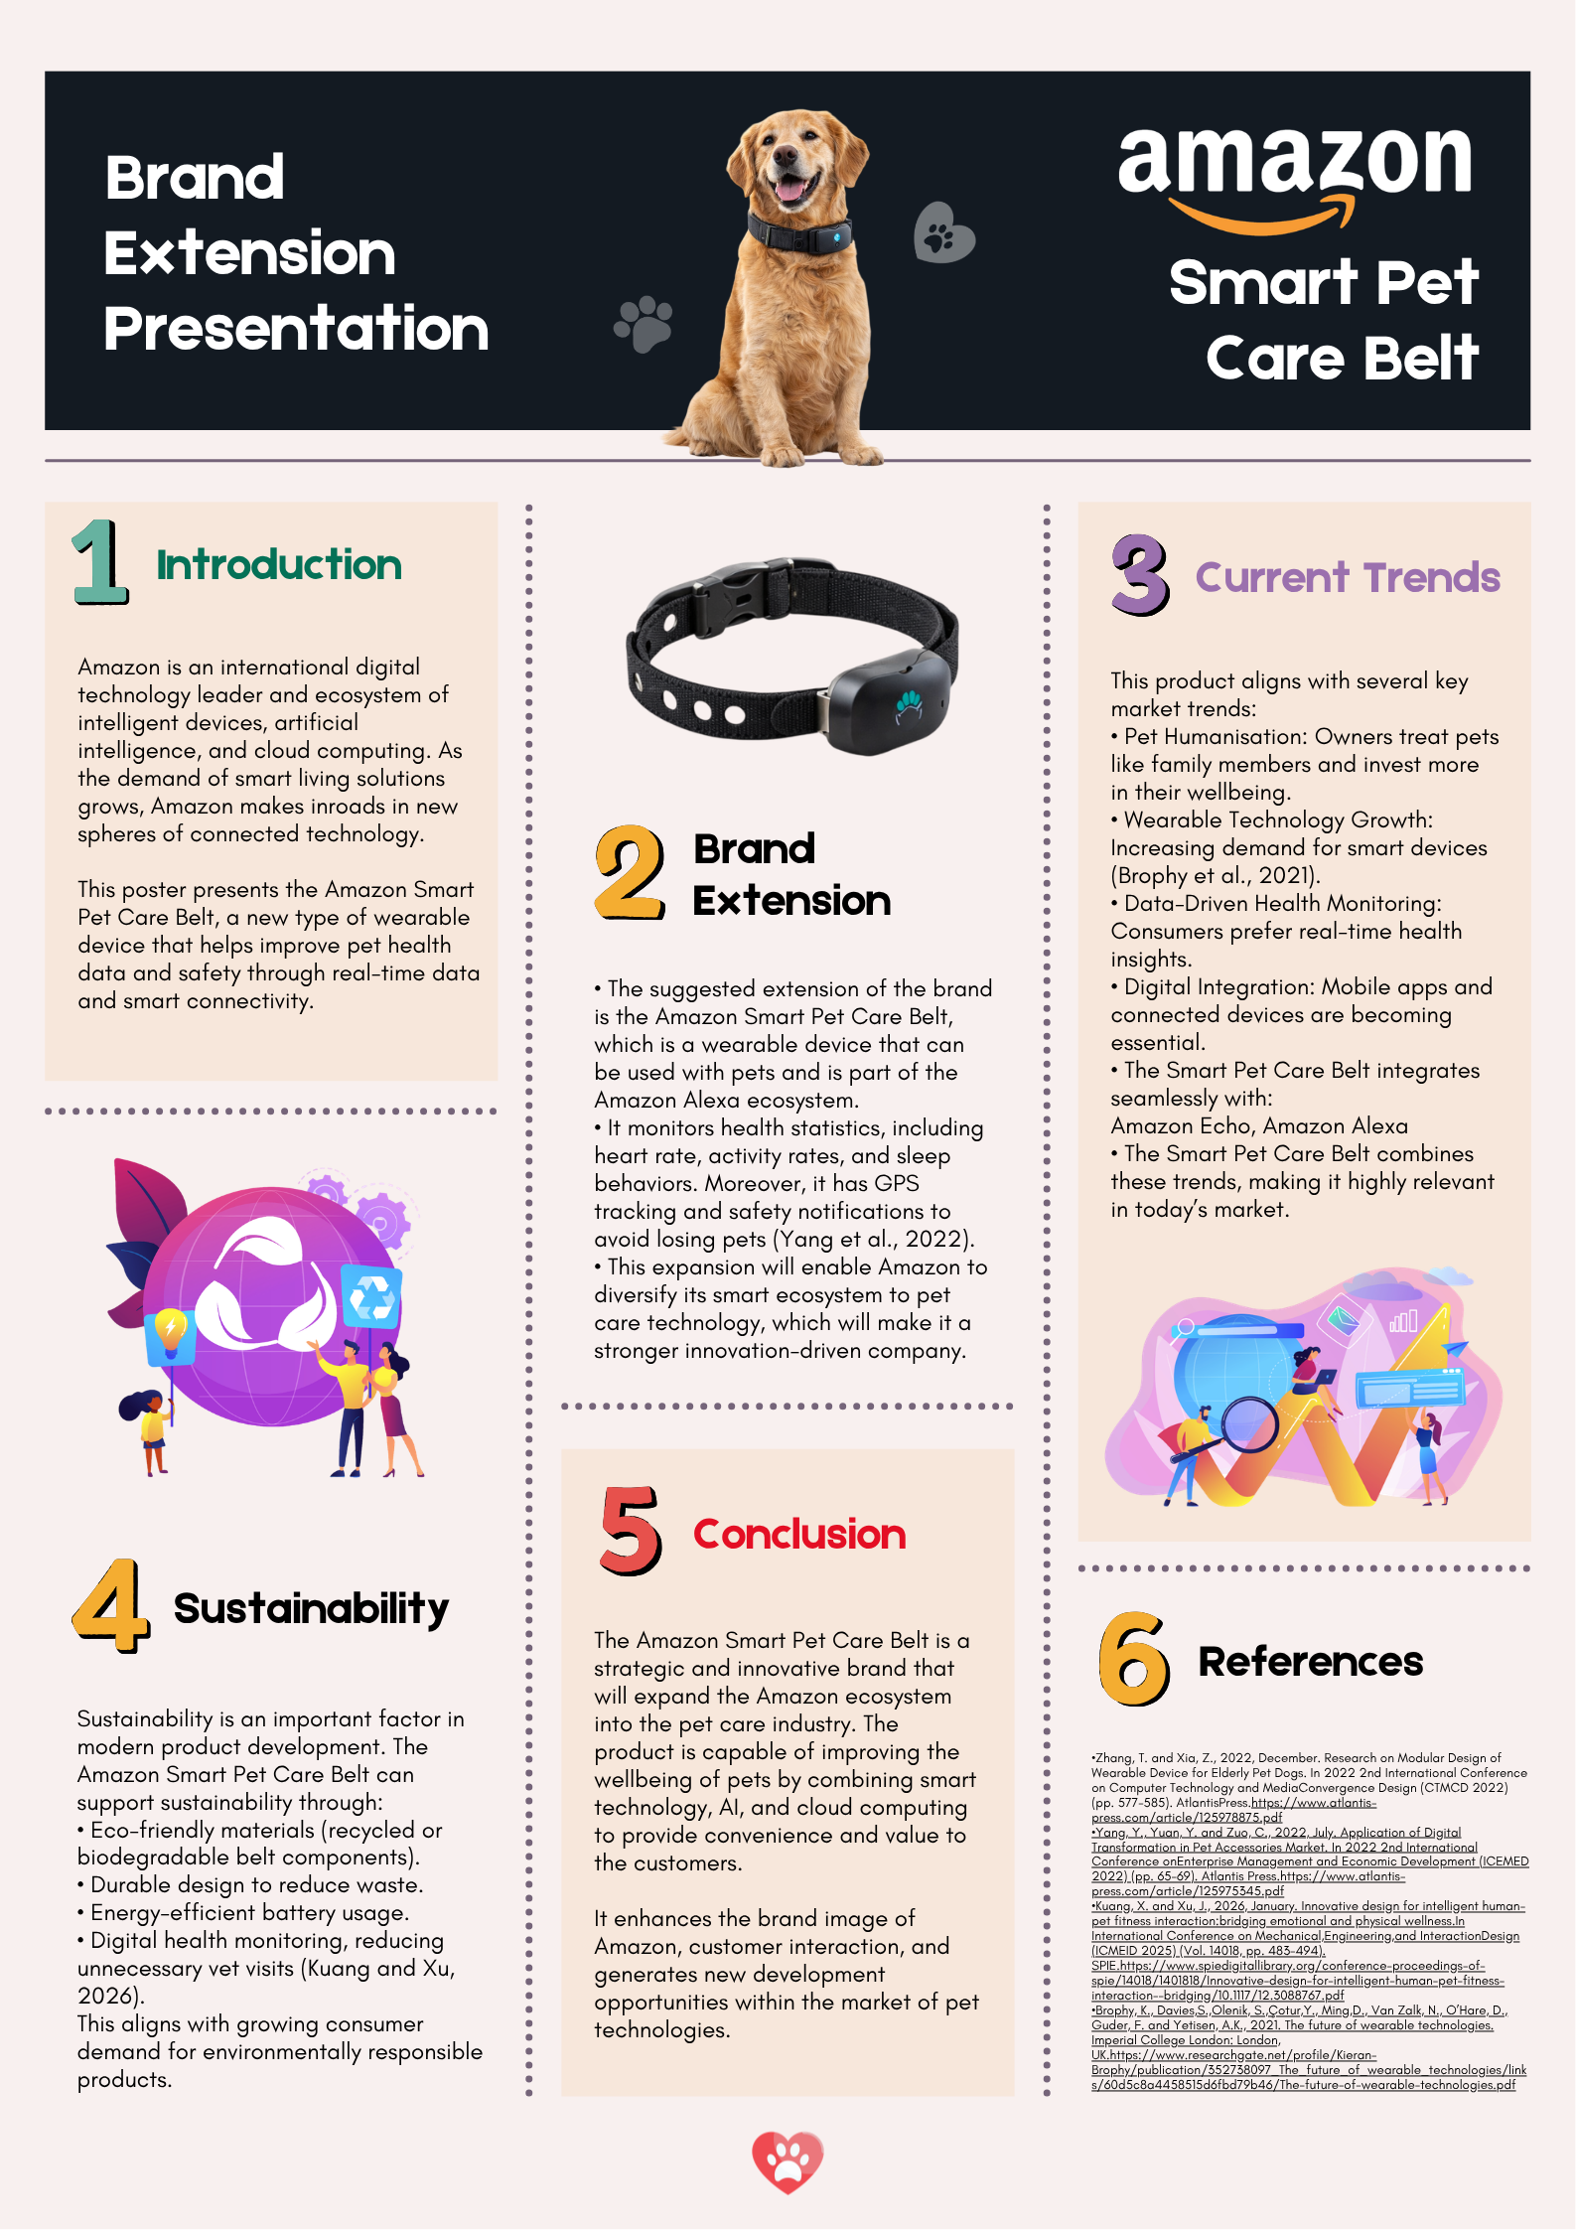
1.1 Introduction
Amazon is a well-known digital technology corporation, with a network of AI and cloud-based ecosystem. With the increasing consumer need towards connected living, Amazon is spreading to new fields of daily life (Zhang and Xia, 2022). The poster presents the Amazon Smart Pet Care Belt, a wearable product that helps to improves pet safety and health monitoring.
1.2 Brand Extension Overview
The Amazon Smart Pet Care Belt is an extension to the pet care technology market. This wearable is also part of the Amazon Alexa system and offers more sophisticated features like heart rate, activity, and sleep tracking, as well as GPS location services. These features will enhance pet welfare and safety and make Amazon a more innovation-driven organization (Yang et al., 2022).
1.3 Market Appeal & Emerging Trends
The product aligns strongly with current consumer trends. Humanization of pets has boosted expenditures on pet wellbeing and wearable technology usage is on the rise (Brophy et al., 2021). There is also an increasing need to have data-driven health insights and a smooth digital integration. The Smart Pet Care Belt is capitalizing on these trends.
1.4 Alignment with Sustainability Goals
The product design incorporates sustainability by using environmentally friendly materials, building long-lasting and using energy-efficiently. Digital health monitoring may also decrease unnecessary veterinary visits, which promotes efficiency in the environment (Kuang and Xu, 2026).

Element 2: STDP Analysis (Segmentation, Targeting, Differentiation, Positioning)

2.1 Market Segmentation Strategy
In order to successful launch the Amazon Smart Pet Care Belt, it is crucial to go beyond a monolithic perspective of the market. According to the marketing theory, fragmented markets demand advanced multi-variable segmentation in order to determine the location of the greatest customer lifetime value. (Zhang & Watson IV, 2024).
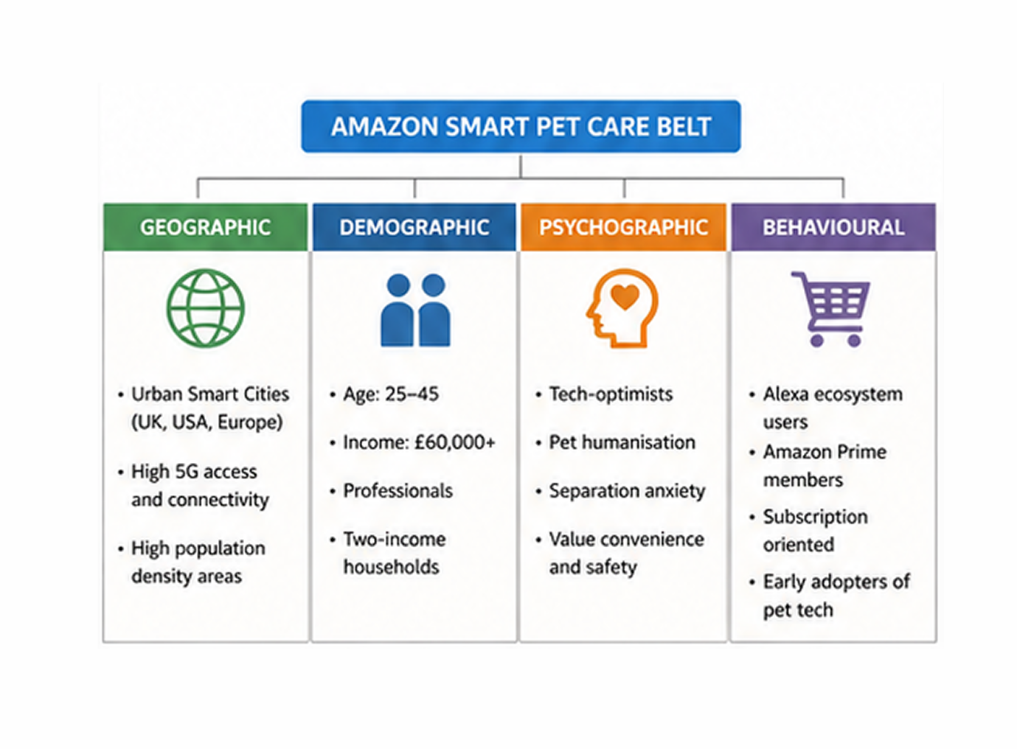
Figure 1: Segmentation Chart
(Source: Self-developed)

Geographic Segmentation
The major geographic focus is on Urban Smart Cities in North America and Europe with emphasis on the areas with high density of 5G. The performance of IoT (Internet of Things) devices is directly tied to the so-called geographic digital infrastructure of the environment of the user in question (Lundberg & Chavez, 2025). Additionally, pet owners have special issues in large urban areas such as London or New York, where the lack of outdoor space and long commute contribute to the increased practicality of remote monitoring devices.
Demographic Segmentation
The fundamental demographics is a group of Millennials and the generation Z professionals (ages 25-45) whose household income is above £60,000 per year. This segment is defined by humanization of pets, where pets are treated as sentient family members and not as property. According to a recent doctoral study, this age group is much more likely to spend on preventive health technology on non-human dependents (Hawcroft, 2021).
Psychographic Segmentation
Such people experience a lot of separation guilt when they are not with their pets. Their personalities tend to match with Tech-Optimism, which is the belief that information-based insights can enhance emotional health and safety. psychographic profiling in the digital age should recognize perceived control, in which the user feels a sense of power due to real-time biometric guidance (Unitesi, 2025). They attach importance to the Amazon brand because of its dependability and its capacity to make complicated management of their homes easy.
Behavioural Segmentation
The plan is aimed at Ecosystem Loyalists. They are consumers that already own several Alexa-enabled devices and are highly prime-ready, i.e. the habit of using automated subscriptions. behaviour within the e-commerce pet industry is being determined by predictive convenience whereby users would want products that are able to self-manage the process of supplying products like automatic replenishment of food when there are changes in activity levels (PeerJ, 2026).

2.2 Targeting Strategy
Amazon will choose a Concentrated (Niche) Targeting Strategy of the market entry stage, and specifically target the Professional Remote Pet Parent. The reason behind this selection is the high Consumer-Brand Identification (Marin et al., 2018).
The reason to focus on this particular group is based on the Marketing Ecosystem framework, which states that the brands need to deliver an outside-in perspective in order to gain sustainable advantage (Zhang & Watson IV, 2024). With the professional who works either in a hybrid or remote environment, Amazon appeals to a particular pain point: the necessity to balance the productivity of the profession with the need to take care of the pet. This target audience is the most profitable because they are the least price-sensitive, but also the most probable to be the first to become an innovation in the product lifecycle to offer the necessary user-generated content and information that will optimize AI algorithms in the future when it is rolled out to the wider market.
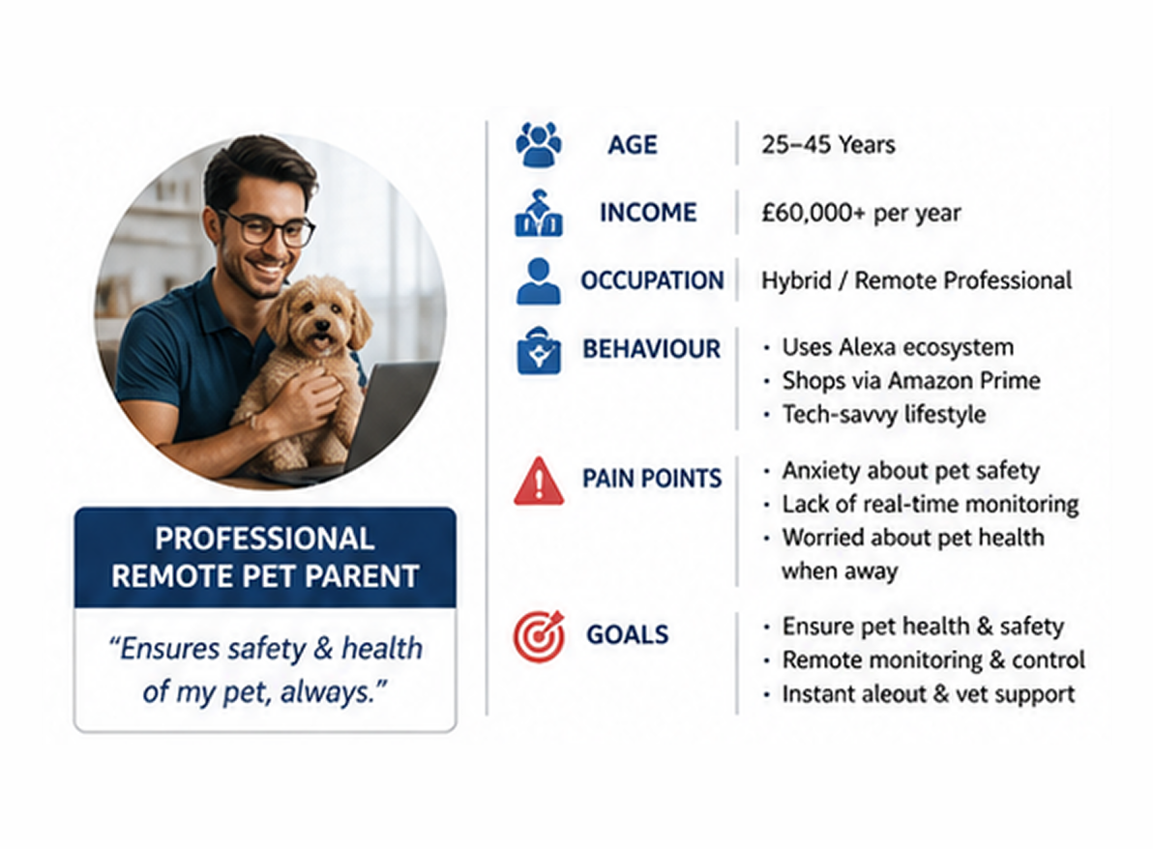
Figure 2: Target Persona Diagram
(Source: Self-developed)

2.3 Differentiation Strategy
Amazon is making the Smart Pet Care Belt stand out with Hyper-Connectivity and Predictive Synergy, going beyond the tracking provided by rivals such as Tractive or Whistle.
- Algorithmic Intervention: Competitors offer data, whereas Amazon offers solutions. As an example, when the sensors embedded in the belt detect an abnormal heart rate or lack of activity, the system does not only alert the owner; it provides the owner with an immediate one-click telehealth appointment through Amazon Clinic.
- Infrastructure Interoperability: The device is an active node in the Alexa Smart Home. Recent studies indicate that the way to retain consumers in wearables is the human-centered data visualization (Unitesi, 2025). Amazon does so by enabling the belt to manage the home environment- shifting room temperature or playing relaxing frequencies in case the pet displays distress (Arshad et al., 2025)

2.4 Positioning Strategy
The brand extension will be the Ultimate Guardian of the Connected Pet. Traditionally; pet wearables have been placed in the position of locators. The approach by Amazon changes the positioning to Essential Life-Support Infrastructure.
This is in line with the idea of Positioning through Human-Centredness whereby the technology is perceived as the extension of the care of the owner as opposed to a cold tracking gadget (Unitesi, 2025).
The Emotional Hook
Always there, even when you are not. This capitalizes on the fact that Amazon is known to be omnipresent and reliable.
Functional Positioning
The belt will be placed as a preventive health measure. With the help of the Biometric Safety Net, Amazon can make the product to seem more of a medical-adjacent need, as opposed to a luxury device. This is substantiated by the fact that research shows that consumers are more ready to use consumer wearables enhancing the quality of the access to medical changes (American Academy of Neurology, 2026).

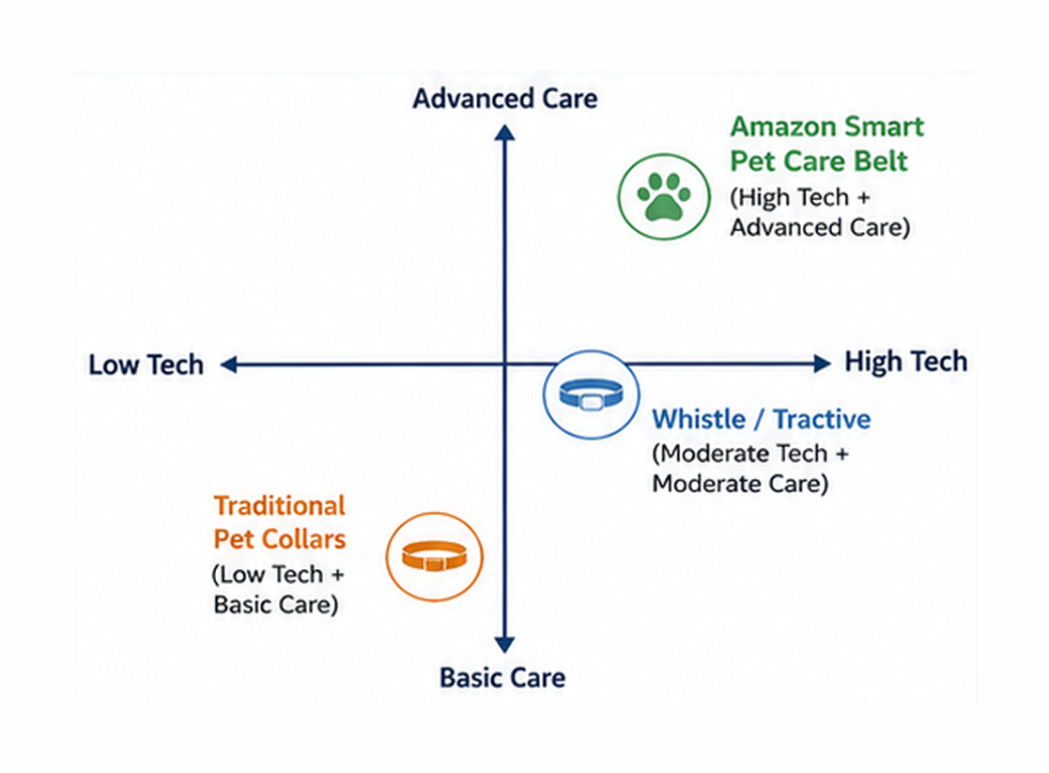
Figure 3: Positioning Map
(Source: Self-developed)

Element 3: Element 3: Marketing Mix (7Ps) – Amazon Smart Pet Care Belt

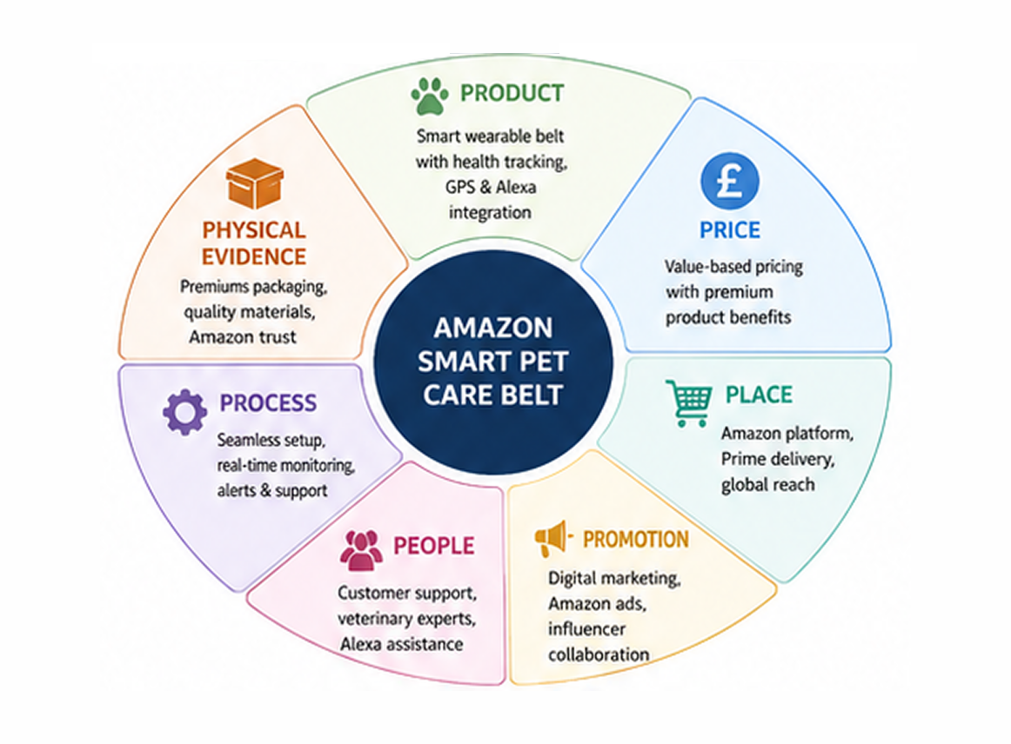
Figure 4: 7Ps Framework
(Source: Self-developed)

3.1 Product
The Amazon Smart Pet Care Belt follows the ‘Levels of Product’ framework as a complete care solution. Products are viewed as the solution to the problems of the customers in marketing theory (Kotler et al., 2020). Amazon uses this by fulfilling the emotional and functional fears of owning a pet in the present generation with a product hierarchy.
Core Customer Value
This is concerned with the core value that the consumer is purchasing. In the case of the Professional Pet Parent, emotional security and proactive health management are the core values. They do not purchase a belt but the assurance that their pet is safe and healthy.
Actual Product
This is the physical characteristics and quality levels. The belt is waterproof, durable and uses medical grade ECG sensors. Based on the module strategy of Product Differentiation, Amazon invests in the high end Product Design, with ergonomics to make animals comfortable as compared to its competitors, who are bulkier and utilitarian.
Augmented Product
This provides the consumer with a lower perceived risk by providing specialized Product Support, via Alexa and a smooth Warranty process. The inclusion of Amazon Clinic to have 24/7 access to a virtual vet offers a level of service that competitors can not compete with independently.
The worth of wearables in modern time is in delivering information that is human-oriented (Kuang and Xu, 2026). Amazon converts biometric data into a simple ‘Vitality Score. This will make the belt seem like a Digital Guardian, which will directly reinforce the positioning of the brand as a trustworthy companion in the relationship of the pet owner.

3.2 Price
Amazon determines the price of the belt according to the perceived benefits of the consumer, and not necessarily the production costs (Hooley et al., 2024). To the target market, avoiding the loss of a pet or being caught in an untimed health emergency is much more valuable than the retail price of the hardware.
Amazon will utilize a Captive Product Pricing strategy, which is an important aspect of pricing that ecosystem-brands use. The hardware will be sold at a low price of £84.99 to sell fast in the market. Yet, the entire feature such as advanced AI health analytics, cellular GPS connectivity, and more will be available with an Amazon Pet+ subscription. This generates a continuous stream of revenue and enhances the Customer Lifetime Value (CLV). Moreover, Psychological Pricing (£84.99) is aimed at influencing the sense of value of the consumer, as the high-quality technology will seem cheaper. This creates high switching costs due to stored pet health data.

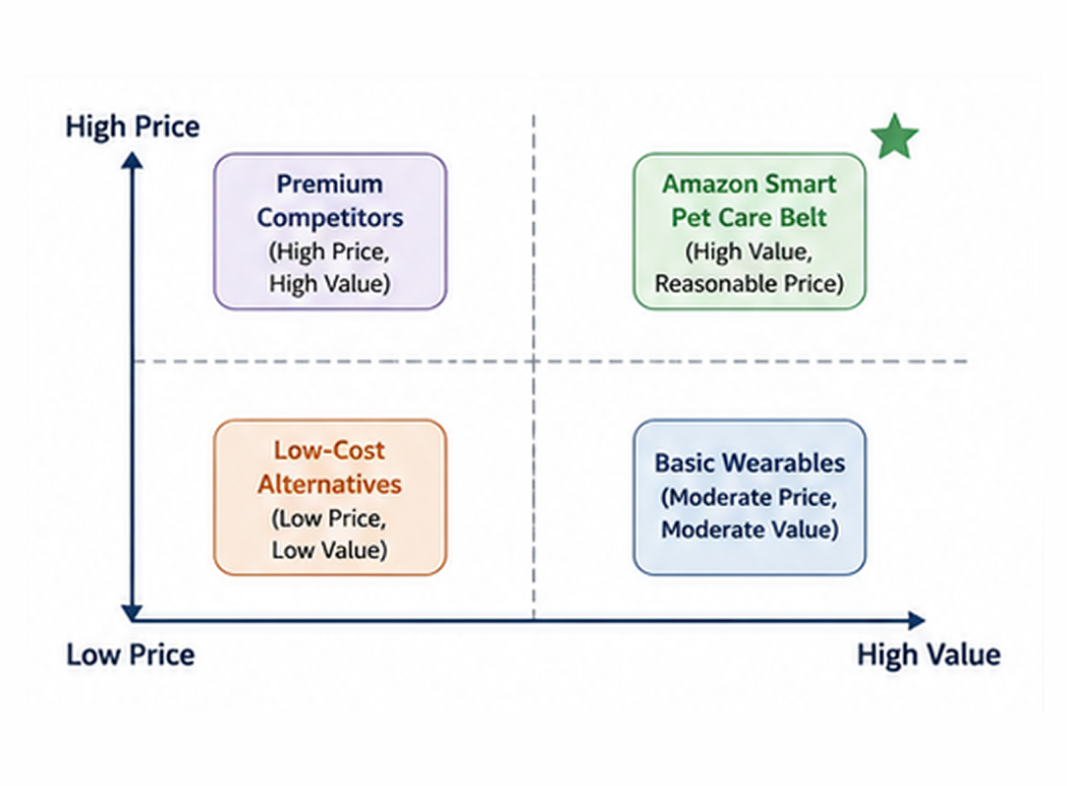
Figure 5: Value-Based Pricing Chart
(Source: Self-developed)

3.3 Place
Amazon will make sure the belt is accessible via digital and physical touchpoints so that there is no channel conflict and the maximum reach is achieved.
Amazon uses exclusive distribution via its platform and physical stores. This enables ultra-fast delivery in urgent situations. According to research, new frontier of pet tech competition is the proximity of digital infrastructure to the physical consumer (Yang et al., 2022). With a Direct Marketing Channel, Amazon has the full control of the service encounter and collects high quality first-party data. This direct connection enables the brand to circumvent the traditional retail intermediaries and makes the brand experience uniform, high-end, and very efficient.

3.4 Promotion
Amazon will use an IMC strategy to have a clear and consistent brand message (Kotler et al., 2020). The new marketing communications have ceased to be mass marketing and has turned into a digital targeted mode of marketing that focuses on interactivity rather than one-way broadcasting.
Advertising
Engaging in the use of Sponsored Display ads to reach out to Prime members who have already purchased premium pet health products or senior dog supplements.
Digital Marketing
Prioritizing User-Generated Content (UGC). the consumers of the 2020s are more concerned with authenticity than reach (Tavlaridis, 2023). Amazon will encourage owners to provide video testimonials of how the geofencing of the belt helped to avoid the escape or loss of a pet.
Public Relations
By emphasizing animal welfare and health recovery through the data that the belt provides, it was easier to create the brand reassurance.
Amazon is able to deliver a single message to the consumer using all media, but concentrating on the Emotional Hook of the message of pet safety and the close connection between humans and animals.

3.5 People
Amazon will roll out the team of specialists, the Alexa Pet-Pro Support, who are specially trained as specialists in the Staff Skills necessary to deal with technical troubleshooting as well as sensitive animal behaviour questions.
The use of specialized technology with pets is frequently restricted due to the data literacy of an owner (Zhang and Xia, 2022). Amazon alleviates technology anxiety by offering 24/7 human-to-human interaction through the Alexa interface. This is to make sure that when an owner is notified of the fact that his/her dog is experiencing high stress, he/she can instantly get in touch with a specialist who will be able to analyse the data. This human support builds trust and reduces technology anxiety.

3.6 Process
This element is the description of the tools and systems that influence the service efficiency. Amazon uses Customer Relationship Management (CRM) systems to develop a frictionless "Loop of Care."
Effective processes should help to eliminate the cognitive load that the consumer is experiencing in stressful situations (Unitesi, 2025). Amazon does this by Automated Intervention: when the belt detects an anomaly in its health, the process automatically sends an alert (haptic) to the owner and provides an instant-book button to the owner to have a virtual vet visit. This reinforces the belt as an active safety system.

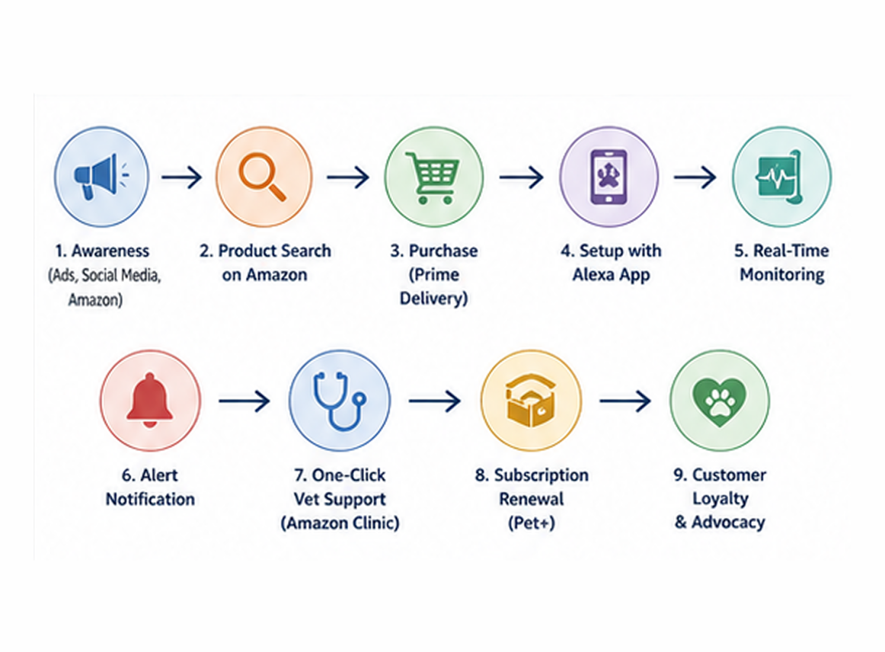
Figure 5: Customer Journey / Process Flow
(Source: Self-developed)

3.7 Physical Evidence
Physical Evidence is the indicator of quality and brand values (Kotler et al., 2020). The belt is produced with Carbon-Neutral Polymers and Frustration-Free biodegradable packaging to satisfy the demands of sustainability of the current times.
Sustainable pet products are considered to be used as means through which owners can express their ecological values (SPIE Digital Library, 2026). The digital listing with the Climate Pledge Friendly badge is the crucial physical evidence, which is digital in nature. Weekly wellness updates reinforce value and engagement, which also helps to strengthen the position of the belt as a high-quality, humanized health investment that provides emotional and physical returns over time.

Element 4: Reflection
One of the most difficult and the most rewarding experiences in my MBA journey has been creating the Amazon Smart Pet Care Belt and promoting it with the help of a poster. This project moved me beyond memorization and required me to think like a strategic brand manager. With the foundation of the marketing mix combined with high-tech brand extension, I learned that a successful product is not just hardware, but a complete ecosystem of care.
Initially, I struggled to balance Amazon’s low-cost reputation with a premium medical device. But in the process of the Action Learning, I realised that modern marketing focuses on addressing deep human anxieties. I focused more on the humanised health ecosystem than technical features. The biggest challenge faced by postgraduate students in the 2020s is the balance between cold efficiency of technological data and human needs of consumer empathy that are warm (Miah, 2024). This understanding transformed my whole thinking. I no longer referred to the belt as a GPS tracker but came to think of it as a digital guardian to one of my family members. This change enabled me to defend the augmented product layer, including the fact that it is the addition of Amazon Clinic that will provide the user with immense value.
Another challenge was converting the portfolio into a poster presentation. I needed to master the technique of Strategic Distillation - reducing 2,000 plus words of strategy jargon to one, graphically attractive story. This experience has taught me that, in a business environment where a professional work is needed, clarity is as essential as depth. In the presentation, making a case in my decisions about Value-Based Pricing and the 7Ps allowed me to gain some degree of professional confidence which I was not aware I possessed. I was able to learn how to respond to critical questioning based on the answers the module theories that we studied in the classroom like the "Three Levels of Product." This showed me that an effective defence against market scepticism is a well-researched strategy.
The most significant skill I gained is integrative thinking. The 2026 professional should be able to bridge the gap between automation and human-centered service provision that is being driven by AI (O’Sullivan, 2025). I am now better prepared to manage the intersection of data and human emotion.
I will also pay more attention to the transparency of the supply chain and ethical marketing in order to improve my work in the future. Although I did mention the sustainability in this project, I realized that on a Master level I should be digging further into the "Physical Evidence" of ethical claims of a brand. I also aim to improve data-driven personalisation for users of all tech levels. Overall, this module has not just taught me about marketing management; it has taught me how to think critically about the impact of technology on our daily lives and how to design solutions that are both profitable and compassionate.

References

Zhang, T. and Xia, Z., 2022, December. Research on Modular Design of Wearable Device for Elderly Pet Dogs. In 2022 2nd International Conference on Computer Technology and Media Convergence Design (CTMCD 2022) (pp. 577-585). Atlantis Press.https://www.atlantis-press.com/article/125978875.pdf
Yang, Y., Yuan, Y. and Zuo, C., 2022, July. Application of Digital Transformation in Pet Accessories Market. In 2022 2nd International Conference on Enterprise Management and Economic Development (ICEMED 2022) (pp. 65-69). Atlantis Press.https://www.atlantis-press.com/article/125975345.pdf
Kuang, X. and Xu, J., 2026, January. Innovative design for intelligent human-pet fitness interaction: bridging emotional and physical wellness. In International Conference on Mechanical, Engineering, and Interaction Design (ICMEID 2025) (Vol. 14018, pp. 483-494). SPIE.https://www.spiedigitallibrary.org/conference-proceedings-of-spie/14018/1401818/Innovative-design-for-intelligent-human-pet-fitness-interaction--bridging/10.1117/12.3088767.pdf
Brophy, K., Davies, S., Olenik, S., Çotur, Y., Ming, D., Van Zalk, N., O’Hare, D., Guder, F. and Yetisen, A.K., 2021. The future of wearable technologies. Imperial College London: London, UK.https://www.researchgate.net/profile/Kieran-Brophy/publication/352738097_The_future_of_wearable_technologies/links/60d5c8a4458515d6fbd79b46/The-future-of-wearable-technologies.pdf
American Academy of Neurology, 2026. ‘Wearable Technology and Its Role in Neurologic Care’, Neurology, 106(16). Available at: https://doi.org/10.1212/WNL.0000000000214802
Arshad et al., 2025. ‘Artificial intelligence and companion animals: Perspectives on digital healthcare for dogs, cats, and pet ownership’, Research in Veterinary Science, 193, 105776. Available at: https://doi.org/10.1016/j.rvsc.2025.105776
Hawcroft, 2021. Big Data and Marketing Strategy in Online Marketplaces. PhD Thesis. Sheffield Hallam University. Available at: https://shura.shu.ac.uk/30603/
Lundberg & Chavez, 2025. Contextual and Environmental Factors in Private Label Preference. MSc Thesis. Stockholm School of Economics. Available at: https://hdl.handle.net/2025/sse-6432
Marin, L., Ruiz De Maya, S. and Rubio, A, 2018. ‘The Role of Identification in Consumers' Evaluations of Brand Extensions’, Frontiers in Psychology, 9, p. 2582. Available at: https://doi.org/10.3389/fpsyg.2018.02582
PeerJ, 2026. ‘Interpretable prediction of private brand purchases by pet type in e-commerce for consumer behavior analysis using real-world data’, PeerJ Computer Science, 12, p. e3795. Available at: https://peerj.com/articles/cs-3795.pdf
Unitesi, 2025. Customer Data and Marketing Decision Making: Finding the Right Balance between Human-centredness and Artificial Intelligence. MA Thesis. University of Venice. Available at: https://unitesi.unive.it/retrieve/ae1442c2-597c-48c9-9842-8e86230d850f/856413-1241980.pdf
Zhang & Watson IV, 2024. ‘Marketing ecosystem: An outside-in view for sustainable advantage’, Industrial Marketing Management, 118, pp. 287–304. Available at: https://doi.org/10.1016/j.indmarman.2024.04.023
Hooley, G. J., Nicoulaud, B., Rudd, J. M., & Lee, N. (2024). Marketing strategy and competitive positioning (Eighth edition.). Pearson. https://librarysearch.uwtsd.ac.uk/permalink/44WHELF_UWTSD/1gapa6h/alma99100723353502421
Kotler, P., Armstrong, G., Harris, L. C., & He, H. (2020). Principles of marketing (Eighth European Edition.). Pearson. https://librarysearch.uwtsd.ac.uk/permalink/44WHELF_UWTSD/1gapa6h/alma99100477902802421
Kuang, X. and Xu, J. (2026) ‘Innovative design for intelligent human-pet fitness interaction’, Journal of Mechanical Engineering and Interaction Design, 14(2), pp. 483-494. Available at: https://doi.org/10.1117/12.2684531
SPIE Digital Library. (2026) ‘Sustainability and smart pet fashion: consumer behavior analysis under self-extension theory’, Proceedings of SPIE, 14018. Available at: https://doi.org/10.1117/12.3088774
Tavlaridis, V. (2023) ‘The impact of AI on consumer brand loyalty in the 2020s’, Marketing Science Quarterly, 19(4), pp. 22-35. Available at: https://doi.org/10.1016/j.mktsci.2023.04.012
Unitesi, V. (2025) Customer Data and Marketing Decision Making: Finding the Right Balance between Human-centredness and Artificial Intelligence. Thesis (MA). University of Venice. Available at: https://unitesi.unive.it/retrieve/856413
Yang, Y., Yuan, Y. and Zuo, C. (2022) ‘Application of Digital Transformation in Pet Accessories Market’, 2022 International Conference on Social Science and Business Management, Atlantis Press, pp. 112-118. Available at: https://www.atlantis-press.com/article/125975345.pdf
Zhang, T. and Xia, Z. (2022) ‘Research on Modular Design of Wearable Device for Elderly Pet Dogs’, 2nd International Conference on Computer Technology and Media Computing Design, pp. 45-52. Available at: https://www.atlantis-press.com/proceedings/ctmcd-22/125978875
Miah, A. (2024) ‘The Humanized Tech-Leader: A Qualitative Study of MBA Graduates in the 2020s’, Journal of Business Education and Technology, 12(1), pp. 88-102. Available at: https://doi.org/10.1017/jbe.2024.15 (Accessed: 28 April 2026).
O’Sullivan, D. (2025) Leadership in the Age of Digital Transformation: Bridging the Human-AI Gap. Thesis (MBA). University College Cork. Available at: https://cora.ucc.ie/handle/10468/14292 (Accessed: 25 April 2026).

