Assembly of 555 Timer Circuit

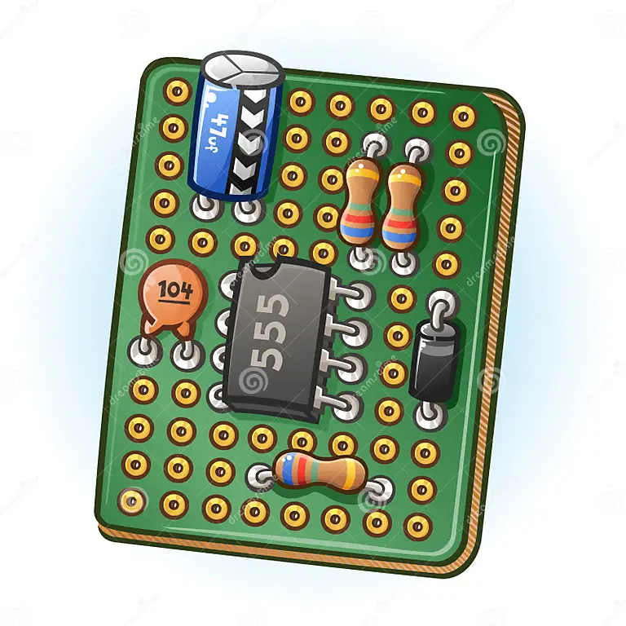
Student: Kieran Wusthoff
Student Number: 2217671
Subject: Electrical and Electronic Systems
Module Code: ACDA4018
Lecturer: Stalin Jacob
Table of Contents
Introduction 3
Circuit Description and Operation 3
Schematic & Proteus 4
Calculations (Proteus) 6
Resistance of R3 & R4 6
On Time, Off time 6
Period 6
Frequency 6
Timing Measurements (Proteus) 7
Capacitor (C1) Proteus 8
555 Timer on Bread board 9
How Testing Was Carried Out 9
Timing Measurements (Bread board) 10
10
Calculations (Bread Board) 11
On Time Off Time 11
Period 11
Frequency 11
Conclusion 11
Bibliography 12

Introduction
For this assignment the subject is required to build and test the astable 555 timer circuit. To complete this assignment, they must create and run a simulation of the circuit in a simulation software. The software that will be used to run simulation is called Proteus. Once this simulation is complete the subject will the create the circuit using a bread board. Measurements and calculations will be carried out on both Proteus and Bread board circuit. They will calculate the Resistance of R3 & R4 (resistors), On time and Off time, Period, and Frequency. Finally, a report is written of all coursework carried out.

Circuit Description and Operation
The components being used in this circuit are as follows: one 555 timer, two capacitors (C1, C2), four resistors (R1, R2, R3, R4), one +9V cell, a ground (earth) and finally two LEDs (D1 & D2). The D1 is a green LED and D2 is a red LED.
Resistors are used to resist and reduce the flow of current in a circuit. Resistors are used for many purposes. A few examples include limiting electric current, voltage division, heat generation, matching and loading circuits, gain control, and setting time constants [1]. The resistance in any circuit is represented as R, with the standard unit of resistance being the ohm Ω. The formula for calculating resistance is R=V/I. In this circuit there is a 1kΩ and 10kΩ resistor. The resistors can be identified by the colour codes located on the sides. 1kΩ resistors are coded Brown Black Red, whereas the 10kΩ resistors are coded Brown Black Orange. And ohmmeter or multi metre can be used to calculate resistance.
Capacitors are used to store electrical energy, synchronise Current & Voltage and can be used in AC to DC conversion. Whilst some capacitance may exist between any two electrical conductors in a circuit, capacitors are components designed to add capacitance to a circuit. The formula to calculate capacitance is as follows C=Q/V. where C is the capacitance, Q is the amount of charge stored, and V is the voltage [2]. Like the resistor it is possible to measure the capacitance on a mustimeter. As stated, there are two capacitors in this circuit, C1 & C2. In the subjects’ circuit C1 is a 100uF (microfarads) capacitor and C2 is a 100nF (nanofarads) capacitor.
The ground is added as a safety measure. It gives excess current a safe place to go. In this breadboard circuit the negative terminal acts as the ground.
Once the circuit is complete and the +9V cell is connected. The purpose of the +9V cell is to add a supply to the circuit. Once connected, the red and green LED lights will begin to continually flash. Green On, Red Off and vise versa. The flashing LED’s will be confirmation that the circuit has been assembled correctly.
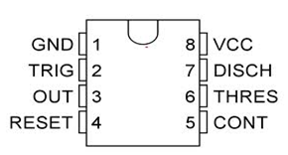
A 555 timer is a type of IC (integrated circuit). It is used in a variety of pulse generation, delay, timer, and oscillator applications. There are 3 different operating modes. These are bistable, monostable, and astable. For this assignment the 555 timer will be in astable mode. The 555 timer has 8 different pins. With each pin having a separate operation. In the following order the pins are named. 1 Ground; this is used to ground the IC preventing stray voltage accumulating within it. 2 Trigger; this is the input for activating the IC’s timing cycle. 3 Output; provides the pulse generated by the 555 timer. It is the output pin. When the IC triggers via pin 2, the output pin goes high depending on the duration of the timing cycle. 4 Reset; this pin gives a low signal to the timer which resets the internal flip flop. 5 Control voltage; The 2/3 supply voltage point on the terminal voltage divider is brought to the control pin. 6 Threshold; the internal flipflop is reset when the voltage exceeds 2/3 of the supply voltage. It is connected to the non-inverting input. 7 Discharge; It provides a discharge path for the timing capacitor. Finally, 8 Power supply; this is connected to the power supply. In this case the +9V cell [3].
Figure 1: 555 timer pin layout.

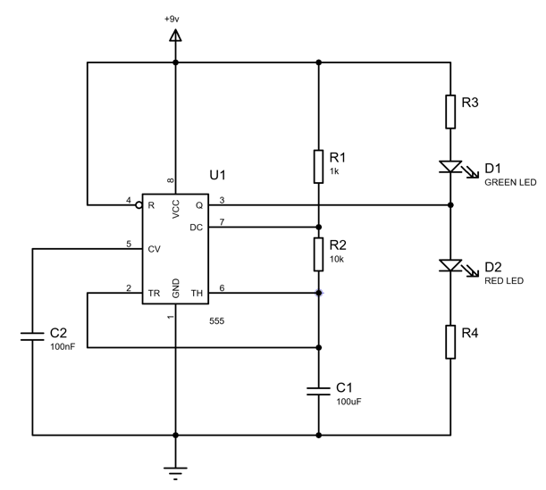
Schematic & Proteus
Figure 2 shows the Schematic of the circuit which will be created on Proteus and the bread board. Here we can see all the components as stated in the circuit description above.

Figure 2 : Schematic of circuit design

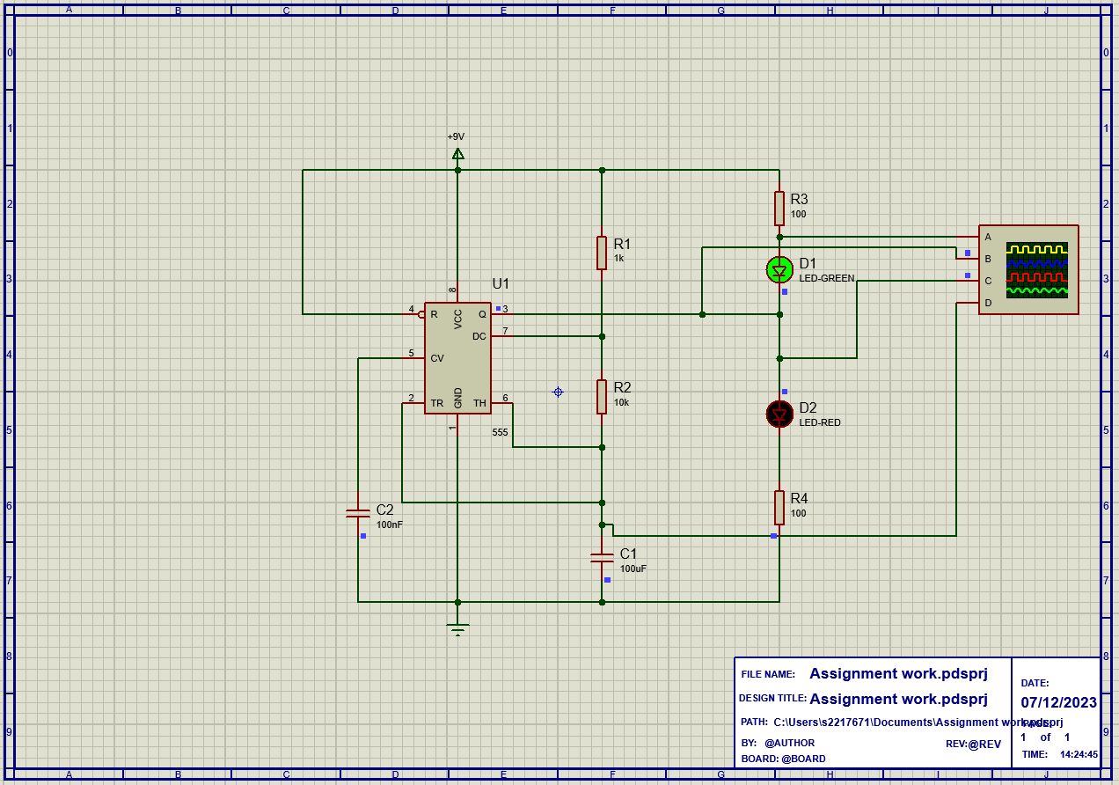
Figure 3 shows the subjects circuit design on Proteus. It is clear to see that D1 LED Green is illuminated. Running this software, it is possible to see D1 & D2 flashing in turn. This is evidence that the subject has successfully simulated in addition to the circuit an oscilloscope. has been added to carry out calculations. This task consisted of searching & selecting all the components from the Parts menu, placing in the correct location and wring up. Once this was complete the values of resistors and capacitors would be adjusted as per the schematic in the brief.
Figure 3: Evidence of circuit made in proteus.

Calculations (Proteus)
By referring to the figure 3 and figure 4 located in the Timing Measurements section, the subject is able to carry out the following calculations:

Resistance of R3 & R4
By knowing the values of the two LEDs’ it is possible to calculate the resistance of R3 & R4. If the two LEDs’ have a value of 10ma at 2V. And knowing the supply voltage being +9V the subject can calculate:

$$R=\frac{V}{I}$$

$$\frac{9-2}{10ma}=\frac{7}{0.01}=700Ω$$

This calculation shows that the resistance that occurs at R3 & R4 is both 700Ω.

On Time, Off time
The values here can be found in the Timing measurements section below with the values highlighted with the red arrows.

$$2.22-1.46=0.765 \left(Time On\right)$$
$$1.46-0.765=0.695 (Time Off)$$

Period
The following shows how Time Period is calculated, the subject will then use this vale to calculate the Frequency.

$$Time On+Time Off=Time period$$
$$0.76+0.695=1.455$$
$$Time Period= 1.455s$$

Frequency
By using Time Period, it is now possible to calculate the frequency (Hz)
$$Frequency=\frac{1}{Time Period}$$
$$Frequency= \frac{1}{1.455}=0.687$$
$$Frequency=0.687Hz$$

Timing Measurements (Proteus)

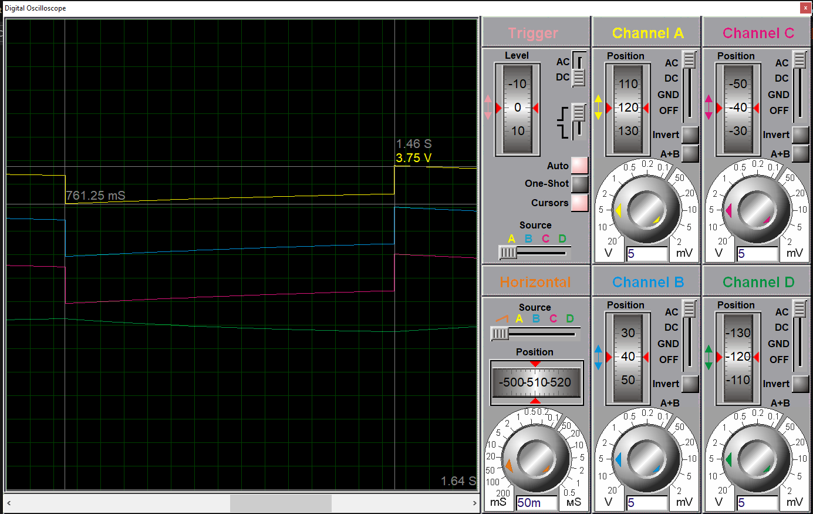
Figure 4 shows the first half of the period. Here time off can be seen.

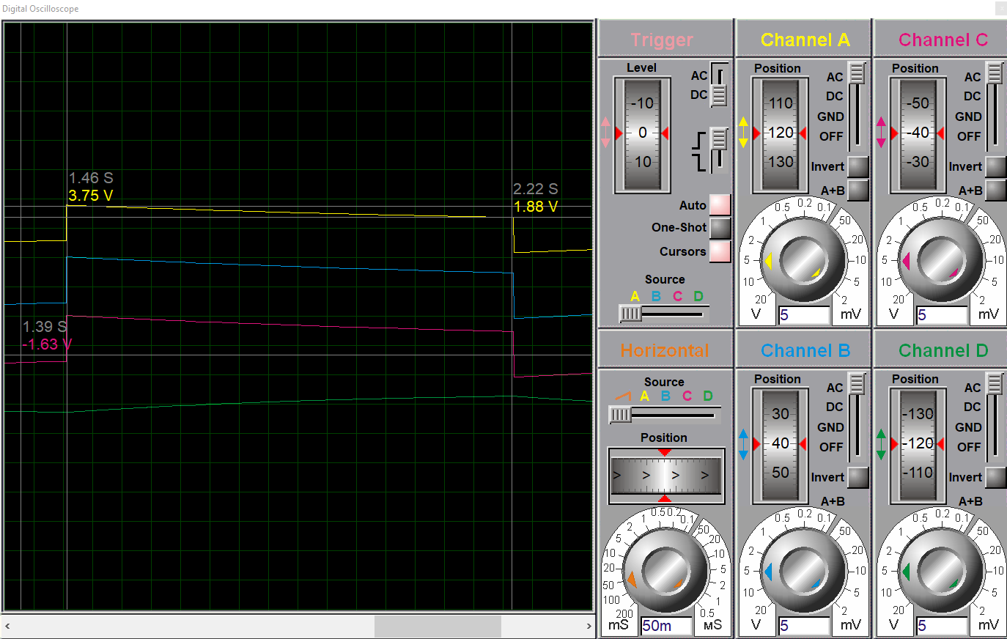
Figure 5: shows the second half of this period. This displays the Time On

Capacitor (C1) Proteus
Figure 6 and figure 7 show the waveform of the capacitor. Figure shows the waveform generated on Proteus. It is difficult to see the waveform on figure 6, so figure 7 shows a better example. What the subject can see here is the capacitor at work. When the capacitor reaches its highest point on the table it means it has reached 2/3 capacity. Once the capacitor reaches 2/3 capacity it then discharges. When the capacitor reaches 1/3 capacity it then charges again up to 2/3. This process is repeated for as long as power is supplied to the circuit.
At 2/3 capacity, begins discharging.
At 1/3 capacity, begins charging.
Figure 6: Graph of capacitor on proteus.
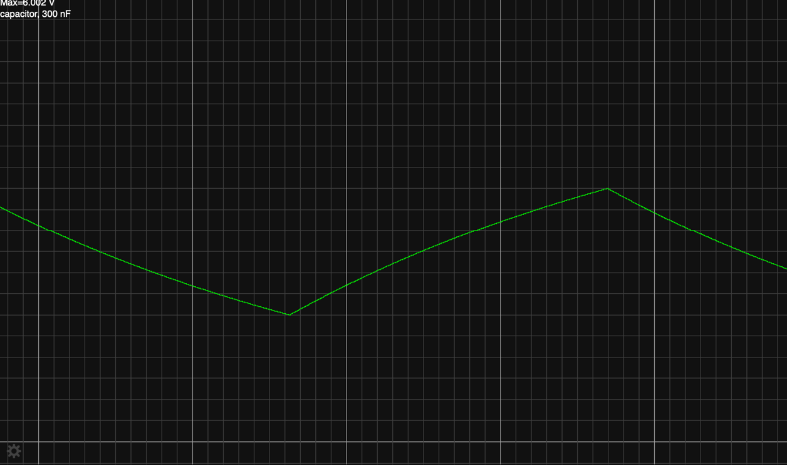
At 2/3 capacity, begins discharging.
At 1/3 capacity, begins charging.
Figure 7: Graph of capacitor for better understanding.

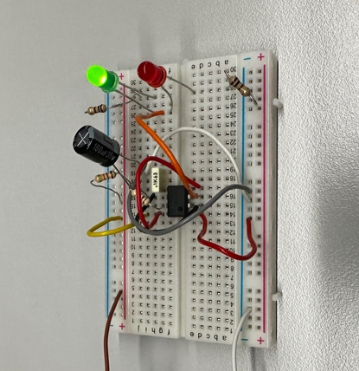
555 Timer on Bread board
Figure 8: Bread board of 555 timer.
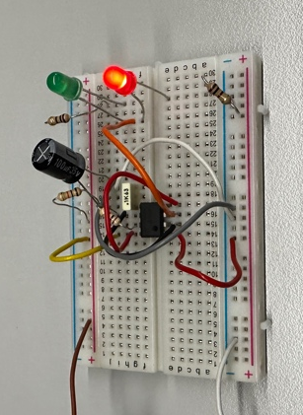
After completing the circuit on the proteus software the subject can now create the circuit on a bread board. The subject would use the same components as seen in the as mentioned in the circuit description and seen in proteus. The subject would follow the schematic that was given in the assignment brief. They would start by placing the 555 timer in the centre of the breadboard. By referring to figure 1 and figure 2 the subject is able to place wires, LEDs’ resistors and capacitors accordingly. However, they experienced some difficulty in placing the components and wires due to their small nature. As shown in figure 8 the subject was successful in creating the 555 timer on bread board. This can be seen by observing the illuminated D2 LED. Figure 9 also clearly shows that the D1 LED is illuminated. Showing D1 & D2 illuminated is evidence of a working 555 timer circuit. The function of a 555 IC was previously stated in the Circuit Description and Operation. However, once connected to the oscilloscope it was apparent that the period was not as it was in the proteus software. It became apparent that it must have been due to an anomaly found in maybe the capacitors or 555 timer.
Figure 9: Red light emitted from circuit.

How Testing Was Carried Out
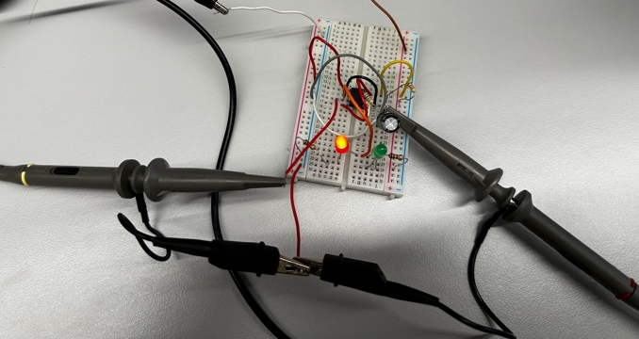
During the build of the bread board circuit the subject encountered problems where they were un-able to get a complete circuit. By connecting to the power supply and using a mustimeter on the resistors, the subject was able to test the circuit. If connected to the supply and D1 & D2 did not emit then the subject would know that there is a fault within the circuit. In the circuit were a number of times where the subject was aware of a fault. They would use the mustimeter to test to see where a current was flowing and where it wasn’t. If the circuit was not complete the subject would take the necessary action to rectify the fault. This could mean rewiring / using different wires or using different components. Once components or wires were changed the subject would then retest using the mustimeter. If no faults were found, then the circuit would be complete and D1 & D2 would intermittently emit light. By continuing to test the circuit the subject was able to replace components and wires which were faulty.
Figure 10: Oscilloscope connection.
To then view how the circuit was performing it would be connected to an oscilloscope as seen in figure 11 below. Figure 10 shows how the oscilloscope was connected to the circuit.

Timing Measurements (Bread board)
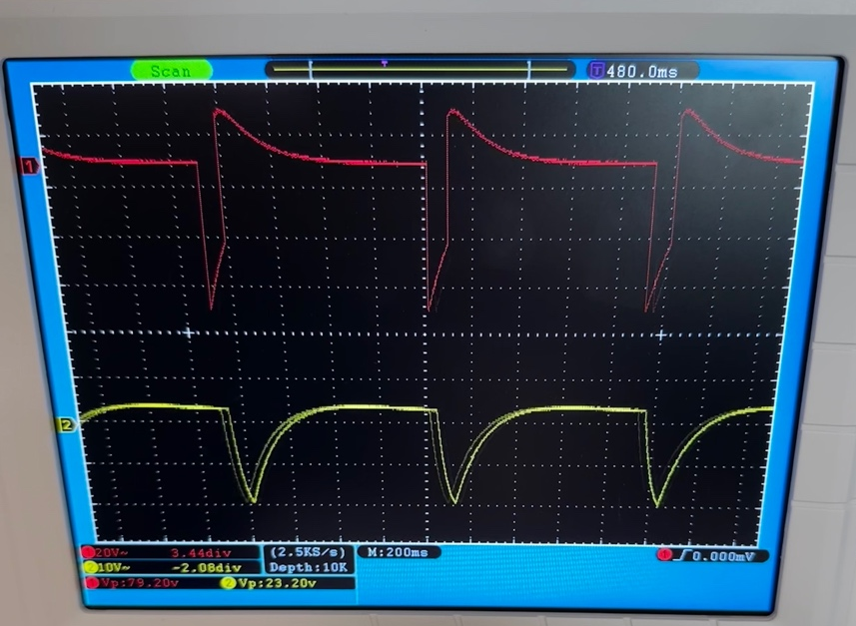
0.4 Time Off
4.1 boxes counted this shows Time On
200ms (used in calcs)
Capacitor values
Figure 11: Oscilloscope results for bread board.

Calculations (Bread Board)
By referring to figure 11 it is possible to carry out the following calculations:

On Time Off Time
$$200ms×4.1=820ms \left(0.82s\right)=Time On$$
$$200ms×0.4=80ms \left(0.08s\right)=Time Off$$

Period
$$Time On+Time Off=Time period$$
$$820ms+80ms=900$$
$$Time Period= 900ms (0.9)$$

Frequency
$$Frequency=\frac{1}{Time Period}$$
$$Frequency= \frac{1}{0.9}=1.1$$
$$Frequency=1.1Hz$$

Conclusion
In conclusion the subject was successful in creating the circuit on both simulator and bread board. By using the Proteus software and trial and error the subject has completed the circuit. Upon completing the circuit, they were then able to complete the calculations of resistance On/Off time Period and Frequency. They also gathered supporting evidence for this along with evidence of the capacitance.
The bread board connection was also a success. Though the subject did have to alter a few connections and components they were able to get intermittent flashing LEDs’. Evidence and numbers gathered from the oscilloscope allowed them to carry out the same calculations as they did for Proteus. The evidence for bread board is also found in the report. Another problem the subject encountered was that the LEDs were not flashing as they were in the Proteus simulation. Upon adjusting a few components and wires the issue persisted. The assumption is that there may have been an anomaly with either the capacitor, 555 timer or human error. However, as the LED’s were flashing intermittently the subject was still able to carry out the calculations and gather the evidence required.

Bibliography

[1] | “EE Power,” EETech Media, LLC., [Online]. Available: https://eepower.com/resistor-guide/resistor-fundamentals/what-is-a-resistor/#. [Accessed 12 January 2023].
[2] | “EE Power,” EETech Media, LLC, [Online]. Available: https://eepower.com/capacitor-guide/fundamentals/. [Accessed 12 January 2023].
[3] | “Elprocus.com,” Elprocus, [Online]. Available: https://www.elprocus.com/555-timer-pin-description-applications/#:~:text=The%20pin%2D2%20of%20IC2,can%20be%20negatively%20edge%20triggered.. [Accessed 12 January 2023].

