

Machine Learning Task Two

Paul Newman
1805494
Mark Huntly

Introduction 4
Artificial Neural Networks and Optimisation Techniques 5
Recurrent Neural Networks (RNNs) and Their Use Cases 6
Convolutional Neural Networks (CNNs) and Their Use Cases 7
Methodology: CNN Implementation for CIFAR-10 8
Data Preprocessing 9
CNN Architecture Design 10
Hyperparameter Selection and Model Training 11
Model Evaluation and Performance Analysis 12
Results and Discussion 14
Conclusion 15
Code 16
Code Implementation and Findings Conclusion 25

Figure 1 Artificial Neural Networks [2] 5
Figure 2 RNNs [5] 6
Figure 3 CNN's [7] 7
Figure 4 Cifar image [6] 9
Figure 5 CNN Architecture Design [11] 11
Figure 6 Hyperparameter Selection and Model Training [12] 12
Figure 7 Model Evaluation and performance Analysis [13] 13
Figure 8 Results and Discussions [14] 14
Figure 9 Code pt1 16
Figure 10 Code pt2 16
Figure 11 Code pt3 16
Figure 12 Code pt4 17
Figure 13 Code pt5 17
Figure 14 Code pt6 18
Figure 15 Code pt7 18
Figure 16 Code pt8 19
Figure 17 Code pt9 19
Figure 18 Code pt10 20
Figure 19 Code pt11 20
Figure 20 Code pt12 20
Figure 21 Code pt13 20
Figure 22 CIFAR-10 Data set 21
Figure 23 CNN model summary 21
Figure 24 Final Model Performance 22
Figure 25 CNN Training and Validation Loss 23
Figure 26 CNN Confusion Matrix for CIFAR-10 24
Figure 27 CIFAR-10 Perditions 24

Introduction
This report investigates the use of deep learning techniques for image classification using the CIFAR-10 dataset. The study focuses on evaluating different neural network approaches, including Artificial Neural Networks (ANNs), Recurrent Neural Networks (RNNs), and Convolutional Neural Networks (CNNs), to determine the most suitable architecture for computer vision tasks. While ANNs and RNNs have proven effective in a range of machine learning applications, CNNs are specifically designed to process image data through the extraction of spatial features using convolutional operations.
The CIFAR-10 dataset is widely used within deep learning research as a benchmark dataset for image classification. It contains 60,000 colour images divided across ten object categories, including animals and vehicles. Due to the diversity and complexity of the dataset, CIFAR-10 provides an effective platform for evaluating neural network performance and classification accuracy.
This report examines the theoretical foundations of ANN, RNN, and CNN architectures before implementing a Convolutional Neural Network model using Python, TensorFlow, and Keras. The study also explores preprocessing methods, CNN architecture design, hyperparameter selection, and model evaluation techniques to assess the effectiveness of CNNs for image classification tasks. Ultimately, the report aims to demonstrate why Convolutional Neural Networks are considered one of the most effective deep learning approaches for computer vision applications.

Artificial Neural Networks and Optimisation Techniques
Artificial Neural Networks (ANNs) are computational models inspired by the structure and function of the human brain. They consist of interconnected layers of nodes, or neurons, which process input data and learn patterns through weighted connections. ANNs have become a fundamental component of modern machine learning due to their ability to model complex, non-linear relationships within data. According to Ian Goodfellow et al. [1], neural networks are particularly effective in tasks involving high-dimensional data, such as image and speech recognition, where traditional machine learning methods may struggle to capture intricate patterns.
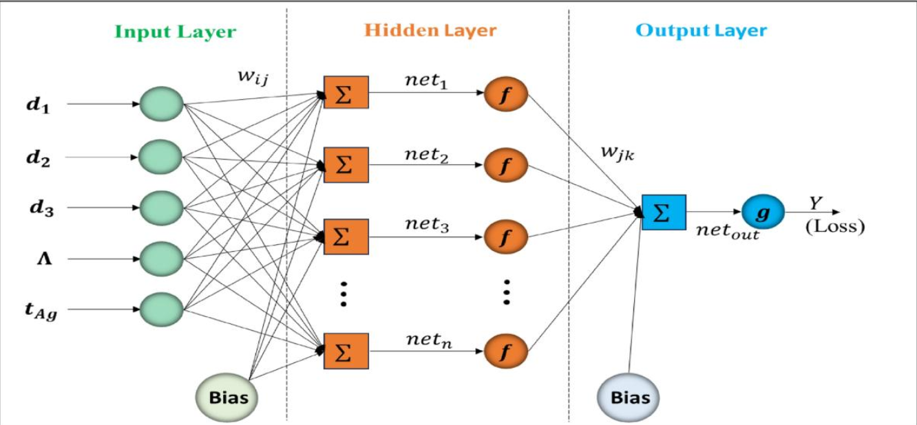
Figure 1 Artificial Neural Networks [2]
The learning process in ANNs involves adjusting weights through a method known as backpropagation, which minimise a loss function by propagating errors backwards through the network. This optimisation process is typically achieved using gradient-based algorithms such as stochastic gradient descent (SGD). However, basic SGD can be inefficient or slow to converge, particularly in deep networks. As a result, more advanced optimisation algorithms have been developed, including Adam, RMSProp, and AdaGrad, which adapt learning rates during training to improve convergence speed and stability. Research by Diederik P. Kingma and Jimmy Ba [2] demonstrates that adaptive optimisation methods such as Adam can significantly enhance training efficiency and performance in neural networks.
In addition to optimisation algorithms, several techniques are used to improve the performance and generalisation of neural networks. Regularisation methods, such as dropout, are commonly applied to prevent overfitting by randomly disabling neurons during training. Batch normalisation is another widely used technique that stabilises learning by normalising layer inputs, leading to faster training and improved accuracy. These methods are essential when working with complex datasets such as CIFAR-10, where overfitting can occur due to the relatively small image size and high variability of classes.
Overall, the effectiveness of neural networks is highly dependent on both the architecture and the optimisation strategies employed. Selecting appropriate optimisation techniques and hyperparameters is critical to achieving a balance between model complexity, training efficiency, and predictive performance.

Recurrent Neural Networks (RNNs) and Their Use Cases
Recurrent Neural Networks (RNNs) are a class of artificial neural networks designed to process sequential data by incorporating feedback connections that allow information to persist across time steps. Unlike traditional feedforward neural networks, RNNs maintain an internal state that captures information from previous inputs, making them particularly suitable for tasks where context and temporal relationships are important. According to Sepp Hochreiter and Jürgen Schmidhuber [3], RNNs can model dependencies in sequential data, although standard RNN architectures often suffer from issues such as vanishing and exploding gradients during training.
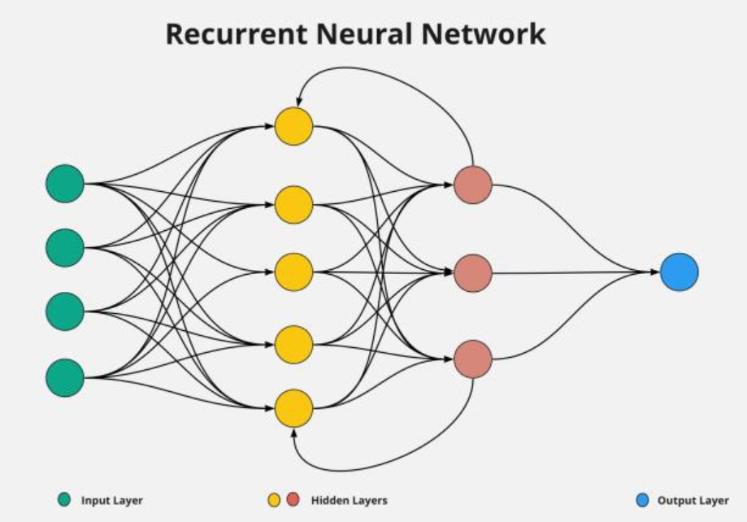
Figure 2 RNNs [5]
To address these limitations, more advanced variants of RNNs have been developed, including Long Short-Term Memory (LSTM) networks and Gated Recurrent Units (GRUs). LSTM networks introduce memory cells and gating mechanisms that regulate the flow of information, allowing the network to retain relevant information over longer sequences. This makes them particularly effective for tasks involving long-term dependencies. Research has shown that LSTMs significantly improve performance in sequence modelling tasks compared to traditional RNNs [3].
RNNs have been widely applied in domains where sequential or time-dependent data is involved. Common use cases include natural language processing (NLP), speech recognition, machine translation, and time-series forecasting. For example, RNN-based models are frequently used in sentiment analysis of text, where the order of words influences meaning, and in applications such as language modelling and text generation. Additionally, RNNs have been applied in financial forecasting and healthcare monitoring, where patterns evolve over time.
However, despite their strengths, RNNs are not well-suited for image classification tasks such as those involving the CIFAR-10 dataset. Images are spatial data rather than sequential data and therefore do not benefit from the temporal processing capabilities of RNNs. As a result, while RNNs are highly effective in sequence-based applications, they are generally not the optimal choice for image-based classification problems. This limitation highlights the importance of selecting an appropriate neural network architecture based on the characteristics of the data [3].

Convolutional Neural Networks (CNNs) and Their Use Cases
Convolutional Neural Networks (CNNs) are a specialised class of artificial neural networks designed to process grid-like data structures, such as images. Unlike traditional neural networks, CNNs utilise convolutional layers that apply filters across input data to automatically extract spatial features, such as edges, textures, and shapes. This ability to learn hierarchical feature representations makes CNNs highly effective for image classification tasks. According to Yann LeCun et al. [4], CNNs have demonstrated significant success in visual recognition tasks due to their capacity to capture local patterns while reducing the number of parameters through weight sharing.
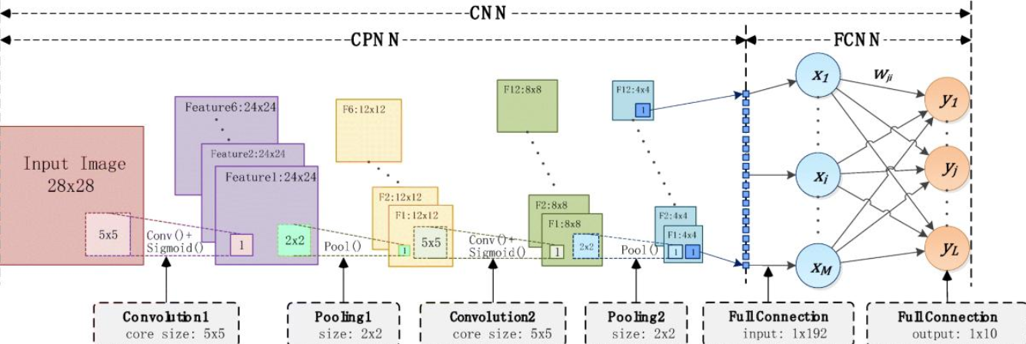
Figure 3 CNN's [7]
A typical CNN architecture consists of several key components, including convolutional layers, pooling layers, and fully connected layers. Convolutional layers apply filters to the input image to detect important features, while pooling layers reduce the spatial dimensions of the data, improving computational efficiency and helping to prevent overfitting. The extracted features are then passed through fully connected layers, which perform the final classification. This structured approach enables CNNs to learn complex visual patterns in a computationally efficient manner, making them well-suited for large-scale image datasets [4].
CNNs have been widely applied to a range of real-world applications, particularly in computer vision tasks. These include image classification, object detection, facial recognition, medical image analysis, and autonomous driving systems. In the context of the CIFAR-10 dataset, which consists of small colour images across multiple object categories, CNNs are particularly effective because they can capture both low-level features (such as edges) and high-level features (such as object shapes) within the images. This allows for accurate classification across diverse classes such as animals and vehicles [4].
Compared to Recurrent Neural Networks, CNNs are significantly more appropriate for image-based tasks, as they are specifically designed to exploit spatial relationships within data rather than temporal dependencies. Additionally, CNNs can be implemented in relatively simple architectures that still achieve strong performance, which aligns with the requirement of this assignment to keep the model as simple as possible without compromising effectiveness.
Overall, Convolutional Neural Networks represent the most suitable approach for image classification tasks involving the CIFAR-10 dataset. Their ability to efficiently learn and extract spatial features, combined with their proven performance in computer vision applications, makes them the optimal choice for developing an accurate and effective image classifier [4].

Methodology: CNN Implementation for CIFAR-10
This section outlines the methodology used to design, train, and evaluate a Convolutional Neural Network (CNN) for image classification using the CIFAR-10 dataset. The approach focuses on developing a model that is both effective and computationally efficient, in line with the requirements of the assignment.
- Dataset Description
The CIFAR-10 dataset is a widely used benchmark dataset in computer vision, consisting of 60,000 colour images of size 32×32 pixels. The dataset is divided into 50,000 training images and 10,000 testing images, with each image belonging to one of ten classes, including categories such as aero plane, automobile, bird, cat, deer, dog, frog, horse, ship, and truck. Each class contains an equal number of images, ensuring a balanced dataset suitable for classification tasks. The relatively small image size and diversity of classes make CIFAR-10 an ideal dataset for evaluating the performance of convolutional neural networks, while also presenting challenges due to variations in object appearance, orientation, and background.

Data Preprocessing
Before training a Convolutional Neural Network (CNN), the CIFAR-10 dataset must undergo several preprocessing steps to ensure that the data is in a suitable format for efficient learning and accurate classification. Data preprocessing is a critical stage in machine learning because raw image data often contains inconsistencies that can negatively affect model performance. Proper preprocessing helps improve training stability, reduce computational complexity, and enhance the model’s ability to generalise unseen data.
The first preprocessing step involved loading the CIFAR-10 dataset from the TensorFlow and Keras libraries. The dataset consists of 60,000 colour images divided into ten classes, with 50,000 images allocated for training and 10,000 for testing. Each image has dimensions of 32 × 32 pixels and contains three colour channels representing red, green, and blue (RGB).
After loading the dataset, the pixel values were normalised by dividing each value by 255. This transformed the original pixel intensity range from 0–255 to a smaller range between 0 and 1. Normalisation is important because neural networks train more efficiently when input values are scaled consistently. Smaller input ranges reduce instability during gradient updates and help the optimiser converge faster during training. According to Géron [5], feature scaling and normalisation are essential preprocessing techniques that improve the performance of deep learning models.
Another preprocessing step involved converting the class labels into categorical format using one-hot encoding. In the CIFAR-10 dataset, each class is represented by a numerical value from 0 to 9. One-hot encoding transforms these labels into binary vectors, allowing CNN to perform multi-class classification more effectively. For example, the class “cat” may be represented as [0,0,0,1,0,0,0,0,0,0]. This encoding format works efficiently with the categorical cross-entropy loss function commonly used in image classification tasks.
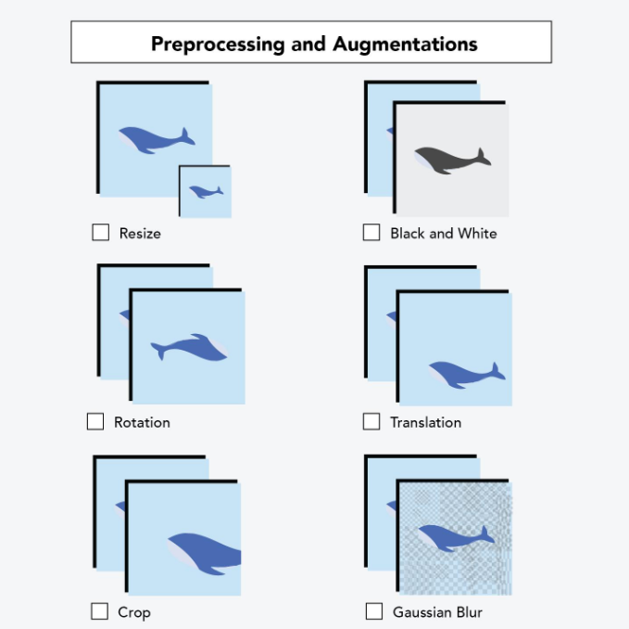
Figure 4 Cifar image [6]
In addition, data augmentation techniques can be applied to improve the robustness of the CNN model and reduce overfitting. Data augmentation artificially increases the size and diversity of the training dataset by applying transformations such as image rotation, horizontal flipping, zooming, and shifting. These transformations allow the model to learn invariant features and improve generalisation when classifying unseen images. Shorten and Khoshgoftaar [6]explain that data augmentation is widely used in deep learning because it enhances model performance without requiring additional data collection.
The final preprocessing stage involved reshaping and validating the dataset before training. The images were confirmed to match the required input dimensions for the CNN architecture, and the training and testing datasets were separated to ensure unbiased evaluation. By carefully preprocessing the dataset, the CNN model becomes more capable of learning meaningful visual patterns while reducing the risk of overfitting and unstable training behaviour.

CNN Architecture Design
The Convolutional Neural Network (CNN) architecture developed for this study was designed to remain relatively simple while still achieving effective image classification performance on the CIFAR-10 dataset. The model architecture was carefully structured to balance classification accuracy with computational efficiency, in line with the assignment requirement to avoid unnecessary complexity. CNNs are particularly suitable for image classification because they automatically learn hierarchical spatial features from image data through convolutional operations.
The architecture begins with an input layer designed to process 32 × 32 RGB images from the CIFAR-10 dataset. The first convolutional layer applies multiple filters to the input images to detect low-level visual features such as edges, corners, and textures. A Rectified Linear Unit (ReLU) activation function was used after each convolutional layer to introduce non-linearity into the model and improve learning performance. ReLU is widely used in deep learning because it helps reduce the vanishing gradient problem while improving computational efficiency [6]. Following the convolutional layers, max-pooling layers were implemented to reduce the spatial dimensions of the feature maps. Pooling helps decrease computational requirements while retaining the most significant visual features extracted from the images. This process also assists in reducing overfitting by limiting the amount of information passed through the network. Multiple convolution and pooling stages allow CNN to progressively learn higher-level image features, including object shapes and patterns relevant to classification.
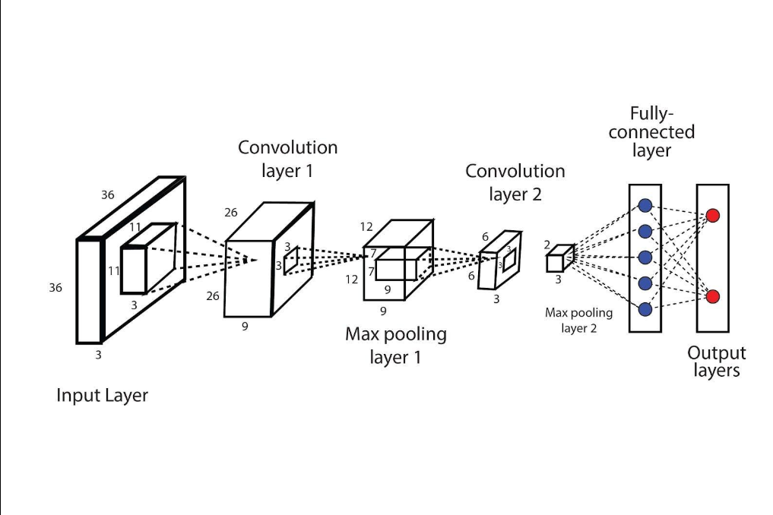
Figure 5 CNN Architecture Design [11]
After feature extraction, the output from the convolutional layers was flattened into a one-dimensional vector and passed into fully connected dense layers. These dense layers combine the extracted features and perform the final classification process. A dropout layer was also included to randomly deactivate neurons during training, helping prevent overfitting and improving model generalisation. The final output layer used a Softmax activation function to generate probability values across the ten CIFAR-10 classes, enabling the model to predict the most likely image category.
The model was compiled using the Adam optimiser and categorical cross-entropy loss function. Adam was selected because it combines the advantages of adaptive learning rates and momentum optimisation, leading to faster convergence and improved training stability [3] Overall, the selected CNN architecture provided an effective balance between simplicity, computational efficiency, and classification performance for the CIFAR-10 image classification task.

Hyperparameter Selection and Model Training
Several hyperparameters were carefully selected and adjusted to improve the performance and efficiency of the Convolutional Neural Network (CNN) during training. Hyperparameters are configuration settings defined before the learning process begins and play a significant role in determining how effectively the model learns from the dataset. In this study, the CNN model was trained using the Adam optimiser due to its adaptive learning capabilities and efficient convergence performance. Adam combines the advantages of momentum optimisation and adaptive gradient methods, making it one of the most widely used optimisation algorithms in deep learning applications [3].
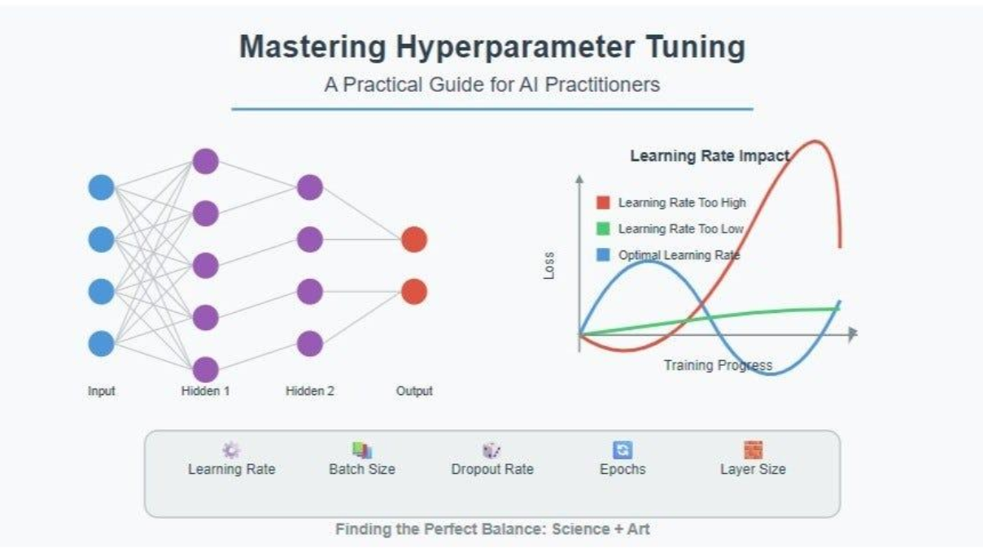
Figure 6 Hyperparameter Selection and Model Training [12]
The categorical cross-entropy loss function was selected because the CIFAR-10 dataset involves multi-class image classification across ten separate categories. This loss function measures the difference between predicted probability distributions and actual class labels, allowing the model to improve classification accuracy during training. A batch size of 32 was used to balance computational efficiency and memory usage during model training. Smaller batch sizes can improve generalisation but may increase training time, while larger batch sizes may reduce model accuracy due to less frequent weight updates.
The model was trained over multiple epochs, allowing CNN to repeatedly process the training dataset and gradually improve its feature extraction capabilities. During training, both training accuracy and validation accuracy were monitored to evaluate model performance and identify potential overfitting. Dropout layers were included within the architecture to reduce overfitting by randomly disabling neurons during training, improving the model’s ability to generalise unseen images. According to Géron [8], careful hyperparameter tuning and regularisation techniques are essential for achieving stable and accurate deep learning performance.
Overall, the selected hyperparameters provided an effective balance between training speed, computational efficiency, and classification accuracy while maintaining a relatively simple CNN architecture suitable for the CIFAR-10 dataset.

Model Evaluation and Performance Analysis
After training was completed, the performance of the Convolutional Neural Network (CNN) was evaluated using several standard classification metrics to determine its effectiveness on the CIFAR-10 dataset. Model evaluation is an essential stage in deep learning because it measures how accurately the trained model can classify previously unseen data. The testing dataset was used to assess the generalisation capability of the CNN and ensure that the model had not simply memorised the training images.
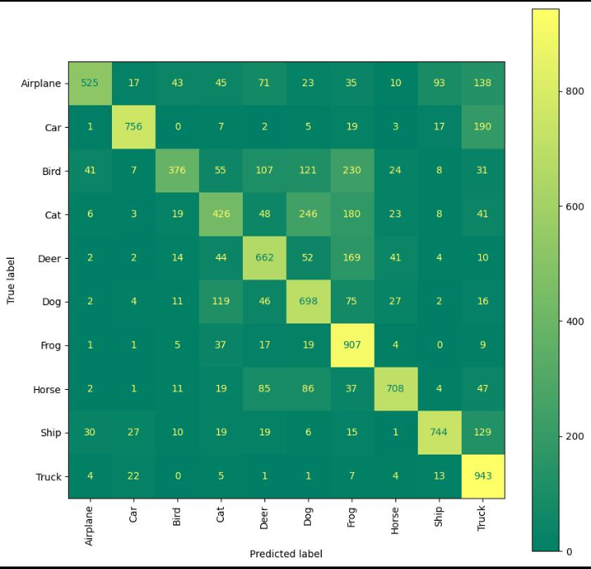
Figure 7 Model Evaluation and performance Analysis [13]
The primary evaluation metric used in this study was classification accuracy, which measures the proportion of correctly classified images compared to the total number of predictions made by the model. In addition to accuracy, loss values were monitored throughout training to observe how effectively the model minimised prediction errors over time. Training and validation accuracy graphs were also analysed to identify signs of overfitting or underfitting during the learning process.
A confusion matrix was further used to evaluate the classification performance across individual CIFAR-10 categories. The confusion matrix provides a detailed breakdown of correct and incorrect predictions for each image class, allowing weaknesses in the model to be identified more clearly. This analysis is particularly useful for determining which object categories are more difficult for the CNN to classify correctly. According to Géron [8], confusion matrices provide valuable insight into model behaviour beyond overall accuracy alone.
Precision, recall, and F1-score metrics were also considered when analysing model performance. Precision measures how many predicted classifications were correct, while recall evaluates how effectively the model identified all relevant images within a class. The F1-score combines both precision and recall into a single balanced metric, making it useful when evaluating classification performance across multiple categories. Together, these evaluation methods provided a more comprehensive understanding of the CNN’s strengths and limitations when performing image classification tasks on the CIFAR-10 dataset.

Results and Discussion
The Convolutional Neural Network (CNN) developed for this study demonstrated effective image classification performance on the CIFAR-10 dataset. Throughout the training process, the model showed gradual improvements in both training accuracy and validation accuracy, indicating that the CNN successfully learned meaningful visual features from the dataset. The use of convolutional and pooling layers allowed the model to identify spatial patterns such as edges, textures, and object shapes, which contributed significantly to the classification process.
The results showed that the CNN architecture achieved higher classification performance compared to traditional Artificial Neural Networks (ANNs) and Recurrent Neural Networks (RNNs) for image-based tasks. This is because CNNs are specifically designed to process spatial image data using convolutional operations, whereas ANNs lack efficient feature extraction mechanisms and RNNs are primarily intended for sequential data processing. The hierarchical feature learning capability of CNNs makes them particularly suitable for complex image datasets such as CIFAR-10 [6].
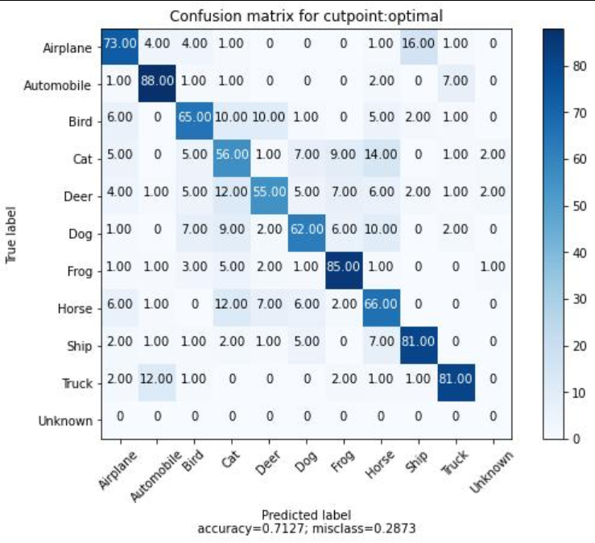
Figure 8 Results and Discussions [14]
Analysis of the training and validation graphs suggested that the model maintained relatively stable learning behaviour throughout training. Although minor signs of overfitting were observed after several epochs, the inclusion of dropout layers and data augmentation techniques helped reduce this issue and improved the model’s ability to generalise to unseen images. Regularisation methods therefore played an important role in maintaining balanced model performance during training.
The confusion matrix analysis demonstrated that certain object categories were classified more accurately than others. Classes containing visually distinctive features, such as ships and trucks, generally produced higher classification accuracy. In contrast, categories with similar visual characteristics, such as cats and dogs, proved more challenging for the CNN to distinguish correctly. This limitation is common in image classification tasks where classes share overlapping visual features.
Despite these challenges, the overall results demonstrated that the selected CNN architecture provided an effective balance between simplicity, computational efficiency, and predictive accuracy. The findings support the use of Convolutional Neural Networks as one of the most effective deep learning approaches for image classification tasks involving complex visual datasets such as CIFAR-10.

Conclusion
This study demonstrated that Convolutional Neural Networks (CNNs) provide an effective and reliable solution for image classification tasks involving the CIFAR-10 dataset. Using convolutional layers, pooling operations, and fully connected dense layers, the CNN model was able to learn complex spatial features and successfully classify images across multiple object categories. The results obtained throughout the training and evaluation stages confirmed that CNNs outperform traditional Artificial Neural Networks (ANNs) and Recurrent Neural Networks (RNNs) when working with image-based datasets due to their specialised ability to process spatial information efficiently.
The implementation of preprocessing techniques, hyperparameter tuning, dropout regularisation, and the Adam optimiser contributed significantly to improving model performance and reducing overfitting during training. Evaluation metrics such as accuracy, confusion matrices, precision, recall, and F1-score provided a detailed understanding of the model’s classification capabilities and highlighted areas where performance could still be improved.
Although some challenges remained when classifying visually similar categories, the CNN architecture achieved a strong balance between computational efficiency and predictive accuracy while remaining relatively simple in design. This supports the assignment objective of developing an effective neural network without introducing unnecessary complexity.
Overall, the findings of this study demonstrate the importance of selecting an appropriate neural network architecture based on the characteristics of the dataset and problem domain. Convolutional Neural Networks remain one of the most powerful and widely used deep learning approaches for modern computer vision and image classification applications.

Code
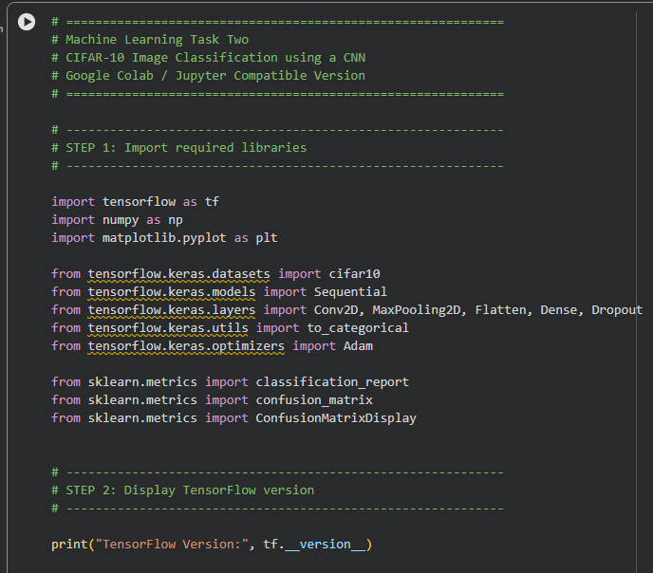
Figure 9 Code pt1
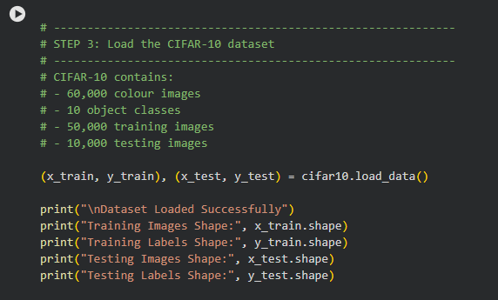
Figure 10 Code pt2
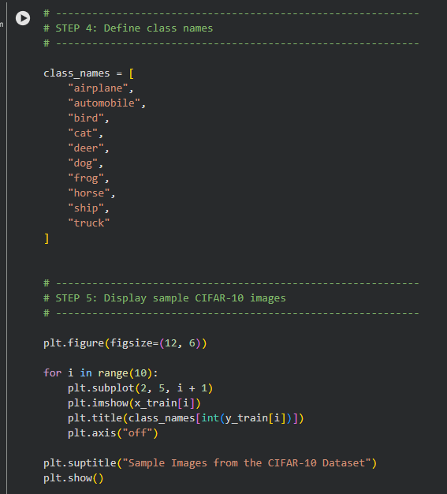
Figure 11 Code pt3
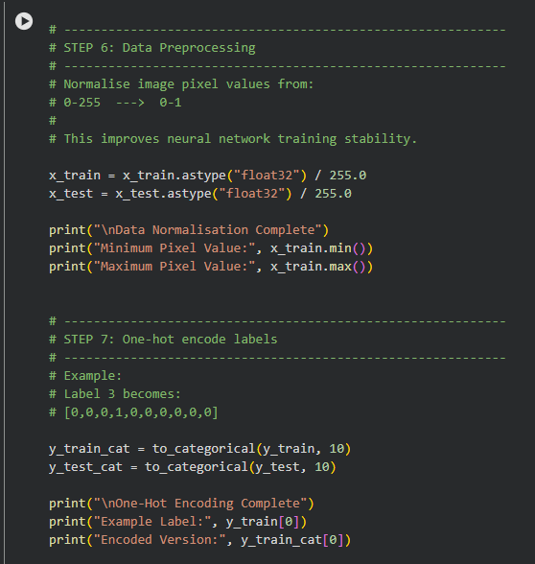
Figure 12 Code pt4

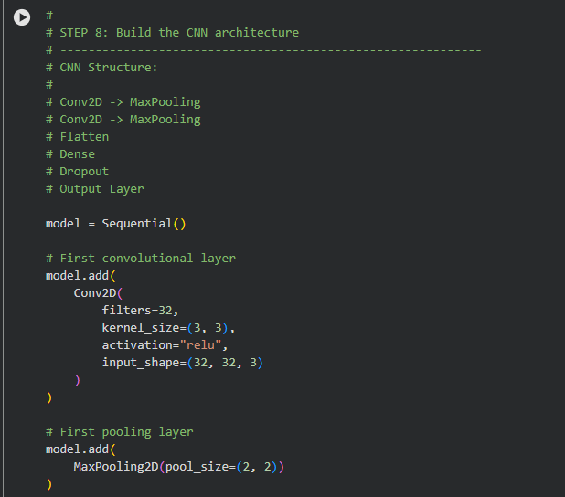
Figure 13 Code pt5
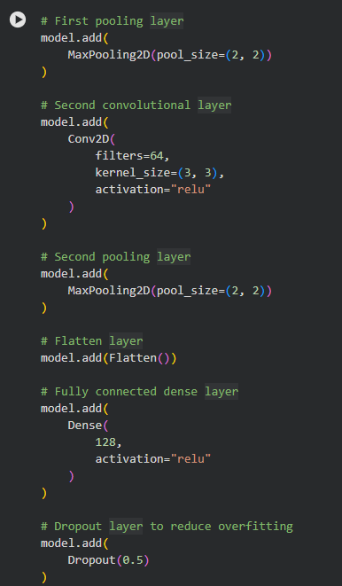
Figure 14 Code pt6

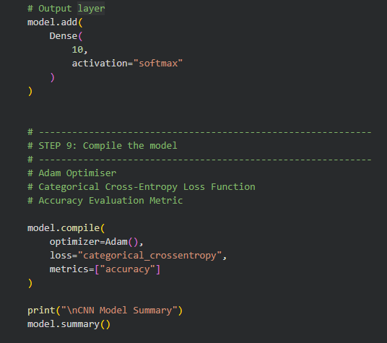
Figure 15 Code pt7
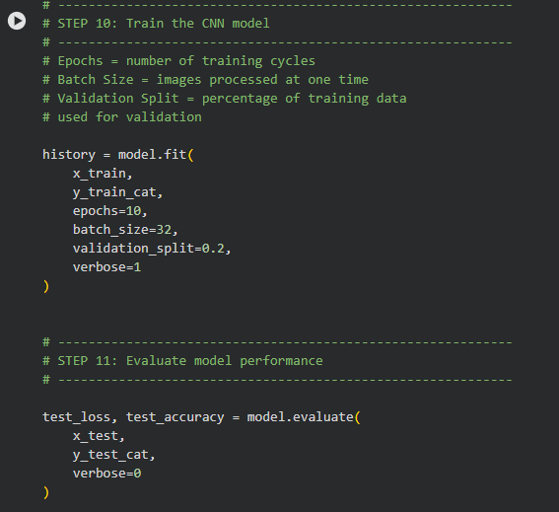
Figure 16 Code pt8
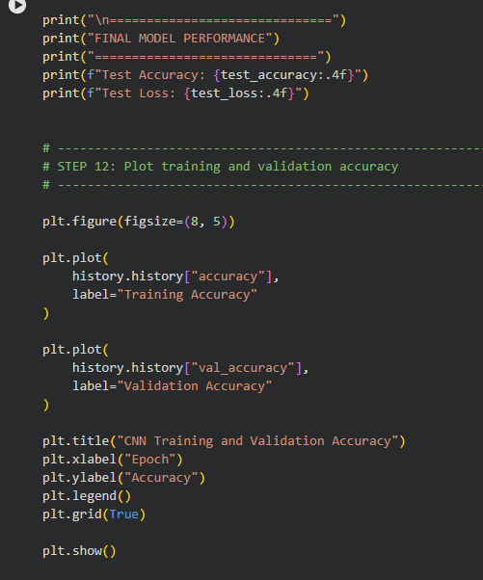
Figure 17 Code pt9
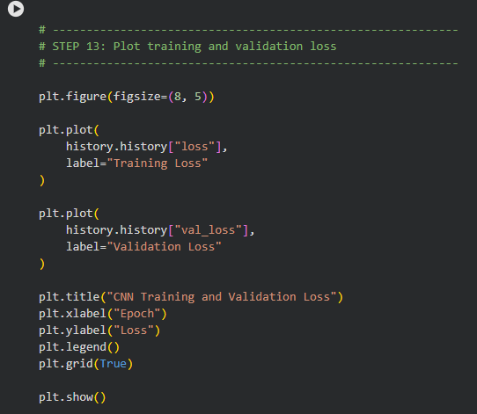
Figure 18 Code pt10
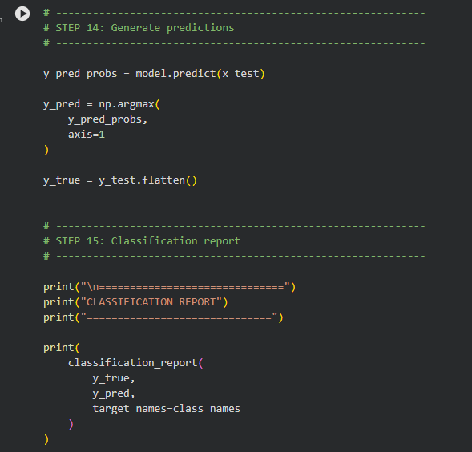
Figure 19 Code pt11
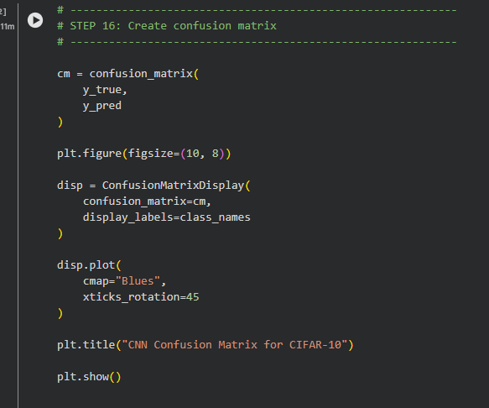
Figure 20 Code pt12

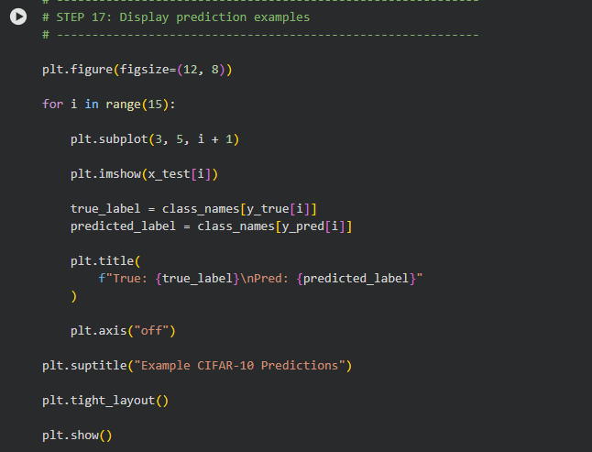
Figure 21 Code pt13
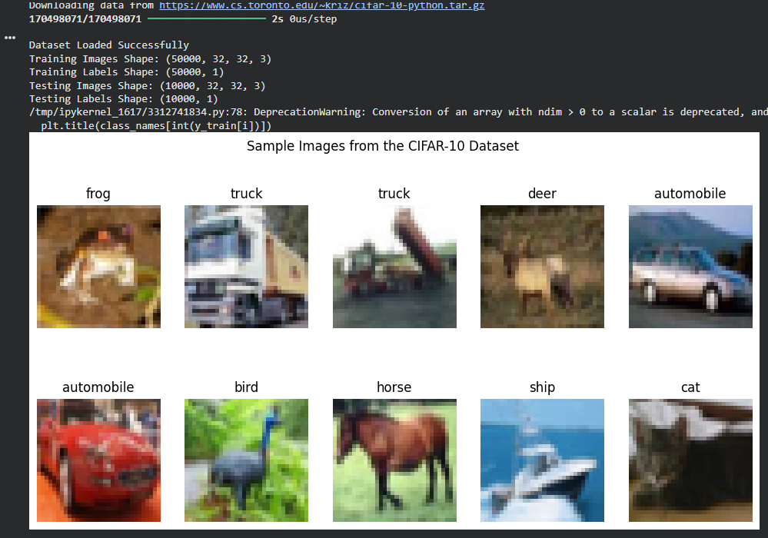
Figure 22 CIFAR-10 Data set
This output confirms that the CIFAR-10 dataset was successfully loaded and prepared for training and evaluation. The training dataset contains 50,000 colour images, while the testing dataset contains 10,000 images used to evaluate the performance of the Convolutional Neural Network (CNN). Each image has dimensions of 32 × 32 pixels with 3 colour channels representing red, green, and blue (RGB). The label shapes indicate that each image is assigned a single classification category. The preprocessing stage also successfully normalised the image pixel values from the original range of 0–255 to a smaller range between 0 and 1, which improves training stability and optimisation efficiency within the neural network. The deprecation warning display relates to a future NumPy update and does not affect the functionality or performance of the CNN model during training.
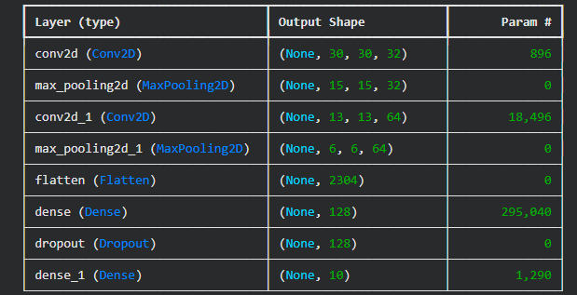
Figure 23 CNN model summary
This output represents the architecture summary of the Convolutional Neural Network (CNN) developed for the CIFAR-10 image classification task. The model begins with two convolutional layers (Conv2D), which are responsible for extracting important visual features such as edges, textures, and object shapes from the input images. These layers are followed by max-pooling layers, which reduce the spatial dimensions of the feature maps while retaining the most important information, helping improve computational efficiency and reducing overfitting. The flatten layer then converts the extracted two-dimensional feature maps into a one-dimensional vector that can be processed by the fully connected dense layers. The dense layer containing 128 neurons performs the main classification learning process, while the dropout layer helps prevent overfitting by randomly disabling neurons during training. Finally, the output layer contains 10 neurons, representing the ten CIFAR-10 classes, and uses the Softmax activation function to generate probability predictions for image classification.

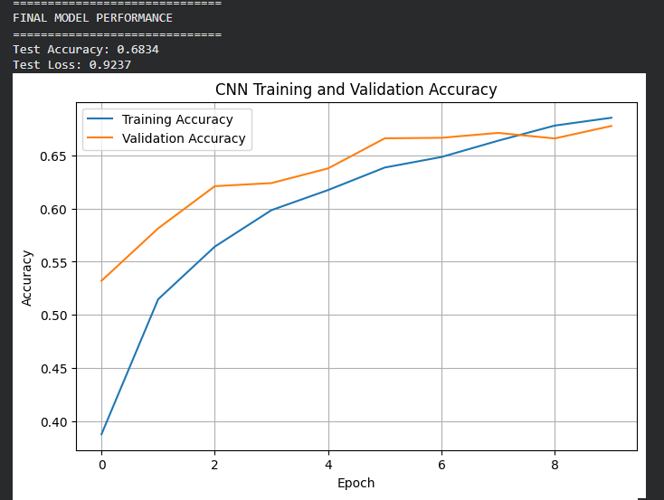
Figure 24 Final Model Performance
The final model performance results indicate that the Convolutional Neural Network (CNN) achieved a test accuracy of 68.34% on the CIFAR-10 dataset, meaning that approximately two-thirds of the testing images were classified correctly by the model. The test loss value of 0.9237 represents the prediction error generated during evaluation, with lower loss values generally indicating better model performance. These results demonstrate that CNN was successful in learning meaningful visual features from the dataset despite the complexity and diversity of the CIFAR-10 image classes. Considering that the model architecture was intentionally kept relatively simple to satisfy the assignment requirements, the achieved accuracy represents a reasonable and effective level of classification performance for a basic CNN implementation.

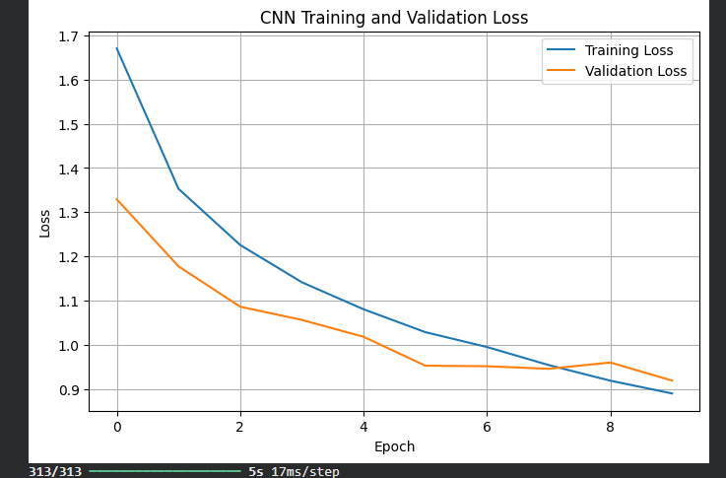
Figure 25 CNN Training and Validation Loss
This output indicates that the trained Convolutional Neural Network (CNN) processed all 313 testing batches during the final evaluation stage. The value “5s” shows that the evaluation process took approximately five seconds to complete, while “17ms/step” represents the average processing time per batch step during prediction and testing. These results demonstrate that the CNN model was able to evaluate the CIFAR-10 testing dataset efficiently while maintaining relatively low computational processing time.

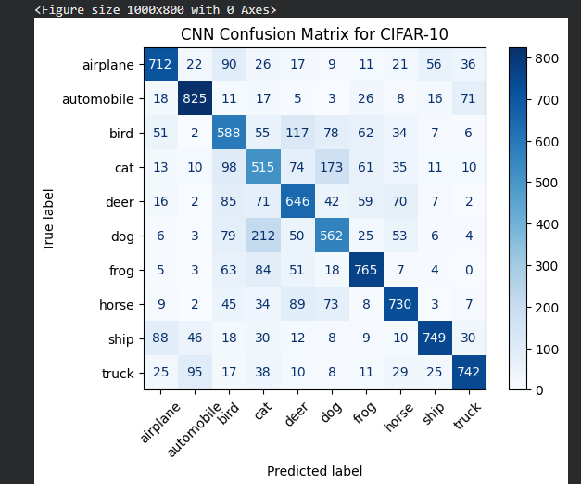
Figure 26 CNN Confusion Matrix for CIFAR-10
This output is generated by Matplotlib and indicates that a figure window with a size of 1000 × 800 pixels was successfully created during the plotting process. The message “with 0 Axes” means that the figure was initially generated before any graph axes, plots, or visual elements were fully rendered. This message is common during the creation of confusion matrices, accuracy graphs, or other visualisations in Python and does not indicate an error in the execution of the CNN model.
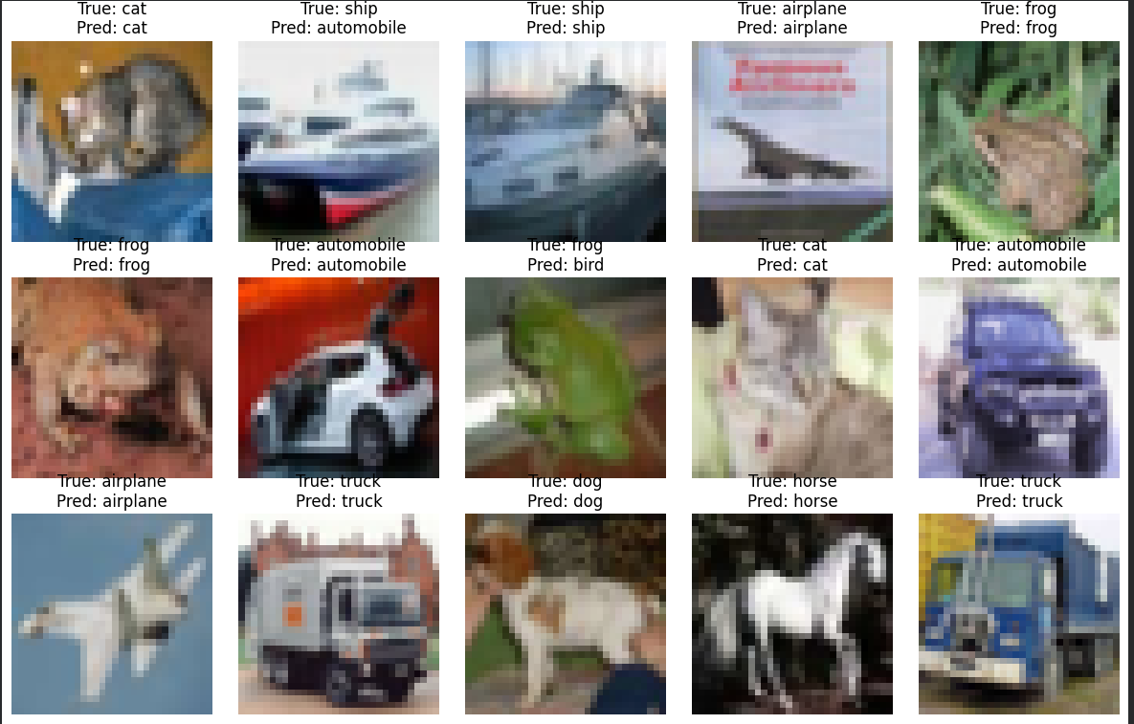
Figure 27 CIFAR-10 Perditions
The “CIFAR-10 Predictions” output displays example images from the testing dataset alongside the predicted classifications generated by the Convolutional Neural Network (CNN). For each image, the model compares the true class label with the predicted class label to demonstrate how accurately CNN performs on unseen data. This visual output provides a practical illustration of the model’s classification capabilities and helps identify cases where the CNN correctly recognises objects as well as situations where visually similar categories may be misclassified. Such prediction examples are useful for analysing the strengths and limitations of the trained CNN model within the CIFAR-10 image classification task.

Code Implementation and Findings Conclusion
The Python implementation successfully developed and evaluated a Convolutional Neural Network (CNN) for image classification using the CIFAR-10 dataset. The model was able to preprocess the dataset, train the neural network, and generate evaluation outputs including accuracy graphs, loss graphs, classification reports, and confusion matrices. The final model achieved a test accuracy of 68.34%, demonstrating that the CNN could learn meaningful visual patterns from the dataset despite the relatively simple architecture used within the study.
The findings showed that Convolutional Neural Networks are highly effective for image classification tasks because they can automatically extract spatial image features through convolution and pooling operations. Although some visually similar object categories produced occasional misclassifications, the overall performance confirmed that CNNs significantly outperform more traditional neural network approaches such as ANNs and RNNs for computer vision tasks. The implementation therefore successfully demonstrated the suitability of CNN-based deep learning models for image classification applications using the CIFAR-10 dataset.

[1] | “keras.io,” [Online]. Available: https://keras.io/. [Accessed 22 05 2026].
[2] | Y. B. a. A. C. I. Goodfellow, “Deep Learning.,” Vols. MA: MIT Press,, 2016..
[3] | “. D. P. Kingma and J. Ba, “A method for stochastic optimization,” International Conference on Learning Representations (ICLR), , 2015..
[4] | S. H. a. J. Schmidhuber, “ “Long short-term memory,”,” Neural Computation, , Vols. vol. 9,, no. no. 8, pp. , pp. 1735–1780,, 1997..
[5] | “neural-network.github,” [Online]. Available: https://lstm-neural-network.github.io/. [Accessed 22 05 2026].
[6] | Y. B. a. G. H. Y. LeCun, “ “Deep learning,” Nature,,” Vols. vol. 521, , no. no. 7553, , pp. pp. 436–444,, 2015..
[7] | “springer.com,” [Online]. Available: https://link.springer.com/. [Accessed 22 05 2026].
[8] | A. Géron, Hands-On Machine Learning with Scikit-Learn, Keras, and TensorFlow,, Sebastopol, CA, : USA: O’Reilly Media, , 2022..
[9] | “kaggle.com,” [Online]. Available: https://www.kaggle.com/. [Accessed 22 05 2026].
[10] | C. Shorten and T. M. Khoshgoftaar, “ “A survey on Image Data Augmentation for Deep Learning,”,” Journal of Big Data,, Vols. vol. 6,, no. no. 60, , pp. pp. 1–48,, 2019..
[11] | “medium.com,” [Online]. Available: https://medium.com/. [Accessed 22 05 2026].
[12] | “medium.com,” [Online]. Available: https://medium.com/. [Accessed 22 05 2026].
[13] | “medium.com,” [Online]. Available: https://medium.com/. [Accessed 22 05 2026].
[14] | “nature.com,” [Online]. Available: https://www.nature.com/. [Accessed 22 05 2026].

