BLOGS ON The Impact of Mobile Health Apps in Type 2 Diabetes Management

Student name- MOHAMMEDASHRSAF PATEL

Student number-2432246

lecturer’s name - Dr Ping Wu

module code- LCHS7009

module- Population Health and Digital Health Promotion
Blog 1: The Impact of Mobile Health Apps in Type 2 Diabetes Management
Understanding the Growing Burden of Type 2 Diabetes
Type 2 diabetes mellitus represents one of the 21st century's most critical healthcare challenges. Globally, approximately 537 million adults had diabetes in 2021, projected to reach 783 million by 2045 (International Diabetes Federation, 2021). In the United Kingdom, over 4.9 million people have diabetes, with roughly 90% having Type 2 (Diabetes UK, 2023). This alarming increase is concerning given associated complications including cardiovascular disease, kidney disease, and lower limb amputation, costing the NHS an estimated £10 billion annually (Hex et al., 2012).
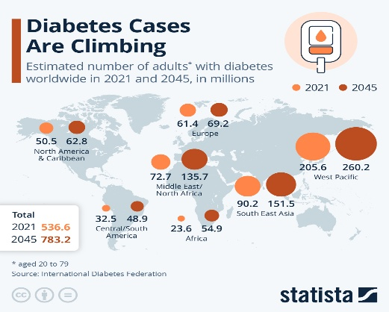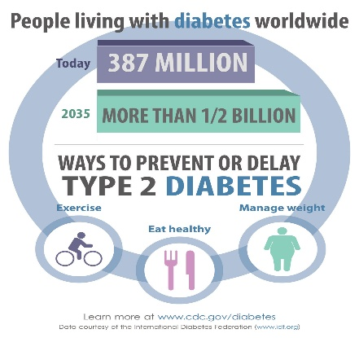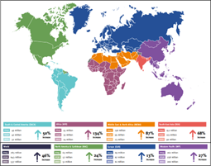

Digital Technology in Action: MySugr App
MySugr, a comprehensive diabetes management app, exemplifies how digital technology addresses daily challenges for Type 2 diabetes patients. This digital logbook enables real-time tracking of blood glucose levels, carbohydrate intake, medication adherence, and physical activity (MySugr GmbH, 2022). It employs gamification and personalized feedback to enhance user engagement while providing automated data synchronization with healthcare providers for remote monitoring.
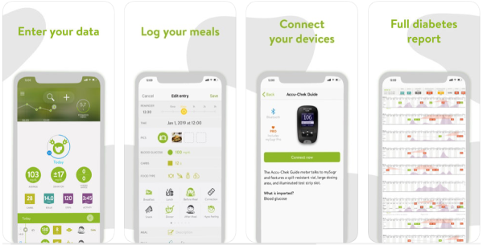
Evidence of Health Promotion Impact
Evidence demonstrates substantial benefits of mobile health applications in diabetes management. A systematic review by Hou et al. (2016) found that mobile app interventions significantly reduced HbA1c by 0.5%, representing clinically meaningful improvements in preventing long-term complications. Additionally, Captieux et al. (2023) reported that digital health interventions increased medication adherence by one-third and enhanced self-management behaviors. These findings align with health promotion principles by empowering individuals with knowledge and tools for autonomous health decision-making.
Critical Analysis: Advantages and Limitations
Advantages
The main advantage of mobile health apps is that it is convenient and available to everyone and allows a person to monitor oneself continuously without any specific limitations in terms of geography (Fagherazzi et al., 2020). Real-time feedback systems allow modifying behaviour instantly, and patient data analytics allows medical services to get all-encompassing patient information and make targeted treatment shifts. In addition to that, social support functionality is integrated and creates peer communities, which can deal with the psychosocial aspects of chronic disease management.
Disadvantages and Shortfalls
Despite promising results, significant limitations exist. The digital divide particularly affects older adults and lower socioeconomic groups with limited smartphone access and digital literacy (Latulippe et al., 2017). Data privacy concerns and information overload may hinder rather than empower users. Furthermore, most applications lack clinical validation and regulatory oversight, raising questions about their validity and safety. User engagement remains unsustainable, with high attrition rates after initial enthusiasm wanes (Krebs and Duncan, 2015).
Addressing the Shortfalls
To address these weaknesses, a multi-faceted approach is needed. Healthcare digital literacy programmes should target vulnerable groups while ensuring applications meet accessibility requirements, including multilingualism and simplified interfaces. Enhanced regulation of internet health products would improve quality assurance and user trust. Additionally, incorporating behavioural science principles into app design could boost long-term engagement, keeping the therapeutic relationship central to holistic care. However, digital solutions must not replace human-to-human healthcare interactions.

Blog 2: DiabetesConnect - A Community-Centred Digital Intervention for Type 2 Diabetes Prevention
The Type 2 Diabetes Prevention Challenge
Type 2 diabetes continues its alarming rise as a preventable yet increasingly prevalent disease. The NHS Diabetes Prevention Programme identifies approximately 5 million people in England at high risk of developing Type 2 diabetes, indicating prediabetes (NHS England, 2023). Lifestyle interventions can reduce diabetes incidence by 58% among high-risk individuals (Knowler et al., 2002). However, traditional face-to-face prevention programmes lack scalability, with attendance rates declining substantially throughout programs (Joiner et al., 2017). This implementation gap necessitates innovative digital solutions that maintain human connection while offering scalability and accessibility.
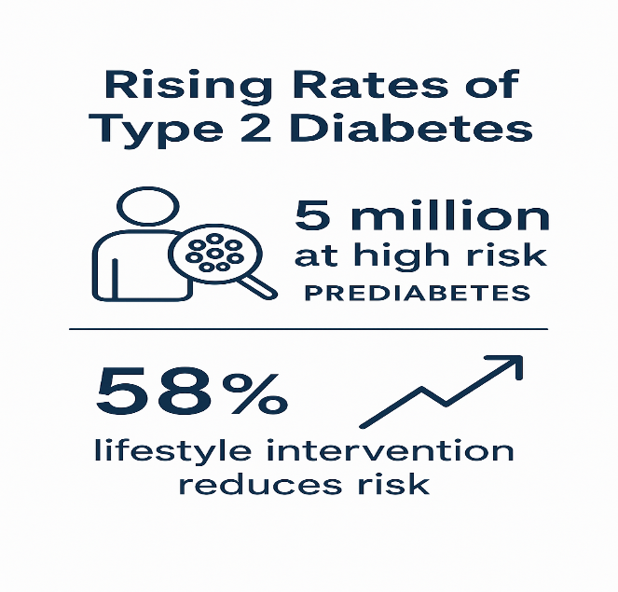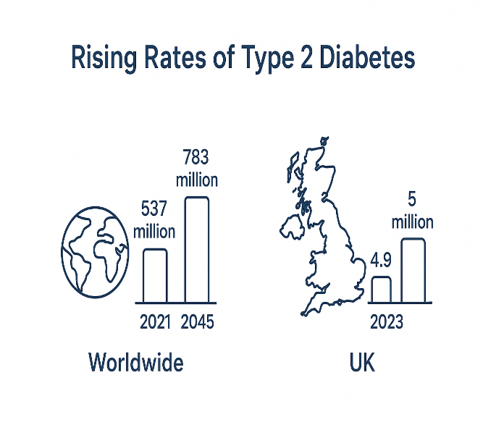
Introducing DiabetesConnect: A Designed Digital Intervention
One of the digital platforms that I have developed is DiabetesConnect, which combines both the mobile application technological platform and the community-based support networks that specifically focus on prediabetes individuals in underserved communities. Compared with the current applications which aim at only tracking individual behaviour, DiabetesConnect uses a socio-ecological model and acknowledges the health behaviours as influenced by interpersonal relationships as well as community contexts (McLeroy et al., 1988).
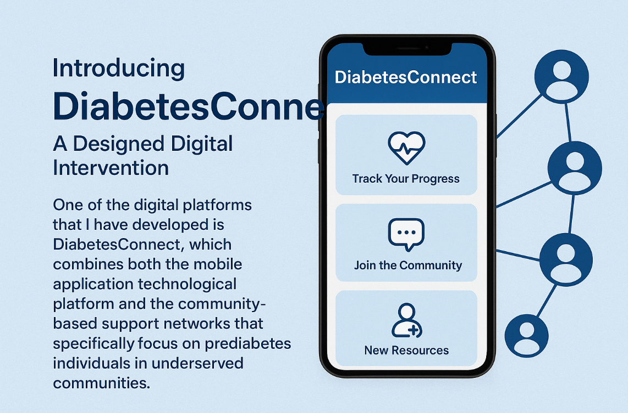

Core Features
The platform will have three connected parts: personal health tracking (glucose tracking, dietary journaling, physical activity tracking), local support groups (mediated by geo-located community forums and monthly face-to-face gatherings), and culturally-sensitive learning materials (crowdfixed by community members to make them culturally relevant and language accessible). The technology employs push notifications, which are timely, delivered on behavioural prompts and are based on the COM-B model, which boosts capability, opportunity, and motivation of behaviour change (Michie et al., 2011).
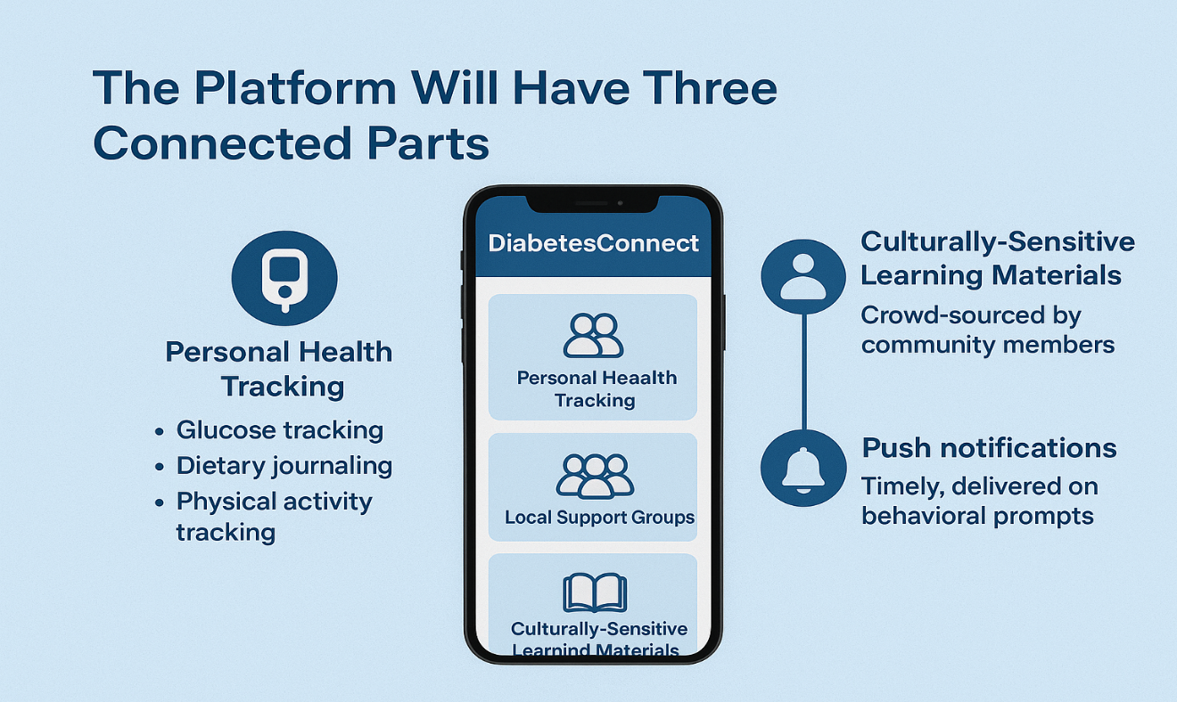

Addressing the Public Health Problem
DiabetesConnect promotes health through Ottawa Charter principles (World Health Organization, 1986). It develops personal skills via interactive modules on nutrition, physical activity, and stress management. Community empowerment occurs through peer support networks for sharing experiences, recipes, and motivation, building collective efficacy. Supportive environments are created by linking users to local affordable fitness facilities and healthy food outlets. Health service reorientation happens through primary care integration, enabling practitioners to monitor trends and provide personalized guidance.
Community-based digital interventions demonstrate superior engagement and sustained behavior change compared to individual-focused applications (Koorts et al., 2018). Social support addresses isolation during lifestyle modifications, with peer support increasing retention by 40% (Dale et al., 2012).
Critical Evaluation: Strengths and Limitations
Advantages
DiabetesConnect's key strength is its community-centered design addressing individual and social health determinants. The platform facilitates local connections, reducing social isolation while remaining scalable. Cultural customization ensures relevance across diverse populations, potentially decreasing health inequalities. Its hybrid model merges technological efficiency with human connection, acknowledging technology alone cannot address complex psychosocial aspects of lifestyle change. Healthcare system integration enables seamless care coordination without fragmenting services.
Weaknesses and Limitations.
Despite these advantages, significant challenges remain. Regular face-to-face meetings may inadvertently exclude individuals with caregiving responsibilities, mobility limitations, or non-standard work schedules. Digital literacy barriers persist, particularly among older adults who constitute a substantial proportion of the at-risk population. Data security concerns arise when handling sensitive health information across multiple platforms. Community facilitation requires sustained resource investment, potentially limiting scalability. Furthermore, maintaining culturally-appropriate content demands continuous community engagement, requiring considerable organizational commitment. Without adequate oversight, community forums risk spreading misinformation.
Addressing the Shortfalls
Several strategies could address these limitations. Flexible virtual and in-person meetings would accommodate diverse circumstances. Volunteer digital champions could support less technologically confident users. NHS Digital-aligned data governance frameworks would address security concerns and build trust. Sustainable funding through public health commissioners and charities would ensure longevity. Professional facilitators chairing forums would maintain information quality while preserving peer leadership. Regular co-production with service users would ensure continued relevance. Mixed-methods pilot testing would identify implementation barriers before full deployment.
References
Captieux, M., Prigmore, H., Wild, S., Guthrie, B., Mercer, S., Kee, F. and Govan, L. (2023) 'The effectiveness of digital health technologies for people with type 2 diabetes: systematic review of reviews', Journal of Medical Internet Research, 25, e43571.
Diabetes UK (2023) Number of people with diabetes reaches 4.9 million. Available at: https://www.diabetes.org.uk/about-us/news/diabetes-statistics (Accessed: 15 October 2025).
Fagherazzi, G., Goetzinger, C., Rashid, M.A., Aguayo, G.A. and Huiart, L. (2020) 'Digital health strategies to fight COVID-19 worldwide: challenges, recommendations, and a call for papers', Journal of Medical Internet Research, 22(6), e19284.
Hex, N., Bartlett, C., Wright, D., Taylor, M. and Varley, D. (2012) 'Estimating the current and future costs of Type 1 and Type 2 diabetes in the UK', Diabetic Medicine, 29(7), pp. 855-862.
Hou, C., Carter, B., Hewitt, J., Francisa, T. and Mayor, S. (2016) 'Do mobile phone applications improve glycemic control (HbA1c) in the self-management of diabetes? A systematic review, meta-analysis, and GRADE of 14 randomized trials', Diabetes Care, 39(11), pp. 2089-2095.
International Diabetes Federation (2021) IDF Diabetes Atlas, 10th edn. Brussels: International Diabetes Federation.
Krebs, P. and Duncan, D.T. (2015) 'Health app use among US mobile phone owners: a national survey', JMIR mHealth and uHealth, 3(4), e4924.
Latulippe, K., Hamel, C. and Giroux, D. (2017) 'Social health inequalities and eHealth: a literature review with qualitative synthesis of theoretical and empirical studies', Journal of Medical Internet Research, 19(4), e136.
MySugr GmbH (2022) MySugr: Diabetes app and blood sugar tracker. Available at: https://www.mysugr.com (Accessed: 20 October 2025).
Dale, J., Caramlau, I.O., Lindenmeyer, A., Williams, S.M. (2012) 'Peer support telephone calls for improving health', Cochrane Database of Systematic Reviews, (4), CD006903.
Joiner, K.L., Nam, S., Whittemore, R. (2017) 'Lifestyle interventions based on the diabetes prevention program delivered via eHealth: a systematic review and meta-analysis', Preventive Medicine, 100, pp. 194-207.
Knowler, W.C., Barrett-Connor, E., Fowler, S.E., Hamman, R.F., Lachin, J.M., Walker, E.A. and Nathan, D.M. (2002) 'Reduction in the incidence of type 2 diabetes with lifestyle intervention or metformin', New England Journal of Medicine, 346(6), pp. 393-403.
Koorts, H., Eakin, E., Estabrooks, P., Timperio, A., Salmon, J. and Bauman, A. (2018) 'Implementation and scale up of population physical activity interventions for clinical and community settings: the PRACTIS guide', International Journal of Behavioral Nutrition and Physical Activity, 15(1), p. 51.
McLeroy, K.R., Bibeau, D., Steckler, A. and Glanz, K. (1988) 'An ecological perspective on health promotion programs', Health Education Quarterly, 15(4), pp. 351-377.
Michie, S., van Stralen, M.M. and West, R. (2011) 'The behaviour change wheel: a new method for characterising and designing behaviour change interventions', Implementation Science, 6(1), p. 42.
NHS England (2023) NHS Diabetes Prevention Programme. Available at: https://www.england.nhs.uk/diabetes/diabetes-prevention/ (Accessed: 18 October 2025).
World Health Organization (1986) Ottawa Charter for Health Promotion. Geneva: World Health Organization.

