Student Name: Victoria Dixon
Student ID: 2328178
Module: Changemakers: Creativity and value creation
Module Code: BMHP5014
Assignment title: Component 2: Written assignment
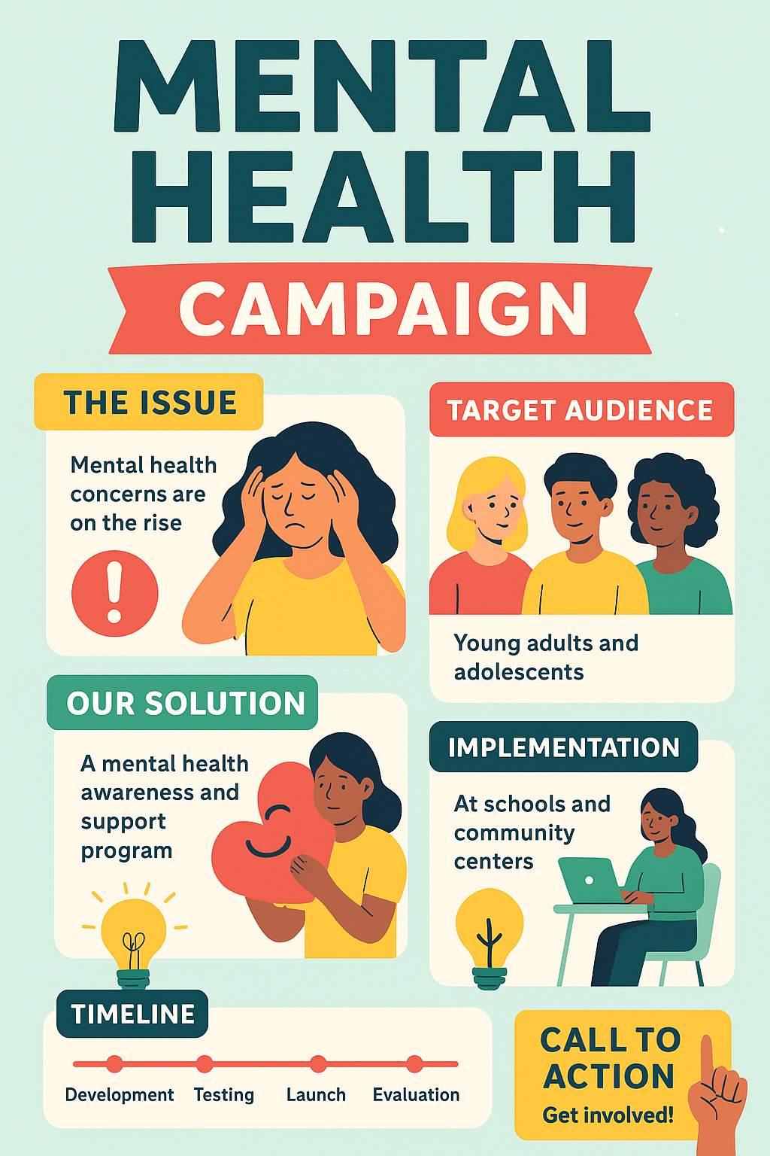
Pitch
Introduction
The Mental Health Campaign showcased in the poster aims to address an increasingly urgent issue affecting young adults and adolescents across the United Kingdom: the rise in mental health concerns among young people. Although the poster introduces the core ideas—highlighting the issue, presenting the target demographic, outlining the proposed solution, and displaying the implementation plan—this expanded pitch offers a deeper explanation of the campaign’s purpose, importance, and potential impact. This proposal supports the wider goals of UK health and social care policy by contributing to prevention, early intervention, and community-based wellbeing support for young people. Ultimately, the campaign seeks to empower individuals, equip communities, and encourage society to work collectively to improve mental health outcomes.
The Issue: Mental Health Concerns on the Rise
The poster identifies the core problem clearly: Mental health concerns are on the rise. National statistics reinforce this statement. Over recent years, young people have reported growing levels of anxiety, depression, low self-esteem, and stress. Factors such as exam pressure, social inequality, bullying—both in-person and online—family instability, and the ongoing influence of social media all play a significant role in heightening emotional distress.
Beyond personal struggles, there is a broader systemic issue. Many young people experience long waiting times for specialised mental health support due to overstretched services and limited resources within Child and Adolescent Mental Health Services (CAMHS). This delay can cause conditions to worsen. Furthermore, stigma, a lack of awareness, and hesitation to seek help often stop young people from reaching out early. As a result, their difficulties can escalate, affecting school engagement, relationships, and overall wellbeing. Addressing this rise is essential for protecting both short-term and long-term health outcomes, making this campaign timely and necessary.
Target Audience: Young Adults and Adolescents
The poster identifies young adults and adolescents as the primary target audience for the campaign. This is arguably the most critical age group for mental health intervention. Adolescence and early adulthood are periods of significant cognitive, emotional, and social development. During these years, individuals may face issues such as forming identity, navigating peer pressure, preparing for exams, experiencing romantic relationships, and planning for their futures. These pressures can lead to heightened emotional vulnerability.
Additionally, young people are often more reluctant to seek help from traditional mental health services due to stigma, fear of judgment, or a lack of trust in professionals. By focusing specifically on this demographic, the campaign aims to normalise mental health conversations and create supportive environments where young people feel safe engaging with mental wellbeing resources.
Parents, caregivers, teachers, and youth workers will also indirectly benefit from the campaign. By increasing awareness across these groups, the initiative helps adults better recognise early signs of distress and provide supportive responses. In this way, the campaign strengthens the overall network surrounding young people, ensuring early identification and intervention.

Our Solution: A Mental Health Awareness and Support Programme
The solution presented in the poster is a mental health awareness and support programme that empowers young people through knowledge, emotional tools, and accessible support. This programme has several key components.
Awareness and Education
Awareness is the first step toward reducing stigma and empowering young people to speak openly about mental health. The programme will educate young people about common mental health challenges, warning signs to look out for, ways to support peers, and the importance of seeking help early. By building this foundational understanding, young people are more likely to identify their own needs and ask for assistance.
Support and Early Intervention
The programme includes structured support sessions, either delivered individually or in groups. These sessions focus on practical strategies such as stress management, mindfulness, emotional regulation, communication skills, and resilience-building. These skills help young people better navigate daily challenges and prevent small issues from developing into more serious conditions.
Creating Safe Spaces
The tone of the poster—warm, supportive, and approachable—reflects the programme’s aim to create safe emotional spaces. Through supportive conversations, guidance from trained facilitators, and peer involvement, the programme aims to reduce feelings of isolation and show young people that they are not alone in their experiences.
Community Empowerment
The focus on awareness and support also strengthens the wider community. By empowering young people with knowledge and confidence, the campaign encourages a ripple effect of understanding throughout schools and communities.
Implementation: Schools and Community Centres
The poster highlights that the campaign will be implemented at schools and community centres, recognising the importance of accessibility and familiarity.
Why Schools?
Schools are ideal for preventive mental health work because they provide consistent, daily access to young people. Mental health awareness sessions integrated into school timetables ensure that students receive reliable support without stigma. Schools also have safeguarding systems in place, allowing trained staff to identify and respond to concerns promptly. This aligns closely with UK policy initiatives such as the Green Paper for Transforming Children and Young People’s Mental Health Provision (2017), which encourages school-based mental health support teams.
Why Community Centres?
Community centres are neutral, welcoming spaces that encourage participation from young people who may not be engaged in school. They offer an inclusive environment where workshops, informal sessions, and peer-support groups can occur. Community-based intervention aligns strongly with the Care Act 2014, which emphasises wellbeing, independence, and community participation.
Collaborative Working
Although the poster does not detail all professional involvement, the programme would naturally require collaboration between mental health practitioners, youth workers, teachers, volunteers, and local authorities. This multi-disciplinary approach ensures safe, high-quality, and consistent delivery of the programme.
Timeline: Development, Testing, Launch, Evaluation
The timeline shown in the poster emphasises a structured, quality-driven approach.
Development
This stage involves designing educational materials, awareness campaigns, session plans, and safeguarding protocols. It also includes liaising with schools, community centres, and relevant professionals.
Testing
Pilot sessions will be trialled with small groups of young people. Feedback will be collected from participants, teachers, and facilitators to refine the content and ensure cultural and developmental appropriateness.
Launch
Once refined, the programme will be rolled out across schools and community centres. Marketing materials, social media campaigns, and information sessions will be used to raise awareness and encourage participation.
Evaluation
Evaluation is essential for understanding impact. Data such as attendance, engagement, reported confidence levels, and wellbeing indicators will be collected. Evaluation also supports future funding and improvement.
Call to Action: Get Involved
The poster ends with a simple but powerful message: Get involved! Public involvement is essential for creating lasting change. Community members can support the campaign by volunteering, sharing information, donating resources, participating in events, or simply encouraging young people to attend sessions. A strong community response increases the campaign’s reach and sustainability, helping more young people access the support they need.
In conclusion, this Mental Health Campaign offers a practical and meaningful response to the rising mental health concerns among young adults and adolescents in the UK. By focusing on awareness, early support, and accessible delivery through schools and community centres, the initiative directly addresses gaps in current services while helping reduce stigma and encouraging open conversations. With continued community involvement and collaboration across health, education, and social care, the campaign has the potential to make a lasting, positive impact on young people’s wellbeing. Encouraging everyone to “get involved” is essential to creating a supportive environment where young people feel heard, valued, and confident seeking help.

