BMIH6003
Hotel Placement-Managing Guest Service Operations
Student Learning Log
Student Name:Danila Iulia
Student ID:2108673

Table of Contents
Introduction 2
Brief overview of the hotel’s guest operation 2
Learning Objectives 2
Section 1: Reflecting Experience and Personal Development 3
Concrete Experience 3
Reflective Observation 4
Abstract Conceptualisation 4
Active Experimentation 5
Section 2: Critical analysis of work-based skills and technical knowledge 5
Section 3: Reflection on Organisational Issue 5
Section 4: Future Action Plan 6
Conclusion 7
References 8

Introduction

Brief overview of the hotel’s guest operation
In my placement area, I served my job role as supervisor of Mercure Hotel Newport for the reception department. In this way, I have achieved effective professional skills and knowledge, which will support me in my future growth. During my placement time, I had to deal with the clients, analyse the data, print the emergency report, interaction with DM, develop the emergency report, and respond to different online portals such as Booking.com and Expedia. Additionally, I printed registration cards, cleared the fast checkout box and develop rooming lists guests. In this way, my regular operations have helped me to understand the rules and regulations to be followed for managing the reception area, as it would develop a positive customer experience depending upon the treatment.

Learning Objectives
- To develop potential work-based and technical skills from the reception area
- To identify the role of reception department in engaging guests for the hotel

Section 1: Reflecting Experience and Personal Development
As reported by Mcleod (2023), Kolb's reflective model is comprised of four stages including concrete experience, reflective observation, abstract conceptualisation, and active experimentation through which an experimental reflective analysis could be developed by following any situation.
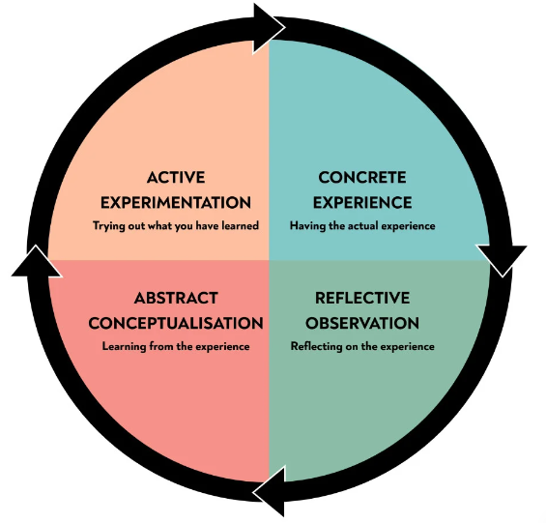
Figure 1: Kolb’s reflective cycle
(Source: Mcleod, 2023)

Concrete Experience
Considering my placement experience, I served as a supervisor role in the reception area of Mercure Hotel. In this context, I had to maintain the clock in, ensure the lobby and reception desk is clean, check the emails, daily data analysis and documentation process, interaction with DM, develop the emergency report, respond to different online portals such as Booking.com and Expedia. Additionally, I printed registration cards, cleared the fast checkout box and develop rooming lists guests. In this way, my professional and technical skills related to the reception area have been enhanced.

Reflective Observation
While working in the reception area of the Mercure Hotel Newport I found that the presence of professional and technical skills is necessary for the guest treatment and engaging them on a long-term basis. According to Shiri et al. (2023), a systematic working process could help to improve the professional and vocational development of the individual. In this way, the overall learning experience from the professional area could be endorsed properly. In the context of my experience, I had to control the overall operations in the reception area, which has generated my work-based and professional experiences. Additionally, I have understood the importance of several technical skills such as communication, business management, time management and task management skills, which are necessary for the reception area handling for a hotel (Main, 2022).

Abstract Conceptualisation
During my placement as a supervisor for the reception area of the Mercure Hotel Newport, I interacted with the customers on a regular basis. In this way, I need to identify their requirements and deliver them the idea of hotel services and high-quality accommodations for better engagement. The study by Ntobaki, Tlapana, and Matli (2022) stated that the consumer decision-making theory considers the five consecutive stages including the need recognition and problem awareness, information search, evaluation of the alternatives, purchased by the customers and development of the post-purchase behaviour. In this way, high quality consumer treatment and guest attendance in the reception area of the hotel is required for better post-purchase behaviour development (Ali et al., 2021).
Additionally, Chen et al. (2022) stated that the consumer engagement process for the hotel business is important, as it could enhance the sales and competitive advantage of the hotel. While operating in the reception area, I had to gain knowledge on sexual tourism involving children and deal with check-in to checkout, complaints, and luggage handling of the guests. In this way, I develop the understanding of consumer management through the effective reception operation.

Active Experimentation
Considering the overall reflective statement, I could state that effective skill development and professional knowledge are required for the reception area handling of a hotel. In this way, I have identified my lack of organisational and decision-making skills, which affected my overall skill development process throughout the placement period. Tucci (2022) stated that effective business organisational skills could help to ensure a systematic workflow process, which ultimately enhances the productivity of the organisation. In this way, the hotel sector could enhance customer engagement and service delivery processes through seamless operational processes (Apostol et al., 2023). However, due to my lack of organisational and decision-making skills, I faced challenges while interacting with the customers and thus, affected my potential.
Section 2: Critical analysis of work-based skills and technical knowledge
Inceoglu et al. (2019) opined that skill development from professional placement would help to enhance the knowledge outcome. In this way, an individual could perform effectively in the future workplace culture with effective potential. Considering my experience development in the hotel, I felt that my communication, business management, time management, and task management skills have been improved effectively. In this way, I could handle the guests with confidence and holistic care (Sayin, 2019). My communication, task management, and business management knowledge helped me to overcome the problematic situation properly and focus on my skill development from the placement learning process.

Section 3: Reflection on Organizational Issue
During my placement, I have faced issues due to a lack of understanding on Opera Cloud Usage for managing the bookings. I felt a little nervous while arranging the bookings using the website, based on which my performance was affected. In this way, I need to work on some skills, which I would analyse further. I have little knowledge on the mentioned website that has been used by the hotel based on which I could not deliver my expertise on booking functions mentioned in the roles and regulations for the reception area. In this way, my work-based and technical expertise became hindered as well.
In this way, I could suggest the management body of the hotel to train the hotel staffs regarding digital platforms and websites to analyse the operations of all departments effectively. Additionally, application of digital employee management tools could be implemented through which better customer treatment and better performance in the reception at the hotel would be possible.
Section 4: Future Action Plan
Considering my experience while working in the reception area, I have identified my lack of business organisation and decision-making skills, which I need to develop through the following action plan.
Objectives | Resources to be used | Timeline | Potential Outcome
To enhance the business organisational skills effectively | I will engage myself in different kinds of group activities, workshops, seminars, and webinars. Additionally, I will read online books for better knowledge development. | 8 months | Better business organisational skills will help me to operate effectively in several departments. Additionally, it will aid the knowledge of the reception area through which my future workplace career would be improved.
To improve decision-making skills for resolving any circumstances | I will read secondary books on decision-making skills. Additionally, I will focus on teamwork for effectively developing my decision-making skills | 12 months | In this way, I could analyse different situations properly and develop my decision-making criteria for better professional potential enhancement.
Table 1: Future Action Plan

Conclusion
At the end of the learning log, it can be stated that effective reception operation could influence the guest’s behavior towards the hotel and it could generate effective workplace skills, which would support the future career within the hotel industry. I have performed the role in the reception area of Mercure Hotel, which has helped me to know my strengths and weaknesses, which could be addressed through the action plan.

References
Ali, B.J. et al. (2021) ‘Hotel Service Quality: The Impact of Service Quality on Customer Satisfaction in Hospitality’, International Journal of Engineering, Business and Management, 5(3), pp. 14–28. Available at: https://doi.org/10.22161/ijebm.5.3.2.
Apostol, E.M.D. et al. (2023) ‘Customer Experience (Cx) Design in the View of Managers: An Analysis of the Impact of Pandemic in the Local Hospitality and Tourism Industry’, American Journal of Tourism and Hospitality, 1(1), pp. 16–26. Available at: https://doi.org/10.54536/ajth.v1i1.1749.
Chen, X. et al. (2022) ‘The Impact of Hotel Customer Engagement and Service Evaluation on Customer Behavior Intention: The Mediating Effect of Brand Trust’, Frontiers in Psychology, 13. Available at: https://doi.org/10.3389/fpsyg.2022.852336.
Inceoglu, I. et al. (2019) ‘(How) Do work placements work? Scrutinizing the quantitative evidence for a theory-driven future research agenda’, Journal of Vocational Behavior, 110(Part B), pp. 317–337. Available at: https://doi.org/10.1016/j.jvb.2018.09.002.
Main, K. (2022) Receptionist Job Description Template, Forbes Advisor. Available at: https://www.forbes.com/advisor/business/receptionist-job-description/ (Accessed: 17 February 2024).
Mcleod, S. (2023) Kolb’s Learning Styles and Experiential Learning Cycle, Simply Psychology. Available at: https://www.simplypsychology.org/learning-kolb.html (Accessed: 17 February 2024).
Ntobaki, P.P., Tlapana, T. and Matli, C.M. (2022) ‘Influence of social media on consumer purchasing decisions in Durban’, Journal of Social Sciences, 5(2), pp. 28–37. Available at: https://doi.org/10.52326/jss.utm.2022.5(2).03.
Sayin, K. (2019) ‘The Effect of Communication Problems on Productivity in Hotel Operations: A Qualitative Application’, Mednarodnoinovativnoposlovanje = Journal of Innovative Business and Management, 11(2), pp. 51–58. Available at: https://doi.org/10.32015/jibm/2019-11-2-6.
Shiri, R. et al. (2023) ‘The Role of Continuing Professional Training or Development in Maintaining Current Employment: A Systematic Review’, Healthcare, 11(21), p. 2900. Available at: https://doi.org/10.3390/healthcare11212900.
Tucci, L. (2022) What is business process management (BPM)? - Definition from WhatIs.com, techtarget. Available at: https://www.techtarget.com/searchcio/definition/business-process-management (Accessed: 19 February 2024).

