Professional and career development
Reflective portfolio

Name: Natalie Tully
Student Number: 2025743
Module code: BMSW4005
Lectures Name: Sujeewa Herath



Contents

Introduction ……………………………………. Page 3

Evaluating your skills and competencies……………………. page 3

As a manager, evaluate new and existing employee learning and development opportunities………………………………………………………………………page 5

Assess and reflect on your learning using one reflective cycle……page 6

Uk employment legislations…………………………………page 8

Conclusion ………………………………………………………. page 9

References……………………………………………Page 10

Introduction
In my reflective portfolio, I will apply a variety of analytic tools covered in this course, such as a personal growth plan and a personality test. I'll also discuss and evaluate the learning styles approach, as well as a SWOT analysis to assess comprehension and advance training for current and new employees. I'll reflect on my open book, mock interview, and general experience with this program using Gibbs' reflective cycle.

Evaluating your skills and competencies:
According to (Bullock and Jamieson, 1998)
PDPs are centred on a dialogue between a student and a tutor that clarifies choices, develops goals, and creates action plans. The goal of this approach is to improve personal understanding, motivation, and effectiveness.
Based on the technique tools I have learned to be more aware of my self-awareness through different techniques to develop my skills by using a (PDP) personal development plan in a tablet form to enable me to track my process to achieve my specific goals, to plan to meet deadlines in a more structured clear format. This enables me and other team members to track each other processes to achieve our deadlines. This is my PDP where I have set actions and planned deadlines to achieve my set goals.


SWOT Analysis:
As implied by (Gurel and Tat, 2017) SWOT Analysis is a method of evaluating an organisation’s strengths, weaknesses, opportunities, and threats concerning a strategy, project, person, or commercial activity.
Knowing the importance of understanding my SWOT will help me determine my goals and skills to be in a better position to gain more knowledge and experience on my weakness and threats to process future in my job role or within the company.
Personality test:
According to (Cherry, 2011) individuals who have Consul personalities are outgoing, loyal, organized, and tender-hearted. consul gain energy from interacting with other people.
After completing the 16-personality quiz it was stated that my personality type is Consul I also fit in two learning styles I’m an auditory/tactile learner, I have two main ways of learning. I agree with this chosen learning style. While at work one of my job roles are to give medication to the elderly/disabled. I will have to speak loud and clearly so that my patients understand, this is a clear example of auditory learning. I also agree with being a tactile learner. It will always depend on the tasks and jobs that I am doing to even out the learning style I require.
Working with vulnerable people I am very hands-on and practical daily. This explains why the tactile style of learning suits me. For example, I cannot sit for long without getting bored. I get distracted and can start swinging on my chair.
As a manager, evaluate new and existing employee learning and development opportunities.
A manager has a variety of responsibilities to assist their team. A manager should always treat each team member as an individual and try to set objectives and goals that are appropriate for their abilities and personalities. A manager's responsibility is to assess their team's learning and provide more training to assist their learning so that they can better themselves, which will not only benefit the team member but also the organisation. By using different learning methods, the team can develop their learning styles by using the following SWOT Analysis, PDP. This is backed up by (Pickton and Wright, 1998) stated that SWOT should not be viewed as a static analytical tool with emphasis solely on its output. It should be used as a dynamic part of the management and business development process.
I will now be exploring two methods that I would use as a manager to assess both new and existing staff and how I think these methods are vital and why they can support the individuals. The two methods I will be looking at are SWOT analysis and learning styles.
SWOT analysis is the first method I will use (Sun, 2008) swot is a way of planning your goals by evaluating oneself through different groups broken up into four categories Strengths, weaknesses, opportunities, and threats (SWOT) As a manager we will support our staff to be more aware of their strengths and weakness and guided them to achieve their goals by improving on their strengths and weaknesses to find more opportunities within the workplace to meet more targets and goals for the organisation and themselves. SWOT is an acceptable and effective approach for organisations to do with current and new employees since it encourages individuals to assess their ideas on their strengths and weaknesses and take them into account. As a manager, I believe SWOT is an important learning approach for organisations since it allows me to understand where and what each job position should be based on their SWOT. By choosing this framework as a manager it can me see alternative strategies for improving organisation. By considering and identifying the ‘SWOT’ we can develop and support the organisation as well as our staff force involved. By using this framework, we have a company that can adapt itself to opportunities and offered more support and training to our staff to develop and grow within the company internal and external, by using their strengths and minimising the impacts of their weaknesses-threats. (Pickton and Wright, 1998)

Learning styles:
My second method is learning style. (Hatami, 2012) states a learning style is a preferred technique of employing one's abilities rather than a talent in and of itself. Individuals differ in their "natural, habitual, and preferred way(s) of acquiring, processing, and retaining new knowledge and abilities," or learning styles. Because each extreme has its potential advantages and disadvantages, where a learner lies on the spectrum has no value. Furthermore, while individuals may have strong style preferences and tendencies, learning styles are no set ways of behaviour and can be extended and adjusted based on different contexts and tasks. Individuals' ability to expand or change their styles to fit a specific setting, on the other hand, differs. This is an important factor to consider when supporting staff to understand their learning style, so as a manager I can help them achieve their goals more productively by setting more realistic targets and training suited for their individual learning style methods which will enable them to become more confident and comfortable in their job role and their behavuior and attitude towards their goals and work accomplishments is the upmost importance considering factor as well.
Assess and reflect on your learning using one reflective cycle
(Husebø, O’Regan and Nestel, 2015) state Gibbs's reflective cycle is a theoretical framework comprised of six stages and can be used during structured debriefing to guide reflection.
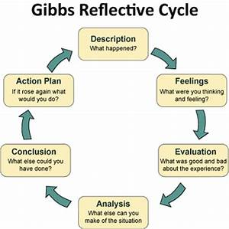

One of the activities on my assignment brief for this module was an open book assessment, for which I was given a case study a week prior and invited to assess and take notes on the case study. I was told that on the day of the open book assessment, I would be given two questions relevant to the case study and that I would have to choose one and respond in 500 words. I began by reading the case study and trying to make notes and highlight important facts. I feel anxious and overwhelmed with thinking that I didn’t know what questions were going to be asked about the case study, my emotions were at their highest at the time of the test as I wanted to achieve high marks. On the day after having a choice of the questions, I feel calmer and relaxed, in a more positive frame of mind. I was also overwhelmed and pleased with my feedback and my mark, this made me feel empowered to believe in myself more.
I had a mock interview for a job I was interested in on March 7, 2022; I had an interview at 2.45 pm. I was asked question basic on the job role I was applying for, I decided to come into class to do my mock interview as we had chosen to do it online, as I know from my learning techniques, I’m better at interacting face to face. I was concerned that I would not be able to answer the questions about the job description and core values of the company, so I research the organisation. I was felt nervous and got worried on the day of the interview questioning myself if I had researched enough and did, I have the right qualities needed for the role. Following my feedback, I can see I could have improved on a few things but happy I tried my best.
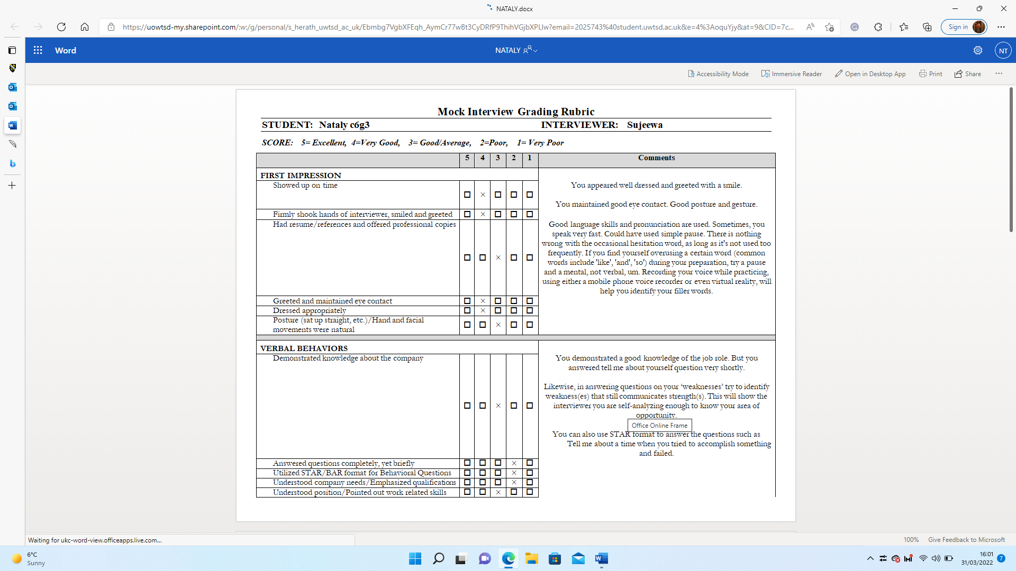

Uk employment legislations
There are many employments legislation that organisations have to uphold and apply within the law regulations, which protects the rights of the employee as well as protecting employers, from any employment tribunal against them.it covers a variety of employment laws including the most important legislation pieces: Employment Right Act 1996 which is basically around the human right ensuring and protecting rights and focus on feelings and recognising the importance in process recruitment, employment contract, data protection, and many more. National minimum wage Act 1998, The Equality Act 2010, ensures employees are not treated unfairly or classified by age, health, race, religion. Understanding and following these on how important the employment legislation is vital for a business to grow and develop with its employee and the organisation. (Group, n.d.)

Conclusion.
Looking back on his module and my experiences I would say I have gathered more in-depth knowledge of the process through different levels of recruitment and my personal development by using different methods for me to have a better understanding of my weaknesses and strengths to be more confident in myself and not to be afraid to step out my comfort stage to progress on to big opportunities and meet my goals. I feel that there have been more positive outcomes than negative through these stages of development. Also, to continue to carry on evaluating and reviewing my qualities to keep progress to reach my targets and goals in the future for me and the organisation I work with and to understand my rights as an employee, I do

References

Bullock, K. and Jamieson, I. (1998). The effectiveness of personal development planning. The Curriculum Journal, 9(1), pp.63–77.

Cherry, K. (2011). ESFJ: The Caregiver (Extraverted, Sensing, Feeling, Judging). [online] Verywell Mind. Available at: https://www.verywellmind.com/esfj-extraverted-sensing-feeling-judging-2795983.

Group, C. (n.d.). List of Employment Laws in the UK. [online] Croner. Available at: https://croner.co.uk/resources/employment-law/legislation-list/# [Accessed 31 Mar. 2022].
‌
Gurel, E. and Tat, M. (2017). SWOT analysis: a Theoretical Review. Journal of International Social Research, [online] 10(51), pp.994–1006. Available at: https://www.researchgate.net/publication/319367788_SWOT_ANALYSIS_A_THEORETICAL_REVIEW.

Hatami, S. (2012). Learning styles. ELT Journal, 67(4), pp.488–490.

Husebø, S.E., O’Regan, S. and Nestel, D. (2015). Reflective Practice and Its Role in Simulation. Clinical Simulation in Nursing, [online] 11(8), pp.368–375. Available at: https://www.sciencedirect.com/science/article/pii/S1876139915000389.
‌
Pickton, D.W. and Wright, S. (1998). What’s swot in strategic analysis? Strategic Change, 7(2), pp.101–109.

Sun, J.Y. (2008). Analysis for improving performance: Tools for diagnosing organizations and documenting workplace expertise (2nd ed.). Performance Improvement Quarterly, 21(1), pp.115–121.

‌

‌

‌

‌
‌
‌

