

Assignment Title:
Assignment- A1
Programme: BA Business Management (BABM)
Module code: LCBB4001
LEVEL 4 ASSESSMENT
ACCOUNTING FUNDAMENTALS
Student no : 2030081
Student name : Luiza Georgiana Lisac

Table of Contents

Introduction 3
Question 1: Preparation of financial statement for the business 3
a.) Preparation of income statement of business on 31st December 2020 3
b.) Why does the financial position matches at the time of computation 6
Question 2 7
A. Analysis and explanation of ratios 7
1. ROCE ratio 7
2. ROE ratio 7
3. Earning per share 8
4. Net profit margin 8
5. Assets turnover ratio 9
6. Stock holding days 10
7. Debtor collection period 10
8. Current ratio 11
9. Gearing ratio 11
10. Inverter cover ratio 12
B. Analyze the financial position and performance 12
Conclusion 12
References 14
Bibliography 15

Introduction
Accounting and finance play an important role in a business that helps the management to track their income and expenditure conducted during a year. The accounting fundamentals include the systematic way of recording daily transactions of a business in order to identify the trend of profit structure over the years. The fundamental starts from identifying income or losses of a year till evaluating the final balance of assets and liabilities. This assessment will help to understand the financial statement of a business that has been prepared for the year ended 31st December along with its financial position on that date. Furthermore, the ratio analysis has been computed to evaluate the trend of financial position from 2019 to 2020.

Question 1: Preparation of financial statement for the business

a.) Preparation of income statement of business
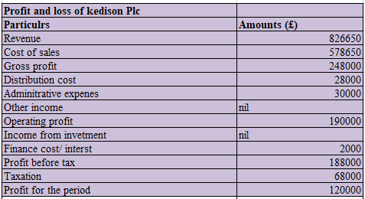
Figure 1: Income statement
(Source: self-developed)
The income statement has been prepared for 31st December 2020 in order to identify the profit for the year earned by the business. There were different types of expenses that had been identified before proceeding with the income statement. Expenses such as distribution cost, administrative expenses, taxation, and even finance cost have been evaluated for computing the income (Robinson, 2020, p.25). The business Kedision PLC is observed to be having a revenue balance of £826650 that has been earned in the respective year. Furthermore, the company has made a certain cost of sales that has been evaluated at £578650.
The gross profit is computed by deducting the value of the cost of sales made with the revenue earned during the year (Hajek and Henriques, 2017, p.139). The gross profit has been evaluated at £248000. There were certain other costs as well that have been deducted from the gross profit earned during the year. Cost such as distribution cost that has been evaluated at £28000 and administrative expenses of £30000 has been deducted in the income statement. There were no other incomes that have been identified in the business in the year 2020. The operating income after deducting all the costs with the gross profit has been computed at £190000.
The respective company has made no income from their investment during the year. Additionally, the finance cost which is also known as interest cost has been deducted from the operating profit in 2020. The finance cost is observed to be recorded at £2000 that has helped to evaluate the value of profit before business taxation. The profit of the business before such taxation has been computed for the year is recorded at £188000. However, the value of taxation paid by the business for their operation is recorded at £68000. This tax is also known as corporation tax which was estimated by the management during the computation of its income statement. The value of net profit achieved by the business on the ending date of December has been evaluated by deducting the value of tax from profit before taxation (Boeckx et al. 2017, p.279). Therefore, the net profit earned by the business at the end of its financial year is £120000.

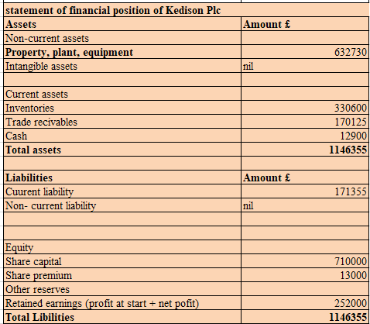
Figure 2: Financial position
(Source: self-developed)
The financial position has been computed for the business Kedisen PLC on December 31st, 2020. The motive of preparing the financial position is to identify the final value of Assets and liabilities during the year (Rengganis et al. 2019, p.1). This statement includes the important value of assets, capital, debentures, liabilities, cash, and many more items on their final value after adjustment. The organization is observed to be having their total asset from a mixture of current and noncurrent assets on December 31st. On the other hand, the business has only current liabilities and equity value as their total liabilities.
The value of assets includes non-current assets of £632730 of property, plant, and equipment. The respective businesses do not have any value for their intangible assets during the year. Furthermore, the value of the current asset includes cash balance, trade receivables, and inventories on the end date of December 31st. The value of inventory on financial position is observed to be recorded at £330600. The value of cash on the entered date is observed to be evaluated at £12900 and a trade receivable balance of £170125. The combination of current and noncurrent assets of the business is computed at £1146355 on 31st December 2020.
The liabilities of the respective business include the combination of current liabilities and equity that has been recorded in the statement of financial position. The company is observed to be having a current liability such as a trade creditor recorded at £171355. The business does not have any valuation left for its non-current liabilities as it has zero value recorded in the books of accounts. Furthermore, the company has a share capital in their equity value recorded in the books at £710000 and a share premium value of £13000. The respective organizations also have retained earnings that include the value of net profit and profit on the beginning of £252000. Therefore, the total value of liabilities is computed at £1146355 on 31st December 2020.

b.) Why does the financial position matches at the time of computation
The term financial position refers to the balance sheet that is prepared for the business at the end of its accounting year. The financial position is computed with a combination of the final value of the assets and liabilities after considering necessary adjustments on it (Omidi et al. 2019, p.25). The motive of preparing the financial position is to identify the health of a business during the period. Furthermore, it is also helpful for the investors and other stakeholders to understand the financial position and to conduct future investments in it.
The principle of double accounting or double-entry system helps to match the position of Assets and liabilities on their financial dates. According to the accounting standard, every entry has its own corresponding entry that is recorded in the other books (Kewo, 2017, p.568). This double-entry principle is responsible for the proper match of both sides of financial positions. The term balance indicates that the financial accounting must tally with each other in order to identify the correct placement of cost and evaluation of profit during a year. It is important that the balance sheet needs to be Tally as it will help the management to identify that every transaction has been placed on its corresponding sides (Anning and Adusei, 2020, p.1). The matching principle of the balance sheet can be easily understood with the help of an example. If a company has purchased machinery worth £7000 on a loan. Therefore, the entry for purchasing machinery will be recorded in two different places such as assets that will reflect the transaction. Furthermore, the value of liabilities will be increased by a similar number as the machinery has been purchased on loan. This is the major reason behind the matching of balance sheets at the end of an accounting year.

Question 2

A. Explanation of ratios

1. ROCE ratio
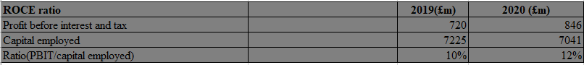
Figure 3: Computation of ratio
(Source: Self-developed)
The respective ratio leads to employed helps in the measurement of the organization named Chocco Plc has been using the capital to generate the profit.
In the above figure, the ratio has been presented of two years, as the profit before tax and interest in the year of 2019 amounts to £720 and the year of 2020 the profit before tax and the interest amounts to £846. The capital employed of the year amounts to £7225 for the year 2019. The employment of capital for the year 2020 amounts to £7041. The ratio which has been computed by application of the formula is 10% in the year 2019 and 12% in 2020.
The ratio of the respective year of 2019 amounts to 10% and of the 2020 is 12%. The current year ratio has been increased than the previous years which helps to analyze that the profit has increased.
The ratio of return on effective capital employed can get improved by increasing the employment of capital and by revoking the unwanted asset for the business.

2. ROE ratio
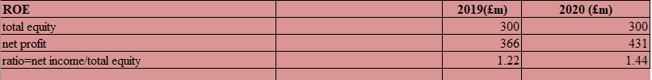
Figure 4: Computation of ratio
(Source: Self-developed)
The concept regarding return on equity ratio has led to measuring the return which has been achieved by investing in the common stocks of the organization.
In the above-stated figure, the total equity has been provided with the amount of £300 in the year 2019 and the amount of equity which has been provided for the year 2020 remains the same.
The ratio leads to get increased from the previous year of 2019 to the amount of 1.44. It has not reached up to the ideal amount which is 10%.
The ratio of return on equity can be effectively improved by increasing the price of nth services and the selling products of the organization. The reduction in the cost of labor will also lead to improving the ratio of the return on equity.

3. Earning per share
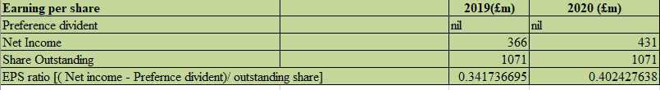
Figure 5: Computation of ratio
(Source: Self-developed)
The respect ratio regarding earning per share helps to measure the profitability of the organization and it can be calculated by dividing the net income of the company by the total amount of shares outstanding.
In the above figure, the net income of the year 2020 has been effectively identified by the amount of 431, and the profit of 2019 amounts to £366. The share which has been outstanding in the year 2019 amounts to £1071 and the share which has outstanding in the year 2020 amounts to £1071.
The ratio of the year 2020 has been increased by the amount of 0.4024 and the ratio of repective year 2019 amounts to 0.341. The net profit has also increased to the amount of £431.
It can be improved by inhering the profit of the company and decreasing the number of shares leading to an improved ratio.

4. Margin of net profit
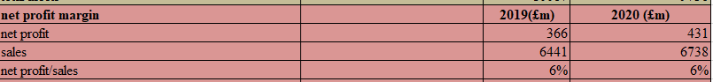
Figure 6: Computation of ratio
(Source: Self-developed)
The factors of net profit helps to stimulate the ability and the earning capacity of the business by deducting the expenses from the earned revenue of the year.
The ratio of respective year 2020 and 2019 has been presented which amounts to 6%. The net profit of the year 2019 amounts to £366. The sales of the year 2020 amount to £6738.
The ratio remains the same in both the year but the sale has been increased in the current to the amount to £6738 and in the year 2019, the amount was £6441.
The ratio of the net profit can be effectively improved by increasing the profit and by decreasing the expense in the year.

5. Assets turnover ratio
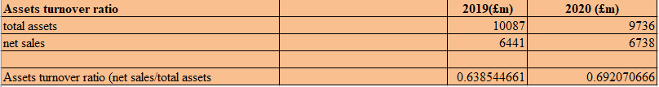
Figure 7: Computation of ratio
(Source: Self-developed)
The term regarding the turnover ratio is the matric which helps to understand the efficiency.
The ratio explained of the total assets for the year 2019 amounts to £10087. The net sale for the year 2020a amounts to £6738 and the net sale for the year 2019 amounts to £6441.
The ratio for the respective year 2020a amounts to 0.6920 which has been increased from the previous year 2019 amounts to 0.6385.
The ratio regarding assets turnover can get improved by increasing the efficiency and the liquidation of assets.

6. Stock holding days
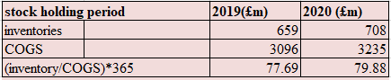
Figure 8: Computation of ratio
(Source: Self-developed)
The term of the stock holding period is defined as the holding of stock by the organization on the average basics for the business. The inventories of respective year 2020 amount to £708 and the year 2019 amounts to £659. The cost of goods sold for the year 2019 provides the amounts to £3096 and the COGS for the year of 2020 amounts to 3235.
The ratio has been increased from the previous year which amounts to 79.88 in 2020. The ratio of the year 21019 amounts to 77.69. The cost of goods sold also has been increased in the year 2020.
The ratio of stock holding days by regularly reviewing the purchase price of the organization. The reduction of the cost of inventory also leads to an improved ratio.

7. Debtor collection period
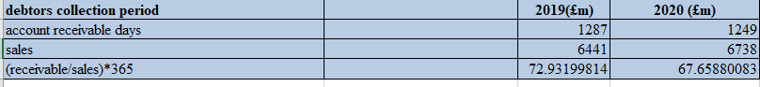
Figure 9: Computation of ratio
(Source: Self-developed)
The term of debtor’s collection has been explained as the average period which is required for the collection of money from the debtors by the company.
The days which have been involved in the year 2019 amount to £73 days and the days which are required for collecting the money are 68 days.
The days have been decreased which is a good sign for the economy as it is receiving the money in fewer days. The accounts receivable also had been increased to the amount of £6738.
The ratio of debtor’s collection period and get improved by improving the control on the stock and offering huge discounts for receiving payment.

8. Current ratio
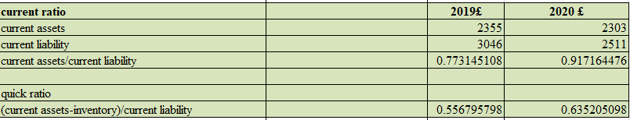
Figure 10: Computation of ratio
(Source: Self-developed)
The ratio leads to the induction for the liquidity of the company. It helps to provide information regarding the payment to its creditors.
In the figure, the current asset for the year 2020 amounts to £2303, and the assets of the year 020 amount to £2355. The ratio of respected year of 2019 amounts to £0.77314 and the ratio for the year 2020 amounts to 0.63
In the current year of 2020, the ratio has been increased. The liability has been decreased in 2020 by £2511.
The ratio leads to get improved by providing the payment to the current liabilities. The selling of all the assets which are unproductive in nature leads to an increase in the ratio.

9. Gearing ratio
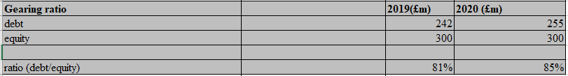
Figure 11: Computation of ratio
The ratio for the year 2019 amounts to 81% and the ratio for the year 2020 amounts to 85%. The debt of the year 2020a amounts to £255 and the debt of the year 2019 amounts to £242. The equity of the years 2020 and 2019 remains the same which amounts to £300.
The ideal ratio for gearing ratio is between 25% to 50%. The company is not in a better position as it has a higher ratio than the ideal ratio. The ratio of the following year 2020 has been inflated by 85%.
The company should decrease the ratio by selling the shares of the organization and also by payoff all the borrowing helps to improve the ratio.

10. Inverter cover ratio
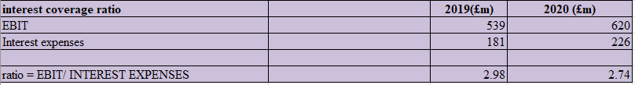
Figure 12: Computation of ratio
(Source: Self-developed)
It is termed as the deft and the profitability ratio which can easily determine the payable interest on the particular debt which is outstanding.
The ratio for the effective year 2019 amounts to 2.98 and the ratio of following year for 2020 amounts to 2.74. The EBIT of the year 2020 amounts to £620 and for the year 2019, it amounts to £539.
In the above following figure, the ratio has diminished to the amount of 2.74 from the previous year. The expenses of the interest have been increased to the amount to £266 in the year 2020.
The ratio of the inverter ratio by increasing the net operating income for the year. The decrease in the operating expenses also helps to improve the ratio further.

B. Analyze the financial position and performance
The investors lead to focus on the generation of profit by using the capital before investing in the organization. The ratio provides help for the investors as it helps to analyze the return on the employed capital (Tingbani et al. 2020, p.180). The return on equity ratio signifies the effective amount of earning done by the company for generating the return for the investment. The financial position is well established but the management has to only focus on the expenses which have to be controlled for increasing the profit earning capacity.

Conclusion
This assessment can be concluded by the importance of accounting fundamentals for running of business and computing income and expenditure. The accounting fundamentals have helped to conduct different types of financial statements and to help the business make future decisions easier. This assessment has helped to understand different types of accounting terms such as revenue, assets and liabilities, income statement, and even ratio analyses. The income statement and financial balance reflect that the business has enough capability to generate profit in the future. The respective company also has enough assets that will help them to overcome its liabilities. Furthermore, the ratio analysis reflects a positive growth of the business over the current year as they have enough capacity to generate income with the help of their sales. Therefore, it can only be recommended that both the businesses need to focus on maximizing their sales volume and reducing their cost. This will help them to overcome their business liabilities and to generate maximum profit in the long run.

References
Anning, A.A. and Adusei, M., 2020. An Analysis of Financial Statement Manipulation among Listed Manufacturing and Trading Firms in Ghana. Journal of African Business, pp.1-15.
Boeckx, J., Dossche, M. and Peersman, G., 2017. Effectiveness and transmission of the ECB's balance sheet policies. International Journal of Central Banking, 13(1), pp.297-333.
Hajek, P. and Henriques, R., 2017. Mining corporate annual reports for intelligent detection of financial statement fraud–A comparative study of machine learning methods. Knowledge-Based Systems, 128, pp.139-152.
Kewo, C.L., 2017. Does quality of financial statement affected by internal control system and internal audit?. International Journal of Economics and Financial Issues, 7(2), pp.568-573.
Omidi, M., Min, Q., Moradinaftchali, V. and Piri, M., 2019. The efficacy of predictive methods in financial statement fraud. Discrete Dynamics in Nature and Society, 2019.
Rengganis, R.M.Y.D., Sari, M.M.R., Budiasih, I.G.A.N., Wirajaya, I.G.A. and Suprasto, H.B., 2019. The fraud diamond: element in detecting financial statement of fraud. International research journal of management, IT and social sciences, 6(3), pp.1-10.
Robinson, T.R., 2020. International financial statement analysis. John Wiley & Sons.
Tingbani, I., Tauringana, V., Damoah, I.S. and Sha'ven, W.B., 2020. Working capital management and financial performance of UK listed firms: a contingency approach. International Journal of Banking, Accounting and Finance, 11(2), pp.173-201.

Bibliography
Elsayed, M. and Elshandidy, T., 2020. Do narrative-related disclosures predict corporate failure? Evidence from UK non-financial publicly quoted firms. International Review of Financial Analysis, 71, p.101555.
Kliestik, T., Valaskova, K., Lazaroiu, G., Kovacova, M. and Vrbka, J., 2020. Remaining financially healthy and competitive: The role of financial predictors. Journal of Competitiveness, 12(1), p.74.
Lea, R., 2019. The UK as a place to do business: still very highly regarded internationally. Arbuthnot Banking Group, 4.
Valaskova, K., Kliestik, T., Svabova, L. and Adamko, P., 2018. Financial risk measurement and prediction modelling for sustainable development of business entities using regression analysis. Sustainability, 10(7), p.2144.

