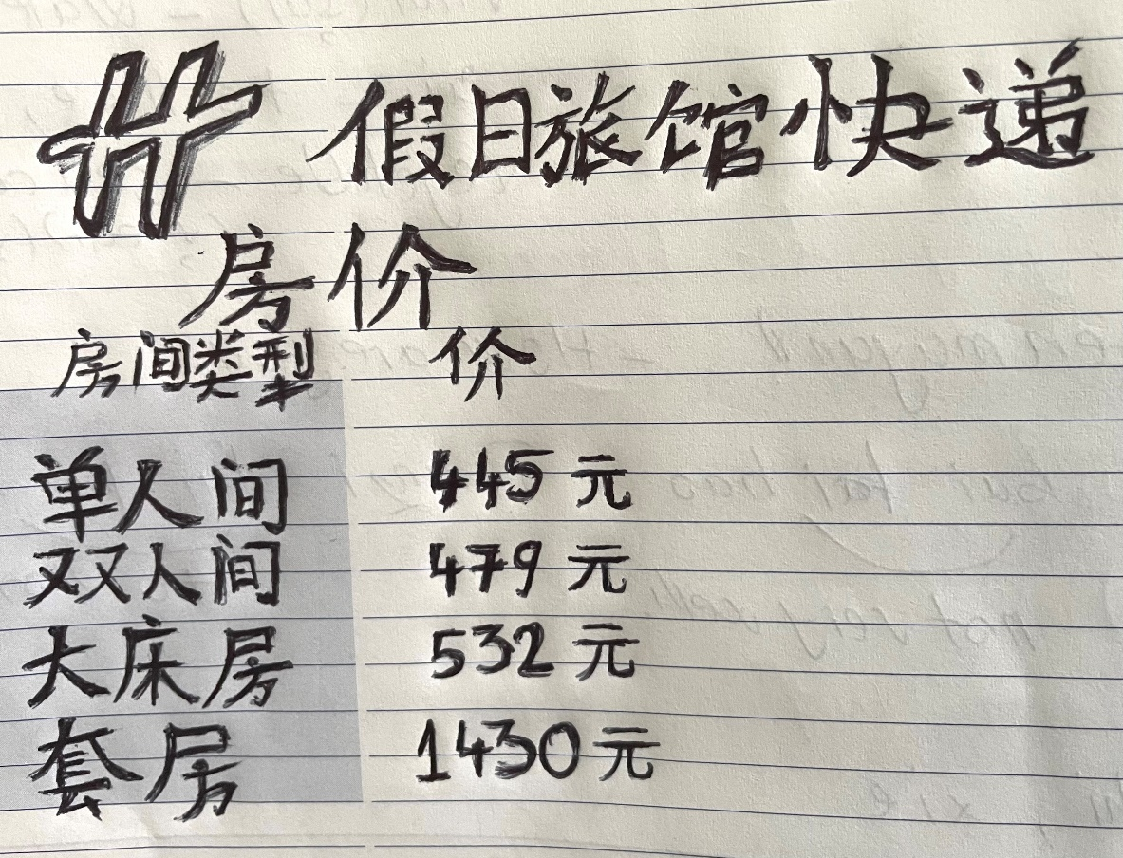
Hotel Display Board

Student: Gabriela Topala / Student Number: 1908808
Module: Foreign Language & Cultural awareness (BMIH5003)
Lecturer: Jinping Li

