Hand rendered draft - block repeat tile
This example has been drafted as a series of motifs in a block, repeated out side by side as a straight block, the original tile has been cut through as a seamless block.
Draft: the first version of a design (not finished, but has the bones to become a finished outcome)

These pattern types can work well in a block repeat system, but are not limited to this method of repeat. Abstract, Check, Chevron, Ditsy, Floral, Geometric, Ogee, Scattered, Spot, Stripe, Trellis.

You can draft out a block repeat within the framework of a square or rectangle, something like this…

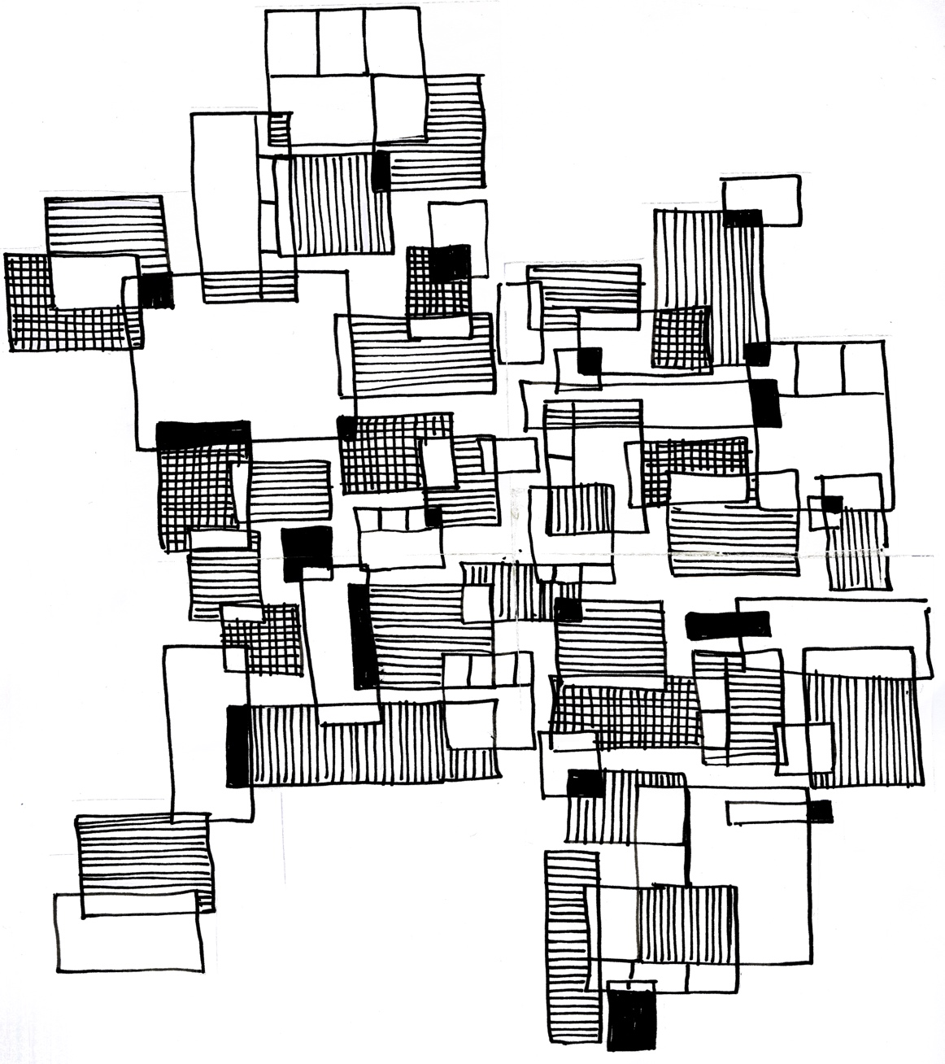

Hand rendered cut through tile (tile has been cut through so that it jigsaws seamlessly into itself on each opposite side).

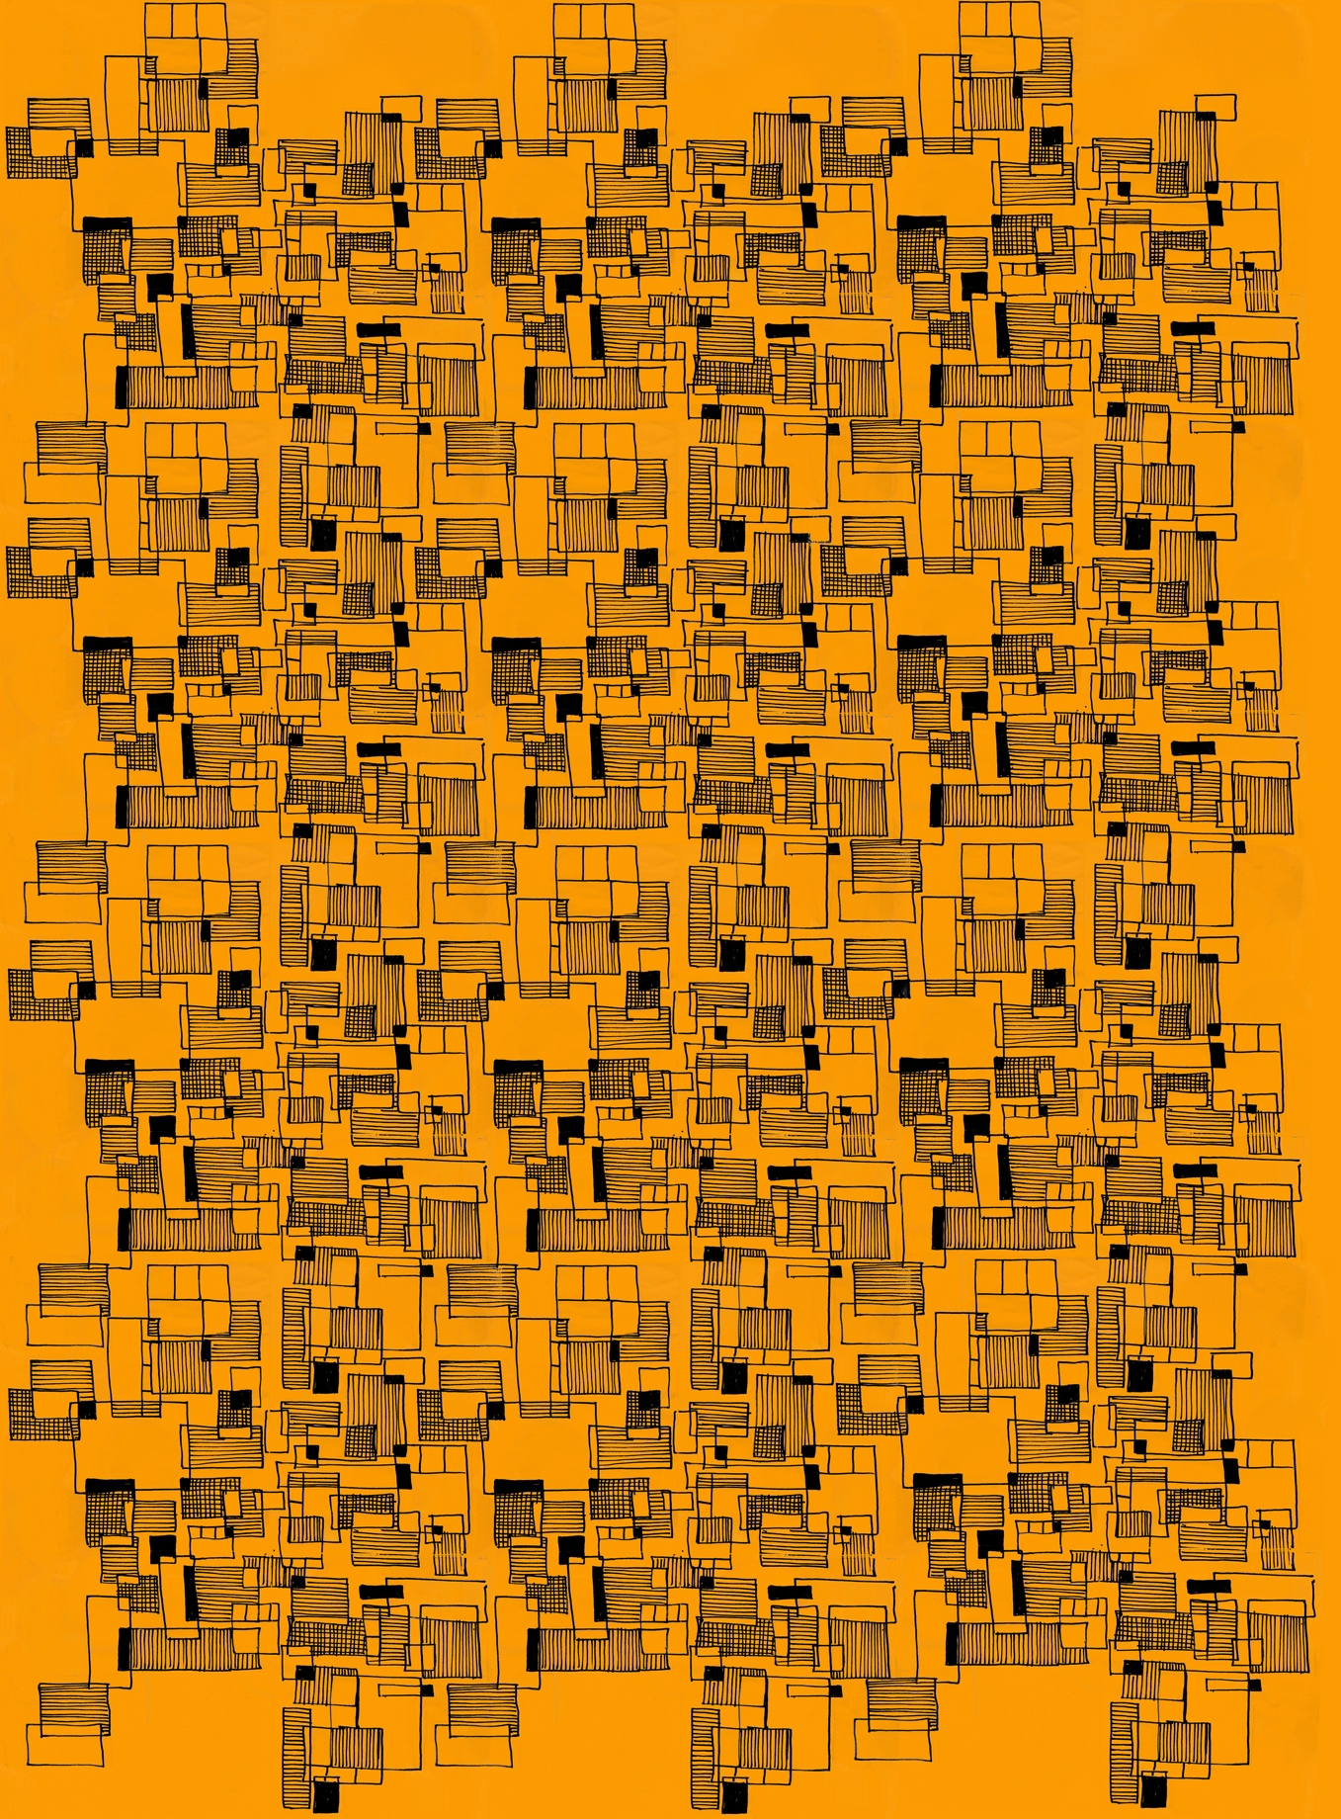
Tile repeated out and digitally coloured (note the obvious track lines, this tile needs more work)

