

BMSW5104
Managing Projects in the Organisation

Surname: Gazepov
Forename: Ivo
Banner ID: 2133589
Course Lecture: Alfred Mensah
Assignment Title: Managing Projects in the Organisation (Onsite Canteen)
TABLE OF CONTENT
Executive Summary 3
Introduction 4
Project Initiation 5
Project Planning 7
Project Execution 13
Project Closure 16
Conclusion 17
Reference List 18
Appendix 20

Executive Summary
Project management is a process that involves utilizing information, skills, tools, and procedures to meet project requirements. It is based on governance, which addresses five fundamental questions. The project aims to establish a fully operational onsite canteen, hire suitable individuals, create a varied cuisine, and establish a feedback system to continually enhance services. Stakeholders include external suppliers, cleaning staff, office staff, factory workers, HR, finance, local government officials, health and safety regulators, CEO, senior management team, and employee union representatives.
Project risk management is crucial for decisions on actions to be included in the project plan, addressing potential risks such as scope, cost, schedule, and client satisfaction. Risk identification involves understanding market demand, financial performance, operational efficiency, regulatory compliance, and supplier relationships. A project budget is allocated within a defined timeframe to achieve objectives. Key stakeholders, such as High Interest and High Power, need to be engaged to steer change.
Quality assurance documentation is essential for maintaining consistency, reliability, and compliance with regulations. Common types of quality assurance documentation include Food Safety Plans, Standard Operating Procedures (SOPs), Menu Specifications, Supplier Records, Equipment Maintenance Records, Temperature Logs, Staff Training Records, Pest Control Records, and Incident Reports. Issue logs help identify, document, prioritize, and resolve problems, ensuring the successful completion of the project.
A precise project closure strategy ensures the smooth transfer of the solution to the customer or end-user, mitigating potential hazards, enhancing customer contentment, and aligning all stakeholders. The project closure process consists of six sequential steps: obtaining customer approval, verifying deliverable installation, verifying documentation, obtaining final report approval, performing a post-implementation audit, and commemorating the achievement.

Introduction
The purpose of this project management report is to provide an overview of the implementation strategy for an onsite canteen.

Reducing the number of employees that leave the premises during their lunch break, which is presently causing problems, contributing to the development of a healthy lifestyle among employees, which the business considers to be a component of their corporate social responsibility, will also result in a reduction in employee absenteeism.

This report discusses a variety of topics, including the scope of the project, its goals, the parties involved, the budget, risk management, and the implementation timetable. The project will guarantee the effective installation and operation of the onsite canteen by using a strategy that is properly organised.

Project Initiation
The application of information, skills, tools, and procedures to aspects of a project in order to fulfil the requirements of the project is what we mean when we talk about project management.
Project management encompasses a collective framework of beliefs, rules, methods, and strategies - known as governance - that the project management team, not just the project manager, use to achieve a successful project outcome.
Governance is important in addressing five fundamental but crucial inquiries that must be resolved, comprehended, recorded, and endorsed by the project authorities, not only at the project's inception but also during its duration. (Roberts, 2011)
Project management involves the use and integration of defined project management techniques in an appropriate way. Organisations may achieve efficient and successful project execution by using project management techniques (Project Management Institute, 2017, p.10).
Scope
Establishing a fully operational onsite canteen on the grounds of the organisation with complete functioning capabilities. Hiring suitable individuals to work in the canteen, including chefs, cooks, and those who serve customers. (Armstrong, 2006, p.92).
Creating a cuisine that is not only wholesome but also varied and accommodating to a variety of dietary requirements. A system for ordering, preparing, and serving meals is being put into place, ensuring that all rules pertaining to health and safety are followed.
In order to continually enhance the services provided by the canteen, a feedback system will be established. The construction of a new building will not be included in the scope of the project. Rather than that, it will make use of a place that is already there inside the organisation. (Project Management Institute, 2017, p.131).

Stakeholders In Our Project

- External Suppliers
- Cleaning Staff
- Office Staff
- Factory Workers
- HR Department
- Finance Department
- Local Government Officials
- Health and Safety Regulators
- CEO
- Senior Management Team
- Employee Union Representatives

Project Planning
Work Breakdown Structure
A Work Breakdown Structure (WBS) is a hierarchical breakdown of project tasks to achieve goals and produce deliverables. It provides structure and outlines the project's extent, with each lower level providing a more specific explanation of the task. The WBS is divided into Work Packages, which are defined in two distinct ways. Work Packages are the most basic level, where cost and schedule can be accurately estimated. The specificity of Work Packages varies depending on the project's magnitude and complexity. The WBS encompasses both internal and external outputs (Norman, Brotherton and Fried, 2008).
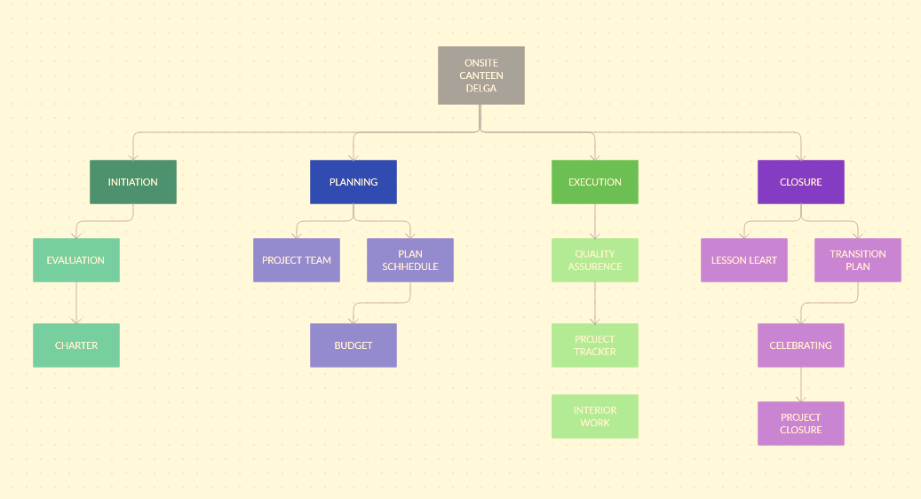

Gantt Chart
A Gantt chart provides a concise and efficient visual representation of planned activities and their corresponding timelines. It measures the passage of time on the horizontal axis. The y-axis displays a comprehensive list of all the project tasks, including their respective start and conclusion dates, as well as the necessary resources. (Albrecht, 2018)

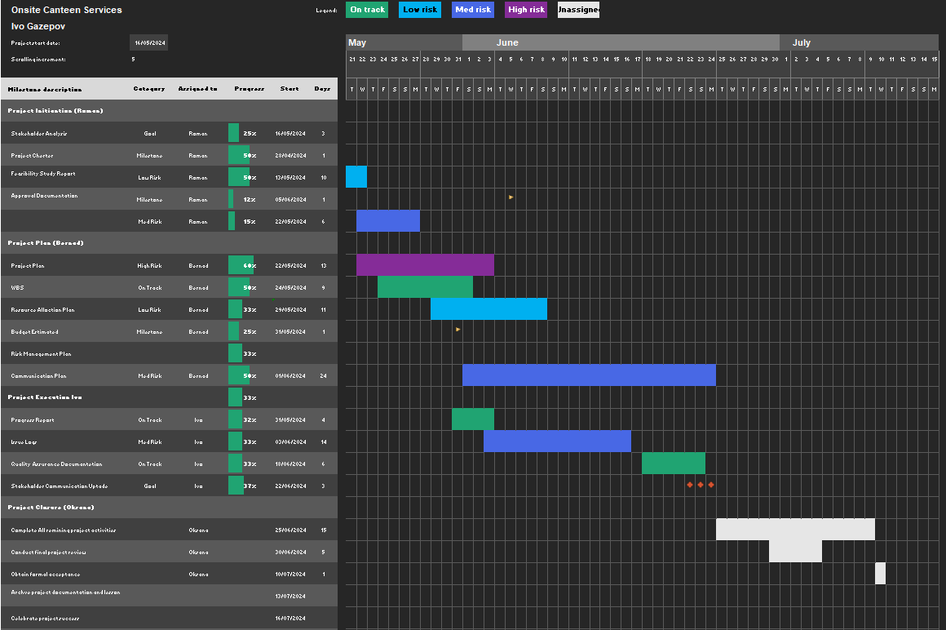

Risk Management
Project risk management is a crucial aspect of project planning, aiming to manage and mitigate potential risks that could impact a project's success. These risks include scope, cost, schedule, and client satisfaction, as well as health, safety, and environmental risks. The critical chain approach streamlines traditional risk management by focusing on exceptional hazards.

High impact refers to anything that has the potential to cause client or project team dissatisfaction by surpassing the project buffer in terms of schedule or cost. Moderate impact impacts require the utilisation of all feeding buffers or two-thirds of the project buffers. Conversely, low impact consequences do not surpass one-third of the project schedule or cost buffers and do not pose substantial concerns to the client or project team. (Leach and Ebrary, 2005)
Risk Identification
The market demand encompasses the level of demand for a product or service in the market. The financial aspect refers to the financial performance and stability of a company.
The operational aspect relates to the efficiency and effectiveness of the company's operations. The regulatory/compliance aspect involves adhering to laws and regulations governing the industry.
The supplier/vendor aspect pertains to the relationships. (Leach and Ebrary, 2005)

Budget
A project budget is the total amount of monies allotted for a certain project during a specified time period. The goal of budget management is to efficiently control project expenses within the approved budget and effectively accomplish the specified project goals (PM4DEV, 2015).
FINANCIAL STATUS
Cash Amount | £75,000
Financed Amount | £0
Total Allotted Funds | £75,000
Funds Used to Date | £60,360
Funds Remining | £14,640
Project Funds Allotted | Funds Used To Date | Funds Remaining
Item | Category | Amount
Tile Flooring | Materials | £1,350,00
Floor Glue | Materials | £750,00
Flooring | Materials | £1,400,00
Floor Caulking | Materials | £120,00
Floor Trim | Materials | £140,00
New Cabinet | Materials | £1,250,00
Cabinet Coating | Materials | £1,200,00
Tables and Chairs | Materials | £9,800,00
Professional Kitchen Hardware | Materials | £25,000,00
Cabinet Hardware | Materials | £1,100,00
Total |  | £42,110,00
Project Funds Allotted | Funds Used To Date | Funds Remaining
Item | Category | Amount
Take Out Floring | Labour | £1,500,00
Strip Flooring Glue | Labour | £200,00
Sand Floor | Labour | £500,00
Prep Floor | Labour | £300,00
Floor Installation | Labour | £4,500,00
Floor Caulking | Labour | £250,00
Floor Trim | Labour | £500,00
Remove Old Cabinets | Labour | £450,00
Prep Cabinet Area | Labour | £50,00
Install New Cabinet | Labour | £3,000,00
Caulk Cabinet | Labour | £1,000,00
Apply Cabinet Coating | Labour | £1,000,00
Install Professional Kitchen Hardware | Labour | £5,000,00
Total |  | £18,250,00

Mendelow’s Matrix
A business must actively engage key stakeholders, such as High Interest and High Power, who have significant influence and can potentially stop change or strategy. They require focus by keeping them updated and empowered to steer change. High Interest and Low Power have an interest in the situation but have little power to influence change.
It is important to keep them updated and they have the option to collaborate with a powerful group. Individuals with low interest and high power have the potential to transition into the high interest and high-power category. However, it is crucial to ensure their satisfaction in order to prevent them from developing interest and exerting their power. Individuals with low interest and low power are unlikely to be interested in the organization's strategic direction, mostly because they lack influence or authority. (Eriksen-Coats, 2018)
Low
Interest
High

Low

Power

High

Onsite Canteen Milestones

A milestone is a predetermined target that represents the expected accomplishment of a project by a specific date. It is a future reality that is desired and pertains to a specific moment rather than a duration. A milestone anticipates the desired outcome rather than the specific process of achieving it.
The definition of a milestone is flawed as it conflates two distinct concepts: a description of the desired achievement and the event occurring when we reach that milestone. It is desirable for milestones to be seen as an inherent and seamless component of the project, with the definition of "natural" varying depending on an individual's expertise and knowledge in relevant fields. Examples of natural milestones include routine choices and deliverables that are part of the project being planned.

Project Execution
Project Tracker
We have implemented a Gantt chart and established project milestones to monitor the progress of our project. Additionally, we have developed a project tracker to improve proactive management and efficiency.
Project tracking is a crucial foundation for effectively planning, executing, and completing projects. Project managers establish explicit objectives and checkpoints to develop a plan for completing the project within the designated timeframe, while managing constraints related to finances and available resources. Project tracking provides an up-to-date assessment of a project's progress and its projected direction, enabling stakeholders, management, and team members to have a shared understanding (Timbó, 2024).
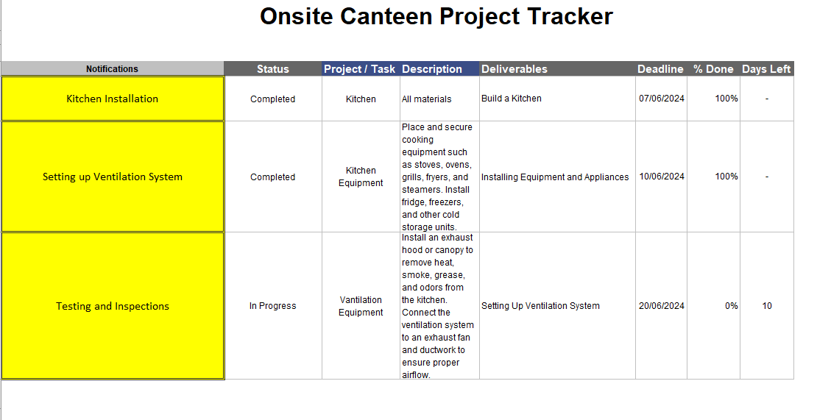

Stakeholder Communication Updates

CEO, Senior Management Team ,Employee Union Representatives

We provide weekly reports and have developed software that allows users to access live data. This software enables users to monitor the progress of our project and identify any issues that may arise.

Quality Assurance
Quality assurance documentation refers to the set of documents created and maintained by an organization to ensure that products or services meet specified quality standards. These documents are crucial for maintaining consistency, reliability, and compliance with relevant regulations or standards. Here are some common types of quality assurance documentation:
Food Safety Plan: This document outlines the canteen's food safety management system, including procedures for handling, storing, preparing, and serving food safely. It should include hazard analysis, critical control points (HACCP), sanitation procedures, and staff training records. (Byrne, 2022)
Standard Operating Procedures (SOPs): SOPs detail the step-by-step processes for various tasks performed in the canteen, such as food preparation, cleaning, sanitizing equipment, and handling foodborne illness incidents. (Byrne, 2022)
Menu Specifications: Detailed specifications for all menu items, including ingredient lists, portion sizes, cooking instructions, and allergen information. This ensures consistency in food preparation and helps manage customer dietary restrictions. (Byrne, 2022)
Supplier Records: Documentation of approved food suppliers, including contact information, product specifications, delivery schedules, and quality assurance certificates. Regular supplier audits and evaluations should also be documented. (Byrne, 2022)
Equipment Maintenance Records: Logs of equipment maintenance and repair activities, including service dates, performed tasks, and any issues identified. Regular maintenance ensures equipment operates safely and efficiently. (Manghani, 2019)
Temperature Logs: Records of food temperatures, refrigeration temperatures, and hot holding temperatures should be maintained to monitor food safety. This includes temperature checks during receiving, storage, cooking, and serving. (Manghani, 2019)
Staff Training Records: Records of staff training sessions, including topics covered, attendance, and assessments. Training should cover food safety practices, hygiene standards, customer service, and emergency procedures. (Manghani, 2019)
Pest Control Records: Documentation of pest control activities, including inspections, treatments, and corrective actions taken to prevent pest infestations. This ensures a clean and sanitary environment for food preparation. (Manghani, 2019)
Incident Reports: Records of any food safety incidents, customer complaints, or other quality-related issues, along with investigations conducted and corrective actions taken to prevent recurrence. (Manghani, 2019)

Issue Logs

Issue logs, also known as problem logs or defect logs, are documents used to track and manage issues or problems encountered during a project, process, or operation. These logs play a critical role in identifying, documenting, prioritizing, and resolving issues to ensure the successful completion of the project or the smooth operation of the process. Here's how issue logs are typically structured and utilized (Pradip, 2013).
Identification: The first stage in effectively addressing problems is to recognise them.
Issue Description: A succinct and precise explanation of the issue or problem encountered.
Reporter: The individual who reported the concern, identified by their name or function.
Severity/Priority: The severity refers to the extent of the issue's influence on the project or process, while the priority indicates the urgency with which it has to be resolved. This may be classified as low, moderate, or high severity/priority.
Status: The present condition of the matter (e.g., active, ongoing, resolved, concluded).
Assigned To: The person or group accountable for dealing with and resolving the problem.
Target Resolution Date refers to the specified deadline or target date by which the problem is expected to be resolved.

Issue Management Log
Project: |  |  |  |  |  |  | Date: 04/21/20xx
Issue | Description | Priority  (H, M, L) | Category | Reported By | Assigned To | Status | Date Resolved | Resolution/ Comments
001 |  | M | Technology | A. White | B. Brown | Closed | 2/25/xx | xx
002 |  | H | Resources | C. Black | D. Green | Open |  | xxx
003 |  | M | Resources | E. Blue | J. Doe | Closed | 4/3/xx | xxx

Project Closure
Initially, it may seem that accomplishing the first three stages of the project lifecycle would enough to conclude your project and deem it satisfactory.
Nevertheless, in the absence of a structured concluding procedure, there is a potential for important particulars to be overlooked, leading to a state of bewilderment, an ongoing project, discontented clientele, and even legal liabilities. (Lucid Content Team, 2019)
Following a well-defined project closure plan enables a seamless handover of your solution to the client or end-user. This approach ensures that the eventual beneficiaries have the requisite expertise, resources, and training to efficiently supervise and use the end product.
(Lucid Content Team, 2019)
By formally concluding a project, you mitigate potential hazards, enhance customer contentment, and guarantee alignment among all stakeholders. Put simply, project closing is an essential step that must not be overlooked. (Lucid Content Team, 2019)
Concluding the project is a standard procedure after the customer has given their approval of the completed tasks. The process consists of six sequential steps:
Obtaining customer approval of completed tasks or outputs.
Verifying the installation of all deliverables.
Verifying the presence of documentation.
Obtaining approval from the customer for the final report.
Performing the post-implementation audit.
Commemorating the achievement. (Wysocki, 2013)

Conclusion
To summarise, the accomplished execution of this project emphasises the significance of efficient communication, involvement of stakeholders, and control of potential risks. The knowledge gained from this project will influence future undertakings, and the suggestions provided will enhance the ongoing enhancement of our project management methodologies.

Reference List
Albrecht, J. (2018). Gantt Chart - an Overview | ScienceDirect Topics. [online] www.sciencedirect.com. Available at: https://www.sciencedirect.com/topics/computer-science/gantt-chart [Accessed 23 Apr. 2024].
Andersen, E.S. (2006). Milestone planning--a Different Planning Approach. [online] www.pmi.org. Available at: https://www.pmi.org/learning/library/milestone-different-planning-approach-7635 [Accessed 25 Apr. 2024].
app.creately.com. (n.d.). Creately. [online] Available at: https://app.creately.com/d/SeNpf377vDx/edit [Accessed 18 Apr. 2024].
Armstrong, M. (2006). A Handbook of Human Resource Management Practice. 10th ed. London: Kogan Page.
Byrne, J. (2022). Quality Control VS Quality Assurance. What Is the difference? [online] Cognidox.com. Available at: https://www.cognidox.com/blog/difference-quality-control-vs-quality-assurance [Accessed 23 Apr. 2024].
Eriksen-Coats, F. (2018). What Is Mendelow’s Matrix and Why Is It Useful for Marketers? [online] Oxford College of Marketing. Available at: https://blog.oxfordcollegeofmarketing.com/2018/04/23/what-is-mendelows-matrix-and-how-is-it-useful/ [Accessed 15 Apr. 2024].
Leach, L.P. and Ebrary, I. (2005). Critical chain project management. Boston: Artech House.
Lucid Content Team (2019). 7 Steps to Nail the Project Management Closure Process | Lucidchart Blog. [online] www.lucidchart.com. Available at: https://www.lucidchart.com/blog/nailing-the-project-management-closure-process#:~:text=The%20closing%20phase%20of%20project [Accessed 19 Apr. 2024].
Manghani, K. (2019). Quality assurance: Importance of Systems and Standard Operating Procedures. Perspectives in Clinical Research, [online] 2(1), p.34. doi:https://doi.org/10.4103/2229-3485.76288.
Norman, E.S., Brotherton, S.A. and Fried, R.T. (2008). Work Breakdown Structures: the Foundation for Project Management Excellence. Hoboken, N.J.: John Wiley & Sons.
PM4DEV (2015). Project Budget Management PROJECT MANAGEMENT FOR DEVELOPMENT ORGANIZATIONS pm4dev, 2015 -management for Development Series ©. [online] Available at: https://www.pm4dev.com/resources/free-e-books/2-project-budget-management/file.html [Accessed 21 Apr. 2024].
Pradip, P. (2013). What Is an Issue Log? [online] Simplilearn.com. Available at: https://www.simplilearn.com/issue-log-concepts-article [Accessed 15 Mar. 2024].
Project Management Institute (2017). A Guide to the Project Management Body of Knowledge (PMBOK guide). 6th ed. Newtown Square, Pennsylvania: Project Management Institute, Project Management Institute.
Roberts, P. (2011). Effective Project Management. London, Uk ; Philadelphia, Pa: Kogan Page.
Timbó, R. (2024). 7 Strategies for Effective Project Management Tracking. [online] www.revelo.com. Available at: https://www.revelo.com/blog/project-tracking [Accessed 24 Apr. 2024].
Wysocki, R.K. (2013). Effective Project Management: Traditional, Agile, Extreme. 7th ed. Wiley-Blackwell.

Appendix
Presentation Part


