Damian Thomas
Damian.thomas@vale.com
Group Project
A reflective report about the new Planning Process implemented at Vale Clydach.
team for the improvement of Maintenance Planning & Scheduling
M5X00400
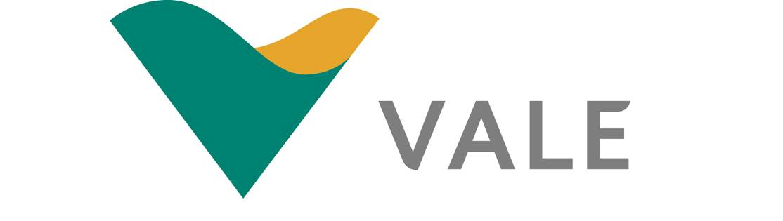

Summary.
This report is a reflective piece of writing that looks at a project that I took part in. A team was created with the objective of updating and improving the planning and execution procedures within Vale Clydach, as they had not been reviewed in over 15 years. This team was created by the Head of Plant who asked that we research new procedures that would be suitable to implement within our company.
We had a new set of procedures provided to us by the Headquarters in Brazil. This was a 120-page document covering many of the in-scope items given to us by the Head of Plant. This allowed for us to spend more time researching other in-scope items such as reviewing the working times. With the result that although team members had sufficient working hours, supervisors were already working at least an extra half hour a day by starting early or finishing late, they would later record this as lieu time. We obtained agreement from the Head of Plant for them to be remunerated for the extra hours worked.
Since this project has been completed, a number our recommendations have been implemented. A new role named the ‘Scheduler’ has been created to schedule all of the work provided to them by the planner. This was originally a task completed by planners however, we found that their workload was already too much to complete during their contracted hours. A new planning office has been prepared for the planners, the scheduler and the apprentice to move into.

Contents.
Summary. ii
Table of Figures 1
Abbreviations. 1
Introduction. 1
1.0 Report. 2
1.1 Planning 2
1.2 Teamwork/Communication 5
1.3 Management. 8
1.4 Motivation. 10
2.0 Conclusion/Recommendation. 12
References. 14
Appendices. 15

Table of Figures
Figure 1 – Team Project Fishbone Diagram. 3
Figure 2 – Gantt Chart 4
Figure 3 – Belbin Team Roles (University of Cambridge, 2016). 5

Table 1 – Table of Project Members. 1
Table 2 – Table of items to Review. 4
Table 3 – Belbin for Project Members. 6
Table 4 – Belbin Table Indicators. 7
Table 5 – Table of Proposals. 12

Abbreviations.
Abbreviation. | Meaning
PPP | Powder & Pellet Plant
CIE | Central Instrumentation Engineering
MTS | Maintenance Training Support
CMMS | Computerised Maintenance Management System
NA | North Atlantic
WM | Work Management
SWOT | Strengths, Weaknesses, Opportunities, Threats
MS | Microsoft
BOM’s | Bill Of Materials

Introduction.

I began in September 2019 as an Apprentice Planner at Vale Clydach, where nickel pellets and powder are made using Carbonyl gas in a process created by Ludwig Mond. During the first few weeks in this position, I was asked to become part of a project that will directly impact my role and others within the company in the future.
The table below shows the team members:
Table 1 – Table of Project Members.
The original team was created by the Head of Plant and conveyed via a PowerPoint presentation (Appendix 1). The purpose was to review the current maintenance planning and scheduling to identify any shortfalls and recommend improvements to the system.
This report concentrates on four main areas:
Planning, Motivation, Teamwork/Communication and Management.
The team attended a weekly meeting lasting a minimum of one hour over a four-month period.

Report.

Planning
The project planning stages began early on to give the team direction. The Apprentice Planner was not invited to the first meeting due to just starting at the company; however, minutes of the meeting were taken (Appendix 2).
During this meeting, the Head of Plant appointed the Engineering Systems Supervisor and Instrumental/Electrical Supervisor as team leaders after outlining the desired outcomes from the team which were to streamline and update the current planning process as it had not been reviewed in over 15 years and was insufficient for current industry requirements.
As a part of this meeting, an Ishikawa diagram, was created so that the root cause of many of the problems on this plant could be seen. First developed by Kauro Ishikawa and also known as the fishbone diagram,
“The Fishbone Diagram enables teams to consider why a problem has occurred and search for the root causes”
Cox & Sandberg [1]
Cox & Sandberg [1] breaks down the four main steps to utilise a fishbone diagram, listed below:
- Define the Problem.
- Add major cause categories.
- Brainstorm causes.
- Keep asking why.

Using these steps, it was found that the Planning and Execution were the causes, mainly planning as the execution cannot be conducted until the plan is in place. The Fishbone diagram created is shown in Figure 1 below:
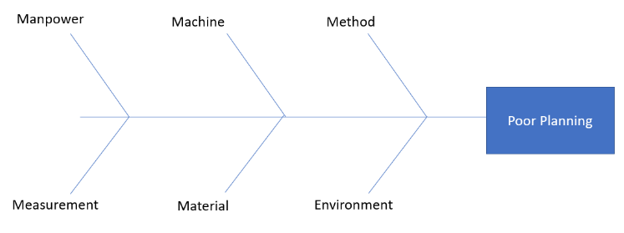
Figure 1 – Team Project Fishbone Diagram.
Problem solving is key in the planning stages of this project. Complex problem solving allows for a project plan to stay on track and for goals to be met. Eichmann, et al. [2] defines it as the ‘ability to solve complex problems is an essential competance in both education and in everyday life’ and also states that ‘planning cannot be observed’ but is ‘inferred from behaviour’ suggesting planning may not be directly seen or praised by supervisors, but is vital to the outcomes of a project.
“In the absence of strategy, there is no reason to engage in formalized strategic planning”
Mintzberg [3]
This statement suggests that without a method already in place, the planning process cannot begin Mintzberg [3] also states that a plan has two purposes; media for communication and as a device for control.
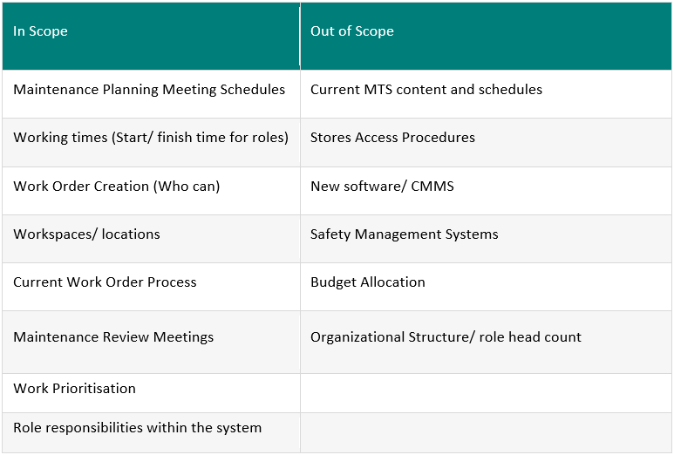
During the planning stage of this team, we discussed the original Powerpoint expanding on outcomes within the remit. The main target of the review was to agree a new and updated set of planning procedures, whilst also considering the execution. On the powerpoint, the review had some items that were ‘in scope’, items to be reviewed and agreed upon, shown below:
Table 2 – Table of items to Review.
Also contained are out of scope items, not as important but should be considered for any further teams taking on a similar project.
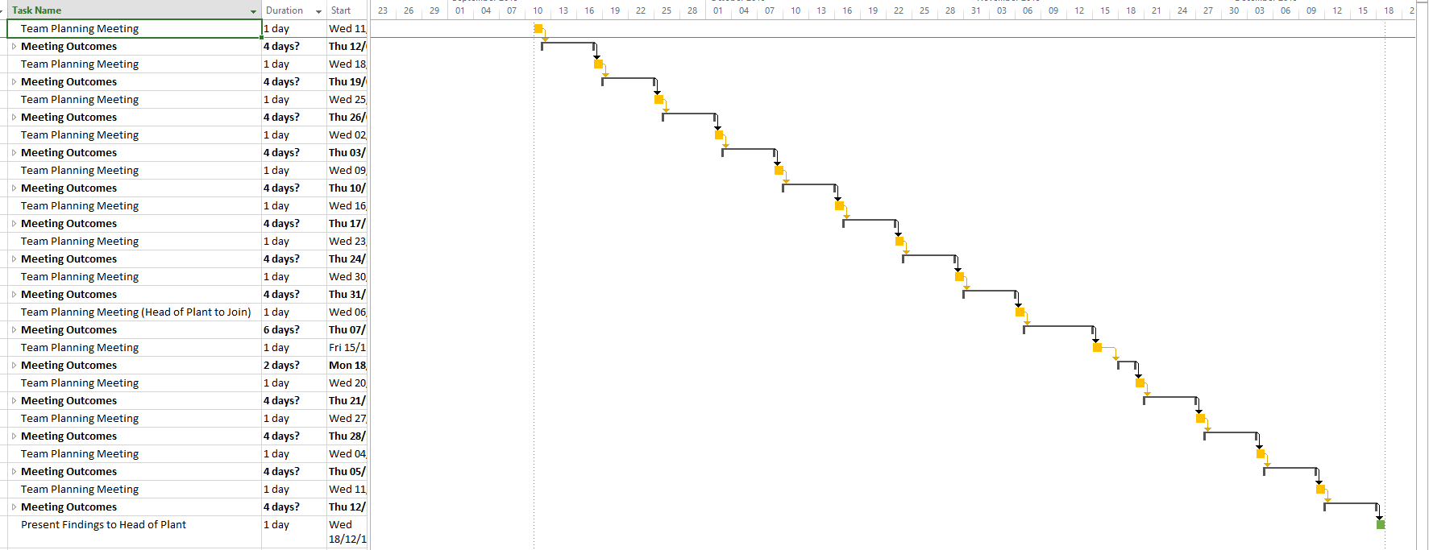
Using these outcomes, a Gantt Chart was created (figure 2) tracking the project progress, to be updated with any new or additional targets not previously considered.
Figure 2 – Gantt Chart
Due to the size of the Gantt chart, only the general headings have been shown above. However, the full Gantt chart has been shown in Appendix 3. To differentiate between the meetings and the outcomes, the colors have been changed so that each can be clearly seen. The final task has been highlighted in green to indicate the end of the project.

Teamwork/Communication
Teamwork and communication were a significant aspect within this project. All individuals who would be directly impacted by the outcomes of this project were involved in its development. Table 1 lists every regular member of the team and their role within the company.
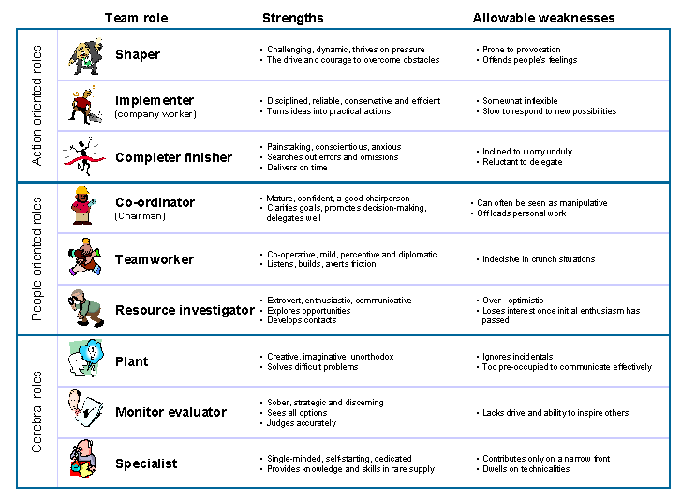
The project involved team members with a variety of roles throughout the company and each wanted the best for their areas and process. Communication and teamwork became vital and had to be considered carefully.
There are nine Belbin roles that have been summarised and shown in Figure 3 below:
Figure 3 – Belbin Team Roles [4].
University of Cambridge [4] explains that the Belbin roles were first developed by Meredith Belbin in 1981 and were ‘designed to define and predict potential success of management teams’. Each role can be put into one of three groups. The first group is ‘Action Orientated’, for a person who wants to get things done. The second group is ‘People Orientated’, focusing on working with others and leadership roles. The third group is ‘Cerebral’, concentrating on research and problem solving. A good team should have at least one of each role within it. However, one person can cover multiple roles.
“A group may be defined as two or more people who interact and influence another”
Sommerville & Dalziel [5]
Table 3 – Belbin for Project Members.
Most project team members have since been categorised into their most applicable Belbin role, their evaluation has been completed and shown above (Table 3). Only eight of these nine roles could be evaluated due to the questionnaire used, the self-perception inventory evaluates Implementor, Co-ordinator, Shaper, Plant, Resource Investigator, Monitor Evaluator, Team Worker and Completer Finisher but excludes the specialist role. This could be due to there being two versions of the test, the original being used to evaluate the team, uses a 56 item inventory, whereas the newer version comprises a 70 item inventory. These perception inventories are used extensively throughout the UK and are necessary for the ‘identification of particular team roles and the individual’s preponderance for the identified roles’ as noted by Sommerville & Dalziel [5].
We compared our results to the one provided in the Self Inventory Test shown below:
Table 4 – Belbin Table Indicators [20]
Comparison of these two tables identifies who is most suitable for each role. In table 3, the three or four strongest roles for each member have been highlighted in green and the highest score for each role highlighted in yellow. Unfortunately, four members of the team were unable to take part in the test. Two of the roles were not within any members top three, meaning that whoever has the highest score in those roles would have to cover it. One of the members who did not complete the test may have covered these roles. We did however have one extra person take part in the test as he attended and contributed to some meetings. In total eight people took part in the self-perception inventory.
Effective communication is extremely important within a team, so we had to ensure that communication between members of the team did not become constrained and was correctly interpreted by each member. With a limited time frame, it was significant that each meeting was used for its intended purpose, not resolving misunderstandings of communication. Kwiek [6] states that ‘communication is fully flexible within this constraint’.

Management.
Management was a critical aspect of this team. The members of the team considered as managers were tasked with directing each meeting and ensuring that we kept on task, with no deviation from the central topic. Although digression was sometimes useful, allowing us to consider aspects which were detrimental to the outcome of the team.
The management members were also important for the timing aspects, as they kept track of our progression and whether we were hitting targets. A plan was developed for the duration of the team, as shown in the Gantt Chart (figure 2). Epstein & Harding [7] agree that an action plan should be developed but also state that it needs to be agreed upon by members. They note that this can promote team buiding which will ultimately help the team function better.
As a team, our final outcomes were presented to the Head of Plant, who had some input into several meetings when required, suggesting that he is Participative manager. Miah & Bird [8] explain that a participative management style is someone who “makes decisions by consensous and sets organisational goals only after all involved members are consulted and their opinions are thoroughly considered” which is why this team was originally created. Olmedo-Cifuentes & Martínez-León [9] sampled 148 employees of an accounting audit firm based in Spain and found that “strong participative management style promotes a better perception of reputation”. This agrees with Rolková & Farkašová [10] who stated “Participative management style is management style positively associated with high level of job satisfaction” at the beginning of their study. The intention of their study was to discover how employees reacted when given more opportunity to participate in high level decision making. However they found that employees did not get the chance to participate in decision making. This is why the Head of Plant asked employees from different areas to take part in this project.

Grace College [11] states that there are six types of management styles:
Autocratic – No input from subordinates.
Consultative – discusses with employees but ultimately has the final decision.
Persuasive – makes decisions based on persuasion from subordinates.
Democratic – decisions based on a majority vote.
Laissez-faire – only provides guidence and allows decisions to be made by the majority
Management by walking around – gathers information from employees that are able to stop the problem.
The Head of Plant is primarily a consultative manager as he is responsible for the entire plant and not just certain areas of it.
Both team leaders required some form of conflict management, an essential skill which when used effectively negative impacts of arguments can be minimized [12], therefore not ultimately affecting the team. Without a sufficient level of management skill, conflict could become destructive and cause problems for the team. Crouch & Yetton [13] states that “managers with good conflict management skills benefit by bringing their subordinates together” supporting the need for a high level of conflict management within a team. Summerell, et al. [14] suggests “humility is one state with the potential to reduce anger and aggression” and in their discussion wrote that “humility significantly reduced aggressive motivation as measured by explicitly aggressive items”. Indicating that any confrontation met with humility is less likely to be elevated to a more aggressive argument.

Multiple management styles should be considered within different work structures. Caramela [15] explains the structre created by Henry Mintzberg, stating that there are five organisational types:
- Simple Structure.
- Machine Bureaucracy.
- Professional Bureaucracy.
- Divisional (Diversified) Form.
- Adhocracy.
Our team worked mainly as a machine bureaucracy, each week members were given separate tasks to complete by team leaders, to be investigated and presented in later meetings. A decision on implementation would then be made as a group.

Motivation.
Motivation is a contributing factor within a team, a member without motivation to complete the goal, can only accomplish limited work. Schunk & DiBenedetto [16] writes that “Motivated actions depend heavily on expected positive consequences for performing modelled actions”. In our case the “positive consequence” was improving the planning process.
Abraham Maslow created a hierarchy of needs in 1943, identifying factors that affected the motivation of people, which has since been updated and refined in 1987. McLeod [17] has reiterated the five needs and given an explanation and examples of each:
- Physiological needs – Food, Air, Sleep, etc.
- Safety needs – Security, Stability, Order, etc.
- Love & Belongingness needs – Trust, Intimacy, Friendship, etc.
- Esteem needs – Achievements, Status, Independency, etc.
- Self-actualization needs – Personal Potential, Personal Growth, etc.
However, these needs are flexible and most behaviour is motivated by at least one or more of them.
McGregor [18] evaluates Maslows theory, providing a new perspective, calling it “Theory Y”. He states that “the motivation, the potential for development, the capacity for assuming responsibility, the readiness to direct behaviour towards organisational are all present in people” indicating that it is up to managers to encourage people to recognise these characteristics themselves.
Story, et al. [19] identifies two forms of motivation. Intrinsic motivation refers to someone motivated by internal rewards, such as work satisfaction whereas extrinsic motivation is someone motivated by external factors, such as money. This project was determined by intrinsic motivation to improve our planning process and there were no particular rewards for any member. This would lead to working time being shortened, less unnecessary expense, fewer breakdowns and nickel production would be improved.

Conclusion/Recommendation.
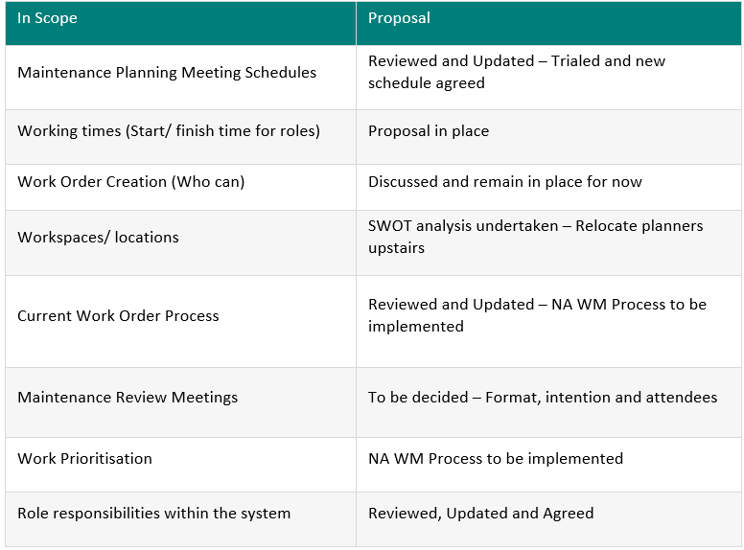
This project began in September 2019 and concluded in December 2019. There was a total of 15 meetings, which focused on the in-scope items. During this period, several aspects were investigated so that as a team, we could present a process to the Head of Plant and upper management members. We had to ensure that all aspects outlined in the original presentation were covered (Appendix 1). Our solutions for each are shown below:
Table 5 – Table of Proposals.

We suggested a three phased approach, so that all major changes could be tested individually. The full presentation has been provided as Appendix 4.
Part of phase 1 was for all planners to be relocated to one office instead of being in separate areas. A SWOT analysis (appendix 5) was created to identify the positive and negative aspects of the proposal. Ultimately, it was decided that this would have a positive affect on the planning process.
Much of Phase 2 is a set of recommendations including that meetings should be held at a time when everyone is most likely to be available and better communication when unable to attend, due to unexpected occurrances on plant. Extra items identified need further investigation and testing. For example, introducing pictures of components into the stores delivery system was investigated by our team, but not within the scope, we briefly considered it and then moved onto more important items that were within the scope.
Phase 3 is an ongoing discussion and review, from which any adjustments will be implemented when the first two are working efficiently.

References.

[1] | M. Cox and K. Sandberg, “Modeling Causal Relationships in Quality Improvement,” Current Problems in Pediatric and Adolescent Health Care, vol. 48, no. 7, pp. 182-185, July 2018.
[2] | B. Eichmann, F. Goldhammer, S. Greiff, L. Pucite and J. Naumann, “The role of planning in complex problem solving,” Computers & Education, vol. 128, pp. 1 - 12, January 2019.
[3] | H. Mintzberg, “Rethinking strategic planning part II: New roles for planners,” Long Range Planning, vol. 27, no. 3, pp. 22 - 30, 1994.
[4] | University of Cambridge, “Belbins Team Roles,” 2016. [Online]. Available: https://www.ifm.eng.cam.ac.uk/research/dmg/tools-and-techniques/belbins-team-roles/. [Accessed 22 April 2020].
[5] | J. Sommerville and S. Dalziel, “Project teambuilding—the applicability of Belbin's team-role self-perception inventory,” International Journal of Project Management, vol. 16, no. 3, pp. 165 - 171, 1998.
[6] | M. Kwiek, “Communication via intermediaries,” Games and Economic Behavior, vol. 121, pp. 190 - 203, May 2020.
[7] | A. L. Epstein and G. H. Harding, “Management styles and human resource development,” in Clinical Engineering Handbook, 2nd ed., E. IADANZA, Ed., Academic Press, 2020, pp. 308-320.
[8] | K. Miah and A. Bird, “The impact of culture on HRM styles and firm performance: evidence from Japanese parents, Japanese subsidiaries/joint ventures and South Asian local companies,” The International Journal of Human Resource Management, vol. 18, no. 5, pp. 908-923, 2007.
[9] | I. Olmedo-Cifuentes and I. Martínez-León, “Influence of management style on employee views of corporate reputation. Application to audit firms,” BRQ Business Research Quarterly, vol. 17, no. 4, pp. 223 - 241, October 2014.
[10] | M. Rolková and V. Farkašová, “The Features of Participative Management Style,” Procedia Economics and Finance, vol. 23, 2015.
[11] | Grace College, “6 Types of Management Styles,” 08 December 2016. [Online]. Available: https://online.grace.edu/news/business/types-of-management-styles/. [Accessed 24 February 2020].
[12] | J. C. Y. Chan, E. N. M. Sit and W. L. Lau, “Conflict management styles, emotional intelligence and implicit theories of personality of nursing students: A cross-sectional study,” Nurse Education Today, vol. 36, no. 6, pp. 934-939, 2013.
[13] | A. Crouch and P. Yetton, “Manager behavior, leadership style, and subordinate performance: An empirical extension of the Vroom-Yetton conflict rule,” Organizational Behavior and Human Decision Processes, vol. 39, no. 3, pp. 384 - 396, 1987.
[14] | E. Summerell, C. Harmon-Jones, T. F. Denson and E. Harmon-Jones, “Humility is associated with less aggressive motivation,” Personality and Individual Differences, vol. 158, pp. 1 - 10, 2020.
[15] | S. Caramela, “The Management Theory of Henry Mintzberg,” 27 February 2018. [Online]. Available: https://www.business.com/articles/management-theory-of-henry-mintzberg-basics/. [Accessed 18 March 2020].
[16] | D. H. Schunk and M. K. DiBenedetto, “Motivation and social cognitive theory,” Contemporary Educational Psychology, vol. 60, pp. 1 - 10, January 2020.
[17] | S. McLeod, “Maslow's Hierarchy of Needs,” 2020. [Online]. Available: https://www.simplypsychology.org/maslow.html. [Accessed 25 February 2020].
[18] | D. M. McGregor, “The Human Side of Enterprise,” in Readings in Managerial Psychology, 3rd ed., H. J. Leavitt, L. R. Pondy and D. M. Boje, Eds., The University of Chicago Press, 1960, pp. 310 - 321.
[19] | P. A. Story, J. W. Hart, M. F. Stasson and J. M. Mahoney, “Using a two-factor theory of achievement motivation to examine performance-based outcomes and self-regulatory processes,” Personality and Individual Differences, vol. 46, no. 4, pp. 391 - 395, 2008.
[20] | UWTSD Moodle, “SELF PERCEPTION INVENTORY,” February 2020. [Online]. Available: https://moodle.uwtsd.ac.uk/pluginfile.php/253266/mod_resource/content/0/SELF%20PERCEPTION%20INVENTORY.pdf. [Accessed 13 May 2020].

Appendices.
Appendix 1 – Original Power Point.
Appendix 2 – Meeting one Minutes.
Appendix 3 – Full Gantt Chart.
Appendix 4 – Outcome Presentation.
Appendix 5 – SWOT Analysis.

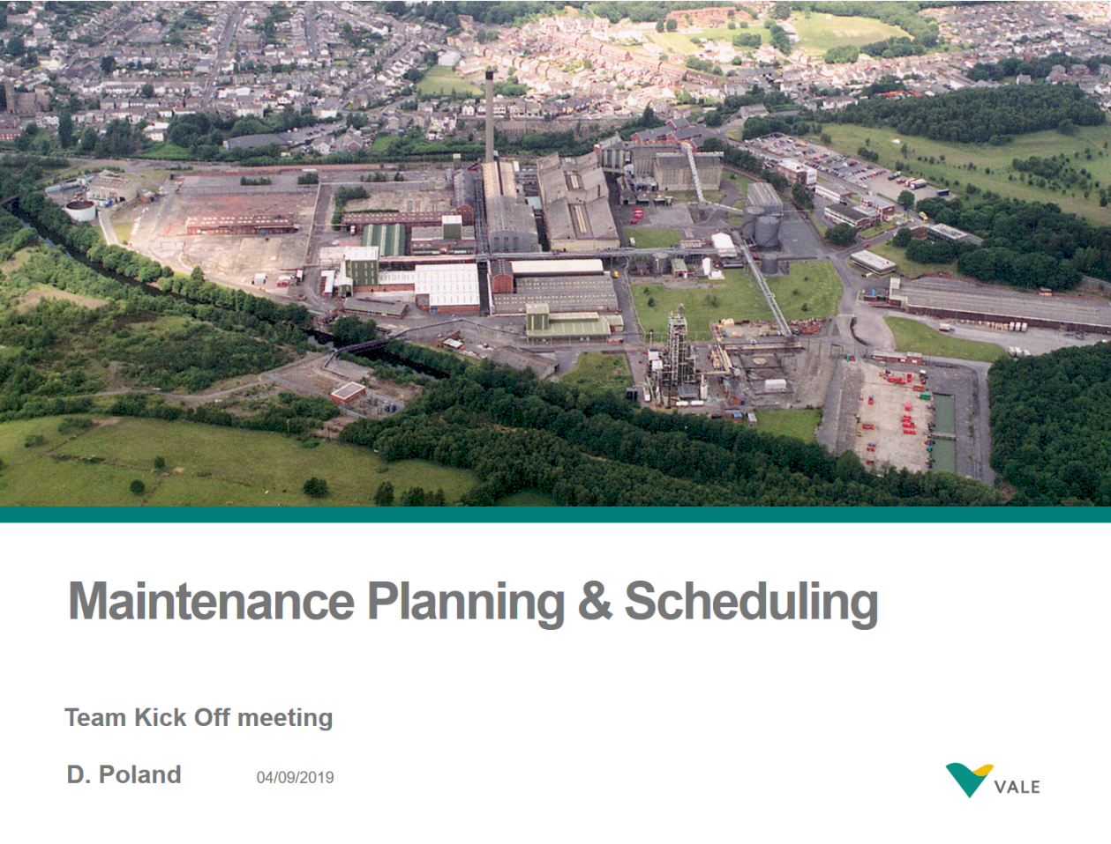
Appendix 1.
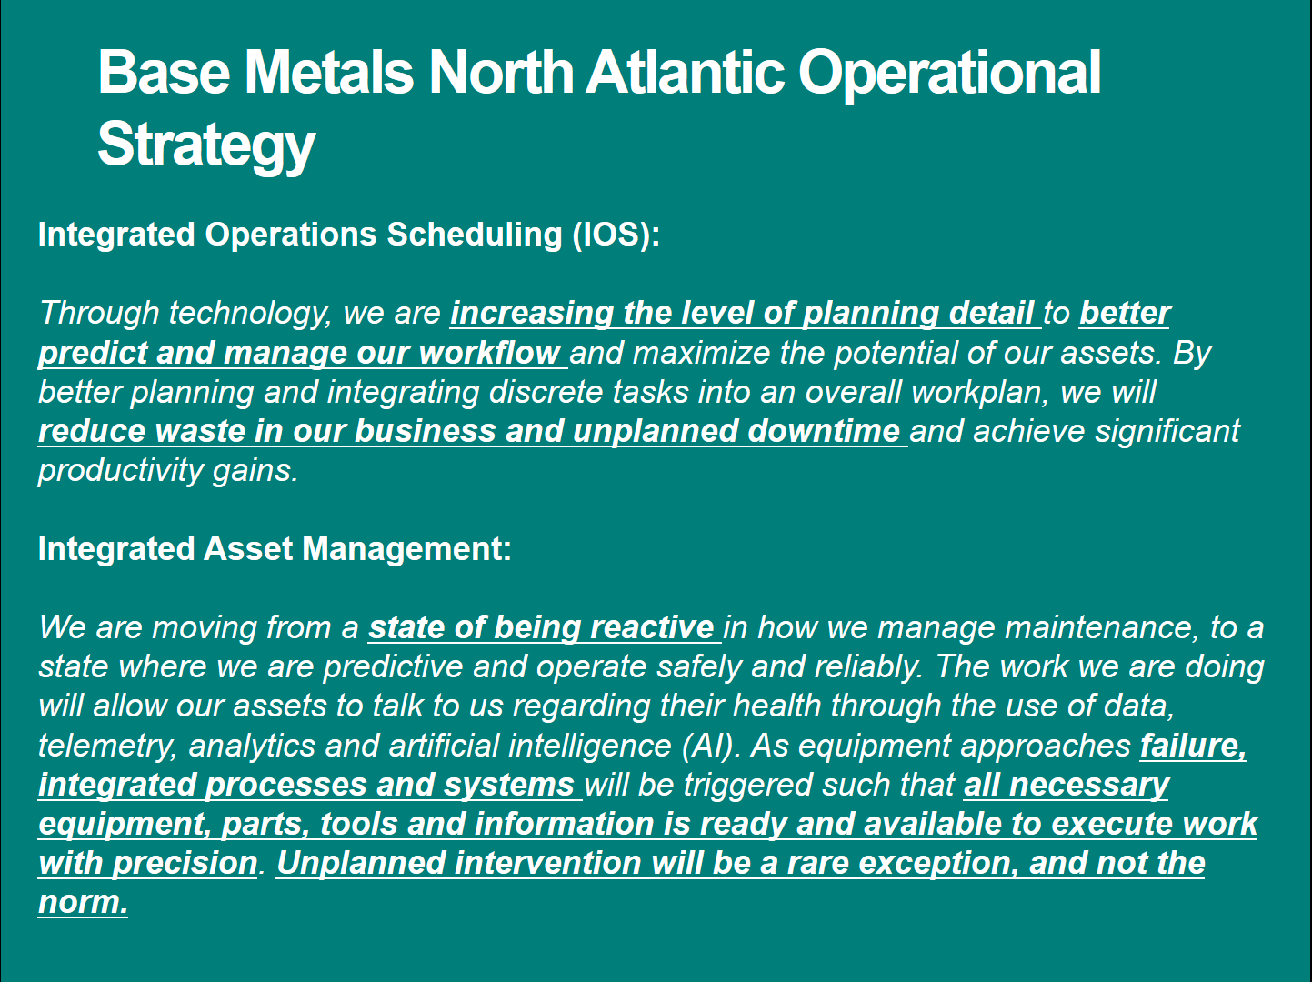
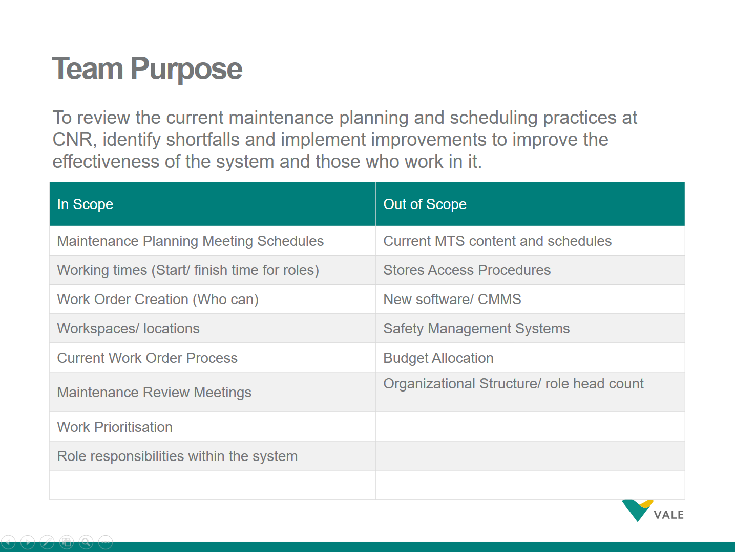
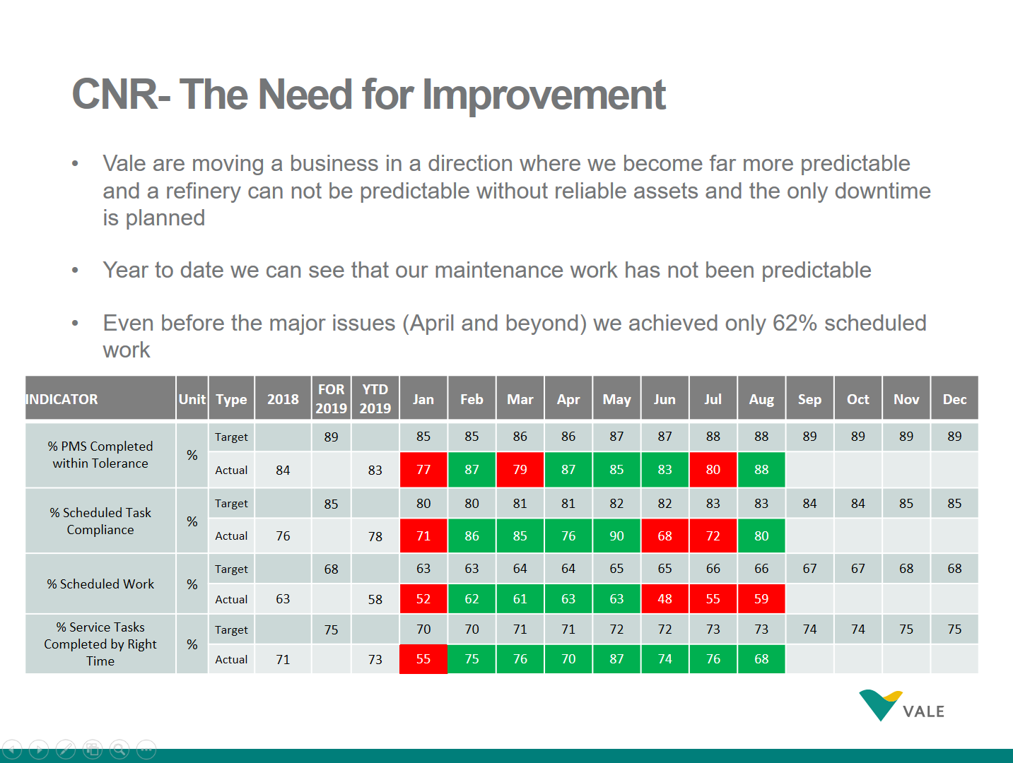
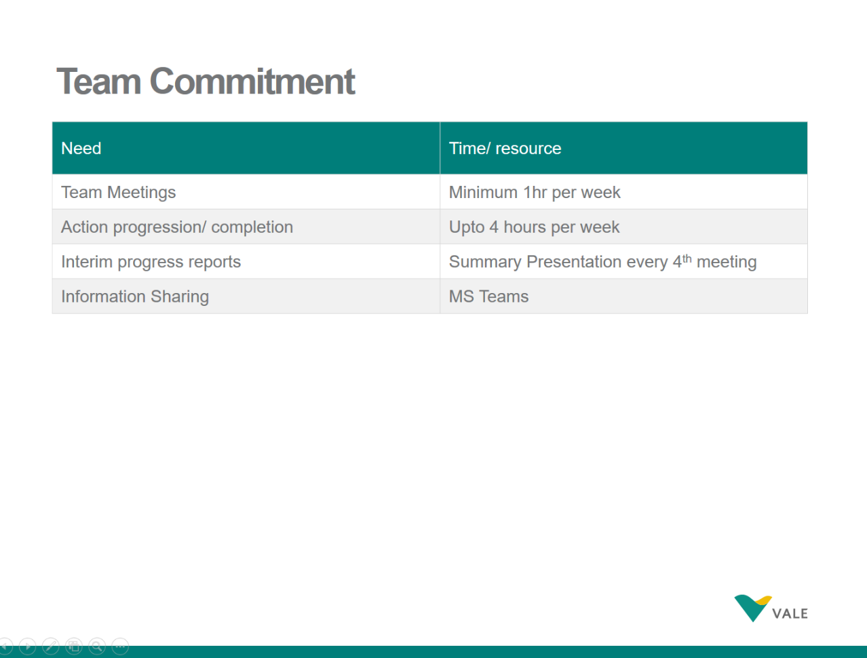
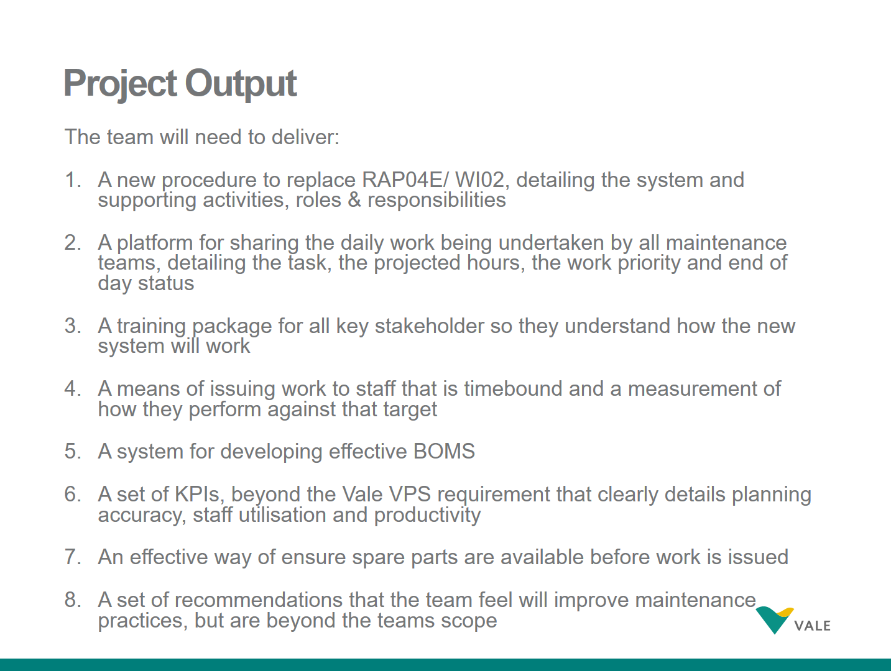

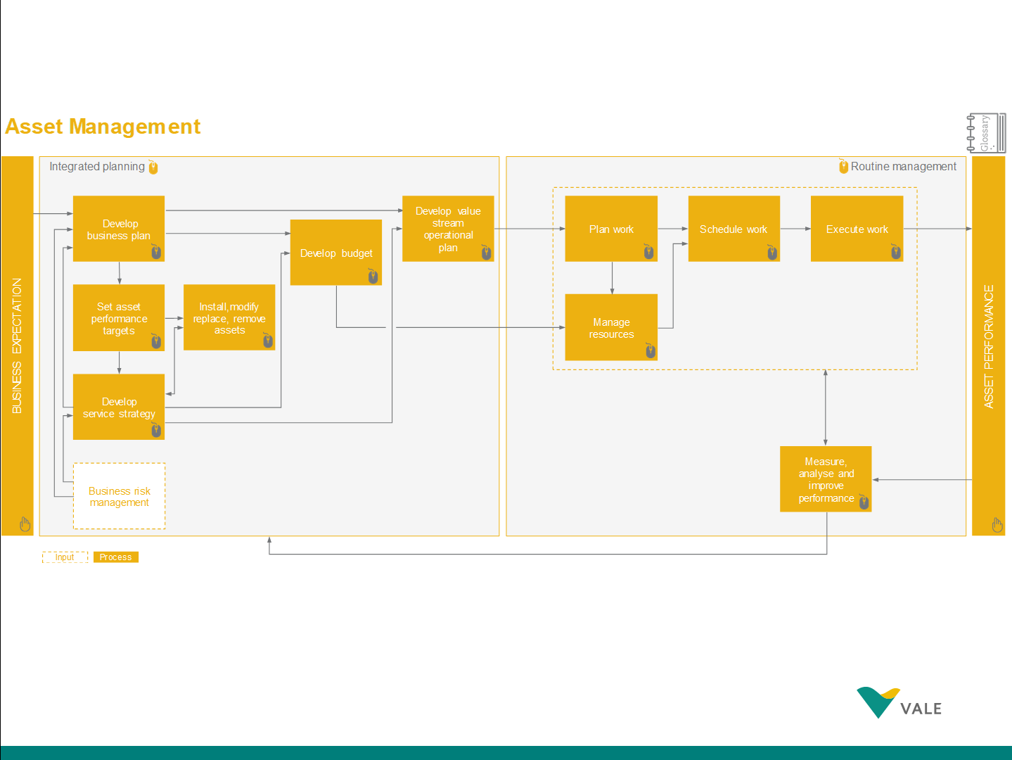
Appendix 2.
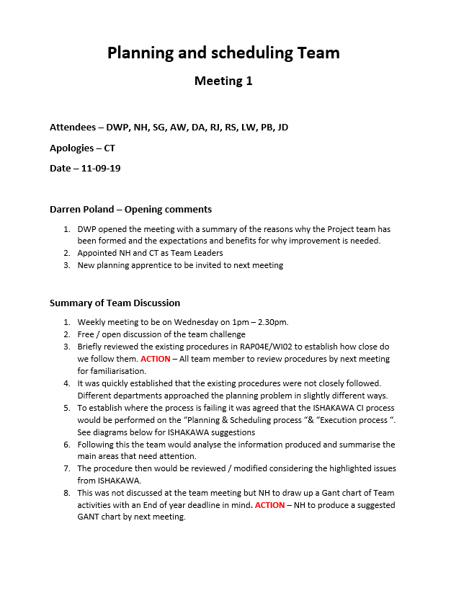
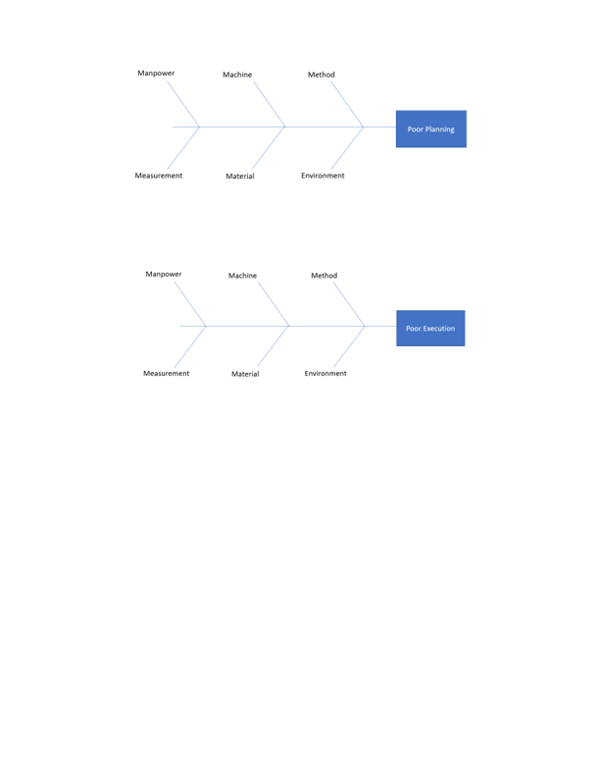

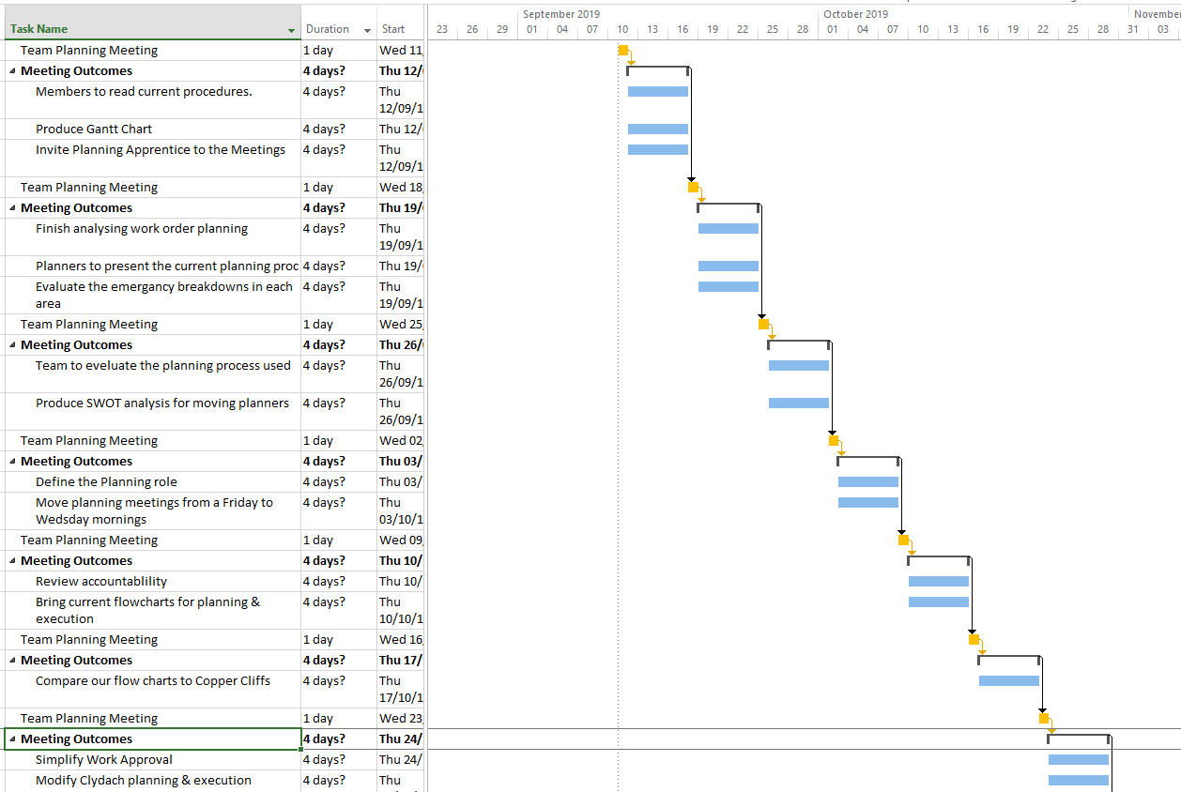
Appendix 3.
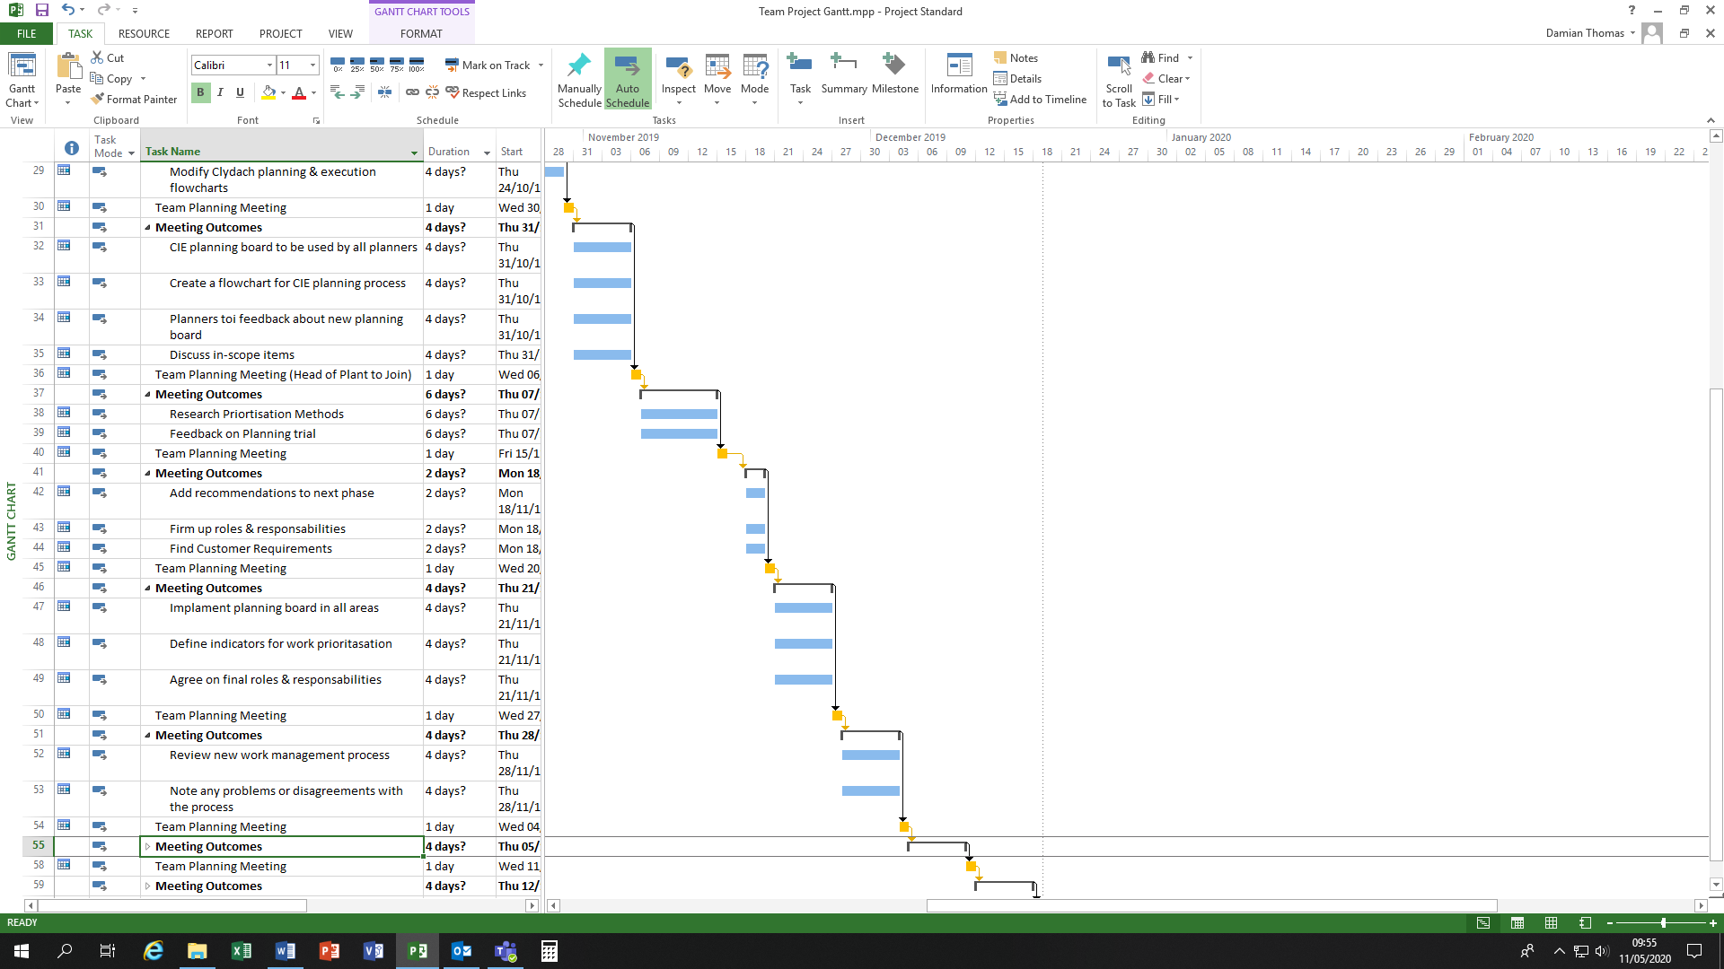

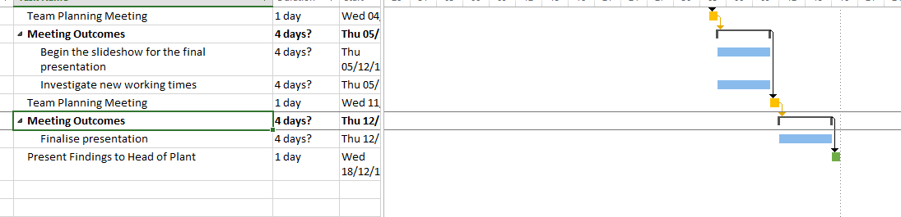
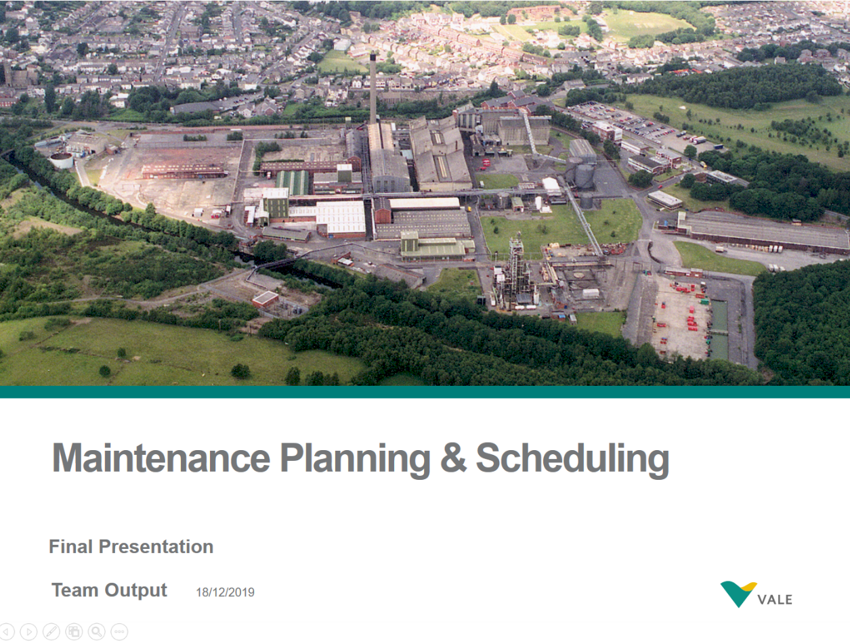
Appendix 4.
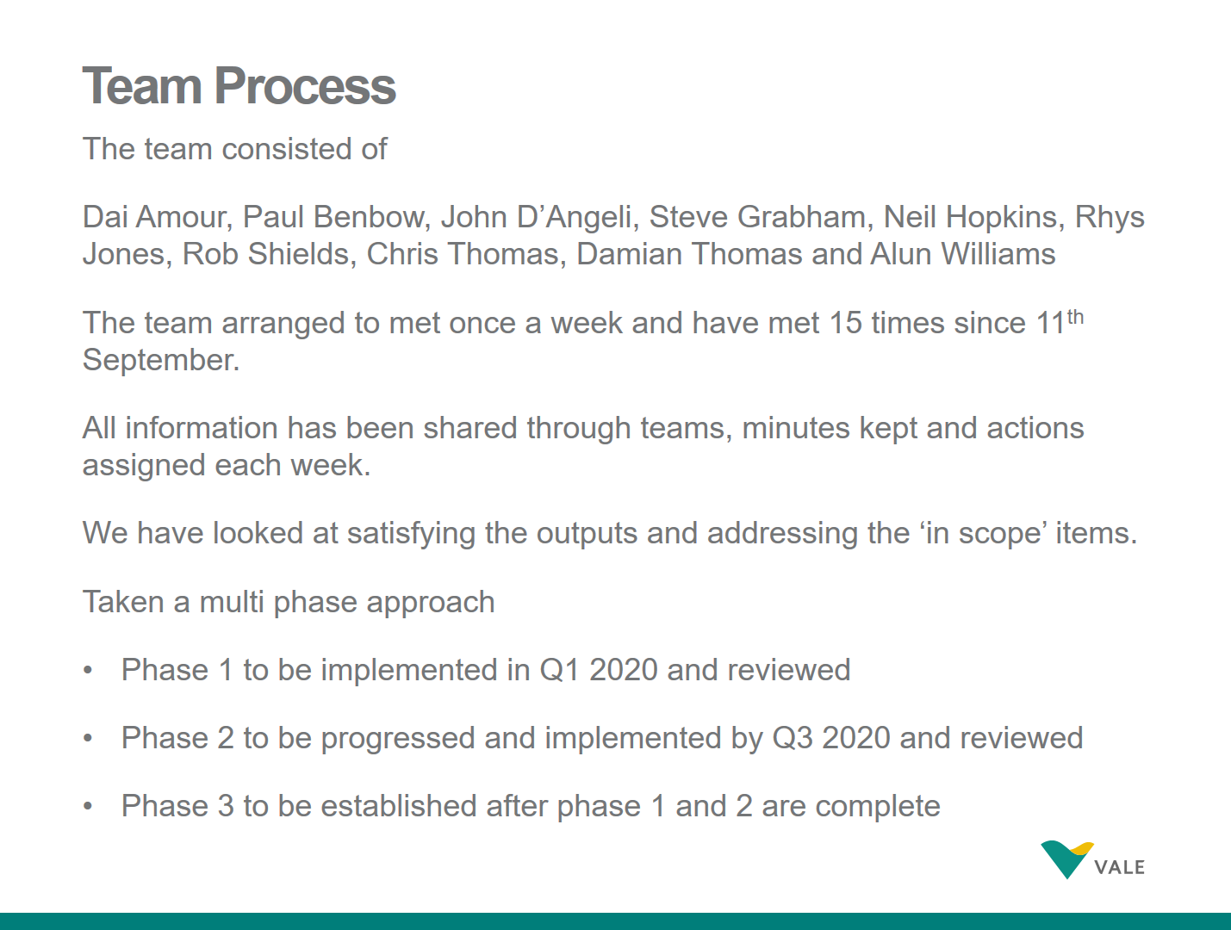
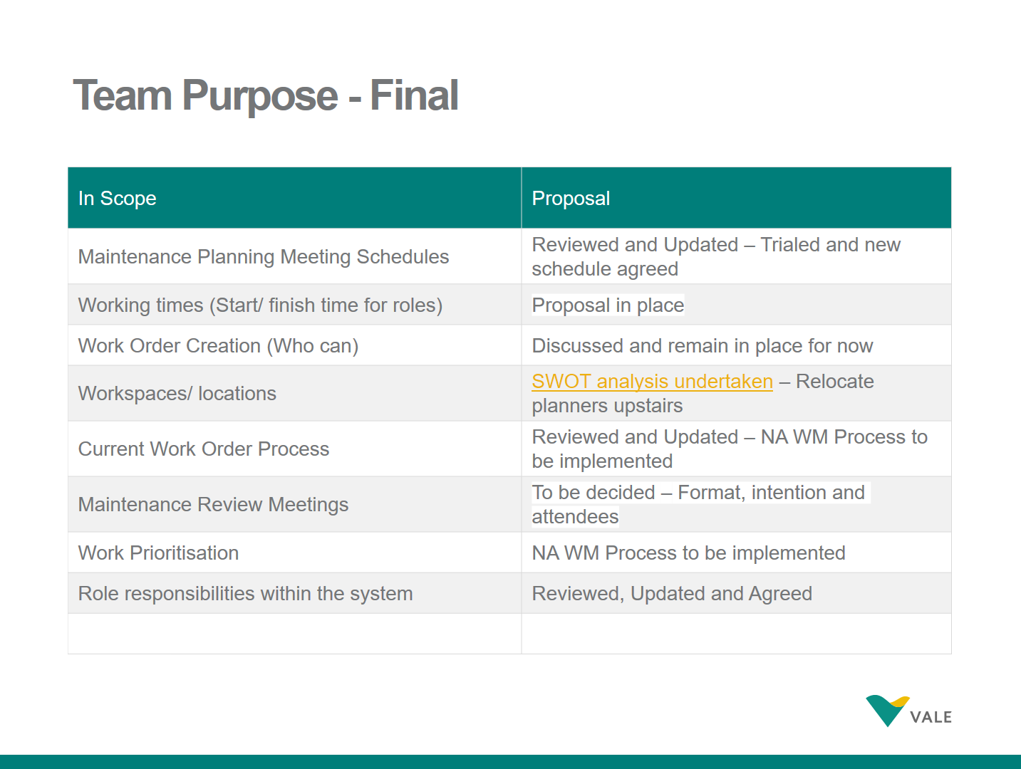
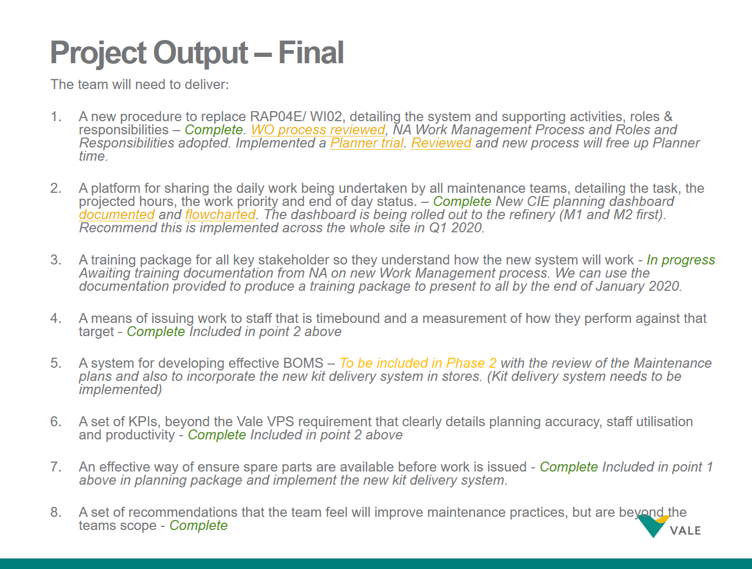

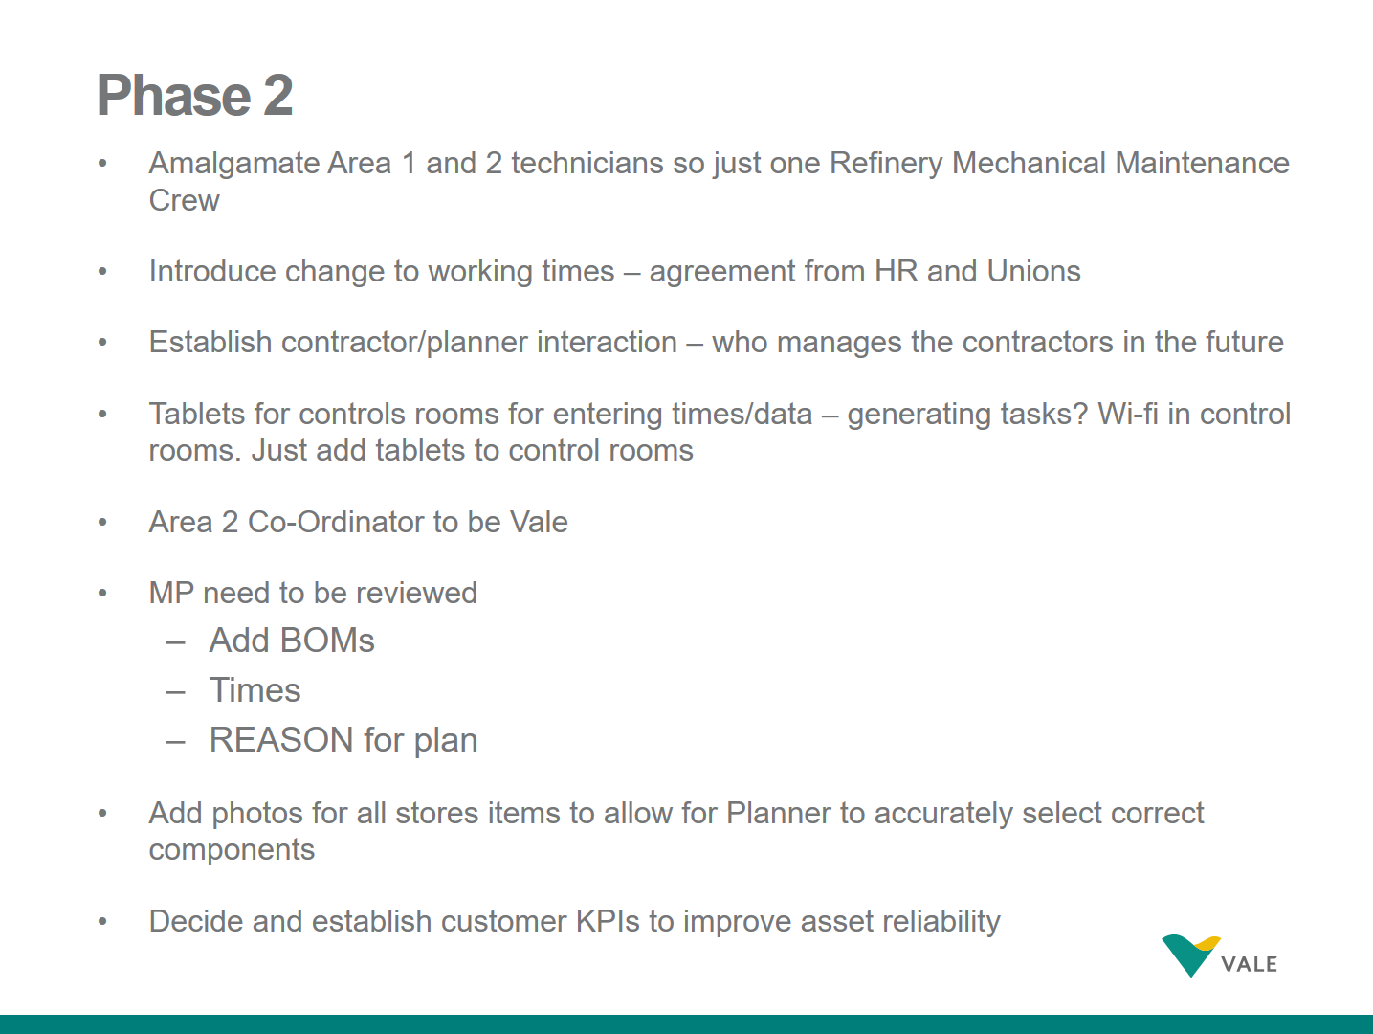
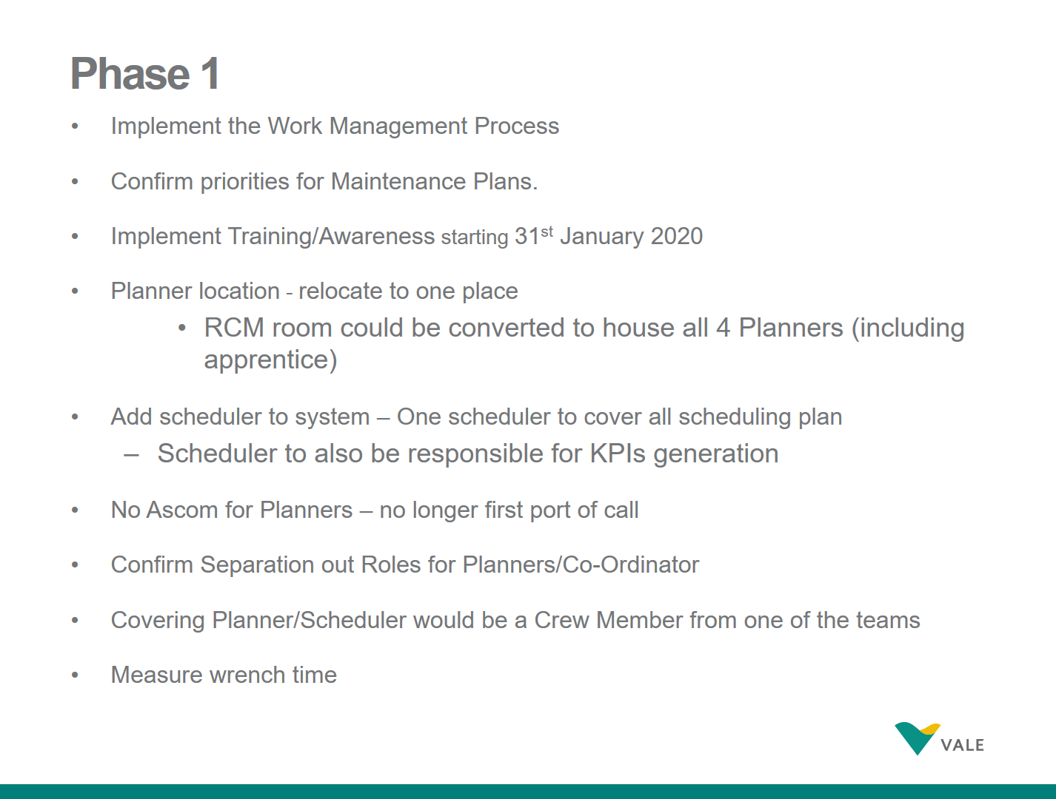
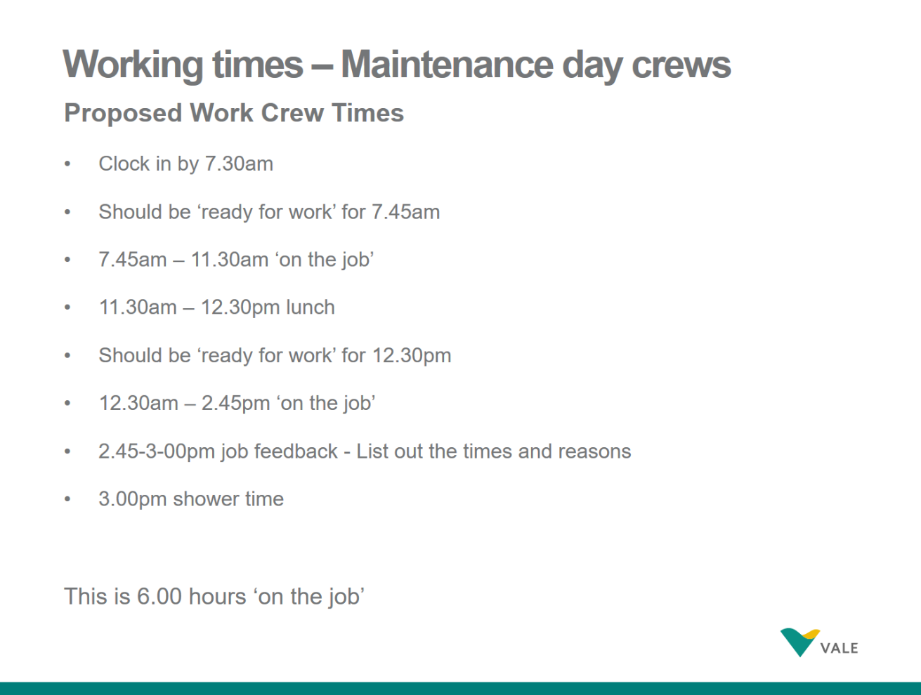
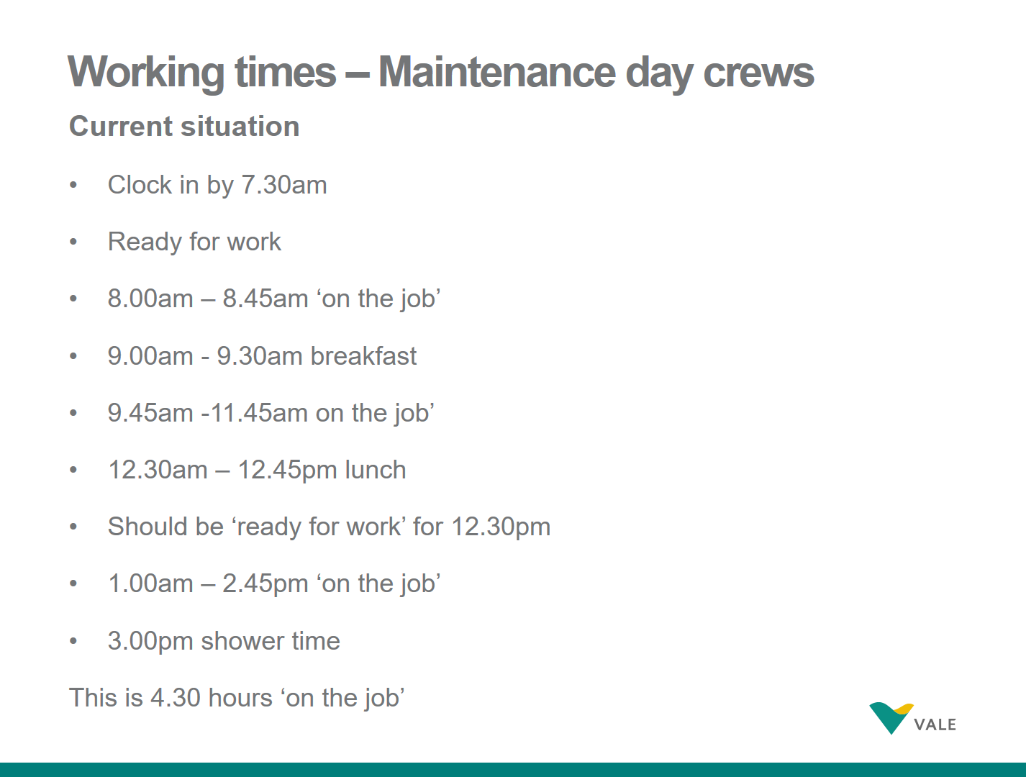


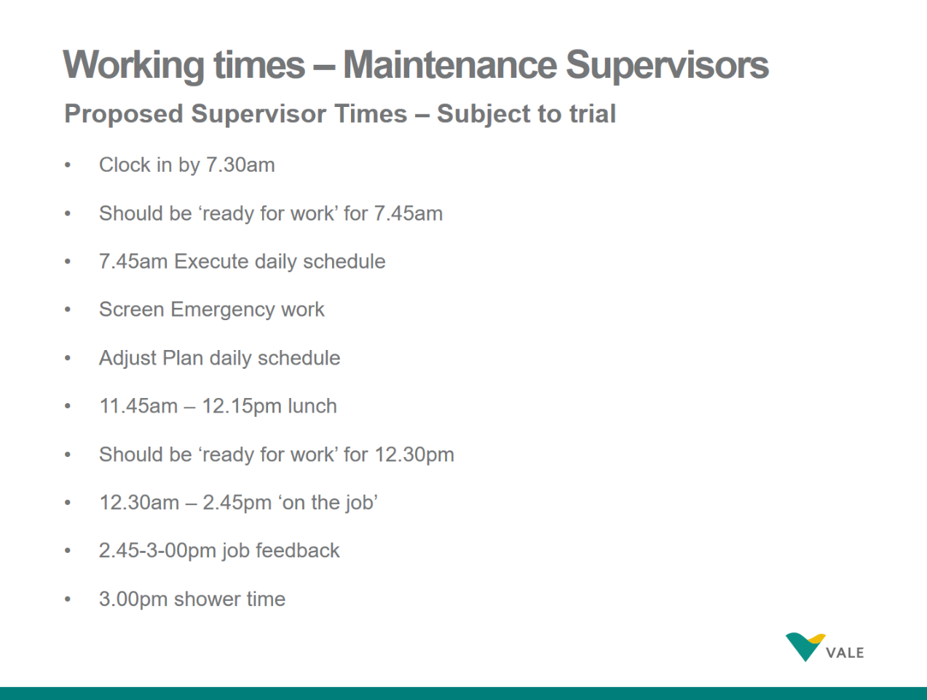

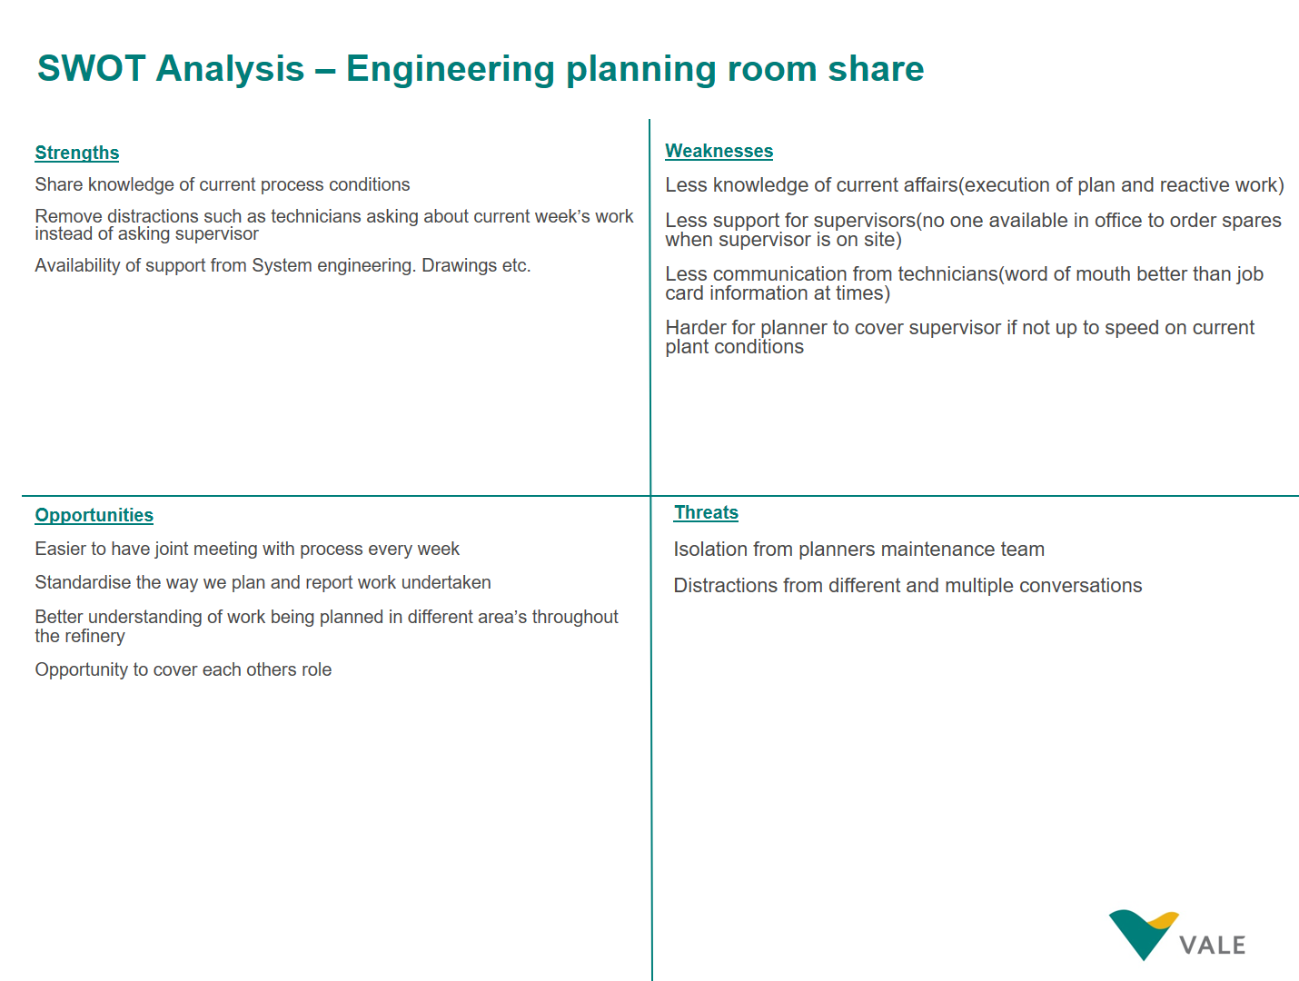
Appendix 5.

