Research Proposal
Title: The Impact of Brand Image on Customer Loyalty in Retail: A Secondary Comparative Case Study of Apple and Samsung
Student Name: Sachin Ashokbhai Japi
Student ID: 2430819
Supervisor: Shahrukh Irfan
Program Manager: Hoang Dang Nguyen
Programme: MBA International Business

1. Introduction and Background
The consumer electronics retail market is saturated. This is because the actual hardware of flagship devices has become overly similar as most premium smartphones now offer the same quality of cameras and processing speed. Consequently, organizations can no longer depend upon technical elements alone to create product differentiation. As a result, to keep hold of the market share and earn profits in the long-run, a strong-branded image has become the primary way of doing business.
A brand image is the way a customer perceives a brand based on their association, feelings, and experience with that brand. For a large retail company like Apple or Samsung, it is more profitable to retain an existing client than to acquire a new one. In the tech industry, customer loyalty entails more than buying the same brand of smartphone. The brand can often have consumer lock-in due to what is called “ecosystem lock-in,” where a consumer’s identification with a brand is reinforced because it would be too much trouble to switch to a competing operating system.
This study examines the effect of brand image on consumer retention in the furniture industry. This research studies secondary data to compare whether apple’s exclusivity lifestyle brand image is better than Samsung’s accessible hardware brand image regarding more considerable and durable consumer loyalty.
2. Problem Statement
Every year, technology retailers spend billions of dollars on marketing and store design, just take a look at the unique layout of the Apple store to see how important they believe it is in creating a particular brand image. Nonetheless, it is complicated to measure the impact of these investments on actual customer loyalty and purchase behaviour due to changing economic conditions.
This research primarily seeks to solve the lack of research into why customers are loyal to technology brands. In today’s world, is a customer’s brand loyalty driven by emotional experiences, social currency and seamless retailing (for example, Apple)? Does Samsung's ongoing innovation, wide array of products, and functional value keep them loyal?
Some academic theories suggest that favourable brand images create loyalty, but there have not been synthesized, contemporary studies that contrast these two very different approaches using real financial and retention data. Retail managers need actual data on whether the “closed-ecosystem” brand image is more powerful, or the “open-ecosystem” brand image for long-term customer retention. The current research paper will do just that.

3. Research Aims and Objectives
Aim: This project aims to evaluate the impact of different brand images on customer loyalty within the consumer electronics retail industry through a secondary comparative analysis of Apple and Samsung.
Objectives:
- To examine existing academic research regarding retail brand image, ecosystem lock-in, and the factors that influence customer loyalty.
- To examine secondary market reports (e.g., from Gartner or Statista) to determine consumer opinions of the Apple and Samsung brands.
- To evaluate the associations among brand images and behavioural loyalty (repeat purchases) as well as attitudinal loyalty (Net Promoter Scores and brand advocacy).
- To develop practical strategies for technology merchants on brand positioning to ensure retention of clients.
Research Questions:
- What specific parts of a brand's image actually drive loyalty in tech retail?
- How do the brand positioning tactics of Apple and Samsung differ according to current market data?
- Which brand strategy Apple's focus on the lifestyle or Samsung's focus on hardware is more effective in deterring customer brand-switching?
4. Literature Review
This section will outline the key academic theories that explain how brand equity and loyalty work in the tech sector.
4.1 Customer-Based Brand Equity (CBBE)
This study will utilise Keller’s (1993) Customer-Based Brand Equity model as its base. Keller posits that brand equity is established when a customer possesses robust, favourable, and distinctive associations with a brand in their memory.
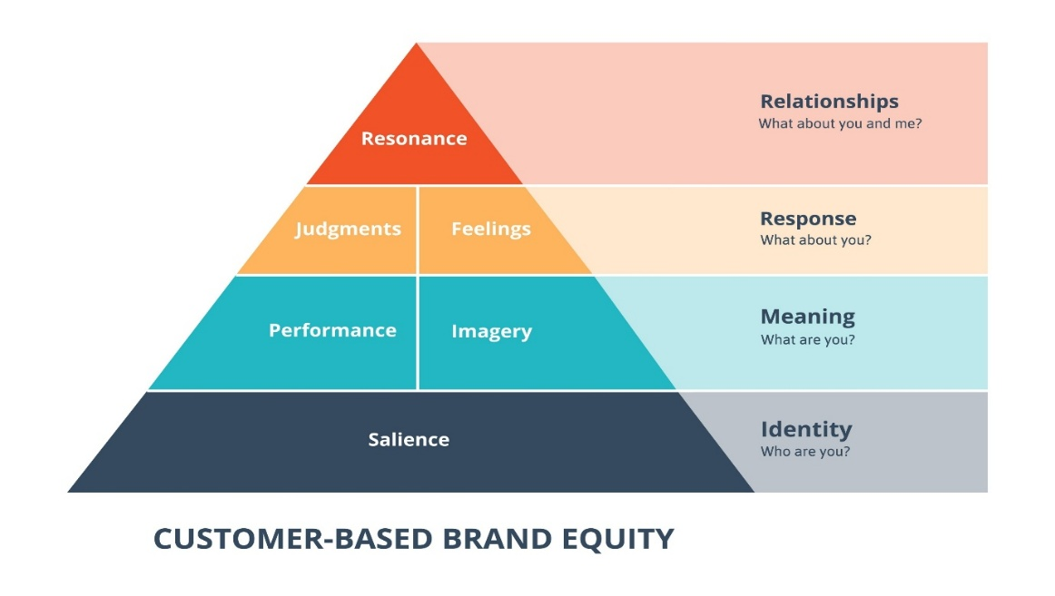
The moment you hear a specific technology name, a particular picture comes into your mind; thus, a brand creates a particular brand-is image in the mind. This image contains the characteristics of the brand. In a similar vein, these types of associations that allow a consumer to recognize and identify a brand and differentiate it from others competitive is build up over time on the part of the user and in the sending of technology retail.
4.2 Understanding Customer Loyalty
Loyalty is not merely a singular behaviour. This study will employ Oliver’s (1999) four-stage loyalty model, dividing it into the affective, cognitive, conative, and action stages.
- Cognitive Loyalty: Buying a brand for logical reasons (e.g., choosing Samsung because it has the best specs for the price).
- Affective Loyalty: Buying a brand based on emotion (e.g., choosing Apple because it fits a certain lifestyle or aesthetic).
The analysis will examine the idea that cognitive loyalty is unstable, as a client may easily transition to a competitor if they reduce their prices. Affective loyalty, nevertheless, establishes a stronger emotional barricade against competition.
4.3 Switching Costs and Ecosystem Lock-in
Switching, which is not usually associated with buying of products, is very commonly associated with technology. Switching basically refers to switching costs. When an individual goes through a switching experience, the former brand might levy costs upon that consumer through procedural costs (rather annoying to transfer this info), monetary costs (having to rebuy all those apps). In the literature I will look at how Apple uses its brand image to create a “walled garden”, the iMessages and Apple Watch integration that makes leaving them costly both physically and socially. Samsung uses the more open Android platform. As a result, switching to other systems is cheaper and requires more dependency.
5. Conceptual Framework
This framework demonstrates the relationships among the variables in this study, as determined by the literature.
- Independent Variables (Brand Image Factors): Perceived Innovation, Brand Personality, Retail Experience.
- Mediating Variables: Ecosystem Lock-in (Switching Costs), Brand Trust.
- Dependent Variable: Customer Loyalty (measured by Retention Rates and Net Promoter Score).
6. Research Methodology
6.1 Research Approach
This project will adopt an interpretivist philosophy using a deductive approach. The analysis begins with existing theories, such as Customer-Based Brand Equity (CBBE), then employs secondary data to evaluate the effectiveness of these theories in explaining the actual rivalry between Apple and Samsung.
6.2 Research Design: Secondary Comparative Case Study
The best way to study the top global brands is through secondary research. Asking a survey to 20 or fewer students for primary research may not prove to be a good thing to find out how Apple and Samsung are ruling the market. Employing reliable secondary data can potentially increase overall evaluations by hundreds of times. The case study style also works well to shows to the reader the huge gap between Apple’s closed system and Samsung’s open system.
6.3 Data Collection Strategy
I will gather data from reputable, published sources to make sure the findings are valid:
- Academic Sources: Peer-reviewed articles from databases like EBSCOhost and Google Scholar to build the theoretical background.
- Market Data: Quantitative data regarding market share, brand switching, and retention will be sourced from trusted sources such as IDC, Gartner, and Statista. I will use YouGov Brand Index to evaluate consumer opinions and brand health.
- Company Reports: Annual financial reports (10-K filings) from Apple and Samsung will be used to back up the market data.
6.4 Data Analysis Method
I will using Thematic Document Analysis to categorise qualitative data into subjects such as "Perception of Exclusivity" and "Value for Money." I will use Comparative Matrix Analysis to cross-reference the identified themes with quantitative loyalty measurements, such as retention percentages, to determine which brand image attributes correlate with increased loyalty.
7. Expected Outcomes and Managerial Implications
The research will demonstrate that the customer loyalty in the B2C context of the consumer electronics retailer has fundamentally different drivers between Apple and Samsung. The research will find that Apple suffers a great deal from affective loyalty, emotional brand attachment, and ecosystem switching costs. Samsung will develop more cognitive-driven loyalty due to their perceptions of product innovation, functional value, and “freedom to switch” in an open ecosystem.
Research is likely to find that affective loyalty through a lifestyle-oriented brand image and ecosystem integration offers much stronger resistance to brand switching than functional satisfaction-based loyalty.
8. Ethical Considerations and Limitations
This study predominantly relies on secondary data and does not carry ethical issues like interviewing or surveying human subjects. Keeping the data accurate and not misleading is my primary ethical responsibility of ensuring integrity in the study. In addition, it implies that I must not copy other people’s work and will always cite back to the source in the referencing system requested by the university. The primary limitation of this method is my dependence on third party data (i.e. Statista) which means I cannot control their original survey methodology. To combat this, I will employ data triangulation. This will ensure that I verify facts through many reports, in order to check the accuracy of trends. Only once I am satisfied with this information will I proceed with the conclusion.
9. Timeframe
Your dissertation will require you to undertake an academic journey over an agreed-upon period. First to be done will be literature review and conceptual framework refinement. After this, information from the journal and market research and corporate will be collected. Thematic and comparative analysis will be used to analyse and synthesise the data. To conclude, the last step in dissertation writing will include writing, reviewing and editing the final dissertation as per university guidelines.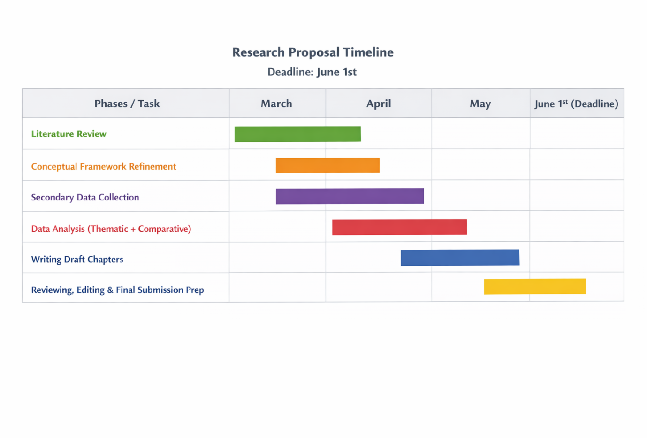
10. Conclusion
The influence of brand image on the loyal customer reviewed critically will be the research proposal. Consumer electronics retailers, the setting of research proposal. Apple and Samsung. The location and situational contexts of the proposed study relate to Pakistan and are limited to the telecom sector. Discussions of the research proposal will revolve around research work due to the secondaries’ offer for insight and implication that could serve the academic and managerial bounds.

References
"Aaker, D.A. (1991) Managing brand equity: capitalizing on the value of a brand name." (“Aaker, D.A. (1991) Managing Brand Equity: Capitalizing on the Value of ...”) New York: The Free Press.
Apple Inc. (2025) Form 10-K annual report. Washington, D.C.: Securities and Exchange Commission.
Burnham, T.A., Frels, J.K. and Mahajan, V. (2003) 'Consumer switching costs: a typology, antecedents, and consequences', Journal of the Academy of Marketing Science, 31(2), pp. 109-126. (“Burnham, T.A., Frels, J.K. and Mahajan, V. (2003) Consumer Switching ...”)
Gao, L. and Bai, X. (2024) 'How brand tribalism affects consumer loyalty in the smartphone industry: a comparative study of Apple and Samsung', Journal of Retailing and Consumer Services, 75, pp. 103-115.
Gartner (2025) Forecast: PCs, ultramobiles and mobile phones, worldwide. Stamford, CT: Gartner Research.
Keller, K.L. (1993) 'Conceptualizing, measuring, and managing customer-based brand equity', Journal of Marketing, 57(1), pp. 1-22. (“Consumer-Based Brand Equity Conceptualisation and Measurement - George ...”)
Liu, Y. and Li, H. (2023) 'Ecosystem lock-in and customer retention in consumer electronics: evidence from the iOS and Android platforms', International Journal of Information Management, 68, p. 102589.
Oliver, R.L. (1999) 'Whence consumer loyalty?', Journal of Marketing, 63(4), pp. 33-44.
Samsung Electronics Co., Ltd. (2025) Annual report and sustainability report. Suwon: Samsung Corporate.
Statista (2025) Global smartphone market share from 4th quarter 2009 to current year. Hamburg: Statista Research Department.
Tariq, M., Khan, A. and Lee, S. (2022) 'Assessing the impact of brand image and customer experience on brand loyalty in the tech retail sector', Journal of Marketing Communications, 28(5), pp. 450-468.

