Felipe Alvares Ribeiro (2120442)

Effective Team Work and Communication (BMSW4002)
Lecturer: Ejiro Albert Esowode
University of Wales Trinity Saint David (London Campus)

Communication
Insights on effective communication

Table of Contents
1 - Introduction 2
2 - Models of communication 2
2.1 - The Shannon and Weaver Model of Communication: 2
2.2 - The Schamm Model of Communication: 3
2.3 - The Berlo Model of Communication: 4
3 - Types of Communication 5
3.1 - Verbal 6
3.2 - Non-verbal 6
3.3 - Listening 7
3.3.1 - Active Listening 7
4 - The Disadvantages of Modern Technology in Communication 7
4.1 - Identity Theft 7
4.2 - Cyber Bullying 8
4.1 – Diminished Social Interaction 8
5 – Conclusion 9
6 - References 9

1 - Introduction

Communication is a pillar of society and helps us to be productive as well as accomplishing and maintaining relationships between other people and ourselves. (Pertemps, 2020)
In a workplace environment, people that communicate effectively are valuable resources within a company. By communicating effectively, trust can be built between peers, conflicts can be resolved, teams can be built and successfully developed, and higher engagement and productivity can be achieved. (Pertemps, 2020)
In this document it is going to be discussed about three important communication models, which are the Shannon and Weaver, Shramm, and Berlo’s models of communication. Those models describe how communication occurs in our society and what are the components that influence the communication process and cause it to be effective or ineffective.
Also, the types of communication (Verbal, non-verbal and listening) are going to be described for more insights on the components of successful communication habits.
As technology and social media is an important part of our contemporary society, there will also be a discussion about some disadvantages of technology when it is used for communication.
The aim of this document is to provide information on human communication as well as analyzing the features and habits that make communication effective or ineffective.

2 - Models of communication

2.1 - The Shannon and Weaver Model of Communication:

The Shannon and Weaver model of communication was first introduced by the mathematician Claude Elwood Shannon when himself, along with the scientist Warren Weaver, published the article “A Mathematical Theory of Communication” in the Bell System Technical Journal. In his model of communication, the message is sent through a technological path, that could be represented by a telephone, telegraph or any other medium. The sender encodes the message so it can be understandable by a machine, the message then can be sent through a medium, all the way towards the receiver. The receiver, after receiving the message, must decode the message into a humanly understandable signal. (Businesstopia, 2018)
The concept of noise is also presented in this model, it is any disturbance in the environment or in the communication medium, this interference can cause problems in the understanding of the communication. (Businesstopia, 2018)
Some disadvantages of this model are that the feedback, the message that allows the sender to acknowledge that the message was received and understood, is not present. And this model can also be misleading, as human communication is not mathematical in nature. (Preeti, 2017)
An example to illustrate the Shannon and Weaver Model of Communication is when you try to speak over the phone with your friend to invite them to a party, but your friend is in a busy street at the time of the call, so when you say the address, instead of understanding “Kidderminster Road, 36” he understands “Westminster Road, 26”, and end up going to the wrong address. As the Shannon and Weaver model doesn’t talk about the feedback, there is no response from your friend to ensure that the message was interpreted correctly.
The following diagram illustrates how this model of communication works:

(Communication Theory, n. d.)

2.2 - The Schramm Model of Communication:

The Schramm model of communication was presented in 1954 and it was inspired by the Shannon Weaver model. But, in this model, the communication happens in two ways. As it happens in the Shannon Weaver model, the Sender must encode the message, then, send it through a medium, after that, the receiver must decode it. After the message has been received and understood, the receiver sends a feedback message back to the sender, acknowledging the message was received properly. (Bhasin, 2021)
Schramm also states that the communication if fulfilled only when the sender receives a response back from the receiver. Regarding the components that can interfere in the message. Schramm also believes that the any of the individual’s personal knowledge, experience and cultural background can affect the way the message is understood. In that case, both parties of the communication must be on the same level of understatement. (Bhasin, 2021)
An example of that model would be the same as the example given in the Shannon Weaver model, with the two friends trying to discuss the address of the party, but this time, the receiver must send a message confirming the first message to the original sender. So now, the receiver can verify if the address that he understood was correct.
The following diagram illustrates how Schramm’s model of communication work. It can be noticed that, differently from the Shannon and Weaver model, the communication now has a return path. That is the feedback:
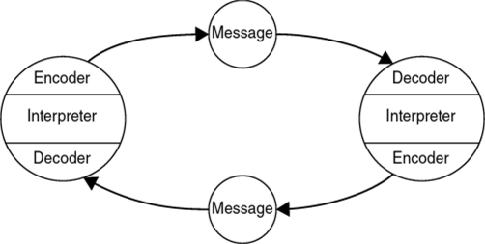
(Ebrary, n.d.)

2.3 - The Berlo Model of Communication:

Berlo’s communication model was also based in the Shannon Weaver model, but it focuses on the encoding and decoding of messages, and it includes four main components in the communication process, which are: sender, message, channel and receiver. Each one of these components can be influenced by different factors. (Janse, 2018)
Berlo discusses that each component can be affected by multiple factors. The sender and receiver can be affected by poor communication skills, attitude, knowledge, social systems and cultural factors. The message can be affected by the content, elements, treatment, structure and code. Lastly, the channel in which the message is transmitted can also be affected by the five human senses, those are: Hearing, seeing, touching, smelling and tasting. (Preeti, 2017)
This model can be criticized by being a linear model, it’s lack of feedback, the lack of consideration for the noise that can affect the message, the complexity of the model and that it doesn’t include the thinking and rationalizing as a human sense. (Preeti, 2017)
The following diagram contains Berlo’s model of communication. By analysing it, it can be stated that this model is more complex than the other two models presented and accounts for various social and cultural factors, behaviours and physical abilities that might influence communication:

(Businesstopia, 2018)

3 - Types of Communication

In the first section of this report, there was an introduction on the models of communication, which explain how the process of communication happen. Although these models are important to describe how communication occurs, it is also important to define how humans interact with each other.
Human communication can be divided between verbal, non-verbal and listening. This section aims to give further explanation on each of these types of communication.
The diagram below illustrates the types of communication that will be discussed in this section:
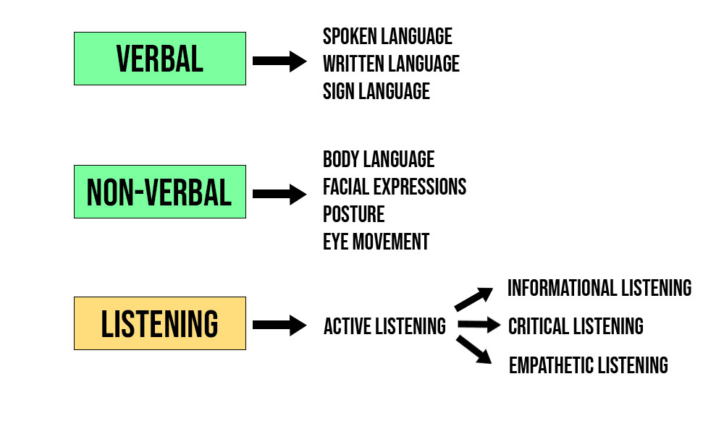
(Author’s Image)

3.1 - Verbal

Verbal communication contains both our words and the and verbal fillers we use in the communication process. It can include spoken, written and sign language. To be effective in this kind of communication, the message sender must be sure that the message being sent is clear for the receiver to understand, apart from that, the skill of properly interpreting verbal communication also must be developed. As the symbols we use for communication can be arbitrary and misunderstood, (Quitanilla and Wahl, 2020, pp. 21-22).

3.2 - Non-verbal

Non-verbal communication can be defined by the communication that has meaning but is not included in written or spoken language. This type of communication can include a variety of body language symbols that can be interpreted as a message by other people. Some examples of this are the way you walk, facial expressions, your posture and even the way you look. As an example, if you lower your eyebrows, squint your eyes, and tighten your lips, other humans might interpret that you are angry. (Quitanilla and Wahl, 2020, pp. 21-22)
Non-verbal communication is not only used to express an emotion or mind state. It is also useful to understand about it for a more effective communication. If you are communicating with someone, you can observe and interpret their body language to get some insights on how the person is responding to your message. (Quitanilla and Wahl, 2020, pp. 21-22)
This type of communication can also be used to show a person’s personality traits to other people and, if used correctly, it can help your verbal communication to get clearer by sending a ‘double message’ with both your speech and body language. (Quitanilla and Wahl, 2020, pp. 21-22)

3.3 - Listening

Listening can often be confused with hearing, but they are two different concepts, hearing is the process of perceiving sound, listening is paying attention to the sound and giving it consideration. (Raypole, 2018)
Listening is crucial for communication, as we have seen in the models of communication, the receiver plays a key role in the process, without it, the communication process cannot be completed. As it is estimated that an average listener remembers between 25 and 50 per cent of the information they hear, it can be said that listening is not well practiced in our society. It is vital to practice effective listening in business and social environments. The best practices for good listening include avoiding distractions, focusing on the message, and listening actively to the message. (Quitanilla and Wahl, 2020, pp. 43-50)
As it is important to understand what active listening is, it will be discussed further in this section.

3.3.1 - Active Listening

Active listening can be divided into three categories, Informational listening, Critical Listening and Empathetic listening. (Quitanilla and Wahl, 2020, pp. 50)
Informational listening relates to focusing the content of the message to remember the content. Critical listening can be defined as the act of evaluating and analyzing the message you are receiving. (Quitanilla and Wahl, 2020, pp. 50-51)
As for empathetic listening, it is important when listening to consider the point of view of the speaker. If receive a message from a communicator, you should try to interpret that message as if you were the sender. You should also consider the social and cultural background of the speaker and try to put yourself in their position. (Quitanilla and Wahl, 2020, pp. 51)

4 - The Disadvantages of Modern Technology in Communication

4.1 - Identity Theft

One of the main problems introduced by technology is the increased risk of identity theft. It can be defined as by the intentional and unauthorized use of other people’s identity for malicious purposes. As the use of technology as a mean to store and share personal information through online platforms has increased, identity has become a common threat in our society (Burnes, DeLiema, and Langton, 2020, p. 1). According to Piquero et al. (2021, p. 446), people who spend their time engaging with online communication, chat rooms, social media, and performing online transactions are at a higher risk of having their personal data stolen.
Some actions can be taken to avoid being a victim of Identity fraud, like keeping antiviruses and firewalls up to date in your devices, being vigilant about links received via e-mail and always checking if the website you are filling a form or performing a transaction is secure. This information can be verified by looking at the left side of the website address in the browser, if the protocol being used is HTTP (Hypertext Transfer Protocol) it means that the connection is not encrypted, and consequently not secure, whereas if the protocol being used is HTTPS (Hypertext Transfer Protocol Secure), it means that the connection is encrypted and secure (Metropolitan Police, no date).

4.2 - Cyber Bullying

Most children nowadays have been victims of cyber-bullying at some point in their lives. As it has become easy to create fake accounts in social media, bullying someone over the internet has become an effortless task (Ahmad, 2016). Threats and other malicious behaviours can be sent with the main goal of harming, scaring or damaging the reputation of the victim (Rémond, J., Kern, L., and Romo L., 2014).
With 97% of adolescents having access to social media, between 15% and 70% of them have allegedly suffered cyberbullying. This type of attack can have several negative impacts in the life of these victims, including inducing depressive mood (Kutok, E. et al, 2021).

4.1 – Diminished Social Interaction

Messaging applications and mobile devices have enabled people to adopt new behaviours that allowed for a more convenient way to complete tasks. For example, people that are travelling abroad do not need to bring a dictionary or to learn a new language anymore, they can simply translate what they want to say in real time, making it easier to communicate. But the human-to-machine relationship has increased along with the development of these mobile technologies. (Wardynski, D., 2019)
The virtual distance created by those technologies has negatively impacted some human relationships. It is common nowadays to see couples and families giving priority to their mobile devices instead of interacting with each other. Parents also prefer to give a tablet to their children to calm them down instead of educating them. (Wardynski, D., 2019)
As it was discussed in the Models of Communication section of this report, technology can also play a role in the failure of the communication process, by introducing noise to the message being sent.

5 – Conclusion

In conclusion, it can be said that, based on the previous research contained in this document, that effective communication is key in building relationships and successful career and business development.
By understanding the entire process of communication, we are then able to reflect on our behavior apply different communication techniques that improve our chances of succeeding in social environments.
Also, it can be said that, although technology can help us to communicate conveniently and quickly, it can have a negative impact in our society.

6 - References

Ahmad, B. (2016), ’10 advantages and disadvantages of social media for society’, Techmaish[blog]. 27 June. Available at: https://www.techmaish.com/advantages-and-disadvantages-of-social-media-for-society/ (Accessed: 13 July 2022).
Bhasin, Hitesh (2021), ‘Schramm’s Model of Communication Elements, Advantages & Limitations’, Marketing91 [blog]. 18 October. Available at: https://www.marketing91.com/schramms-model-of-communication/ (Accessed: 23 June 2022).
Burnes D., DeLiema M., and Langton L. (2020) ‘Risk and Protective Factors of identity victimization in the United States’, Preventive Medicine Reports, 17(101058), pp. 1-8. Available at: https://www.ncbi.nlm.nih.gov/pmc/articles/PMC7013169/pdf/main.pdf (Accessed: 08 July 2022).
Businesstopia (2018) Shannon and Weaver Model of Communication. Available at: https://www.businesstopia.net/communication/shannon-and-weaver-model-communication (Accessed: 23 June 2022).
Businesstopia (n. d.) Berlo’s SMCR Model of Communication. Available at: https://www.businesstopia.net/communication/berlo-model-communication (Accessed: 28 August 2022)
Communication Theory (n. d.) Shannon and Weaver Model of Communication. Available at: https://www.communicationtheory.org/shannon-and-weaver-model-of-communication/ (Accessed: 28 August 2022)
Ebrary (n. d.) Osgood-Schramm’s model of communication. Available at: https://ebrary.net/htm/img/13/1879/20.png (Accessed: 28 August 2022)
Janse, B. (2019), ‘Berlo’s SMCR Model of Communication’, Toolshero[blog]. 1 August. Available at: https://www.toolshero.com/communication-methods/berlos-smcr-model-of-communication (Accessed: 18 July 2022)
Kutok, E. et al (2021), ‘A Cyberbullying Media-Based Prevention Intervention for adolescents on Instagram: Pilot Randomized Controlled Trial’, JMIR Ment Health. 15;8(9):e26029. DOI: 10.2196/26029
Metropolitan Police (no date), Identity fraud. Available at: https://www.met.police.uk/advice/advice-and-information/fa/fraud/personal-fraud/identity-fraud/ (Accessed: 08 July 2022).
Pertemps (2020), The importance of communication in today’s working world. Available at: https://www.pertemps.co.uk/candidates/career-advice/life-at-work/the-importance-of-communication-in-today-s-working-world/ (Accessed: 28 August 2022)
Piquero, N. L. et al (2021), Preventing Identity Theft: ‘Perspectives on Technological Solutions from Industry Insiders’, Victims & Offenders, 16(3), pp. 444-463. Available at: https://researchmgt.monash.edu/ws/portalfiles/portal/334019011/333799780_oa.pdf (Accessed: 08 July 2022).
Preeti (2017) ‘Communication Models – Types, Advantages and Disadvantages’, Simply Notes [blog]. 28 February. Available at: http://www.simplynotes.in/communication-models-2/2/ (Accessed: 23 June 2022).
Quintanilla, K. M. and Wahl, S. T. (2020) Business and Professional Communication: Keys for workplace excellence. 4th edn. Los Angeles: SAGE.
Raypole, C. (2018) ‘What is the difference between Hearing and Listening?’, Healthline[blog]. 16 September. Available at: https://www.healthline.com/health/hearing-vs-listening (Accessed: 18 July 2022).
Rémond, J., Kern, L., and Romo L. (2014) [A cyberbullying study: Analysis of cyberbullying, comorbities and coping mechanisms], L'Encéphale. 41(4), pp. 287-94. DOI: 10.1016/j.encep.2014.08.003
Wardynski, D. (2019), What Are the Effects of Technology on Human Interaction, Brainspire[blog]. 7 November. Available at: https://www.brainspire.com/blog/what-are-the-effects-of-technology-on-human-interaction (Accessed: 13 July 2022).

