

The Impact of Talent Management Strategy on Business Performance in the Retail Industry in the UK
BMMB7003 MBA

NAME: Eyashin Miah
Student No.: 2420408
Supervisor: Daniela Hellyer

Level 7 Dissertation
BMMB7003
2024- 25

Abstract
The investigation of how talent management (TM) practice may be connected to the business performance of the UK retail sector, which is marked by a high rate of employee turnover, skills shortage, and increasing digitalisation, is the research problem of the proposed study. The research considers the impact of recruitment, training, recognition, career development and managerial support on the operational and performance performance based on the Resource-Based View (RBV), Ability Motivation Opportunity (AMO) theory and Organisational Support Theory (OST). A survey was conducted on 161 employees working in large and mid-sized organisations in the UK using a quantitative survey. Data analysis was conducted through the assistance of descriptive statistics, correlation and multiple regression (Licht, 2011). The findings indicate that the best predictors of perceived business performance are Career Development and Succession Planning, Managerial Support and Recruitment and Employer Branding, which predict the perceived business performance with 82 of the variance. The correlation between Training and Recognition and performance was positive but not significant when they were both combined with other stronger predictors of TM. The results affirm the current studies that underscore the importance of employee development, leadership support, and acquisition of the best quality talent in promoting organisational success. The study contributes to the specialised sector evidence by demonstrating how these practices interplay in the unique setting of the UK retail, and what missing links and gaps remain and where the implementation does not work as well, including a deficiency of consistent training and recognition systems (Ellis-Chadwick, Doherty and Hart, 2002). Practical recommendations include strengthening development pathways, investing in managerial capability, and integrating recruitment with long-term TM strategies. The study concludes that more empirical research is needed to understand causal effects and the impact of digital transformation on TM in the retail sector.

Declaration and Statements
DECLARATION
This work has not previously been accepted in substance for any degree and is not being concurrently submitted in candidature for any degree.
Signed ....................... Eyashin Miah...............................................
Date ..................................12/12/2025......................................
STATEMENT 1
This work is the result of my own investigations, except where otherwise stated. Other sources are acknowledged by footnotes giving explicit references. A bibliography is appended.
Signed ....................... Eyashin Miah..............................................
Date .............................12/12/2025...........................................
STATEMENT 2
I hereby give consent for my work, if accepted, to be available for photocopying and for inter-library loan, and for the title and summary to be made available to outside organisations.
Signed .......................... Eyashin Miah...........................................
Date ..............................12/12/2025..........................................

Table of Contents
Abstract ii
Declaration and Statements iii
List of Figures vii
List of Tables vii
Acknowledgement 8
CHAPTER-1: Introduction 9
1.1 Research Background and Context 9
1.2 Research Problem and Rationale 10
1.3 Academic Focus and Theoretical Perspective 12
1.4 Aim of the Study 13
1.5 Research Objectives 13
1.6 Research Question 13
1.7 Scope and Delimitations 14
1.8 Structure of the Dissertation 14
2 Chapter 2: Literature Review and Theoretical Framework 16
2.1 Introduction 16
2.2 Theoretical Framework 16
2.2.1 Resource-Based View (RBV) 17
2.2.2 Ability–Motivation–Opportunity (AMO) Framework 18
2.2.3 Organisational Support Theory (OST) 20
2.2.4 Integrated Theoretical Perspective 21
2.3 Conceptualising Talent and Talent Management 22
2.4 Theoretical Lenses Linking Talent Management to Business Performance 23
2.5 Evidence from Retail Sector Studies 24
2.6 Cross-Sector Evidence and Transferability 25
2.7 Mechanisms Through Which Talent Management Influences Business Performance 26
2.8 Critical Evaluation of the Talent Management–Performance Link 27
2.9 Implications for the UK Retail Industry 28
2.10 Research Gaps and Future Directions 29
3 Chapter 3: Research Methodology 31
3.1 Introduction 31
3.2 Research Strategy and Choice 32
3.3 Research Philosophy 32
3.4 Research Design 33
3.5 Data Collection Procedure 33
3.5.1 Data Preparation and Coding 35
3.5.2 Data Measures 36
3.6 Population, Sampling and Sample Size 37
3.6.1 Target population and inclusion criteria 37
3.6.2 Sampling strategy 38
3.6.3 Sample size and recruitment plan 38
3.7 Data Analysis Plan 38
3.8 Reliability and Validity 40
3.9 Methodological Limitations 41
3.10 Ethics 41
4 Chapter-4: Data Analysis 43
4.1 Findings 43
4.2 Discussion 50
Chapter-5: Conclusion & RECOMMENDATIONs 54
References 59
APPENDICES 80
Appendix A: Survey Questionnaire 80
Appendix B: SPSS Result 83
Appendix C: Ethics Form 92

List of Figures
Figure 1: RBV Framework Source: (Opinaldo, 2022) 19
Figure 2: AMO Framework Source: (Rahul Choudhury, 2023) 21
Figure 3:Organisational Support Theory (OST) Source: Self-designed 22
Figure 4: Research Onion Method Source: (Saunders, 2019) 34
Figure 5: Age Distribution 46
Figure 6: Gender Distributions 47
Figure 7: Organisational Size Distribution 47

List of Tables
Table 1: Demographic Profile Analysis 43
Table 2: Reliability Statistics for Talent Management 44
Table 3: Descriptive Statistics for Talent Management 45
Table 4: Pearson Correlation Matrix for Talent Management 46
Table 5: Multiple Regression Analysis Predicting Business Performance 47

Acknowledgement
I would like to thank my supervisor personally, as she has been guiding, supporting, and giving constructive feedback to me the whole time I worked on this dissertation. It has also been my pleasure to have the other participants who, willingly, gave me their time to fill in the survey, and without them, my research could not have been conducted. My family and friends are also the ones I would like to thank because they have supported and understood me throughout my studies. They have been able to help me achieve this work through their support.

CHAPTER-1: Introduction

Research Background and Context
The United Kingdom retail industry is a strategic and huge industry with well over 3 million workers, approximately 9% of the entire workforce and a contribution of approximately 5% of GDP (British Retail Consortium) (GOV.UK, 2020). It is represented by a wide range of formats, such as supermarkets, department stores, fashion stores, home and DIY stores, food stores of specialities, discount retailers and websites. Big national chains like Tesco, Sainsbury, Asda, and Morrisons are available alongside regional chains and mid-sized retailers in the competitive environment to set up a two-dimensional competition environment where both large and mid-sized companies need to plan and execute optimal talent management strategies. The UK retail sector experienced a radical transformation in the past ten years due to the accelerated digitalisation, shifting consumer needs, the rise of e-commerce and omni-channel business models (Wadud, Liang and Polkinghorne, 2025). The innovations have brought new opportunities in innovation in the sphere of data-driven merchandising, customised marketing and unified supply chains. Meanwhile, they have added to the conventional workforce problems, especially skills shortages, excessive staff turnover and strain on labour expenses. According to ManpowerGroup (2022), in the UK, one-fifth of employers have difficulties filling vacancies due to a lack of talent, and Distinct Recruitment (2024) observes that the annual turnover of employees in the retail sector may reach over 50% compared to the national average of approximately 15%. This instability raises the cost of recruitment, interrupts the service delivery process and reduces customer satisfaction (Logan et al., 2024). The labour force of the retail sector is also structurally distinct. It is highly reliant on the frontline employees who often have part-time working hours, work on flexible or temporary contracts and work in jobs that do not have much of a progression ladder and have relatively low wages. However, the frontline employees play a vital role in terms of retaining the customers, brand image, as well as the day-to-day performance of operations. Such a high dependence with low structural security guarantees long-term issues with engagement, absenteeism and turnover (Mensah, 2019; Logan et al., 2024). A recent McKinsey survey has shown that the lack of promotion opportunities and career advancement is one of the most prevalent motivations in the retail industry to leave the workforce, which, again, supports the idea that it is necessary to pay not just attention to the attraction, but also to the development and retention of talent (Logan et al., 2024). It is against this backdrop that talent management has taken the form of the order of the day: organisations are increasingly recognising strategic planning, attraction, development and retention of talented employees as an essential pathway to competitiveness and sustainability. High engagement, increased service quality and profitability, and effective talent management (TM) have become linked (Zada et al., 2024; Gallardo-Gallardo et al., 2020). In service-oriented businesses like retail, where the attitude and behaviour of the employees define how customers experience the services, how organisations manage and align talent may prove to be critical in determining business performance. Despite this strategic importance, much of the existing TM literature has focused on large multinational enterprises or sectors such as telecommunications, banking and public services (Peynirci, 2023). There is comparatively limited empirical work that contextualises TM in the UK retail sector, especially in mid-sized enterprises that operate at a national or regional scale but do not possess the same resources as global corporations. This gap is significant because mid-sized retailers face many of the same labour market pressures as large firms, but often have less sophisticated HR infrastructures and fewer resources for investment in structured TM programmes. As a result, it is not clear whether talent management frameworks and practices developed in other contexts can simply be transferred into UK retail, or whether sector-specific approaches are required. In parallel, the nature of “talent” itself is contested (Questsearch, 2017). Early contributions tended to treat talent as an innate attribute of a small group of high performers, leading to exclusive TM practices focused on succession pipelines for senior roles. More recent work advocates a more inclusive perspective that recognises the contribution of the wider workforce and emphasises the alignment of recruitment, training, recognition, career development and retention strategies across staff groups. For retailers, where customer-facing roles, store-level supervision and back-office support all influence performance outcomes, the question of whether to adopt exclusive or inclusive TM practices is practically and strategically important. The intersection of high turnover, skills shortages, digital disruption and contested notions of talent means that UK retailers must make careful choices about how they design and implement talent management strategies (R. Rifa Herdian, 2025). Understanding which TM practices most strongly influence business performance, and under what conditions, is therefore a crucial area of inquiry for both academics and practitioners.

Research Problem and Rationale
The central problem underpinning this study is the misalignment between the strategic importance of talent management in UK retail and the limited empirical evidence on how specific TM practices influence business performance in this sector. Existing research confirms, in general terms, that well-designed TM systems are associated with better organisational outcomes, including higher productivity, innovation and employee retention (Zada et al., 2024; Gallardo-Gallardo et al., 2020). However, several gaps remain when this body of work is examined through the lens of UK retail. First, much of the empirical evidence on TM–performance links comes from non-retail sectors or from organisations operating in emerging markets (Wu, Fan and Chen, 2022). Studies in telecommunications, real estate or public services often confirm the value of recruitment, training and career management, but their findings may not transfer directly to the specific conditions faced by UK retailers, which combine high-volume frontline staffing, intense price competition and strong consumer expectations around service quality (Aljumah, 2023). Contextual differences in labour regulations, unionisation levels and customer expectations further complicate direct transferability. Second, within the retail-focused literature, TM strategies are frequently examined at a high level without distinguishing which bundles of practices are most strongly associated with particular performance outcomes (Macas, 2021). For instance, many retailers invest heavily in employer branding and recruitment campaigns to attract talent, yet evidence suggests that long-term outcomes may be more strongly driven by development opportunities, career pathways and supportive managerial practices (Nguyen et al., 2022; Al Aina and Atan, 2020). There is therefore a need to disentangle the relative impact of attraction, development, recognition, career progression and managerial support on key business indicators. Third, the majority of studies emphasise employee attitudes such as engagement, job satisfaction or intention to stay, but provide less systematic evidence on “hard” business outcomes such as operational efficiency, sales growth, profitability, shrinkage reduction or customer satisfaction in a retail context (Silva, Dias and Pereira, 2023). For UK retailers facing tight margins and rising operating costs, understanding whether TM investments translate into measurable business performance is essential to justify continued or expanded investment. Fourth, past research typically targets big and endowed organisations, and middle-sized retail chains are not well-researched. Such organisations may not necessarily have any TM departments, but they equally face the same competitive pressures and workforce challenges as other larger organisations. The success of the different strategies used by TM in large and national stores and mid-sized chains can be contrasted in relation to the perceived result to discern the possibility of the size and availability of resources to affect the effectiveness of various strategies (Nascimento et al., 2021). Finally, the digital disruption has transformed the retailer process and its talent management, be it the HR analytics and e-learning tools or the development of new employment opportunities in the digital marketing processes, online customer services and online omnichannel logistics. However, the implications of digitalisation on retail TM strategies and their impact on performance are not well developed in academic literature. Together with these gaps, there is the justification for empirical research that directly deals with the UK retail sector and examines the levels of TM at different levels and explores the perceived influence on different performance outcomes (Megicks, 2007). The economic significance of the retail industry, the acute nature of the issues of its employees and the absence of industry-related evidence predetermines the topicality of the issue as an object of research and the urgency of its practical application.

Academic Focus and Theoretical Perspective
This dissertation is situated at the intersection of human resource management and strategic management. It builds on the premise that human capital is a critical driver of sustainable competitive advantage and that the way organisations manage talent has direct and indirect implications for business performance. The academic foundation draws on several complementary theoretical perspectives. Early work on talent management in services often used Social Exchange Theory and Human Capital Theory to explain how investments in training, fair treatment and career support generate reciprocal commitment, loyalty and enhanced service quality (Cropanzano et al., 2017; Becker, 1964; Marginson, 2017). The Resource-Based View (RBV) conceptualises human capital as a valuable, rare, inimitable and non-substitutable resource that can underpin competitive advantage when effectively developed and retained (Barney, 1991; Madhani, 2010).
Building on this foundation, the present study primarily employs three interrelated frameworks that are elaborated in Chapter 2:
- Resource-Based View (RBV), which frames employees’ skills, knowledge and behaviours as strategic assets that can drive sustainable performance when supported by appropriate TM practices.
- Ability–Motivation–Opportunity (AMO) framework, which explains how recruitment, training, rewards and work design interact to build employees’ ability, motivation and opportunity to contribute to organisational outcomes (Kellner et al., 2019; Bos-Nehles et al., 2023).
• The Organisational Support Theory (OST) that dwells on the perceptions of employees towards organisational and managerial support and the impact on commitment, discretionary effort and performance (Kurtessis et al., 2017).
Combining these views, one can have a multi-layered perspective through which one can analyse the role of certain sets of talent management practices, i.e. recruitment practices, training practices, performance recognition practices, career development practices, succession planning and managerial practices, in influencing employee attitudes and behaviours, and, consequently, the business performance in UK retail (Silva, Dias and Pereira, 2023).

Aim of the Study
The objective of the study will be to investigate the role of talent management strategies in the performance of businesses in the retail sector in the United Kingdom, with specific reference to large national retailers and mid-sized chains that are nationally or internationally based.

Research Objectives
In order to achieve this overall aim, the study is guided by the following research objectives:
- To analyse current talent management practices in UK retail, including recruitment, development and retention.
- To evaluate which practices most effectively enhance operational efficiency, employee engagement and financial outcomes.
- To identify barriers and challenges to implementing effective talent management in retail.
- To compare talent management approaches between large and mid-sized retailers.
- To recommend evidence-based strategies to optimise human capital and strengthen competitive advantage.

Research Question
The overarching research question in the study is as follows:
- What is the relationship between talent management strategy and business performance in the UK retail sector and what are the most commonly practiced strategies to improve the cost-effective activities of an organisation, employee involvement, and organisational development?
Sub-questions:
What talent management practices are currently used by large and mid-sized UK retailers?
- How do employees perceive the impact of these practices on engagement, productivity and customer outcomes?
- Are there discernible differences in TM approaches and outcomes between large and mid-sized retailers?
- Which combinations of TM practices are perceived as most strongly linked to positive business performance indicators?
These questions will be addressed through a quantitative survey of employees working in UK retail organisations, as outlined in the methodology chapter.

Scope and Delimitations
The research concentrates on the retail organisations located in the United Kingdom and analyses talent management practices as understood by the employees working within this industry. It focuses on big national retailers and mid-sized chain stores that are at regional, national or international levels, as opposed to micro-business or very small and independent stores (Hensel et al., 2021). This emphasis is an indication of the relevance of multi-site organisations in the UK retail consumer landscape and their ability to embrace structured TM approaches. The study will assume a cross-sectional study design, where data will be gathered at one point in time, thus giving a picture of what is happening and what the perceived effects are, but it will not show how these effects have been changing over time. The research assumes that self-reported survey data can be prone to the influence of response biases, such as social desirability and recollection constraints (Latkin et al., 2021). It also focuses on the perceptions of employees that talent management has on business performance instead of directly quantifying financial indices like profit margins or customer churn. The study also concentrates on a specified group of TM dimensions, such as recruitment and employer branding, training and development, performance recognition, career development, succession planning and managerial support and overall TM impact, which have been cited by the literature as the key TM dimensions in service industries. Other HR practices, including pay structures or industrial relation set ups, are recognised but not studied in detail (Sonar and Pandey, 2023). Such restrictions are needed to prevent an impossible scope of a Master's dissertation, but also shape the interpretation of results and the hypothesis of further investigation.

Structure of the Dissertation
The remainder of this dissertation is organised into four further chapters.
- Chapter 2 – Literature Review and Theoretical Framework critically reviews academic and practitioner literature on talent management and business performance, with a particular focus on the retail sector. It synthesises evidence from UK and international contexts, identifies mechanisms through which TM practices influence performance, and highlights gaps in the existing research. Theoretical framework of the study is also formulated in the chapter, relying on the RBV, the AMO framework and the Organisational Support Theory.
- Chapter 3 Research Methodology will provide the research design and support the methodological decisions taken. It describes the philosophical position, the research methodology, research strategy, methods of data collection, the sampling and the sample size, as well as the methods of data analysis applied to test the relationship between the TM practices and business performance (R. Rifa Herdian, 2025). Discussed also are ethical considerations, limitations and research schedule.
- Chapter 4, Data Analysis and Findings, shows the survey as the empirical results. It presents the sample, gives descriptive statistics of the major variables and the use of the relevant statistical methods, including correlation and regression analysis, to investigate the relationship between TM practices and business performance indicators (Sonar and Pandey, 2023).
- Chapter 5: Discussion, Conclusions and Recommendations is an interpretation of the findings and the way they relate to the literature and theoretical framework, answers the research objectives and questions, and outlines the implications for UK retail organisations. It further presents the scholarly work of the study, outlines its shortcomings and recommends future research studies.
In such a structure, the dissertation seeks to offer a consistent and empirical explanation of the role of talent management strategies on business performance within the UK retail industry, and it will determine how retailers can be offered practical recommendations to help in the need to enhance their human capital and competitive edge.

Chapter 2: Literature Review and Theoretical Framework

Introduction
The chapter is a critical examination of the effect of talent management (TM) on business performance and, in this case, retail in the United Kingdom. It is based on the research purpose to investigate how talent management practices influence key organisational outcomes, and it justifies the research purposes to analyse existing TM practices, to find their relations to the operational and financial performance, to explore the contextual barriers, and to identify the differences between large and mid-sized retailers (Milezi et al., 2023). Accordingly, the chapter shifts away from the general conceptual arguments regarding TM, to sector- and cross-sector empirical findings, to a list of precisely defined research gaps, which themselves explain the initiation of empirical studies subsequently in the dissertation. The chapter is structured in the following way. First, it conceptualises talent and talent management, closely regarding the shift from the exclusive and high-potential-oriented ones to more inclusive and sustainable ones that are especially applicable to retail. It goes on to describe the key theoretical frames that relate TM to business performance, followed by a review of empirical studies in the retail and other industries, and the deconstruction of how TM can influence organisational performance (Ali Almohtaseb et al., 2020). The chapter then gives a critical analysis of the TM-performance relationship, implications on the UK retail environment, significant gaps and the directions that research can take and finally gives the theoretical framework of the research based on the Resource-based view (RBV), the Ability-motivation-opportunity (AMO) framework and the Organisational Support Theory (OST).

Theoretical Framework
Based on the above review, this study uses RBV, AMO and OST as a theoretical framework to examine how TM practices can affect the performance of businesses in the UK retail industry. RBV gives a macro-level explanation by the conceptualisation of the skills, knowledge and behaviours of the employees as the strategic resources. AMO also defines the micro-level processes of how TM affects employee performance, and OST emphasises the importance of perceived organisational and managerial support as a key mediator.

Resource-Based View (RBV)
RBV is among the most powerful theories in strategic management that have been extensively applied to examine the origins of sustainable competitive advantage (Barney, 1991; Mailani et al., 2024). It states that companies do better with resources that are valuable, are rare, are difficult to imitate and not easily substituted, usually referred to as VRIN. Human capital is becoming a VRIN resource of critical importance in the modern service and knowledge-intensive sector. The skills, tacit knowledge, and creativity in employees are not easy to replicate by the competitors, particularly when they are entrenched in supportive cultures and systems (Madhani, 2009; 2010). The Tesco, the John Lewis and the Marks and Spencer organisations in the UK retail sectors rely on the frontline employees to deliver services to the customer, solve problems and be seen as the brand representative to their customers. These employees are able to create unique customer experiences and operational efficiencies that help them in their financial performance when they are equipped with high product knowledge, interpersonal skills, and the ability to use digital tools. The way that TM practices, recruitment, training, development and retention, are viewed through the lens of RBV is that these are strategic investments in the formation and maintenance of VRIN human capital (Madhani, 2010; El Nemar et al., 2022). Nevertheless, RBV has its criticisms that apply to retail. Other researchers say that it is tautological, as it defines resources as something valuable because they are related to success, and provides little information about how to quantify or create such resources in practice. In addition to this, retail settings are volatile, seasonal and technologically dynamic, unlike the comparatively stable resources that RBV has been historically concerned with. It is against this reason that RBV is supplemented in this study by AMO and OST, which lay more emphasis on processes and perceptions.
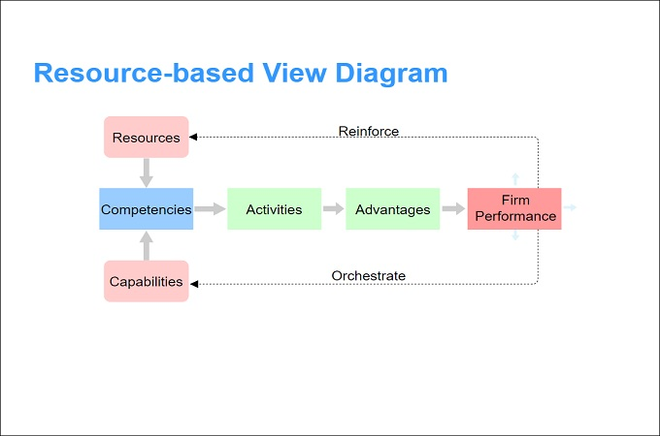
Figure 1: RBV Framework Source: (Opinaldo, 2022)

Ability–Motivation–Opportunity (AMO) Framework
The AMO model is a common model applied in HRM research to elaborate on how HR practices have an influence on the performance of individuals and organisations. It suggests that performance can be a factor of how well employees can perform their tasks, how much they are motivated to work hard, and how they have a chance to work, which is usually written as P = f(A, M, O). According to Kellner, Cafferkey and Townsend (2019), HR systems work best when improving all three components, as opposed to individual ones; the latter also discusses the interaction of these components in practice in greater detail. The talent management practices can be directly mapped onto AMO. Key levers in developing ability are recruitment and selection practices, as well as training and development, since they ensure that employees have the required skills and knowledge. The main effects of recognition, rewards and career development avenues are motivational in that they determine the feeling of worthiness, equality and future in employees. Employee voice, flexible work schedules and mechanisms, work design and empowerment give employees an opportunity to practice their skills and share ideas (Al-shahwani, 2020). Opportunity-enhancing practices are especially relevant in UK retail, which has the regularity of shifts, excessive workloads, and poor autonomy (Henly and Lambert, 2014); without the opportunity, even a well-skilled and highly motivated worker will not perform well. The AMO framework can also be used to describe the tendency of isolated practices in TM to fail. As an illustration, aggressive recruitment programmes can bring high-potential (increasing ability) people on board, but if recognition is low and the managers fail to offer meaningful opportunities to contribute towards decision-making, motivation and opportunity will not be high, and no performance gains will be realised. Equally, good training programmes can increase ability, but unless work design and coaching by line managers, employees may lack the opportunity to apply new skills. This rationale passes on well with empirical evidence, which shows that learning and career management, as opposed to attraction, are related to sustainable performance (Al Aina and Atan, 2020). This survey measures the study in terms of operational aspects, i.e., recruitment and employer branding, training and development, performance recognition, career development and succession planning, managerial support, and overall TM impact, which can be mapped onto the dimensions of the AMO.
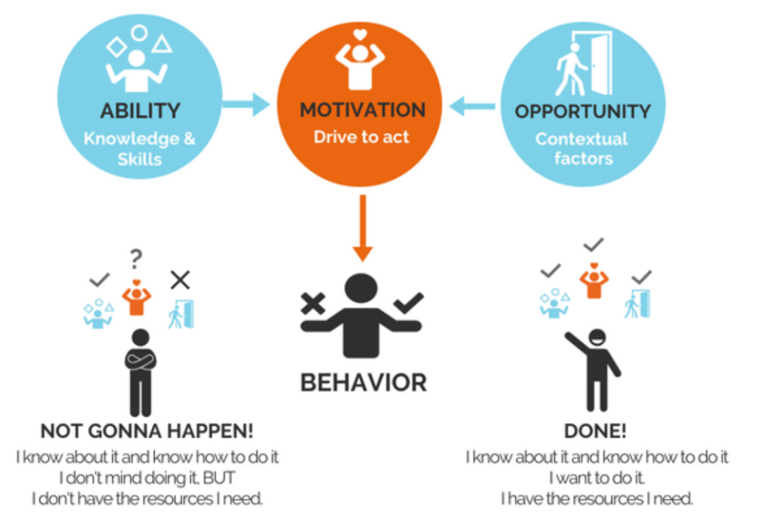
Figure 2: AMO Framework Source: (Rahul Choudhury, 2023)

Organisational Support Theory (OST)
The organisational Support Theory concerns the perceptions of the employees about the degree to which the organisation appreciates their contributions and cares about their wellbeing, perceived organisational support (POS) and goes further to perceived supervisor support. Kurtessis et al. (2017) give meta-analytic data to support this, saying that high levels of perceived support correlate with higher affective commitment, job satisfaction, performance and reduced turnover intentions. TM practices are viewed as support, i.e., fair treatment, opportunity to develop, recognition and supportive supervision are all regarded as the forces that make the perceptions of commitment stronger in OST. Line managers play a key facilitating role of organisational support in UK retail. Store managers will design training, shifts, and assessment of performance and will frequently address employee issues (Doan and Nguyen, 2022). As soon as these managers are eager to promote the growth of employees and their welfare, TM practices will be seen as authentic, which will build confidence and mutuality. On the other hand, when line managers are too many, inconsistent or unresponsive, employees can consider TM initiatives as empty or hollow, and thus undermine their effectiveness. That is why the implementation gaps are a frequent occurrence and why managerial capability seems to be a recurring motif in the literature (Kravariti et al., 2023). OST can also be utilised to comprehend the impact of TM on not only the performance, but also the well-being and retention. Employees will also have increased chances of giving back through loyalty when they can see that the organisation is offering good organisational and managerial support, and they will give out discretionary effort and positive word-of-mouth regarding the organisation as an employer. These attitudes may be converted into more positive service experiences and team stability in customer-facing retail positions.
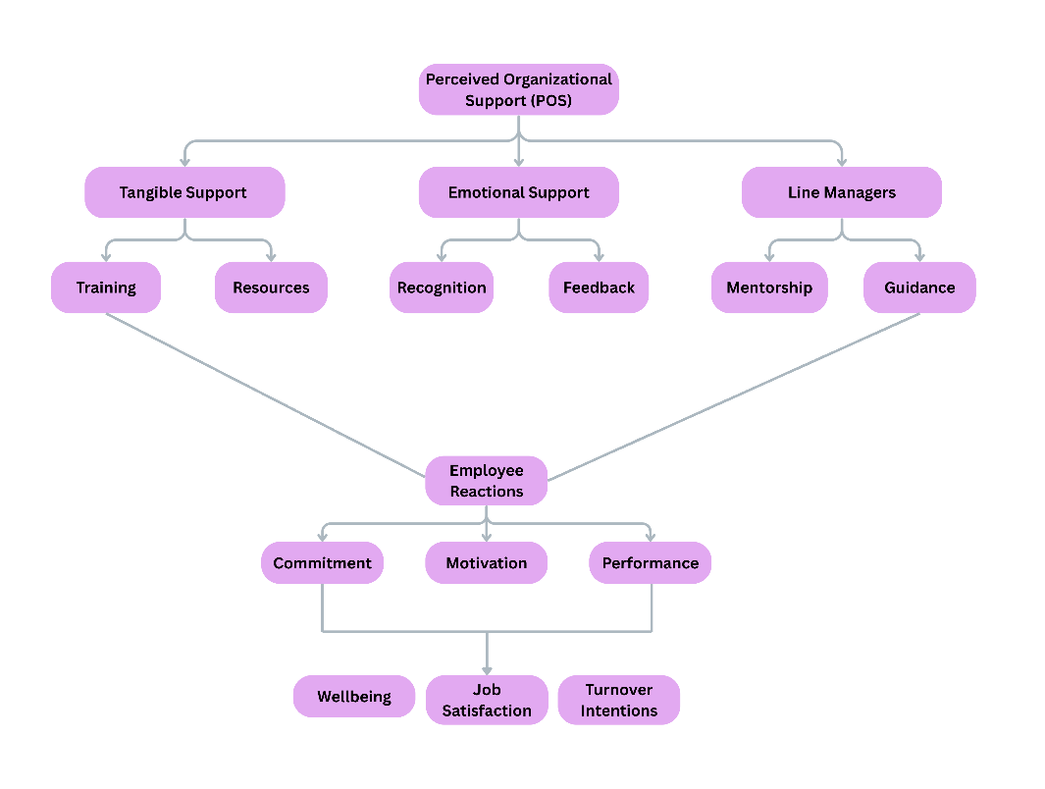
Figure 3:Organisational Support Theory (OST) Source: Self-designed

Integrated Theoretical Perspective
All three theories represent different yet complementary information about the relationship between TM and performance. RBV provides the strategic justification of investing in TM on a firm level that human capital is a source of competitive advantage. AMO describes on the individual and collective levels how TM practices influence performance through ability, motivation and opportunity. Ost adds to this image by highlighting perceived organisational and managerial support as key mediators of HR consequences. When these theories are applied jointly, it is indicated that TM will have the greatest impact on business performance in UK retail when it is combined with the development of the VRIN human capital, the ability, motivation and opportunity of employees, as well as the strong perceptions of support of the organisation and the line managers. As UK retailers struggle to cope with labour shortages, mounting costs and digital disruption, this combined framework helps to highlight that people investment is not just a cost and that it is a strategic need. It further emphasises that the effectiveness of TM is not the issue of formal policies, but the experience of the employees in the interaction and daily work procedures.

Conceptualising Talent and Talent Management
Talent management (TM) is a concept of multidimensional and dynamic nature, but it incorporates strategic human resource practices of attracting, developing and retaining employees in order to improve organisational performance. Initial strategies perceived talent as a narrow elite of high performers or A players who take central roles that are vital in maintaining a competitive advantage (Singh, 2021). Yet, this narrow method of thinking has been progressively faulted due to its ignorance of the greater role of the broader workforce. An inclusive strategy is more theoretically and practically applicable in the labour-intensive industries such as retail, where front-line staff directly affect customer experience (Zhang and Thippayana, 2022). Recent publications have moved to the definition of TM as an organisational-wide holistic approach that appreciates every employee as a potential product of strategic results (Amelia and Rofaida, 2023; Saleh and Atan, 2021). This inclusivity is close to the purpose of the study to understand how various TM practices, including recruitment, training, recognition, and career development, interact to produce performance in the UK retail industry. The initial point in this chain is employer branding and recruiting, especially in the context of an increase in labour shortages throughout the UK (Ch Rajitha, 2025). Nevertheless, research like the one by Al Aina and Atan (2020) and Nguyen et al. (2022) states that attraction and retention programs do not guarantee continuous performance without a well-designed development and succession strategy. This has evolved to include training and continuous learning. They promote flexibility and creativity among employees, which are crucial in the field of a fast digital revolution and automation (Machado, 2024). Equally, performance-based and recognition rewards are effective to motivate and engage employees, whereas career development prospects are used to prevent turnover by promoting psychological ownership and career development prospects (Nguyen et al., 2022). All these aspects of TM contribute to the ability-motivation-opportunity (AMO) model discussed below that predicts that when employees have the ability, motivation, and freedom to act productively, performance goes up. There is a developing body of literature that incorporates sustainability in TM, claiming that sustainable talent management supports the competitiveness of businesses, employee welfare, and resilience in the long term (Amelia and Rofaida, 2023). This view is especially relevant to the UK retail sector, where high stress, lack of attendance, and work-life imbalance remain widespread issues (Aina and Atan, 2020). In this regard, therefore, TM is not just an engine of short-term productivity but also a source of long term organisational sustainability. Importantly, although the majority of the research findings argue in favour of the positive correlation between TM and performance, researchers also differ in which dimensions have the most significant impact. There are ones that focus on development and learning (Al Aina & Atan, 2020), and there are ones that focus on motivation and recognition (Zhang & Thippayana, 2022).

Theoretical Lenses Linking Talent Management to Business Performance
Interpretations of the relationship between talent management and business performance have been made through a variety of theoretical perspectives, all of which have identified specific yet complementary mechanisms. Some of the most mentioned frameworks include the Resource-Based View (RBV), the Ability-motivation-opportunity (AMO) framework, and Organisational Support Theory (OST). These combined give a multi-level insight into how talent practices turn human capital into long-term organisational performance. Resource-Based View (RBV) Barney (1991) had developed the idea of human capital as a strategic resource capable of creating a long-lasting competitive advantage in cases where it is valuable, rare, inimitable, and non-substitutable (VRIN). Human capabilities, including interpersonal communication, technology flexibility, and service orientation, meet the above VRIN criteria in the retail environment (El Nemar et al., 2022). Companies that combine these attributes successfully by managing talent will be able to stand out in a rather competitive market. Critics, however, point to the fact that RBV deemphasises the environmental forces like labour mobility and technological change, which are especially severe in the UK retail sector (Çela et al., 2022). The high employee turnover in the retail sector does not support the RBV in its static assumption that resources are immobile, proposing that dynamic capability frameworks would be more appropriate in capturing the retail realities. The AMO framework is a complement to the RBV because it determines the relationship between HR practices and performance. It hypothesises that employees are able (skills and competence), motivated (willingness to perform), and enabled (freedom and resources to act) to contribute to the organisational outcomes which optimise the outcomes (Bos-Nehles et al., 2023). Talent management practices like specific training are able to develop capacity, a recognition and reward system is able to maintain motivation, and a participative management structure is able to increase opportunity. The three components interrelate, not in isolation, as empirical studies (Al-Hussaini et al., 2019) display that the three components are simultaneously related. However, opportunity can be compromised by structural constraints, such as inflexible scheduling or a lack of autonomy in retail, as Kravariti et al. (2023) warn, undermining the AMO mechanism. This is applicable particularly to the supermarkets and fashion chains in the UK, where the pressures placed on the operations of the line managers are often prioritised, overshadowing the developmental requirements. The AMO logic is furthered in the Organisational Support Theory (OST), which concentrates on what employees think the organisation values and supports them (Kurtessis et al., 2017). Perceived organisational support is high, which creates reciprocity; employees are more committed, more engaged and more willing to work harder discretionally (Doan and Nguyen, 2022). Line-managerial support is important in retail environments because line managers are the main connection between corporate HR policies and employees (Kravariti et al., 2023).

Evidence from Retail Sector Studies
There is an increasing body of empirical support on the connection between TM and performance within the retail context, as much of the research is carried out beyond the UK. Kumar (2011) explored the relationship between talent management and business development within the organised retail sector on the premise that TM is needed to curb high turnover, skills deficiencies and inefficient operations. His research proposed that combined strategies of TM in terms of recruiting, training and career management can improve the results of employees as well as customer satisfaction, which facilitates the development of business. Nevertheless, the context and regulatory background are dissimilar to the UK, which restricts the direct transferability. Zhang and Thippayana (2022) reported the positive correlation of high quality of recruitment, training, recognition and employee performance in a quantitative study conducted in the Chinese retail sector. Training turned out to be the most significant factor, meaning that further development of skills is especially crucial in the spheres of services where direct contact with customers and knowledge of products are the major concerns. This is shown in their work as TM practices can have a great influence on the performance of employees, although it concentrates on single-level results rather than on the overall business measures like profitability or growth. The UK is more closely paralleled by European research. As Yohannes et al. (2025) noted, employee engagement directly affects customer satisfaction and financial performance of service-based enterprises, which is very applicable to the businesses of the retail organisation, whose success relies on repeat buying and good customer experiences. In the same manner, Osayawe et al. (2023) highlight the importance of HR strategies, such as engagement programmes, training and recognition, in revolutionising retail with better employee and customer engagement. All of these studies are indicative of the idea that TM-related investments may have returns in various dimensions of performance. Although this is a rather encouraging image in general, there are some significant limitations and issues identified in the literature. According to Schuler et al. (2017), TM in most retail organisations is reduced to a set of recruitment and employer branding activities to fill in vacancies in the shortest time possible, whereas more long-term concerns, including career development, internal mobility and managerial competency, are paid less consideration.

Cross-Sector Evidence and Transferability
Since research on retail-specific aspects of the UK is relatively scarce, there has been a tendency to draw upon other areas of research in order to infer ways in which TM can be applied to the performance in retail. Al-Hussaini et al. (2019) analyse TM approaches in the telecommunications industry and discover that TM has a positive impact on the performance of the employees, and such outputs as the development of skills and motivation intermediates the process. Their findings also support the AMO reasoning that TM practices enhance performance through the effect they have on the abilities and motivation of employees and not the very existence of the formal programmes. Kravariti et al. (2023) discuss the problem of talent management in the Bahraini governmental sector and emphasise the critical part played by organisational and line-managerial assistance to turn TM initiatives into performance improvements. They demonstrate that even the most effective TM systems cannot provide significant benefits to the employees unless they feel that the organisation and their immediate supervisors are interested in their development. Al Aina and Atan (2020) concentrate on real estate organisations in the UAE and conclude that learning and career management practices are associated with sustainable organisational performance, and attraction and retention initiatives are not. The results are consistent with those of other researchers who indicate that long-term development is more strongly related to performance based on the short-term recruitment or retention strategies. The evidence of cross-sector suggests thus the specific importance of development and career pathways to sustainable performance, which can be applied to retail with a certain caution. Nevertheless, cross-sector findings cannot be easily applied to the UK retail sector. Gautam and Gautam (2023) emphasise that organisational culture and union influence are contextual factors that should build the HR outcome. Telecommunications, public sector and real estate organisations may have dissimilar regulatory regimes, labour-market conditions and consumer anticipations than retail. For example, retail can be described as high volumes of transactional interaction with customers, comparatively low pay, and sometimes unpredictable scheduling (Henly and Lambert, 2014), which can limit the usefulness of some TM practices. Cross-sector evidence is still useful, but should thus be viewed critically, with both common and sector-specific limitations in place.

Mechanisms Through Which Talent Management Influences Business Performance
In addition to listing practices and outcomes, literature has started to define how TM has an effect on the performance of businesses. Recruitment costs can be lowered, and a better quality of applicants can be achieved by using attraction techniques, including employer branding and focused recruitment, especially in competitive labour markets. However, their contribution to longer-term performance seems to be minimal unless they are combined with development and support mechanisms which preserve and upgrade the abilities of those hired (Sembiring and Damayanti, 2023). Training and development can be listed among the fundamental mechanisms of the association between TM and performance. The Chinese evidence, the UAE and European retail evidence show that training contributes to the ability of employees to be flexible, to work with customers and increase productivity (Lai et al., 2021; Zhang and Thippayana, 2022; Machado, 2024). Training in AMO terms makes the ability stronger by providing the staff with the relevant knowledge and skills needed to be effective. In the UK, skills gaps are being resolved through the rising popularity of apprenticeships, in-store coaching and digital learning platforms, especially in digital tools and omnichannel service delivery. These investments may be turned into a high level of operational efficiency and enhanced customer experiences, which will facilitate sales and profitability. The second important mechanism is recognition and engagement. According to Zhang and Thippayana (2022), recognition and employee performance are strongly related in the retail setting, which means that employees who feel valued will work harder during discretionary effort. The same conclusion is made by Machado (2024), who concludes that engagement and productivity of large retail chains are improved with the help of constant feedback, clear performance expectations, and a performance management system that supports. These results are consistent with the motivation factor of AMO, as well as the focus of OST on the perceived organisational support; indicators of the perception that the organisation values the input of employees, which leads to loyalty and commitment. A third mechanism is career development and succession planning. As demonstrated by Al Aina and Atan (2020), career management practices correlate with sustainable organisational performance and the focus on the availability of effective promotion and executive succession. Machado (2024) emphasises how digital HR tools, such as performance management systems, e-learning platforms and mobile applications, can be used to monitor, provide feedback and communication in large and dispersed retail operations. These tools may assist the line managers to monitor the training completion, detect performance problems and support them as required. Meanwhile, the studies of digital change in HR caution that digital technology should be accompanied by human-centeredness; data-driven scheduling or hard-and-fast performance interfaces may cause stress and surveillance complexes unless it is supported by adaptability and human understanding (Gričnik et al., 2024). There are two levels of these mechanisms. At a more proximate, employee-level, TM has such outcomes as job satisfaction, engagement, psychological ownership, intention to stay and wellbeing (Almomani, Obeidat and Sweis, 2021; Nguyen et al., 2022; Saleh and Atan, 2021). On a more distal level, it is assumed that these employee outcomes influence operational outcomes (e.g. productivity, error rate, shrinkage), customer outcomes (e.g. customer satisfaction, loyalty), and financial outcomes (e.g. sales growth, profitability) (Yohannes et al., 2025; Kumar, 2011).

Critical Evaluation of the Talent Management–Performance Link
Management-Performance Relationship. Despite the fact that the literature massively tends to support the existence of a positive relationship between TM and business performance, a number of conceptual, methodological and contextual limitations should be critically addressed. To begin with, a significant part of the available evidence is cross-sectional and correlational. The collected studies often evaluate the performance results and TM practices at one time with self-report questionnaires, and assume that observed connections are causal (e.g. Zhang and Thippayana, 2022; Al-Hussaini et al., 2019). According to Faber and Fonseca (2014), these kinds of designs are vulnerable to sample size and sampling bias, and cannot conclusively prove that TM leads to better performance or that better-performing organisations simply have more resources to invest in TM. Second, findings are usually constrained by sample sizes and sampling methods. Numerous TM research utilises convenience samples of single organisations or sub-sectors, and in some cases, small sample sizes. Although useful insights are given through such studies, they might not reflect the diversity of employment conditions, organisational cultures and competitive pressures within the wider retail industry. The use of cross-sectional surveys also introduces possibilities of cross-sectional bias and other social desirability bias, especially where a respondent is reporting on both TM practices and performance outcomes. Third, the TMperformance relationship is conceptualised in too simplistic a way, in which studies have assumed that there is a strong linear relationship whereby increased TM will automatically translate to improved performance. One such example is Sembiring and Damayanti (2023), who discovered that talent attraction and retention strategies are widely applied but not always lead to a sustainable increase in performance. Fourth, contextual factors are often underspecified. Most quantitative researches use aggregated data across sectors or across nations without properly considering the variations in labour laws, unionisation, cultural values and customer demands. Gautam and Gautam (2023) show that organisational culture orientation and the presence of a union play an important role in determining the nature of HR dynamics and, therefore, practices that are effectively applied in one environment might not necessarily apply to the other. In the case of UK retail, the peculiarities of the business, such as the uncertainty in scheduling, part-time employment, and the high consumer demands on the service, can considerably dampen the effects of TM strategies (Henly and Lambert, 2014). Lastly, there is the theme of the implementation gap. Kravariti et al. (2023) and others demonstrate that line managers can be a very vital mediating factor; even well-designed TM models can fail unless the store managers have the time, the skills or the autonomy to act on them. The implemented challenge is particularly acute in the retail industry when line managers are commonly pulled between the operational and the HR-related endeavours.

Implications for the UK Retail Industry
The literature has several implications for UK retailers. To begin with, it has always been proven that development-oriented practices are much more effective and efficient when compared to transactional-based attraction or retention programs. The relevance of learning, skill growth and career management in the context of sustainable performance is found in studies in real estate, telecommunications and public sector environments (Al Aina and Atan, 2020). To manage high staff turnover and skills shortage issues, UK retailers may find it necessary to invest in apprenticeships as well as micro-learning, coaching and internal career pathways; they cannot be regarded as discretionary expenditures but rather strategic needs. Second, the importance of line-manager capability is highlighted in the literature. According to the OST-informed studies, there is a mediating role of perceived organisational and managerial support between TM and performance (Kurtessis et al., 2017; Kravariti et al., 2023). Store managers in UK retail are usually operational leaders and front-line HR practitioners, and they are expected to schedule, provide feedback, performance appraisal and coaching. Their HR competences, the necessary time and opportunities, and the matching of the performance parameters with the people-development targets are thus the essential measures that the TM strategies should become effective in practice. Third, organisational culture should include sustainable practices and inclusive TM practices embedded in it. Saleh and Atan (2021) demonstrate that sustainable TM with a strong organisational culture increases job satisfaction and leads to long-term competitiveness. In the case of UK retailers, this implies that flexible working, wellbeing programmes and fair schedules, instead of being isolated, should be combined with TM strategies. This will assist in minimising absenteeism and turnover, as well as brand reputation as an employer of choice. Last but not least, the increasing presence of technology also suggests that the digital HR tools and human support should be balanced accordingly by the retailers. Learning platforms and analytics have the ability to improve efficiency and insight. However, they should be applied to empower workers and managers, as opposed to monitoring and controlling. The studies of the digital transformation of talent management show that companies integrating data-driven technologies with high relational support are more apt to attract, develop, and retain talent in the realm of swift change (Gričnik et al., 2024).

Research Gaps and Future Directions
Despite considerable progress, several important gaps remain in the literature, particularly in relation to the UK retail context. First, while many studies establish links between TM and employee attitudes such as engagement, satisfaction or intention to stay, fewer explicitly examine “hard” business performance outcomes such as sales, profitability, shrinkage reduction or customer satisfaction in retail. Exceptions such as Yohannes et al. (2025) suggest that engagement can translate into financial performance, but more sector-specific research is needed to understand the strength and conditions of these relationships in UK retail. Second, there is a lack of comparative studies across retail sub-sectors and organisational sizes. Most existing work focuses either on global fashion brands or on single supermarket chains, with limited attention to mid-sized retailers operating at a regional or national scale. Yet these mid-sized organisations may lack the sophisticated HR infrastructures and analytics capabilities of larger firms, potentially shaping both the mix and effectiveness of TM practices. Comparisons between large and mid-sized retailers could therefore clarify whether TM strategies need to be tailored according to organisational size, structure and resource availability. Third, there is under-researched data on the role of TM in employee wellbeing in high-stress retail settings. The literature recognises that exclusive TM programmes and high-performance expectations have the potential to cause stress and burnout, but empirical research seldom incorporates wellbeing measures with engagement and performance indicators (Sembiring and Damayanti, 2023). This lacuna is especially relevant to the UK, where inconsistent work hours, peak times of trade and direct customer service may pose a serious emotional and physical burden. Research in the future ought to explore the way in which TM can be developed to be wellbeing-enhancing, rather than just performance-enhancing. Fourth, the digital disruption and the emergence of new functions in such directions as e-commerce, data analytics and omnichannel logistics create new challenges to TM that have not yet been fully resolved. Although research like Machado (2024) and Gričnik et al. (2024) indicates that digital tools have been instrumental in performance management and talent strategies.

Chapter 3: Research Methodology

Introduction
The chapter describes the method used in the study to ascertain the impacts of talent management practices (TM) in the UK retail sector, as regards business performance. The chapter starts with the paraphrasing of the purpose, objectives, and research question of the study to have a clear picture of the purpose of the research and the methodological decisions. The point is to test the impacts of the strategies of TM, such as recruitment, training, recognition, career development and managerial support on the results in the form of productivity, employee engagement, customer satisfaction, and organisational growth (Urme, 2023). The research question which the methodology will answer is therefore the following: How do talent management practices affect the business performance in the UK retail industry, and what practices would most probably be beneficial in enhancing the efficiency of operations, employee involvement and organisational development? The chapter has been structured into a more narrowed-down, or funnelled format, where the more general philosophical and theoretical issues yield to a more specific process being involved regarding the sampling and data collection procedures, the instrument's design, analysis, and ethical practice (Bergmann, 2023). This design is in such a way that all the methodological decisions are obvious as to why they are upholding the objectives of the study in general. The methodology of research has been developed based on the research onion approach.
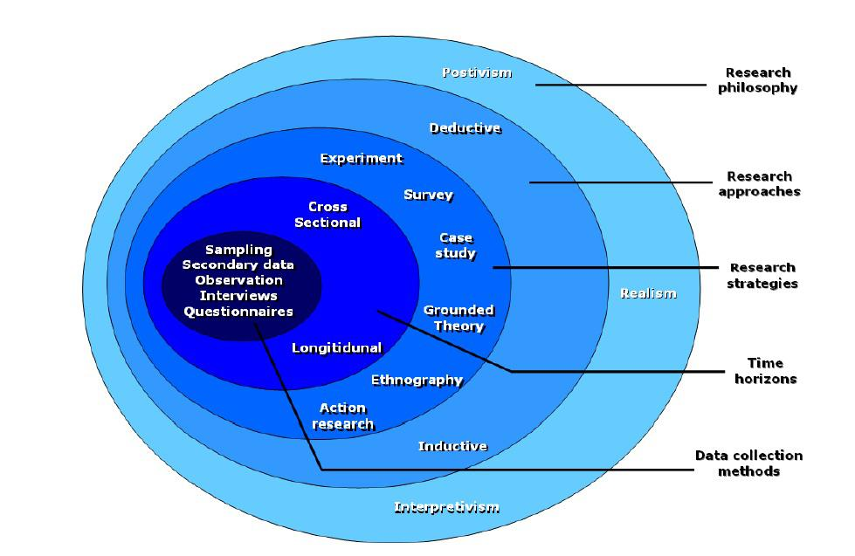
Figure 4: Research Onion Method Source: (Saunders, 2019)

Research Strategy and Choice
A quantitative survey approach is used in this study, which is suitable for analysing trends and associations between the practice of talent management and business performance amongst a heterogeneous sample of employees in the UK retail sectors (None G.J Precila and None Dr R.Sakthivel, 2024). A survey will allow gathering standardised data on more people, which will help to pursue the purpose of the study to determine which TM practices are the most effective and compare the results between the employees of big and medium-sized retailers. The quantitative design is suitable. It is abductive in nature because it offers empirical observations that can be contrasted with the currently existing theoretical expectations without being too difficult to accomplish (Lipscomb, 2012). The retail sector is also a practical place to use a survey strategy because of the geographical location of the employees, who in this case have little time and data collection through online is an effective and readily available tool.

Research Philosophy
In this study, the research philosophy is pragmatist, since it is the most suitable approach to exploring the issue of talent management in a practical organisational setting (Elgeddawy and Abouraia, 2024). As pragmatism focuses on solving practical problems and applying the most appropriate methods in order to achieve the research objective, the approach is applicable to a study oriented at the comprehension of how TM practices affect the business performance in the UK retail. In comparison with purely positivist approaches (that focus on objectivity and controlled measurement) and interpretivist approaches (that focus on subjective meaning), pragmatism can be flexible and provide a balanced orientation that can be used to support quantitative analysis and, at the same time, be grounded in the needs of practitioners (Maksimović and Evtimov, 2023). This conceptual approach concurs with the goal of the study to produce actionable findings to retailers, as well as makes sure that the methodological choices are informed by the most effective approach in providing answers to the research question.

Research Design
The research approach taken in the present study is abductive research, which is suitable considering the need to investigate the mechanism of operation of existing theories on talent management (RBV, AMO, and OST) in the context of the particular and under-studied UK retail sector. Abduction can be applied to both theory and empirical observations, movement in both directions, and it is thus applicable in environments where existing theories provide helpful advice but are not always able to explain sector-specific processes (Hofmann, Paavola and Rainio, 2024). The literature in this research offers a basis to predict the relationship between TM practices and business performance, whereas the empirical evidence collected among the employees working in a retail setting offers an opportunity to refine, make it more nuanced, or even modify theoretical expectations. The abductive approach consequently promotes context-driven interpretation, as well as theory-informed reasoning, which allows the study to produce insights that are informed by existing knowledge but attentive to the nature and issues of UK retail (Kistruck and Shantz, 2021).

Data Collection Procedure
Hosting and introduction: To make the survey easily accessible and compatible across a broad range of devices, which the employees of the retail crew work with, the survey was hosted on Google Forms. The introduction page was also explicit in the purpose of the study and emphasised that participation was voluntary, that it was expected to take a certain amount of time, and that no personal identifiers would be gathered (Raju and Harinarayana, 2021). It also explained that all the responses were to be used in the academic research only.
Distribution & schedule: The survey link was shared via LinkedIn groups where UK retail employees, professional networks, and other related online forums (Taneja, 2024). The connection was also permitted to be communicated internally through shop-floor communication channels where feasible. The collection of the data was implemented within two or three weeks, and a reminder was sent in the middle in order to promote further involvement and enhance the rate of responding.
Consent & eligibility: Participants signed the informed consent by choosing a confirmation checkbox before starting the questionnaire, which included placing a confirmation checkbox before the participant filled out the questionnaire to confirm that he or she met the eligibility criteria, that is, the participant was aged 18 years or older and worked in the retail sector in the UK (GOV.UK, 2016). This process was conducted according to the usual ethical principles by making sure that the participants were well-informed to make an informed decision on whether they should participate.
Data treatment and protection: When the completion was made, responses were downloaded into SPSS to be cleansed and analysed. The data were stored safely in an encrypted drive that could only be accessed by the researcher and the supervisor (Karcher, Secen and Weber, 2023). No names or email addresses, or store identifiers, were stored, and the information accidentally shared was promptly deleted. Such measures provided confidentiality and adherence to ethical principles of research.
The questionnaire operationalises the TM bundles and outcomes specified in Chapter 2 (RBV/AMO/OST logic). Items were derived from the literature reviewed (e.g., training and development, recognition, career pathways, managerial support, perceived TM impact on performance) and expressed as clear, single-idea statements suitable for Likert-type responses (Mcdonnell et al., 2017). The instrument includes the following construct blocks (illustrative items shown here as paraphrases; full wording appears in the instrument):
- Recruitment & Employer Branding (e.g., employer branding effectiveness; clarity and transparency of recruitment; focus on potential).
- Training & Development (e.g., regularity of training; role relevance; career-enabling development; training’s contribution to motivation).
- Performance Recognition (e.g., regular recognition; timely feedback; meaningful rewards linked to recognition).
- Career Development & Succession Planning (e.g., clarity of pathways; opportunities to advance; presence of succession planning).
- Managerial Support (e.g., developmental coaching; adequate feedback; line-manager capability for TM).
- Overall TM Impact (e.g., TM’s effect on business performance, productivity, customer satisfaction, and engagement).
Scale and anchors: Items use a 5-point Likert scale (1 = strongly disagree … 5 = strongly agree). To reduce satisficing and cueing, items are positively phrased, concise, and ordered by construct with brief transitions. Where factual responses are needed (e.g., organisation size, role), categorical options are provided (ScienceDirect, 2025). Demographics include age, position, and years of retail experience, enabling subgroup comparisons.
Content validity: Items reflect established constructs in the literature (e.g., AMO-consistent training/recognition/opportunity, OST-consistent support) and the specific UK retail context discussed in Chapter 2.
Questionnaire access. The instrument is hosted in Google Forms at:
https://docs.google.com/forms/d/e/1FAIpQLSd1sFhXK418KiXWsCzE94Fsb4L_11v1akTF_J69Fpujn7BmCw/viewform?usp=header
Pilot (approximately 8-15 participants who meet the inclusion criteria) is carried out before the actual data collection. The pilot will assess: clarity of instructions and items; time of completion; face validity, and potential non-responding patterns of data. Changes (e.g., make the wording simpler, change the order of blocks, use role-neutral language with frontline and supervisory employees) are made based on the feedback. The pilot results are not aggregated with the primary data unless this is the case that the timing of the pilot coincides with the main data window. Pilot is a part of a number of procedural strategies of validity complementary to the future reliability and validity testing, and it is consistent with the mainstream methodology advice.

Data Preparation and Coding
Screening: Data are screened for duplicates, ineligible respondents (e.g., non-UK retail), and straight-lining. Inclusion checks are applied using eligibility responses.
Coding: Likert responses are coded 1–5 (higher = more of the construct). Where a respondent selects “I don’t know / not applicable” on a scale item, that response is treated as missing for that construct. For factual items (e.g., organisation size), “I don’t know” remains a valid category for descriptive summaries.
Missing data. Rules are pre-specified:
- If ≥20% of items within a construct are missing for a respondent, the construct score is set to missing for that respondent (listwise deletion for that construct).
- Otherwise, missing items within a construct may be replaced by the respondent’s construct-mean (within-scale imputation), a conservative choice that preserves variance structure for reliability analysis.
Assumption checks: For metric analyses, variable distributions are examined (histograms, skew/kurtosis), and outliers are screened using |z| > 3. If necessary, transformations or robust methods are used. Data preparation and assumption checking are executed in SPSS, following standard practice.

Data Measures
Each construct is operationalised with three to four Likert-type items (5-point; higher scores = greater presence of the construct). Construct scores are computed as the mean of their items (provided internal consistency is acceptable).
- Recruitment & Employer Branding (REB)
- Definition: Organisational efforts to attract and select suitable applicants through branding clarity, transparent processes, and emphasis on potential.
- Operationalisation: Items on employer branding effectiveness, recruitment transparency, and talent-potential focus.
- Training & Development (TD)
- Definition: Investments to enhance employee knowledge, skills, and career-enabling capabilities, with relevance to role and motivation (Whitehead, 2022).
- Operationalisation: Items on regularity, role relevance, skill-development pathways, and motivational contribution of training.
- Performance Recognition (PR)
- Definition: Formal and informal mechanisms to acknowledge contributions and provide feedback, including links to meaningful rewards (Imran, Ghazwan and Firmansyah, 2024).
- Operationalisation: Items on regular recognition, timeliness of feedback, and reward meaningfulness.
- Career Development & Succession Planning (CDS)
- Definition: Clarity of advancement pathways, presence of opportunities to progress, and systematic planning for key roles.
- Operationalisation: Items on pathway clarity, advancement opportunities, and succession planning.
- Managerial Support (MS)
- Definition: Direct supervisor behaviours that enable development, provide performance-improving feedback, and evidence capability to implement TM.
- Operationalisation: Items on developmental support, adequacy of feedback, and line-manager TM capability.
- Perceived Business Performance Impact (BP)
- Definition: Employees’ perceptions of how TM affects business outcomes (overall performance, productivity, customer satisfaction, engagement).
- Operationalisation: Items on TM’s impact on business performance, productivity, customer satisfaction, and engagement.
Demographic variables (age, position, years in retail, and organisation size) enable contextual description and subgroup comparisons (e.g., large vs mid-sized).

Population, Sampling and Sample Size

Target population and inclusion criteria
The target population for this study comprises employees working in UK retail organisations, including large national chains and mid-sized multi-site retailers (Shahab and Webb, 2024). This reflects the sectoral scope of the research and supports the objective of comparing talent management practices across different organisational scales. Inclusion criteria were leveled to make sure that the relevant and consistent outcomes of the study, the participants had to be actively working in the UK retail sector, be 18 or older, and be working in any capacity, including frontline work, supervisor, manager, or support functions. Ensuring that the job levels are high will help the study to elicit varied perceptions of talent management and how it is perceived to impact business performances.

Sampling strategy
The study involved a non-probability sampling plan, which is a combination of convenience and snowball sampling approaches, as per the direction of the supervisor and the practical limitations. This is a suitable method since the retail workforce is dispersed and the sampling frame is not comprehensive (Makwana et al., 2023). The participants were reached by means of LinkedIn groups, professional networks, store teams, and alumni channels so that the geographical and organisational coverage was comprehensive. Though non-probability sampling reduces the possibilities of generalising results to the whole sector, it is generally used in management research and is efficient in attracting employees, who have different availability and high pressure at work in a sector.

Sample size and recruitment plan
Following established methodological guidelines and the supervisor’s recommendation, the study aimed to collect 150–200 completed responses. This sample size is suitable for correlation and regression analysis and enables subgroup comparisons between employees in large and mid-sized retailers. Recruitment was carried out through posts in UK retail professional groups, internal store communication channels (where permission was granted), and QR-code posters placed in staff areas. Targeted reminders were issued to maintain response momentum. If realised n is lower than the target, analyses will be scaled accordingly (e.g., descriptive statistics and correlations as primary, parsimonious regression models, cautious subgroup testing). This acknowledges the well-known impacts of sample size on statistical power, precision and the risk of Type II error.

Data Analysis Plan
The statistical analysis of quantitative information gathered using Google Forms was exported to excel and then imported into SPSS Version 26. The analysis was conducted in a systematic order to allow reliability, accuracy and validity of the findings.
1. Data Cleaning and Coding
The raw data was filtered through missing data, frequency of repetition in the data and pattern of responses suggesting straight-lining. The 161 responses were valid and included in the analysis. All the items used in the surveys were assigned numerical values (115), as the Likert scale was utilised in the instrument (Ribeiro and Freitas, 2021). Each construct, Recruitment and Employer Branding (REB), Training and Development (TD), Performance Recognition (PR), Career Development and Succession Planning (CDS), Managerial Support (MS), and Business Performance (BP), was done in composite variables through the MEAN function in SPSS.
2. Reliability Analysis
Cronbach's alpha will be used to determine whether the measurement scales have internal consistency. The alpha values obtained were all greater than the acceptable level of 0.70, and this showed that the items were able to measure the intended concepts.
3. Descriptive Statistics
An analysis to give a summary of the perceptions of the participants will be created using descriptive statistics. The analysis of means, standard deviations, minimum, and maximum values will be used to know the central tendencies and variability of the six dimensions of talent management.
4. Correlation Analysis
Pearson correlation coefficients will be estimated to investigate the strength and direction of the relationship between the constructs of talent management and business performance. The variables were all found to be significantly and positively correlated, meaning that the perceived business performance was accompanied by an increase in the talent management practices.
5. Regression Model Specification
The conceptualisation of the predictive relationship between the independent variables and the dependent variable in the standard linear format was done before testing of the regression model in SPSS:
$$Y=b_{1}(\text{REB})+b_{2}(\text{TD})+b_{3}(\text{PR})+b_{4}(\text{CDS})+b_{5}(\text{MS})+a$$
Where:
Y = Business Performance (BP)
REB = Recruitment & Employer Branding
TD = Training & Development
PR = Performance Recognition
CDS = Career Development & Succession Planning
MS = Managerial Support
a = constant (intercept)
The multiple regression analysis was developed conceptually using the equation above.
6. Multiple Regression Analysis
Subsequently, the regular multiple regression was conducted in SPSS, which determined the degree to which the five dimensions of talent management would be effective predictors of business performance (Al-Haraisa et al., 2021). Assumptions of linearity, normality of residues, homoscedasticity, and multicollinearity were met. The predictive power of all the constructs was interpreted based on the regression coefficients, significant values, R-squared and the collinearity diagnostics.
7. Interpretation of Outputs
The results of Chapter 4 findings and discussion were informed by the outcome of descriptive analysis, the reliability analysis, correlation and regression analysis. Through the regression analysis, there has been a clear insight into the talent management practices that influenced business performance most in the UK retailing industry.

Reliability and Validity
Another process involved the quality and validity of the measurement scales, whereby the quality and accuracy of the measurement scales were observed in the study. To establish internal consistency reliability, the alpha Cronbach was used, and the definition is that ά ≥ 0.70, indicating that the reliability is acceptable, which was achieved by all six constructs, which indicated that the items in each scale are working as per the intended concept (Taber, 2018). It was supported by the construct validity, which was estimated by the observation of the high relationship of the theoretically coherent character in the correlation analysis, and the results remained unchanged and consistent with the available frameworks, the AMO model, the Resource-Based View and the Organisational Support Theory; the high reliability and clarity of the measuring model did not imply the application of an Exploratory Factor Analysis (EFA). A strict development procedure was crucial for content validity; all the questions in the questionnaires were informed by the literature and the conceptual framework, which was revised by the supervisor on its clarity and relevance and finally reduced after a pilot test based on whether it covered all the constructs. Certain procedural solutions were implemented to reduce the research common-method bias, including the anonymity of the participants, neutral wording of the items, and the separation of the constructs into identifiable, clear sections. A one-factor post hoc test determined that there was no single factor that explained the highest proportion of variance, pointing out that common-method bias was not a serious problem in the dataset.

Methodological Limitations
Several limitations are related to this study. First, a cross-sectional design captures the perceptions of the participants at one point in time, therefore restricting the causal conclusion and is not capable of examining the changes and trends across time. Second, there is a possibility of certain potential bias of a self-report survey measure, such as social desirability and common-method variance, which were also guarded by the procedural factors, such as anonymity and the use of neutral wording of items (Cooper et al., 2020). Third, the non-probability sampling, which was appropriate in the process of reaching out to the spread-out retail employees, reduces the external generalisability of the findings to the sample, and needs to be applied carefully in the process of comparing the subgroup difference between the types of retailers or job roles. Also, 161 was adequate to provide a correlation and regression analysis, but the inappropriate sampling techniques and unequal representation of the subgroups may affect the statistical power and stability of the parameter estimates. Finally, it has an industry-specific orientation in the UK retail sector that enhances contextual relevance at the expense of transferability of findings to other industries or geographical locations where labour market features or organisational designs vary (Sayad, 2022). Such limitations do not diminish the value of the study, but they provide a good framework when interpreting the results and guide future research.

Ethics
These ethical principles are followed: informed consent, voluntary participation, right to withdraw, anonymity/confidentiality, and data security storage (Bhandari, 2024). The consent process also emphasises clarity and understanding that is in tandem with the current arguments regarding informed consent in research ethics. No personal data is collected in the course of the research, and the data is stored in secure stores that are only accessible to a few academicians. The ethics committees give approval to carry out research.

Chapter-4: Data Analysis

Findings
The dataset was exported from Google Forms, and then 161 responses were imported into SPSS to perform the analysis. Accuracy and reliability were then maintained by performing a systematic data-cleaning process. First, the responses were filtered according to completeness, and those cases whose missing data was over 20% of all questions were filtered out. The dataset was also tested to remove cases of duplication of the submission, responses to people who did not qualify to be provided to the study (like non-UK retail employees), and straight-line responses, including in cases where participants made the same choice (say, all 3s or all 5s) across the questionnaire. Since there were no items in the instrument that were negatively phrased, reverse coding was not required. After cleaning the dataset, every questionnaire item has been coded on a five-point Likert scale of the study with the following codes: 1 was Strongly Disagree, 2 was Disagree, 3 was Neutral, 4 was Agree, 5 was Strongly Agree. The 161 responses that could be used were then sorted into the six talent management and performance constructs that were established in the design of the instruments. Items 1 to 3 fell under Recruitment and Employer Branding (REB) and items 4 to 10 under Training and Development (TD) and items 11 to 13 under Career Development and Succession Planning (CDS), items 14 to 16 under Managerial Support (MS), and items 17 to 20 under Business Performance (BP). Each construct was given its mean scores, which were analysed in coherent and similar ways, to determine how the practice of talent management is correlated with perceived business performance among the overall sample of 161 respondents. That is, as a way of facilitating the consistency of the study, the average score of each construct was made by averaging the corresponding questionnaire items, which created composite variables (REB, Recruitment and Employer Branding), TD (Training and Development), PR (Performance Recognition), CDS (Career Development and Succession Planning), MS (Managerial Support) and BP (Business Performance).
Table 1: Demographic Profile Analysis
Variable | Category | %
Age Range | Under 25 | 30.4
 | 25–34 | 51.6
 | 31–44 | 16.1
 | 45–54 | 1.2
 | 55+ | 0.6
Gender | Male | 59.6
 | Female | 39.8
 | Other/Prefer not to say | 0.6
Position | Frontline Staff | 13.7
 | Supervisor | 13.0
 | Manager | 52.2
 | Other roles* | 21.1
Years of Experience | <1 year | 14.3
 | 1–3 years | 50.3
 | 4–6 years | 29.8
 | 7+ years | 5.6
Organisation Size | Small (<50) | 18.6
 | Medium (50–249) | 65.8
 | Large (250+) | 11.2
 | Not sure | 4.3

A total of 161 respondents participated in the survey, representing a diverse cross-section of the UK retail workforce.
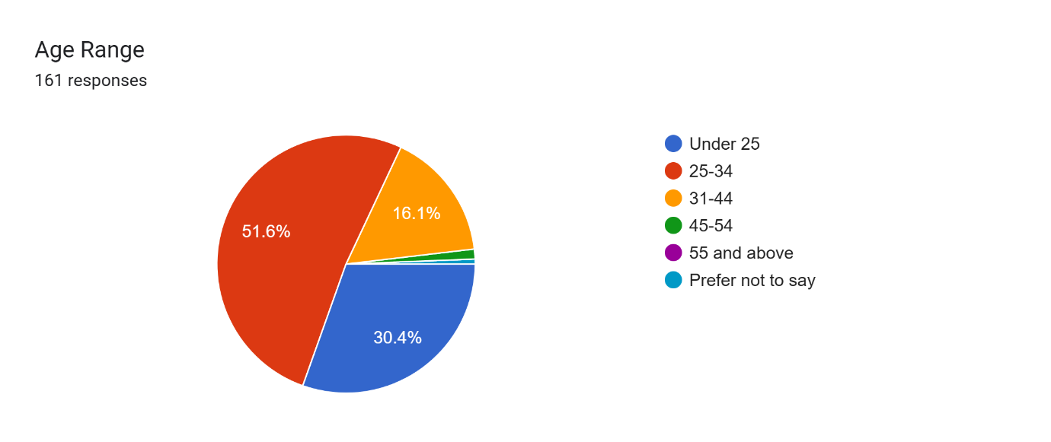
Figure 5: Age Distribution
The majority were aged between 25 and 34 (51.6%), followed by those under 25 (30.4%), indicating a predominantly young workforce.
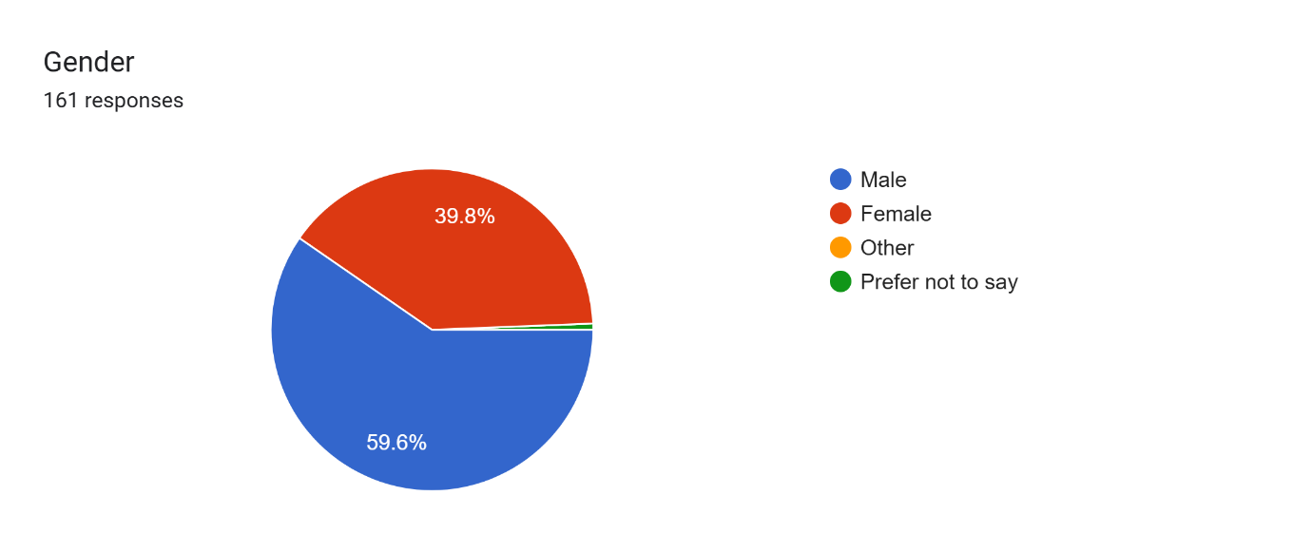
Figure 6: Gender Distributions
The number of male respondents was 59.6, and that of females was 39.8. Concerning job roles, over fifty percent of the respondents were managers (52.2), and frontline staff and supervisors were 13.7% and 13.0 percent respectively, with other occupational groups (senior manager, consultant, or waitress) taking the rest. The career profiles showed that the majority of the participants (50.3) had one-three years of industry experience, which is rather an early career experience, with 29.8 years of experience.
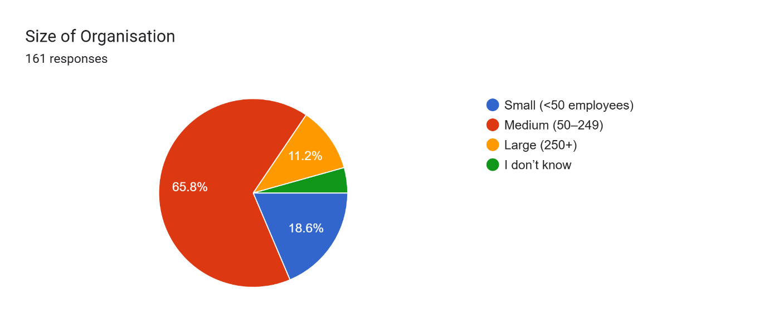
Figure 7: Organisational Size Distribution
Speaking of the size of organisations, most of them were employed in a medium-sized retailer (65.8%), 18.6% worked in a small organisation, and 11.2% worked in a large retail chain. The given demographic population gives a wide and representative foundation to examine the perceptions of talent management across various age groups, the size of organisations, and job levels of the UK retail industry.
Table 2: Reliability Statistics for Talent Management
Construct | Items | Cronbach’s Alpha (α) | Interpretation
Recruitment & Employer Branding (REB) | 3 items | 0.755 | Acceptable reliability
Training & Development (TD) | 4 items | 0.863 | Very good reliability
Performance Recognition (PR) | 3 items | 0.811 | Good reliability
Career Development & Succession Planning (CDS) | 3 items | 0.804 | Good reliability
Managerial Support (MS) | 3 items | 0.783 | Acceptable–good reliability
Business Performance (BP) | 4 items | 0.837 | Very good reliability

The internal consistency reliability test based on Cronbach's alpha revealed that all six measures employed in the study had acceptable to very good internal consistency, which indicated that the names of the measurement scales were applicable in the subsequent statistical analysis. The alpha of Recruitment and Employer Branding was 0.755, which is satisfactory in a three-item scale. The alpha of 0.863 obtained by Training and Development is higher; it indicates a high level of internal consistency among the four items that measure the training support and skills development. The performance Recognition ( alpha = 0.811 ) and Career Development and Succession Planning ( alpha = 0.804 ) all had good reliability, which indicated that the items of the two constructs were able to measure their intended dimension. Managerial Support had an alpha of 0.783, which is acceptable and meets the expectations of three item construct. Lastly, Business Performance had an alpha of 0.837, and this shows that the results are very good, which proves that the respondents were very consistent in their ratings of performance-related outcomes. In general, the values of all Cronbach's alphas were higher than the recommended value of 0.70, which signifies that the scales were consistent in terms of internal consistency and that the constructs were valid to be further correlated and regressed.
Table 3: Descriptive Statistics for Talent Management
Construct | Mean (M) | Standard Deviation (SD)
Recruitment & Employer Branding (REB) | 3.33 | 0.94
Training & Development (TD) | 3.63 | 0.99
Performance Recognition (PR) | 3.63 | 1.04
Career Development & Succession Planning (CDS) | 3.65 | 1.05
Managerial Support (MS) | 3.73 | 1.01
Business Performance (BP) | 3.76 | 0.98
Descriptive statistics were calculated to assess respondents’ overall perceptions of talent management practices and perceived business performance within UK retail organisations. The results show that all constructs recorded mean scores above the midpoint of the five-point scale, indicating generally positive perceptions across the sample. Among the talent management dimensions, Managerial Support (M = 3.73) and Career Development and Succession Planning (M = 3.65) received the highest average ratings, suggesting that respondents felt relatively well supported by their line managers and recognised opportunities for development within their organisations. Training and Development (M = 3.63) and Performance Recognition (M = 3.63) also showed favourable perceptions, though with slightly higher variability, as indicated by their standard deviations. Recruitment and Employer Branding presented the lowest mean score (M = 3.33), although still above the neutral midpoint, suggesting that respondents viewed recruitment practices as adequate but comparatively less strong than other TM components. Business Performance reported the highest mean overall (M = 3.76), indicating that employees generally perceived their organisations as performing well. The standard deviations for all constructs (ranging from 0.94 to 1.05) suggest moderate variability in responses, which reflects the diverse roles, experience levels, and organisational contexts represented in the sample.
Table 4: Pearson Correlation Matrix for Talent Management
Variable | REB | TD | PR | CDS | MS | BP
REB | 1 | .811** | .743** | .807** | .724** | .789**
TD | .811** | 1 | .839** | .861** | .774** | .785**
PR | .743** | .839** | 1 | .821** | .824** | .784**
CDS | .807** | .861** | .821** | 1 | .835** | .875**
MS | .724** | .774** | .824** | .835** | 1 | .842**
BP | .789** | .785** | .784** | .875** | .842** | 1
The Pearson analysis has been used to investigate the correlation between the talent management practice and the perceived business performance in the UK retail industry. The findings indicate that all variables have a positive correlation with each other in high and statistically significant negative correlations (p < .01), meaning that an improvement of any talent management area is correlated with perceived business performance. Career Development and Succession Planning (CDS) is the most closely related construct of talent management that exhibited the best correlation with Business Performance (r = .875, p < .01). This poses the possibility that growth opportunities, avenues of career, and formal development programs are very instrumental in the way employees perceive organisational performance. Managerial Support (MS) was also significantly related to performance (r = .842, p <.01), which, again, emphasises the significance of supportive leadership behaviours and efficient line management in bringing about positive results. All of it, Training and Development (r = .785, p < .01), Performance Recognition (r =.784, p <.01), and Recruitment and Employer Branding (r =.789, p <.01), showed significant positive relationships with performance meaning that they are practices that add value to the overall feedbacks that the employees have concerning the performance of their organisations. There are also very high correlations between the constructs of talent management, which also demonstrate the inter-relationship between TM systems, where strengths in one area are frequently matched with strengths in others. In general, the results confirm the theoretical assumptions of the Resource-Based View, AMO, and Organisational Support Theory, which state that those organisations that invest in employee capabilities, motivation, and support structures with the aim of achieving better performance results have a higher likelihood of success.
Table 5: Multiple Regression Analysis Predicting Business Performance
Predictor | Standardised Beta (β) | t-value | p-value (Sig.) | VIF | Significant?
Recruitment & Employer Branding (REB) | 0.201 | 3.190 | .002 | 3.407 | Yes (p < .05)
Training & Development (TD) | –0.056 | –0.704 | .483 | 5.440 | No
Performance Recognition (PR) | 0.034 | 0.468 | .640 | 4.633 | No
Career Development & Succession Planning (CDS) | 0.456 | 5.531 | .000 | 5.836 | Yes (p < .001)
Managerial Support (MS) | 0.331 | 4.793 | .000 | 4.103 | Yes (p < .001)
The multiple regression analysis was done to determine the talent management practices that play a significant role in predicting the perceived business performance in the UK retail sector. The model as a whole was significantly different, F(5,155) = 140.743, p <.001 and indicated an extremely strong explanatory ability with R² of.819. It means that the five dimensions of talent management used in the model can explain around 82% of the variance in business performance.
The findings also established that there were three important predictors of business performance:
- The most significant predictor ( 0.456, p < 0.001) was Career Development & Succession Planning (CDS). This implies that employees who see development directions and success in their careers have a high probability of rating business performance positively. This observation is quite consistent with the Resource-Based View and AMO framework, which focus on development as an important source of capability and performance.
- The second strongest and important predictor ( 0.331, p <.001) was Managerial Support (MS). This shows that supportive leadership, effective communication, and direct involvement of managers in shaping the perceptions of employees on the organisational performance are important. The finding is in line with Organisational Support Theory, which postulates that perceived support increases motivation and discretionary effort.
- The recruitment & Employer Branding (REB) also exhibited a great positive impact ( =.201, p =.002). This implies that well-managed recruitment and good employer image have some significance to the perceived organisational performance by the employees, though not so much as compared to development or managerial support.
Two predictors were not significant:
- Training & Development (TD) (β = –.056, p = .483)
- Performance Recognition (PR) (β = .034, p = .640)
Although the two variables have correlations that were positive correlations with the performance of the business in previous analysis, their prediction was not significant when other strong variables (CDS, MS, REB) were incorporated into the regression model. This implies that there could be an overlapping variance, or it could be that training and recognition could have an indirect influence on other practices, including managerial support or career development. Lastly, all VIF values were below 10, as indicated by multicollinearity diagnostics showing that there was no concerning overlap of predictor variables. Altogether, the regression analysis shows that career development, managerial support, and effective recruitment are the most effective aspects of talent management to forecast business performance in the UK retail industry. Such insights indicate certain areas in which the retail organisations can revise their efforts to enhance the workforce and organisational performance. According to the non-standardised coefficients of the multiple regression analysis, the predictive model of the business performance (BP) is presented as follows:
$$\text{BP}=0.387+0.211(\text{REB})-0.055(\text{TD})+0.033(\text{PR})+0.426(\text{CDS})+0.322(\text{MS})$$This equation shows that the business performance would increase by 0.211 units with a constant other variable held constant, a one-unit change in Recruitment and Employer Branding (REB), a one-unit change in Career Development and Succession Planning (CDS), and a one-unit change in Managerial Support (MS). The training and development (TD) and performance recognition (PR) coefficients are negligible and statistically insignificant, and therefore provide evidence that these two dimensions will not make any meaningful contribution to business performance in the presence of the other dimensions of talent management in the model.

Discussion
The primary objective of the study was to investigate the impact of talent management (TM) strategy on business performance of the UK retail sector, and the research has been able to substantially support this objective. The findings reveal that employees had a positive perception of most of the TM practices, with the average score of employees being above 3.3 on the five-point scale. Managerial Support and Career Development had the highest scores as they represent the significance of day-to-day supervisor behaviour and visible progression as factors influencing the experience of the employees. Such trends can be related to the literature that emphasises the high role of line managers and career progressions in the increase of engagement and organisational performance (Kravariti et al., 2023; Al Aina and Atan, 2020). In addition to the statistical findings of the significance of predictors, the results also demonstrate the valuable structural and behavioural dynamics influencing the functioning of talent management in UK retail organisations. This extremely high degree of variance in business performance implies that the employees see talent management as the core of organisational performance, and not a marginal HR activity. Human interaction, quality of service and continuity of the frontline delivery are of greater relevance in this perception as far as operational success in retail is concerned. An important lesson learned during the findings is that talent management practices seem to have a hierarchy. Although all practices showed a high degree of bivariate relationships with performance, all dimensions could not maintain explanatory power when models were analysed at once. This implies that the practices can serve as primary drivers, and others can serve as facilitating or enabling processes. Career Development and Succession Planning seems to serve as a structural anchor of the talent system. Employees with a long-term perspective are likely to view business with a more positive outlook generally and to rate the business in a more positive light regardless of the harsh conditions in which they operate. This implies that the perceived future security might override the short-term incentives in performance perceptions. Managerial Support has a complementary role to play. The results suggest that managerial behaviour can be the main source of formal talent management policy experience. In the high-work intensity and low-autonomy retail environments, employees can look to immediate supervisors to be more helpful in offering clarity, encouragement and developmental direction. As a result, managerial support could be beneficial to performance both directly and indirectly through the legitimisation and reinforcement of other talent practices. This further supports the point that the effectiveness of talent management is strongly reliant on the quality of implementation and not policy development. The unpredictable meaning of the Training and Development and Performance Recognition is a critical aspect of the analysis. These are positive practices that could be inadequate in what can be termed as an execution-impact gap. Generic training programs, those that are occasional or not linked with progression, could not be converted into perceived organisational benefits. Equally, the recognition practices that are not consistently achieved or have no concrete results can be considered as symbolic instead of performance-enhancing. This observation contradicts the belief that the greater the organisational investment in training or recognition, the better the organisational results, and this underlines the necessity of strategic alignment. Also, the results indicate that employees base their business performance on an experience-based approach instead of objective criteria. The organisational competence, credibility of the leadership and long-term orientation seem to be the factors that influence performance perceptions. Talent management practices that convey a sense of stability, growth and support could thus impact performance perceptions despite the financial results not necessarily being seen directly by the employees. One of the main aims of the study was the evaluation of which TM practices are the most effective at improving business performance, and the regression analysis provides the direct answer to this. The three practices that were relevant predictors of the business performance include Career Development and Succession Planning ( =.456), Managerial Support ( =.331) and Recruitment and Employer Branding ( =.201). This is because when employees are given clear room to develop, supported by their managers and perceive that the organisation is attracting the right individuals, the employees are more likely to perceive that the business is doing well. These findings also coincide with the previous literature findings that career trajectories and managerial supportive behaviour are associated with increased productivity and performance (Nguyen et al., 2022; Kurtessis et al., 2017). These conclusions are supported by the correlation analysis, which demonstrates positive and strong relationships among all TM practices and business performance. Career Development once again demonstrated the highest correlation (r =.875), and this supports the argument that progression opportunities are a fundamental driver of performance perceptions. This applies to the literature review in Chapter 2, which consequently identifies learning, development and succession planning as key processes by which TM is related to sustainable organisational performance (Al Aina & Atan, 2020; Sembiring & Damayanti, 2023). The arguments of the Organisational Support Theory are also present in the strong correlation between Managerial Support and performance (r =.842), which implies that employees are more likely to perform better when they feel that they are important and supported by supervisors. Critically, out of two practices, such as Training and Development, and Performance Recognition, two practices which are positively linked with performance but not significant in the regression model were identified. This should not imply that these practices are insignificant, but it simply indicates that training and recognition may be more indirect under the influence of stronger forces like career development as well as managerial support. This is similar to the contradictory results in the literature, where training is not always equal to performance without the opportunities and supportive management (AMO framework; Bos-Nehles et al., 2023). On the whole, the results will answer the research question- How do talent management strategies contribute to business performance in UK retail and what practices are most effective? Because it demonstrates that talent management has a positive contribution to the business performance in the form of development-oriented practices and supportive line manager behaviour. These findings are quite consistent with the theoretical frameworks adopted in the research. According to the RBV, human capital is a strategic resource, and the value of career development in this study supports the fact that establishing value in employees by developing their skills and potential brings value to the organisation. The AMO model is also highly evident in the results: the development of careers and recruitment makes employees more competent, and the management support helps to motivate them and give a chance to perform better. Lastly, the managerial support has a positive impact that directly correlates to the Organisational Support Theory, which holds that the more employees feel that they are supported by their managers and the organisation at large, the more committed they are and the better they perform. Using these findings in connection with the objectives and theoretical backgrounds of the study, this summary demonstrates that talent management does provide an obvious and significant influence on the business performance in the UK retailing sector. Three priority areas have been identified as career development, managerial support, and effective recruitment as the TM practices that best relate to performance, and the result is a very strong foundation for the practical recommendations that follow in Chapter 5.

Chapter-5: Conclusion & RECOMMENDATIONs
The study was to investigate the extent to which talent management (TM) practices impact the performance of the business in the United Kingdom retail business, and what practices employees believe have made the greatest contribution towards the success of the organisation. This study has been conducted against the backdrop of the incessant workforce-associated issues in the retail sector, that are high rate of employee turnover, skills gaps, high rate of competition and increasing intricacy of operations. Trying to make a theoretically grounded and empirical statement of the impact of the talent management practices on the performance scores in the given industry, the study included the Resource-Based View (RBV), the Ability-Motivation-Opportunity (AMO) framework, and the Organisational Support Theory (OST). The research findings show a clear understanding that talent management has a significant and considerable contribution to the perceived business performance of the UK-based retail organisations. The talent management practices presented in this research had a substantial portion of the variance of business performance as a group, and this implies that employees regard TM as a driver of organisational effectiveness as a whole, and not a marginal human resource practice. This confirms the growing literature which shows that people management practices are critical to sustainable performance, in particular within industries that engage in services where worker behaviour directly affects the customer experience and operating performance (Sariwulan et al., 2021). Among the key results of the study is the fact that the talent management practices do not equally contribute to the performance of the business. In spite of a positive correlation between all TM dimensions and the performance, the regression analysis revealed only three statistically significant practices, including Career Development and Succession Planning, Managerial Support and Recruitment and Employer Branding. The outcome of this finding suggests the applicability of prioritisation in the talent management action plans and nullifies the perception that all HR activities offer equal value in terms of performance. Career Development and Succession Planning (CDS) was the most predictive of business performance since the standardised beta coefficient ( =.456) had the highest value. The implication of this discovery is that long-term growth opportunities and career development mean a lot to the staff members in evaluating the performance of organisations. As a part of the UK retail market, where the general pattern is characterised by a lack of progress and turnover, the presence of specified career ladders appears to be a solid indicator of organisational stability and intent to play. When employees have a sense that their organisation is investing in them, they will become more inclined to make wider organisational implication in the workplaces despite the organisational pressure being apparent It is a strong confirmation of the earlier research according to which career development is among the most significant elements that determine the capacity, devotion, and output of employees (Al Aina and Atan, 2020; Sembiring and Damayanti, 2023). Regarding the development of value and the exclusive human capital, the RBV holds that career development also helps in the rise in value, owing to the fact that it is being developed along the firm-specific skills and knowledge that cannot be understood by any other competing firm. This is also associated with AMO because development programs not only enhance the capacity of the employees, but also enhance motivation as a result of creating the impression of future promotion investment. Managerial Support (MS) was the second predictor of business performance with the greatest impact ( =.331). The above finding shows the acute importance of line managers in shaping the experience of the employees and translating the formal policies of talent management into practice. Supervisors and store managers are also hired to perform scheduling, performance feedback and on-the-job coaching. Most retail organisations, thus, are the contacts to be used between the employee and the organisation. The managerial support can be highly predictive, with the implication that the supportive managerial behaviour is viewed by the employees as a way of direct measurement of organisational competence and effectiveness(Bourini et al., 2019). Another reason, which proves the relevance of the Organisational Support Theory, which states that employees who feel valued and supported will be more engaged and will be more willing to make additional effort, is the close relationship between managerial support and business performance (r =.842). The results are consistent with the literature presented in Chapter 2, which suggests that managerial behaviour is one of the key mechanisms that offer the talent management practices within the retail environment. It also portrays the risk of implementation mismatches, i.e. deliberated TM plans fail to provide any outcomes due to a deficiency of managerial skills or willingness. The importance of Recruitment and Employer Branding (REB) was likewise gained positively with a business performance ( = 0.201), which is less than that of career development and managerial support. It is an outcome that confirms the importance of attracting the appropriate talent to the hugely competitive labour market and supports the existing research indicating that employer branding is a contributor to organisational performance (Gurgu and Kuleto, 2023). Under the RBV, the quality of human capital will be enhanced through good recruitment that will get into the organisation, which will underpin future performance. However, considering the relatively low impact of recruiting in contrast to practices based on development, one can observe that the attraction is hardly enough to sustain performance when the support of performance within an organisation and its promotion is not provided. Training and Development (TD) and Performance Recognition (PR) are linked to a less obvious conclusion of the research. Even though the two practices were highly and positively correlated to the business performance, neither of them was found to be a significant predictor of the business performance when other TM practices were included in the regression model (Ali and Ullah, 2023). This result does not imply that training and recognition are unimportant; they may be indirect or require the presence of other practices. The observation is consistent with the current literature, which demonstrates that training alone is not an unquestionable method of guaranteeing improved performance unless the employees are provided with an opportunity to apply newly acquired skills practically and assisted by efficient management (Saleh and Azimi, 2025). In the same way, recognition of performance may increase motivation and morale but fail to have a direct impact on the higher performance perceptions in the example where there are already good performance structural forces, including career advancement and managerial support (Imran, Ghazwan and Firmansyah, 2024). One AMO definition of the same is that performance-producing practices, which are ability and motivation-enhancing, are to be accompanied by complementary opportunity-enhancing situations. In total, the findings indicate that the employees base their evaluation of the performance of the business on a combination of structural cues, relational cues, and developmental cues. The most impactful on the perception of performance appears to be the practice of talent management, which is the process of communicating the long-term investment, the supportive leadership, and the coherence of the organisation. The practices can be instrumental in making a difference and maintaining in the competitive and volatile UK retail environment (Harris and Ogbonna, 2023). Overall, it is reaffirmed in this paper that talent management is a significant determinant of business performance within the retail industry in the UK, though with varied impacts on the different practices. The highest influence of perceived performance are career development and succession planning, managerial support, and competent recruitment. Training and recognition are relevant parts of the talent management system. However, they appear to be more effective in the context of a more extensive system of development and support of the leadership. Such inferences provide a good empirical foundation for the useful recommendations below.
Limitations of the Study
Although this research has its contributions, it should be admitted that it has various limitations. In the first place, the research design used a cross-sectional research design, which obtained the perceptions of the employees at a single point. Through this, there are no conclusive causal ties between talent management practices and business performance that can be established. Second, the non-probability sampling reduces the external validity of the findings to the sample studied. Even though the sample size used was sufficient, it is possible that due to the participation based on convenience, there was a sampling bias (Ahmed, 2024). Third, the research utilised self-reported data only, which can be biased by the possibility of a response and common-method errors. Although measures were put in place to reduce such risks as anonymity, they are not completely avoidable.
Recommendations
In accordance with the results, a number of recommendations to be applied in the retail organisations that aim to reinforce talent management and business performance can be made:
1. Focus on Career Development and Succession Planning: Retailers are supposed to offer clear career advancement, internal promotions and detailed development programmes (Setyawati, Woelandari and Rianto, 2022). This will be able to retain manpower and minimise turnover, and create a better internal talent pipeline.
2. Uphold Managerial Support at all Levels: Due to the high impact of managerial support, the organisation ought to invest in managerial and supervisor leadership and coaching skills (Osuzoka, 2024). Retail line managers usually become the key to the overall experience of the employees; thus, increasing their capacity to support personnel can help boost motivation and performance considerably.
3. Entice Recruitment and Employer Branding: Retailers ought to invest in transparent, attractive, and clear recruitment procedures. Having a good employer brand is useful in attracting quality candidates, and this has a positive influence on the performance of an organisation (Gurgu and Kuleto, 2023).
4. Improve Training and Recognition Systems but Combine Them with More Wide-Ranging TM Practices: Training and recognition did not play crucial roles in the regression model, yet there were positive relationships with performance (Nguyen and Duong, 2020). The retailers ought to make the training viable, related to growth and backed by the managers. Timely recognition must be in terms of organisational values.
5. Take a Comprehensive Talent Management Perspective: The findings indicate that TM practices are not independent of each other. Everything should be coordinated by retailers, and that should include training, recognition, development, recruitment, and managerial support to provide a consistent and positive employee experience (Walters and Rodriguez, 2017).

References
Ahmad, R., Nawaz, M.R., Ishaq, M.I., Khan, M.M. and Ashraf, H.A. (2023) ‘Social Exchange theory: Systematic Review and Future Directions’, Frontiers in Psychology, 13, pp.1–13. doi:10.3389/fpsyg.2022.1015921.
Ahmad, R., Nawaz, M.R., Ishaq, M.I., Khan, M.M. and Ashraf, H.A. (2023) ‘Social Exchange Theory: Systematic Review and Future Directions’, Frontiers in Psychology, 13, pp. 1–13. doi: 10.3389/fpsyg.2022.1015921.
Ahmed, S.K. (2024). Research methodology simplified: How to choose the right sampling technique and determine the appropriate sample size for research. Oral Oncology Reports, [online] 12(100662), pp.1–7. doi:https://doi.org/10.1016/j.oor.2024.100662.
Aina , R.A. and Atan, T. (2020). (PDF) 📄 The Impact of Implementing Talent Management Practices on Sustainable Organizational Performance. [online] ResearchGate. Available at: https://www.researchgate.net/publication/344743615_The_Impact_of_Implementing_Talent_Management_Practices_on_Sustainable_Organizational_Performance.
Al Aina, R. and Atan, T. (2020) ‘The impact of implementing talent management practices on sustainable organizational performance’, Sustainability, 12(20), p.8372. doi:10.3390/su12208372.
Al Aina, R. and Atan, T. (2020) ‘The impact of implementing talent management practices on sustainable organizational performance’, Sustainability, 12(20), p. 8372. doi:10.3390/su12208372.
Al Aina, R. and Atan, T. (2020) ‘The Impact of Implementing Talent Management Practices on Sustainable Organizational Performance’, Sustainability, 12(20), p. 8372. doi: 10.3390/su12208372.
Al Habsi, S.S. (2024) ‘Ethical Considerations in Obtaining Informed Consent in Research Participation’, International Journal of Educational Contemporary Explorations, 1(1), pp.22–32. doi:https://doi.org/10.69481/divl1152.
Al Habsi, S.S. (2024). Ethical Considerations in Obtaining Informed Consent in Research Participation. International Journal of Educational Contemporary Explorations, 1(1), pp.22–32. doi:https://doi.org/10.69481/divl1152.
Alharahsheh, H.H. and Pius, A. (2020) ‘A review of key paradigms: Positivism vs interpretivism’, Global Academic Journal of Humanities and Social Sciences [online]. Available at: https://www.researchgate.net/publication/338244145_A_Review_of_key_paradigms_positivism_VS_interpretivism.
Alharahsheh, H.H. and Pius, A. (2020). A review of key paradigms: Positivism vs interpretivism. [online] Global Academic Journal of Humanities and Social Sciences. Available at: https://www.researchgate.net/publication/338244145_A_Review_of_key_paradigms_positivism_VS_interpretivism.
Al-Haraisa, Y.E., Al-Ma’aitah, N., Al-Tarawneh, K. and Abuzaid, A. (2021). Talent Management Practices and Competitive Advantage. International Journal of Service Science, Management, Engineering, and Technology, 12(5), pp.102–115. doi:https://doi.org/10.4018/ijssmet.2021090107.
Al-Hussaini, S.H., Turi, J.A., Altamimi, A.N.A., Khan, M.A. and Ahmad, M. (2019) ‘Impact of talent management strategies on employee performance behaviour with the mediating role of talent management outputs’, Archives of Business Research, 7(3), pp.116–124. doi:10.14738/abr.73.6309.
Al-Hussaini, S.H., Turi, J.A., Altamimi, A.N.A., Khan, M.A. and Ahmad, M. (2019) ‘Impact of talent management strategies on employee performance behaviour with the mediating role of talent management outputs’, Archives of Business Research, 7(3), pp. 116–124. doi:10.14738/abr.73.6309.
Ali Almohtaseb, A., A Kareem Shaheen, H., Mohummed Alomari, K. and Yousef Almahameed, M.A. (2020). Impact of Talent Management on Organizational Performance: The Moderating Role of an Effective Performance Management System. International Journal of Business and Management, 15(4), p.11. doi:https://doi.org/10.5539/ijbm.v15n4p11.
Ali, M. and Ullah, M.S. (2023). Role of laissez-faire Leadership in Talent management: Evidence from the Pharmaceutical Industry of Bangladesh. Role of laissez-faire Leadership in Talent management: Evidence from the Pharmaceutical Industry of Bangladesh, [online] 9(6), pp.e17234–e17234. doi:https://doi.org/10.1016/j.heliyon.2023.e17234.
Aljbour, A., French, E.L. and Ali, M. (2025) ‘The Many Faces of Talent Management: Organizational Perspectives on Talent Management Practices in Jordan’, Human Resource Development Quarterly, 36(1) (forthcoming).
Aljumah, A. (2023). The Impact of Job Training on Recruitment and Employability Skills Among Graduates. International Journal of Professional Business Review, 8(10), pp.e02806–e02806. doi:https://doi.org/10.26668/businessreview/2023.v8i10.2806.
Almomani, L.M., Obeidat, B.Y. and Sweis, R. (2021) ‘The impact of talent management practices on employees’ job satisfaction’, International Journal of Business Environment, 1(1), p.1. doi:https://doi.org/10.1504/ijbe.2021.10043619.
Almomani, L.M., Obeidat, B.Y. and Sweis, R. (2021). The impact of talent management practices on employees’ job satisfaction. International Journal of Business Environment, 1(1), p.1. doi:https://doi.org/10.1504/ijbe.2021.10043619.
Al-shahwani, T.M. (2020) ‘Impact of AMO enhancing human resource management practices on sustainable competitive advantage in insurance companies in Qatar’, Management Science Letters, 10(8), pp.1827–1834. doi:https://doi.org/10.5267/j.msl.2019.12.036.
Al-shahwani, T.M. (2020). Impact of AMO enhancing human resource management practices on sustainable competitive advantage in insurance companies in Qatar. Management Science Letters, 10(8), pp.1827–1834. doi:https://doi.org/10.5267/j.msl.2019.12.036.
Amelia, E. and Rofaida, R. (2023) ‘Talent management in organizations’, Airlangga Journal of Innovation Management, 4(1), pp.41–59. doi:https://doi.org/10.20473/ajim.v4i1.44981.
Amelia, E. and Rofaida, R. (2023). TALENT MANAGEMENT IN ORGANIZATIONS. Airlangga Journal of Innovation Management, 4(1), pp.41–59. doi:https://doi.org/10.20473/ajim.v4i1.44981.
Barney, J.B. (1991) ‘Firm resources and sustained competitive advantage’, Journal of Management, 17(1), pp.99–120.
Barney, J.B. (1991) ‘Firm Resources and Sustained Competitive Advantage’, Journal of Management, 17(1), pp. 99–120.
Bergmann, J. (2023). Research Philosophy, Methodological Implications, and Research Design. Studien zur Migrations- und Integrationspolitik, [online] pp.57–89. Available at: https://link.springer.com/chapter/10.1007/978-3-658-42298-1_3.
Bhandari, P. (2024). Ethical considerations in research | types & examples. [online] Scribbr. Available at: https://www.scribbr.com/methodology/research-ethics/.
Bolander, P., Werr, A. and Asplund, K. (2017) ‘The evolution of talent management: A framework for emerging patterns’, Academy of Management Proceedings, 2017(1), p.11350.
Bos-Nehles, A., Townsend, K., Cafferkey, K. and Trullen, J. (2023) ‘Examining the Ability, Motivation and Opportunity (AMO) Framework in HRM research: Conceptualization, Measurement and Interactions’, International Journal of Management Reviews, 25(4), pp.725–739.
Bos-Nehles, A., Townsend, K., Cafferkey, K. and Trullen, J. (2023). Examining the Ability, Motivation and Opportunity (AMO) Framework in HRM research: Conceptualization, Measurement and Interactions. International Journal of Management Reviews, 25(4), pp.725–739.
Bourini, I., Jahmani, A., Mumtaz, R. and Al-Bourini, F.A. (2019). Investigating the managerial practices’ effect on Employee-Perceived Service Quality with the moderating role of supportive leadership behavior. European Research on Management and Business Economics, 25(1), pp.8–14. doi:https://doi.org/10.1016/j.iedeen.2018.11.001.
Brannen, J. (2017) ‘Combining qualitative and quantitative approaches: an overview’, in Mixing Methods: qualitative and quantitative research. Abingdon: Routledge, pp.3–37. doi:10.4324/9781315248813-1.
British Retail Consortium (2025) UK Retail Key Facts 2025. London: BRC.
Çela, A., Hysa, E., Voica, M.C., Panait, M. and Manta, O. (2022) ‘Internationalization of large companies from Central and Eastern Europe or the birth of new stars’, Sustainability, 14(261), pp.1–18. doi:10.3390/su14010261.
Çela, A., Hysa, E., Voica, M.C., Panait, M. and Manta, O. (2022) ‘Internationalization of large companies from Central and Eastern Europe or the birth of new stars’, Sustainability, 14(261), pp. 1–18. doi:10.3390/su14010261.
Ch Rajitha (2025) ‘The role of employer branding in attracting and retaining top talent: a study in IT industry’, Journal of Information Systems Engineering and Management, 10(4), pp.769–780. doi:https://doi.org/10.52783/jisem.v10i4.9902.
Ch Rajitha (2025). The Role of Employer Branding in Attracting and Retaining Top Talent a Study in IT Industry. Journal of Information Systems Engineering and Management, 10(4), pp.769–780. doi:https://doi.org/10.52783/jisem.v10i4.9902.
CIPD (2022) Resourcing and Talent Planning Survey 2022. Chartered Institute of Personnel and Development.
Collings, D.G., Mellahi, K. and Cascio, W.F. (2019) ‘Global talent management and performance in multinational enterprises: A multilevel perspective’, Journal of Management, 45(2), pp.540–566.
Cooper, B., Eva, N., Zarea Fazlelahi, F., Newman, A., Lee, A. and Obschonka, M. (2020). Addressing common method variance and endogeneity in vocational behavior research: A review of the literature and suggestions for future research. Journal of Vocational Behavior, 121, p.103472. doi:https://doi.org/10.1016/j.jvb.2020.103472.
Cropanzano, R., Anthony, E.L., Daniels, S.R. and Hall, A.V. (2017) ‘Social Exchange Theory: a critical review with theoretical remedies’, Academy of Management Annals, 11(1), pp.479–516. doi:10.5465/annals.2015.0099.
Cropanzano, R., Anthony, E.L., Daniels, S.R. and Hall, A.V. (2017) ‘Social Exchange Theory: A Critical Review with Theoretical Remedies’, Academy of Management Annals, 11(1), pp. 479–516. doi: 10.5465/annals.2015.0099.
Dacin, P.A., Dacin, M.T. and Matear, M. (2010) ‘Social entrepreneurship: Why we don’t need a new theory and how we move forward from here’, Academy of Management Perspectives, 24(3), pp.37–57.
De Vos, A. and Dries, N. (2013) ‘Applying a talent management lens to career management: the role of human capital composition and continuity’, The International Journal of Human Resource Management, 24(9), pp.1816–1831. doi:10.1080/09585192.2013.777537.
Distinct Recruitment (2024) ‘Tackling retail turnover: HR strategies for attracting and retaining talent’. Available at: https://www.distinctrecruitment.com/uk/resources/blog/tackling-retail-turnover-hr-strategies-for-attracting-and-retaining-talent/ (Accessed: 10 August 2025).
Distinct Recruitment (2024) ‘Tackling Retail Turnover: HR Strategies for Attracting and Retaining Talent’. Available at: https://www.distinctrecruitment.com/uk/resources/blog/tackling-retail-turnover-hr-strategies-for-attracting-and-retaining-talent/ (Accessed: 10 August 2025).
Doan, T. and Nguyen, L.T. (2022) The Key Strategies for Measuring Employee Performance in Companies: A Systematic Review [online]. Available at: https://www.researchgate.net/publication/367528681_The_Key_Strategies_for_Measuring_Employee_Performance_in_Companies_A_Systematic_Review.
Doan, T. and Nguyen, L.T. (2022). The Key Strategies for Measuring Employee Performance in Companies: A Systematic Review. [online] ResearchGate. Available at: https://www.researchgate.net/publication/367528681_The_Key_Strategies_for_Measuring_Employee_Performance_in_Companies_A_Systematic_Review.
El Nemar, S., El-Chaarani, H., Dandachi, I. and Castellano, S. (2022) ‘Resource-based view and sustainable advantage: a framework for SMEs’, Journal of Strategic Marketing, 33(6), pp.1–24.
El Nemar, S., El-Chaarani, H., Dandachi, I. and Castellano, S. (2022). Resource-based View and Sustainable advantage: a Framework for SMEs. Journal of Strategic Marketing, 33(6), pp.1–24.
Elgeddawy, M. and Abouraia, M. (2024) ‘Pragmatism as a research paradigm’, European Conference on Research Methodology for Business and Management Studies, 23(1), pp.71–74. doi:https://doi.org/10.34190/ecrm.23.1.2444.
Elgeddawy, M. and Abouraia, M. (2024). Pragmatism as a Research Paradigm. European Conference on Research Methodology for Business and Management Studies, [online] 23(1), pp.71–74. doi:https://doi.org/10.34190/ecrm.23.1.2444.
Elgeddawy, M. and Abouraia, M. (2024). Pragmatism as a Research Paradigm. European Conference on Research Methodology for Business and Management Studies, [online] 23(1), pp.71–74. doi:https://doi.org/10.34190/ecrm.23.1.2444.
Ellis-Chadwick, F., Doherty, N. and Hart, C. (2002). Signs of change? A longitudinal study of Internet adoption in the UK retail sector. Journal of Retailing and Consumer Services, 9(2), pp.71–80. doi:https://doi.org/10.1016/s0969-6989(01)00030-3.
Faber, J. and Fonseca, L.M. (2014) ‘How sample size influences research outcomes’, Dental Press Journal of Orthodontics, 19(4), pp.27–29. Available at: https://pmc.ncbi.nlm.nih.gov/articles/PMC4296634/.
Faber, J. and Fonseca, L.M. (2014). How Sample Size Influences Research Outcomes. Dental Press Journal of Orthodontics, [online] 19(4), pp.27–29. Available at: https://pmc.ncbi.nlm.nih.gov/articles/PMC4296634/.
Festing, M. and Schäfer, L. (2014) ‘Generational challenges to talent management: A framework for talent retention based on the psychological-contract perspective’, Journal of World Business, 49(2), pp.262–271. doi:10.1016/j.jwb.2013.11.010.
Gallardo-Gallardo, E., Thunnissen, M. and Scullion, H. (2020) ‘Talent management: Context matters’, The International Journal of Human Resource Management, 31(4), pp.457–473.
Gallardo-Gallardo, E., Thunnissen, M. and Scullion, H. (2020) ‘Talent Management: Context Matters’, The International Journal of Human Resource Management, 31(4), pp. 457–473. doi: 10.1080/09585192.2019.1642645.
Gautam, P.K. and Gautam, R.R. (2023) ‘Organizational culture orientation and union influence’, Management Dynamics, 26(1), pp.43–55. doi:https://doi.org/10.3126/md.v26i1.59150.
Gautam, P.K. and Gautam, R.R. (2023). Organizational Culture Orientation and Union Influence. Management Dynamics, 26(1), pp.43–55. doi:https://doi.org/10.3126/md.v26i1.59150.
Ghanad, A. (2023) An Overview of Quantitative Research Methods [online]. Available at: https://www.researchgate.net/publication/373370007_An_Overview_of_Quantitative_Research_Methods.
Ghanad, A. (2023). An Overview of Quantitative Research Methods. [online] ResearchGate. Available at: https://www.researchgate.net/publication/373370007_An_Overview_of_Quantitative_Research_Methods.
GOV.UK (2016). Immigration Rules - Immigration Rules Appendix Global Talent - Guidance - GOV.UK. [online] Www.gov.uk. Available at: https://www.gov.uk/guidance/immigration-rules/immigration-rules-appendix-global-talent.
GOV.UK (2020). Retail article great.gov.uk international. [online] Business.gov.uk. Available at: https://www.business.gov.uk/invest-in-uk/investment/sectors/retail/.
Gričnik, A.M., Žižek, S.Š., Branka Zolak Poljašević and Črnjar, K. (2024) ‘Talent management in the age of digital transformation and changes in the workforce characteristics’, Tourism and Hospitality Industry / Tourism & Hospitality Industry. doi:https://doi.org/10.20867/thi.27.25.
Gričnik, A.M., Žižek, S.Š., Branka Zolak Poljašević and Črnjar, K. (2024). TALENT MANAGEMENT IN THE AGE OF DIGITAL TRANSFORMATION AND CHANGES IN THE WORKFORCE CHARACTERISTICS. Tourism and hospitality industry/Tourism & hospitality industry ... doi:https://doi.org/10.20867/thi.27.25.
Gurgu, E. and Kuleto, V. (2023). THE IMPACT OF EMPLOYER BRANDING ON ORGANIZATIONAL PERFORMANCE: A COMPREHENSIVE ANALYSIS. Annals of Spiru Haret University Economic Series, 23(2). doi:https://doi.org/10.26458/23216.
Harris, L.C. and Ogbonna, E. (2023). Competitive Advantage in the UK Food Retailing sector: past, Present and Future. Journal of Retailing and Consumer Services, 8(3), pp.157–173. doi:https://doi.org/10.1016/s0969-6989(00)00009-6.
Harsch, K. and Festing, M. (2020) ‘Dynamic talent management capabilities and organizational performance’, Journal of Organizational Effectiveness: People and Performance, 7(3), pp.221–247.
Henly, J.R. and Lambert, S.J. (2014) ‘Unpredictable work timing in retail jobs’, ILR Review, 67(3), pp.986–1016. doi:https://doi.org/10.1177/0019793914537458.
Henly, J.R. and Lambert, S.J. (2014). Unpredictable Work Timing in Retail Jobs. ILR Review, 67(3), pp.986–1016. doi:https://doi.org/10.1177/0019793914537458.
Hensel, R., Visser, R., Overdiek, A. and Sjoer, Prof.E. (2021). A small independent retailer’s performance: Influenced by innovative strategic decision-making skills? Journal of Innovation & Knowledge, 6(4). doi:https://doi.org/10.1016/j.jik.2021.10.002.
Hofmann, R., Paavola, S. and Rainio, A.P. (2024). Abductive methodology: opening the mystery of generating theory through qualitative inquiry in practice settings. [online] Available at: https://www.researchgate.net/publication/381321835_Abductive_methodology_opening_the_mystery_of_generating_theory_through_qualitative_inquiry_in_practice_settings.
Imran, U.D., Ghazwan, M.F. and Firmansyah, F. (2024). The Effect of Recognition and Appreciation on Employee Motivation and Performance. Economics and Digital Business Review, [online] 6(1), pp.1–18. doi:https://doi.org/10.37531/ecotal.v6i1.1890.
Imran, U.D., Ghazwan, M.F. and Firmansyah, F. (2024). The Effect of Recognition and Appreciation on Employee Motivation and Performance. Economics and Digital Business Review, [online] 6(1), pp.1–18. doi:https://doi.org/10.37531/ecotal.v6i1.1890.
Karcher, S., Secen, S. and Weber, N. (2023). Protecting Sensitive Data Early in the Research Data Lifecycle. Journal of Privacy and Confidentiality, [online] 13(2). doi:https://doi.org/10.29012/jpc.846.
Kellner, A.K., Cafferkey, K. and Townsend, K. (2019) Ability, Motivation and Opportunity theory: a formula for employee performance? [online]. Available at: https://www.researchgate.net/publication/333405972_Ability_Motivation_and_Opportunity_theory_a_formula_for_employee_performance.
Kellner, A.K., Cafferkey, K. and Townsend, K. (2019). Ability, Motivation and Opportunity theory: a formula for employee performance? [online] ResearchGate. Available at: https://www.researchgate.net/publication/333405972_Ability_Motivation_and_Opportunity_theory_a_formula_for_employee_performance.
Khalifa, G.S.A., Abdulla A.S.A. Alkheyi, Hossain, M.S., Alneadi, K.M., Safaa El Aidie and Alhaj, B.K. (2025). Organisational performance from a resource-based view: a study of public service sector in the United Arab Emirates. International Journal of Public Sector Performance Management, 15(1), pp.90–109. doi:https://doi.org/10.1504/ijpspm.2025.143580.
Khalifa, G.S.A., Abdulla, A.S.A. Alkheyi, Hossain, M.S., Alneadi, K.M., Safaa El Aidie and Alhaj, B.K. (2025) ‘Organisational performance from a resource-based view: a study of public service sector in the United Arab Emirates’, International Journal of Public Sector Performance Management, 15(1), pp.90–109. doi:https://doi.org/10.1504/ijpspm.2025.143580.
Kistruck, G.M. and Shantz, A.S. (2021). Research on Grand Challenges: Adopting an Abductive Experimentation Methodology. Organization Studies, [online] 43(9), p.017084062110448. doi:https://doi.org/10.1177/01708406211044886.
Kravariti, F., Tasoulis, K., Scullion, H. and Alali, M.K. (2023) ‘Talent management and performance in the public sector: the role of organisational and line managerial support for development’, The International Journal of Human Resource Management, 34(9), pp.1782–1807. doi:10.1080/09585192.2022.2032265.
Kravariti, F., Tasoulis, K., Scullion, H. and Alali, M.K. (2023) ‘Talent management and performance in the public sector: the role of organisational and line managerial support for development’, The International Journal of Human Resource Management, 34(9), pp. 1782–1807. doi:10.1080/09585192.2022.2032265.
Kumar, D.M. (2011) ‘Talent management and business development in retail industry: integrated qualitative and quantitative research’, International Journal of Trade in Services, 3(2), pp.179–200. Available at: https://www.researchgate.net/publication/259294674_Talent_Management_and_Business_Development_in_Retail_Industry (Accessed: 9 September 2025).
Kumar, D.M. (2011) ‘Talent management and business development in retail industry: integrated qualitative and quantitative research’, International Journal of Trade in Services, 3(2), pp. 179–200. Available at: https://www.researchgate.net/publication/259294674_Talent_Management_and_Business_Development_in_Retail_Industry (Accessed: 9 September 2025).
Kuphanga, D. (2024) Questionnaires in Research: Their Role, Advantages, and Main Aspects [online]. Available at: https://www.researchgate.net/publication/378868278_Questionnaires_in_Research_Their_Role_Advantages_and_Main_Aspects.
Kuphanga, D. (2024). Questionnaires in Research: Their Role, Advantages, and Main Aspects. [online] ResearchGate. Available at: https://www.researchgate.net/publication/378868278_Questionnaires_in_Research_Their_Role_Advantages_and_Main_Aspects.
Kurtessis, J.N., Eisenberger, R., Ford, M.T., Buffardi, L.C., Stewart, K.A. and Adis, C.S. (2017) ‘Perceived organizational support: A meta-analytic evaluation of organizational support theory’, Journal of Management, 43(6), pp.1854–1884. doi:https://doi.org/10.1177/0149206315575554.
Kurtessis, J.N., Eisenberger, R., Ford, M.T., Buffardi, L.C., Stewart, K.A. and Adis, C.S. (2017). Perceived organizational support: A meta-analytic evaluation of organizational support theory. Journal of Management, 43(6), pp.1854–1884. doi:https://doi.org/10.1177/0149206315575554.
Lai, H., Pitafi, A.H., Hasany, N. and Islam, T. (2021) ‘Enhancing employee agility through information technology competency: An empirical study of China’, SAGE Open, 11(2), p.215824402110066. doi:https://doi.org/10.1177/21582440211006687.
Lai, H., Pitafi, A.H., Hasany, N. and Islam, T. (2021). Enhancing Employee Agility Through Information Technology Competency: An Empirical Study of China. SAGE Open, 11(2), p.215824402110066. doi:https://doi.org/10.1177/21582440211006687.
Latkin, C.A., Edwards, C., Davey-Rothwell, M.A. and Tobin, K.E. (2021). The relationship between social desirability bias and self-reports of health, substance use, and social network factors among urban substance users in baltimore, maryland. Addictive Behaviors, [online] 73(1), pp.133–136. doi:https://doi.org/10.1016/j.addbeh.2017.05.005.
Licht, M.H. (2011). Multiple Correlation and Multiple Regression. [online] doi:https://doi.org/10.1007/978-1-4419-9934-4_7.
Lipscomb, M. (2012). Abductive reasoning and qualitative research. Nursing Philosophy, 13(4), pp.244–256. doi:https://doi.org/10.1111/j.1466-769x.2011.00532.x.
Lockett, A., Thompson, S. and Morgenstern, U. (2009) ‘The development of the resource-based view of the firm: a critical appraisal’, International Journal of Management Reviews, 11(1), pp.9–28. doi:10.1111/j.1468-2370.2008.00252.x.
Logan, B., Fuller, D., Jakic, N. and Wu, J. (2024) How retailers can build and retain a strong frontline workforce in 2024. McKinsey & Company. Available at: https://www.mckinsey.com/industries/retail/our-insights/how-retailers-can-build-and-retain-a-strong-frontline-workforce-in-2024 (Accessed: 10 August 2025).
Macas, C.V.M. (2021). (PDF) Inventory management for retail companies: A literature review and current trends. ResearchGate. [online] doi:https://doi.org/10.1109//ICI2ST51859.2021.00018.
Machado, S.R. (2024) Role of human resources in performance management of employees in retail industry. Master’s thesis. National College of Ireland. Available at: http://norma.ncirl.ie (Accessed: 9 September 2025).
Machado, S.R. (2024) Role of human resources in performance management of employees in retail industry. Master’s thesis. National College of Ireland. Available at: http://norma.ncirl.ie (Accessed: 9 September 2025).
Madhani, Dr.P.M. (2009). Resource Based View (RBV) of Competitive Advantages: Importance, Issues and Implications. [online] ResearchGate. Available at: https://www.researchgate.net/publication/45072537_Resource_Based_View_RBV_of_Competitive_Advantages_Importance_Issues_and_Implications.
Madhani, P.M. (2009) Resource Based View (RBV) of Competitive Advantages: Importance, Issues and Implications [online]. Available at: https://www.researchgate.net/publication/45072537_Resource_Based_View_RBV_of_Competitive_Advantages_Importance_Issues_and_Implications.
Madhani, P.M. (2010) The Resource-Based View (RBV): Issues and Perspectives [online]. Available at: https://www.researchgate.net/publication/45072517_The_Resource-Based_View_RBV_Issues_and_Perspectives.
Madhani, P.M. (2010). The Resource-Based View (RBV): Issues and Perspectives. [online] ResearchGate. Available at: https://www.researchgate.net/publication/45072517_The_Resource-Based_View_RBV_Issues_and_Perspectives.
Mahtani, P.M. (2010) ‘Resource Based View (RBV) of Competitive Advantage: an Overview’. Available at: https://papers.ssrn.com/sol3/papers.cfm?abstract_id=1578704 (Accessed: 10 August 2025).
Mailani, D., Hulu, M.Z.T., Simamora, M.R. and Kesuma, S.A. (2024) ‘Resource-based view theory to achieve a sustainable competitive advantage of the firm: systematic literature review’, International Journal of Entrepreneurship and Sustainability Studies, 4(1), pp.1–15. doi:https://doi.org/10.31098/ijeass.v4i1.2002.
Mailani, D., Hulu, M.Z.T., Simamora, M.R. and Kesuma, S.A. (2024). Resource-Based View Theory to Achieve a Sustainable Competitive Advantage of the Firm: Systematic Literature Review. International Journal of Entrepreneurship and Sustainability Studies, [online] 4(1), pp.1–15. doi:https://doi.org/10.31098/ijeass.v4i1.2002.
Maksimović, J. and Evtimov, J. (2023) ‘Positivism and post-positivism as the basis of quantitative research in pedagogy’, Research in Pedagogy, 13(1), pp.208–218. doi:https://doi.org/10.5937/istrped2301208m.
Maksimović, J. and Evtimov, J. (2023). Positivism and post-positivism as the Basis of Quantitative Research in Pedagogy. Research in Pedagogy, 13(1), pp.208–218. doi:https://doi.org/10.5937/istrped2301208m.
Maksimović, J. and Evtimov, J. (2023). Positivism and post-positivism as the Basis of Quantitative Research in Pedagogy. Research in Pedagogy, 13(1), pp.208–218. doi:https://doi.org/10.5937/istrped2301208m.
Makwana, D., Engineer, P., Dabhi, A. and Chudasama, H. (2023) Sampling methods in research: A review [online]. Available at: https://www.researchgate.net/publication/371985656_Sampling_Methods_in_Research_A_Review.
Makwana, D., Engineer, P., Dabhi, A. and Chudasama, H. (2023). Sampling methods in research: A review. [online] ResearchGate. Available at: https://www.researchgate.net/publication/371985656_Sampling_Methods_in_Research_A_Review.
Makwana, D., Engineer, P., Dabhi, A. and Chudasama, H. (2023). Sampling methods in research: A review. [online] ResearchGate. Available at: https://www.researchgate.net/publication/371985656_Sampling_Methods_in_Research_A_Review.
ManpowerGroup (2022) 2022 Talent Shortage Survey – UK Results. Available at: https://www.manpowergroup.co.uk/wp-content/uploads/2022/06/2022-talent-shortage-uk_report.pdf (Accessed: 10 August 2025).
ManpowerGroup (2022) 2022 Talent Shortage Survey – UK Results. Available at: https://www.manpowergroup.co.uk/wp-content/uploads/2022/06/2022-talent-shortage-uk_report.pdf (Accessed: 10 August 2025).
Marginson, S. (2017) ‘Limitations of human capital theory’, Studies in Higher Education, 44(2), pp.287–301.
Mcdonnell, A., Collings, D.G., Kamel Mellahi and Schuler, R.S. (2017). Talent management: A systematic review and future prospects. [online] ResearchGate. Available at: https://www.researchgate.net/publication/312032404_Talent_management_A_systematic_review_and_future_prospects.
Megicks, P. (2007). Levels of strategy and performance in UK small retail businesses. Management Decision, 45(3), pp.484–502. doi:https://doi.org/10.1108/00251740710745098.
Mensah, J.K. (2019) ‘Talent management and employee outcomes: A psychological contract fulfilment perspective’, Public Organization Review, 19(3), pp.325–344. doi:10.1007/s11115-018-0407-9.
Mensah, J.K. (2019) ‘Talent Management and Employee Outcomes: A Psychological Contract Fulfilment Perspective’, Public Organization Review, 19(3), pp. 325–344. doi: 10.1007/s11115-018-0407-9.
Meyers, M.C., van Woerkom, M. and Dries, N. (2020) ‘Talent – innate or acquired? Theoretical considerations and their implications for talent management’, Human Resource Management Review, 30(3), 100688.
Milezi, J., Asa Romeo Asa, Johanna Pangeiko Nautwima and Bojan Obrenovic (2023). Assessing the Impact of Management Practices on Organisational Growth at a Multinational Company in Namibia. International journal of operations management, 3(2), pp.22–34. doi:https://doi.org/10.18775/ijom.2757-0509.2020.32.4002.
Nascimento, R.L.L.D., Júnior, J.A.L.M., Paixão, A.E.A., Souza, D.M.D., Santos, K.D.O. and Santos, O.B.D. (2021). Factors that contribute to the success of the brand in the international market. International Journal for Innovation Education and Research, [online] 9(3), pp.313–323. doi:https://doi.org/10.31686/ijier.vol9.iss3.3005.
Nguyen, C. and Duong, A. (2020). (PDF) The Impact of Training and Development, Job Satisfaction and Job Performance on Young Employee Retention. [online] ResearchGate. Available at: https://www.researchgate.net/publication/341775695_The_Impact_of_Training_and_Development_Job_Satisfaction_and_Job_Performance_on_Young_Employee_Retention.
Nguyen, D., Homolka, L., Hoang, S. and Nguyen, H. (2022) ‘Employee retention and the moderating role of psychological ownership in retail’, Operations and Supply Chain Management: An International Journal, 15(3), pp.313–327. doi:https://doi.org/10.31387/oscm0500349.
Nguyen, D., Homolka, L., Hoang, S. and Nguyen, H. (2022). Employee Retention and the Moderating Role of Psychological Ownership in Retail. Operations and Supply Chain Management: An International Journal, [online] 15(3), pp.313–327. doi:https://doi.org/10.31387/oscm0500349.
None G.J Precila and None Dr. R.Sakthivel (2024). A Study On Talent Management Practicesimpact On Employee Job Performance In Information Technology Industry. Journal Of Advanced Zoology, 45(1), pp.890–896. doi:https://doi.org/10.17762/jaz.v45i1.3446.
Osayawe, J., Funmilola Olatundun Olatoye, Emmanuel Osamuyimen Eboigbe and Henry Onyeka Daraojimba (2023) Revolutionizing retail: HR tactics for improved employee and customer engagement [online]. Available at: https://www.researchgate.net/publication/376320898_REVOLUTIONIZING_RETAIL_HR_TACTICS_FOR_IMPROVED_EMPLOYEE_AND_CUSTOMER_ENGAGEMENT.
Osayawe, J., Funmilola Olatundun Olatoye, Emmanuel Osamuyimen Eboigbe and Henry Onyeka Daraojimba (2023). REVOLUTIONIZING RETAIL: HR TACTICS FOR IMPROVED EMPLOYEE AND CUSTOMER ENGAGEMENT. [online] ResearchGate. Available at: https://www.researchgate.net/publication/376320898_REVOLUTIONIZING_RETAIL_HR_TACTICS_FOR_IMPROVED_EMPLOYEE_AND_CUSTOMER_ENGAGEMENT.
Osuzoka, J.K.A. (2024). Leadership and Strategic Management: The Impact of Effective Leadership Skills on Organizational Performance. Leadership and Strategic Management: The Impact of Effective Leadership Skills on Organizational Performance. [online] doi:https://doi.org/10.20944/preprints202409.1484.v1.
Peynirci, N.B. - (2023). Internationalization of emerging market multinational enterprises: A systematic literature review and future directions. Journal of Business Research, [online] 164, p.114002. doi:https://doi.org/10.1016/j.jbusres.2023.114002.
Questsearch (2017). Key Challenges in Retaining Retail Talent in the UK. [online] Questsearch.co.uk. Available at: https://www.questsearch.co.uk/2024/10/key-challenges-in-retaining-retail-talent-in-the-uk/.
R. Rifa Herdian (2025). Systematic Literature Review on The Role of Digital Talents in Corporate Digital Transformation. Journal of Information Systems Engineering and Management, 10(3), pp.340–356. doi:https://doi.org/10.52783/jisem.v10i3.4753.
Rahman, A. and Muktadir, G. (2021) ‘SPSS: An imperative quantitative data analysis tool for social science research’, International Journal of Research and Innovation in Social Science (IJRISS) [online]. doi:https://doi.org/10.47772/IJRISS.2021.51012.
Rahman, A. and Muktadir, G. (2021). SPSS: An Imperative Quantitative Data Analysis Tool for Social Science Research. [online] ResearchGate. doi:https://doi.org/10.47772/IJRISS.2021.51012.
Raju, N.V. and Harinarayana, N.S. (2021). Online Survey tools: a Case Study of Google Forms. [online] ResearchGate. Available at: https://www.researchgate.net/publication/326831738_Online_survey_tools_A_case_study_of_Google_Forms.
Ribeiro, C. and Freitas, A.A. (2021). A data-driven missing value imputation approach for longitudinal datasets. Artificial Intelligence Review. doi:https://doi.org/10.1007/s10462-021-09963-5.
Saleh, M.Y. and Azimi, hamdullah (2025). Impact of Training & Development (T&D) on Employee’s Performance & Productivity (P&P). SSRN Electronic Journal. [online] doi:https://doi.org/10.2139/ssrn.5161569.
Saleh, R. and Atan, T. (2021) ‘The involvement of sustainable talent management practices on employee’s job satisfaction: mediating effect of organizational culture’, Sustainability, 13(23), p.13320. doi:10.3390/su132313320.
Saleh, R. and Atan, T. (2021) ‘The involvement of sustainable talent management practices on employee’s job satisfaction: mediating effect of organizational culture’, Sustainability, 13(13320), pp. 1–17. doi:10.3390/su132313320.
Saleh, R. and Atan, T. (2021). The Involvement of Sustainable Talent Management Practices on Employee’s Job Satisfaction: Mediating Effect of Organizational Culture. Sustainability, [online] 13(23), p.13320. doi:https://doi.org/10.3390/su132313320.
Sariwulan, T., Thamrin, S., Suyatni, M., Agung, I., Widiputera, F., Susanto, A.B. and Capnary, M.C. (2021). Impact of Employee Talent Management. Academic Journal of Interdisciplinary Studies, 10(5), p.184. doi:https://doi.org/10.36941/ajis-2021-0133.
Saunders (2019). Research onion . [online] ResearchGate. Available at: https://www.researchgate.net/figure/Research-onion-Saunders-et-al-2019-p-108_fig1_349083776.
Saunders, M. (2019) ‘Research onion’, ResearchGate [online]. Available at: https://www.researchgate.net/figure/Research-onion-Saunders-et-al-2019-p-108_fig1_349083776.
Saunders, M., Lewis, P. and Thornhill, A. (2019) Research Methods for Business Students. 8th edn. Harlow: Pearson Education.
Sayad, S.E. (2022). Delineation of UK Retail Sector: An Actor-Network Perspective. Academic Journal of Interdisciplinary Studies, [online] 11(2), p.83. doi:https://doi.org/10.36941/ajis-2022-0037.
Schuler, R., Mellahi, K., McDonnell, A. and Collings, D.G. (2017) ‘Talent management: a systematic review and future prospects’, European Journal of International Management, 11(1), p.86. doi:https://doi.org/10.1504/ejim.2017.10001680.
Schuler, R., Mellahi, K., McDonnell, A. and Collings, D.G. (2017). Talent management: a systematic review and future prospects. European J. of International Management, [online] 11(1), p.86. doi:https://doi.org/10.1504/ejim.2017.10001680.
Schumpeter, J.A. (1934) The Theory of Economic Development. Cambridge, MA: Harvard University Press.
ScienceDirect (2025). Categorical Variable - an overview | ScienceDirect Topics. [online] www.sciencedirect.com. Available at: https://www.sciencedirect.com/topics/mathematics/categorical-variable.
Sembiring, E. and Damayanti, N. (2023) ‘Talent attraction, talent retention, and talent management as a mediating on organization performance’, Ultima Management: Jurnal Ilmu Manajemen, 15(1), pp.58–76. doi:https://doi.org/10.31937/manajemen.v15i1.3125.
Sembiring, E. and Damayanti, N. (2023). TALENT ATTRACTION, TALENT RETENTION, AND TALENT MANAGEMENT AS A MEDIATING ON ORGANIZATION PERFORMANCE. Ultima Management : Jurnal Ilmu Manajemen, [online] 15(1), pp.58–76. doi:https://doi.org/10.31937/manajemen.v15i1.3125.
Setyawati, N.W., Woelandari, D.S. and Rianto, M.R. (2022). Career Development, Motivation and Promotion on Employee Performance. East Asian Journal of Multidisciplinary Research, [online] 1(9), pp.1957–1970. doi:https://doi.org/10.55927/eajmr.v1i9.1453.
Shahab, S. and Webb, B. (2024). How are the UK Core Cities responding to retail-related challenges in city centres? Local economy, [online] 38(7). doi:https://doi.org/10.1177/02690942241258138.
Silva, I., Dias, Á. and Pereira, L. (2023). Determinants of employee intention to stay: a generational multigroup analysis. The international journal of organizational analysis. doi:https://doi.org/10.1108/ijoa-06-2023-3796.
Singh, R.P. (2021) ‘Talent management literature review’, Feedforward: Journal of Human Resource, 1(1), p.43. doi:https://doi.org/10.19166/ff.v1i1.3804.
Singh, R.P. (2021). TALENT MANAGEMENT LITERATURE REVIEW. Feedforward: Journal of Human Resource, 1(1), p.43. doi:https://doi.org/10.19166/ff.v1i1.3804.
Sonar, A. and Pandey, D.R.K. (2023). Human Resource (HR) Practices - A Comprehensive Review. Management Journal for Advanced Research, [online] 3(5), pp.42–56. doi:https://doi.org/10.54741/mjar.3.5.5.
Syed Hussain al-Hussaini, Jamshid Ali Turi, Abbod Naseb Abbod Altamimi, Dr.Muhammad Asif Khan and Mushtaq Ahmad (2019). IMPACT OF TALENT MANAGEMENT STRATEGIES ON EMPLOYEE PERFORMANCE BEHAVIOUR WITH THE MEDIATING ROLE OF TALENT MANAGEMENT OUTPUTS. Archives of Business Research, 7(3). doi:https://doi.org/10.14738/abr.73.6309.
Taber, K.S. (2018). The Use of Cronbach’s Alpha When Developing and Reporting Research Instruments in Science Education. Research in Science Education, 48(6), pp.1273–1296.
Taneja, B. (2024). ‘Social Media’s Influence on Job Search’. [online] Available at: https://www.researchgate.net/publication/380003913_Social_Media.
Thunnissen, M. and Gallardo-Gallardo, E. (2017) ‘Toward a contextualized talent management approach’, Human Resource Management Review, 27(3), pp.341–353.
Urme, U.N. (2023). The Impact of Talent Management Strategies on Employee Retention. [online] ResearchGate. Available at: https://www.researchgate.net/publication/374147805_The_Impact_of_Talent_Management_Strategies_on_Employee_Retention.
Villiger, D. (2024) ‘Informed consent under ignorance’, American Journal of Bioethics, pp.1–13. doi:https://doi.org/10.1080/15265161.2023.2296429.
Villiger, D. (2024). Informed Consent Under Ignorance. American Journal of Bioethics, pp.1–13. doi:https://doi.org/10.1080/15265161.2023.2296429.
Visvizi, A. (ed.) (2022) Sustainability in international business: Talent management, market entry strategies, competitiveness. Basel: MDPI. doi:10.3390/su141610191.
Visvizi, A. (ed.) (2022) Sustainability in international business: talent management, market entry strategies, competitiveness. Basel: MDPI. doi:10.3390/su141610191.
Wadud, I., Liang, Y.D. and Polkinghorne, M. (2025). Digital Transformation in the UK Retail Sector. Encyclopedia, [online] 5(3), p.142. doi:https://doi.org/10.3390/encyclopedia5030142.
Walters, K. and Rodriguez, J. (2017). The Importance of Training and Development in Employee Performance and Evaluation. [online] ResearchGate. Available at: https://www.researchgate.net/publication/332537797_The_Importance_of_Training_and_Development_in_Employee_Performance_and_Evaluation.
Whitehead, T.A. (2022). Training and Development: Investing in Employees Through Assessment. [online] ResearchGate. Available at: https://www.researchgate.net/publication/359327923_Training_and_Development_Investing_in_Employees_Through_Assessment.
Wu, S., Fan, D. and Chen, L. (2022). Revisiting the Internationalization-Performance Relationship: A Twenty-Year Meta-Analysis of Emerging Market Multinationals. Management International Review, 62. doi:https://doi.org/10.1007/s11575-022-00466-1.
Yohannes, N., Razi, N., Bibi, N.K. and Bashir, N.F. (2025) ‘The impact of employee engagement on customer satisfaction and financial performance in services oriented enterprises’, Social Science Review Archives, 3(1), pp.2606–2615. doi:https://doi.org/10.70670/sra.v3i1.574.
Yohannes, N., Razi, N., bibi, N.K. and Bashir, N.F. (2025). The Impact of Employee Engagement on Customer Satisfaction and financial Performance in Services Oriented Enterprises. Social science review archives., [online] 3(1), pp.2606–2615. doi:https://doi.org/10.70670/sra.v3i1.574.
Zada, M., Manzoor, S.R., Irtaimeh, E.K., Al Mannai, A.A., Khattak, A. and Salameh, A.A. (2024) ‘Talent management intervention towards performance outcomes of Jordanian telecommunication companies: mediating role of perceived organizational support’, BMC Psychology, 12, p.798. doi:10.1186/s40359-024-02225-3.
Zada, M., Manzoor, S.R., Irtaimeh, E.K., Al Mannai, A.A., Khattak, A. and Salameh, A.A. (2024) ‘Talent Management Intervention Towards Performance Outcomes of Jordanian Telecommunication Companies: Mediating Role of Perceived Organizational Support’, BMC Psychology, 12, p. 798. doi: 10.1186/s40359-024-02225-3.
Zain Alamgeer (2023) ‘Time horizon in research onion’, The Innovidea [online]. Available at: https://theinnovidea.com/time-horizon-in-research-onion.
Zain Alamgeer (2023). Time Horizon in Research onion. [online] THE INNOVIDEA. Available at: https://theinnovidea.com/time-horizon-in-research-onion.
Zhang, C. and Thippayana, P. (2022) ‘Talent management and employee job performance in the retail sector of China’, Science, Technology, and Social Sciences Procedia, 2022(2), CiM04, pp.1–15. Available at: https://wjst.wu.ac.th/index.php/stssp (Accessed: 9 September 2025).
Zhang, C. and Thippayana, P. (2022) ‘Talent management and employee job performance in the retail sector of China’, Science, Technology, and Social Sciences Procedia, 2022(2), CiM04, pp. 1–15. Available at: https://wjst.wu.ac.th/index.php/stssp (Accessed: 9 September 2025).

APPENDICES

Appendix A: Survey Questionnaire
Section | Statement | Response Scale (1 = Strongly Disagree, 5 = Strongly Agree)
Demographic Information | 1. Age: __________
 | 2. Gender: [ ] Male [ ] Female [ ] Other
 | 3. Position: [ ] Frontline Staff [ ] Manager [ ] Supervisor [ ] Other (Please specify): ___________
 | 4. Years of Experience in Retail: __________
Recruitment & Employer Branding | 1. Our company effectively uses employer branding to attract high-quality candidates. | [ ] 1 [ ] 2 [ ] 3 [ ] 4 [ ] 5
 | 2. The recruitment process at our company focuses on hiring talent with the potential to perform well. | [ ] 1 [ ] 2 [ ] 3 [ ] 4 [ ] 5
 | 3. The recruitment process is clear and transparent, allowing candidates to understand the role. | [ ] 1 [ ] 2 [ ] 3 [ ] 4 [ ] 5
Training & Development | 1. Training programs are regularly offered to improve employee skills in my organization. | [ ] 1 [ ] 2 [ ] 3 [ ] 4 [ ] 5
 | 2. I feel that the training I receive at work is relevant to my role and helps me perform better. | [ ] 1 [ ] 2 [ ] 3 [ ] 4 [ ] 5
 | 3. My organization provides opportunities for career advancement through training and skill development. | [ ] 1 [ ] 2 [ ] 3 [ ] 4 [ ] 5
 | 4. The training programs offered by my organization help me improve my job satisfaction and motivation. | [ ] 1 [ ] 2 [ ] 3 [ ] 4 [ ] 5
Performance Recognition | 1. The company recognizes employees’ performance and achievements regularly. | [ ] 1 [ ] 2 [ ] 3 [ ] 4 [ ] 5
 | 2. I receive timely feedback about my performance, which helps me improve my work. | [ ] 1 [ ] 2 [ ] 3 [ ] 4 [ ] 5
 | 3. Recognition programs at our company are linked to meaningful rewards that motivate employees. | [ ] 1 [ ] 2 [ ] 3 [ ] 4 [ ] 5
Career Development & Succession Planning | 1. My organization offers clear career development pathways that encourage long-term commitment. | [ ] 1 [ ] 2 [ ] 3 [ ] 4 [ ] 5
 | 2. There are opportunities within my organization to advance to higher roles. | [ ] 1 [ ] 2 [ ] 3 [ ] 4 [ ] 5
 | 3. My organization’s talent management strategy includes succession planning for key roles. | [ ] 1 [ ] 2 [ ] 3 [ ] 4 [ ] 5
Managerial Support | 1. My direct manager supports my personal and professional development. | [ ] 1 [ ] 2 [ ] 3 [ ] 4 [ ] 5
 | 2. I receive adequate feedback from my line manager that helps me improve my performance. | [ ] 1 [ ] 2 [ ] 3 [ ] 4 [ ] 5
 | 3. Line managers at my organization are equipped with the skills to manage talent effectively. | [ ] 1 [ ] 2 [ ] 3 [ ] 4 [ ] 5
Overall Talent Management Impact | 1. Talent management practices at my organization positively influence business performance. | [ ] 1 [ ] 2 [ ] 3 [ ] 4 [ ] 5
 | 2. The talent management strategy helps improve overall employee productivity in my organization. | [ ] 1 [ ] 2 [ ] 3 [ ] 4 [ ] 5
 | 3. Effective talent management practices have a direct impact on customer satisfaction in my organization. | [ ] 1 [ ] 2 [ ] 3 [ ] 4 [ ] 5
 | 4. Employee engagement at my company has improved due to effective talent management practices. | [ ] 1 [ ] 2 [ ] 3 [ ] 4 [ ] 5

Appendix B: SPSS Result
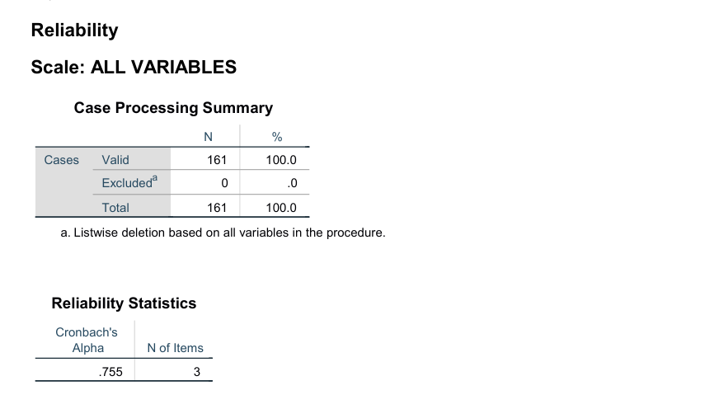
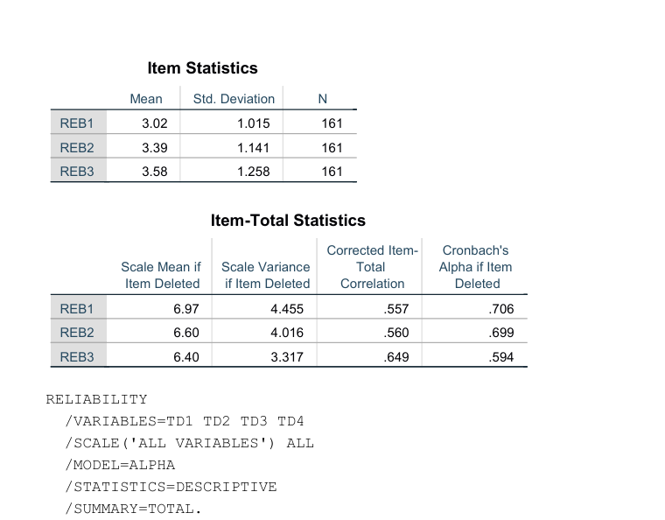
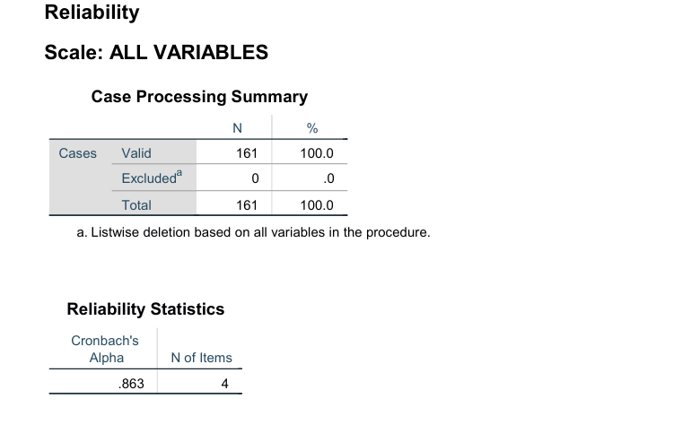
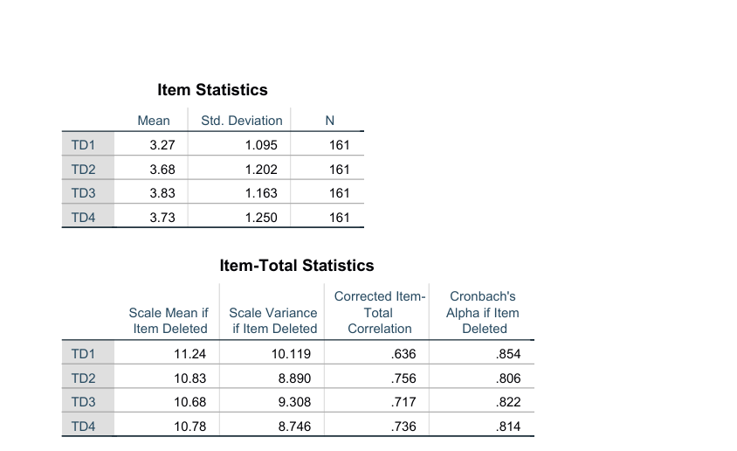
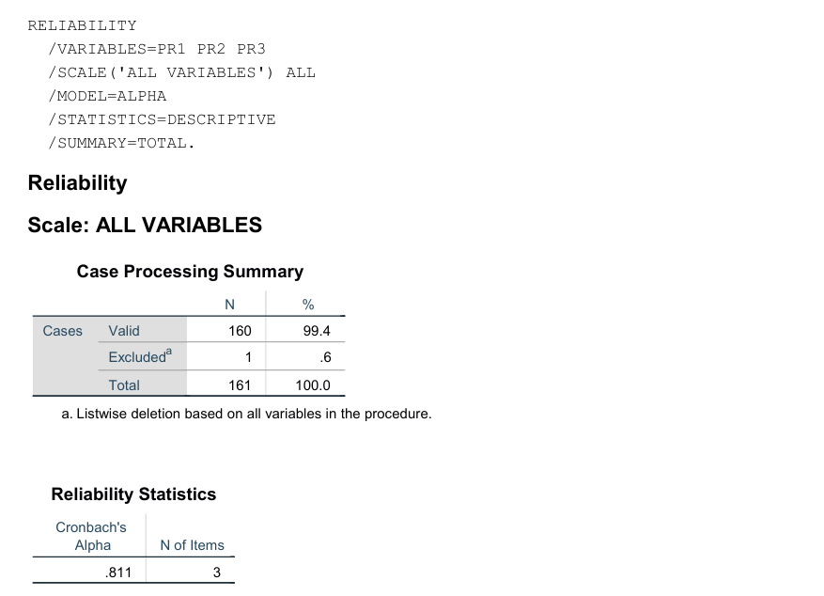
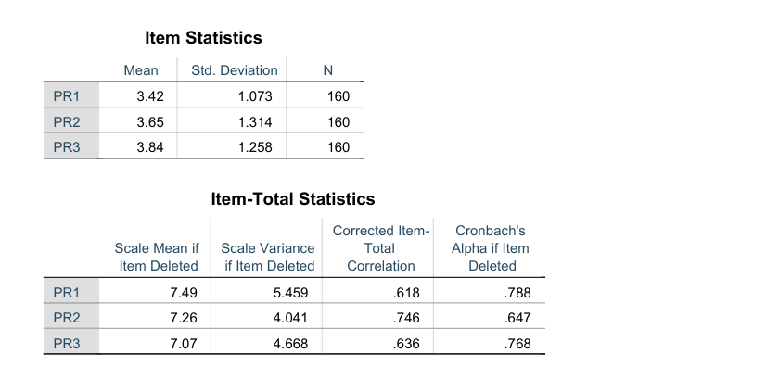
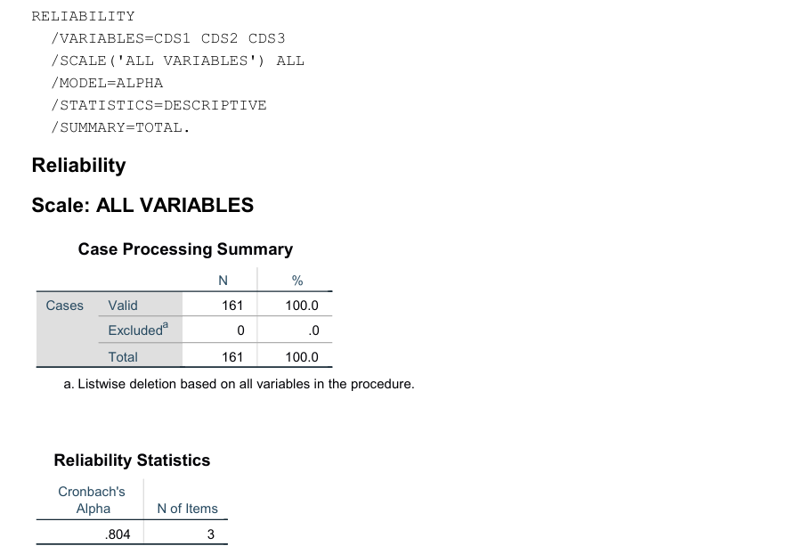
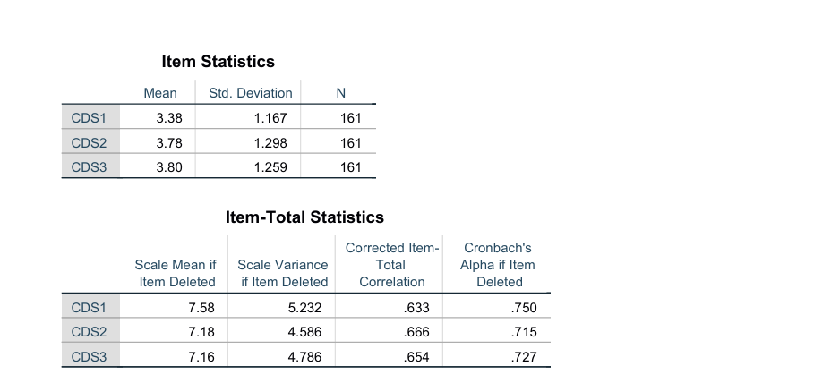
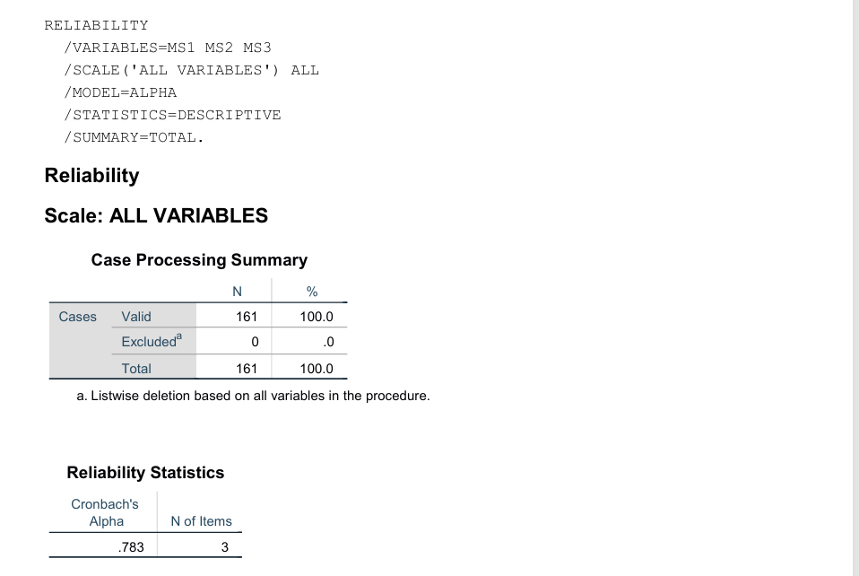
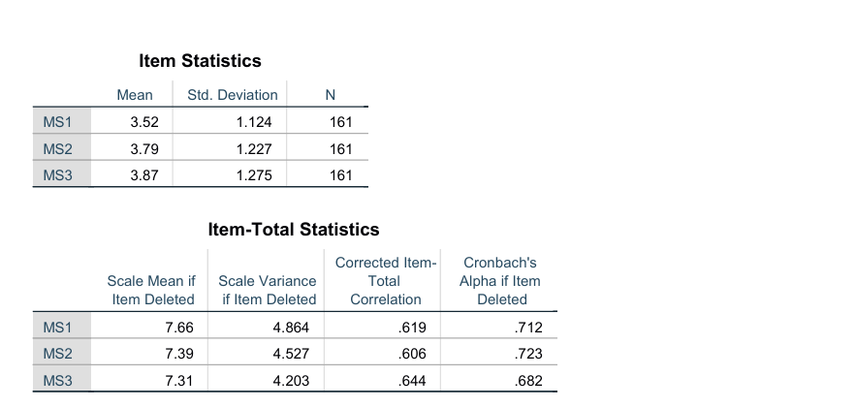
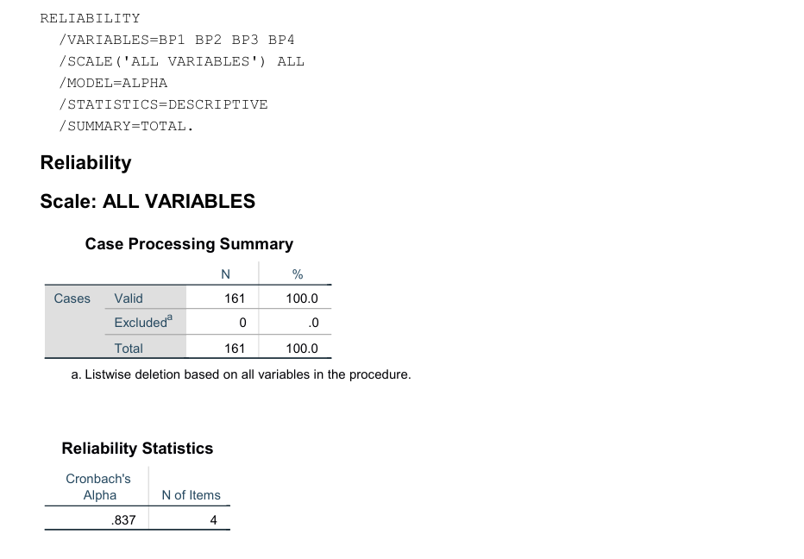

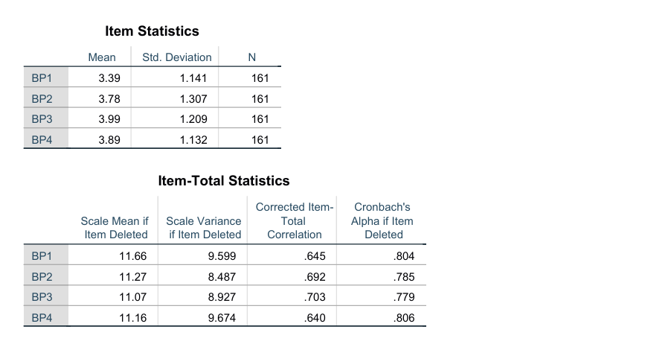
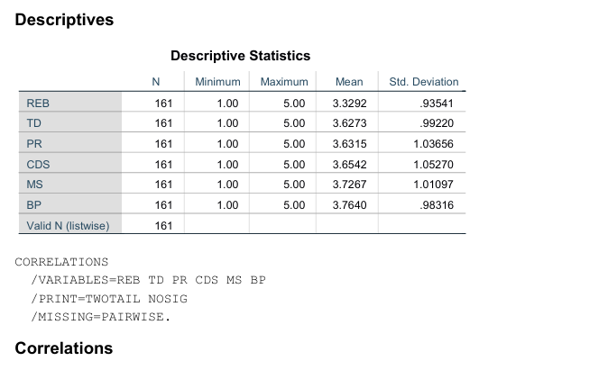
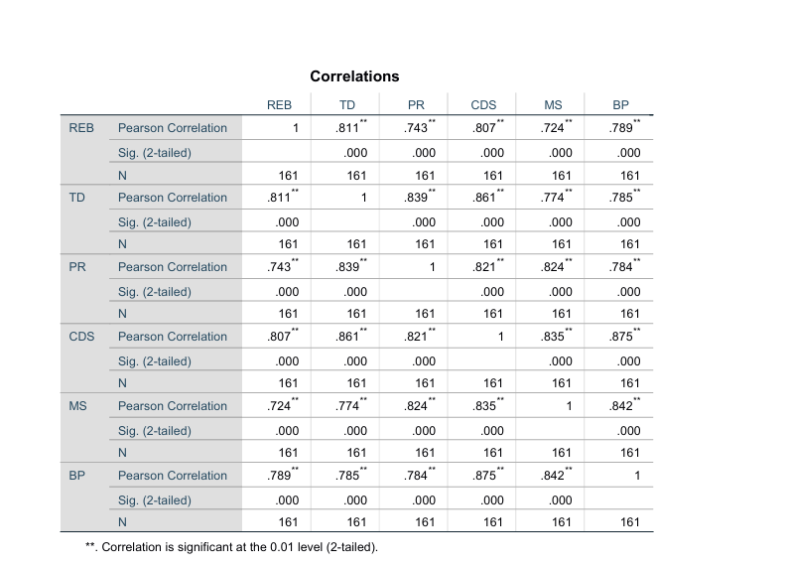
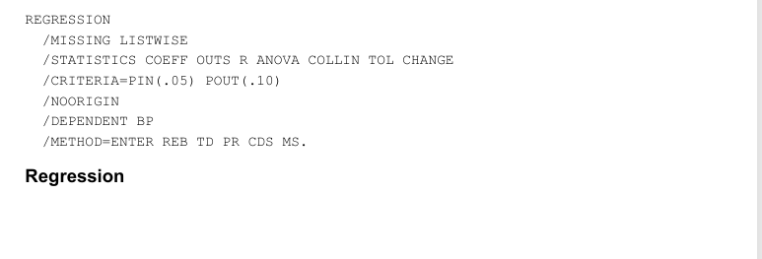
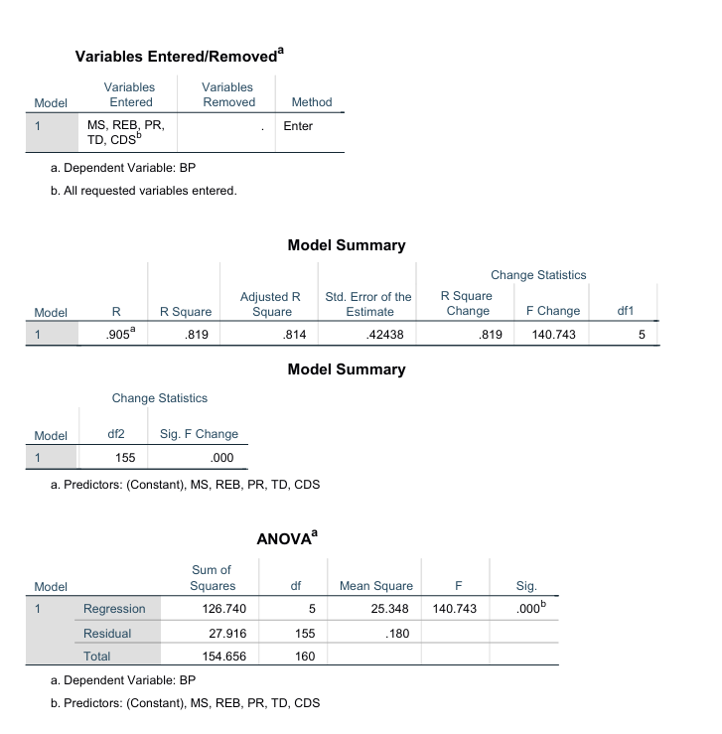
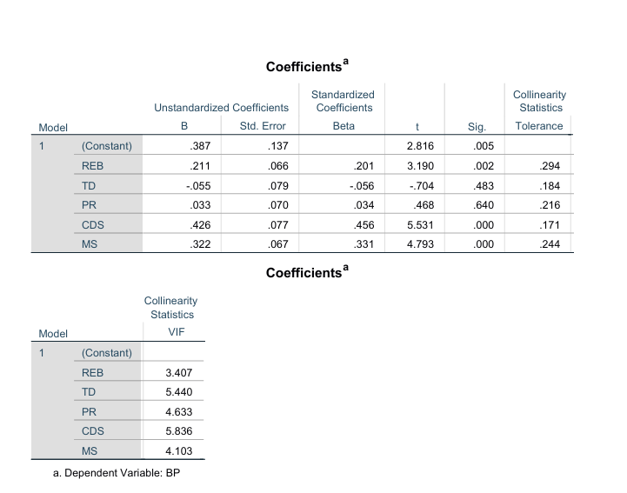
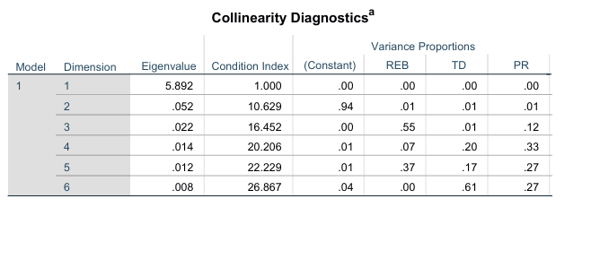
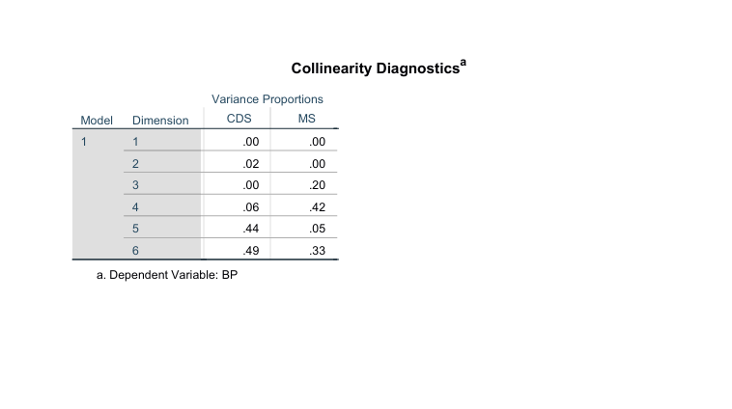

Appendix C: Ethics Form

