Thomas Sellwood (2215661)

Data Mining

Table of Contents
Purpose and Practice of Data Mining 1
Dataset Description and Exploration 2
Dataset Overview 2
Missing Values 2
Exploratory Analysis 3
Pre-Processing and Post-Processing 16
Sample Runs and Analysis Methods 20
Predictive Modelling 20
Maths Output 21
Portuguese Output 22
Clustering 23
Maths Output 23
Portuguese Output 25
Business Recommendations 28
Reflective Commentary 31
Appendix 1: Best Run SMO Maths 33
Appendix 2: Best SMO Run Portuguese 36
Appendix 3: Runs Maths 42
Appendix 4: Runs Portuguese 64
Appendix 5: Clustering Runs Maths 79
Appendix 6: Clustering Runs Portuguese 100

Purpose and Practice of Data Mining
Data mining represents the analysis stage of the knowledge discovery in databases process. This process transforms structured data into meaningful patterns, predictive models, and actionable intelligence [1]. The purpose of data mining extends beyond pattern identification, it also enables organisations to reduce uncertainty, improve their forecasting accuracy, and through that support strategic decision making through systematic analysis of data [1].

The two primary functions that define data mining practice are:
- Predictive modelling [2].
- Descriptive modelling [2].

Predictive approaches, including classification and regression, apply supervised learning algorithms to estimate future or unknown outcomes based on historical data [3]. Descriptive approaches, such as clustering and association rule mining, uncover latent structures, relationships, and behavioural segments without predefined targets [2]. The application of these techniques allows for the anticipation of future performance but also for the understanding of the underlying drivers of that performance.

For business’ data mining underpins risk modelling, fraud detection, demand forecasting, customer churn prediction, and driverless cars [1]. Most importantly, the value of data mining lies in identifying relationships that aren’t obvious through traditional reporting methods [2].

Within educational analytics, predictive models can identify students at risk of underperformance, while clustering techniques can segment learners based on behavioural and socio-demographic characteristics [4]. Such insights support proactive intervention strategies and evidence-based policy decisions.

Dataset Description and Exploration

Dataset Overview
The dataset analysed is the Student Performance dataset from the UCI Machine Learning Repository [5], consisting of two csv files, student-mat.csv (395 instances) and student-por.csv (649 instances) both having 33 variables, relating to students in two Portuguese secondary schools. Using the provided R script, the datasets were merged to remove duplicates, producing 382 unique students described by 53 variables. These were suffixed with _maths and _por to distinguish where the data has come from. The primary target variable is G3 (final grade), with G1 and G2 representing prior academic performance from period 1 and 2. The analytical tasks comprise regression (predicting G3) and clustering (identifying student groups).

Attributes include demographic (sex, age, address), socio-economic (parental education, occupation, internet access), behavioural (study time, absences, failures, activities), and academic history (G1, G2) variables. The dataset contains nominal, ordinal, numeric (discrete and continuous), and binary attributes, which will inform subsequent encoding and modelling decisions in Weka [6].

Missing Values
On examination of the data set, no missing values were observed for any of the variables within the dataset, so no imputation or data removal was required. This reduces the pre-processing complexity significantly. This simplifies the pre-processing stage and ensures that no rows are lost through removal or estimation methods.

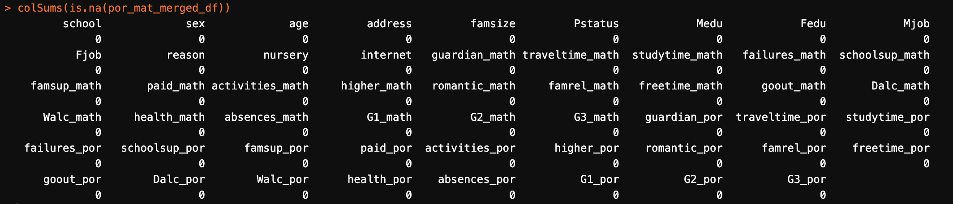

Figure 1: Output of missing value analysis

Exploratory Analysis
The initial exploration examined the distribution of the final grade variable (G3) for both subjects. Summary statistics and visualisations indicate that Portuguese grades are generally higher and less dispersed, while Maths grades exhibit greater variability and more low outliers this is demonstrated in figure 3. Histograms (figures 4 and 5) show that Portuguese results cluster around higher grade ranges, whereas Maths displays a wider spread of outcomes, including a higher number of very low scores.
These differences suggest that students tend to perform better and more consistently in Portuguese than in Maths. The variation between subjects also implies that predictive modelling approaches may perform differently across subjects, as variance can influence model stability and accuracy. Overall, the distributional characteristics support testing both regression and classification approaches when predictively modelling the student outcomes.

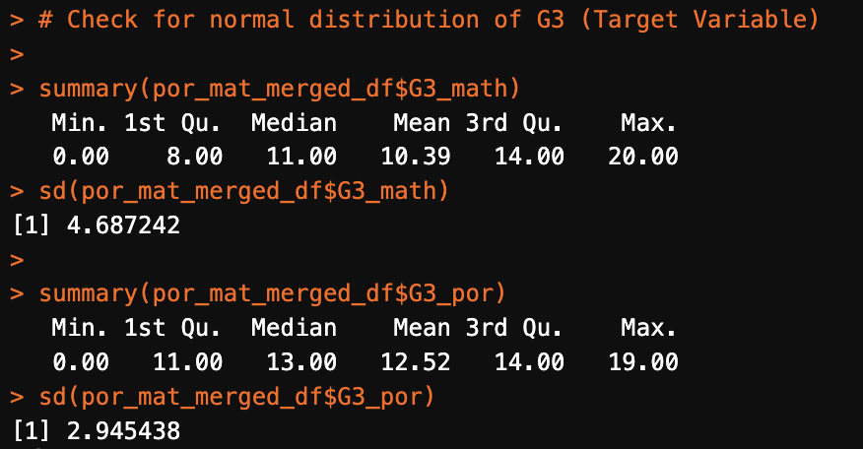
Figure2: Output of summary of G3 variable

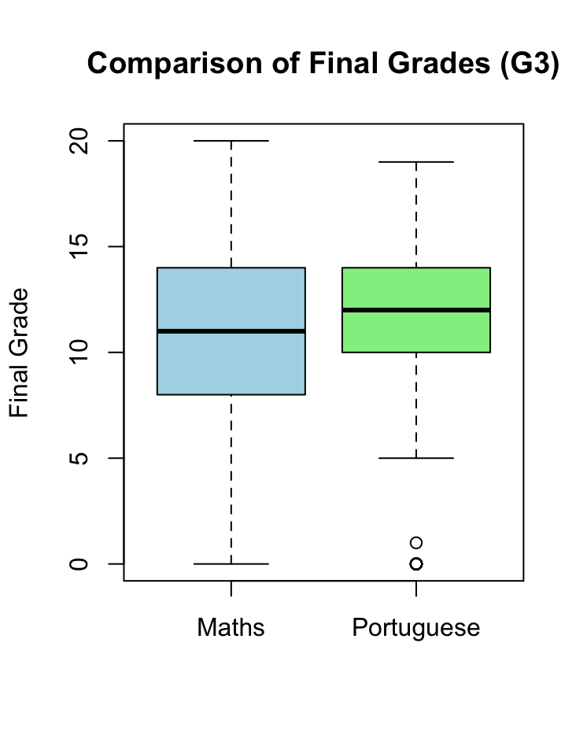
Figure3: Visualisation of Distribution G3 variable

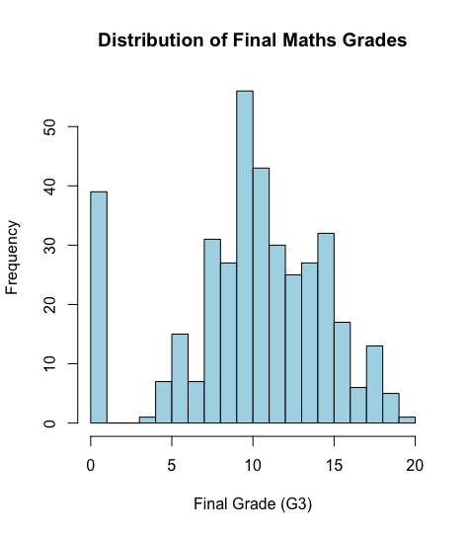
Figure4: Histogram of G3 maths

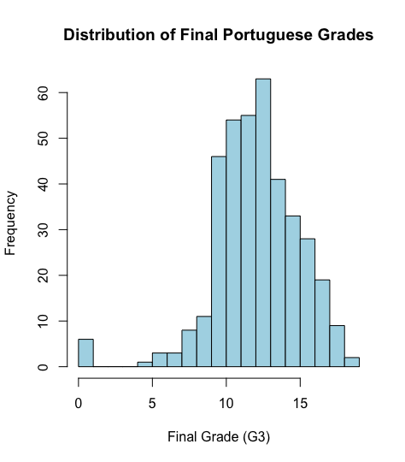
Figure5: Histogram of G3 Portuguese

A paired t-test (figure6) was conducted to compare average final grades between the two subjects. The results show that Maths grades are statistically lower than Portuguese grades, indicating clear subject-specific performance differences.

This indicates that Maths may represent a bigger challenge for students. From a modelling perspective, this finding highlights the potential value of identifying students at risk of poor Maths grades, for early interventions.

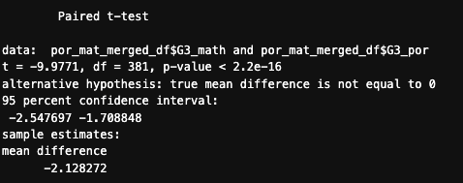
Figure6: Paired t-test results

Correlation analysis (figure 7 and 8) reveals strong relationships between assessment grades. In both subjects, earlier grades (G1 and G2) are strongly correlated with final grades (G3) this is also highlighted by the researchers of the data [5]. This indicates that academic performance tends to remain consistent across the school year, making prior grades highly informative for predictive modelling.

In contrast, previous academic failures show moderate negative correlations with performance, suggesting that students with a history of failing subjects are more likely to achieve lower grades. Absences, however, demonstrate very weak correlations with grades, indicating that attendance alone does not strongly explain academic outcomes. Overall, these findings suggest that student performance is driven primarily by prior academic achievement rather than behavioural variables such as attendance.

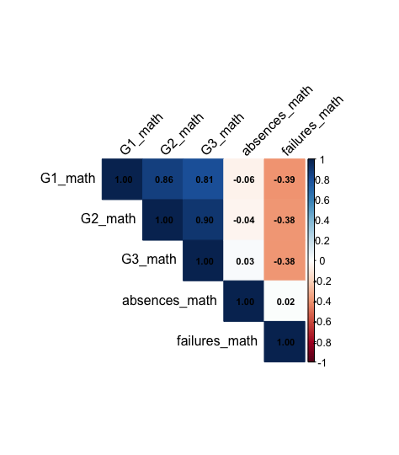
Figure7: Correlation matrix of maths grades to absences and failures

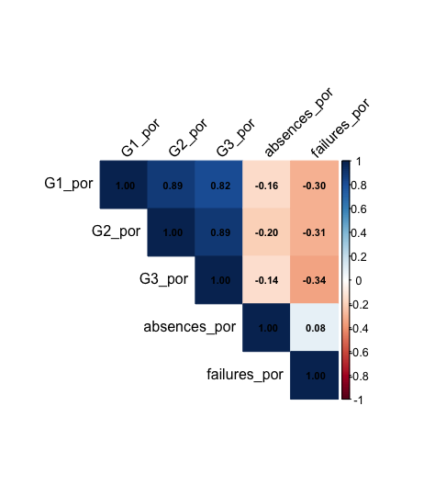
Figure8: Correlation matrix of Portuguese grades to absences and failures

Gender comparisons show small but statistically significant differences in performance. Male students achieve slightly higher average grades in Maths, while female students perform marginally better in Portuguese.

However, the distributions show substantial overlap, indicating that gender differences are relatively minor compared with academic variables. This indicates that these demographic characteristics may have limited predictive value for modelling.

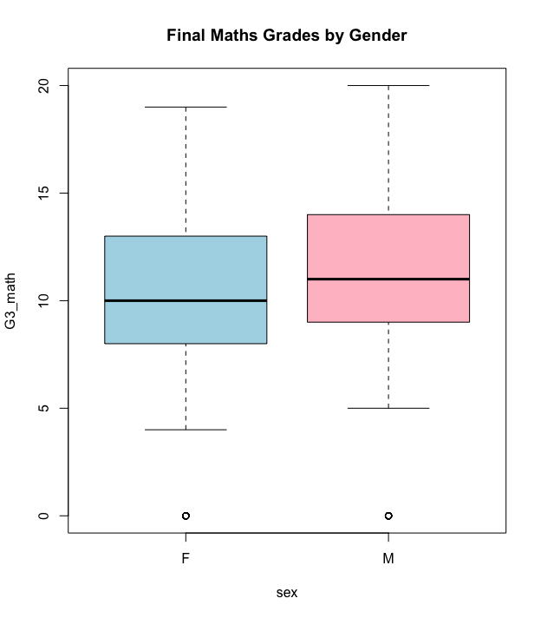
Figure9: Final grades maths by gender

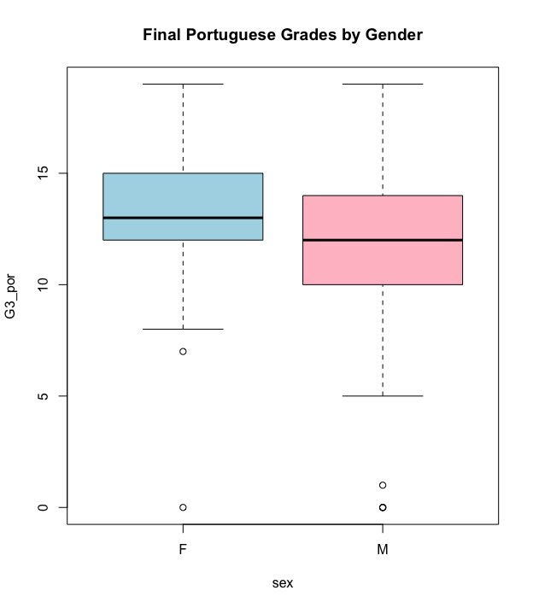
Figure10: Final grades Portuguese by gender

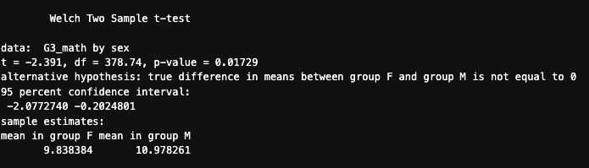
Figure11: T-test final grades maths by gender

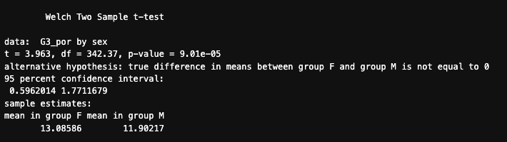
Figure12: T-test final grades Portuguese by gender

Study time demonstrates a strong relationship with Portuguese performance. Students who study more than five hours per week achieving higher median grades, than those who don’t. For Maths, the relationship between study time and performance is weaker and not statistically significant.

Parental education levels show moderate positive associations with Portuguese performance, particularly for higher education levels, but the relationship with Maths is weaker and inconsistent. These findings suggest that behavioural and socio-economic factors may influence Portuguese more strongly than Maths, although their overall predictive strength remains lower than that of prior academic performance.

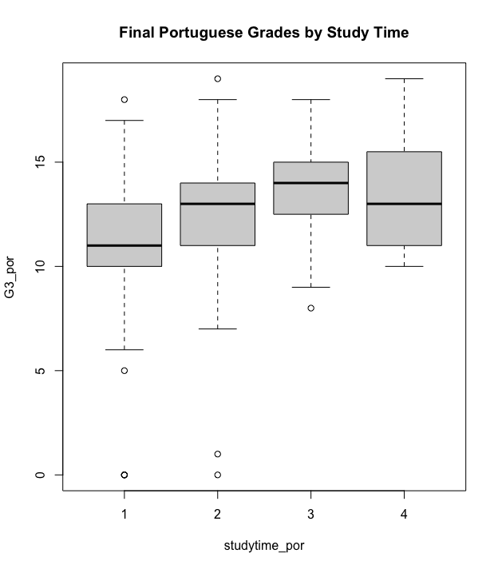
Figure13: Visualisation of study time by final Portuguese grade

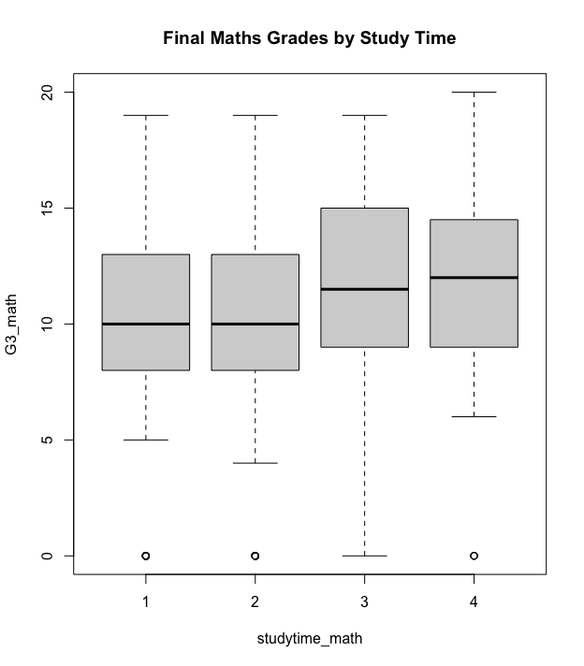
Figure14: Visualisation of study time by final maths grade

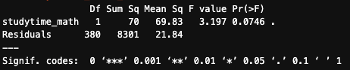
Figure15: Anova maths grades by study time

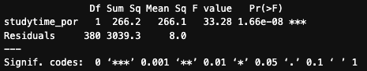
Figure16: Anova Portuguese grades by study time

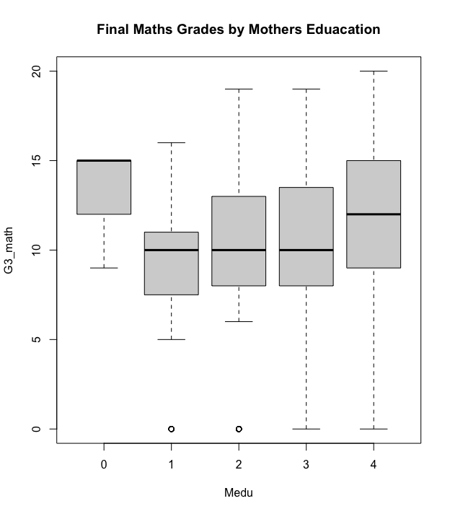
Figure17: Final maths grade by mothers’ education

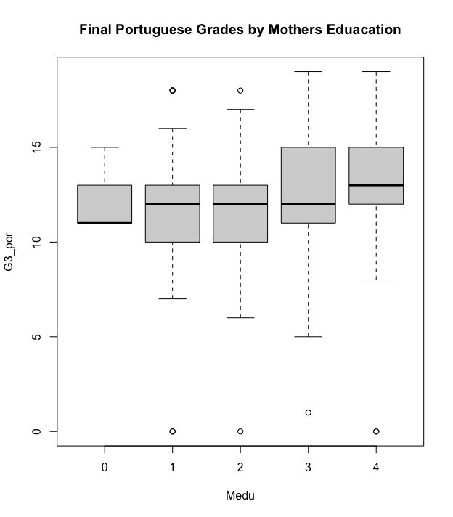
Figure18: Final Portuguese grade by mothers’ education

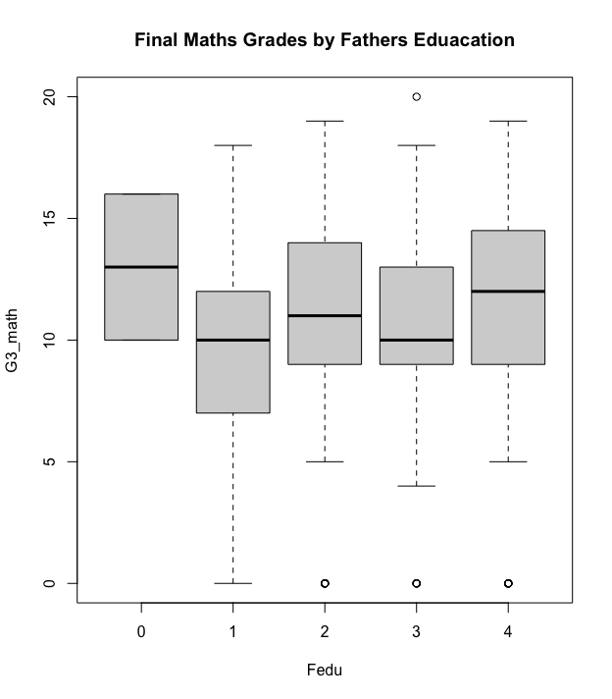
Figure19: Final maths grade by fathers’ education

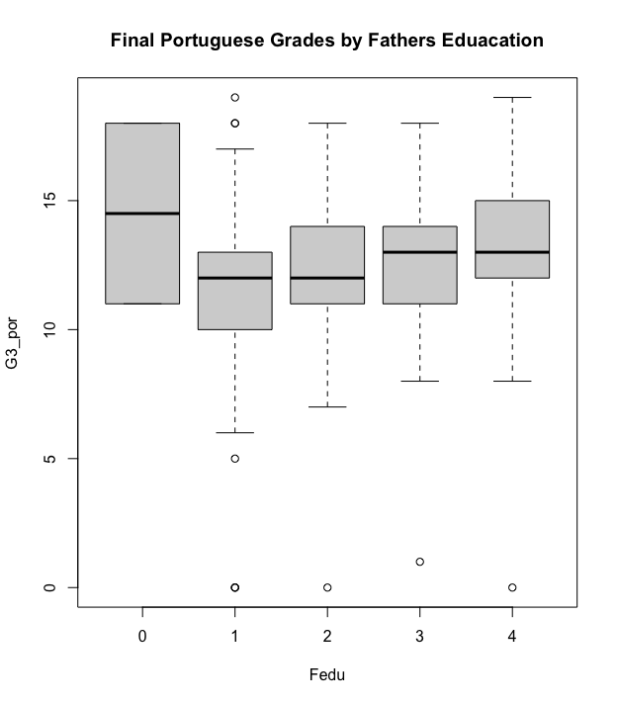
Figure20: Final Portuguese grade by fathers’ education

These assessment techniques were included to identify statistically significant differences and relationships between variables in order to support the feature selection for modelling.

Pre-Processing and Post-Processing
Data pre-processing is a key step in the data mining process, as it improves data quality and ensures that algorithms can effectively identify patterns [7]. Data sets often contain missing values, values in an inconsistent format by processing this before data mining starts, we get improved model performance and reliable analytical results [3].

During the process there was two stages of data pre-processing the primary pre-processing which was conducted in R [8] and then the secondary pre-processing which was conducted in Weka [6].

The data was initially available as two separate datasets with CSV files, one containing the Maths data and then one containing the Portuguese data [5]. The datasets contained overlapping student data, so the R script provided from the UCI [5] was used to combine the data into one dataset. The merge operation was performed using a set of shared demographic and socio-economic attributes including school, sex, age, address, family size, parental status, parental education levels, parental occupations, study motivation, nursery attendance and internet access. This ensured that only students appearing in both datasets were retained.

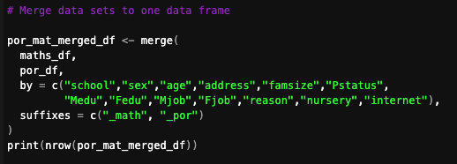
Figure21: Merge of datasets

Merging the datasets enabled direct comparison of student performance across subjects, supported paired statistical analysis, and reduced potential duplication of student observations. The resulting merged dataset contained 382 student records and 53 attributes, representing students enrolled in both courses.

Following dataset integration, the merged data frame was examined for missing values using the colSums(is.na()) function in R [8]. No missing values were identified within the dataset, meaning that further data cleaning techniques such as imputation were not required. Assessing data completeness at this stage is important because missing or inconsistent data can negatively affect the accuracy of predictive models [7].

The dataset structure was then reviewed to verify attribute types and ensure compatibility with statistical analysis and machine learning techniques. The merged dataset contains both numeric attributes, such as grades, absences and previous failures, and categorical attributes describing demographic and behavioural characteristics, see Table 1 for full details. Categorical variables such as sex, school, address, family size and internet access were converted to factor data types within R [8] to ensure they were correctly interpreted during subsequent analysis [1].

R_Class | Count | Variables
character | 17 | Mjob, Fjob, reason, guardian_math, schoolsup_math, famsup_math, paid_math, activities_math, higher_math, romantic_math, guardian_por, schoolsup_por, famsup_por, paid_por, activities_por, higher_por, romantic_por
factor | 9 | school, sex, address, famsize, Pstatus, nursery, internet, pass_math, pass_por
integer | 29 | age, Medu, Fedu, traveltime_math, studytime_math, failures_math, famrel_math, freetime_math, goout_math, Dalc_math, Walc_math, health_math, absences_math, G1_math, G2_math, G3_math, traveltime_por, studytime_por, failures_por, famrel_por, freetime_por, goout_por, Dalc_por, Walc_por, health_por, absences_por, G1_por, G2_por, G3_por

Table1: Summary of variable types in merged dataset.

In addition to analysing the continuous final grade variable (G3), a binary classification variable was created to distinguish between students who passed and failed each subject. Grades greater than or equal to 10 were classified as Pass, while grades below 10 were classified as Fail. Creating this additional variable allows the dataset to support regression modelling and classification algorithms, enabling the identification of students who may be at risk of failing [7].

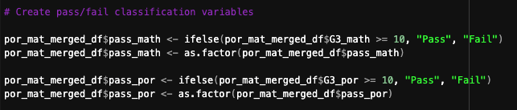
Figure22: Pass fail variable creation

After preprocessing and validation, the cleaned dataset was exported as a CSV file using the write.csv() function. The CSV file was then converted to the ARFF file format using ChatGPT [9], as data in the ARFF format works optimally with Weka [6] rather than as a CSV although Weka [6] does have the functionality to support working with CSV.

After the first stage of preprocessing in R [8], the cleaned dataset was imported into Weka [6] for further preparation prior to modelling.

Weka [6]provides a range of tools for data transformation, attribute filtering and dataset inspection that support predictive modelling workflows [3][1]. The dataset was imported using the Explorer interface, here the attributes and instance counts were verified to ensure that the data had been correctly transferred from the preprocessing stage.

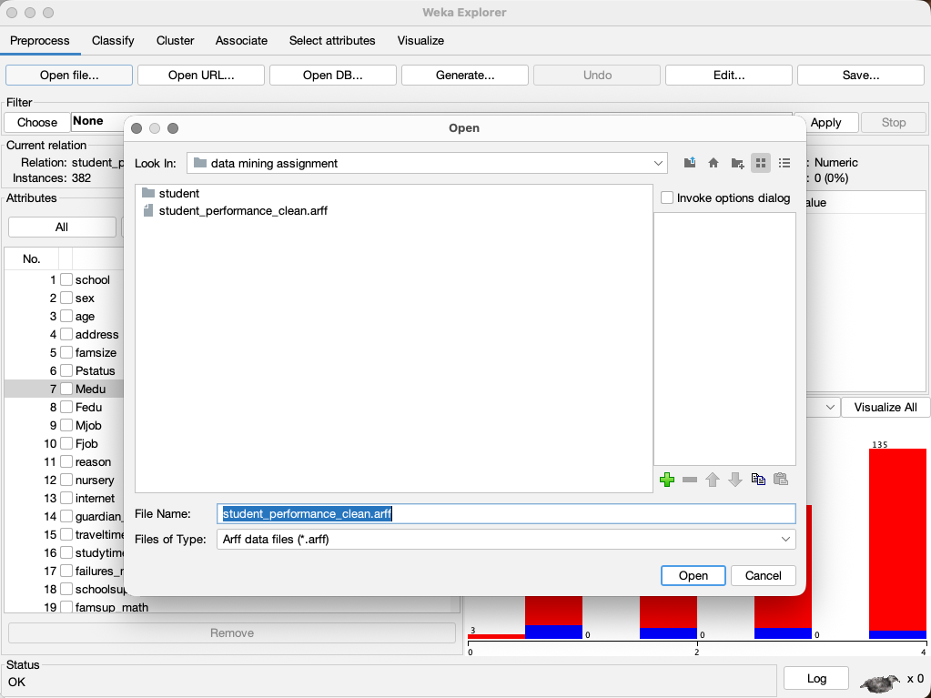
Figure23: Import in Weka

Using the Weka preprocessing panel, the dataset attributes were reviewed to confirm that numeric and categorical variables were correctly recognised. Attributes representing categorical information, such as demographic variables, were interpreted as nominal attributes, while performance-related variables such as grades, absences and failures were interpreted as numeric attributes. Correct attribute recognition is essential for ensuring compatibility with different machine learning algorithms [3].

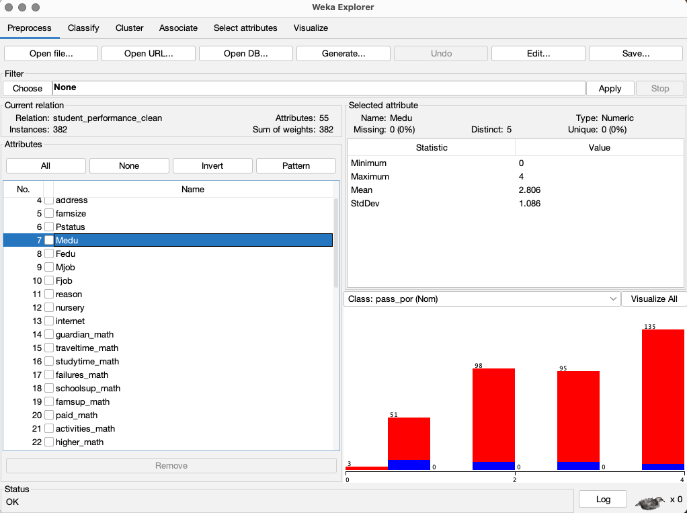
Figure24: Data imported to Weka

Additional attribute inspection was conducted to identify any redundant or irrelevant attributes that could negatively influence the performance of the model. Feature selection and attribute filtering are commonly applied preprocessing techniques in data mining as they help reduce dataset dimensionality and improve model interpretability [10]. In this instance many of the attributes were retained to allow the model to define importance, but the dataset was refined to Maths and Portuguese versions. The pass_por, pass_math, g3_math and g3_por were removed for clustering to prevent data leakage as it is an unsupervised training model [11].

Once attribute verification and selection were complete, the dataset was ready for the application of machine learning models. These models will be discussed in the next section.

Sample Runs and Analysis Methods

Predictive Modelling
The Sequential Minimal Optimization (SMO) algorithm was selected for classification modelling as it provides an efficient implementation of Support Vector Machines within the Weka environment. Support Vector Machines are well suited to binary classification problems and can identify optimal separating boundaries between classes [11]. This makes Support Vector Machines particularly suitable for predicting pass or fail outcomes based on student academic and behavioural characteristics. Support Vector Machine models focus on observations that lie closest to the decision boundary, known as support vectors, which contribute most to defining the classification boundary [11]. By concentrating on these critical observations, SVMs can improve classification accuracy while helping to reduce overfitting [11].

Maths Output
The SMO classifier achieved strong predictive performance, correctly classifying 89.0052% of instances using 10-fold cross-validation see appendix 1 for full results. On analysis of the model output, it indicated that previous academic performance variables were the most influential predictors of student success. In particular, the second assessment grade G2_math and first assessment grade G1_math had substantially larger coefficients than any other variables, demonstrating that earlier academic performance is strongly associated with final course outcomes this was shown also in the exploratory data analysis section. Behavioural variables such as absences and prior failures were negatively associated with the probability of passing, suggesting that students with higher absenteeism or repeated academic difficulties are at greater risk of failing the course again this was identified in the exploratory data analysis section.

The classifier demonstrated slightly stronger performance in identifying students who passed the course compared to those who failed recall of 0.811 for fail and 0.929 for pass, this could reflect the class imbalance present in the dataset.

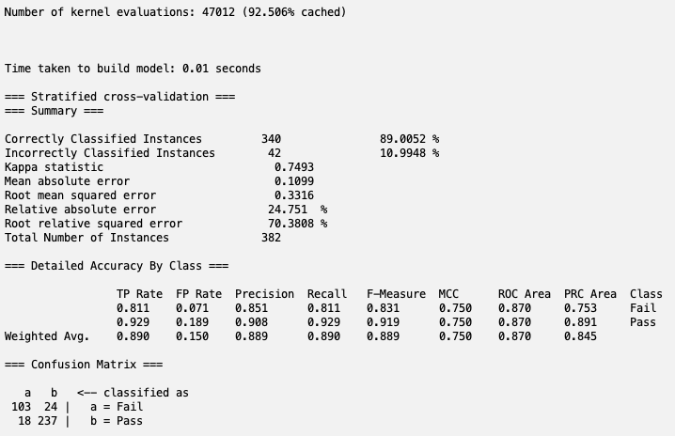
Figure25: Best SMO Run Maths

Portuguese Output
The Portuguese SMO classification model achieved its strongest performance when using a polynomial kernel with exponent 2 and a complexity parameter of C = 0.05. Under 10-fold cross-validation, this model correctly classified 94.7644% of instances, with a kappa statistic of 0.627. The confusion matrix showed that the model was highly effective at predicting students who passed Portuguese, it correctly classified 343 pass cases, but then was less effective at identifying students who failed, correctly classifying 19 fail cases while misclassifying 13 fail cases as pass. This indicates that the SMO model performs very well overall but is still more reliable for the majority pass class than for the minority fail class. This is also demonstrated in the recall section with fail having a recall 0.594 and pass a recall of 0.980.

Comparison of tuning runs undertaken showed that when reducing the C parameter from 1.5 to 0.05 this gave a slightly improved predictive performance and generalisation. In contrast, changing the polynomial kernel exponent from 2 to 1 caused a substantial reduction in performance, with the linear version predicting all students as pass. This indicates that Portuguese pass/fail outcomes are better represented by a nonlinear decision boundary, and that parameter tuning was necessary to achieve the most effective model. Full details of the runs performed can be seen in Appendix 4.

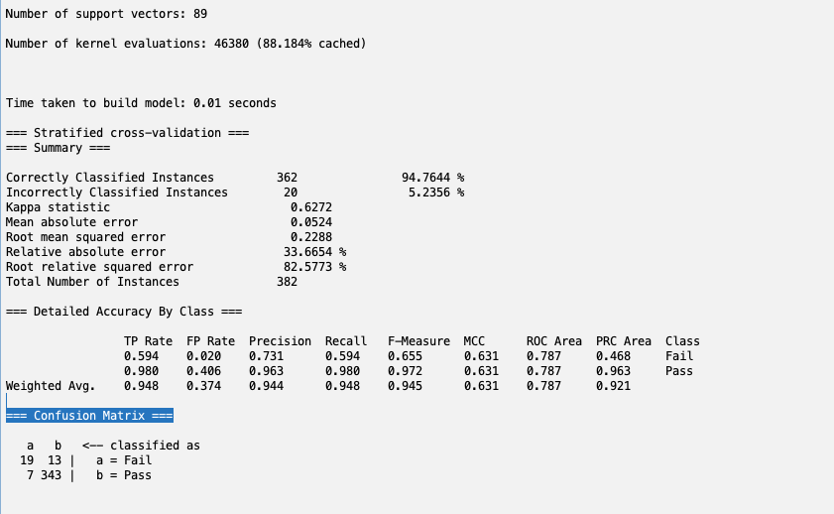
Figure26: Best SMO Runs Portuguese

The model showed lower recall for failing students, this indicates a class imbalance within the dataset, this is possible that it could be at risk of identifying students that could be at risk of poor academic performance.

Clustering
The clustering algorithm chosen was the Expectation–Maximisation (EM) clustering. This is a probabilistic clustering algorithm used to identify hidden patterns or groups within a dataset [3]. Unlike partitioning methods such as K-means, which assign each observation to a single cluster [11], EM estimates the probability that each observation belongs to different clusters [3]. The algorithm iteratively alternates between two stages:
- The expectation step, this estimates cluster membership probabilities[3].
- The maximisation step, this updates the parameters of the clusters to maximise the likelihood of the observed data [3].

Maths Output
The final model selected for the clustering of the maths dataset was the Expectation–Maximisation (EM) algorithm with three clusters. This model provided the most meaningful and interpretable segmentation of students while avoiding over-fragmentation seen in higher cluster solutions (numClusters=5).
In addition to EM, SimpleKMeans was also tested with different cluster numbers. While the k = 3 solution produced clearer student groupings than k = 2, EM was retained as the final clustering method because its probabilistic approach produced interpretable clusters for further analysis.
The EM model identified three distinct student clusters:
- Cluster 0 (55%) represented the strongest academic group, the cluster is characterised by the highest G1 and G2 grades, higher study time, few prior failures, lower alcohol consumption compared to other clusters, and fewer absences. This indicates that this cluster of students are more academically engaged.
- Cluster 1 (20%) represented a moderate-risk group. These students demonstrated lower study time, higher levels of social activity (higher alcohol consumption and frequency of going out), and middle range academic performance. This cluster reflects students whose behavioural factors may be impacting academic outcomes.
- Cluster 2 (24%), this represented the weakest academic group. This group showed the lowest G1 and G2 grades, higher numbers of past failures, and increased absences. Additionally, this cluster was associated with lower parental education levels, suggesting potential socio-economic influences on performance.
The EM model with three clusters was selected as the final model because it provided a clear balance between model complexity and interpretability for business users. While alternative models such as K-Means and higher-cluster EM solutions were tested, these either produced overly simplistic groupings or fragmented clusters that provided less informative outputs for further analysis.

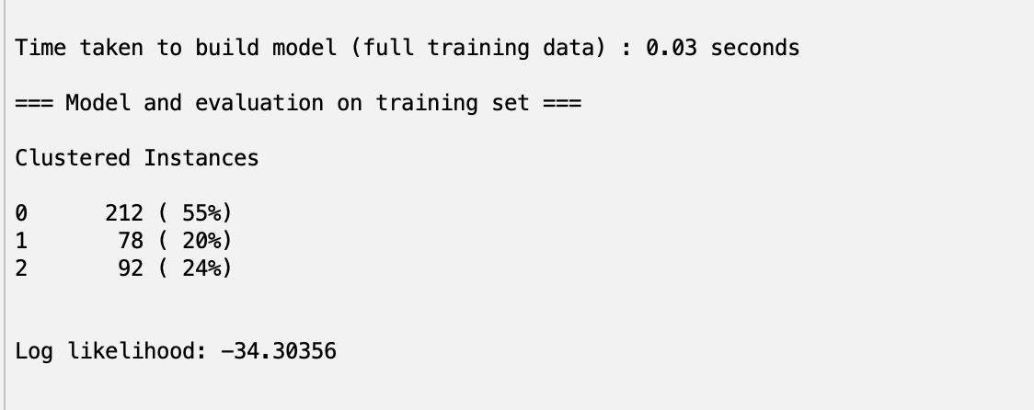
Figure27: Clustered Instances for Maths

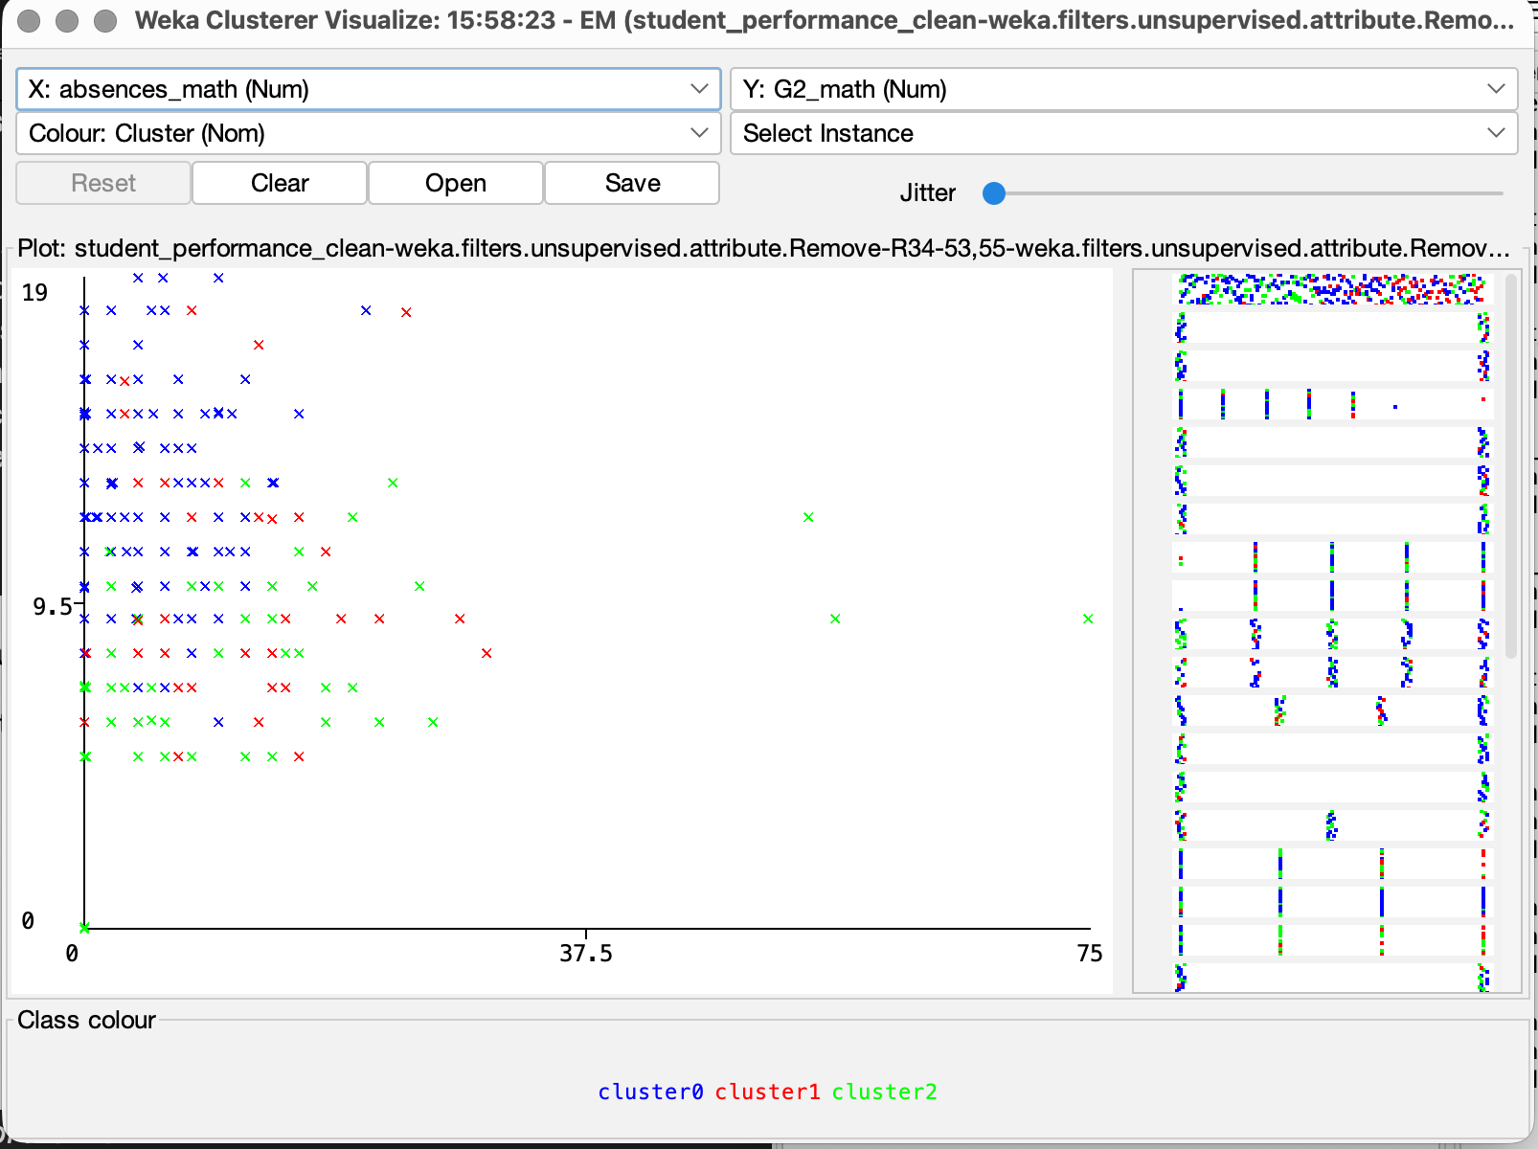
Figure28: Clustering of Maths Results Absence

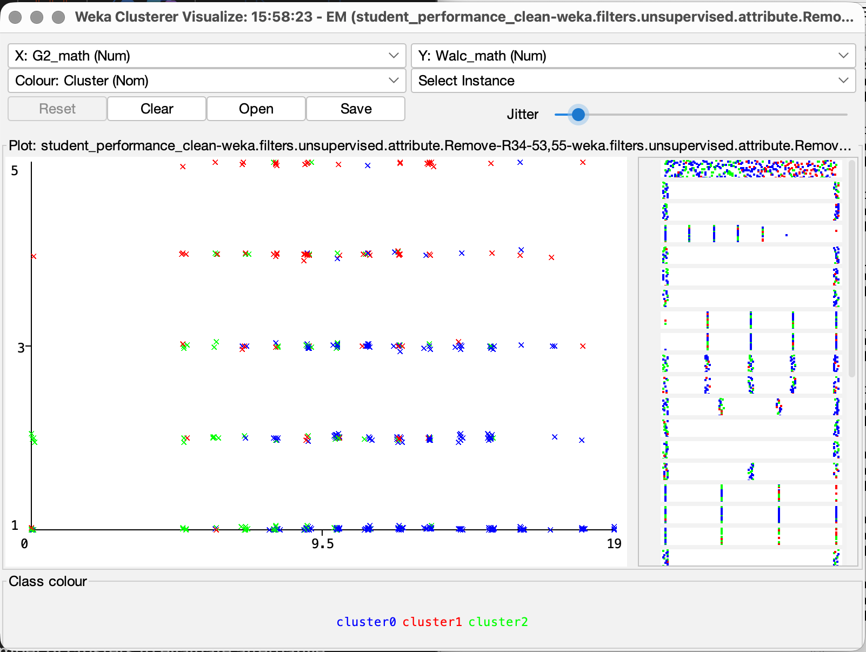
Figure29: Clustering of Maths Results weekly alcohol consumption by G2

Portuguese Output
The final model selected for the clustering of the Portuguese dataset was the Expectation–Maximisation (EM) algorithm with four clusters. This model provided the most meaningful and interpretable segmentation of students while avoiding overly simplistic groupings seen in lower cluster solutions and fragmentation in higher cluster configurations for SimpleKMeans.
In addition to EM, SimpleKMeans was also tested with different cluster numbers. While the k = 3 solution produced clearer student groupings than k = 2, increasing to k = 4 in SimpleKMeans did not improve model quality, as it resulted in less distinct clusters. EM was again retained as the final clustering method.
The EM model identified four distinct student clusters:
- Cluster 0 (29%) represented a strong academic group, characterised by relatively high G1 and G2 grades, no prior failures, lower alcohol consumption, and moderate absence levels. This indicates a group of students with consistent academic performance and stable behavioural patterns.
- Cluster 1 (16%) represented the most at-risk group. These students demonstrated the lowest G1 and G2 grades, the lowest study time, the highest number of prior failures, and the highest levels of alcohol consumption, social activity, and absences. This cluster reflects students whose behavioural and academic factors are negatively impacting performance.
- Cluster 2 (14%) represented the highest-performing group, characterised by the strongest G1 and G2 grades, higher study time, no prior failures, low absence levels, and relatively low alcohol consumption. This indicates a highly engaged and academically successful group of students.
- Cluster 3 (41%) represented an upper-mid performing group, with good G1 and G2 grades, moderate study time, no prior failures, and balanced behavioural characteristics. This cluster reflects students achieving positive outcomes without extreme behavioural patterns.
The EM model with four clusters was selected as the final model because it provided a clear balance between model complexity and interpretability for business users. While alternative models such as K-Means and lower-cluster EM solutions were tested, these either produced overly broad groupings or failed to capture the variation between high-performing and at-risk students, resulting in less informative outputs for further analysis. Details of the full runs can be seen in Appendix 6.

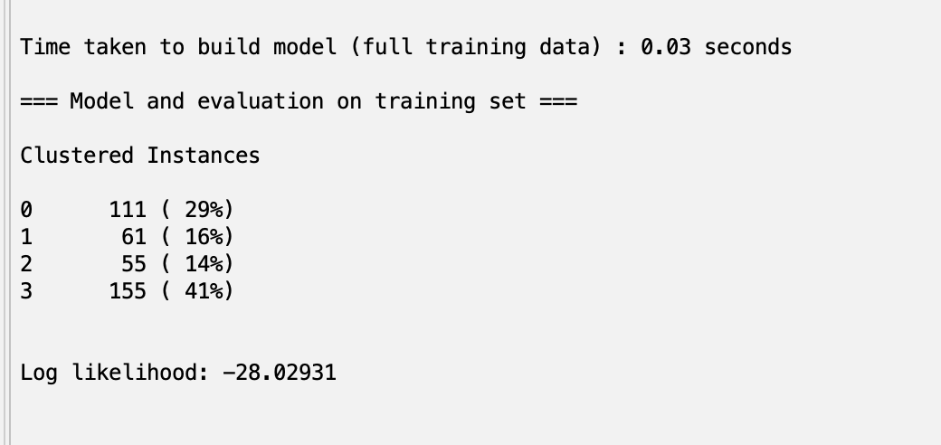
Figure30: Clustered Instances Portuguese

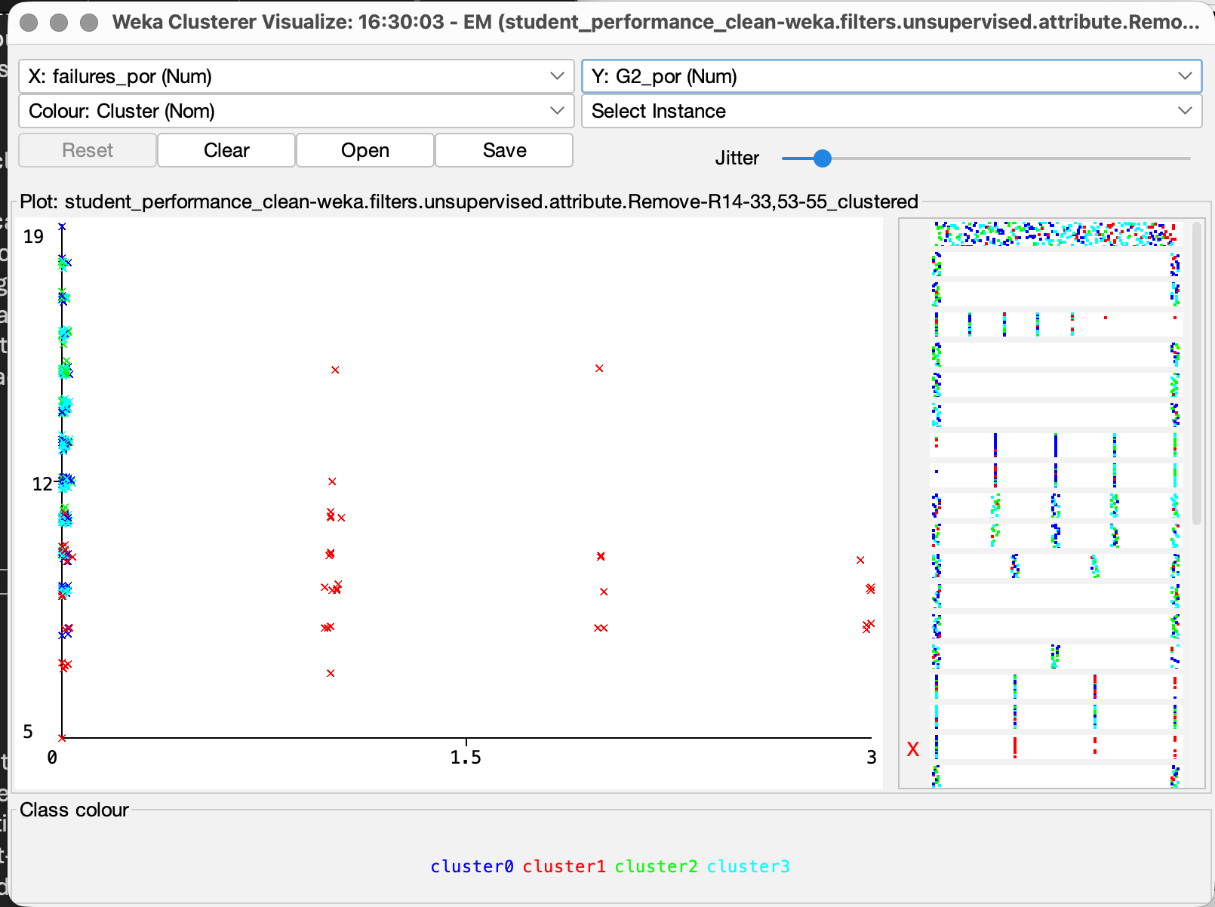
Figure31:Clustering of G2 by Prior Failures

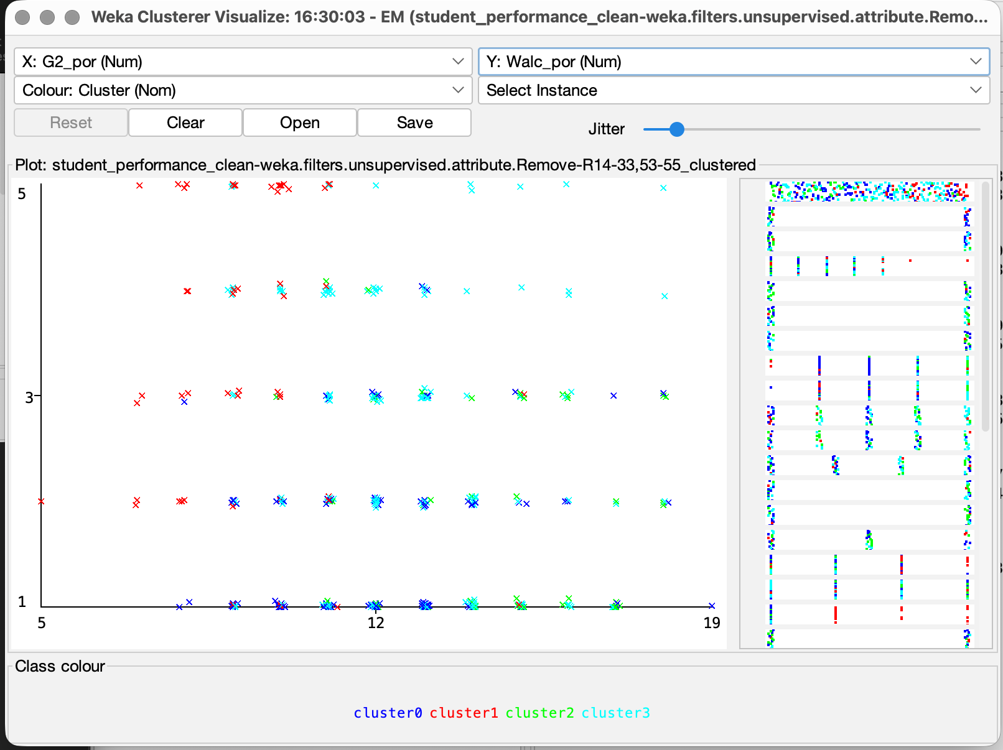
Figure32: Clustering of Portuguese Results cluster by weekly alcohol consumption

Business Recommendations
The results of the data mining analysis for maths results highlight several practical actions that the schools could implement to support student performance in maths. The classification model demonstrated that previous academic performance, particularly grades from the earlier assessment periods, are a strong predictor of students’ final performance. This indicates that early identification of students with low G1 or G2 grades could allow schools to introduce targeted academic support interventions before final assessments [12]. This could be as weekly tutoring or additional group sessions for students.

The clustering analysis also revealed some behavioural factors associated with different student performance clusters. In particular the clusters identified as performing lower were characterised by higher absence levels, lower study time, and a greater number of previous failures, this indicates an at risk group.

Figure33: Clustering of Maths Results Absences by G3

Schools could therefore implement monitoring systems to identify students with increasing absence rates or declining engagement and provide additional guidance or mentoring. Previous research has demonstrated attendance is strongly linked with performance [13]. These recommendations could be further applied across clusters such as to the higher performing cluster to ensure that these students can maintain the results.

These findings suggest that combining academic monitoring with behavioural support strategies may help educators identify students at risk earlier and implement targeted interventions to improve mathematics achievement and overall student outcomes.

The results from both the SMO classification model and the EM clustering analysis provide useful insights for improving Portuguese student outcomes. The SMO model demonstrated that previous academic performance variables, particularly earlier grades, were strong predictors of final outcomes, suggesting that continuous assessment monitoring could be used to identify students at risk of underperforming. Schools could therefore implement early warning systems that flag students whose grades begin to decline, enabling targeted academic support or tutoring interventions [12]. This recommendation is like that recommended for maths students.

The clustering analysis further identified distinct groups of students with differing academic and behavioural characteristics. One cluster identified as most at risk displayed lower academic performance alongside higher alcohol consumption and lower study time, indicating that behavioural factors may also influence academic outcomes of students. We see this further supported by this research [14].

Figure34: Clustering of Portuguese Results cluster by weekly alcohol consumption

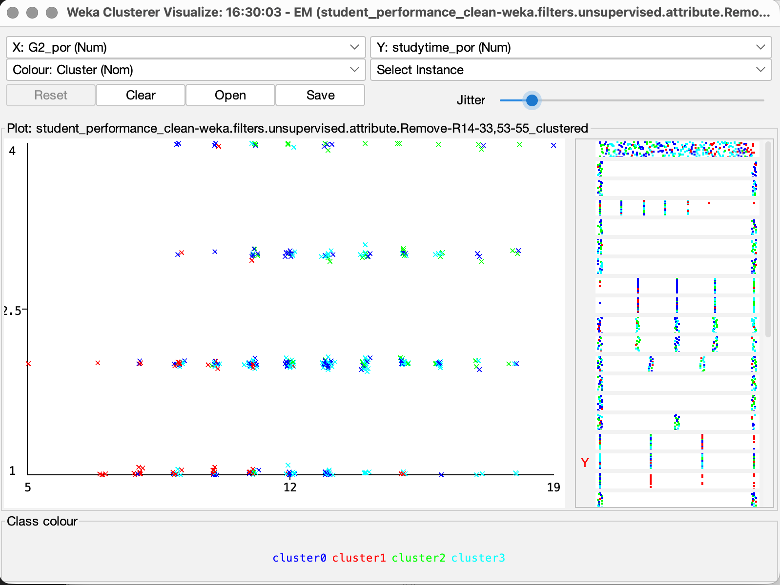
Figure35: Clustering of Portuguese Results cluster by study time

These results suggest that behavioural factors such as weekly alcohol consumption and social activity have a measurable impact on academic performance within this cluster.

Providing students with support programmes focusing on study skills, time management and student wellbeing may therefore be beneficial as supported by Crede et al [15].

Utilising a combined approach of predictive modelling using the SMO model with student clustering using the EM Clustering model, this enables educators to implement more proactive support, to support and improve academic outcomes for those students who most require it and for students who don’t to maintain their outcomes.

Reflective Commentary
The selection of algorithms aimed to incorporate both predictive and descriptive data mining approaches to gain a more comprehensive understanding of the dataset. The SMO algorithm was chosen for classification because it provides an efficient implementation of Support Vector Machines and performs well for binary classification problems such as predicting student pass or fail outcomes [3].

The model achieved strong classification performance, this demonstrated that previous academic performance variables were highly effective predictors of final outcomes in the dataset. One advantage presented by Support Vector Machines is their ability to identify an optimal separating boundary between the classes by focusing on support vectors [11], this can improve generalisation and reduce the risk of overfitting.

The EM clustering algorithm was used to explore hidden patterns within the dataset and identify groups of students with similar academic and behavioural characteristics. This approach was useful for identifying meaningful student profiles and highlighting potential relationships between behavioural factors and academic outcomes.

Clustering algorithms such as EM due to their probabilistic nature make these models more difficult to interpret than supervised models such as SMO as the resulting groups in EM clustering are not predefined and require additional analysis to understand their significance [4], this is something that may not be preferable for normal business users.

For future work, some alternative algorithms such as decision trees and j48 for classification and K-median models or DBSCAN for classification could be explored to improve interpretability and allow for easier explanation of predictive factors for business users[4].

References
[1] P. Bhatia, Data mining and data warehousing : principles and practical techniques, Cambridge: Cambridge University Press, 2019.
[2] U. Fayyad, G. Piatetsky‐Shapiro and P. Smyth, "From Data Mining to Knowledge Discovery in Databases," vol. 17, no. 3, pp.37–54, 1996, doi: 10.1609/aimag.v17i3.1230.
[3] I. H. Witten, E. Frank, M. A. Hall, C. J. Pal, J. R. Foulds and I. H. Witten,Data mining : practical machine learning tools and techniques, Amsterdam: Morgan Kaufmann, 2026.
[4] A. Abdulahi Hasan and H. Fang, "Data Mining in Education: Discussing Knowledge Discovery in Database (KDD) with Cluster Associative Study", pp. 1–6. [Online].doi: 10.1145/3469213.3471319.
[5] A. M. G. S. P. Cortez. "Student Performance - UCI Machine Learning Repository." UC Irvine Machine Learning Repository. Accessed: Mar 2 2026. [Online]. Available: https://archive.ics.uci.edu/dataset/320/student+performance
[6] "Weka 3 - Data Mining with Open Source Machine Learning Software in Java." Accessed: Mar 2 2026. [Online]. Available: https://ml.cms.waikato.ac.nz/weka/
[7] J. Han and M. Kamber,Data mining : concepts and techniques, 2nd Ed. Amsterdam ;: Elsevier, 2006.
[8] "R: The R Project for Statistical Computing." https://www.r-project.org. Accessed: Mar 11 2026. [Online]. Available: https://www.r-project.org/
[9] M. A. Bramer, Principles of data mining, 4th Ed. London: Springer, 2020.
[10] A. Géron, Hands-on machine learning with Scikit-Learn, Keras and TensorFlow : concepts, tools, and techniques to build intelligent systems, Sebastopol, CA: O'Reilly Media, Inc, 2023.
[11] C. Romero and S. Ventura, "Educational data mining and learning analytics: An updated survey," vol. 10, no. 3, pp.e1355–n/a, 2020, doi: 10.1002/widm.1355.
[12] G. Keppens, "School absenteeism and academic achievement: Does the timing of the absence matter?" vol. 86, pp.101769, 2023, doi: 10.1016/j.learninstruc.2023.101769.
[13] W. El Ansari, A. Salam and S. Suominen, "Is Alcohol Consumption Associated with Poor Perceived Academic Performance? Survey of Undergraduates in Finland," vol. 17, no. 4, pp.1369, 2020, doi: 10.3390/ijerph17041369.
[14] M. Credé and N. R. Kuncel, "Study Habits, Skills, and Attitudes: The Third Pillar Supporting Collegiate Academic Performance," vol. 3, no. 6, pp.425–453, 2008, doi: 10.1111/j.1745-6924.2008.00089.x.

Appendix 1: Best Run SMO Maths
=== Run information ===

Scheme: weka.classifiers.functions.SMO -C 1.5 -L 0.001 -P 1.0E-12 -N 0 -V -1 -W 1 -K "weka.classifiers.functions.supportVector.PolyKernel -E 1.0 -C 250007" -calibrator "weka.classifiers.functions.Logistic -R 1.0E-8 -M -1 -num-decimal-places 4"
Relation: student_performance_clean-weka.filters.unsupervised.attribute.Remove-R11-12,34-53,55-weka.filters.unsupervised.attribute.Remove-R31
Instances: 382
Attributes: 31
school
sex
age
address
famsize
Pstatus
Medu
Fedu
Mjob
Fjob
internet
guardian_math
traveltime_math
studytime_math
failures_math
schoolsup_math
famsup_math
paid_math
activities_math
higher_math
romantic_math
famrel_math
freetime_math
goout_math
Dalc_math
Walc_math
health_math
absences_math
G1_math
G2_math
pass_math
Test mode: 10-fold cross-validation

=== Classifier model (full training set) ===

SMO

Kernel used:
Linear Kernel: K(x,y) = <x,y>

Classifier for classes: Fail, Pass

BinarySMO

Machine linear: showing attribute weights, not support vectors.

0.6973 * (normalized) school=MS
+ -0.1048 * (normalized) sex=M
+ -1.4546 * (normalized) age
+ -0.1335 * (normalized) address=U
+ -0.0969 * (normalized) famsize=LE3
+ -0.366 * (normalized) Pstatus=T
+ -0.0577 * (normalized) Medu
+ -0.1081 * (normalized) Fedu
+ 0.0879 * (normalized) Mjob=at_home
+ -0.0041 * (normalized) Mjob=health
+ -0.0336 * (normalized) Mjob=other
+ 0.2771 * (normalized) Mjob=services
+ -0.3273 * (normalized) Mjob=teacher
+ -0.3445 * (normalized) Fjob=at_home
+ -0.5081 * (normalized) Fjob=health
+ 0.4806 * (normalized) Fjob=other
+ -0.2392 * (normalized) Fjob=services
+ 0.6112 * (normalized) Fjob=teacher
+ 0.0457 * (normalized) internet=yes
+ 0.0094 * (normalized) guardian_math=father
+ 0.1568 * (normalized) guardian_math=mother
+ -0.1662 * (normalized) guardian_math=other
+ 0.3471 * (normalized) traveltime_math
+ -0.3257 * (normalized) studytime_math
+ -0.456 * (normalized) failures_math
+ 0.3143 * (normalized) schoolsup_math=yes
+ -0.3116 * (normalized) famsup_math=yes
+ -0.0054 * (normalized) paid_math=yes
+ -0.2001 * (normalized) activities_math=yes
+ 0.0777 * (normalized) higher_math=yes
+ -0.4358 * (normalized) romantic_math=yes
+ 0.8108 * (normalized) famrel_math
+ -0.3056 * (normalized) freetime_math
+ -0.7357 * (normalized) goout_math
+ 0.2805 * (normalized) Dalc_math
+ 0.7858 * (normalized) Walc_math
+ -0.3152 * (normalized) health_math
+ -1.2779 * (normalized) absences_math
+ 4.2845 * (normalized) G1_math
+ 7.3056 * (normalized) G2_math
- 4.1287

Number of kernel evaluations: 47012 (92.506% cached)

Time taken to build model: 0.01 seconds

=== Stratified cross-validation ===
=== Summary ===

Correctly Classified Instances 340 89.0052 %
Incorrectly Classified Instances 42 10.9948 %
Kappa statistic 0.7493
Mean absolute error 0.1099
Root mean squared error 0.3316
Relative absolute error 24.751 %
Root relative squared error 70.3808 %
Total Number of Instances 382

=== Detailed Accuracy By Class ===

TP Rate FP Rate Precision Recall F-Measure MCC ROC Area PRC Area Class
0.811 0.071 0.851 0.811 0.831 0.750 0.870 0.753 Fail
0.929 0.189 0.908 0.929 0.919 0.750 0.870 0.891 Pass
Weighted Avg. 0.890 0.150 0.889 0.890 0.889 0.750 0.870 0.845

=== Confusion Matrix ===

a b <-- classified as
103 24 | a = Fail
18 237 | b = Pass

Appendix 2: Best SMO Run Portuguese
=== Run information ===

Scheme: weka.classifiers.functions.SMO -C 0.05 -L 0.001 -P 1.0E-12 -N 0 -V -1 -W 1 -K "weka.classifiers.functions.supportVector.PolyKernel -E 2.0 -C 250007" -calibrator "weka.classifiers.functions.Logistic -R 1.0E-8 -M -1 -num-decimal-places 4"
Relation: student_performance_clean-weka.filters.unsupervised.attribute.Remove-R14-33,54-weka.filters.unsupervised.attribute.Remove-R33
Instances: 382
Attributes: 33
school
sex
age
address
famsize
Pstatus
Medu
Fedu
Mjob
Fjob
reason
nursery
internet
guardian_por
traveltime_por
studytime_por
failures_por
schoolsup_por
famsup_por
paid_por
activities_por
higher_por
romantic_por
famrel_por
freetime_por
goout_por
Dalc_por
Walc_por
health_por
absences_por
G1_por
G2_por
pass_por
Test mode: 10-fold cross-validation

=== Classifier model (full training set) ===

SMO

Kernel used:
Poly Kernel: K(x,y) = <x,y>^2.0

Classifier for classes: Fail, Pass

BinarySMO

- 0.0017 * <0 1 0.428571 1 0 1 0.5 0.25 0 0 0 1 0 0 0 0 1 0 0 0 1 0 0 1 0 1 0 0 0 0.666667 0 0 0 0 0 0 0.5 0.25 1 0.25 1 1 0.125 0.368421 0.214286 > * X]
+ 0.0093 * <1 0 0.285714 1 0 1 0.5 0.5 0 0 1 0 0 1 0 0 0 0 0 1 0 0 1 0 0 1 0 0 0.666667 0 0 0 0 1 1 1 0.5 0.75 0.5 0 0 0.5 0.25 0.526316 0.428571 > * X]
- 0.048 * <0 0 0.285714 1 0 1 0.75 1 1 0 0 0 0 0 0 0 1 0 0 1 0 0 1 1 0 1 0 0 0.666667 0.333333 0 1 1 0 1 1 0.75 0.75 0.5 0.5 0.75 1 0.4375 0.421053 0.285714 > * X]
- 0.05 * <1 0 0.428571 1 0 1 0.25 0.25 0 0 1 0 0 0 0 1 0 0 1 0 0 0 1 0 0 1 0 0.333333 0.333333 0 0 0 0 1 1 0 0 0 0 0 0 1 0.1875 0.578947 0.5 > * X]
+ 0.0154 * <0 0 0.428571 1 0 0 1 1 1 0 0 0 0 0 0 0 0 1 1 0 0 0 1 0 0 1 0 0.333333 0.333333 0 1 0 0 0 1 0 0.75 0.5 0.75 0 0 0.5 0.125 0 0.428571 > * X]
- 0.0203 * <1 0 0.428571 0 0 1 1 1 0 0 1 0 0 0 0 0 0 1 0 0 1 0 0 1 1 0 0 0.666667 0.333333 0 0 1 0 0 1 1 0.5 0.25 0.25 0.75 0.25 1 0 0.368421 0 > * X]
+ 0.032 * <0 1 0.428571 1 0 1 0.5 0.5 0 0 1 0 0 0 0 1 0 0 0 1 0 0 1 1 0 1 0 0.333333 0.333333 1 0 1 1 0 1 0 0.5 0.5 0.5 1 1 0.75 0.28125 0.526316 0.285714 > * X]
+ 0.0237 * <0 1 0.142857 1 0 1 0 0.5 0 0 1 0 0 0 0 1 0 0 0 0 1 0 0 1 0 1 0 0 0 0 0 0 0 0 1 0 0.75 0.5 0.25 0.25 0.75 1 0 0.578947 0.5 > * X]
- 0.0163 * <0 1 0.285714 0 1 1 0.5 0.25 1 0 0 0 0 0 0 1 0 0 1 0 0 0 1 1 0 1 0 0.333333 0 0.333333 0 0 1 1 0 1 0.5 0.5 0.25 0.25 0.25 1 0.25 0.421053 0.214286 > * X]
- 0.05 * <0 1 0 1 0 1 0.5 0.75 0 0 1 0 0 0 0 1 0 0 0 1 0 0 0 1 0 1 0 0 0.666667 0 1 0 0 0 1 0 1 0.5 0.25 0 0.25 1 0.0625 0.526316 0.285714 > * X]
+ 0.0134 * <0 1 0.285714 0 1 1 0.25 0.5 0 0 1 0 0 0 0 1 0 0 0 0 0 1 1 0 0 1 0 0 0 1 0 0 0 0 1 0 0.25 0.25 0.25 0.5 0.5 1 0.4375 0.473684 0.214286 > * X]
+ 0.028 * <0 1 0 1 0 1 0.5 0.5 0 0 1 0 0 0 0 1 0 0 0 1 0 0 1 1 0 1 0 0 0 0 0 1 0 0 1 0 0.75 0.25 0.25 0 0.25 1 0.25 0.578947 0.5 > * X]
+ 0.0088 * <0 1 0.285714 1 0 1 1 0.75 0 0 1 0 0 0 0 1 0 0 1 0 0 0 1 1 0 1 0 0 0.333333 0 0 1 1 1 1 1 1 0.25 0.5 0 0 0.25 0.125 0.578947 0.428571 > * X]
+ 0.005 * <0 0 0.285714 1 0 1 0.25 0.25 1 0 0 0 0 0 0 0 1 0 1 0 0 0 1 1 0 1 0 0 0.333333 0 0 0 0 1 1 0 1 0.5 0.5 0 0 0.5 0 0.631579 0.428571 > * X]
- 0.05 * <0 1 0.142857 1 1 1 0.25 0.25 0 0 1 0 0 0 0 1 0 0 0 1 0 0 1 1 0 1 0 0.333333 0.333333 0 0 1 0 0 1 0 0.5 0.75 0.25 0 0 1 0.0625 0.473684 0.285714 > * X]
+ 0.0005 * <0 1 0.285714 1 0 1 0.25 0.5 1 0 0 0 0 0 0 0 1 0 0 0 1 0 0 1 0 0 1 0.333333 0.333333 0 0 0 0 1 1 0 0.75 0.75 0.75 0.75 1 1 0.5 0.526316 0.428571 > * X]
- 0.0069 * <0 1 0 1 0 1 0.75 1 0 0 0 1 0 0 0 0 1 0 0 1 0 0 1 1 1 0 0 0 0 0 1 0 0 0 1 0 1 1 1 0.5 0.25 1 0.0625 0.473684 0.285714 > * X]
+ 0.0283 * <1 0 0.428571 0 0 1 0.25 0.25 0 0 1 0 0 0 0 1 0 0 0 1 0 0 1 1 0 1 0 1 0.666667 0 0 0 0 0 1 0 0.75 0.5 0.25 0 0.25 0.75 0.125 0.526316 0.428571 > * X]
- 0.0252 * <1 1 0.428571 0 0 1 1 0.5 0 0 1 0 0 0 0 1 0 0 0 1 0 0 1 0 1 0 0 0.333333 0 0.333333 0 0 1 0 1 0 1 0.75 0.5 0.75 0.5 0.5 0 0.368421 0.142857 > * X]
+ 0.0099 * <0 0 0.428571 0 0 0 0.75 0.5 0 0 1 0 0 0 0 0 1 0 0 1 0 0 0 1 0 1 0 0.333333 0.333333 0 0 0 0 0 0 1 0.75 0 0 0 0 1 0.46875 0.631579 0.285714 > * X]
+ 0.0096 * <0 0 0.142857 1 0 1 0.5 0.5 1 0 0 0 0 0 0 1 0 0 0 1 0 0 1 1 0 1 0 0 0.333333 0.333333 1 0 0 1 1 0 0.5 0 0.25 0 0 1 0.375 0.421053 0.357143 > * X]
+ 0.0139 * <0 0 0.285714 1 0 1 1 0.75 0 0 1 0 0 0 0 1 0 0 0 0 0 1 1 1 0 1 0 0 0.333333 0 0 0 0 0 1 1 0.5 0.75 1 0.25 0.75 0 0.5 0.578947 0.285714 > * X]
+ 0.0045 * <0 1 0 1 0 1 1 1 0 1 0 0 0 0 0 0 1 0 0 1 0 0 0 1 0 1 0 0 0.333333 0 0 1 1 0 1 0 1 0.75 0.25 0.5 0.75 1 0 0.526316 0.428571 > * X]
+ 0.0054 * <1 0 0.428571 1 0 1 0.75 0.75 0 0 0 1 0 0 0 0 1 0 0 0 1 0 1 1 0 1 0 0.333333 0.333333 0 0 1 0 0 1 1 0.75 0.5 0.25 0 0.5 0.5 0.1875 0.684211 0.5 > * X]
- 0.0117 * <0 1 0 0 0 1 0.5 0.75 1 0 0 0 0 0 0 0 1 0 1 0 0 0 1 0 0 1 0 0 0.333333 0 1 0 1 1 1 0 0.75 0.75 0.75 0 0 0 0 0.368421 0.214286 > * X]
- 0.0019 * <1 1 0.571429 0 0 1 0.25 0.25 0 0 1 0 0 0 0 0 1 0 0 0 1 0 1 0 0 1 0 0.333333 0 0.333333 0 0 0 0 1 0 0.75 0.5 0.25 0 0.5 1 0 0.263158 0.214286 > * X]
+ 0.0158 * <0 1 0.142857 1 0 1 1 1 0 0 0 0 1 0 0 0 0 1 0 1 0 0 1 1 0 1 0 0 0.333333 0 0 1 1 1 1 1 0.75 0.75 1 1 1 1 0.125 0.631579 0.428571 > * X]
- 0.05 * <0 1 0.428571 1 1 1 0.25 0.25 0 0 1 0 0 0 0 1 0 0 1 0 0 0 1 1 0 1 0 0 0 0.666667 0 0 0 0 0 1 0.25 0.5 1 0.25 1 0.75 0 0.578947 0.285714 > * X]
+ 0.0005 * <1 0 0.285714 0 0 1 1 1 0 0 0 0 1 0 0 0 1 0 0 0 1 0 1 1 1 0 0 0.333333 0.333333 0 0 1 1 1 1 0 0.75 0.5 0.5 0 0.25 1 0.0625 0.631579 0.5 > * X]
+ 0.0007 * <0 1 0 0 0 1 0.5 0.25 0 1 0 0 0 0 0 0 1 0 0 0 0 1 1 1 0 1 0 0 0.333333 0 0 0 0 1 1 1 1 0.75 0.25 0 0 1 0.125 0.526316 0.285714 > * X]
- 0.0182 * <1 1 0.428571 0 0 1 0.5 0.25 0 0 1 0 0 0 0 1 0 0 0 0 1 0 0 1 0 1 0 0.333333 0 0 0 0 0 1 1 1 0.75 0.75 0.5 0 0.5 1 0 0.368421 0.142857 > * X]
+ 0.0042 * <0 0 0.142857 1 0 1 0.25 0.25 0 0 0 1 0 0 0 0 1 0 1 0 0 0 0 1 1 0 0 1 0 0 1 1 0 1 1 1 1 1 1 1 1 1 0 0.526316 0.357143 > * X]
- 0.0256 * <0 1 0.142857 1 0 1 1 1 0 0 0 0 1 0 0 0 0 1 1 0 0 0 1 1 0 1 0 0 0 0 0 1 0 0 0 1 0.5 0.5 0.25 0.25 0 1 0.5 0.473684 0.285714 > * X]
+ 0.0222 * <1 0 0.428571 1 0 1 0.5 0.75 1 0 0 0 0 0 0 0 1 0 1 0 0 0 1 1 1 0 0 0.333333 0 0 0 1 0 0 1 1 1 0.25 0.5 0 0.25 0.75 0 0.526316 0.357143 > * X]
+ 0.0353 * <1 1 0.428571 0 0 1 0.75 0.5 0 0 1 0 0 0 0 1 0 0 1 0 0 0 0 1 0 1 0 0.333333 0 0 0 1 0 0 1 0 0.25 1 1 1 1 1 0.25 0.473684 0.357143 > * X]
+ 0.0212 * <1 1 0.571429 0 0 1 0.25 0.25 0 0 1 0 0 0 0 0 1 0 0 1 0 0 1 1 0 0 1 0.666667 0.333333 0.333333 0 0 0 0 1 0 1 0.75 0.75 0.5 0.5 0.25 0.25 0.526316 0.285714 > * X]
- 0.05 * <0 1 0.142857 1 0 1 0.75 0.75 0 0 1 0 0 0 0 0 1 0 1 0 0 0 1 1 1 0 0 0 0.333333 0.333333 0 1 0 0 1 1 0.75 1 1 0.75 0.75 1 0 0.526316 0.357143 > * X]
+ 0.0047 * <1 0 0.285714 0 0 1 0.25 0.5 0 0 1 0 0 0 0 0 1 0 1 0 0 0 0 0 1 0 0 0.333333 0.333333 0 0 0 0 0 1 0 0.5 0.25 0.25 0 0.25 0.5 0 0.684211 0.571429 > * X]
- 0.0062 * <0 1 0.142857 1 0 1 1 1 0 0 0 0 1 0 0 0 0 1 1 0 0 0 1 1 0 1 0 0 0 0 0 1 0 0 0 1 0.5 0.5 0.25 0.25 0 1 0.5 0.473684 0.285714 > * X]
- 0.05 * <0 0 0.428571 0 0 1 0.75 0.25 0 0 1 0 0 0 0 1 0 0 0 0 0 1 1 1 0 1 0 0 0.333333 0 0 0 0 1 1 1 1 0.5 0.5 0 0 0.75 0.125 0.421053 0.214286 > * X]
- 0.0421 * <0 1 0.428571 1 0 1 0.75 0.5 0 0 0 1 0 0 0 1 0 0 1 0 0 0 1 1 0 1 0 0.333333 0 0 0 0 0 0 0 0 0.75 0.75 1 0.25 0.75 1 0.25 0.368421 0.214286 > * X]
+ 0.0115 * <0 1 0.142857 1 0 1 0.25 0.5 0 0 0 1 0 0 0 0 1 0 0 0 1 0 1 1 0 1 0 0 0 0 0 1 0 1 1 1 0.5 0.5 0.5 0 0.25 0.5 0 0.526316 0.285714 > * X]
+ 0.0187 * <0 1 0.428571 1 1 1 0.5 0.5 0 0 1 0 0 0 0 1 0 0 1 0 0 0 1 1 0 1 0 0 1 0 0 1 1 1 1 0 0.75 1 1 0.25 0.75 1 0 0.578947 0.428571 > * X]
+ 0.0069 * <0 1 0.142857 0 0 1 1 0.75 0 0 0 1 0 0 0 1 0 0 0 0 0 1 0 1 0 1 0 0.333333 0 0 1 1 1 1 1 0 0.5 0.5 0.5 0 0 0.75 0.1875 0.473684 0.428571 > * X]
+ 0.0016 * <0 0 0 0 0 1 0.5 0.5 1 0 0 0 0 0 0 1 0 0 0 0 0 1 1 0 0 1 0 0 0 0 1 1 0 1 1 0 0.75 0.5 0 0 0 0.25 0.25 0.736842 0.571429 > * X]
+ 0.007 * <0 1 0.142857 1 0 1 0.75 0.25 0 0 1 0 0 0 0 1 0 0 0 0 0 1 1 0 0 1 0 0 0 0 0 0 0 1 1 0 1 0.5 0.25 0.25 0.25 1 0 0.684211 0.571429 > * X]
+ 0.05 * <0 0 0.428571 0 0 1 0.5 0.25 0 0 1 0 0 0 0 1 0 0 0 0 0 1 1 1 0 1 0 0.333333 0.333333 0 0 1 0 0 0 1 0.75 0.5 1 0 0.25 0.5 0.375 0.421053 0.285714 > * X]
+ 0.0021 * <0 1 0.142857 0 0 1 1 0.5 0 0 0 0 1 0 0 0 1 0 0 0 1 0 1 1 0 1 0 0 0 0 0 1 0 1 1 1 0.75 0.5 0.5 0.5 0.75 0.5 0.25 0.526316 0.285714 > * X]
- 0.0333 * <0 1 0.285714 1 0 1 0.5 0.25 0 0 1 0 0 0 0 1 0 0 0 1 0 0 1 1 0 1 0 0 0 0 0 1 0 0 1 0 1 0.75 1 0 0.25 1 0.6875 0.473684 0.142857 > * X]
- 0.0095 * <0 1 0.428571 1 0 1 0.5 0.5 0 0 1 0 0 0 0 0 1 0 0 0 0 1 1 1 1 0 0 0 0.333333 0 0 0 0 0 0 0 1 1 0.75 0.5 1 0.25 0.5 0.421053 0.142857 > * X]
+ 0.0078 * <0 1 0.285714 0 0 1 0.25 0.5 1 0 0 0 0 0 0 1 0 0 0 1 0 0 1 0 0 1 0 0 0.333333 0 0 0 0 0 1 0 0.5 0 0.5 0 1 0.5 0.1875 0.473684 0.285714 > * X]
+ 0.004 * <1 0 0.428571 1 0 1 0.75 0.75 0 0 0 1 0 0 0 0 1 0 1 0 0 0 1 0 1 0 0 0 0.333333 0 0 1 0 0 1 1 1 0.5 0.75 0 0 1 0 0.526316 0.357143 > * X]
+ 0.0092 * <1 0 0.571429 0 0 1 0.5 0.75 0 0 0 1 0 0 0 1 0 0 1 0 0 0 0 1 0 1 0 0 0.666667 0.333333 0 0 0 1 1 0 1 0.75 0.25 0 0.25 1 0.125 0.526316 0.428571 > * X]
+ 0.0192 * <0 1 0.571429 0 0 1 0.75 0.75 0 0 1 0 0 0 0 0 1 0 0 0 0 1 1 0 1 0 0 0 0.333333 0 0 0 0 1 1 1 0.75 1 0.5 0 0.25 1 0 0.526316 0.357143 > * X]
+ 0.045 * <0 0 0.142857 1 0 1 0.5 0.25 0 0 1 0 0 0 0 1 0 0 0 1 0 0 1 1 0 1 0 0 0 0 0 0 0 0 1 1 0.75 1 0.25 0 0 1 0.125 0.473684 0.357143 > * X]
- 0.0279 * <0 1 0 1 1 0 1 0.5 0 1 0 0 0 0 1 0 0 0 0 0 1 0 1 0 1 0 0 0.333333 0 0 0 0 0 0 1 0 1 1 1 0.5 0.75 1 0.125 0.526316 0.285714 > * X]
+ 0.0002 * <1 0 0.428571 0 0 1 1 1 0 0 0 0 1 1 0 0 0 0 0 0 0 1 1 1 0 1 0 0.666667 0 0 0 1 0 1 1 1 0.75 0.75 0.5 0.25 0.25 1 0.125 0.368421 0.285714 > * X]
- 0.0135 * <0 1 0.285714 1 0 1 0.75 0.5 0 0 0 1 0 0 0 0 1 0 1 0 0 0 1 1 0 1 0 0 0 1 0 1 1 1 1 0 1 1 1 0.25 0.75 1 0.0625 0.421053 0.214286 > * X]
- 0.05 * <0 1 0.285714 1 0 1 0.5 0.25 0 0 1 0 0 0 0 1 0 0 0 1 0 0 1 1 0 1 0 0 0 0 0 1 0 0 1 0 1 0.75 1 0 0.25 1 0.6875 0.473684 0.142857 > * X]
+ 0.0066 * <0 1 0.285714 1 1 0 0.75 0.5 0 0 0 0 1 0 0 0 1 0 0 1 0 0 1 1 0 1 0 0 0 0 0 0 0 0 1 0 0.75 0.75 0.75 0.5 0.75 0.5 0.5625 0.684211 0.571429 > * X]
+ 0.0124 * <0 1 0 1 0 1 1 1 0 1 0 0 0 0 1 0 0 0 0 0 1 0 1 1 1 0 0 0 0 0 0 1 1 0 1 0 1 0.75 0.25 0 0 1 0 0.578947 0.5 > * X]
+ 0.05 * <0 1 0.142857 1 0 1 0.5 0.5 0 0 1 0 0 0 0 1 0 0 1 0 0 0 1 1 1 0 0 0 0.333333 0 0 0 0 0 0 0 0.75 0.5 1 0.25 0.75 0.75 0 0.473684 0.357143 > * X]
+ 0.0025 * <1 1 0.285714 0 0 1 1 0.75 0 0 0 1 0 0 0 1 0 0 0 1 0 0 0 1 0 1 0 0.333333 0.333333 0.333333 0 1 1 1 1 1 0.75 1 1 0 0.5 0.25 0.125 0.526316 0.428571 > * X]
+ 0.0201 * <1 1 0.428571 0 1 1 0.25 0.5 1 0 0 0 0 0 0 0 1 0 0 0 1 0 1 1 1 0 0 0.666667 0 0 0 1 0 1 0 1 0.75 0.5 0.5 0.25 0.5 0.5 0.09375 0.473684 0.357143 > * X]
+ 0.0374 * <0 1 0.142857 1 1 1 0.5 0.25 1 0 0 0 0 0 0 1 0 0 1 0 0 0 1 0 0 1 0 0 0 0.333333 0 0 0 1 1 1 0.75 0.75 0.75 0.5 1 1 0.1875 0.473684 0.357143 > * X]
+ 0.0063 * <0 1 0.142857 1 1 1 0.5 0.5 0 0 1 0 0 0 0 1 0 0 0 1 0 0 1 1 0 1 0 0 0.333333 0 0 0 0 0 1 0 0.75 0.75 0.75 0 0 0.5 0 0.684211 0.5 > * X]
- 0.0415 * <1 1 0.428571 0 0 1 0.25 0.75 1 0 0 0 0 0 0 1 0 0 1 0 0 0 1 0 0 1 0 0.333333 0.333333 0 0 1 1 0 1 0 0.5 0.5 0.75 0.25 0.75 0.5 0 0.421053 0.357143 > * X]
- 0.0471 * <1 0 0.285714 0 0 1 0.25 0.25 0 0 1 0 0 0 0 0 1 0 0 0 0 1 1 1 0 1 0 0.666667 0 0.333333 0 1 0 0 1 1 1 0.25 0 0 0.25 0 0 0.421053 0.214286 > * X]
+ 0.0103 * <0 0 0 1 0 0 0.75 0.75 0 0 1 0 0 0 1 0 0 0 0 0 0 1 1 0 1 0 0 0 1 0 1 0 0 0 1 0 0.75 0.5 0.5 0 0 0.75 0.3125 0.526316 0.357143 > * X]
+ 0.0001 * <0 1 0 1 1 0 0.5 0.25 0 0 0 1 0 0 0 1 0 0 1 0 0 0 1 1 0 1 0 1 0 0 0 0 0 0 1 0 0.75 1 1 0.25 1 1 0 0.631579 0.428571 > * X]
+ 0.0177 * <0 1 0.285714 0 0 1 0.75 1 1 0 0 0 0 0 0 1 0 0 1 0 0 0 1 0 0 1 0 0.666667 0.333333 0 0 0 0 0 1 0 1 0.75 1 0.25 0.75 1 0.0625 0.526316 0.285714 > * X]
+ 0.0247 * <1 1 0.285714 1 0 1 0.75 0.75 0 1 0 0 0 0 0 1 0 0 1 0 0 0 1 1 0 1 0 0.333333 0.333333 0.333333 0 1 0 0 1 0 0.75 1 0.75 0.25 0.5 0.5 0.125 0.421053 0.285714 > * X]
+ 0.0017 * <0 1 0.285714 1 0 1 0.5 0.25 0 0 1 0 0 0 0 1 0 0 0 1 0 0 1 1 0 1 0 0.333333 0 1 1 1 0 1 0 0 0.75 1 0 0 0 0.5 0 0.473684 0.285714 > * X]
+ 0.0421 * <0 1 0.428571 0 1 1 0.75 0.75 0 0 1 0 0 0 0 0 1 0 1 0 0 0 1 1 0 1 0 0 0.333333 0 0 1 0 0 1 1 0.75 0.5 0.5 0 0.5 1 0.25 0.526316 0.285714 > * X]
+ 0.0159 * <0 1 0.142857 1 0 1 0.75 0.5 0 0 1 0 0 0 0 1 0 0 0 1 0 0 0 1 0 1 0 0 0 0 0 1 0 0 1 0 1 0.75 0.5 0 0 1 0.125 0.631579 0.5 > * X]
+ 0.02 * <0 1 0.285714 1 0 1 0.5 0.25 0 0 1 0 0 0 0 1 0 0 0 1 0 0 1 1 0 1 0 0.333333 0 1 1 1 0 1 0 0 0.75 1 0 0 0 0.5 0 0.473684 0.285714 > * X]
+ 0.0202 * <0 0 0.285714 0 0 1 0.5 0.25 1 0 0 0 0 0 0 0 1 0 0 0 0 1 1 1 0 1 0 0.333333 0.333333 0 0 1 0 1 1 0 0.75 0.25 1 0 0.25 1 0 0.578947 0.357143 > * X]
- 0.0168 * <1 0 0.285714 0 0 1 0.25 0.5 0 0 1 0 0 0 0 1 0 0 1 0 0 0 1 1 0 1 0 0 0 0 0 0 0 1 1 0 0.5 1 1 0 0.5 0 0.125 0.368421 0.214286 > * X]
- 0.0187 * <0 1 0.142857 1 0 1 1 1 0 0 0 1 0 0 0 0 1 0 0 0 1 0 1 1 0 1 0 0 0 0 1 1 0 1 1 0 0.75 1 1 1 1 0.75 0.375 0.473684 0.285714 > * X]
+ 0.0002 * <0 1 0 0 0 1 0.75 1 1 0 0 0 0 0 0 0 0 1 1 0 0 0 1 0 0 1 0 1 0.333333 0 0 1 0 0 1 1 1 0.5 0.5 0 0 1 0.0625 0.631579 0.428571 > * X]
- 0.0384 * <1 0 0.285714 0 0 1 0.75 0.25 1 0 0 0 0 0 0 1 0 0 0 0 0 1 0 1 0 1 0 0 0.333333 0 0 1 0 1 1 0 0.75 1 0.75 0.25 0.5 0 0.3125 0.421053 0.285714 > * X]
+ 0.0175 * <0 1 0.571429 1 0 1 0.75 0.5 0 0 0 1 0 1 0 0 0 0 0 1 0 0 1 1 0 1 0 0 0 0 0 1 0 0 0 1 0.75 1 0.75 0 0 0.75 0.1875 0.578947 0.285714 > * X]
+ 0.0024 * <0 1 0 1 0 1 0.5 0.5 0 0 0 1 0 0 0 0 1 0 1 0 0 0 1 1 1 0 0 0 0 0 1 1 0 0 1 0 1 0.75 0 0 0 0 0 0.473684 0.357143 > * X]
- 0.0222 * <0 1 0.285714 0 1 1 0.25 0.25 0 0 1 0 0 0 0 0 1 0 1 0 0 0 1 0 0 1 0 1 0.333333 0 0 0 0 1 0 1 1 0.5 1 0 1 1 0 0.421053 0.214286 > * X]
- 0.0112 * <1 1 0.428571 1 1 1 0.25 0.75 1 0 0 0 0 0 0 0 1 0 1 0 0 0 1 1 0 1 0 0 0 0 0 0 0 0 0 1 0.75 0.5 0.5 0.25 0.5 0.5 0 0.473684 0.357143 > * X]
+ 0.0083 * <0 0 0.285714 1 0 1 1 1 0 0 0 0 1 0 0 0 1 0 1 0 0 0 1 1 0 1 0 0 0.333333 0 0 1 1 0 1 1 1 0.5 0 0 0.75 1 0.0625 0.578947 0.428571 > * X]
+ 0.0135 * <0 1 0.142857 1 1 1 0.25 0.25 0 0 0 1 0 0 0 1 0 0 1 0 0 0 1 0 0 1 0 0 0.333333 0.666667 0 0 0 0 1 1 0.75 0.75 0.75 0 0.5 1 0 0.526316 0.357143 > * X]
+ 0.01 * <0 0 0.142857 1 0 1 0.75 0.75 0 0 1 0 0 0 0 0 1 0 0 1 0 0 1 1 0 1 0 0 0.333333 0 1 1 0 1 1 0 0.75 0.5 0.5 0.25 0.75 1 0.125 0.578947 0.428571 > * X]
+ 0.0187 * <1 1 0.285714 1 1 1 0.75 0.25 0 0 0 1 0 0 0 0 1 0 1 0 0 0 0 1 0 1 0 0.333333 0 0 0 0 0 0 1 0 0.25 0.75 1 0.5 0.75 0.25 0.1875 0.526316 0.357143 > * X]
+ 0.5441

Number of support vectors: 89

Number of kernel evaluations: 46380 (88.184% cached)

Time taken to build model: 0.01 seconds

=== Stratified cross-validation ===
=== Summary ===

Correctly Classified Instances 362 94.7644 %
Incorrectly Classified Instances 20 5.2356 %
Kappa statistic 0.6272
Mean absolute error 0.0524
Root mean squared error 0.2288
Relative absolute error 33.6654 %
Root relative squared error 82.5773 %
Total Number of Instances 382

=== Detailed Accuracy By Class ===

TP Rate FP Rate Precision Recall F-Measure MCC ROC Area PRC Area Class
0.594 0.020 0.731 0.594 0.655 0.631 0.787 0.468 Fail
0.980 0.406 0.963 0.980 0.972 0.631 0.787 0.963 Pass
Weighted Avg. 0.948 0.374 0.944 0.948 0.945 0.631 0.787 0.921

=== Confusion Matrix ===

a b <-- classified as
19 13 | a = Fail
7 343 | b = Pass

Appendix 3: Runs Maths

=== Run information ===

Scheme: weka.classifiers.functions.SMO -C 1.0 -L 0.001 -P 1.0E-12 -N 0 -V -1 -W 1 -K "weka.classifiers.functions.supportVector.PolyKernel -E 1.0 -C 250007" -calibrator "weka.classifiers.functions.Logistic -R 1.0E-8 -M -1 -num-decimal-places 4"
Relation: student_performance_clean-weka.filters.unsupervised.attribute.Remove-R11-12,34-53,55-weka.filters.unsupervised.attribute.Remove-R31
Instances: 382
Attributes: 31
school
sex
age
address
famsize
Pstatus
Medu
Fedu
Mjob
Fjob
internet
guardian_math
traveltime_math
studytime_math
failures_math
schoolsup_math
famsup_math
paid_math
activities_math
higher_math
romantic_math
famrel_math
freetime_math
goout_math
Dalc_math
Walc_math
health_math
absences_math
G1_math
G2_math
pass_math
Test mode: 20-fold cross-validation

=== Classifier model (full training set) ===

SMO

Kernel used:
Linear Kernel: K(x,y) = <x,y>

Classifier for classes: Fail, Pass

BinarySMO

Machine linear: showing attribute weights, not support vectors.

0.4747 * (normalized) school=MS
+ -0.0913 * (normalized) sex=M
+ -1.5828 * (normalized) age
+ -0.0606 * (normalized) address=U
+ -0.0661 * (normalized) famsize=LE3
+ -0.2734 * (normalized) Pstatus=T
+ -0.1902 * (normalized) Medu
+ 0.0615 * (normalized) Fedu
+ 0.0956 * (normalized) Mjob=at_home
+ -0.0609 * (normalized) Mjob=health
+ -0.0112 * (normalized) Mjob=other
+ 0.2066 * (normalized) Mjob=services
+ -0.2301 * (normalized) Mjob=teacher
+ -0.3554 * (normalized) Fjob=at_home
+ -0.4338 * (normalized) Fjob=health
+ 0.3829 * (normalized) Fjob=other
+ -0.1664 * (normalized) Fjob=services
+ 0.5728 * (normalized) Fjob=teacher
+ -0.1178 * (normalized) internet=yes
+ 0.0975 * (normalized) guardian_math=father
+ 0.1705 * (normalized) guardian_math=mother
+ -0.268 * (normalized) guardian_math=other
+ 0.3173 * (normalized) traveltime_math
+ -0.2228 * (normalized) studytime_math
+ -0.3421 * (normalized) failures_math
+ 0.1393 * (normalized) schoolsup_math=yes
+ -0.3219 * (normalized) famsup_math=yes
+ 0.0313 * (normalized) paid_math=yes
+ 0.0014 * (normalized) activities_math=yes
+ 0.0862 * (normalized) higher_math=yes
+ -0.3559 * (normalized) romantic_math=yes
+ 0.6933 * (normalized) famrel_math
+ -0.3652 * (normalized) freetime_math
+ -0.5285 * (normalized) goout_math
+ 0.1246 * (normalized) Dalc_math
+ 0.6542 * (normalized) Walc_math
+ -0.3282 * (normalized) health_math
+ -1.0493 * (normalized) absences_math
+ 3.6489 * (normalized) G1_math
+ 5.9434 * (normalized) G2_math
- 3.3145

Number of kernel evaluations: 44682 (90.693% cached)

Time taken to build model: 0.03 seconds

=== Stratified cross-validation ===
=== Summary ===

Correctly Classified Instances 332 86.911 %
Incorrectly Classified Instances 50 13.089 %
Kappa statistic 0.7074
Mean absolute error 0.1309
Root mean squared error 0.3618
Relative absolute error 29.465 %
Root relative squared error 76.787 %
Total Number of Instances 382

=== Detailed Accuracy By Class ===

TP Rate FP Rate Precision Recall F-Measure MCC ROC Area PRC Area Class
0.819 0.106 0.794 0.819 0.806 0.708 0.857 0.710 Fail
0.894 0.181 0.908 0.894 0.901 0.708 0.857 0.883 Pass
Weighted Avg. 0.869 0.156 0.870 0.869 0.870 0.708 0.857 0.826

=== Confusion Matrix ===

a b <-- classified as
104 23 | a = Fail
27 228 | b = Pass

=== Run information ===

Scheme: weka.classifiers.functions.SMO -C 1.0 -L 0.001 -P 1.0E-12 -N 0 -V -1 -W 1 -K "weka.classifiers.functions.supportVector.PolyKernel -E 1.0 -C 250007" -calibrator "weka.classifiers.functions.Logistic -R 1.0E-8 -M -1 -num-decimal-places 4"
Relation: student_performance_clean-weka.filters.unsupervised.attribute.Remove-R11-12,34-53,55-weka.filters.unsupervised.attribute.Remove-R31
Instances: 382
Attributes: 31
school
sex
age
address
famsize
Pstatus
Medu
Fedu
Mjob
Fjob
internet
guardian_math
traveltime_math
studytime_math
failures_math
schoolsup_math
famsup_math
paid_math
activities_math
higher_math
romantic_math
famrel_math
freetime_math
goout_math
Dalc_math
Walc_math
health_math
absences_math
G1_math
G2_math
pass_math
Test mode: 10-fold cross-validation

=== Classifier model (full training set) ===

SMO

Kernel used:
Linear Kernel: K(x,y) = <x,y>

Classifier for classes: Fail, Pass

BinarySMO

Machine linear: showing attribute weights, not support vectors.

0.4747 * (normalized) school=MS
+ -0.0913 * (normalized) sex=M
+ -1.5828 * (normalized) age
+ -0.0606 * (normalized) address=U
+ -0.0661 * (normalized) famsize=LE3
+ -0.2734 * (normalized) Pstatus=T
+ -0.1902 * (normalized) Medu
+ 0.0615 * (normalized) Fedu
+ 0.0956 * (normalized) Mjob=at_home
+ -0.0609 * (normalized) Mjob=health
+ -0.0112 * (normalized) Mjob=other
+ 0.2066 * (normalized) Mjob=services
+ -0.2301 * (normalized) Mjob=teacher
+ -0.3554 * (normalized) Fjob=at_home
+ -0.4338 * (normalized) Fjob=health
+ 0.3829 * (normalized) Fjob=other
+ -0.1664 * (normalized) Fjob=services
+ 0.5728 * (normalized) Fjob=teacher
+ -0.1178 * (normalized) internet=yes
+ 0.0975 * (normalized) guardian_math=father
+ 0.1705 * (normalized) guardian_math=mother
+ -0.268 * (normalized) guardian_math=other
+ 0.3173 * (normalized) traveltime_math
+ -0.2228 * (normalized) studytime_math
+ -0.3421 * (normalized) failures_math
+ 0.1393 * (normalized) schoolsup_math=yes
+ -0.3219 * (normalized) famsup_math=yes
+ 0.0313 * (normalized) paid_math=yes
+ 0.0014 * (normalized) activities_math=yes
+ 0.0862 * (normalized) higher_math=yes
+ -0.3559 * (normalized) romantic_math=yes
+ 0.6933 * (normalized) famrel_math
+ -0.3652 * (normalized) freetime_math
+ -0.5285 * (normalized) goout_math
+ 0.1246 * (normalized) Dalc_math
+ 0.6542 * (normalized) Walc_math
+ -0.3282 * (normalized) health_math
+ -1.0493 * (normalized) absences_math
+ 3.6489 * (normalized) G1_math
+ 5.9434 * (normalized) G2_math
- 3.3145

Number of kernel evaluations: 44682 (90.693% cached)

Time taken to build model: 0.01 seconds

=== Stratified cross-validation ===
=== Summary ===

Correctly Classified Instances 333 87.1728 %
Incorrectly Classified Instances 49 12.8272 %
Kappa statistic 0.707
Mean absolute error 0.1283
Root mean squared error 0.3582
Relative absolute error 28.8762 %
Root relative squared error 76.0199 %
Total Number of Instances 382

=== Detailed Accuracy By Class ===

TP Rate FP Rate Precision Recall F-Measure MCC ROC Area PRC Area Class
0.780 0.082 0.825 0.780 0.802 0.708 0.849 0.716 Fail
0.918 0.220 0.893 0.918 0.905 0.708 0.849 0.875 Pass
Weighted Avg. 0.872 0.175 0.870 0.872 0.871 0.708 0.849 0.822

=== Confusion Matrix ===

a b <-- classified as
99 28 | a = Fail
21 234 | b = Pass

=== Run information ===

Scheme: weka.classifiers.functions.SMO -C 1.8 -L 0.001 -P 1.0E-12 -N 0 -V -1 -W 1 -K "weka.classifiers.functions.supportVector.PolyKernel -E 1.0 -C 250007" -calibrator "weka.classifiers.functions.Logistic -R 1.0E-8 -M -1 -num-decimal-places 4"
Relation: student_performance_clean-weka.filters.unsupervised.attribute.Remove-R11-12,34-53,55-weka.filters.unsupervised.attribute.Remove-R31
Instances: 382
Attributes: 31
school
sex
age
address
famsize
Pstatus
Medu
Fedu
Mjob
Fjob
internet
guardian_math
traveltime_math
studytime_math
failures_math
schoolsup_math
famsup_math
paid_math
activities_math
higher_math
romantic_math
famrel_math
freetime_math
goout_math
Dalc_math
Walc_math
health_math
absences_math
G1_math
G2_math
pass_math
Test mode: 10-fold cross-validation

=== Classifier model (full training set) ===

SMO

Kernel used:
Linear Kernel: K(x,y) = <x,y>

Classifier for classes: Fail, Pass

BinarySMO

Machine linear: showing attribute weights, not support vectors.

0.7009 * (normalized) school=MS
+ -0.1088 * (normalized) sex=M
+ -1.4594 * (normalized) age
+ -0.1011 * (normalized) address=U
+ -0.1053 * (normalized) famsize=LE3
+ -0.4338 * (normalized) Pstatus=T
+ -0.0797 * (normalized) Medu
+ -0.231 * (normalized) Fedu
+ 0.1184 * (normalized) Mjob=at_home
+ -0 * (normalized) Mjob=health
+ -0.0012 * (normalized) Mjob=other
+ 0.2361 * (normalized) Mjob=services
+ -0.3533 * (normalized) Mjob=teacher
+ -0.3823 * (normalized) Fjob=at_home
+ -0.4534 * (normalized) Fjob=health
+ 0.4885 * (normalized) Fjob=other
+ -0.2635 * (normalized) Fjob=services
+ 0.6107 * (normalized) Fjob=teacher
+ 0.1307 * (normalized) internet=yes
+ 0.0149 * (normalized) guardian_math=father
+ 0.201 * (normalized) guardian_math=mother
+ -0.2159 * (normalized) guardian_math=other
+ 0.2802 * (normalized) traveltime_math
+ -0.4261 * (normalized) studytime_math
+ -0.3136 * (normalized) failures_math
+ 0.3775 * (normalized) schoolsup_math=yes
+ -0.3837 * (normalized) famsup_math=yes
+ 0.0703 * (normalized) paid_math=yes
+ -0.18 * (normalized) activities_math=yes
+ 0.0576 * (normalized) higher_math=yes
+ -0.4903 * (normalized) romantic_math=yes
+ 0.9434 * (normalized) famrel_math
+ -0.2751 * (normalized) freetime_math
+ -0.857 * (normalized) goout_math
+ 0.2832 * (normalized) Dalc_math
+ 0.8701 * (normalized) Walc_math
+ -0.3486 * (normalized) health_math
+ -1.3308 * (normalized) absences_math
+ 4.3404 * (normalized) G1_math
+ 7.8443 * (normalized) G2_math
- 4.3851

Number of kernel evaluations: 47619 (91.467% cached)

Time taken to build model: 0.01 seconds

=== Stratified cross-validation ===
=== Summary ===

Correctly Classified Instances 337 88.2199 %
Incorrectly Classified Instances 45 11.7801 %
Kappa statistic 0.732
Mean absolute error 0.1178
Root mean squared error 0.3432
Relative absolute error 26.519 %
Root relative squared error 72.851 %
Total Number of Instances 382

=== Detailed Accuracy By Class ===

TP Rate FP Rate Precision Recall F-Measure MCC ROC Area PRC Area Class
0.803 0.078 0.836 0.803 0.819 0.732 0.862 0.737 Fail
0.922 0.197 0.904 0.922 0.913 0.732 0.862 0.885 Pass
Weighted Avg. 0.882 0.157 0.881 0.882 0.882 0.732 0.862 0.836

=== Confusion Matrix ===

a b <-- classified as
102 25 | a = Fail
20 235 | b = Pass

=== Run information ===

Scheme: weka.classifiers.functions.SMO -C 1.0 -L 0.001 -P 1.0E-12 -N 0 -V -1 -W 1 -K "weka.classifiers.functions.supportVector.RBFKernel -C 250007 -G 0.01" -calibrator "weka.classifiers.functions.Logistic -R 1.0E-8 -M -1 -num-decimal-places 4"
Relation: student_performance_clean-weka.filters.unsupervised.attribute.Remove-R11-12,34-53,55-weka.filters.unsupervised.attribute.Remove-R31
Instances: 382
Attributes: 31
school
sex
age
address
famsize
Pstatus
Medu
Fedu
Mjob
Fjob
internet
guardian_math
traveltime_math
studytime_math
failures_math
schoolsup_math
famsup_math
paid_math
activities_math
higher_math
romantic_math
famrel_math
freetime_math
goout_math
Dalc_math
Walc_math
health_math
absences_math
G1_math
G2_math
pass_math
Test mode: 10-fold cross-validation

=== Classifier model (full training set) ===

SMO

Kernel used:
RBF Kernel: K(x,y) = exp(-0.01*(x-y)^2)

Classifier for classes: Fail, Pass

BinarySMO

- 1 * <0 0 0.142857 1 0 0 0.75 0.75 0 0 1 0 0 0 0 1 0 0 1 0 0 1 0.333333 0 0.666667 0 1 0 1 1 1 0.75 0.5 0.25 0 0 1 0 0.0625 0 > * X]
- 1 * <0 1 0.285714 0 1 1 0.25 0.25 0 0 1 0 0 0 0 0 1 0 0 0 1 0 1 0.333333 1 0 0 0 1 0 1 1 0.5 1 0 1 1 0 0.125 0.421053 > * X]
- 1 * <0 0 0.285714 1 0 1 0.5 0.5 0 0 1 0 0 0 0 1 0 0 0 0 1 0 0 0.333333 0 0 1 0 0 1 1 0.75 0.25 0.25 0 0 0.5 0.16 0.5 0.473684 > * X]
+ 1 * <0 0 0 1 0 0 0.75 0.75 0 0 1 0 0 0 1 0 0 0 0 1 0 0 0 1 0 1 0 0 0 1 0 0.75 0.5 0.5 0 0 0.75 0.133333 0.4375 0.578947 > * X]
+ 1 * <0 0 0.142857 1 1 1 0.25 0.25 1 0 0 0 0 1 0 0 0 0 1 0 1 0 0 0 0 0 0 0 0 1 0 0.5 0.75 0.75 0.5 0.5 0 0.026667 0.6875 0.736842 > * X]
- 1 * <0 1 0 1 1 1 0.25 0.5 0 0 1 0 0 1 0 0 0 0 1 1 0 0 0 0.333333 0 1 1 0 1 1 0 0.75 0.5 0.25 0 0 1 0.026667 0.375 0.526316 > * X]
- 1 * <1 0 0.428571 1 0 1 0.25 0.25 0 0 1 0 0 0 0 1 0 0 0 0 1 0 0.333333 0.333333 0.333333 0 0 0 1 1 0 0 0 0 0 0 1 0 0.1875 0.263158 > * X]
+ 1 * <0 1 0.428571 1 0 1 1 0.5 0 1 0 0 0 0 0 1 0 0 1 1 0 0 0 0.333333 0 0 1 1 1 1 1 1 0.75 1 0 0.5 1 0.133333 0.4375 0.473684 > * X]
+ 1 * <0 0 0 1 1 0 0.75 1 0 0 1 0 0 0 0 1 0 0 1 0 1 0 0 0.333333 0 1 0 0 1 1 1 1 0.5 0.25 0 0 0 0 0.25 0.526316 > * X]
+ 1 * <0 0 0.142857 1 0 1 0.75 0.75 0 0 1 0 0 0 0 1 0 0 0 0 1 0 0.666667 0.333333 0 1 1 0 1 1 0 1 0.5 0.25 0 0 0.75 0.053333 0.3125 0.526316 > * X]
- 1 * <0 0 0 0 0 1 0.25 0.25 0 0 1 0 0 0 0 1 0 0 1 0 1 0 0 0.333333 0.666667 1 1 0 0 1 1 0.5 0.5 0.75 0.25 0.75 1 0.026667 0.3125 0.315789 > * X]
+ 0.0112 * <0 1 0.142857 0 0 0 1 1 0 0 1 0 0 0 0 0 0 1 1 0 1 0 0.333333 0.666667 0 0 1 0 1 1 1 0.25 0.75 0.5 0 0 1 0.093333 0.75 0.842105 > * X]
+ 1 * <0 1 0.428571 1 0 1 1 0.5 0 0 0 0 1 0 0 1 0 0 1 0 1 0 0 0.333333 0 0 1 1 1 1 1 0.75 0.5 0.25 0 0.75 1 0.146667 0.5625 0.578947 > * X]
+ 1 * <0 0 0.285714 1 0 1 0.25 0.25 0 0 0 1 0 0 0 0 0 1 1 0 1 0 0 0.666667 0 0 1 1 0 1 0 0.75 0.5 0.5 0 0 0.5 0.08 0.625 0.631579 > * X]
- 1 * <0 1 0.142857 0 0 1 1 0.5 0 0 0 0 1 0 0 0 1 0 1 0 1 0 0 0 0 0 1 0 1 1 1 0.75 0.5 0.5 0.5 0.75 0.5 0.133333 0.4375 0.421053 > * X]
- 1 * <0 0 0.142857 1 1 1 0.25 0.5 0 0 1 0 0 0 0 0 1 0 1 1 0 0 0 0.333333 0 1 0 0 1 1 0 0.75 0.75 0.5 0 0 0 0.053333 0.3125 0.526316 > * X]
+ 1 * <0 0 0.285714 1 0 1 0.5 0.5 1 0 0 0 0 1 0 0 0 0 1 0 1 0 0 0.666667 0 0 1 1 1 1 0 0.75 0.5 0.5 0 0 0.75 0.053333 0.375 0.526316 > * X]
- 1 * <0 0 0.428571 0 0 1 0.5 0.25 0 0 1 0 0 0 0 1 0 0 1 0 1 0 0.333333 0.333333 0 0 1 0 0 0 1 0.75 0.5 1 0 0.25 0.5 0 0.1875 0 > * X]
+ 1 * <0 0 0.142857 1 1 0 0.75 0.75 0 0 1 0 0 0 0 0 1 0 1 0 1 0 0 0.333333 0 0 1 0 0 1 0 0.25 0.5 1 0 0.75 0.5 0.16 0.5 0.631579 > * X]
- 1 * <0 1 0.428571 1 0 1 1 1 0 0 0 0 1 0 0 0 1 0 1 0 1 0 0.333333 0 0 0 0 1 1 1 0 0.5 0.25 0.75 0 0.75 0.5 0.293333 0.375 0.473684 > * X]
- 1 * <1 0 0.428571 1 1 1 0.75 0.25 0 0 0 0 1 0 0 0 1 0 1 0 1 0 0 0.333333 0 0 1 1 0 1 0 0.75 0.5 0.75 0 0 0 0 0.25 0.473684 > * X]
+ 1 * <0 1 0.285714 1 0 1 0.5 0.25 0 0 1 0 0 0 0 1 0 0 1 0 1 0 0.333333 0 1 1 1 0 1 0 0 0.75 1 0 0 0 0.5 0.026667 0.3125 0.421053 > * X]
- 1 * <0 0 0.142857 1 0 1 1 0.75 0 0 1 0 0 1 0 0 0 0 1 0 1 0 0 0.666667 0 1 1 1 0 1 0 1 0.5 1 0 0 0.5 0 0.25 0.473684 > * X]
+ 1 * <0 0 0.428571 1 0 1 0.25 0.25 0 0 1 0 0 0 0 1 0 0 1 0 1 0 0.333333 0.333333 0 1 0 0 1 1 0 1 0.75 0.75 0 0 0.75 0.053333 0.3125 0.473684 > * X]
+ 1 * <0 0 0.285714 0 0 1 0.5 1 1 0 0 0 0 0 0 1 0 0 1 1 0 0 0 0.666667 0 0 1 0 0 1 1 0.75 0.75 0.5 0 0 1 0.093333 0.5625 0.736842 > * X]
+ 1 * <0 1 0.428571 1 0 1 1 1 0 0 1 0 0 0 0 1 0 0 1 0 1 0 0 0.666667 0 0 0 0 1 1 0 0.75 0.5 0.5 0.25 0.25 0.5 0.04 0.375 0.631579 > * X]
+ 1 * <0 0 0.142857 0 0 1 1 1 0 1 0 0 0 0 0 0 0 1 0 0 1 0 0 0.333333 0 0 1 0 1 1 0 0.25 0.75 0.75 0.25 0.5 0.75 0.08 0.4375 0.578947 > * X]
+ 1 * <0 1 0.142857 1 0 1 0.75 0.75 0 0 1 0 0 0 0 0 1 0 1 1 0 0 0 0.333333 0.333333 0 1 1 0 1 1 0.75 1 1 0.75 0.75 1 0.053333 0.4375 0.631579 > * X]
+ 0.3282 * <0 1 0.285714 1 1 1 1 1 0 0 0 0 1 0 0 1 0 0 1 0 1 0 0 0.333333 0 0 1 1 1 1 0 0.75 0.75 0.75 0 0.5 1 0 0.625 0.578947 > * X]
+ 1 * <1 1 0.428571 1 1 1 0.25 0.25 0 0 1 0 0 0 0 0 1 0 1 1 0 0 0.333333 0 0 0 0 0 0 1 1 0.5 0.5 0.25 0 0.25 0.5 0.053333 0.4375 0.526316 > * X]
- 1 * <0 0 0.285714 1 0 0 0.75 0.75 0 1 0 0 0 0 0 1 0 0 1 0 1 0 0 0.333333 0 0 1 0 0 1 1 0.5 0.5 0.5 0 0.5 0.5 0.08 0.3125 0.368421 > * X]
+ 0.6403 * <0 0 0 1 0 1 0.5 0.25 0 0 0 1 0 0 0 1 0 0 1 1 0 0 0.666667 0.666667 0 0 1 0 1 1 0 1 0.25 0.25 0 0 0.75 0.053333 0.4375 0.631579 > * X]
+ 0.3074 * <0 0 0.285714 0 1 1 1 1 0 0 0 1 0 0 0 1 0 0 0 0 1 0 0 0 0 0 1 1 0 1 0 1 0.25 0 0 0.25 0.5 0.16 0.3125 0.526316 > * X]
- 1 * <1 1 0.571429 0 0 1 0.25 0.25 0 0 1 0 0 0 0 1 0 0 1 0 0 1 0.666667 0 0.333333 0 1 0 0 1 0 0.75 0.75 0.75 0.5 0.5 1 0.053333 0.3125 0.421053 > * X]
- 1 * <0 1 0.428571 1 1 1 0.5 0.25 1 0 0 0 0 0 0 1 0 0 1 0 1 0 1 0.333333 0 1 1 1 1 1 1 0.75 0.5 0.25 0.75 1 0.5 0.186667 0.4375 0.421053 > * X]
- 1 * <0 0 0.428571 1 0 1 0.5 0.25 0 0 1 0 0 0 0 1 0 0 1 0 0 1 0.333333 0.666667 0 0 1 1 0 1 1 0.75 0.75 0.75 0 0 0.5 0 0.25 0 > * X]
+ 1 * <0 0 0 1 0 1 0.25 0.25 0 0 1 0 0 0 0 1 0 0 1 1 0 0 0 0.333333 0 0 1 0 1 1 0 0.75 0.5 0.25 0.25 0.5 0.75 0.026667 0.375 0.526316 > * X]
+ 1 * <0 1 0 1 0 1 1 0.75 0 0 0 0 1 0 0 1 0 0 1 0 1 0 0.333333 0.333333 0 0 1 1 0 1 0 1 0.75 0.5 0 0.25 0.5 0.026667 0.4375 0.526316 > * X]
+ 1 * <0 0 0.428571 0 0 1 1 1 0 0 0 0 1 0 0 1 0 0 1 0 1 0 0.333333 0.333333 0 0 0 1 1 1 0 0.75 0.5 0.75 0.25 0.25 0.75 0.106667 0.5625 0.526316 > * X]
- 1 * <0 0 0 1 0 1 1 1 0 0 0 0 1 0 1 0 0 0 1 0 1 0 0 0.333333 0 0 1 1 0 1 0 0.5 0.5 0.5 0 0.25 0.25 0 0.4375 0.421053 > * X]
+ 1 * <0 1 0.285714 0 0 1 0.5 0.5 0 0 0 1 0 0 0 1 0 0 1 0 1 0 1 0 0 0 1 0 0 1 0 0.75 0.75 1 1 1 0.75 0.106667 0.5 0.526316 > * X]
- 1 * <1 0 0.428571 1 0 1 0.25 0.25 0 0 1 0 0 0 0 1 0 0 0 0 1 0 0.333333 0.333333 0.333333 0 0 0 1 1 0 0 0 0 0 0 1 0 0.1875 0.263158 > * X]
+ 0.0061 * <0 1 0.285714 1 0 1 0.25 0.25 0 0 1 0 0 0 0 1 0 0 1 1 0 0 0 0.333333 0 0 0 1 0 1 0 0.75 0.5 0.5 0 0.25 0.75 0.026667 0.5625 0.526316 > * X]
- 1 * <0 1 0.142857 1 0 1 1 0.75 0 0 0 0 1 0 0 1 0 0 1 0 1 0 0 0.333333 0 0 1 1 1 1 0 0.5 0.75 0.5 0.25 0.5 0.5 0.133333 0.375 0.421053 > * X]
- 1 * <0 0 0 0 1 1 0.5 0.5 0 1 0 0 0 0 0 0 1 0 1 0 1 0 0.333333 0.333333 0 1 1 1 0 1 0 0.75 0 0.5 0 0.5 0.75 0.026667 0.3125 0.473684 > * X]
+ 0.0263 * <0 1 0.142857 1 0 1 1 1 0 0 0 1 0 0 0 0 1 0 1 0 1 0 0 0 0 0 0 0 1 1 0 1 0.5 0.25 0 0.25 1 0 0.625 0.631579 > * X]
- 1 * <0 0 0.428571 1 1 1 0.5 0.5 0 0 1 0 0 0 0 1 0 0 1 0 0 1 0 0.333333 0 0 0 0 1 1 1 0.75 0.5 0.5 0 0 0.25 0 0.3125 0.421053 > * X]
+ 1 * <0 0 0.285714 1 0 1 1 1 0 0 0 0 1 0 0 0 0 1 1 0 1 0 0.333333 0.666667 0 0 1 1 0 1 1 0.75 0.5 0.5 0 0.25 0.75 0.053333 0.6875 0.736842 > * X]
+ 1 * <0 0 0.142857 1 0 1 0.75 0.75 0 0 1 0 0 0 0 0 1 0 1 0 1 0 0 0.333333 0 1 1 1 1 1 0 0.75 0.5 0.5 0.25 0.75 1 0.72 0.5 0.631579 > * X]
+ 0.1173 * <0 1 0.142857 1 1 1 0.5 0.5 0 0 1 0 0 0 0 1 0 0 1 0 1 0 0.333333 0.333333 0 0 1 0 1 1 0 1 0.75 0.75 0.25 0.75 1 0 0.625 0.684211 > * X]
- 1 * <0 1 0.142857 0 0 1 0.5 0.25 0 0 1 0 0 0 0 1 0 0 0 0 1 0 0.333333 0 0 0 0 0 1 1 0 0.5 0.5 0.25 0 0.5 0.5 0 0.3125 0.473684 > * X]
+ 1 * <1 1 0.428571 0 1 1 0.25 0.5 1 0 0 0 0 0 0 0 1 0 1 1 0 0 0.666667 0 0 0 1 1 1 0 1 0.75 0.5 0.5 0.25 0.5 0.5 0.04 0.6875 0.631579 > * X]
- 1 * <0 0 0 1 0 1 1 1 0 0 0 1 0 0 0 0 1 0 1 1 0 0 0.333333 0.333333 0.666667 0 0 1 0 1 1 0.75 0.75 0.75 0.25 0.5 1 0.08 0.25 0.473684 > * X]
- 1 * <0 0 0.285714 1 0 1 1 1 0 0 0 0 1 0 0 0 1 0 1 0 1 0 0 0.666667 0 0 1 1 1 1 0 1 0.75 0.75 0 0.5 0.75 0.093333 0.4375 0.473684 > * X]
- 1 * <0 1 0.285714 1 0 1 0.25 0.5 1 0 0 0 0 0 0 0 1 0 1 0 0 1 0.333333 0.333333 0 0 0 1 1 1 0 0.75 0.75 0.75 0.75 1 1 0.16 0.25 0.421053 > * X]
- 1 * <0 0 0.285714 1 1 1 0.5 0.5 0 0 0 1 0 0 0 0 1 0 1 1 0 0 0 1 0 0 0 1 1 1 1 0.5 0.75 0 0 0 0.25 0 0.4375 0.473684 > * X]
- 1 * <0 1 0.142857 1 1 1 0.5 0.5 0 0 0 1 0 0 0 0 1 0 1 1 0 0 0.333333 0 0.666667 0 1 0 1 1 0 0.25 0.5 0.5 0.25 0.25 0.25 0.106667 0.375 0.473684 > * X]
+ 1 * <0 1 0.142857 0 1 1 0.75 0.75 0 0 0 0 1 0 0 1 0 0 1 1 0 0 0.666667 0 0 0 1 1 1 1 0 0.5 0.5 0.75 0.5 1 0.5 0.106667 0.375 0.473684 > * X]
- 1 * <0 1 0.428571 1 1 1 0.5 0.5 0 0 1 0 0 0 0 1 0 0 1 0 1 0 0 1 0 0 1 0 1 1 0 0.75 1 1 0.25 0.75 1 0.026667 0.375 0.421053 > * X]
+ 1 * <0 1 0.142857 0 0 1 0.75 0.75 0 0 0 1 0 0 0 0 1 0 1 0 1 0 0 0 0 0 1 0 1 1 0 0.75 0.5 0.25 0.5 0.75 1 0.106667 0.3125 0.473684 > * X]
- 1 * <1 1 0.428571 1 1 1 0.25 0.75 1 0 0 0 0 0 0 0 1 0 1 0 1 0 0 0 0.333333 0 0 0 0 0 1 0.75 0.5 0.5 0.25 0.5 0.5 0.093333 0.3125 0.368421 > * X]
+ 1 * <1 0 0.285714 1 0 1 0.5 0.5 0 0 1 0 0 1 0 0 0 0 0 0 1 0 0 0.666667 0 0 0 0 1 1 1 0.5 0.75 0.5 0 0 0.5 0.106667 0.625 0.578947 > * X]
+ 1 * <0 0 0.285714 1 0 1 0.5 1 1 0 0 0 0 0 1 0 0 0 1 0 1 0 0.333333 0.333333 0 0 1 1 0 1 1 0.75 0.5 0.5 0 0 0 0.026667 0.4375 0.526316 > * X]
+ 0.1254 * <0 1 0.142857 0 0 1 1 0.75 0 0 0 1 0 0 0 1 0 0 1 0 1 0 0.333333 0 0 1 1 0 1 1 0 0.5 0.5 0.5 0 0 0.75 0.026667 0.5 0.789474 > * X]
+ 1 * <0 1 0 1 1 1 0.5 0.5 0 0 0 1 0 0 1 0 0 0 1 0 1 0 0 1 0 0 1 0 1 1 0 0.75 0.5 0.75 0 0 0.75 0.08 0.5 0.684211 > * X]
- 1 * <0 1 0.142857 1 0 1 1 1 0 0 0 1 0 0 0 0 1 0 1 0 1 0 0 0 0 1 1 1 1 1 0 0.75 1 1 1 1 0.75 0.186667 0.25 0.368421 > * X]
- 1 * <0 1 0.285714 1 0 1 0.5 0.25 0 0 1 0 0 0 0 1 0 0 1 0 1 0 0 0 1 0 1 0 0 1 0 1 0.75 1 0 0.25 1 0 0.125 0 > * X]
- 1 * <0 0 0 1 0 1 0.25 0.25 1 0 0 0 0 0 0 1 0 0 1 0 1 0 0.666667 0 0 0 1 0 1 1 1 0.75 0.5 0.5 0 0.25 0.75 0 0.3125 0 > * X]
+ 0.7963 * <1 0 0.285714 0 0 1 1 1 0 0 0 0 1 0 0 0 1 0 1 1 0 0 0.333333 0.333333 0 0 1 1 1 1 0 0.75 0.5 0.5 0 0.25 1 0.053333 0.5625 0.684211 > * X]
+ 1 * <0 1 0.285714 1 0 1 1 0.75 0 0 1 0 0 0 0 1 0 0 1 0 1 0 0 0.333333 0 0 1 0 1 1 1 1 0.25 0.5 0 0 0.25 0.053333 0.4375 0.526316 > * X]
- 1 * <0 0 0.428571 0 0 1 0.5 0.5 1 0 0 0 0 0 0 1 0 0 0 0 1 0 0.333333 1 0 0 0 0 1 1 0 0.75 0.75 0.75 0 0 0.75 0 0.4375 0.473684 > * X]
- 1 * <0 1 1 1 0 1 0.75 0.25 0 0 0 1 0 0 0 0 1 0 1 0 1 0 0 0 1 0 0 0 0 0 1 1 0.75 1 1 1 0 0.213333 0.1875 0.421053 > * X]
- 1 * <0 1 0.285714 0 0 1 0.75 1 1 0 0 0 0 0 0 1 0 0 0 0 1 0 0.666667 0.333333 0 0 0 0 0 1 0 1 0.75 1 0.25 0.75 1 0 0.4375 0 > * X]
- 1 * <0 0 0.142857 1 1 1 0.75 0.25 0 0 1 0 0 0 0 1 0 0 0 1 0 0 0 0.333333 0 1 1 0 0 1 0 0.5 0.5 0.5 0.25 0.5 0.25 0.053333 0.25 0.315789 > * X]
+ 1 * <0 1 0 1 0 1 1 1 0 0 1 0 0 0 0 0 0 1 0 1 0 0 0.333333 0.333333 0 0 1 0 1 1 0 0.75 0.75 0.5 0 0 0.25 0.026667 0.5 0.684211 > * X]
- 1 * <0 0 0.428571 0 0 1 0.75 0.25 0 0 1 0 0 0 0 1 0 0 1 0 1 0 0 0.333333 0.333333 0 0 0 1 1 1 1 0.5 0.5 0 0 0.75 0.213333 0.375 0.421053 > * X]
- 1 * <0 1 0 0 0 1 0.5 0.75 1 0 0 0 0 0 0 0 1 0 0 0 1 0 0 0.333333 0 1 0 1 1 1 0 0.75 0.75 0.75 0 0 0 0.026667 0.5 0.421053 > * X]
+ 1 * <0 0 0 1 1 1 1 0.75 0 0 0 1 0 0 0 0 1 0 1 1 0 0 0 0.333333 0 1 0 0 1 1 1 0.75 0.75 0.75 0.25 0.75 0.25 0 0.4375 0.526316 > * X]
- 1 * <0 0 0.428571 1 0 0 1 1 1 0 0 0 0 0 0 0 0 1 0 0 1 0 0.333333 0.333333 0 1 0 0 0 1 0 0.75 0.5 0.75 0 0 0.5 0.08 0.125 0.315789 > * X]
+ 1 * <0 0 0.142857 1 0 1 1 0.75 0 0 0 0 1 0 0 1 0 0 1 0 1 0 0 0.333333 0 0 0 1 1 1 1 0 0.5 0.25 0 0 0 0.133333 0.5 0.631579 > * X]
- 1 * <0 1 0.285714 0 0 1 0.25 0.75 0 0 1 0 0 0 0 1 0 0 1 1 0 0 0.666667 0.333333 0.333333 0 1 0 1 1 0 1 0.25 0.75 0 0.75 1 0.266667 0.375 0.368421 > * X]
+ 1 * <0 0 0.142857 1 0 1 0.5 0.25 0 0 1 0 0 0 0 1 0 0 1 0 1 0 0 0 0 0 0 0 0 1 1 0.75 1 0.25 0 0 1 0.266667 0.625 0.631579 > * X]
+ 1 * <0 1 0.285714 0 0 1 0.5 0.25 0 0 1 0 0 0 0 1 0 0 1 0 1 0 0 0 0 0 0 0 0 1 0 0.75 0.75 0.25 0.25 0.75 1 0 0.3125 0.631579 > * X]
+ 1 * <1 0 0.285714 0 0 1 0.75 0.25 1 0 0 0 0 0 0 1 0 0 1 0 1 0 0 0.333333 0 0 1 1 1 1 0 0.75 1 0.75 0.25 0.5 0 0.226667 0.4375 0.526316 > * X]
+ 1 * <0 0 0.285714 1 1 1 0.5 0.5 0 0 0 1 0 0 0 1 0 0 1 0 1 0 0.333333 0.333333 0 1 1 1 0 1 1 0.75 0.75 0.75 0.25 0.5 1 0.08 0.5625 0.631579 > * X]
- 1 * <0 1 0.571429 1 0 1 0.75 0.5 0 0 0 1 0 1 0 0 0 0 1 0 1 0 0 0 1 0 1 0 0 0 1 0.75 1 0.75 0 0 0.75 0 0.125 0 > * X]
- 1 * <0 1 0.428571 1 0 1 1 0.75 0 0 0 0 1 0 0 1 0 0 1 0 1 0 0 0.666667 0 0 1 1 0 1 1 1 0.75 1 0.25 0.5 1 0 0.4375 0.526316 > * X]
+ 1 * <0 1 0.285714 1 0 1 0.75 0.25 0 0 0 1 0 0 0 1 0 0 1 0 1 0 0 0.333333 0 0 0 1 1 1 1 1 0.75 0.75 0.5 0.75 1 0.026667 0.375 0.473684 > * X]
+ 1 * <0 0 0.285714 1 0 1 1 1 0 0 1 0 0 0 0 0 0 1 0 0 1 0 0 0 0 1 1 0 0 1 1 0.75 0.25 0 0 0 0.75 0 0.5 0.578947 > * X]
+ 1 * <0 0 0.285714 0 1 1 0.5 0.5 0 0 0 1 0 0 0 0 1 0 1 0 1 0 0 0.666667 0 0 1 1 1 1 0 0.5 0.5 0.25 0.25 0.25 0.5 0.04 0.5 0.578947 > * X]
+ 0.9053 * <0 0 0.428571 1 0 1 0.5 0.75 0 0 1 0 0 0 0 0 1 0 1 1 0 0 0 1 0 0 1 1 1 1 1 0.75 1 1 0 0.5 0.25 0.053333 0.75 0.736842 > * X]
- 1 * <0 1 0.285714 0 1 1 0.5 0.25 1 0 0 0 0 0 0 1 0 0 1 0 1 0 0.333333 0 0.666667 0 0 0 1 0 1 0.5 0.5 0.25 0.25 0.25 1 0 0.25 0.315789 > * X]
+ 1 * <0 0 0.428571 1 1 0 1 1 0 1 0 0 0 0 0 1 0 0 1 0 1 0 0 0.333333 0 0 1 0 0 1 1 0.75 0.25 0.75 0 0 0.75 0.186667 0.5625 0.526316 > * X]
+ 1 * <0 1 0 1 0 0 0.5 0.5 0 0 1 0 0 0 0 1 0 0 1 0 0 1 0 0.666667 0 0 1 0 0 1 1 0.75 1 0.25 0 0 0.5 0 0.6875 0.842105 > * X]
+ 1 * <1 0 0.428571 0 1 1 1 1 0 0 0 0 1 0 0 0 1 0 1 0 1 0 0 0.333333 0 0 0 1 1 1 0 1 0.75 0.5 0.5 0.75 0.25 0.053333 0.3125 0.473684 > * X]
- 1 * <1 0 0.428571 0 0 1 1 1 0 0 0 0 1 1 0 0 0 0 1 0 1 0 0.666667 0 0 0 1 1 1 1 1 0.75 0.75 0.5 0.25 0.25 1 0.093333 0.1875 0.263158 > * X]
- 1 * <0 0 0 0 0 1 0.75 1 0 0 0 1 0 0 0 0 0 1 1 1 0 0 0.333333 0.666667 0.666667 0 1 0 0 1 1 0.75 0.25 0.25 0.25 0.25 1 0 0.5625 0 > * X]
+ 0.1588 * <0 0 0.142857 1 1 1 1 1 0 1 0 0 0 0 1 0 0 0 1 0 1 0 0 0.666667 0 0 1 1 1 1 1 1 0.75 1 0 0 0.75 0.053333 0.6875 0.789474 > * X]
- 1 * <0 1 0.285714 1 0 1 0.75 0.75 0 0 1 0 0 0 0 1 0 0 1 1 0 0 0 0.333333 0 0 0 0 1 1 0 0.75 0.5 0.75 0 0.75 0.75 0.053333 0.1875 0.263158 > * X]
- 1 * <0 0 0.285714 0 0 1 0.5 0.25 1 0 0 0 0 0 0 0 1 0 1 0 1 0 0.333333 0.333333 0 0 1 0 1 1 0 0.75 0.25 1 0 0.25 1 0.026667 0.1875 0.315789 > * X]
- 1 * <0 0 0.142857 1 0 1 0.5 0.5 0 0 1 0 0 0 0 1 0 0 1 0 1 0 0 0.333333 0 0 0 1 0 1 1 1 0.75 0.75 0 0 1 0 0.3125 0.368421 > * X]
+ 0.0905 * <0 1 0.428571 1 0 1 0.5 0.25 0 0 1 0 0 0 0 1 0 0 1 0 1 0 0 0.333333 0 0 0 0 1 1 0 1 0.25 0.75 0 0.25 0.75 0.106667 0.75 0.736842 > * X]
+ 0.3317 * <0 1 0.142857 1 1 1 1 0.75 0 1 0 0 0 0 0 1 0 0 1 1 0 0 0 0 0 0 0 1 1 1 0 0.5 0 0.5 0 0.5 1 0.053333 0.3125 0.526316 > * X]
+ 1 * <0 1 0.571429 1 1 0 1 0.75 0 0 0 1 0 1 0 0 0 0 1 0 1 0 0 0.333333 0 0 1 0 0 1 0 0.75 0.5 0 0 0 0 0.16 0.5 0.578947 > * X]
+ 1 * <0 0 0.428571 1 0 1 0.25 0.25 0 0 1 0 0 0 0 1 0 0 1 0 1 0 0.333333 0.333333 0 1 0 0 1 1 0 1 0.75 0.75 0 0 0.75 0.053333 0.3125 0.473684 > * X]
- 1 * <0 0 0.285714 1 0 1 0.75 0.75 0 0 1 0 0 0 0 1 0 0 0 0 1 0 0 0.666667 0 0 0 0 1 1 0 0.5 0.25 0.5 0 0 0.75 0.053333 0.4375 0.473684 > * X]
- 1 * <0 0 0.142857 1 1 1 0.5 0.5 0 0 1 0 0 1 0 0 0 0 1 1 0 0 0.333333 0.333333 0.333333 1 0 0 1 1 0 0.75 0.5 0.5 0.25 0.25 1 0.186667 0.4375 0.526316 > * X]
+ 1 * <0 0 0.142857 1 0 1 0.5 0.25 0 0 1 0 0 0 0 1 0 0 0 0 1 0 0 0.333333 0 0 1 1 0 1 1 0.75 0.5 1 0 0 1 0.026667 0.3125 0.473684 > * X]
- 1 * <0 1 0.142857 1 1 0 1 1 0 0 0 0 1 0 1 0 0 0 0 0 1 0 0 0.333333 0 0 1 0 0 1 0 0.75 0 0.5 0.5 1 1 0.24 0.3125 0.315789 > * X]
- 1 * <0 0 0 1 0 1 0.75 0.5 0 0 0 1 0 0 0 1 0 0 1 0 1 0 0.333333 0.333333 0 1 1 1 0 1 0 0.75 0.5 1 0 0 0.25 0.346667 0.25 0.315789 > * X]
+ 1 * <0 0 0.285714 1 0 0 0.5 0.25 0 0 1 0 0 0 0 1 0 0 1 0 1 0 0.333333 0.666667 0 0 0 0 1 1 1 0.5 0.25 0.5 0 0.25 0.5 0.133333 0.5625 0.526316 > * X]
- 1 * <0 1 0.285714 1 0 1 0.5 0.25 0 0 1 0 0 0 0 1 0 0 1 0 1 0 0 0 1 0 1 0 0 1 0 1 0.75 1 0 0.25 1 0 0.125 0 > * X]
- 1 * <0 1 0.428571 1 0 1 1 1 0 0 0 0 1 0 0 0 1 0 1 1 0 0 0 0.333333 0.333333 0 1 0 1 1 0 0.75 0.5 0.5 0.25 0.25 0.25 0 0.4375 0.526316 > * X]
- 1 * <1 1 0.428571 0 0 1 1 0.5 0 0 1 0 0 0 0 1 0 0 0 1 0 0 0.333333 0 0.333333 0 0 1 0 1 0 1 0.75 0.5 0.75 0.5 0.5 0.186667 0.1875 0.263158 > * X]
- 1 * <0 1 0 0 0 1 0.75 1 1 0 0 0 0 0 0 0 0 1 0 0 1 0 1 0.333333 0 0 1 0 0 1 1 1 0.5 0.5 0 0 1 0 0.375 0 > * X]
+ 1 * <0 0 0.142857 1 0 1 0.75 0.75 0 0 1 0 0 0 0 1 0 0 0 1 0 0 0 0.333333 0 0 1 1 0 1 0 0.75 0.5 0.25 0 0.25 1 0.053333 0.1875 0.526316 > * X]
+ 1 * <1 0 0.428571 0 0 1 0.5 0.5 1 0 0 0 0 0 0 1 0 0 0 0 1 0 0.333333 0.666667 0 0 0 1 0 1 0 1 0.5 0.5 0 0.5 0.75 0.026667 0.4375 0.473684 > * X]
+ 1 * <0 0 0.142857 1 0 1 0.5 0.5 0 0 1 0 0 0 0 1 0 0 1 0 1 0 0 1 0 0 0 1 0 1 1 1 0.25 0.5 0 0.5 0.5 0 0.5 0.578947 > * X]
+ 0.0221 * <0 1 0 1 0 0 1 1 0 0 1 0 0 0 0 0 1 0 1 0 1 0 0 1 0 0 1 0 1 1 1 0 0.5 0.5 1 1 0.5 0.053333 0.625 0.684211 > * X]
+ 1 * <0 0 0.285714 0 0 1 0.5 0.25 1 0 0 0 0 0 0 0 1 0 0 0 1 0 0.666667 0.333333 0 0 0 0 1 1 0 0.25 0 0 0 0 0.5 0.026667 0.625 0.578947 > * X]
+ 1 * <0 1 0.428571 1 1 1 1 0.75 0 0 0 0 1 0 0 0 1 0 1 0 1 0 0.333333 0 0 0 0 1 1 1 0 0.75 0.25 0.5 0 0.25 0 0.106667 0.4375 0.578947 > * X]
- 1 * <0 1 0.142857 1 0 1 0.75 1 0 0 1 0 0 0 0 1 0 0 1 1 0 0 0.666667 0 0.666667 0 1 0 1 1 0 0.5 0.75 1 0.25 0.75 0.25 0 0.1875 0.263158 > * X]
+ 1 * <0 0 0.285714 0 0 0 0.75 0.5 0 0 1 0 0 0 0 1 0 0 1 0 1 0 0 0.333333 0 0 1 1 0 1 0 0.75 0.5 0.5 0.25 0.5 0.25 0.053333 0.375 0.526316 > * X]
- 1 * <1 0 0.285714 0 0 1 0.25 0.25 0 0 1 0 0 0 0 0 1 0 1 0 1 0 0.666667 0 0.333333 0 1 1 0 1 1 1 0.25 0 0 0.25 0 0 0.25 0.315789 > * X]
+ 1 * <0 0 0.428571 0 0 1 0.25 0.25 1 0 0 0 0 0 0 1 0 0 0 0 1 0 0.666667 0 1 0 1 0 1 1 0 1 0.25 1 0 1 0.75 0.08 0.375 0.421053 > * X]
- 1 * <0 0 0.285714 0 0 1 0.5 0.5 0 0 1 0 0 0 0 1 0 0 1 0 1 0 0 0 0 0 1 0 0 1 0 1 0.5 0.25 0 0.25 0.5 0.24 0.25 0.315789 > * X]
- 1 * <0 0 0 1 0 1 0.5 0.75 0 0 1 0 0 0 0 1 0 0 0 1 0 0 0.333333 0 0 0 1 0 1 1 0 0.5 1 0 0 0 1 0 0.3125 0.368421 > * X]
- 1 * <0 0 0.571429 1 0 1 1 1 0 1 0 0 0 0 0 1 0 0 1 0 0 1 0.333333 0.333333 0 0 1 1 1 1 0 0.25 0.5 0.75 0.25 0.5 0.25 0 0.4375 0.473684 > * X]
- 1 * <0 0 0.285714 1 0 1 0.25 0.25 1 0 0 0 0 0 0 1 0 0 0 0 1 0 0 0.666667 0.333333 0 1 0 1 1 1 0.75 0.5 0.75 0 0 1 0 0.1875 0.263158 > * X]
+ 1 * <0 0 0.142857 1 0 1 0.25 0.25 0 0 0 1 0 0 0 0 1 0 1 1 0 0 1 0 0 1 1 0 1 1 1 1 1 1 1 1 1 0.08 0.4375 0.421053 > * X]
+ 1 * <0 1 0.571429 0 0 1 0.75 0.75 0 0 1 0 0 0 0 0 1 0 0 1 0 0 0 0.333333 0.333333 0 0 0 1 1 1 0.75 1 0.5 0 0.25 1 0 0.75 0.631579 > * X]
+ 1 * <0 0 0 1 0 1 1 1 0 0 0 1 0 0 0 0 1 0 1 0 1 0 0 0 0 1 1 1 0 1 0 0.5 0.5 0.75 0.25 0.5 1 0 0.3125 0.526316 > * X]
- 1 * <0 0 0.142857 1 0 1 0.5 0.5 0 0 0 1 0 0 0 0 1 0 1 0 1 0 0 0 0.666667 0 1 1 0 1 0 0 0.25 0.25 0 0.5 1 0.186667 0.1875 0.473684 > * X]
- 1 * <0 1 0 1 0 1 1 0.75 0 0 0 0 1 0 0 0 1 0 1 1 0 0 0.333333 1 0 1 1 0 0 1 0 0.25 0.25 0.25 0 0 0.5 0 0.25 0.473684 > * X]
+ 0.0363 * <0 1 0.428571 0 0 1 1 0.75 0 0 0 0 1 0 0 0 1 0 1 0 1 0 0 0.666667 0 0 0 0 0 1 1 1 0.5 0.25 0 0.25 0.75 0.12 0.8125 0.789474 > * X]
- 1 * <0 0 0 1 0 1 1 1 0 0 0 1 0 1 0 0 0 0 1 0 1 0 0 0.666667 0 0 1 0 1 1 1 0.75 0.5 0.5 0 0 1 0 0.5 0 > * X]
- 1 * <0 0 0.571429 1 0 1 0 0.25 1 0 0 0 0 0 0 1 0 0 0 0 0 1 0 0.333333 1 0 1 0 0 0 0 0.5 0.75 0.25 0 0 1 0.026667 0.25 0.421053 > * X]
+ 1 * <0 1 0.142857 1 1 1 0.25 0.25 0 0 0 1 0 0 0 1 0 0 0 0 1 0 0 0.333333 0.333333 0 0 0 0 1 1 0.75 0.75 0.75 0 0.5 1 0 0.6875 0.631579 > * X]
- 1 * <0 0 0.285714 1 0 1 1 0.75 0 0 1 0 0 0 0 1 0 0 1 0 1 0 0 0.333333 0.666667 0 0 1 0 1 1 0.5 0.75 1 0.25 0.75 0 0.293333 0.1875 0.315789 > * X]
- 1 * <0 1 0.285714 1 0 1 0.75 0.5 0 0 0 1 0 0 0 0 1 0 1 0 1 0 0 0 1 0 1 0 1 1 0 1 1 1 0.25 0.75 1 0.213333 0.1875 0.263158 > * X]
- 1 * <0 0 0 0 0 1 0.5 1 0 0 0 1 0 0 1 0 0 0 1 0 1 0 0 0.666667 0 1 1 1 1 1 0 0.75 0.5 0.25 0 0 1 0.026667 0.4375 0.473684 > * X]
+ 1 * <0 0 0.142857 1 0 1 1 1 0 0 0 0 1 0 0 0 1 0 1 0 1 0 0 0.666667 0 0 1 0 1 1 0 1 0.5 0.25 0 0 1 0 0.625 0.684211 > * X]
+ 0.3027 * <0 0 0.142857 1 0 1 1 1 0 0 1 0 0 0 0 1 0 0 1 0 1 0 0 0 0 0 0 0 1 1 0 1 0.5 0.75 0 0.25 0 0.08 0.5 0.736842 > * X]
+ 1 * <0 0 0 1 0 1 1 1 0 0 0 0 1 0 0 0 1 0 1 0 1 0 0 0.666667 0 0 1 1 1 1 0 0.75 0.25 0.25 0 0 1 0.026667 0.375 0.578947 > * X]
+ 0.3326 * <0 1 0 1 0 1 1 1 0 0 0 0 1 0 1 0 0 0 0 0 1 0 0 0.333333 0 0 1 0 1 1 0 0.5 0.25 0.25 0 0 1 0.053333 0.6875 0.789474 > * X]
+ 1 * <0 1 0.285714 1 0 1 0.75 0.75 0 0 0 1 0 0 0 0 1 0 1 0 1 0 0 0.333333 0 0 1 0 1 1 1 0.75 0.5 0.75 0.25 0.5 0.75 0.16 0.5625 0.631579 > * X]
+ 1 * <0 0 0.142857 1 0 1 0.5 0.75 0 0 1 0 0 0 0 1 0 0 0 0 1 0 0 0.333333 0 1 1 1 1 1 0 0.75 0.75 0.5 0 0.5 0.75 0.08 0.3125 0.526316 > * X]
+ 1 * <0 0 0 0 0 1 0.75 0.75 0 0 0 1 0 0 0 0 1 0 1 0 0 1 0.333333 0.666667 0.666667 0 1 1 1 1 1 0.75 0.25 0 0.25 0.5 0.5 0.106667 0.4375 0.526316 > * X]
- 1 * <0 0 0.142857 1 0 1 0.5 0.5 0 0 1 0 0 0 0 1 0 0 1 0 1 0 0 0.333333 0 0 1 1 0 1 0 1 0 1 0 0 0.75 0 0.1875 0.368421 > * X]
- 1 * <1 0 0.285714 0 0 1 0.25 0.5 0 0 1 0 0 0 0 1 0 0 1 0 1 0 0 0 0 0 0 0 1 1 0 0.5 1 1 0 0.5 0 0.186667 0.1875 0.263158 > * X]
+ 0.5989 * <0 0 0.142857 1 1 1 0.5 1 0 0 1 0 0 0 1 0 0 0 1 1 0 0 0.333333 0.333333 0 0 1 1 1 1 1 0.75 0.25 0.25 0 0.25 1 0.026667 0.625 0.684211 > * X]
- 1 * <0 0 0.285714 1 0 0 0.5 0.5 1 0 0 0 0 1 0 0 0 0 1 1 0 0 0 0.333333 0.333333 0 1 0 0 1 1 0.5 0.5 0 0 0.25 0.75 0 0.375 0.421053 > * X]
- 1 * <1 0 0.428571 1 0 1 0.75 0.75 0 0 0 1 0 0 0 0 1 0 0 1 0 0 0 0.333333 0 0 1 0 0 1 1 1 0.5 0.75 0 0 1 0 0.4375 0.473684 > * X]
+ 1 * <0 0 0.285714 0 0 1 0.75 1 1 0 0 0 0 0 0 0 1 0 1 1 0 0 0 0.666667 0 0 1 1 1 1 0 0.75 0.5 0.75 0.25 1 1 0 0.5 0.578947 > * X]
- 1 * <0 1 0.142857 1 1 1 0.25 0.25 0 0 1 0 0 0 0 1 0 0 1 0 1 0 0.333333 0.333333 0 0 1 1 0 1 0 0.5 0.75 0.25 0 0 1 0.24 0.375 0.368421 > * X]
+ 0.0633 * <0 1 0.142857 1 0 1 0.75 0.25 0 0 1 0 0 0 0 1 0 0 0 0 1 0 0 0 0 0 0 0 1 1 0 1 0.5 0.25 0.25 0.25 1 0.026667 0.5625 0.631579 > * X]
- 1 * <0 0 0.285714 1 0 1 1 1 0 0 0 0 1 0 0 0 1 0 1 0 1 0 0 0.666667 0 0 1 1 1 1 0 1 0.75 0.75 0 0.5 0.75 0.093333 0.4375 0.473684 > * X]
- 1 * <0 0 0.285714 1 1 1 0.75 0.75 0 0 1 0 0 0 0 1 0 0 1 0 1 0 0 0.333333 0 0 1 0 1 1 1 1 0.5 0.5 0.25 0.5 0 0.746667 0.375 0.473684 > * X]
+ 0.0383 * <0 1 0.142857 1 0 1 0.75 0.5 0 0 1 0 0 0 0 1 0 0 1 0 1 0 0 0 0 0 1 1 0 1 0 1 0.75 0.5 0 0 1 0 0.5625 0.736842 > * X]
+ 0.519 * <0 0 0.142857 1 0 1 1 1 0 1 0 0 0 0 0 1 0 0 1 0 1 0 0 0 0 0 1 0 0 1 0 0.75 0.75 0.75 0 0.25 0.25 0.053333 0.6875 0.736842 > * X]
+ 1 * <0 0 0 1 1 1 0.25 0.25 1 0 0 0 0 0 0 1 0 0 1 0 1 0 0 0.333333 1 1 0 1 0 1 0 0.75 0.5 0.25 0.25 0.5 0.5 0.133333 0.25 0.421053 > * X]
+ 0.81 * <0 1 0 1 0 1 1 0 0 0 0 0 1 0 0 1 0 0 1 0 1 0 0.333333 1 0 0 0 0 1 1 0 0.5 0.75 0.5 0 0 0 0.106667 0.5 0.578947 > * X]
- 1 * <0 0 0.285714 1 0 1 0.25 0.25 1 0 0 0 0 0 0 0 1 0 1 0 1 0 0 0.333333 0 0 0 0 1 1 0 1 0.5 0.5 0 0 0.5 0 0.3125 0.421053 > * X]
- 1 * <0 0 0 1 1 0 1 0.75 0 0 1 0 0 0 0 1 0 0 1 0 1 0 0 0.333333 0 1 1 1 1 1 1 1 0.25 0.25 0 0 1 0.106667 0.3125 0.421053 > * X]
- 1 * <0 0 0.142857 1 0 1 0.25 0.75 1 0 0 0 0 0 0 0 1 0 1 0 1 0 0 0.333333 1 0 0 0 1 1 1 0.75 0.5 1 0 0 0.5 0 0.3125 0.368421 > * X]
+ 1 * <0 1 0 1 0 1 0.5 0.75 0 0 1 0 0 0 0 0 1 0 1 1 0 0 0 0 0 1 1 1 1 1 1 0.5 0.25 0.25 0 0.5 0.5 0.026667 0.4375 0.631579 > * X]
+ 0.0131 * <0 1 0.285714 0 1 0 1 1 0 0 0 0 1 0 0 1 0 0 1 0 1 0 0.333333 0.333333 0 0 1 1 0 1 0 0.5 0.5 0.5 0.25 0.5 0.75 0.026667 0.4375 0.578947 > * X]
+ 1 * <0 1 0.142857 1 0 1 0.75 0.5 1 0 0 0 0 0 0 1 0 0 1 0 1 0 0.333333 0.666667 0 0 0 0 1 1 1 1 0.5 0.5 0 0.5 0.25 0.133333 0.5 0.473684 > * X]
- 1 * <1 1 0.571429 0 0 1 0.25 0.25 0 0 1 0 0 0 0 0 1 0 1 0 0 1 0.666667 0.333333 1 0 0 0 0 1 0 1 0.75 0.75 0.5 0.5 0.25 0.106667 0.3125 0.368421 > * X]
- 1 * <0 0 0.285714 1 0 1 0.25 0.25 1 0 0 0 0 0 0 1 0 0 1 1 0 0 0 0.333333 0 0 1 0 0 1 0 1 0.5 0.5 0 0 0.5 0.053333 0.125 0.263158 > * X]
+ 1 * <0 1 0 1 1 1 1 1 0 0 0 0 1 0 0 1 0 0 1 0 0 1 0 0 0 0 1 0 0 1 1 1 0.75 0.5 0.25 0.75 1 0.106667 0.5625 0.631579 > * X]
+ 0.1628 * <0 0 0 0 0 1 0.75 1 0 0 0 1 0 0 1 0 0 0 1 0 1 0 0 0.666667 0 1 1 1 1 1 0 0.75 0.5 0.25 0 0 1 0.026667 0.5625 0.631579 > * X]
- 1 * <0 1 0.428571 1 0 1 0.5 0.5 0 0 0 1 0 0 0 1 0 0 1 0 1 0 0 0.333333 0.333333 0 1 1 1 1 0 0.75 0.75 0.75 0.25 0.75 1 0.2 0.1875 0.368421 > * X]
+ 0.5354 * <0 1 0 1 0 1 0.75 1 0 0 0 1 0 0 0 0 1 0 1 1 0 0 0 0 0 1 0 0 0 1 0 1 1 1 0.5 0.25 1 0 0.625 0.684211 > * X]
- 1 * <0 0 0.428571 1 0 1 1 0.75 0 0 1 0 0 0 0 1 0 0 1 0 1 0 0 0.666667 0 0 1 1 1 1 1 0.75 0.5 0.75 0 0 1 0.12 0.375 0.526316 > * X]
+ 1 * <1 0 0.428571 1 0 1 0.75 0.75 0 0 0 1 0 0 0 0 1 0 1 0 1 0 0.333333 0.333333 0 0 1 0 0 1 1 0.75 0.5 0.25 0 0.5 0.5 0 0.5 0.578947 > * X]
+ 1 * <0 1 0.142857 1 1 1 0.5 0.25 1 0 0 0 0 0 0 1 0 0 0 0 1 0 0 0 0.333333 0 0 0 1 1 1 0.75 0.75 0.75 0.5 1 1 0.08 0.5625 0.684211 > * X]
- 1 * <0 1 0.142857 1 1 1 1 0.75 0 0 0 0 1 0 0 1 0 0 1 0 1 0 0 0 0 0 0 0 1 1 0 1 0.75 1 0 0 0.5 0 0.1875 0 > * X]
- 1 * <0 0 0.285714 1 0 0 1 1 0 0 1 0 0 0 0 0 0 1 0 0 1 0 0.333333 0.333333 0 1 1 0 0 1 0 0.75 0 0.75 0 0 0 0.08 0.1875 0.263158 > * X]
+ 1 * <0 1 0 1 0 1 0.5 0.5 0 0 0 1 0 0 0 0 1 0 1 1 0 0 0 0 0 1 1 0 0 1 0 1 0.75 0 0 0 0 0 0.3125 0.421053 > * X]
+ 0.6859 * <0 0 0.285714 1 1 1 1 0.5 0 0 0 0 1 0 0 0 1 0 1 0 1 0 0 1 0 0 1 1 1 1 0 0.75 0.25 0.5 0 0 0.75 0.08 0.6875 0.631579 > * X]
- 1 * <0 1 0 0 0 1 0.5 0.25 0 1 0 0 0 0 0 0 1 0 1 0 1 0 0 0.333333 0 0 0 0 1 1 1 1 0.75 0.25 0 0 1 0.106667 0.375 0.473684 > * X]
+ 1 * <0 0 0 0 0 1 0.25 0.25 1 0 0 0 0 0 0 1 0 0 1 0 1 0 0.333333 1 0.333333 1 1 1 1 1 0 0.5 0 0.25 0 0 0 0.026667 0.25 0.526316 > * X]
+ 1 * <0 1 0.285714 1 0 1 0.5 0.25 0 0 1 0 0 0 0 1 0 0 1 0 1 0 0.333333 0 1 1 1 0 1 0 0 0.75 1 0 0 0 0.5 0.026667 0.3125 0.421053 > * X]
- 1 * <0 0 0.428571 0 0 0 0.75 0.5 0 0 1 0 0 0 0 0 1 0 1 0 1 0 0.333333 0.333333 0 0 0 0 0 0 1 0.75 0 0 0 0 1 1 0.4375 0.473684 > * X]
+ 0.1371 * <0 1 0 0 0 1 1 1 0 0 1 0 0 0 0 1 0 0 1 1 0 0 1 1 0 0 1 1 1 1 1 0 0.5 1 0.5 1 0 0.08 0.4375 0.684211 > * X]
+ 1 * <1 0 0.428571 1 0 1 0.5 0.75 1 0 0 0 0 0 0 0 1 0 1 1 0 0 0.333333 0 0 0 1 1 0 1 1 1 0.25 0.5 0 0.25 0.75 0 0.5 0.526316 > * X]
+ 1 * <0 0 0.428571 1 0 1 0.75 0.5 0 0 1 0 0 0 0 0 1 0 1 0 1 0 0 0.666667 0 0 0 0 0 1 1 1 0.75 0.5 0.25 0.5 0 0.093333 0.625 0.684211 > * X]
+ 1 * <0 1 0.142857 1 0 1 1 1 0 0 0 0 1 0 0 0 0 1 1 0 1 0 0 0.333333 0 0 1 1 1 1 1 0.75 0.75 1 1 1 1 0.213333 0.4375 0.631579 > * X]
- 1 * <0 0 0 1 0 1 0.5 0.5 0 0 1 0 0 0 0 1 0 0 1 0 1 0 0 1 0 1 1 1 0 1 0 1 0 0.25 0 0 0.5 0.106667 0.25 0.421053 > * X]
+ 1 * <0 0 0.142857 0 0 1 0.5 0.5 0 0 0 1 0 0 0 0 1 0 1 0 1 0 0.333333 1 0 0 1 1 1 1 0 1 0.5 1 0 0 1 0.08 0.4375 0.526316 > * X]
- 1 * <0 1 0.285714 1 1 1 1 0.75 0 0 0 0 1 0 0 1 0 0 1 0 1 0 0.333333 0.333333 0 0 0 1 1 1 0 0.75 0.75 0.75 0.75 0.75 0.75 0.053333 0.4375 0.473684 > * X]
- 1 * <0 1 0.285714 1 1 0 1 0.25 0 0 0 1 0 0 0 1 0 0 1 0 1 0 0.333333 0 0 0 0 1 1 1 1 0.75 1 0.75 0.25 0.75 1 0.4 0.3125 0.421053 > * X]
+ 0.7262 * <1 0 0.285714 1 1 0 0.75 0.5 0 0 0 1 0 0 0 1 0 0 0 0 1 0 0.333333 0.333333 0 0 0 0 0 1 1 0 0.25 0.5 0 0.25 1 0.026667 0.5625 0.631579 > * X]
- 1 * <0 0 0.142857 1 0 0 0.75 0.25 0 0 0 1 0 0 0 1 0 0 1 0 1 0 0 0.333333 1 0 1 1 0 1 0 0.25 0.5 0.5 0.25 0.25 0.75 0.066667 0.25 0.368421 > * X]
+ 1 * <1 1 0.428571 0 0 1 0.75 0.5 0 0 1 0 0 0 0 1 0 0 1 0 1 0 0.333333 0 0.333333 0 1 0 0 1 0 0.25 1 1 1 1 1 0.133333 0.5 0.684211 > * X]
+ 1 * <0 0 0.142857 1 0 1 1 0.5 0 0 0 0 1 0 0 0 1 0 1 0 1 0 0.333333 0.333333 0 0 1 1 1 1 0 1 0.5 0.5 0 0 0 0 0.5 0.526316 > * X]
+ 1 * <0 0 0.285714 1 0 1 0.25 0.25 0 0 1 0 0 0 0 1 0 0 0 0 1 0 0 0.333333 0 0 1 1 0 1 0 0.75 0.75 0.75 0 0.5 0 0.053333 0.375 0.473684 > * X]
- 1 * <0 0 0.142857 1 0 1 1 0.75 0 0 0 0 1 0 1 0 0 0 1 0 1 0 0 0.666667 0 1 1 1 1 1 0 0.5 0.75 0.75 0.25 0.75 0.75 0.026667 0.4375 0.473684 > * X]
+ 1 * <1 0 0.428571 0 0 1 0.25 0.25 0 0 1 0 0 0 0 1 0 0 1 0 1 0 1 0.666667 0 0 0 0 0 1 0 0.75 0.5 0.25 0 0.25 0.75 0.026667 0.3125 0.421053 > * X]
- 1 * <0 0 0 1 1 1 0.75 0.5 0 0 0 1 0 0 0 1 0 0 1 0 1 0 0 0.333333 0 0 1 1 0 1 0 0.75 0.75 0.75 0 0 1 0.133333 0.25 0.315789 > * X]
+ 1 * <0 0 0.428571 1 0 1 1 1 0 0 0 0 1 0 0 1 0 0 1 0 1 0 0 0.333333 0 0 1 1 0 1 0 0.75 0.75 0.75 0.5 0.5 1 0.026667 0.5 0.578947 > * X]
+ 1 * <0 1 0 1 1 1 0.75 0.75 0 0 1 0 0 0 0 1 0 0 1 0 1 0 0 0.333333 0 0 0 0 1 1 0 1 0.5 0.25 0 0 0.25 0 0.3125 0.526316 > * X]
+ 1 * <0 1 0.142857 1 0 1 0.75 0.75 1 0 0 0 0 0 0 1 0 0 1 0 0 1 0.666667 0.333333 0 1 1 0 0 1 0 1 0.5 0.5 0 0.5 0.25 0.08 0.25 0.526316 > * X]
+ 1 * <0 0 0 1 0 1 0.25 0.5 1 0 0 0 0 0 0 1 0 0 1 0 1 0 0 0.333333 0 0 1 1 0 1 0 0.75 0.5 0.25 0 0 1 0.026667 0.4375 0.578947 > * X]
- 1 * <0 1 0.285714 1 0 1 1 1 0 0 0 0 1 0 0 0 0 1 1 0 1 0 0 0.333333 0 1 1 0 1 1 1 0.75 1 1 0 0.5 0.25 0.186667 0.5 0.473684 > * X]
+ 1 * <0 0 0.428571 1 0 1 0.5 0.75 1 0 0 0 0 0 0 1 0 0 1 0 1 0 0 0.666667 0 0 1 0 0 1 0 0.75 0.5 0.5 0 0.25 0.5 0.053333 0.5 0.526316 > * X]
- 1 * <0 1 0.285714 1 1 1 0.25 0.25 0 1 0 0 0 0 0 1 0 0 1 0 1 0 0.333333 0 0.333333 0 1 0 1 1 0 0.75 0.75 0.75 0 0.25 1 0.026667 0.25 0.473684 > * X]
+ 0.6487 * <0 0 0.285714 1 0 0 1 0.75 0 0 0 1 0 0 0 0 1 0 1 0 1 0 0 0.333333 0 0 1 1 0 1 1 1 0.25 0.25 0 0.25 1 0.306667 0.625 0.684211 > * X]
- 1 * <0 0 0.428571 1 0 1 1 1 0 1 0 0 0 0 1 0 0 0 1 1 0 0 0 0.333333 0.333333 1 1 0 1 1 1 0.25 0.75 0.75 0 0 0.75 0.2 0.375 0.421053 > * X]
+ 1 * <0 0 0.142857 1 0 1 0.5 0.75 0 0 0 1 0 0 0 0 1 0 1 0 1 0 0 0.333333 0 0 0 0 0 1 0 0.75 0.5 0.5 0 0 0.25 0.133333 0.5 0.631579 > * X]
+ 1 * <0 1 0 1 0 1 1 1 0 1 0 0 0 0 0 0 1 0 1 0 1 0 0 0.333333 0 0 1 1 0 1 0 1 0.75 0.25 0.5 0.75 1 0 0.375 0.578947 > * X]
- 1 * <0 0 0.285714 0 0 1 1 0.75 0 0 0 0 1 0 0 1 0 0 1 0 1 0 0.333333 0.666667 0 0 1 1 1 1 1 0.75 0.75 0.25 0 0 0.75 0.08 0.25 0.368421 > * X]
- 1 * <0 1 0.428571 1 1 1 0.25 0.25 0 0 1 0 0 0 0 1 0 0 1 0 1 0 0 0 1 0 0 0 0 0 1 0.25 0.5 1 0.25 1 0.75 0 0.1875 0.263158 > * X]
+ 0.1135 * <0 1 0.142857 1 0 1 0.5 0.5 0 0 0 1 0 0 0 1 0 0 1 1 0 0 0.333333 0.333333 0.333333 0 0 1 1 1 0 0.75 0.75 0.25 0 0 0.5 0.16 0.5 0.526316 > * X]
+ 1 * <0 1 0 1 1 0 1 0.5 0 1 0 0 0 0 1 0 0 0 0 1 0 0 0.333333 0 0.333333 0 0 0 0 1 0 1 1 1 0.5 0.75 1 0.08 0.5 0.578947 > * X]
+ 1 * <1 1 0.428571 0 0 1 0.25 0.75 1 0 0 0 0 0 0 1 0 0 0 0 1 0 0.333333 0.333333 0 0 1 1 0 1 0 0.5 0.5 0.75 0.25 0.75 0.5 0.053333 0.4375 0.526316 > * X]
+ 1 * <0 1 0.142857 1 0 1 0.5 0.5 0 0 1 0 0 0 0 1 0 0 1 1 0 0 0 0.333333 0 0 0 0 0 0 0 0.75 0.5 1 0.25 0.75 0.75 0.053333 0.4375 0.526316 > * X]
- 1 * <0 0 0.142857 1 1 1 0.5 0.5 1 0 0 0 0 0 0 1 0 0 0 0 1 0 0 0.333333 0 0 1 0 0 1 0 0.75 0.5 0.75 0 0.25 0.25 0.053333 0.3125 0.368421 > * X]
- 1 * <0 1 0.428571 1 1 1 0.75 0.75 0 0 0 1 0 0 1 0 0 0 1 1 0 0 0 0.333333 0.333333 0 1 1 0 1 0 0.5 0.25 0.75 0.25 0.75 0.75 0.173333 0.1875 0.315789 > * X]
- 1 * <0 0 0.142857 1 0 1 0.75 0.25 0 0 0 1 0 0 0 1 0 0 1 0 1 0 0 1 0 1 1 1 0 1 0 0.75 0.5 0.5 0 0.25 1 0.053333 0.25 0.368421 > * X]
- 1 * <0 0 0.428571 1 0 1 0.75 0.75 0 0 0 1 0 0 0 0 1 0 1 0 1 0 0 0.333333 0 0 0 0 1 1 0 1 0.5 0.75 0 0 0.75 0 0.25 0 > * X]
- 1 * <0 0 0.285714 1 0 1 0.5 0.75 1 0 0 0 0 0 0 1 0 0 0 1 0 0 0.333333 0 0 0 1 1 0 1 0 0.5 0.5 0.5 0 0.75 0.5 0.04 0.25 0.368421 > * X]
+ 1 * <0 0 0.428571 1 1 1 0.25 0.25 0 0 1 0 0 0 0 1 0 0 0 0 1 0 0.333333 0.333333 0 0 1 1 0 1 0 0.75 0.75 0.5 0 0 0.5 0.026667 0.5 0.578947 > * X]
+ 1 * <0 1 0.142857 1 0 1 1 1 0 1 0 0 0 0 0 1 0 0 1 0 1 0 0 0 0 0 1 0 1 1 0 0.5 0.75 0.75 0 0.75 1 0.24 0.6875 0.578947 > * X]
- 1 * <0 0 0.428571 1 0 1 0.5 0.5 1 0 0 0 0 0 0 0 1 0 1 0 1 0 0 0.666667 0 0 1 1 1 1 1 0.75 0.5 0.5 0 0 0.5 0 0.375 0.526316 > * X]
- 1 * <1 1 0.428571 0 0 1 0.5 0.25 0 0 1 0 0 0 0 1 0 0 1 0 1 0 0.333333 0 0 0 0 0 1 1 1 0.75 0.75 0.5 0 0.5 1 0.066667 0.25 0.315789 > * X]
- 1 * <0 1 0.428571 0 1 1 0.75 0.75 0 0 1 0 0 0 0 0 1 0 1 0 1 0 0 0.333333 0.333333 0 1 0 0 1 1 0.75 0.5 0.5 0 0.5 1 0.106667 0 0.263158 > * X]
- 1 * <0 1 0.428571 1 0 1 1 1 0 0 0 0 1 0 0 0 1 0 1 0 1 0 0.333333 0 0 0 0 1 1 1 0 0.5 0.25 0.75 0 0.75 0.5 0.293333 0.375 0.473684 > * X]
+ 1 * <0 0 0.142857 1 0 1 0.5 0.5 1 0 0 0 0 0 0 1 0 0 1 0 1 0 0 0.333333 0.333333 1 0 0 1 1 0 0.5 0 0.25 0 0 1 0.08 0.4375 0.684211 > * X]
- 1 * <0 0 0.571429 1 0 1 0.75 0.75 0 0 1 0 0 0 0 0 1 0 1 0 0 1 0 0.333333 0.666667 0 1 1 1 1 0 0.75 0.5 1 0.5 0.5 1 0.2 0.375 0.473684 > * X]
+ 1 * <1 1 0.285714 1 0 1 0.5 0.75 0 0 1 0 0 0 0 0 1 0 1 1 0 0 0.333333 0.333333 0 0 0 0 1 1 0 0.75 0.75 0.5 0 0 0.5 0.026667 0.5 0.578947 > * X]
+ 1 * <0 0 0.142857 1 1 1 1 1 0 0 0 0 1 0 0 0 0 1 1 0 1 0 0 0.333333 0 0 1 1 0 1 0 0.75 1 0.25 0 0.25 0.5 0 0.375 0.473684 > * X]
+ 0.5678 * <1 1 0.285714 0 0 1 1 0.75 0 0 0 1 0 0 0 1 0 0 1 0 1 0 0.333333 0.333333 0 0 1 1 1 1 1 0.75 1 1 0 0.5 0.25 0.053333 0.625 0.578947 > * X]
+ 1 * <0 1 0.285714 1 0 1 0.75 0.75 0 0 1 0 0 0 0 0 1 0 1 0 1 0 0 0 0 0 0 0 1 1 0 0.75 0.5 1 0.5 1 1 0.04 0.6875 0.789474 > * X]
+ 0.6873 * <0 1 0 1 0 1 0.5 0.5 0 0 1 0 0 0 0 1 0 0 1 0 1 0 0 0 0 0 1 1 0 1 0 0.75 0.25 0.25 0 0.25 1 0.026667 0.5625 0.631579 > * X]
+ 1 * <0 0 0.142857 1 0 0 0.5 0.25 0 0 1 0 0 0 0 1 0 0 1 0 1 0 0 0.333333 0 0 0 1 1 1 1 1 0.5 0.75 0 0 0.25 0.106667 0.3125 0.473684 > * X]
+ 1 * <0 1 0 1 1 0 0.5 0.25 0 0 0 1 0 0 0 1 0 0 1 0 1 0 1 0 1 0 0 0 0 1 0 0.75 1 1 0.25 1 1 0 0.3125 0.473684 > * X]
- 1 * <1 1 0.571429 0 0 1 0.25 0.25 0 0 1 0 0 0 0 0 1 0 0 0 1 0 0.333333 0 0.333333 0 0 0 0 1 0 0.75 0.5 0.25 0 0.5 1 0 0.1875 0.263158 > * X]
- 1 * <0 0 0.142857 1 0 1 0.75 0.75 0 0 1 0 0 0 0 1 0 0 1 0 1 0 0 0.666667 0 0 1 1 0 1 1 0.75 0.5 0.5 0 0.5 0.75 0 0.25 0.368421 > * X]
- 1 * <1 0 0.571429 0 0 1 0.5 0.75 0 0 0 1 0 0 0 1 0 0 1 0 1 0 0 0.666667 0.333333 0 0 0 1 1 0 1 0.75 0.25 0 0.25 1 0 0.25 0.263158 > * X]
+ 0.564 * <0 1 0 0 0 1 1 0.75 0 0 0 0 1 1 0 0 0 0 1 0 1 0 0 0.333333 0 0 1 0 1 1 1 0.75 1 0.25 0 0 1 0 0.875 0.842105 > * X]
+ 1 * <1 0 0.285714 0 0 1 0.25 0.5 0 0 1 0 0 0 0 0 1 0 0 1 0 0 0.333333 0.333333 0 0 0 0 0 1 0 0.5 0.25 0.25 0 0.25 0.5 0 0.5625 0.578947 > * X]
- 1 * <0 0 0 1 0 1 0.75 0.5 0 1 0 0 0 0 0 0 1 0 1 1 0 0 0 0.333333 1 0 1 0 0 1 0 0.5 0.5 0.25 0 0 0.5 0 0.1875 0.368421 > * X]
+ 1 * <0 0 0.285714 1 0 1 0.5 0.5 0 0 1 0 0 0 0 1 0 0 1 0 1 0 0 0.333333 0 0 1 0 0 1 0 1 0.75 1 0 0.25 1 0.053333 0.4375 0.473684 > * X]
- 1 * <0 0 0.571429 1 0 1 0.75 0.75 0 0 1 0 0 0 0 1 0 0 1 0 0 1 0 1 0 0 1 1 1 1 0 0.75 0.5 0.5 0 0.25 0.5 0.133333 0.3125 0.421053 > * X]
+ 0.0356 * <0 0 0.142857 1 0 1 0.75 0.5 0 0 1 0 0 0 0 1 0 0 1 0 1 0 0 0.333333 0 0 1 1 0 1 0 0 0.25 0.25 0 0.25 0 0.186667 0.5625 0.684211 > * X]
+ 1 * <0 1 0.285714 0 0 1 0.25 0.5 1 0 0 0 0 0 0 1 0 0 0 0 1 0 0 0.333333 0 0 0 0 0 1 0 0.5 0 0.5 0 1 0.5 0.053333 0.3125 0.473684 > * X]
+ 1 * <0 0 0.285714 1 0 1 0.75 0.25 0 0 0 1 0 0 0 0 1 0 1 1 0 0 0 0.666667 0 0 1 0 0 1 0 0.5 0.75 0.5 0.25 0.5 1 0.013333 0.5625 0.736842 > * X]
+ 1 * <0 1 0.285714 1 1 1 1 0.75 0 1 0 0 0 0 0 1 0 0 1 0 1 0 0.333333 0.333333 0 0 0 0 1 1 1 0.25 1 1 0 0.75 1 0.186667 0.5625 0.631579 > * X]
- 1 * <0 0 0.142857 1 0 1 0.75 1 1 0 0 0 0 0 0 1 0 0 1 0 1 0 0 0.333333 0 0 1 0 0 1 0 0.25 0.75 0.5 0 0.25 0.5 0.16 0.125 0.263158 > * X]
+ 1 * <0 0 0.142857 1 0 1 0.25 0.25 1 0 0 0 0 0 0 1 0 0 0 0 1 0 0.333333 0 0 0 1 1 0 1 0 0.75 0.5 0.25 0 0.75 1 0.08 0.375 0.473684 > * X]
- 1 * <0 1 0.428571 1 0 1 0.5 0.5 0 0 1 0 0 0 0 0 1 0 1 1 0 0 0 0.333333 0.333333 0 0 0 0 0 0 1 1 0.75 0.5 1 0.25 0 0.25 0.368421 > * X]
+ 1 * <0 0 0.142857 0 0 1 0.75 0.75 0 0 0 1 0 0 0 1 0 0 1 1 0 0 0 0.666667 0.333333 1 1 0 1 1 0 0.75 0 0.25 0 0 0.25 0 0.25 0.526316 > * X]
- 1 * <0 0 0.285714 1 0 1 0.75 0.5 0 0 1 0 0 0 0 1 0 0 1 0 1 0 0 0.333333 0 0 1 1 0 1 1 0.75 0.5 0.25 0.25 0.5 0.25 0 0.25 0.421053 > * X]
+ 1 * <0 1 0 1 0 1 1 0.75 0 0 0 0 1 0 0 1 0 0 1 0 1 0 0 0.333333 0 0 1 1 1 1 0 0.75 0.5 0.5 0.25 0.5 1 0.08 0.375 0.473684 > * X]
+ 1 * <1 0 0.428571 0 0 1 1 1 0 0 1 0 0 0 0 0 0 1 1 1 0 0 0.666667 0.333333 0 0 1 1 0 1 1 0.5 0.25 0.25 0.75 0.25 1 0.133333 0.6875 0.631579 > * X]
+ 1 * <0 0 0 1 0 1 0.25 0.25 0 0 1 0 0 0 0 0 1 0 1 1 0 0 0 0.333333 0 0 1 1 0 1 0 0.75 0.75 0.25 0 0.25 1 0 0.3125 0.578947 > * X]
+ 1 * <0 1 0.142857 1 0 1 0.25 0.5 0 0 0 1 0 0 0 0 1 0 1 0 1 0 0 0 0 0 1 1 1 1 1 0.5 0.5 0.5 0 0.25 0.5 0.026667 0.5 0.631579 > * X]
- 1 * <0 0 0 1 0 1 1 1 0 0 0 1 0 0 0 0 0 1 1 1 0 0 0 0.333333 0.333333 1 1 0 1 1 0 0.75 0.75 0.75 0 0 0.5 0.026667 0.25 0.368421 > * X]
- 1 * <0 1 0.142857 1 0 1 1 1 0 0 0 0 1 0 0 0 0 1 1 0 1 0 0 0 0 0 1 0 0 0 1 0.5 0.5 0.25 0.25 0 1 0 0.25 0.315789 > * X]
- 1 * <0 1 0.428571 1 0 1 0.75 0.5 0 0 0 1 0 0 0 1 0 0 1 0 1 0 0.333333 0 0.333333 0 0 0 0 0 0 0.75 0.75 1 0.25 0.75 1 0 0.1875 0.421053 > * X]
+ 0.0212 * <0 1 0.285714 1 1 1 1 1 0 0 0 1 0 0 0 1 0 0 1 0 1 0 0 0.333333 0 0 1 1 0 1 1 1 0.5 1 0.75 1 0.5 0.173333 0.5625 0.631579 > * X]
+ 1 * <0 0 0.285714 1 1 1 0.5 0.5 0 0 1 0 0 0 0 1 0 0 1 1 0 0 0 0 0 0 1 0 0 1 1 0.5 0.75 0.75 0 0.5 1 0.16 0.4375 0.684211 > * X]
- 1 * <0 0 0.142857 1 1 1 0.75 0.75 0 0 1 0 0 0 0 1 0 0 1 0 1 0 0.333333 0.333333 0 0 1 1 1 1 0 0.75 0.75 1 0 0 0.75 0.053333 0.4375 0.578947 > * X]
- 1 * <0 0 0.285714 1 0 1 0.75 1 1 0 0 0 0 0 0 0 1 0 1 0 1 0 0 0.666667 0.333333 0 1 1 0 1 1 0.75 0.75 0.5 0.5 0.75 1 0.373333 0.4375 0.473684 > * X]
+ 1 * <0 1 0.142857 1 1 1 0.5 0.5 0 0 1 0 0 0 0 1 0 0 1 0 1 0 0 0.333333 0 0 0 0 0 1 0 0.75 0.75 0.75 0 0 0.5 0 0.5625 0.631579 > * X]
+ 0.522 * <0 0 0.142857 1 0 0 0.5 0.5 0 0 1 0 0 0 0 1 0 0 1 0 1 0 0 0.333333 0 1 1 1 0 1 0 0.5 0.5 0.75 0 0 0.75 0 0.5625 0.684211 > * X]
- 1 * <0 1 0.428571 1 0 1 1 0.75 0 0 0 0 1 0 0 1 0 0 1 0 1 0 0 0.333333 0 0 1 1 0 1 0 0.75 0.5 0.25 0 0 0.5 0.026667 0.3125 0.421053 > * X]
- 1 * <0 0 0.428571 1 0 1 0.5 0.25 0 0 0 1 0 0 0 1 0 0 1 0 1 0 0.333333 0.333333 0 0 1 1 1 1 0 1 0.5 0.5 0 0.25 0 0 0.3125 0.421053 > * X]
+ 1 * <0 0 0.142857 1 1 1 0.5 0.5 0 0 1 0 0 0 0 1 0 0 1 0 1 0 0.333333 0.333333 0.333333 0 1 0 1 1 1 0.5 0.5 0.5 0 0.25 0.5 0.333333 0.25 0.526316 > * X]
+ 1 * <0 1 0.285714 1 1 0 0.75 0.5 0 0 0 0 1 0 0 0 1 0 1 0 1 0 0 0 0.333333 0 0 0 0 1 0 0.75 0.75 0.75 0.5 0.75 0.5 0.253333 0.5 0.473684 > * X]
+ 1 * <0 1 0 1 0 1 1 1 0 0 0 1 0 0 0 1 0 0 1 0 1 0 0 0 0 0 1 0 1 1 0 1 0.5 0.5 0 0 1 0.053333 0.4375 0.684211 > * X]
+ 1 * <0 1 0 1 0 1 1 0.5 0 0 1 0 0 0 0 1 0 0 1 0 1 0 0 1 0 0 0 0 0 1 0 0.5 0.5 0.5 0 0 0.5 0 0.4375 0.526316 > * X]
- 1 * <0 1 0.142857 1 0 1 1 1 0 0 0 0 1 0 0 0 0 1 1 0 1 0 0 0 0 0 1 0 0 0 1 0.5 0.5 0.25 0.25 0 1 0 0.25 0.315789 > * X]
- 1 * <0 1 0.428571 1 0 1 1 1 0 0 0 0 1 0 0 0 1 0 1 1 0 0 0 0.333333 0.333333 0 1 0 1 1 0 0.75 0.5 0.5 0.25 0.25 0.25 0 0.4375 0.526316 > * X]
- 1 * <0 0 0.428571 1 1 1 1 0.75 0 0 1 0 0 0 0 1 0 0 1 0 0 1 0.333333 0.333333 0 0 1 1 0 1 1 0.75 0.75 1 0 0.25 0.25 0.133333 0.4375 0.421053 > * X]
+ 0.0112 * <0 1 0.142857 1 0 1 1 1 0 0 0 1 0 0 0 0 1 0 1 0 1 0 0 0 0 0 0 0 1 1 0 1 0.5 0.25 0 0.25 1 0 0.625 0.631579 > * X]
- 1 * <0 1 0.428571 1 0 1 0.5 0.25 0 0 0 1 0 0 0 0 1 0 1 0 1 0 0 0 0.333333 0 0 0 0 0 0 0.5 0.25 1 0.25 1 1 0.053333 0.1875 0.473684 > * X]
+ 0.5796

Number of support vectors: 279

Number of kernel evaluations: 69421 (84.906% cached)

Time taken to build model: 0.03 seconds

=== Stratified cross-validation ===
=== Summary ===

Correctly Classified Instances 256 67.0157 %
Incorrectly Classified Instances 126 32.9843 %
Kappa statistic 0.0105
Mean absolute error 0.3298
Root mean squared error 0.5743
Relative absolute error 74.2531 %
Root relative squared error 121.9031 %
Total Number of Instances 382

=== Detailed Accuracy By Class ===

TP Rate FP Rate Precision Recall F-Measure MCC ROC Area PRC Area Class
0.008 0.000 1.000 0.008 0.016 0.073 0.504 0.338 Fail
1.000 0.992 0.669 1.000 0.802 0.073 0.504 0.669 Pass
Weighted Avg. 0.670 0.662 0.779 0.670 0.540 0.073 0.504 0.559

=== Confusion Matrix ===

a b <-- classified as
1 126 | a = Fail
0 255 | b = Pass

Appendix 4: Runs Portuguese
=== Run information ===

Scheme: weka.classifiers.functions.SMO -C 1.5 -L 0.001 -P 1.0E-12 -N 0 -V -1 -W 1 -K "weka.classifiers.functions.supportVector.PolyKernel -E 2.0 -C 250007" -calibrator "weka.classifiers.functions.Logistic -R 1.0E-8 -M -1 -num-decimal-places 4"
Relation: student_performance_clean-weka.filters.unsupervised.attribute.Remove-R14-33,54-weka.filters.unsupervised.attribute.Remove-R33
Instances: 382
Attributes: 33
school
sex
age
address
famsize
Pstatus
Medu
Fedu
Mjob
Fjob
reason
nursery
internet
guardian_por
traveltime_por
studytime_por
failures_por
schoolsup_por
famsup_por
paid_por
activities_por
higher_por
romantic_por
famrel_por
freetime_por
goout_por
Dalc_por
Walc_por
health_por
absences_por
G1_por
G2_por
pass_por
Test mode: 10-fold cross-validation

=== Classifier model (full training set) ===

SMO

Kernel used:
Poly Kernel: K(x,y) = <x,y>^2.0

Classifier for classes: Fail, Pass

BinarySMO

0.007 * <1 0 0.285714 1 0 1 0.5 0.5 0 0 1 0 0 1 0 0 0 0 0 1 0 0 1 0 0 1 0 0 0.666667 0 0 0 0 1 1 1 0.5 0.75 0.5 0 0 0.5 0.25 0.526316 0.428571 > * X]
- 0.0489 * <0 0 0.285714 1 0 1 0.75 1 1 0 0 0 0 0 0 0 1 0 0 1 0 0 1 1 0 1 0 0 0.666667 0.333333 0 1 1 0 1 1 0.75 0.75 0.5 0.5 0.75 1 0.4375 0.421053 0.285714 > * X]
- 0.0529 * <1 0 0.428571 1 0 1 0.25 0.25 0 0 1 0 0 0 0 1 0 0 1 0 0 0 1 0 0 1 0 0.333333 0.333333 0 0 0 0 1 1 0 0 0 0 0 0 1 0.1875 0.578947 0.5 > * X]
+ 0.0163 * <0 0 0.428571 1 0 0 1 1 1 0 0 0 0 0 0 0 0 1 1 0 0 0 1 0 0 1 0 0.333333 0.333333 0 1 0 0 0 1 0 0.75 0.5 0.75 0 0 0.5 0.125 0 0.428571 > * X]
- 0.0163 * <1 0 0.428571 0 0 1 1 1 0 0 1 0 0 0 0 0 0 1 0 0 1 0 0 1 1 0 0 0.666667 0.333333 0 0 1 0 0 1 1 0.5 0.25 0.25 0.75 0.25 1 0 0.368421 0 > * X]
+ 0.0017 * <1 1 0.571429 0 0 1 0.25 0.25 0 0 1 0 0 0 0 1 0 0 0 1 0 0 1 1 0 0 1 0.666667 0 0.333333 0 1 0 0 1 0 0.75 0.75 0.75 0.5 0.5 1 0.125 0.421053 0.285714 > * X]
+ 0.0444 * <0 1 0.428571 1 0 1 0.5 0.5 0 0 1 0 0 0 0 1 0 0 0 1 0 0 1 1 0 1 0 0.333333 0.333333 1 0 1 1 0 1 0 0.5 0.5 0.5 1 1 0.75 0.28125 0.526316 0.285714 > * X]
+ 0.0227 * <0 1 0.142857 1 0 1 0 0.5 0 0 1 0 0 0 0 1 0 0 0 0 1 0 0 1 0 1 0 0 0 0 0 0 0 0 1 0 0.75 0.5 0.25 0.25 0.75 1 0 0.578947 0.5 > * X]
- 0.0093 * <0 1 0.285714 0 1 1 0.5 0.25 1 0 0 0 0 0 0 1 0 0 1 0 0 0 1 1 0 1 0 0.333333 0 0.333333 0 0 1 1 0 1 0.5 0.5 0.25 0.25 0.25 1 0.25 0.421053 0.214286 > * X]
- 0.1169 * <0 1 0 1 0 1 0.5 0.75 0 0 1 0 0 0 0 1 0 0 0 1 0 0 0 1 0 1 0 0 0.666667 0 1 0 0 0 1 0 1 0.5 0.25 0 0.25 1 0.0625 0.526316 0.285714 > * X]
+ 0.0223 * <0 1 0.285714 0 1 1 0.25 0.5 0 0 1 0 0 0 0 1 0 0 0 0 0 1 1 0 0 1 0 0 0 1 0 0 0 0 1 0 0.25 0.25 0.25 0.5 0.5 1 0.4375 0.473684 0.214286 > * X]
+ 0.0523 * <0 1 0 1 0 1 0.5 0.5 0 0 1 0 0 0 0 1 0 0 0 1 0 0 1 1 0 1 0 0 0 0 0 1 0 0 1 0 0.75 0.25 0.25 0 0.25 1 0.25 0.578947 0.5 > * X]
- 0.1744 * <0 1 0.142857 1 1 1 0.25 0.25 0 0 1 0 0 0 0 1 0 0 0 1 0 0 1 1 0 1 0 0.333333 0.333333 0 0 1 0 0 1 0 0.5 0.75 0.25 0 0 1 0.0625 0.473684 0.285714 > * X]
- 0.003 * <0 1 0 1 0 1 0.75 1 0 0 0 1 0 0 0 0 1 0 0 1 0 0 1 1 1 0 0 0 0 0 1 0 0 0 1 0 1 1 1 0.5 0.25 1 0.0625 0.473684 0.285714 > * X]
+ 0.0461 * <1 0 0.428571 0 0 1 0.25 0.25 0 0 1 0 0 0 0 1 0 0 0 1 0 0 1 1 0 1 0 1 0.666667 0 0 0 0 0 1 0 0.75 0.5 0.25 0 0.25 0.75 0.125 0.526316 0.428571 > * X]
- 0.0344 * <1 1 0.428571 0 0 1 1 0.5 0 0 1 0 0 0 0 1 0 0 0 1 0 0 1 0 1 0 0 0.333333 0 0.333333 0 0 1 0 1 0 1 0.75 0.5 0.75 0.5 0.5 0 0.368421 0.142857 > * X]
+ 0.0052 * <0 0 0.428571 0 0 0 0.75 0.5 0 0 1 0 0 0 0 0 1 0 0 1 0 0 0 1 0 1 0 0.333333 0.333333 0 0 0 0 0 0 1 0.75 0 0 0 0 1 0.46875 0.631579 0.285714 > * X]
+ 0.0254 * <0 0 0.142857 1 0 1 0.5 0.5 1 0 0 0 0 0 0 1 0 0 0 1 0 0 1 1 0 1 0 0 0.333333 0.333333 1 0 0 1 1 0 0.5 0 0.25 0 0 1 0.375 0.421053 0.357143 > * X]
+ 0.0129 * <0 0 0.285714 1 0 1 1 0.75 0 0 1 0 0 0 0 1 0 0 0 0 0 1 1 1 0 1 0 0 0.333333 0 0 0 0 0 1 1 0.5 0.75 1 0.25 0.75 0 0.5 0.578947 0.285714 > * X]
+ 0.0122 * <0 1 0 1 0 1 1 1 0 1 0 0 0 0 0 0 1 0 0 1 0 0 0 1 0 1 0 0 0.333333 0 0 1 1 0 1 0 1 0.75 0.25 0.5 0.75 1 0 0.526316 0.428571 > * X]
- 0.0131 * <0 1 0 0 0 1 0.5 0.75 1 0 0 0 0 0 0 0 1 0 1 0 0 0 1 0 0 1 0 0 0.333333 0 1 0 1 1 1 0 0.75 0.75 0.75 0 0 0 0 0.368421 0.214286 > * X]
- 0.0033 * <1 1 0.571429 0 0 1 0.25 0.25 0 0 1 0 0 0 0 0 1 0 0 0 1 0 1 0 0 1 0 0.333333 0 0.333333 0 0 0 0 1 0 0.75 0.5 0.25 0 0.5 1 0 0.263158 0.214286 > * X]
+ 0.0128 * <0 1 0.142857 1 0 1 1 1 0 0 0 0 1 0 0 0 0 1 0 1 0 0 1 1 0 1 0 0 0.333333 0 0 1 1 1 1 1 0.75 0.75 1 1 1 1 0.125 0.631579 0.428571 > * X]
- 0.0727 * <0 1 0.428571 1 1 1 0.25 0.25 0 0 1 0 0 0 0 1 0 0 1 0 0 0 1 1 0 1 0 0 0 0.666667 0 0 0 0 0 1 0.25 0.5 1 0.25 1 0.75 0 0.578947 0.285714 > * X]
+ 0.0147 * <0 1 0 0 0 1 0.5 0.25 0 1 0 0 0 0 0 0 1 0 0 0 0 1 1 1 0 1 0 0 0.333333 0 0 0 0 1 1 1 1 0.75 0.25 0 0 1 0.125 0.526316 0.285714 > * X]
- 0.0001 * <1 1 0.428571 0 0 1 0.5 0.25 0 0 1 0 0 0 0 1 0 0 0 0 1 0 0 1 0 1 0 0.333333 0 0 0 0 0 1 1 1 0.75 0.75 0.5 0 0.5 1 0 0.368421 0.142857 > * X]
+ 0.0043 * <1 1 0.428571 1 1 1 0.25 0.25 0 0 1 0 0 0 0 0 1 0 0 1 0 0 0 1 1 0 0 0.333333 0 0 0 0 0 0 1 1 0.5 0.5 0.25 0 0.25 0.5 0.0625 0.736842 0.571429 > * X]
+ 0.0096 * <0 0 0.142857 1 0 1 0.25 0.25 0 0 0 1 0 0 0 0 1 0 1 0 0 0 0 1 1 0 0 1 0 0 1 1 0 1 1 1 1 1 1 1 1 1 0 0.526316 0.357143 > * X]
- 0.0293 * <0 1 0.142857 1 0 1 1 1 0 0 0 0 1 0 0 0 0 1 1 0 0 0 1 1 0 1 0 0 0 0 0 1 0 0 0 1 0.5 0.5 0.25 0.25 0 1 0.5 0.473684 0.285714 > * X]
+ 0.0244 * <1 0 0.428571 1 0 1 0.5 0.75 1 0 0 0 0 0 0 0 1 0 1 0 0 0 1 1 1 0 0 0.333333 0 0 0 1 0 0 1 1 1 0.25 0.5 0 0.25 0.75 0 0.526316 0.357143 > * X]
+ 0.0273 * <1 1 0.428571 0 0 1 0.75 0.5 0 0 1 0 0 0 0 1 0 0 1 0 0 0 0 1 0 1 0 0.333333 0 0 0 1 0 0 1 0 0.25 1 1 1 1 1 0.25 0.473684 0.357143 > * X]
+ 0.0198 * <1 1 0.571429 0 0 1 0.25 0.25 0 0 1 0 0 0 0 0 1 0 0 1 0 0 1 1 0 0 1 0.666667 0.333333 0.333333 0 0 0 0 1 0 1 0.75 0.75 0.5 0.5 0.25 0.25 0.526316 0.285714 > * X]
+ 0.0147 * <0 1 0 1 0 1 1 0.5 0 0 1 0 0 0 0 1 0 0 1 0 0 0 1 1 0 1 0 0 1 0 0 0 0 0 1 0 0.5 0.5 0.5 0 0 0.5 0 0.578947 0.285714 > * X]
+ 0.0001 * <0 0 0 0 0 1 0.25 0.25 1 0 0 0 0 0 0 1 0 0 0 1 0 0 1 1 0 1 0 0.333333 1 0 1 1 1 1 1 0 0.5 0 0.25 0 0 0 0.125 0.684211 0.571429 > * X]
- 0.0788 * <0 1 0.142857 1 0 1 0.75 0.75 0 0 1 0 0 0 0 0 1 0 1 0 0 0 1 1 1 0 0 0 0.333333 0.333333 0 1 0 0 1 1 0.75 1 1 0.75 0.75 1 0 0.526316 0.357143 > * X]
- 0.0009 * <0 1 0.142857 1 0 1 1 1 0 0 0 0 1 0 0 0 0 1 1 0 0 0 1 1 0 1 0 0 0 0 0 1 0 0 0 1 0.5 0.5 0.25 0.25 0 1 0.5 0.473684 0.285714 > * X]
- 0.1423 * <0 0 0.428571 0 0 1 0.75 0.25 0 0 1 0 0 0 0 1 0 0 0 0 0 1 1 1 0 1 0 0 0.333333 0 0 0 0 1 1 1 1 0.5 0.5 0 0 0.75 0.125 0.421053 0.214286 > * X]
- 0.0616 * <0 1 0.428571 1 0 1 0.75 0.5 0 0 0 1 0 0 0 1 0 0 1 0 0 0 1 1 0 1 0 0.333333 0 0 0 0 0 0 0 0 0.75 0.75 1 0.25 0.75 1 0.25 0.368421 0.214286 > * X]
+ 0.0152 * <0 1 0.142857 1 0 1 0.25 0.5 0 0 0 1 0 0 0 0 1 0 0 0 1 0 1 1 0 1 0 0 0 0 0 1 0 1 1 1 0.5 0.5 0.5 0 0.25 0.5 0 0.526316 0.285714 > * X]
+ 0.0314 * <0 1 0.428571 1 1 1 0.5 0.5 0 0 1 0 0 0 0 1 0 0 1 0 0 0 1 1 0 1 0 0 1 0 0 1 1 1 1 0 0.75 1 1 0.25 0.75 1 0 0.578947 0.428571 > * X]
+ 0.007 * <0 1 0.142857 0 0 1 1 0.75 0 0 0 1 0 0 0 1 0 0 0 0 0 1 0 1 0 1 0 0.333333 0 0 1 1 1 1 1 0 0.5 0.5 0.5 0 0 0.75 0.1875 0.473684 0.428571 > * X]
+ 0.0055 * <0 1 0.428571 1 1 1 0.75 0.75 0 0 0 1 0 0 1 0 0 0 0 1 0 0 1 1 1 0 0 0 0.333333 0 0 1 0 0 1 0 0.5 0.25 0.75 0.25 0.75 0.75 0.3125 0.526316 0.357143 > * X]
+ 0.0009 * <0 0 0 0 0 1 0.5 0.5 1 0 0 0 0 0 0 1 0 0 0 0 0 1 1 0 0 1 0 0 0 0 1 1 0 1 1 0 0.75 0.5 0 0 0 0.25 0.25 0.736842 0.571429 > * X]
+ 0.0258 * <0 1 0.142857 1 1 1 0.5 0.5 0 0 1 0 0 0 0 1 0 0 0 0 0 1 1 1 0 1 0 0.333333 0.333333 0 0 1 0 1 1 0 1 0.75 0.75 0.25 0.75 1 0.0625 0.526316 0.357143 > * X]
+ 0.0028 * <0 0 0 1 0 1 0.5 0.5 0 0 1 0 0 0 0 1 0 0 1 0 0 0 1 1 0 1 0 0 1 0 1 1 0 0 1 0 1 0 0.25 0 0 0.5 0.125 0.526316 0.357143 > * X]
+ 0.0011 * <0 1 0.142857 1 0 1 0.75 0.25 0 0 1 0 0 0 0 1 0 0 0 0 0 1 1 0 0 1 0 0 0 0 0 0 0 1 1 0 1 0.5 0.25 0.25 0.25 1 0 0.684211 0.571429 > * X]
+ 0.0788 * <0 0 0.428571 0 0 1 0.5 0.25 0 0 1 0 0 0 0 1 0 0 0 0 0 1 1 1 0 1 0 0.333333 0.333333 0 0 1 0 0 0 1 0.75 0.5 1 0 0.25 0.5 0.375 0.421053 0.285714 > * X]
- 0.0345 * <0 1 0.285714 1 0 1 0.5 0.25 0 0 1 0 0 0 0 1 0 0 0 1 0 0 1 1 0 1 0 0 0 0 0 1 0 0 1 0 1 0.75 1 0 0.25 1 0.6875 0.473684 0.142857 > * X]
- 0.0206 * <0 1 0.428571 1 0 1 0.5 0.5 0 0 1 0 0 0 0 0 1 0 0 0 0 1 1 1 1 0 0 0 0.333333 0 0 0 0 0 0 0 1 1 0.75 0.5 1 0.25 0.5 0.421053 0.142857 > * X]
+ 0.001 * <0 1 0.285714 0 0 1 0.25 0.5 1 0 0 0 0 0 0 1 0 0 0 1 0 0 1 0 0 1 0 0 0.333333 0 0 0 0 0 1 0 0.5 0 0.5 0 1 0.5 0.1875 0.473684 0.285714 > * X]
+ 0.0023 * <1 0 0.428571 1 0 1 0.75 0.75 0 0 0 1 0 0 0 0 1 0 1 0 0 0 1 0 1 0 0 0 0.333333 0 0 1 0 0 1 1 1 0.5 0.75 0 0 1 0 0.526316 0.357143 > * X]
+ 0.0124 * <1 0 0.571429 0 0 1 0.5 0.75 0 0 0 1 0 0 0 1 0 0 1 0 0 0 0 1 0 1 0 0 0.666667 0.333333 0 0 0 1 1 0 1 0.75 0.25 0 0.25 1 0.125 0.526316 0.428571 > * X]
+ 0.0352 * <0 1 0.571429 0 0 1 0.75 0.75 0 0 1 0 0 0 0 0 1 0 0 0 0 1 1 0 1 0 0 0 0.333333 0 0 0 0 1 1 1 0.75 1 0.5 0 0.25 1 0 0.526316 0.357143 > * X]
+ 0.0862 * <0 0 0.142857 1 0 1 0.5 0.25 0 0 1 0 0 0 0 1 0 0 0 1 0 0 1 1 0 1 0 0 0 0 0 0 0 0 1 1 0.75 1 0.25 0 0 1 0.125 0.473684 0.357143 > * X]
+ 0.0102 * <0 1 0.428571 0 0 1 0.75 0.5 0 0 1 0 0 0 0 1 0 0 1 0 0 0 0 0 0 1 0 0 0.666667 0 0 0 0 1 1 0 1 0.5 0.25 0 0 0.5 0.0625 0.526316 0.428571 > * X]
- 0.03 * <0 1 0 1 1 0 1 0.5 0 1 0 0 0 0 1 0 0 0 0 0 1 0 1 0 1 0 0 0.333333 0 0 0 0 0 0 1 0 1 1 1 0.5 0.75 1 0.125 0.526316 0.285714 > * X]
+ 0.0065 * <1 0 0.428571 0 0 1 1 1 0 0 0 0 1 1 0 0 0 0 0 0 0 1 1 1 0 1 0 0.666667 0 0 0 1 0 1 1 1 0.75 0.75 0.5 0.25 0.25 1 0.125 0.368421 0.285714 > * X]
- 0.0218 * <0 1 0.285714 1 0 1 0.75 0.5 0 0 0 1 0 0 0 0 1 0 1 0 0 0 1 1 0 1 0 0 0 1 0 1 1 1 1 0 1 1 1 0.25 0.75 1 0.0625 0.421053 0.214286 > * X]
- 0.0457 * <0 1 0.285714 1 0 1 0.5 0.25 0 0 1 0 0 0 0 1 0 0 0 1 0 0 1 1 0 1 0 0 0 0 0 1 0 0 1 0 1 0.75 1 0 0.25 1 0.6875 0.473684 0.142857 > * X]
+ 0.0003 * <0 1 0.285714 1 1 0 0.75 0.5 0 0 0 0 1 0 0 0 1 0 0 1 0 0 1 1 0 1 0 0 0 0 0 0 0 0 1 0 0.75 0.75 0.75 0.5 0.75 0.5 0.5625 0.684211 0.571429 > * X]
+ 0.0052 * <0 1 0 1 0 1 1 1 0 1 0 0 0 0 1 0 0 0 0 0 1 0 1 1 1 0 0 0 0 0 0 1 1 0 1 0 1 0.75 0.25 0 0 1 0 0.578947 0.5 > * X]
+ 0.0816 * <0 1 0.142857 1 0 1 0.5 0.5 0 0 1 0 0 0 0 1 0 0 1 0 0 0 1 1 1 0 0 0 0.333333 0 0 0 0 0 0 0 0.75 0.5 1 0.25 0.75 0.75 0 0.473684 0.357143 > * X]
+ 0.0041 * <0 0 0 0 0 1 0.25 0.25 0 0 1 0 0 0 0 1 0 0 0 0 0 1 0 1 0 1 0 0 0.333333 0 1 1 0 0 1 1 0.5 0.5 0.75 0.25 0.75 1 0.0625 0.684211 0.428571 > * X]
+ 0.0128 * <1 1 0.428571 0 1 1 0.25 0.5 1 0 0 0 0 0 0 0 1 0 0 0 1 0 1 1 1 0 0 0.666667 0 0 0 1 0 1 0 1 0.75 0.5 0.5 0.25 0.5 0.5 0.09375 0.473684 0.357143 > * X]
+ 0.0364 * <0 1 0.142857 1 1 1 0.5 0.25 1 0 0 0 0 0 0 1 0 0 1 0 0 0 1 0 0 1 0 0 0 0.333333 0 0 0 1 1 1 0.75 0.75 0.75 0.5 1 1 0.1875 0.473684 0.357143 > * X]
+ 0.0577 * <0 1 0.142857 1 1 1 0.5 0.5 0 0 1 0 0 0 0 1 0 0 0 1 0 0 1 1 0 1 0 0 0.333333 0 0 0 0 0 1 0 0.75 0.75 0.75 0 0 0.5 0 0.684211 0.5 > * X]
- 0.0396 * <1 1 0.428571 0 0 1 0.25 0.75 1 0 0 0 0 0 0 1 0 0 1 0 0 0 1 0 0 1 0 0.333333 0.333333 0 0 1 1 0 1 0 0.5 0.5 0.75 0.25 0.75 0.5 0 0.421053 0.357143 > * X]
- 0.0461 * <1 0 0.285714 0 0 1 0.25 0.25 0 0 1 0 0 0 0 0 1 0 0 0 0 1 1 1 0 1 0 0.666667 0 0.333333 0 1 0 0 1 1 1 0.25 0 0 0.25 0 0 0.421053 0.214286 > * X]
+ 0.015 * <0 0 0 1 0 0 0.75 0.75 0 0 1 0 0 0 1 0 0 0 0 0 0 1 1 0 1 0 0 0 1 0 1 0 0 0 1 0 0.75 0.5 0.5 0 0 0.75 0.3125 0.526316 0.357143 > * X]
+ 0.0047 * <0 1 0 1 1 0 0.5 0.25 0 0 0 1 0 0 0 1 0 0 1 0 0 0 1 1 0 1 0 1 0 0 0 0 0 0 1 0 0.75 1 1 0.25 1 1 0 0.631579 0.428571 > * X]
+ 0.0114 * <0 1 0.285714 0 0 1 0.75 1 1 0 0 0 0 0 0 1 0 0 1 0 0 0 1 0 0 1 0 0.666667 0.333333 0 0 0 0 0 1 0 1 0.75 1 0.25 0.75 1 0.0625 0.526316 0.285714 > * X]
+ 0.0187 * <1 1 0.285714 1 0 1 0.75 0.75 0 1 0 0 0 0 0 1 0 0 1 0 0 0 1 1 0 1 0 0.333333 0.333333 0.333333 0 1 0 0 1 0 0.75 1 0.75 0.25 0.5 0.5 0.125 0.421053 0.285714 > * X]
+ 0.0124 * <0 1 0.285714 1 0 1 0.5 0.25 0 0 1 0 0 0 0 1 0 0 0 1 0 0 1 1 0 1 0 0.333333 0 1 1 1 0 1 0 0 0.75 1 0 0 0 0.5 0 0.473684 0.285714 > * X]
+ 0.0647 * <0 1 0.428571 0 1 1 0.75 0.75 0 0 1 0 0 0 0 0 1 0 1 0 0 0 1 1 0 1 0 0 0.333333 0 0 1 0 0 1 1 0.75 0.5 0.5 0 0.5 1 0.25 0.526316 0.285714 > * X]
+ 0.0444 * <0 1 0.142857 1 0 1 0.75 0.5 0 0 1 0 0 0 0 1 0 0 0 1 0 0 0 1 0 1 0 0 0 0 0 1 0 0 1 0 1 0.75 0.5 0 0 1 0.125 0.631579 0.5 > * X]
+ 0.0228 * <0 1 0.285714 1 0 1 0.5 0.25 0 0 1 0 0 0 0 1 0 0 0 1 0 0 1 1 0 1 0 0.333333 0 1 1 1 0 1 0 0 0.75 1 0 0 0 0.5 0 0.473684 0.285714 > * X]
+ 0.0187 * <0 0 0.285714 0 0 1 0.5 0.25 1 0 0 0 0 0 0 0 1 0 0 0 0 1 1 1 0 1 0 0.333333 0.333333 0 0 1 0 1 1 0 0.75 0.25 1 0 0.25 1 0 0.578947 0.357143 > * X]
- 0.024 * <1 0 0.285714 0 0 1 0.25 0.5 0 0 1 0 0 0 0 1 0 0 1 0 0 0 1 1 0 1 0 0 0 0 0 0 0 1 1 0 0.5 1 1 0 0.5 0 0.125 0.368421 0.214286 > * X]
- 0.0169 * <0 1 0.142857 1 0 1 1 1 0 0 0 1 0 0 0 0 1 0 0 0 1 0 1 1 0 1 0 0 0 0 1 1 0 1 1 0 0.75 1 1 1 1 0.75 0.375 0.473684 0.285714 > * X]
- 0.04 * <1 0 0.285714 0 0 1 0.75 0.25 1 0 0 0 0 0 0 1 0 0 0 0 0 1 0 1 0 1 0 0 0.333333 0 0 1 0 1 1 0 0.75 1 0.75 0.25 0.5 0 0.3125 0.421053 0.285714 > * X]
+ 0.0128 * <0 1 0.571429 1 0 1 0.75 0.5 0 0 0 1 0 1 0 0 0 0 0 1 0 0 1 1 0 1 0 0 0 0 0 1 0 0 0 1 0.75 1 0.75 0 0 0.75 0.1875 0.578947 0.285714 > * X]
+ 0.0077 * <0 1 0 1 0 1 0.5 0.5 0 0 0 1 0 0 0 0 1 0 1 0 0 0 1 1 1 0 0 0 0 0 1 1 0 0 1 0 1 0.75 0 0 0 0 0 0.473684 0.357143 > * X]
- 0.0265 * <0 1 0.285714 0 1 1 0.25 0.25 0 0 1 0 0 0 0 0 1 0 1 0 0 0 1 0 0 1 0 1 0.333333 0 0 0 0 1 0 1 1 0.5 1 0 1 1 0 0.421053 0.214286 > * X]
- 0.0069 * <1 1 0.428571 1 1 1 0.25 0.75 1 0 0 0 0 0 0 0 1 0 1 0 0 0 1 1 0 1 0 0 0 0 0 0 0 0 0 1 0.75 0.5 0.5 0.25 0.5 0.5 0 0.473684 0.357143 > * X]
+ 0.0082 * <0 0 0.285714 1 0 1 1 1 0 0 0 0 1 0 0 0 1 0 1 0 0 0 1 1 0 1 0 0 0.333333 0 0 1 1 0 1 1 1 0.5 0 0 0.75 1 0.0625 0.578947 0.428571 > * X]
+ 0.0228 * <0 1 0.142857 1 1 1 0.25 0.25 0 0 0 1 0 0 0 1 0 0 1 0 0 0 1 0 0 1 0 0 0.333333 0.666667 0 0 0 0 1 1 0.75 0.75 0.75 0 0.5 1 0 0.526316 0.357143 > * X]
+ 0.0101 * <0 0 0.142857 1 0 1 0.75 0.75 0 0 1 0 0 0 0 0 1 0 0 1 0 0 1 1 0 1 0 0 0.333333 0 1 1 0 1 1 0 0.75 0.5 0.5 0.25 0.75 1 0.125 0.578947 0.428571 > * X]
+ 0.0201 * <1 1 0.285714 1 1 1 0.75 0.25 0 0 0 1 0 0 0 0 1 0 1 0 0 0 0 1 0 1 0 0.333333 0 0 0 0 0 0 1 0 0.25 0.75 1 0.5 0.75 0.25 0.1875 0.526316 0.357143 > * X]
+ 0.5052

Number of support vectors: 88

Number of kernel evaluations: 45321 (93.122% cached)

Time taken to build model: 0.01 seconds

=== Stratified cross-validation ===
=== Summary ===

Correctly Classified Instances 358 93.7173 %
Incorrectly Classified Instances 24 6.2827 %
Kappa statistic 0.5661
Mean absolute error 0.0628
Root mean squared error 0.2507
Relative absolute error 40.3985 %
Root relative squared error 90.4589 %
Total Number of Instances 382

=== Detailed Accuracy By Class ===

TP Rate FP Rate Precision Recall F-Measure MCC ROC Area PRC Area Class
0.563 0.029 0.643 0.563 0.600 0.568 0.767 0.398 Fail
0.971 0.438 0.960 0.971 0.966 0.568 0.767 0.959 Pass
Weighted Avg. 0.937 0.403 0.934 0.937 0.935 0.568 0.767 0.912

=== Confusion Matrix ===

a b <-- classified as
18 14 | a = Fail
10 340 | b = Pass

=== Run information ===

Scheme: weka.classifiers.functions.SMO -C 0.1 -L 0.001 -P 1.0E-12 -N 0 -V -1 -W 1 -K "weka.classifiers.functions.supportVector.PolyKernel -E 2.0 -C 250007" -calibrator "weka.classifiers.functions.Logistic -R 1.0E-8 -M -1 -num-decimal-places 4"
Relation: student_performance_clean-weka.filters.unsupervised.attribute.Remove-R14-33,54-weka.filters.unsupervised.attribute.Remove-R33
Instances: 382
Attributes: 33
school
sex
age
address
famsize
Pstatus
Medu
Fedu
Mjob
Fjob
reason
nursery
internet
guardian_por
traveltime_por
studytime_por
failures_por
schoolsup_por
famsup_por
paid_por
activities_por
higher_por
romantic_por
famrel_por
freetime_por
goout_por
Dalc_por
Walc_por
health_por
absences_por
G1_por
G2_por
pass_por
Test mode: 10-fold cross-validation

=== Classifier model (full training set) ===

SMO

Kernel used:
Poly Kernel: K(x,y) = <x,y>^2.0

Classifier for classes: Fail, Pass

BinarySMO

0.009 * <1 0 0.285714 1 0 1 0.5 0.5 0 0 1 0 0 1 0 0 0 0 0 1 0 0 1 0 0 1 0 0 0.666667 0 0 0 0 1 1 1 0.5 0.75 0.5 0 0 0.5 0.25 0.526316 0.428571 > * X]
- 0.0491 * <0 0 0.285714 1 0 1 0.75 1 1 0 0 0 0 0 0 0 1 0 0 1 0 0 1 1 0 1 0 0 0.666667 0.333333 0 1 1 0 1 1 0.75 0.75 0.5 0.5 0.75 1 0.4375 0.421053 0.285714 > * X]
- 0.0562 * <1 0 0.428571 1 0 1 0.25 0.25 0 0 1 0 0 0 0 1 0 0 1 0 0 0 1 0 0 1 0 0.333333 0.333333 0 0 0 0 1 1 0 0 0 0 0 0 1 0.1875 0.578947 0.5 > * X]
+ 0.0148 * <0 0 0.428571 1 0 0 1 1 1 0 0 0 0 0 0 0 0 1 1 0 0 0 1 0 0 1 0 0.333333 0.333333 0 1 0 0 0 1 0 0.75 0.5 0.75 0 0 0.5 0.125 0 0.428571 > * X]
- 0.0177 * <1 0 0.428571 0 0 1 1 1 0 0 1 0 0 0 0 0 0 1 0 0 1 0 0 1 1 0 0 0.666667 0.333333 0 0 1 0 0 1 1 0.5 0.25 0.25 0.75 0.25 1 0 0.368421 0 > * X]
+ 0.0416 * <0 1 0.428571 1 0 1 0.5 0.5 0 0 1 0 0 0 0 1 0 0 0 1 0 0 1 1 0 1 0 0.333333 0.333333 1 0 1 1 0 1 0 0.5 0.5 0.5 1 1 0.75 0.28125 0.526316 0.285714 > * X]
+ 0.0263 * <0 1 0.142857 1 0 1 0 0.5 0 0 1 0 0 0 0 1 0 0 0 0 1 0 0 1 0 1 0 0 0 0 0 0 0 0 1 0 0.75 0.5 0.25 0.25 0.75 1 0 0.578947 0.5 > * X]
- 0.0151 * <0 1 0.285714 0 1 1 0.5 0.25 1 0 0 0 0 0 0 1 0 0 1 0 0 0 1 1 0 1 0 0.333333 0 0.333333 0 0 1 1 0 1 0.5 0.5 0.25 0.25 0.25 1 0.25 0.421053 0.214286 > * X]
- 0.1 * <0 1 0 1 0 1 0.5 0.75 0 0 1 0 0 0 0 1 0 0 0 1 0 0 0 1 0 1 0 0 0.666667 0 1 0 0 0 1 0 1 0.5 0.25 0 0.25 1 0.0625 0.526316 0.285714 > * X]
+ 0.0176 * <0 1 0.285714 0 1 1 0.25 0.5 0 0 1 0 0 0 0 1 0 0 0 0 0 1 1 0 0 1 0 0 0 1 0 0 0 0 1 0 0.25 0.25 0.25 0.5 0.5 1 0.4375 0.473684 0.214286 > * X]
+ 0.0307 * <0 1 0 1 0 1 0.5 0.5 0 0 1 0 0 0 0 1 0 0 0 1 0 0 1 1 0 1 0 0 0 0 0 1 0 0 1 0 0.75 0.25 0.25 0 0.25 1 0.25 0.578947 0.5 > * X]
+ 0.0049 * <0 1 0.285714 1 0 1 1 0.75 0 0 1 0 0 0 0 1 0 0 1 0 0 0 1 1 0 1 0 0 0.333333 0 0 1 1 1 1 1 1 0.25 0.5 0 0 0.25 0.125 0.578947 0.428571 > * X]
- 0.1 * <0 1 0.142857 1 1 1 0.25 0.25 0 0 1 0 0 0 0 1 0 0 0 1 0 0 1 1 0 1 0 0.333333 0.333333 0 0 1 0 0 1 0 0.5 0.75 0.25 0 0 1 0.0625 0.473684 0.285714 > * X]
- 0.0021 * <0 1 0 1 0 1 0.75 1 0 0 0 1 0 0 0 0 1 0 0 1 0 0 1 1 1 0 0 0 0 0 1 0 0 0 1 0 1 1 1 0.5 0.25 1 0.0625 0.473684 0.285714 > * X]
+ 0.0384 * <1 0 0.428571 0 0 1 0.25 0.25 0 0 1 0 0 0 0 1 0 0 0 1 0 0 1 1 0 1 0 1 0.666667 0 0 0 0 0 1 0 0.75 0.5 0.25 0 0.25 0.75 0.125 0.526316 0.428571 > * X]
- 0.0326 * <1 1 0.428571 0 0 1 1 0.5 0 0 1 0 0 0 0 1 0 0 0 1 0 0 1 0 1 0 0 0.333333 0 0.333333 0 0 1 0 1 0 1 0.75 0.5 0.75 0.5 0.5 0 0.368421 0.142857 > * X]
+ 0.0056 * <0 0 0.428571 0 0 0 0.75 0.5 0 0 1 0 0 0 0 0 1 0 0 1 0 0 0 1 0 1 0 0.333333 0.333333 0 0 0 0 0 0 1 0.75 0 0 0 0 1 0.46875 0.631579 0.285714 > * X]
+ 0.0223 * <0 0 0.142857 1 0 1 0.5 0.5 1 0 0 0 0 0 0 1 0 0 0 1 0 0 1 1 0 1 0 0 0.333333 0.333333 1 0 0 1 1 0 0.5 0 0.25 0 0 1 0.375 0.421053 0.357143 > * X]
+ 0.0171 * <0 0 0.285714 1 0 1 1 0.75 0 0 1 0 0 0 0 1 0 0 0 0 0 1 1 1 0 1 0 0 0.333333 0 0 0 0 0 1 1 0.5 0.75 1 0.25 0.75 0 0.5 0.578947 0.285714 > * X]
+ 0.0087 * <0 1 0 1 0 1 1 1 0 1 0 0 0 0 0 0 1 0 0 1 0 0 0 1 0 1 0 0 0.333333 0 0 1 1 0 1 0 1 0.75 0.25 0.5 0.75 1 0 0.526316 0.428571 > * X]
- 0.0126 * <0 1 0 0 0 1 0.5 0.75 1 0 0 0 0 0 0 0 1 0 1 0 0 0 1 0 0 1 0 0 0.333333 0 1 0 1 1 1 0 0.75 0.75 0.75 0 0 0 0 0.368421 0.214286 > * X]
- 0.0035 * <1 1 0.571429 0 0 1 0.25 0.25 0 0 1 0 0 0 0 0 1 0 0 0 1 0 1 0 0 1 0 0.333333 0 0.333333 0 0 0 0 1 0 0.75 0.5 0.25 0 0.5 1 0 0.263158 0.214286 > * X]
+ 0.0156 * <0 1 0.142857 1 0 1 1 1 0 0 0 0 1 0 0 0 0 1 0 1 0 0 1 1 0 1 0 0 0.333333 0 0 1 1 1 1 1 0.75 0.75 1 1 1 1 0.125 0.631579 0.428571 > * X]
- 0.067 * <0 1 0.428571 1 1 1 0.25 0.25 0 0 1 0 0 0 0 1 0 0 1 0 0 0 1 1 0 1 0 0 0 0.666667 0 0 0 0 0 1 0.25 0.5 1 0.25 1 0.75 0 0.578947 0.285714 > * X]
+ 0.0089 * <0 1 0 0 0 1 0.5 0.25 0 1 0 0 0 0 0 0 1 0 0 0 0 1 1 1 0 1 0 0 0.333333 0 0 0 0 1 1 1 1 0.75 0.25 0 0 1 0.125 0.526316 0.285714 > * X]
- 0.0068 * <1 1 0.428571 0 0 1 0.5 0.25 0 0 1 0 0 0 0 1 0 0 0 0 1 0 0 1 0 1 0 0.333333 0 0 0 0 0 1 1 1 0.75 0.75 0.5 0 0.5 1 0 0.368421 0.142857 > * X]
+ 0.0029 * <1 1 0.428571 1 1 1 0.25 0.25 0 0 1 0 0 0 0 0 1 0 0 1 0 0 0 1 1 0 0 0.333333 0 0 0 0 0 0 1 1 0.5 0.5 0.25 0 0.25 0.5 0.0625 0.736842 0.571429 > * X]
+ 0.0082 * <0 0 0.142857 1 0 1 0.25 0.25 0 0 0 1 0 0 0 0 1 0 1 0 0 0 0 1 1 0 0 1 0 0 1 1 0 1 1 1 1 1 1 1 1 1 0 0.526316 0.357143 > * X]
- 0.028 * <0 1 0.142857 1 0 1 1 1 0 0 0 0 1 0 0 0 0 1 1 0 0 0 1 1 0 1 0 0 0 0 0 1 0 0 0 1 0.5 0.5 0.25 0.25 0 1 0.5 0.473684 0.285714 > * X]
+ 0.0254 * <1 0 0.428571 1 0 1 0.5 0.75 1 0 0 0 0 0 0 0 1 0 1 0 0 0 1 1 1 0 0 0.333333 0 0 0 1 0 0 1 1 1 0.25 0.5 0 0.25 0.75 0 0.526316 0.357143 > * X]
+ 0.0316 * <1 1 0.428571 0 0 1 0.75 0.5 0 0 1 0 0 0 0 1 0 0 1 0 0 0 0 1 0 1 0 0.333333 0 0 0 1 0 0 1 0 0.25 1 1 1 1 1 0.25 0.473684 0.357143 > * X]
+ 0.0226 * <1 1 0.571429 0 0 1 0.25 0.25 0 0 1 0 0 0 0 0 1 0 0 1 0 0 1 1 0 0 1 0.666667 0.333333 0.333333 0 0 0 0 1 0 1 0.75 0.75 0.5 0.5 0.25 0.25 0.526316 0.285714 > * X]
+ 0.0099 * <0 1 0 1 0 1 1 0.5 0 0 1 0 0 0 0 1 0 0 1 0 0 0 1 1 0 1 0 0 1 0 0 0 0 0 1 0 0.5 0.5 0.5 0 0 0.5 0 0.578947 0.285714 > * X]
- 0.0787 * <0 1 0.142857 1 0 1 0.75 0.75 0 0 1 0 0 0 0 0 1 0 1 0 0 0 1 1 1 0 0 0 0.333333 0.333333 0 1 0 0 1 1 0.75 1 1 0.75 0.75 1 0 0.526316 0.357143 > * X]
- 0.0032 * <0 1 0.142857 1 0 1 1 1 0 0 0 0 1 0 0 0 0 1 1 0 0 0 1 1 0 1 0 0 0 0 0 1 0 0 0 1 0.5 0.5 0.25 0.25 0 1 0.5 0.473684 0.285714 > * X]
- 0.1 * <0 0 0.428571 0 0 1 0.75 0.25 0 0 1 0 0 0 0 1 0 0 0 0 0 1 1 1 0 1 0 0 0.333333 0 0 0 0 1 1 1 1 0.5 0.5 0 0 0.75 0.125 0.421053 0.214286 > * X]
- 0.0618 * <0 1 0.428571 1 0 1 0.75 0.5 0 0 0 1 0 0 0 1 0 0 1 0 0 0 1 1 0 1 0 0.333333 0 0 0 0 0 0 0 0 0.75 0.75 1 0.25 0.75 1 0.25 0.368421 0.214286 > * X]
+ 0.0124 * <0 1 0.142857 1 0 1 0.25 0.5 0 0 0 1 0 0 0 0 1 0 0 0 1 0 1 1 0 1 0 0 0 0 0 1 0 1 1 1 0.5 0.5 0.5 0 0.25 0.5 0 0.526316 0.285714 > * X]
+ 0.0234 * <0 1 0.428571 1 1 1 0.5 0.5 0 0 1 0 0 0 0 1 0 0 1 0 0 0 1 1 0 1 0 0 1 0 0 1 1 1 1 0 0.75 1 1 0.25 0.75 1 0 0.578947 0.428571 > * X]
+ 0.008 * <0 1 0.142857 0 0 1 1 0.75 0 0 0 1 0 0 0 1 0 0 0 0 0 1 0 1 0 1 0 0.333333 0 0 1 1 1 1 1 0 0.5 0.5 0.5 0 0 0.75 0.1875 0.473684 0.428571 > * X]
+ 0.0007 * <0 1 0.428571 1 1 1 0.75 0.75 0 0 0 1 0 0 1 0 0 0 0 1 0 0 1 1 1 0 0 0 0.333333 0 0 1 0 0 1 0 0.5 0.25 0.75 0.25 0.75 0.75 0.3125 0.526316 0.357143 > * X]
+ 0.0001 * <0 0 0 0 0 1 0.5 0.5 1 0 0 0 0 0 0 1 0 0 0 0 0 1 1 0 0 1 0 0 0 0 1 1 0 1 1 0 0.75 0.5 0 0 0 0.25 0.25 0.736842 0.571429 > * X]
+ 0.0073 * <0 1 0.142857 1 1 1 0.5 0.5 0 0 1 0 0 0 0 1 0 0 0 0 0 1 1 1 0 1 0 0.333333 0.333333 0 0 1 0 1 1 0 1 0.75 0.75 0.25 0.75 1 0.0625 0.526316 0.357143 > * X]
+ 0.0079 * <0 1 0.142857 1 0 1 0.75 0.25 0 0 1 0 0 0 0 1 0 0 0 0 0 1 1 0 0 1 0 0 0 0 0 0 0 1 1 0 1 0.5 0.25 0.25 0.25 1 0 0.684211 0.571429 > * X]
+ 0.0691 * <0 0 0.428571 0 0 1 0.5 0.25 0 0 1 0 0 0 0 1 0 0 0 0 0 1 1 1 0 1 0 0.333333 0.333333 0 0 1 0 0 0 1 0.75 0.5 1 0 0.25 0.5 0.375 0.421053 0.285714 > * X]
+ 0.0003 * <0 1 0.142857 0 0 1 1 0.5 0 0 0 0 1 0 0 0 1 0 0 0 1 0 1 1 0 1 0 0 0 0 0 1 0 1 1 1 0.75 0.5 0.5 0.5 0.75 0.5 0.25 0.526316 0.285714 > * X]
- 0.0308 * <0 1 0.285714 1 0 1 0.5 0.25 0 0 1 0 0 0 0 1 0 0 0 1 0 0 1 1 0 1 0 0 0 0 0 1 0 0 1 0 1 0.75 1 0 0.25 1 0.6875 0.473684 0.142857 > * X]
- 0.0183 * <0 1 0.428571 1 0 1 0.5 0.5 0 0 1 0 0 0 0 0 1 0 0 0 0 1 1 1 1 0 0 0 0.333333 0 0 0 0 0 0 0 1 1 0.75 0.5 1 0.25 0.5 0.421053 0.142857 > * X]
+ 0.0043 * <0 1 0.285714 0 0 1 0.25 0.5 1 0 0 0 0 0 0 1 0 0 0 1 0 0 1 0 0 1 0 0 0.333333 0 0 0 0 0 1 0 0.5 0 0.5 0 1 0.5 0.1875 0.473684 0.285714 > * X]
+ 0.004 * <1 0 0.428571 1 0 1 0.75 0.75 0 0 0 1 0 0 0 0 1 0 1 0 0 0 1 0 1 0 0 0 0.333333 0 0 1 0 0 1 1 1 0.5 0.75 0 0 1 0 0.526316 0.357143 > * X]
+ 0.0129 * <1 0 0.571429 0 0 1 0.5 0.75 0 0 0 1 0 0 0 1 0 0 1 0 0 0 0 1 0 1 0 0 0.666667 0.333333 0 0 0 1 1 0 1 0.75 0.25 0 0.25 1 0.125 0.526316 0.428571 > * X]
+ 0.0293 * <0 1 0.571429 0 0 1 0.75 0.75 0 0 1 0 0 0 0 0 1 0 0 0 0 1 1 0 1 0 0 0 0.333333 0 0 0 0 1 1 1 0.75 1 0.5 0 0.25 1 0 0.526316 0.357143 > * X]
+ 0.0655 * <0 0 0.142857 1 0 1 0.5 0.25 0 0 1 0 0 0 0 1 0 0 0 1 0 0 1 1 0 1 0 0 0 0 0 0 0 0 1 1 0.75 1 0.25 0 0 1 0.125 0.473684 0.357143 > * X]
+ 0.0051 * <0 1 0.428571 0 0 1 0.75 0.5 0 0 1 0 0 0 0 1 0 0 1 0 0 0 0 0 0 1 0 0 0.666667 0 0 0 0 1 1 0 1 0.5 0.25 0 0 0.5 0.0625 0.526316 0.428571 > * X]
- 0.0297 * <0 1 0 1 1 0 1 0.5 0 1 0 0 0 0 1 0 0 0 0 0 1 0 1 0 1 0 0 0.333333 0 0 0 0 0 0 1 0 1 1 1 0.5 0.75 1 0.125 0.526316 0.285714 > * X]
+ 0.0025 * <1 0 0.428571 0 0 1 1 1 0 0 0 0 1 1 0 0 0 0 0 0 0 1 1 1 0 1 0 0.666667 0 0 0 1 0 1 1 1 0.75 0.75 0.5 0.25 0.25 1 0.125 0.368421 0.285714 > * X]
- 0.0158 * <0 1 0.285714 1 0 1 0.75 0.5 0 0 0 1 0 0 0 0 1 0 1 0 0 0 1 1 0 1 0 0 0 1 0 1 1 1 1 0 1 1 1 0.25 0.75 1 0.0625 0.421053 0.214286 > * X]
- 0.0536 * <0 1 0.285714 1 0 1 0.5 0.25 0 0 1 0 0 0 0 1 0 0 0 1 0 0 1 1 0 1 0 0 0 0 0 1 0 0 1 0 1 0.75 1 0 0.25 1 0.6875 0.473684 0.142857 > * X]
+ 0.003 * <0 1 0.285714 1 1 0 0.75 0.5 0 0 0 0 1 0 0 0 1 0 0 1 0 0 1 1 0 1 0 0 0 0 0 0 0 0 1 0 0.75 0.75 0.75 0.5 0.75 0.5 0.5625 0.684211 0.571429 > * X]
+ 0.0079 * <0 1 0 1 0 1 1 1 0 1 0 0 0 0 1 0 0 0 0 0 1 0 1 1 1 0 0 0 0 0 0 1 1 0 1 0 1 0.75 0.25 0 0 1 0 0.578947 0.5 > * X]
+ 0.0869 * <0 1 0.142857 1 0 1 0.5 0.5 0 0 1 0 0 0 0 1 0 0 1 0 0 0 1 1 1 0 0 0 0.333333 0 0 0 0 0 0 0 0.75 0.5 1 0.25 0.75 0.75 0 0.473684 0.357143 > * X]
+ 0.0005 * <0 0 0 0 0 1 0.25 0.25 0 0 1 0 0 0 0 1 0 0 0 0 0 1 0 1 0 1 0 0 0.333333 0 1 1 0 0 1 1 0.5 0.5 0.75 0.25 0.75 1 0.0625 0.684211 0.428571 > * X]
+ 0.0155 * <1 1 0.428571 0 1 1 0.25 0.5 1 0 0 0 0 0 0 0 1 0 0 0 1 0 1 1 1 0 0 0.666667 0 0 0 1 0 1 0 1 0.75 0.5 0.5 0.25 0.5 0.5 0.09375 0.473684 0.357143 > * X]
+ 0.0385 * <0 1 0.142857 1 1 1 0.5 0.25 1 0 0 0 0 0 0 1 0 0 1 0 0 0 1 0 0 1 0 0 0 0.333333 0 0 0 1 1 1 0.75 0.75 0.75 0.5 1 1 0.1875 0.473684 0.357143 > * X]
+ 0.0269 * <0 1 0.142857 1 1 1 0.5 0.5 0 0 1 0 0 0 0 1 0 0 0 1 0 0 1 1 0 1 0 0 0.333333 0 0 0 0 0 1 0 0.75 0.75 0.75 0 0 0.5 0 0.684211 0.5 > * X]
- 0.0406 * <1 1 0.428571 0 0 1 0.25 0.75 1 0 0 0 0 0 0 1 0 0 1 0 0 0 1 0 0 1 0 0.333333 0.333333 0 0 1 1 0 1 0 0.5 0.5 0.75 0.25 0.75 0.5 0 0.421053 0.357143 > * X]
- 0.0462 * <1 0 0.285714 0 0 1 0.25 0.25 0 0 1 0 0 0 0 0 1 0 0 0 0 1 1 1 0 1 0 0.666667 0 0.333333 0 1 0 0 1 1 1 0.25 0 0 0.25 0 0 0.421053 0.214286 > * X]
+ 0.0143 * <0 0 0 1 0 0 0.75 0.75 0 0 1 0 0 0 1 0 0 0 0 0 0 1 1 0 1 0 0 0 1 0 1 0 0 0 1 0 0.75 0.5 0.5 0 0 0.75 0.3125 0.526316 0.357143 > * X]
+ 0.0035 * <0 1 0 1 1 0 0.5 0.25 0 0 0 1 0 0 0 1 0 0 1 0 0 0 1 1 0 1 0 1 0 0 0 0 0 0 1 0 0.75 1 1 0.25 1 1 0 0.631579 0.428571 > * X]
+ 0.0149 * <0 1 0.285714 0 0 1 0.75 1 1 0 0 0 0 0 0 1 0 0 1 0 0 0 1 0 0 1 0 0.666667 0.333333 0 0 0 0 0 1 0 1 0.75 1 0.25 0.75 1 0.0625 0.526316 0.285714 > * X]
+ 0.0226 * <1 1 0.285714 1 0 1 0.75 0.75 0 1 0 0 0 0 0 1 0 0 1 0 0 0 1 1 0 1 0 0.333333 0.333333 0.333333 0 1 0 0 1 0 0.75 1 0.75 0.25 0.5 0.5 0.125 0.421053 0.285714 > * X]
+ 0.0031 * <0 1 0.285714 1 0 1 0.5 0.25 0 0 1 0 0 0 0 1 0 0 0 1 0 0 1 1 0 1 0 0.333333 0 1 1 1 0 1 0 0 0.75 1 0 0 0 0.5 0 0.473684 0.285714 > * X]
+ 0.06 * <0 1 0.428571 0 1 1 0.75 0.75 0 0 1 0 0 0 0 0 1 0 1 0 0 0 1 1 0 1 0 0 0.333333 0 0 1 0 0 1 1 0.75 0.5 0.5 0 0.5 1 0.25 0.526316 0.285714 > * X]
+ 0.0397 * <0 1 0.142857 1 0 1 0.75 0.5 0 0 1 0 0 0 0 1 0 0 0 1 0 0 0 1 0 1 0 0 0 0 0 1 0 0 1 0 1 0.75 0.5 0 0 1 0.125 0.631579 0.5 > * X]
+ 0.0246 * <0 1 0.285714 1 0 1 0.5 0.25 0 0 1 0 0 0 0 1 0 0 0 1 0 0 1 1 0 1 0 0.333333 0 1 1 1 0 1 0 0 0.75 1 0 0 0 0.5 0 0.473684 0.285714 > * X]
+ 0.0175 * <0 0 0.285714 0 0 1 0.5 0.25 1 0 0 0 0 0 0 0 1 0 0 0 0 1 1 1 0 1 0 0.333333 0.333333 0 0 1 0 1 1 0 0.75 0.25 1 0 0.25 1 0 0.578947 0.357143 > * X]
- 0.0217 * <1 0 0.285714 0 0 1 0.25 0.5 0 0 1 0 0 0 0 1 0 0 1 0 0 0 1 1 0 1 0 0 0 0 0 0 0 1 1 0 0.5 1 1 0 0.5 0 0.125 0.368421 0.214286 > * X]
- 0.0153 * <0 1 0.142857 1 0 1 1 1 0 0 0 1 0 0 0 0 1 0 0 0 1 0 1 1 0 1 0 0 0 0 1 1 0 1 1 0 0.75 1 1 1 1 0.75 0.375 0.473684 0.285714 > * X]
- 0.0397 * <1 0 0.285714 0 0 1 0.75 0.25 1 0 0 0 0 0 0 1 0 0 0 0 0 1 0 1 0 1 0 0 0.333333 0 0 1 0 1 1 0 0.75 1 0.75 0.25 0.5 0 0.3125 0.421053 0.285714 > * X]
+ 0.0155 * <0 1 0.571429 1 0 1 0.75 0.5 0 0 0 1 0 1 0 0 0 0 0 1 0 0 1 1 0 1 0 0 0 0 0 1 0 0 0 1 0.75 1 0.75 0 0 0.75 0.1875 0.578947 0.285714 > * X]
+ 0.0045 * <0 1 0 1 0 1 0.5 0.5 0 0 0 1 0 0 0 0 1 0 1 0 0 0 1 1 1 0 0 0 0 0 1 1 0 0 1 0 1 0.75 0 0 0 0 0 0.473684 0.357143 > * X]
- 0.0246 * <0 1 0.285714 0 1 1 0.25 0.25 0 0 1 0 0 0 0 0 1 0 1 0 0 0 1 0 0 1 0 1 0.333333 0 0 0 0 1 0 1 1 0.5 1 0 1 1 0 0.421053 0.214286 > * X]
- 0.0068 * <1 1 0.428571 1 1 1 0.25 0.75 1 0 0 0 0 0 0 0 1 0 1 0 0 0 1 1 0 1 0 0 0 0 0 0 0 0 0 1 0.75 0.5 0.5 0.25 0.5 0.5 0 0.473684 0.357143 > * X]
+ 0.0094 * <0 0 0.285714 1 0 1 1 1 0 0 0 0 1 0 0 0 1 0 1 0 0 0 1 1 0 1 0 0 0.333333 0 0 1 1 0 1 1 1 0.5 0 0 0.75 1 0.0625 0.578947 0.428571 > * X]
+ 0.0203 * <0 1 0.142857 1 1 1 0.25 0.25 0 0 0 1 0 0 0 1 0 0 1 0 0 0 1 0 0 1 0 0 0.333333 0.666667 0 0 0 0 1 1 0.75 0.75 0.75 0 0.5 1 0 0.526316 0.357143 > * X]
+ 0.0139 * <0 0 0.142857 1 0 1 0.75 0.75 0 0 1 0 0 0 0 0 1 0 0 1 0 0 1 1 0 1 0 0 0.333333 0 1 1 0 1 1 0 0.75 0.5 0.5 0.25 0.75 1 0.125 0.578947 0.428571 > * X]
+ 0.0193 * <1 1 0.285714 1 1 1 0.75 0.25 0 0 0 1 0 0 0 0 1 0 1 0 0 0 0 1 0 1 0 0.333333 0 0 0 0 0 0 1 0 0.25 0.75 1 0.5 0.75 0.25 0.1875 0.526316 0.357143 > * X]
+ 0.6528

Number of support vectors: 87

Number of kernel evaluations: 45062 (92.403% cached)

Time taken to build model: 0.01 seconds

=== Stratified cross-validation ===
=== Summary ===

Correctly Classified Instances 361 94.5026 %
Incorrectly Classified Instances 21 5.4974 %
Kappa statistic 0.6145
Mean absolute error 0.055
Root mean squared error 0.2345
Relative absolute error 35.3487 %
Root relative squared error 84.6166 %
Total Number of Instances 382

=== Detailed Accuracy By Class ===

TP Rate FP Rate Precision Recall F-Measure MCC ROC Area PRC Area Class
0.594 0.023 0.704 0.594 0.644 0.617 0.785 0.452 Fail
0.977 0.406 0.963 0.977 0.970 0.617 0.785 0.962 Pass
Weighted Avg. 0.945 0.374 0.942 0.945 0.943 0.617 0.785 0.920

=== Confusion Matrix ===

a b <-- classified as
19 13 | a = Fail
8 342 | b = Pass

=== Run information ===

Scheme: weka.classifiers.functions.SMO -C 0.05 -L 0.001 -P 1.0E-12 -N 0 -V -1 -W 1 -K "weka.classifiers.functions.supportVector.PolyKernel -E 1.0 -C 250007" -calibrator "weka.classifiers.functions.Logistic -R 1.0E-8 -M -1 -num-decimal-places 4"
Relation: student_performance_clean-weka.filters.unsupervised.attribute.Remove-R14-33,54-weka.filters.unsupervised.attribute.Remove-R33
Instances: 382
Attributes: 33
school
sex
age
address
famsize
Pstatus
Medu
Fedu
Mjob
Fjob
reason
nursery
internet
guardian_por
traveltime_por
studytime_por
failures_por
schoolsup_por
famsup_por
paid_por
activities_por
higher_por
romantic_por
famrel_por
freetime_por
goout_por
Dalc_por
Walc_por
health_por
absences_por
G1_por
G2_por
pass_por
Test mode: 10-fold cross-validation

=== Classifier model (full training set) ===

SMO

Kernel used:
Linear Kernel: K(x,y) = <x,y>

Classifier for classes: Fail, Pass

BinarySMO

Machine linear: showing attribute weights, not support vectors.

-0.1085 * (normalized) school=MS
+ -0.0237 * (normalized) sex=M
+ 0.0065 * (normalized) age
+ -0.0104 * (normalized) address=U
+ 0.0306 * (normalized) famsize=LE3
+ -0.05 * (normalized) Pstatus=T
+ 0.0396 * (normalized) Medu
+ 0.0331 * (normalized) Fedu
+ -0.0137 * (normalized) Mjob=at_home
+ 0.0427 * (normalized) Mjob=health
+ -0.0581 * (normalized) Mjob=other
+ 0.0131 * (normalized) Mjob=services
+ 0.0159 * (normalized) Mjob=teacher
+ 0.0679 * (normalized) Fjob=at_home
+ -0.05 * (normalized) Fjob=health
+ 0.0527 * (normalized) Fjob=other
+ -0.0206 * (normalized) Fjob=services
+ -0.05 * (normalized) Fjob=teacher
+ -0.0016 * (normalized) reason=course
+ 0.0446 * (normalized) reason=home
+ -0.042 * (normalized) reason=other
+ -0.001 * (normalized) reason=reputation
+ -0.0106 * (normalized) nursery=yes
+ 0.0203 * (normalized) internet=yes
+ 0.0026 * (normalized) guardian_por=father
+ -0.0739 * (normalized) guardian_por=mother
+ 0.0713 * (normalized) guardian_por=other
+ 0.0164 * (normalized) traveltime_por
+ 0.0807 * (normalized) studytime_por
+ -0.0202 * (normalized) failures_por
+ -0.0456 * (normalized) schoolsup_por=yes
+ 0.0653 * (normalized) famsup_por=yes
+ -0.0977 * (normalized) paid_por=yes
+ 0.0235 * (normalized) activities_por=yes
+ 0.15 * (normalized) higher_por=yes
+ 0.0119 * (normalized) romantic_por=yes
+ -0.0433 * (normalized) famrel_por
+ -0.0316 * (normalized) freetime_por
+ -0.0836 * (normalized) goout_por
+ -0.0356 * (normalized) Dalc_por
+ 0.0037 * (normalized) Walc_por
+ -0.0323 * (normalized) health_por
+ -0.0685 * (normalized) absences_por
+ 0.1385 * (normalized) G1_por
+ 0.1933 * (normalized) G2_por
+ 0.8867

Number of kernel evaluations: 8037 (74.504% cached)

Time taken to build model: 0 seconds

=== Stratified cross-validation ===
=== Summary ===

Correctly Classified Instances 350 91.623 %
Incorrectly Classified Instances 32 8.377 %
Kappa statistic 0
Mean absolute error 0.0838
Root mean squared error 0.2894
Relative absolute error 53.8647 %
Root relative squared error 104.453 %
Total Number of Instances 382

=== Detailed Accuracy By Class ===

TP Rate FP Rate Precision Recall F-Measure MCC ROC Area PRC Area Class
0.000 0.000 ? 0.000 ? ? 0.500 0.084 Fail
1.000 1.000 0.916 1.000 0.956 ? 0.500 0.916 Pass
Weighted Avg. 0.916 0.916 ? 0.916 ? ? 0.500 0.846

=== Confusion Matrix ===

a b <-- classified as
0 32 | a = Fail
0 350 | b = Pass

Appendix 5: Clustering Runs Maths
=== Run information ===

Scheme: weka.clusterers.SimpleKMeans -init 0 -max-candidates 100 -periodic-pruning 10000 -min-density 2.0 -t1 -1.25 -t2 -1.0 -N 2 -A "weka.core.EuclideanDistance -R first-last" -I 500 -num-slots 1 -S 10
Relation: student_performance_clean-weka.filters.unsupervised.attribute.Remove-R34-53,55-weka.filters.unsupervised.attribute.Remove-R33
Instances: 382
Attributes: 33
school
sex
age
address
famsize
Pstatus
Medu
Fedu
Mjob
Fjob
reason
nursery
internet
guardian_math
traveltime_math
studytime_math
failures_math
schoolsup_math
famsup_math
paid_math
activities_math
higher_math
romantic_math
famrel_math
freetime_math
goout_math
Dalc_math
Walc_math
health_math
absences_math
G1_math
G2_math
pass_math
Test mode: evaluate on training data

=== Clustering model (full training set) ===

kMeans
======

Number of iterations: 9
Within cluster sum of squared errors: 2208.9770690852674

Initial starting points (random):

Cluster 0: MS,M,18,U,LE3,T,1,3,at_home,services,course,yes,yes,mother,1,1,1,no,no,no,no,no,yes,4,3,3,2,3,3,7,8,7,Fail
Cluster 1: GP,F,15,U,GT3,A,3,3,other,health,reputation,yes,no,father,1,4,0,yes,no,no,no,yes,no,4,3,3,1,1,4,10,10,11,Pass

Missing values globally replaced with mean/mode

Final cluster centroids:
Cluster#
Attribute Full Data 0 1
(382.0) (191.0) (191.0)
==================================================
school GP GP GP
sex F M F
age 16.5864 16.5916 16.5812
address U U U
famsize GT3 GT3 GT3
Pstatus T T T
Medu 2.8063 2.7225 2.8901
Fedu 2.5654 2.4974 2.6335
Mjob other other other
Fjob other other other
reason course course reputation
nursery yes yes yes
internet yes yes yes
guardian_math mother mother mother
traveltime_math 1.4424 1.5131 1.3717
studytime_math 2.034 1.7539 2.3141
failures_math 0.2906 0.3874 0.1937
schoolsup_math no no no
famsup_math yes no yes
paid_math no no yes
activities_math yes yes no
higher_math yes yes yes
romantic_math no no no
famrel_math 3.9398 3.9476 3.9319
freetime_math 3.2225 3.3665 3.0785
goout_math 3.1126 3.1832 3.0419
Dalc_math 1.4738 1.5864 1.3613
Walc_math 2.2801 2.4607 2.0995
health_math 3.5785 3.7225 3.4346
absences_math 5.3194 4.8796 5.7592
G1_math 10.8613 10.9058 10.8168
G2_math 10.712 10.5759 10.8482
pass_math Pass Pass Pass

Time taken to build model (full training data) : 0.01 seconds

=== Model and evaluation on training set ===

Clustered Instances

0 191 ( 50%)
1 191 ( 50%)

=== Run information ===

Scheme: weka.clusterers.SimpleKMeans -init 0 -max-candidates 100 -periodic-pruning 10000 -min-density 2.0 -t1 -1.25 -t2 -1.0 -N 3 -A "weka.core.EuclideanDistance -R first-last" -I 500 -num-slots 1 -S 10
Relation: student_performance_clean-weka.filters.unsupervised.attribute.Remove-R34-53,55-weka.filters.unsupervised.attribute.Remove-R33
Instances: 382
Attributes: 33
school
sex
age
address
famsize
Pstatus
Medu
Fedu
Mjob
Fjob
reason
nursery
internet
guardian_math
traveltime_math
studytime_math
failures_math
schoolsup_math
famsup_math
paid_math
activities_math
higher_math
romantic_math
famrel_math
freetime_math
goout_math
Dalc_math
Walc_math
health_math
absences_math
G1_math
G2_math
pass_math
Test mode: evaluate on training data

=== Clustering model (full training set) ===

kMeans
======

Number of iterations: 7
Within cluster sum of squared errors: 2134.1226237922097

Initial starting points (random):

Cluster 0: MS,M,18,U,LE3,T,1,3,at_home,services,course,yes,yes,mother,1,1,1,no,no,no,no,no,yes,4,3,3,2,3,3,7,8,7,Fail
Cluster 1: GP,F,15,U,GT3,A,3,3,other,health,reputation,yes,no,father,1,4,0,yes,no,no,no,yes,no,4,3,3,1,1,4,10,10,11,Pass
Cluster 2: MS,F,18,R,GT3,T,4,4,teacher,at_home,reputation,yes,yes,mother,3,1,0,no,yes,yes,yes,yes,yes,4,4,3,2,2,5,7,6,5,Fail

Missing values globally replaced with mean/mode

Final cluster centroids:
Cluster#
Attribute Full Data 0 1 2
(382.0) (103.0) (124.0) (155.0)
=============================================================
school GP GP GP GP
sex F M F F
age 16.5864 16.8641 16.6371 16.3613
address U U U U
famsize GT3 LE3 GT3 GT3
Pstatus T T T T
Medu 2.8063 2.6796 2.4597 3.1677
Fedu 2.5654 2.4078 2.2823 2.8968
Mjob other other other services
Fjob other other other other
reason course course home reputation
nursery yes yes yes yes
internet yes yes yes yes
guardian_math mother mother mother mother
traveltime_math 1.4424 1.5437 1.4597 1.3613
studytime_math 2.034 1.6311 2.0323 2.3032
failures_math 0.2906 0.3883 0.379 0.1548
schoolsup_math no no no no
famsup_math yes no yes yes
paid_math no no no yes
activities_math yes no no yes
higher_math yes yes yes yes
romantic_math no no no no
famrel_math 3.9398 3.9029 3.9274 3.9742
freetime_math 3.2225 3.4466 3.0242 3.2323
goout_math 3.1126 3.3301 2.879 3.1548
Dalc_math 1.4738 1.8641 1.2258 1.4129
Walc_math 2.2801 3.0291 1.7661 2.1935
health_math 3.5785 3.7379 3.5565 3.4903
absences_math 5.3194 5.301 4.7661 5.7742
G1_math 10.8613 11.2621 9.7016 11.5226
G2_math 10.712 11.1456 9.2661 11.5806
pass_math Pass Pass Pass Pass

Time taken to build model (full training data) : 0 seconds

=== Model and evaluation on training set ===

Clustered Instances

0 103 ( 27%)
1 124 ( 32%)
2 155 ( 41%)

=== Run information ===

Scheme: weka.clusterers.SimpleKMeans -init 0 -max-candidates 100 -periodic-pruning 10000 -min-density 2.0 -t1 -1.25 -t2 -1.0 -N 3 -A "weka.core.EuclideanDistance -R first-last" -I 500 -num-slots 1 -S 10
Relation: student_performance_clean-weka.filters.unsupervised.attribute.Remove-R34-53,55-weka.filters.unsupervised.attribute.Remove-R33-weka.filters.unsupervised.attribute.Remove-R33
Instances: 382
Attributes: 32
school
sex
age
address
famsize
Pstatus
Medu
Fedu
Mjob
Fjob
reason
nursery
internet
guardian_math
traveltime_math
studytime_math
failures_math
schoolsup_math
famsup_math
paid_math
activities_math
higher_math
romantic_math
famrel_math
freetime_math
goout_math
Dalc_math
Walc_math
health_math
absences_math
G1_math
G2_math
Test mode: evaluate on training data

=== Clustering model (full training set) ===

kMeans
======

Number of iterations: 10
Within cluster sum of squared errors: 1978.6108078026605

Initial starting points (random):

Cluster 0: MS,M,18,U,LE3,T,1,3,at_home,services,course,yes,yes,mother,1,1,1,no,no,no,no,no,yes,4,3,3,2,3,3,7,8,7
Cluster 1: GP,F,15,U,GT3,A,3,3,other,health,reputation,yes,no,father,1,4,0,yes,no,no,no,yes,no,4,3,3,1,1,4,10,10,11
Cluster 2: MS,F,18,R,GT3,T,4,4,teacher,at_home,reputation,yes,yes,mother,3,1,0,no,yes,yes,yes,yes,yes,4,4,3,2,2,5,7,6,5

Missing values globally replaced with mean/mode

Final cluster centroids:
Cluster#
Attribute Full Data 0 1 2
(382.0) (128.0) (108.0) (146.0)
=============================================================
school GP GP GP GP
sex F M F F
age 16.5864 16.7188 16.6944 16.3904
address U U U U
famsize GT3 GT3 GT3 GT3
Pstatus T T T T
Medu 2.8063 2.7109 2.4537 3.1507
Fedu 2.5654 2.4609 2.2963 2.8562
Mjob other other other services
Fjob other other other other
reason course course home reputation
nursery yes yes yes yes
internet yes yes yes yes
guardian_math mother mother mother mother
traveltime_math 1.4424 1.5547 1.3796 1.3904
studytime_math 2.034 1.7188 2 2.3356
failures_math 0.2906 0.3438 0.4722 0.1096
schoolsup_math no no no no
famsup_math yes no yes yes
paid_math no no no yes
activities_math yes no no yes
higher_math yes yes yes yes
romantic_math no no no no
famrel_math 3.9398 3.9141 3.963 3.9452
freetime_math 3.2225 3.3047 3.1481 3.2055
goout_math 3.1126 3.2109 3.0185 3.0959
Dalc_math 1.4738 1.6641 1.3056 1.4315
Walc_math 2.2801 2.6719 1.9444 2.1849
health_math 3.5785 3.7734 3.5556 3.4247
absences_math 5.3194 4.7422 5.4444 5.7329
G1_math 10.8613 10.9063 9.7778 11.6233
G2_math 10.712 10.6172 9.3981 11.7671

Time taken to build model (full training data) : 0.01 seconds

=== Model and evaluation on training set ===

Clustered Instances

0 128 ( 34%)
1 108 ( 28%)
2 146 ( 38%)

=== Run information ===

Scheme: weka.clusterers.EM -I 100 -N -1 -X 10 -max -1 -ll-cv 1.0E-6 -ll-iter 1.0E-6 -M 1.0E-6 -K 10 -num-slots 1 -S 100
Relation: student_performance_clean-weka.filters.unsupervised.attribute.Remove-R34-53,55-weka.filters.unsupervised.attribute.Remove-R33-weka.filters.unsupervised.attribute.Remove-R33
Instances: 382
Attributes: 32
school
sex
age
address
famsize
Pstatus
Medu
Fedu
Mjob
Fjob
reason
nursery
internet
guardian_math
traveltime_math
studytime_math
failures_math
schoolsup_math
famsup_math
paid_math
activities_math
higher_math
romantic_math
famrel_math
freetime_math
goout_math
Dalc_math
Walc_math
health_math
absences_math
G1_math
G2_math
Test mode: evaluate on training data

=== Clustering model (full training set) ===

EM
==

Number of clusters selected by cross validation: 6
Number of iterations performed: 1

Cluster
Attribute 0 1 2 3 4 5
(0.13) (0.18) (0.22) (0.11) (0.18) (0.17)
==================================================================
school
GP 34.0879 62.1202 82.5178 39.6074 66.7834 62.8832
MS 18.0202 9.7981 3.9213 5.1004 5.7928 3.3672
[total] 52.1081 71.9183 86.4391 44.7079 72.5762 66.2505
sex
F 10.9982 46.7424 14.9832 27.26 57.361 46.6553
M 41.1099 25.176 71.456 17.4479 15.2152 19.5952
[total] 52.1081 71.9183 86.4391 44.7079 72.5762 66.2505
age
mean 17.3379 16.6919 16.3171 16.18 16.5564 16.5425
std. dev. 1.2143 1.1631 1.1368 1.1008 1.1105 1.0122

address
R 29.9415 21.3802 7.4196 10.2043 12.634 5.4204
U 22.1665 50.5381 79.0195 34.5035 59.9422 60.8301
[total] 52.1081 71.9183 86.4391 44.7079 72.5762 66.2505
famsize
GT3 34.7869 36.4912 61.3998 38.6596 62.0714 50.5911
LE3 17.3212 35.4271 25.0393 6.0483 10.5047 15.6594
[total] 52.1081 71.9183 86.4391 44.7079 72.5762 66.2505
Pstatus
A 4.6154 10.8314 9.2302 1.2563 9.6599 8.4068
T 47.4927 61.0869 77.2089 43.4516 62.9162 57.8437
[total] 52.1081 71.9183 86.4391 44.7079 72.5762 66.2505
Medu
mean 1.9454 3.2547 3.1864 3.1941 2.1825 2.9176
std. dev. 0.9594 0.8992 0.8988 0.9293 0.9769 1.0911

Fedu
mean 1.7659 2.7452 2.9116 3.3218 2.0652 2.5852
std. dev. 0.8587 1.0144 1.0244 0.9012 1.0584 0.967

Mjob
at_home 15.0674 7.218 2.3026 3.6287 21.5601 9.2232
health 1.9756 9.1091 6.9298 6.816 4.3085 9.861
other 24.6015 14.4957 34.4694 6.7924 32.7591 30.882
services 11.3489 26.1231 21.3736 20.473 13.6829 8.9984
teacher 2.1147 17.9724 24.3638 9.9977 3.2656 10.2859
[total] 55.1081 74.9183 89.4391 47.7079 75.5762 69.2505
Fjob
at_home 1.7847 4.3927 3.1227 2.4769 5.5409 4.6821
health 1.8755 3.0913 2.2306 7.8844 2.3001 5.618
other 31.5542 41.0844 51.8475 2.358 47.3589 42.797
services 18.0093 22.1081 21.0715 27.6402 13.2663 10.9047
teacher 1.8843 4.2418 11.1668 7.3484 7.11 5.2487
[total] 55.1081 74.9183 89.4391 47.7079 75.5762 69.2505
reason
course 30.9662 19.0484 27.3455 21.0561 38.4022 9.1815
home 9.5849 8.0519 38.6458 5.5769 17.5558 36.5848
other 9.351 5.168 3.0597 10.6122 4.4871 7.3219
reputation 4.2059 41.65 19.3881 9.4626 14.131 15.1623
[total] 54.1081 73.9183 88.4391 46.7079 74.5762 68.2505
nursery
no 17.5645 6.9287 17.6751 9.3314 17.4515 9.0488
yes 34.5436 64.9897 68.764 35.3764 55.1247 57.2017
[total] 52.1081 71.9183 86.4391 44.7079 72.5762 66.2505
internet
no 17.0642 7.5331 8.2075 3.256 18.186 9.7533
yes 35.0439 64.3852 78.2317 41.4519 54.3902 56.4971
[total] 52.1081 71.9183 86.4391 44.7079 72.5762 66.2505
guardian_math
father 11.181 11.539 23.2522 22.4685 18.0753 10.484
mother 37.9471 58.2465 59.5839 20.2763 50.3504 54.5959
other 3.98 3.1328 4.603 2.9631 5.1505 2.1706
[total] 53.1081 72.9183 87.4391 45.7079 73.5762 67.2505
traveltime_math
mean 2.1475 1.4926 1.1948 1.2667 1.4286 1.2953
std. dev. 1.0264 0.6272 0.3968 0.5518 0.6196 0.5228

studytime_math
mean 1.478 2.3662 1.8945 2.2516 2.0584 2.1183
std. dev. 0.67 0.8574 0.7658 0.8955 0.8489 0.7554

failures_math
mean 0.7562 0.0041 0.0797 0.2005 0.7234 0.1007
std. dev. 1.0412 0.0641 0.2795 0.5442 1.0974 0.3454

schoolsup_math
no 49.3524 63.6037 77.6274 36.009 52.8864 57.5212
yes 2.7557 8.3146 8.8117 8.6989 19.6897 8.7293
[total] 52.1081 71.9183 86.4391 44.7079 72.5762 66.2505
famsup_math
no 37.6571 18.8047 54.1222 4.3445 21.9693 13.1021
yes 14.4509 53.1136 32.3169 40.3633 50.6069 53.1483
[total] 52.1081 71.9183 86.4391 44.7079 72.5762 66.2505
paid_math
no 42.5192 18.502 62.6208 16.062 59.0309 12.2652
yes 9.5889 53.4163 23.8184 28.6458 13.5453 53.9852
[total] 52.1081 71.9183 86.4391 44.7079 72.5762 66.2505
activities_math
no 34.3115 24.1112 20.8471 12.8987 43.5355 51.2961
yes 17.7966 47.8071 65.5921 31.8092 29.0407 14.9544
[total] 52.1081 71.9183 86.4391 44.7079 72.5762 66.2505
higher_math
no 11.7404 1.0221 1.6423 1.3235 7.2507 1.021
yes 40.3677 70.8962 84.7968 43.3844 65.3255 65.2295
[total] 52.1081 71.9183 86.4391 44.7079 72.5762 66.2505
romantic_math
no 35.9503 53.0894 61.7897 25.9885 48.041 42.141
yes 16.1577 18.829 24.6494 18.7193 24.5351 24.1095
[total] 52.1081 71.9183 86.4391 44.7079 72.5762 66.2505
famrel_math
mean 3.8819 3.9609 4.1851 4.1145 3.7305 3.7533
std. dev. 0.9507 0.902 0.8198 0.7209 1.0282 0.9334

freetime_math
mean 3.3745 3.2093 3.3785 3.3656 3.0359 3.0232
std. dev. 1.0588 0.9982 0.9926 0.8871 0.9724 0.9133

goout_math
mean 3.4693 3.0746 3.0051 3.1742 2.904 3.205
std. dev. 1.336 1.0572 1.0284 1.1511 1.2024 0.9777

Dalc_math
mean 2.1365 1.2583 1.401 1.6746 1.1346 1.5265
std. dev. 1.2239 0.5241 0.8529 1.0932 0.3423 0.869

Walc_math
mean 3.4651 2.0181 2.1705 2.3528 1.6418 2.438
std. dev. 1.2956 1.0636 1.2908 1.2352 0.8454 1.2523

health_math
mean 3.8523 2.7561 3.873 4.4491 3.745 3.1116
std. dev. 1.2886 1.4771 1.2768 0.8205 1.1987 1.4595

absences_math
mean 6.5325 5.4671 4.6694 3.9626 3.8793 7.5504
std. dev. 11.4384 6.228 5.3372 4.4057 4.7419 10.7378

G1_math
mean 9.526 12.0349 12.3295 11.4849 8.4047 10.9798
std. dev. 3.2874 3.0246 3.0136 2.9461 2.6694 3.1585

G2_math
mean 9.0148 12.0879 12.3581 11.6473 7.603 11.1687
std. dev. 3.5956 3.0049 3.3339 3.1343 3.9065 3.165

Time taken to build model (full training data) : 1.6 seconds

=== Model and evaluation on training set ===

Clustered Instances

0 47 ( 12%)
1 124 ( 32%)
2 76 ( 20%)
3 31 ( 8%)
4 68 ( 18%)
5 36 ( 9%)

Log likelihood: -34.54007

=== Run information ===

Scheme: weka.clusterers.EM -I 100 -N 4 -X 10 -max -1 -ll-cv 1.0E-6 -ll-iter 1.0E-6 -M 1.0E-6 -K 10 -num-slots 1 -S 100
Relation: student_performance_clean-weka.filters.unsupervised.attribute.Remove-R34-53,55-weka.filters.unsupervised.attribute.Remove-R33-weka.filters.unsupervised.attribute.Remove-R33
Instances: 382
Attributes: 32
school
sex
age
address
famsize
Pstatus
Medu
Fedu
Mjob
Fjob
reason
nursery
internet
guardian_math
traveltime_math
studytime_math
failures_math
schoolsup_math
famsup_math
paid_math
activities_math
higher_math
romantic_math
famrel_math
freetime_math
goout_math
Dalc_math
Walc_math
health_math
absences_math
G1_math
G2_math
Test mode: evaluate on training data

=== Clustering model (full training set) ===

EM
==

Number of clusters: 4
Number of iterations performed: 2

Cluster
Attribute 0 1 2 3
(0.32) (0.23) (0.12) (0.32)
======================================================
school
GP 113.793 70.9393 45.4158 115.852
MS 11.0983 20.3176 3.2733 9.3108
[total] 124.8912 91.2569 48.6891 125.1628
sex
F 50.667 26.4683 31.766 93.0987
M 74.2242 64.7886 16.9231 32.0641
[total] 124.8912 91.2569 48.6891 125.1628
age
mean 16.3985 17.133 16.2883 16.4907
std. dev. 1.1024 1.251 1.076 1.086

address
R 22.2857 33.0364 6.4488 23.2291
U 102.6055 58.2205 42.2403 101.9337
[total] 124.8912 91.2569 48.6891 125.1628
famsize
GT3 85.8209 64.4127 39.532 92.2344
LE3 39.0703 26.8442 9.1571 32.9284
[total] 124.8912 91.2569 48.6891 125.1628
Pstatus
A 15.2054 6.9394 5.5339 14.3213
T 109.6858 84.3175 43.1552 110.8415
[total] 124.8912 91.2569 48.6891 125.1628
Medu
mean 3.7054 2.0011 2.9802 2.4268
std. dev. 0.555 0.953 0.9185 0.9663

Fedu
mean 3.3275 1.7925 3.0441 2.1838
std. dev. 0.8016 0.8798 0.9447 0.9655

Mjob
at_home 3.972 20.5847 5.9054 26.5379
health 24.432 3.6406 3.7687 5.1587
other 16.8311 46.9291 8.7441 69.4956
services 33.4664 19.3952 26.31 20.8284
teacher 49.1896 3.7072 6.961 6.1421
[total] 127.8912 94.2569 51.6891 128.1628
Fjob
at_home 4.2213 3.8135 4.2699 7.6953
health 9.7923 2.2526 3.6139 5.3412
other 52.3927 59.2427 11.6393 91.7253
services 44.1773 26.8475 21.9308 18.0443
teacher 17.3076 2.1005 10.2352 5.3567
[total] 127.8912 94.2569 51.6891 128.1628
reason
course 34.8646 44.6879 19.08 45.3674
home 37.4231 22.6412 18.2072 35.7285
other 15.105 11.1485 4.1908 7.5558
reputation 39.4985 14.7793 9.2111 38.5111
[total] 126.8912 93.2569 50.6891 127.1628
nursery
no 15.2889 27.7905 7.6747 25.2459
yes 109.6023 63.4664 41.0144 99.9169
[total] 124.8912 91.2569 48.6891 125.1628
internet
no 5.9596 23.3372 3.8481 28.8551
yes 118.9316 67.9197 44.841 96.3077
[total] 124.8912 91.2569 48.6891 125.1628
guardian_math
father 23.8726 19.6685 26.8901 24.5688
mother 99.009 64.5417 20.6987 94.7507
other 3.0097 8.0467 2.1003 6.8434
[total] 125.8912 92.2569 49.6891 126.1628
traveltime_math
mean 1.2732 1.8138 1.2821 1.4029
std. dev. 0.5397 0.9604 0.4519 0.5652

studytime_math
mean 2.0697 1.549 2.0696 2.3365
std. dev. 0.8185 0.6371 0.818 0.8561

failures_math
mean 0 0.9652 0.5182 0.0054
std. dev. 0.0006 1.1185 0.7603 0.0731

schoolsup_math
no 115.0118 82.8303 37.5448 99.6131
yes 9.8794 8.4266 11.1443 25.5497
[total] 124.8912 91.2569 48.6891 125.1628
famsup_math
no 37.7872 55.7331 16.3295 38.1501
yes 87.104 35.5237 32.3596 87.0127
[total] 124.8912 91.2569 48.6891 125.1628
paid_math
no 46.9436 72.207 36.581 53.2684
yes 77.9476 19.0499 12.1081 71.8944
[total] 124.8912 91.2569 48.6891 125.1628
activities_math
no 36.5903 46.5857 25.1725 76.6515
yes 88.3009 44.6712 23.5166 48.5113
[total] 124.8912 91.2569 48.6891 125.1628
higher_math
no 1.1411 15.3857 3.832 1.6412
yes 123.7501 75.8712 44.8571 123.5216
[total] 124.8912 91.2569 48.6891 125.1628
romantic_math
no 85.319 61.912 28.9345 88.8346
yes 39.5722 29.3449 19.7546 36.3282
[total] 124.8912 91.2569 48.6891 125.1628
famrel_math
mean 3.9172 3.8831 3.7054 4.0922
std. dev. 0.9885 0.9839 0.96 0.7448

freetime_math
mean 3.3335 3.4854 2.8961 3.045
std. dev. 1.0046 1.0205 0.9339 0.8913

goout_math
mean 3.2453 3.4243 2.5278 2.9759
std. dev. 1.0805 1.3245 0.9919 0.9581

Dalc_math
mean 1.5714 1.9609 1.3116 1.0849
std. dev. 0.9416 1.1904 0.5074 0.2789

Walc_math
mean 2.5686 2.9942 1.7602 1.6718
std. dev. 1.2702 1.4287 0.9555 0.8547

health_math
mean 3.5465 3.9743 3.8176 3.2331
std. dev. 1.4921 1.2279 1.3074 1.3597

absences_math
mean 6.1853 4.5766 7.8682 4.0274
std. dev. 7.7982 5.5399 13.9338 4.2508

G1_math
mean 12.5103 9.1603 11.0055 10.3938
std. dev. 2.7875 3.2718 3.6959 2.9956

G2_math
mean 12.5634 8.47 10.697 10.4953
std. dev. 2.8615 4.0971 4.4687 3.2284

Time taken to build model (full training data) : 0.04 seconds

=== Model and evaluation on training set ===

Clustered Instances

0 187 ( 49%)
1 68 ( 18%)
2 23 ( 6%)
3 104 ( 27%)

Log likelihood: -31.68856

=== Run information ===

Scheme: weka.clusterers.EM -I 100 -N 3 -X 10 -max -1 -ll-cv 1.0E-6 -ll-iter 1.0E-6 -M 1.0E-6 -K 10 -num-slots 1 -S 100
Relation: student_performance_clean-weka.filters.unsupervised.attribute.Remove-R34-53,55-weka.filters.unsupervised.attribute.Remove-R33-weka.filters.unsupervised.attribute.Remove-R33
Instances: 382
Attributes: 32
school
sex
age
address
famsize
Pstatus
Medu
Fedu
Mjob
Fjob
reason
nursery
internet
guardian_math
traveltime_math
studytime_math
failures_math
schoolsup_math
famsup_math
paid_math
activities_math
higher_math
romantic_math
famrel_math
freetime_math
goout_math
Dalc_math
Walc_math
health_math
absences_math
G1_math
G2_math
Test mode: evaluate on training data

=== Clustering model (full training set) ===

EM
==

Number of clusters: 3
Number of iterations performed: 2

Cluster
Attribute 0 1 2
(0.42) (0.27) (0.3)
=============================================
school
GP 152.6034 92.4011 99.9956
MS 11.5836 12.9862 18.4302
[total] 164.1869 105.3873 118.4258
sex
F 96.8541 12.6273 91.5186
M 67.3328 92.76 26.9072
[total] 164.1869 105.3873 118.4258
age
mean 16.3408 16.8305 16.7117
std. dev. 1.1252 1.289 1.0558

address
R 27.4032 23.0034 33.5934
U 136.7837 82.3839 84.8324
[total] 164.1869 105.3873 118.4258
famsize
GT3 118.24 68.3521 94.4079
LE3 45.9469 37.0352 24.0179
[total] 164.1869 105.3873 118.4258
Pstatus
A 13.7928 11.8471 15.3601
T 150.3941 93.5402 103.0657
[total] 164.1869 105.3873 118.4258
Medu
mean 3.2234 2.9411 2.1055
std. dev. 0.9338 1.037 0.971

Fedu
mean 2.9084 2.6254 2.0344
std. dev. 0.9856 1.1291 0.9992

Mjob
at_home 14.2812 6.3805 35.3382
health 24.3852 8.3709 3.2439
other 35.9567 40.6951 64.3482
services 54.7455 27.3431 16.9114
teacher 37.8183 25.5976 1.5841
[total] 167.1869 108.3873 121.4258
Fjob
at_home 9.5277 2.9807 6.4916
health 14.199 4.2838 1.5172
other 73.5903 57.0005 83.4093
services 54.1272 32.6996 23.1731
teacher 15.7427 11.4227 6.8346
[total] 167.1869 108.3873 121.4258
reason
course 55.5703 38.1046 49.3252
home 32.1924 38.4127 42.3948
other 16.1232 13.5329 7.344
reputation 62.3011 17.3371 21.3618
[total] 166.1869 107.3873 120.4258
nursery
no 17.9365 24.2214 32.8421
yes 146.2505 81.1659 85.5837
[total] 164.1869 105.3873 118.4258
internet
no 14.2917 11.4337 35.2746
yes 149.8952 93.9536 83.1512
[total] 164.1869 105.3873 118.4258
guardian_math
father 40.354 29.1499 24.4962
mother 121.1968 69.5144 87.2888
other 3.6361 7.723 7.6408
[total] 165.1869 106.3873 119.4258
traveltime_math
mean 1.2731 1.5742 1.5612
std. dev. 0.4888 0.8598 0.7237

studytime_math
mean 2.368 1.5664 1.9841
std. dev. 0.8727 0.6795 0.7197

failures_math
mean 0.0041 0.5291 0.4778
std. dev. 0.064 0.9298 0.8764

schoolsup_math
no 140.281 96.3491 97.3699
yes 23.906 9.0382 21.0558
[total] 164.1869 105.3873 118.4258
famsup_math
no 43.7232 52.8015 50.4753
yes 120.4637 52.5858 67.9505
[total] 164.1869 105.3873 118.4258
paid_math
no 63.7337 65.0052 79.2611
yes 100.4532 40.3821 39.1647
[total] 164.1869 105.3873 118.4258
activities_math
no 63.1952 47.463 73.3418
yes 100.9918 57.9243 45.0839
[total] 164.1869 105.3873 118.4258
higher_math
no 1.1146 13.0057 6.8797
yes 163.0724 92.3816 111.5461
[total] 164.1869 105.3873 118.4258
romantic_math
no 115.0878 73.716 75.1963
yes 49.0992 31.6713 43.2295
[total] 164.1869 105.3873 118.4258
famrel_math
mean 4.0439 3.9039 3.8266
std. dev. 0.8342 0.9558 0.9848

freetime_math
mean 3.1512 3.6279 2.9619
std. dev. 0.9047 0.9958 0.9769

goout_math
mean 2.9248 3.5779 2.9609
std. dev. 0.9789 1.1987 1.1479

Dalc_math
mean 1.1333 2.2957 1.2183
std. dev. 0.3416 1.2475 0.4461

Walc_math
mean 1.8136 3.2531 2.0659
std. dev. 0.9562 1.3931 1.0949

health_math
mean 3.3812 3.9096 3.5593
std. dev. 1.4826 1.2739 1.3275

absences_math
mean 3.7084 5.9542 6.9999
std. dev. 4.0088 6.0191 11.3543

G1_math
mean 12.3136 10.5289 9.1332
std. dev. 2.9547 3.3508 2.9244

G2_math
mean 12.4398 10.4365 8.5499
std. dev. 3.0926 3.7341 3.669

Time taken to build model (full training data) : 0.03 seconds

=== Model and evaluation on training set ===

Clustered Instances

0 212 ( 55%)
1 78 ( 20%)
2 92 ( 24%)

Log likelihood: -34.30356

Appendix 6: Clustering Runs Portuguese
=== Run information ===

Scheme: weka.clusterers.SimpleKMeans -init 0 -max-candidates 100 -periodic-pruning 10000 -min-density 2.0 -t1 -1.25 -t2 -1.0 -N 2 -A "weka.core.EuclideanDistance -R first-last" -I 500 -num-slots 1 -S 10
Relation: student_performance_clean-weka.filters.unsupervised.attribute.Remove-R14-33,53-55
Instances: 382
Attributes: 32
school
sex
age
address
famsize
Pstatus
Medu
Fedu
Mjob
Fjob
reason
nursery
internet
guardian_por
traveltime_por
studytime_por
failures_por
schoolsup_por
famsup_por
paid_por
activities_por
higher_por
romantic_por
famrel_por
freetime_por
goout_por
Dalc_por
Walc_por
health_por
absences_por
G1_por
G2_por
Test mode: evaluate on training data

=== Clustering model (full training set) ===

kMeans
======

Number of iterations: 7
Within cluster sum of squared errors: 1982.3918165171362

Initial starting points (random):

Cluster 0: MS,M,18,U,LE3,T,1,3,at_home,services,course,yes,yes,mother,1,1,0,no,no,no,no,no,yes,4,3,3,2,3,3,0,9,10
Cluster 1: GP,F,15,U,GT3,A,3,3,other,health,reputation,yes,no,father,1,4,0,yes,no,no,no,yes,no,4,3,3,1,1,4,10,10,10

Missing values globally replaced with mean/mode

Final cluster centroids:
Cluster#
Attribute Full Data 0 1
(382.0) (203.0) (179.0)
=================================================
school GP GP GP
sex F M F
age 16.5864 16.5862 16.5866
address U U U
famsize GT3 GT3 GT3
Pstatus T T T
Medu 2.8063 2.9163 2.6816
Fedu 2.5654 2.6453 2.4749
Mjob other other other
Fjob other other other
reason course course reputation
nursery yes yes yes
internet yes yes yes
guardian_por mother mother mother
traveltime_por 1.445 1.5172 1.3631
studytime_por 2.0393 1.8522 2.2514
failures_por 0.1414 0.2069 0.067
schoolsup_por no no no
famsup_por yes yes yes
paid_por no no no
activities_por yes yes no
higher_por yes yes yes
romantic_por no no no
famrel_por 3.9424 3.9951 3.8827
freetime_por 3.2304 3.4236 3.0112
goout_por 3.1178 3.2315 2.9888
Dalc_por 1.4764 1.67 1.257
Walc_por 2.2906 2.5764 1.9665
health_por 3.5759 3.867 3.2458
absences_por 3.6728 3.6305 3.7207
G1_por 12.1126 11.734 12.5419
G2_por 12.2382 11.867 12.6592

Time taken to build model (full training data) : 0 seconds

=== Model and evaluation on training set ===

Clustered Instances

0 203 ( 53%)
1 179 ( 47%)

=== Run information ===

Scheme: weka.clusterers.SimpleKMeans -init 0 -max-candidates 100 -periodic-pruning 10000 -min-density 2.0 -t1 -1.25 -t2 -1.0 -N 3 -A "weka.core.EuclideanDistance -R first-last" -I 500 -num-slots 1 -S 10
Relation: student_performance_clean-weka.filters.unsupervised.attribute.Remove-R14-33,53-55
Instances: 382
Attributes: 32
school
sex
age
address
famsize
Pstatus
Medu
Fedu
Mjob
Fjob
reason
nursery
internet
guardian_por
traveltime_por
studytime_por
failures_por
schoolsup_por
famsup_por
paid_por
activities_por
higher_por
romantic_por
famrel_por
freetime_por
goout_por
Dalc_por
Walc_por
health_por
absences_por
G1_por
G2_por
Test mode: evaluate on training data

=== Clustering model (full training set) ===

kMeans
======

Number of iterations: 6
Within cluster sum of squared errors: 1854.002524390467

Initial starting points (random):

Cluster 0: MS,M,18,U,LE3,T,1,3,at_home,services,course,yes,yes,mother,1,1,0,no,no,no,no,no,yes,4,3,3,2,3,3,0,9,10
Cluster 1: GP,F,15,U,GT3,A,3,3,other,health,reputation,yes,no,father,1,4,0,yes,no,no,no,yes,no,4,3,3,1,1,4,10,10,10
Cluster 2: MS,F,18,R,GT3,T,4,4,teacher,at_home,reputation,yes,yes,mother,3,1,0,no,yes,no,yes,yes,yes,4,4,3,2,2,5,4,7,9

Missing values globally replaced with mean/mode

Final cluster centroids:
Cluster#
Attribute Full Data 0 1 2
(382.0) (120.0) (122.0) (140.0)
============================================================
school GP GP GP GP
sex F M F F
age 16.5864 16.7583 16.623 16.4071
address U U U U
famsize GT3 GT3 GT3 GT3
Pstatus T T T T
Medu 2.8063 2.65 2.5082 3.2
Fedu 2.5654 2.375 2.2869 2.9714
Mjob other other other services
Fjob other other other other
reason course course home reputation
nursery yes yes yes yes
internet yes yes yes yes
guardian_por mother mother mother mother
traveltime_por 1.445 1.6083 1.3934 1.35
studytime_por 2.0393 1.675 2.1148 2.2857
failures_por 0.1414 0.2333 0.1393 0.0643
schoolsup_por no no no no
famsup_por yes no yes yes
paid_por no no no no
activities_por yes no no yes
higher_por yes yes yes yes
romantic_por no no no no
famrel_por 3.9424 3.9 3.8525 4.0571
freetime_por 3.2304 3.325 3.1393 3.2286
goout_por 3.1178 3.25 2.9836 3.1214
Dalc_por 1.4764 1.7333 1.3607 1.3571
Walc_por 2.2906 2.7667 2.0574 2.0857
health_por 3.5759 3.6833 3.459 3.5857
absences_por 3.6728 3.7917 4.2951 3.0286
G1_por 12.1126 11.225 12.1639 12.8286
G2_por 12.2382 11.4417 12.2705 12.8929

Time taken to build model (full training data) : 0 seconds

=== Model and evaluation on training set ===

Clustered Instances

0 120 ( 31%)
1 122 ( 32%)
2 140 ( 37%)

=== Run information ===

Scheme: weka.clusterers.SimpleKMeans -init 0 -max-candidates 100 -periodic-pruning 10000 -min-density 2.0 -t1 -1.25 -t2 -1.0 -N 4 -A "weka.core.EuclideanDistance -R first-last" -I 500 -num-slots 1 -S 10
Relation: student_performance_clean-weka.filters.unsupervised.attribute.Remove-R14-33,53-55
Instances: 382
Attributes: 32
school
sex
age
address
famsize
Pstatus
Medu
Fedu
Mjob
Fjob
reason
nursery
internet
guardian_por
traveltime_por
studytime_por
failures_por
schoolsup_por
famsup_por
paid_por
activities_por
higher_por
romantic_por
famrel_por
freetime_por
goout_por
Dalc_por
Walc_por
health_por
absences_por
G1_por
G2_por
Test mode: evaluate on training data

=== Clustering model (full training set) ===

kMeans
======

Number of iterations: 7
Within cluster sum of squared errors: 1902.1235834138583

Initial starting points (random):

Cluster 0: MS,M,18,U,LE3,T,1,3,at_home,services,course,yes,yes,mother,1,1,0,no,no,no,no,no,yes,4,3,3,2,3,3,0,9,10
Cluster 1: GP,F,15,U,GT3,A,3,3,other,health,reputation,yes,no,father,1,4,0,yes,no,no,no,yes,no,4,3,3,1,1,4,10,10,10
Cluster 2: MS,F,18,R,GT3,T,4,4,teacher,at_home,reputation,yes,yes,mother,3,1,0,no,yes,no,yes,yes,yes,4,4,3,2,2,5,4,7,9
Cluster 3: GP,F,17,U,GT3,T,1,1,at_home,services,course,yes,yes,mother,1,2,0,no,no,no,yes,yes,no,5,3,3,1,1,3,0,12,11

Missing values globally replaced with mean/mode

Final cluster centroids:
Cluster#
Attribute Full Data 0 1 2 3
(382.0) (101.0) (48.0) (64.0) (169.0)
=======================================================================
school GP GP GP GP GP
sex F M F F F
age 16.5864 16.7921 16.375 16.7188 16.4734
address U U U R U
famsize GT3 LE3 GT3 GT3 GT3
Pstatus T T T T T
Medu 2.8063 2.5941 2.7917 3.1719 2.7988
Fedu 2.5654 2.3465 2.4167 2.8906 2.6154
Mjob other other other teacher other
Fjob other other other other other
reason course course reputation reputation course
nursery yes yes yes yes yes
internet yes yes no yes yes
guardian_por mother mother father mother mother
traveltime_por 1.445 1.604 1.4792 1.5625 1.2959
studytime_por 2.0393 1.5941 2.1042 2.1719 2.2367
failures_por 0.1414 0.2376 0.1042 0.0625 0.1243
schoolsup_por no no no no no
famsup_por yes no yes yes yes
paid_por no no no no no
activities_por yes no no yes yes
higher_por yes yes yes yes yes
romantic_por no no no yes no
famrel_por 3.9424 3.8713 3.8542 3.8438 4.0473
freetime_por 3.2304 3.396 2.8958 3.2969 3.2012
goout_por 3.1178 3.4455 2.3333 3 3.1893
Dalc_por 1.4764 1.9901 1.2083 1.5938 1.2012
Walc_por 2.2906 3.1782 1.875 2.375 1.8462
health_por 3.5759 3.7327 3.6875 3.6719 3.4142
absences_por 3.6728 4.3564 3.0208 4.3906 3.1775
G1_por 12.1126 11.3762 12.75 11.7188 12.5207
G2_por 12.2382 11.4752 13.125 11.6563 12.6627

Time taken to build model (full training data) : 0 seconds

=== Model and evaluation on training set ===

Clustered Instances

0 101 ( 26%)
1 48 ( 13%)
2 64 ( 17%)
3 169 ( 44%)

=== Run information ===

Scheme: weka.clusterers.EM -I 100 -N -1 -X 10 -max -1 -ll-cv 1.0E-6 -ll-iter 1.0E-6 -M 1.0E-6 -K 10 -num-slots 1 -S 100
Relation: student_performance_clean-weka.filters.unsupervised.attribute.Remove-R14-33,53-55
Instances: 382
Attributes: 32
school
sex
age
address
famsize
Pstatus
Medu
Fedu
Mjob
Fjob
reason
nursery
internet
guardian_por
traveltime_por
studytime_por
failures_por
schoolsup_por
famsup_por
paid_por
activities_por
higher_por
romantic_por
famrel_por
freetime_por
goout_por
Dalc_por
Walc_por
health_por
absences_por
G1_por
G2_por
Test mode: evaluate on training data

=== Clustering model (full training set) ===

EM
==

Number of clusters selected by cross validation: 3
Number of iterations performed: 1

Cluster
Attribute 0 1 2
(0.41) (0.29) (0.3)
============================================
school
GP 146.7423 91.6257 106.632
MS 12.1281 20.9877 9.8842
[total] 158.8704 112.6134 116.5162
sex
F 100.307 20.1843 80.5087
M 58.5634 92.4291 36.0075
[total] 158.8704 112.6134 116.5162
age
mean 16.4607 16.9224 16.434
std. dev. 1.1303 1.235 1.0973

address
R 32.5938 34.5718 16.8344
U 126.2766 78.0416 99.6818
[total] 158.8704 112.6134 116.5162
famsize
GT3 116.9778 74.8809 89.1413
LE3 41.8926 37.7325 27.3749
[total] 158.8704 112.6134 116.5162
Pstatus
A 14.9047 8.8891 17.2062
T 143.9657 103.7243 99.31
[total] 158.8704 112.6134 116.5162
Medu
mean 3.1728 2.4599 2.6388
std. dev. 0.9598 1.1154 1.0654

Fedu
mean 2.9011 2.1572 2.5
std. dev. 1.013 1.0697 1.0806

Mjob
at_home 16.9239 15.5508 23.5253
health 21.1476 7.7523 7.1001
other 47.2407 53.0773 40.682
services 40.3449 23.862 34.793
teacher 36.2133 15.371 13.4158
[total] 161.8704 115.6134 119.5162
Fjob
at_home 8.1853 3.0255 7.7892
health 13.1365 2.3695 4.4939
other 69.4038 74.1157 70.4805
services 54.9655 30.628 24.4065
teacher 16.1792 5.4747 12.3461
[total] 161.8704 115.6134 119.5162
reason
course 33.3985 50.8767 58.7248
home 40.1007 35.8 37.0993
other 15.7926 14.3828 6.8246
reputation 71.5786 13.5538 15.8676
[total] 160.8704 114.6134 118.5162
nursery
no 19.3949 29.8362 25.7689
yes 139.4755 82.7772 90.7473
[total] 158.8704 112.6134 116.5162
internet
no 19.3566 20.6688 20.9746
yes 139.5138 91.9446 95.5416
[total] 158.8704 112.6134 116.5162
guardian_por
father 40.8354 24.2851 28.8795
mother 113.1975 81.8073 82.9952
other 5.8375 7.521 5.6415
[total] 159.8704 113.6134 117.5162
traveltime_por
mean 1.3045 1.7131 1.3786
std. dev. 0.5071 0.8919 0.637

studytime_por
mean 2.3842 1.5807 2.0097
std. dev. 0.8465 0.6945 0.7512

failures_por
mean 0 0.445 0.0417
std. dev. 0 0.8574 0.2

schoolsup_por
no 138.8877 101.1875 94.9248
yes 19.9827 11.4259 21.5914
[total] 158.8704 112.6134 116.5162
famsup_por
no 48.3607 71.6735 25.9658
yes 110.5097 40.9399 90.5504
[total] 158.8704 112.6134 116.5162
paid_por
no 152.0334 100.447 106.5197
yes 6.837 12.1664 9.9965
[total] 158.8704 112.6134 116.5162
activities_por
no 43.6994 49.8472 91.4534
yes 115.171 62.7662 25.0628
[total] 158.8704 112.6134 116.5162
higher_por
no 1.2266 14.9182 4.8552
yes 157.6438 97.6952 111.661
[total] 158.8704 112.6134 116.5162
romantic_por
no 107.2859 77.6269 77.0872
yes 51.5845 34.9865 39.429
[total] 158.8704 112.6134 116.5162
famrel_por
mean 3.9436 3.9447 3.9385
std. dev. 0.9044 0.9321 0.8881

freetime_por
mean 3.1538 3.5757 3.0017
std. dev. 0.9607 1.0695 0.827

goout_por
mean 3.043 3.4638 2.8861
std. dev. 1.0402 1.2662 1.0337

Dalc_por
mean 1.252 2.0435 1.2362
std. dev. 0.5365 1.2626 0.4921

Walc_por
mean 1.9932 3.0883 1.9274
std. dev. 1.0959 1.4277 0.9957

health_por
mean 3.2123 3.8864 3.7741
std. dev. 1.4797 1.2974 1.2735

absences_por
mean 2.9094 4.494 3.9252
std. dev. 4.0262 5.4084 5.3013

G1_por
mean 13.3627 10.5582 11.9015
std. dev. 2.177 2.348 2.3256

G2_por
mean 13.4879 10.646 12.0643
std. dev. 2.2373 2.2987 1.9213

Time taken to build model (full training data) : 0.59 seconds

=== Model and evaluation on training set ===

Clustered Instances

0 321 ( 84%)
1 61 ( 16%)

Log likelihood: -26.7509

=== Run information ===

Scheme: weka.clusterers.EM -I 100 -N 3 -X 10 -max -1 -ll-cv 1.0E-6 -ll-iter 1.0E-6 -M 1.0E-6 -K 10 -num-slots 1 -S 100
Relation: student_performance_clean-weka.filters.unsupervised.attribute.Remove-R14-33,53-55
Instances: 382
Attributes: 32
school
sex
age
address
famsize
Pstatus
Medu
Fedu
Mjob
Fjob
reason
nursery
internet
guardian_por
traveltime_por
studytime_por
failures_por
schoolsup_por
famsup_por
paid_por
activities_por
higher_por
romantic_por
famrel_por
freetime_por
goout_por
Dalc_por
Walc_por
health_por
absences_por
G1_por
G2_por
Test mode: evaluate on training data

=== Clustering model (full training set) ===

EM
==

Number of clusters: 3
Number of iterations performed: 1

Cluster
Attribute 0 1 2
(0.41) (0.29) (0.3)
============================================
school
GP 146.7423 91.6257 106.632
MS 12.1281 20.9877 9.8842
[total] 158.8704 112.6134 116.5162
sex
F 100.307 20.1843 80.5087
M 58.5634 92.4291 36.0075
[total] 158.8704 112.6134 116.5162
age
mean 16.4607 16.9224 16.434
std. dev. 1.1303 1.235 1.0973

address
R 32.5938 34.5718 16.8344
U 126.2766 78.0416 99.6818
[total] 158.8704 112.6134 116.5162
famsize
GT3 116.9778 74.8809 89.1413
LE3 41.8926 37.7325 27.3749
[total] 158.8704 112.6134 116.5162
Pstatus
A 14.9047 8.8891 17.2062
T 143.9657 103.7243 99.31
[total] 158.8704 112.6134 116.5162
Medu
mean 3.1728 2.4599 2.6388
std. dev. 0.9598 1.1154 1.0654

Fedu
mean 2.9011 2.1572 2.5
std. dev. 1.013 1.0697 1.0806

Mjob
at_home 16.9239 15.5508 23.5253
health 21.1476 7.7523 7.1001
other 47.2407 53.0773 40.682
services 40.3449 23.862 34.793
teacher 36.2133 15.371 13.4158
[total] 161.8704 115.6134 119.5162
Fjob
at_home 8.1853 3.0255 7.7892
health 13.1365 2.3695 4.4939
other 69.4038 74.1157 70.4805
services 54.9655 30.628 24.4065
teacher 16.1792 5.4747 12.3461
[total] 161.8704 115.6134 119.5162
reason
course 33.3985 50.8767 58.7248
home 40.1007 35.8 37.0993
other 15.7926 14.3828 6.8246
reputation 71.5786 13.5538 15.8676
[total] 160.8704 114.6134 118.5162
nursery
no 19.3949 29.8362 25.7689
yes 139.4755 82.7772 90.7473
[total] 158.8704 112.6134 116.5162
internet
no 19.3566 20.6688 20.9746
yes 139.5138 91.9446 95.5416
[total] 158.8704 112.6134 116.5162
guardian_por
father 40.8354 24.2851 28.8795
mother 113.1975 81.8073 82.9952
other 5.8375 7.521 5.6415
[total] 159.8704 113.6134 117.5162
traveltime_por
mean 1.3045 1.7131 1.3786
std. dev. 0.5071 0.8919 0.637

studytime_por
mean 2.3842 1.5807 2.0097
std. dev. 0.8465 0.6945 0.7512

failures_por
mean 0 0.445 0.0417
std. dev. 0 0.8574 0.2

schoolsup_por
no 138.8877 101.1875 94.9248
yes 19.9827 11.4259 21.5914
[total] 158.8704 112.6134 116.5162
famsup_por
no 48.3607 71.6735 25.9658
yes 110.5097 40.9399 90.5504
[total] 158.8704 112.6134 116.5162
paid_por
no 152.0334 100.447 106.5197
yes 6.837 12.1664 9.9965
[total] 158.8704 112.6134 116.5162
activities_por
no 43.6994 49.8472 91.4534
yes 115.171 62.7662 25.0628
[total] 158.8704 112.6134 116.5162
higher_por
no 1.2266 14.9182 4.8552
yes 157.6438 97.6952 111.661
[total] 158.8704 112.6134 116.5162
romantic_por
no 107.2859 77.6269 77.0872
yes 51.5845 34.9865 39.429
[total] 158.8704 112.6134 116.5162
famrel_por
mean 3.9436 3.9447 3.9385
std. dev. 0.9044 0.9321 0.8881

freetime_por
mean 3.1538 3.5757 3.0017
std. dev. 0.9607 1.0695 0.827

goout_por
mean 3.043 3.4638 2.8861
std. dev. 1.0402 1.2662 1.0337

Dalc_por
mean 1.252 2.0435 1.2362
std. dev. 0.5365 1.2626 0.4921

Walc_por
mean 1.9932 3.0883 1.9274
std. dev. 1.0959 1.4277 0.9957

health_por
mean 3.2123 3.8864 3.7741
std. dev. 1.4797 1.2974 1.2735

absences_por
mean 2.9094 4.494 3.9252
std. dev. 4.0262 5.4084 5.3013

G1_por
mean 13.3627 10.5582 11.9015
std. dev. 2.177 2.348 2.3256

G2_por
mean 13.4879 10.646 12.0643
std. dev. 2.2373 2.2987 1.9213

Time taken to build model (full training data) : 0.03 seconds

=== Model and evaluation on training set ===

Clustered Instances

0 321 ( 84%)
1 61 ( 16%)

Log likelihood: -26.7509

=== Run information ===

Scheme: weka.clusterers.EM -I 100 -N 4 -X 10 -max -1 -ll-cv 1.0E-6 -ll-iter 1.0E-6 -M 1.0E-6 -K 10 -num-slots 1 -S 100
Relation: student_performance_clean-weka.filters.unsupervised.attribute.Remove-R14-33,53-55
Instances: 382
Attributes: 32
school
sex
age
address
famsize
Pstatus
Medu
Fedu
Mjob
Fjob
reason
nursery
internet
guardian_por
traveltime_por
studytime_por
failures_por
schoolsup_por
famsup_por
paid_por
activities_por
higher_por
romantic_por
famrel_por
freetime_por
goout_por
Dalc_por
Walc_por
health_por
absences_por
G1_por
G2_por
Test mode: evaluate on training data

=== Clustering model (full training set) ===

EM
==

Number of clusters: 4
Number of iterations performed: 2

Cluster
Attribute 0 1 2 3
(0.27) (0.2) (0.28) (0.25)
=====================================================
school
GP 91.4789 58.6823 102.1913 93.6475
MS 12.4636 21.136 7.081 3.3194
[total] 103.9424 79.8183 109.2723 96.9669
sex
F 81.3217 22.6329 77.8574 20.1881
M 22.6207 57.1854 31.415 76.7789
[total] 103.9424 79.8183 109.2723 96.9669
age
mean 16.5687 17.1703 16.3239 16.4235
std. dev. 1.0439 1.2394 1.0968 1.1631

address
R 21.6717 31.112 20.6858 11.5304
U 82.2708 48.7063 88.5865 85.4365
[total] 103.9424 79.8183 109.2723 96.9669
famsize
GT3 86.2912 56.1689 77.3851 62.1548
LE3 17.6512 23.6494 31.8872 34.8121
[total] 103.9424 79.8183 109.2723 96.9669
Pstatus
A 11.7038 6.4511 7.8411 16.004
T 92.2386 73.3672 101.4312 80.963
[total] 103.9424 79.8183 109.2723 96.9669
Medu
mean 2.0979 2.215 3.1631 3.6482
std. dev. 0.8567 1.086 0.9367 0.5584

Fedu
mean 1.9907 1.9987 2.8586 3.3156
std. dev. 0.9404 1.0323 0.9977 0.7726

Mjob
at_home 31.3188 17.7677 6.7899 1.1235
health 1.5385 5.9048 16.3073 13.2494
other 58.4174 36.8662 25.1695 21.5469
services 14.1592 19.0607 44.6653 22.1147
teacher 1.5085 3.2189 19.3402 41.9324
[total] 106.9424 82.8183 112.2723 99.9669
Fjob
at_home 7.1769 4.2516 5.0397 3.5318
health 2.4417 2.8106 10.6712 5.0764
other 72.5813 51.2286 39.6776 51.5125
services 18.22 21.5074 48.4613 22.8113
teacher 6.5225 3.0201 8.4225 17.0349
[total] 106.9424 82.8183 112.2723 99.9669
reason
course 43.6729 34.7615 32.6489 32.9167
home 31.9429 21.694 20.5618 39.8013
other 6.7968 12.8277 12.8971 5.4784
reputation 23.5299 12.535 45.1646 20.7706
[total] 105.9424 81.8183 111.2723 98.9669
nursery
no 24.7653 22.6041 15.9907 12.6399
yes 79.1772 57.2142 93.2816 84.327
[total] 103.9424 79.8183 109.2723 96.9669
internet
no 33.8485 15.8982 6.5816 5.6718
yes 70.094 63.9201 102.6907 91.2952
[total] 103.9424 79.8183 109.2723 96.9669
guardian_por
father 23.107 18.1312 33.6896 20.0722
mother 77.05 54.9506 72.3707 74.6286
other 4.7854 7.7364 4.212 3.2661
[total] 104.9424 80.8183 110.2723 97.9669
traveltime_por
mean 1.5258 1.8722 1.3078 1.1632
std. dev. 0.6884 0.9716 0.5013 0.3728

studytime_por
mean 2.2127 1.5725 2.4971 1.7184
std. dev. 0.8609 0.7019 0.8245 0.5923

failures_por
mean 0.0001 0.6937 0 0
std. dev. 0.0114 0.9521 0.0055 0.0002

schoolsup_por
no 83.9702 68.2514 95.1514 88.627
yes 19.9722 11.5669 14.1209 8.3399
[total] 103.9424 79.8183 109.2723 96.9669
famsup_por
no 43.0326 39.7662 29.2092 34.992
yes 60.9098 40.0521 80.0631 61.975
[total] 103.9424 79.8183 109.2723 96.9669
paid_por
no 100.7239 70.8394 104.1646 84.2721
yes 3.2185 8.9789 5.1077 12.6949
[total] 103.9424 79.8183 109.2723 96.9669
activities_por
no 63.3374 42.7832 41.7034 38.1761
yes 40.6051 37.0351 67.569 58.7909
[total] 103.9424 79.8183 109.2723 96.9669
higher_por
no 2.0049 15.259 1.013 3.723
yes 101.9375 64.5593 108.2593 93.2439
[total] 103.9424 79.8183 109.2723 96.9669
romantic_por
no 70.8428 50.8851 71.1795 70.0926
yes 33.0997 28.9332 38.0928 26.8743
[total] 103.9424 79.8183 109.2723 96.9669
famrel_por
mean 3.921 3.853 3.9552 4.0242
std. dev. 0.9499 0.946 0.8587 0.8748

freetime_por
mean 2.8902 3.6791 3.15 3.3186
std. dev. 0.9476 1.0118 0.8302 1.0038

goout_por
mean 2.8438 3.6472 2.9382 3.1811
std. dev. 1.054 1.2519 0.9686 1.1266

Dalc_por
mean 1.005 2.2916 1.2467 1.5741
std. dev. 0.0704 1.2692 0.4358 0.8715

Walc_por
mean 1.5497 3.3909 1.9661 2.5508
std. dev. 0.7569 1.3058 0.9999 1.3

health_por
mean 3.4089 3.869 3.3707 3.7469
std. dev. 1.2634 1.3852 1.4666 1.4208

absences_por
mean 3.1392 5.639 2.8959 3.5119
std. dev. 4.304 6.6831 4.0564 4.1605

G1_por
mean 12.2525 9.6624 13.4293 12.4828
std. dev. 2.5139 1.981 2.0439 2.1136

G2_por
mean 12.424 9.8267 13.4981 12.5917
std. dev. 2.1977 1.8648 2.104 2.1654

Time taken to build model (full training data) : 0.03 seconds

=== Model and evaluation on training set ===

Clustered Instances

0 111 ( 29%)
1 61 ( 16%)
2 55 ( 14%)
3 155 ( 41%)

Log likelihood: -28.02931

