Simulation of Digital Modulation Techniques.
Module code: ACDA5008
Student name: Olly Overton
Student ID: 1910610
Lecturer: Dr Steve Mosey

Abstract:
Data can be found as many different forms all around us, from alphabetical data such as speech to numerical data such as binary. All data plays a key role in helping humans and complex computing devices to be able to communicate by giving/receiving inputs and outputs. The transfer of data is what makes electronic devices work holistically to receive phone calls, or connect via Bluetooth. The transfer of data can be done in many ways. I will be exploring ways of modulating amplitude and also the phase difference of a wave in order to transfer data in the presence of noise.

Contents:
- Table of figures
- Introduction…Background information
- Background information…Simulation models
- Simulation models…Predictions…Limitations
- Results
8) Results…Conclusion
9) References

Table of figures:
Figure 1. – Simplified diagram of how an analogue signal is converted into a digital one and combined with a carrier wave in order to transfer it.
Figure 2. – ASK modulator/demodulator circuit.
Figure 3. – PSK modulator/demodulator circuit.
Figure 4. – QPSK modulator/demodulator circuit.
Figure 5. – Shows the AWGN part to have a high signal to noise ratio, so noise is disregarded.
Figure 6. – Shows the bit error rate as 0 in the top reading.
Figure 7. – Outlies what the scope is seeing from our inputs in an ASK circuit with no noise.
Figure 8. – Graph of SNR against BER for the ASK circuit.
Figure 9. – Graph of SNR against BER for the PSK circuit.
Figure 10. – Graph of SNR against BER for the QPSK circuit.

Introduction:
There are many different ways of transferring data. They all have their strengths and weaknesses. Many data transfer methods follow a similar standard procedure:
Information source
Message
User
Message
Receiver
Transmitter
Source encoder
Source decoder
Channel decoder
Channel encoder
Demodulator
Modulator

Received signal
Figure 1.
Channel

This procedure enables data to be transferred effectively. An example of this would be your voice being recorded by a microphone in a mobile phone and sent to another mobile device. The source encoder crunches/compresses the original analogue signal into a more compact like bit in the form of binary digits. The channel encoder detects any errors with this message. The message signal is carried by a carrier wave (in our example, a voice-band modem would do this and transmit it through the telephone network) by the modulator. The demodulator recovers the data from the modulated format. Then the channel encoder coverts the binary bits back into its original form. Finally, the source decoder expands the compressed data back into an analogue format.
In this report I will be comparing ASK to PSK in the presence of white Gaussian noise. The comparison will consider the bit error rate as this determines how efficient our method of data transfer is when exposed to different noise levels.

Background information:
Amplitude shift keying is the alternation in amplitude to distinguish different sections of the carrier wave and retrieve data from those points. The frequency of the carrier wave is constant and fixed. The changes in amplitude represent a different binary digit. An example of ASK is Morse code. The benefits of ASK is that it is cheap and relatively simple in comparison to something like QPSK. However, it suffers from atmospheric noise and can be easily distorted. ASK is also referred to as on-off shift keying as commonly a 1 and 0 are transmitted. As well as suffering from noise, ASK offers lower power efficiency than PSK.
PSK is the modulation of the phase difference of a wave. Altering the phase means a reference point is selected for when data is transmitted. This reference point is typically the start of the sine wave which is the most common wave to be transmitted. The frequency of the wave is also kept constant like in ASK. PSK is found in Bluetooth and also RFID. PSK suffers less from noise distortion compared to ASK, however it has poor bandwidth efficiency. The reference point in PSK is harder to recognise as it is non-coherent.
QAM is like ASK in the fact that amplitude is varied. However, two data waves are transmitted. The second wave is 90 degrees out of phase to prevent constructive/destructive interference which would create super peaks and super troughs. Essentially this means the bandwidth is doubled.
QPSK is PSK doubled up. Two bits are transmitted at once instead of one. The carrier waves use either 0, 90, 180 or 270 degrees in order to separate them from one another. As there are 4 possible pathways the transmitter and receiver need to be re-synchronised often. However it does have good immunity to noise and low error probability.

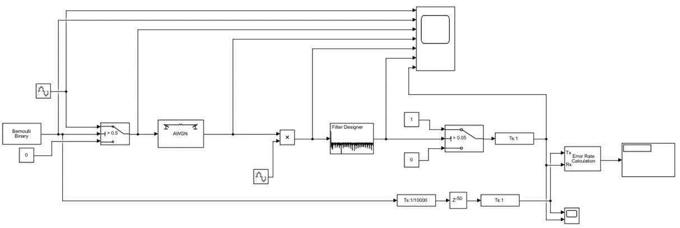
Simulation models:
Figure 2.
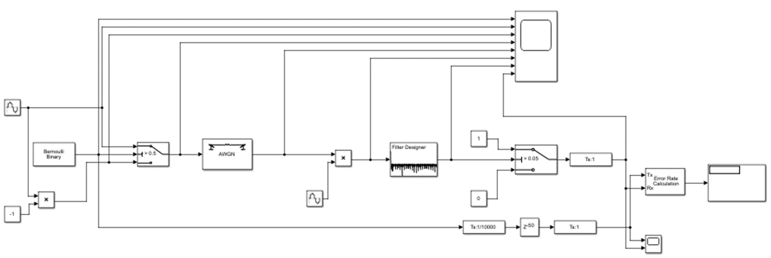
This circuit represents an ASK modulator and demodulator. As we can see from the far left a sine wave and a 0 are transmitted to our switch which runs through a noisy channel. It is then filtered to a switch which is turned on when a 1 is read (on-off shift keying).
Figure 3.
Following on from the ASK circuit, this PSK circuit is similar with the key difference being that a -1 is transmitted rather than a 0. This -1 inverts the sine wave.

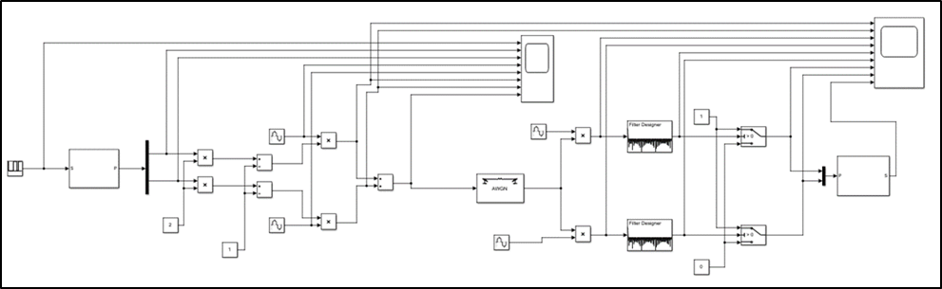
This larger circuit replicates a QPSK modulator/demodulator. The key differences from the PSK circuit are:
Figure 4.
- There are now two channels, not one.
- The two channels are summed together.
- We introduce a de-multiplexer to compress/cram more data into the same original space.
- Two bits of data are being modulated.
- 0, 90, 180 and 270 degrees are route options for the transmission.

Predictions:
- I predict that the PSK circuit will produce less errors than the ASK circuit due to the fact that ASK circuits enforce a lot of strain on the parts as it is constantly turned off and back on again. However ASK has poor bandwidth efficiency which reduces data rate, which means less errors.
- I predict that QPSK will be the most consistent as the circuit is not under stress from being constantly turned on and off.
- I predict PSK will be more immune to noise than ASK, but QPSK will be more further immune than PSK.

Limitations:
Simulink offers us perfect parts so the results you get from the simulation would be slightly better than if you were to build it in the real world due to manufacturing differences between parts.
In the real world a circuit would suffer from background noise and interference whether it is from other ionising waves or electrical fields. Simulink does not take this into consideration so the performance of our modelled circuits will be better than in the real world.

Results:
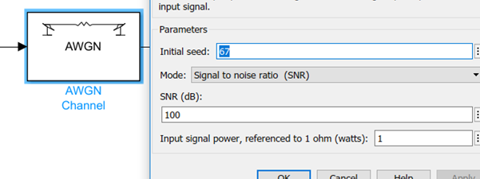
Before running the simulations at a variety of noise levels, the simulations were all run without any noise in order to make sure our scope received the signals as expected. To remove the white noise the AWGN part could be deleted from the circuit. However as the AWGN is set up in signal to noise ratio (dB) then a high number (100) would mean the noise would be negligible and not cause any interference.

Figure 5.

When the signal to noise ratio is set at 100, the bit error rate is 0, because there is no distortion or errors in our signal being transmitted, by our carrier wave which is 5 times the value of our source from the Bernoulli generator.
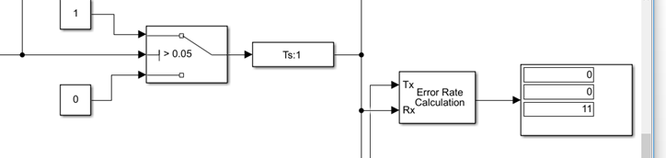

Figure 6.

The three element vector on the right hand side consists of the error rate, followed by the total number of errors detected in our circuit, then the number of symbols compared.
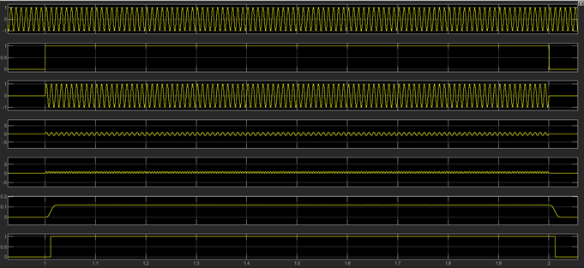
Received signal multiplied with carrier wave
Received signal
Filtered signal
Received signal
Transmitted signal
Source wave
Carrier wave
Figure 7.
This is the graph produced by the scope with its inputs. We can see a value of 100dB provides us with no significant noise, because there is no distortion. The delay is expected and is not due to noise.

ASK:
The selected range for the signal to noise ratio ranges from 10 to -50, with intervals of 5. This gives us a total of 13 readings which is representative of any trends found. This range was chosen because any higher ratio of SNR, would mean the noise is still somewhat negligible and has no significant impact on our bit error rate. Beyond -50dB the simulation was not running to its end run time and over half (0.5 BER) of the data was lost meaning non-recoverable data.
Figure 8.

From the graph above we can see the general trend is that as the signal to noise ratio increases, the bit error rate decreases. This is because the signal is more easily traced through the circuit at higher SNR due to the noise being subdued and not causing distortion. However after calculating the mean and standard deviation from 5 different runs (all runs were done after running the simulation with 100SNR prior) we can see that our error bars overlap. The overlap indicates that there is no significant change in our results and that any change is due to chance. Although there is overlap, there is a significant difference from -50, -20 and -5 SNR. This means that as SNR increases BER decreases.

PSK:
PSK is a more power efficient modulation technique in comparison to ASK. Altering the phase means the source does not have not have to regulate the amplitude which is stressful on component parts.
Figure 9.

Comparing PSK to ASK we can see that after 5 runs of altering the SNR, we can see that PSK has higher tolerance than ASK to larger noise ratios. ASK stayed consistently at 0 BER until -5dB , whereas PSK doesn’t produce any error rate until -10dB. As ASK is highly demanding of its parts (constantly being turned on/off) the BER is fluctuating in comparison wit PSK which appears to have a more linear relationship of BER and SNR. The error bars do overlap like with ASK, however the overlap is less prominent. Therefore the trend is more clearly outlined by the graph and is more likely to be due to the change in SNR rather than be due to chance.

QPSK:
QPSK uses a modulation of digital signals onto a radio-frequency carrier signal which consists of four ‘patways’. The signal can be transmitted at 0, 90, 180, or 270 degrees out of phase from one another. This means two bits of data are being modulated at any one time. Therefore a de-multiplexer is used in order to cram/compress the data into a smaller format for transmission. Although the bandwidth of QPSK is small, the data rate remains high as it transmits two bits per carrier signal.
From the graph below (figure 10.) we can see that QPSK has the same tolerance as ASK to -5dB. Any more noise beyond this level causes errors. Previously both ASK and PSK have given results in BER greater than 0.5 meaning they are un-recoverable. Whereas QPSK has peaked at 0.4118, therefore it is still recoverable and offers the best immunity to noise out of all the circuits. The 5 simulation runs all produced the same results at each SNR level, showing the difference in BER is due to the SNR and not chance. We have a 99% confidence level that the results are not due to chance because of the P-value from standard deviation being 0.

Figure 10.

Conclusion:
When comparing modulating/demodulating circuits, it is key to know that they all have their own advantages and disadvantages. ASK is simple and cheap and used in Morse code. PSK has poor bandwidth efficiency but greater noise immunity and is found in Bluetooth and RFID. QPSK has great noise immunity and is reliable yet also expensive. It doesn’t need the transmitter and receiver to be re-synchronised as much as PSK. QPSK is used for videoconferencing and cable modems.
From our collated data, PSK has the highest noise level (-10dB) immunity where 0 errors were detected. However it still reaches a failure beyond recovery (0.5BER+), whereas QPSK is the best at producing recoverable data in the presence of higher noise levels. QPSK is the most consistent circuit and has no fluctuations in its data between different runs, therefore it is the most reliable and offers less random errors than ASK. It is also important to note that the QPSK circuit took the longest to run in Simulink. However it never reached a point of failure. I ran QPSK beyond our testing limits but Simulink would crash.
Overall ASK, PSK and QPSK are all capable of transmitting signals. They each have their own niche where they can be optimised to the maximum.

References:
1: Dr Steve Mosey’ slides and PowerPoints on DSP. Dates used – 11/03/2021 12/03/2021 and 13/03/2021. Used these slides to understand the circuits and recreate them in Simulink.
2: Code: The Hidden Language of Computer Hardware and Software – Charles Petzold. Used on the 14/03/2021. Not a great read, had basics on transmission and signalling.
3: https://www.open.edu/openlearn/science-maths-technology/exploring-communications-technology/content-section-1.4. - Used on 15/03/2021. Principles of ASK.
4:https://www.tutorialspoint.com/digital_communication/digital_communication_amplitude_shift_keying.htm. Used on 15/03/2021. Good diagrams on ASK.
5: https://www.ni.com/en-gb/innovations/white-papers/08/amplitude-shift-keying--frequency-shift-keying--and-phase-shift-.html. Used on 16/03/2021. ASK, PSK and QPSK basics.
6. Tables used for graphs.
dB (ask) | BER 1 | BER 2 | BER 3 | BER 4 | BER 5 | Mean | SD
-50 | 0 | 0 | 0 | 0 | 0 | 0.54548 | 0.099612
-45 | 0 | 0 | 0 | 0 | 0 | 0.38178 | 0.068023
-40 | 0 | 0 | 0 | 0 | 0 | 0.43634 | 0.145468
-35 | 0 | 0 | 0 | 0 | 0 | 0.45452 | 0.057522
-30 | 0.09091 | 0.09091 | 0.1818 | 0.09091 | 0.1818 | 0.30906 | 0.07272
-25 | 0.1818 | 0.1818 | 0.09091 | 0.1818 | 0.1818 | 0.3636 | 0
-20 | 0.2727 | 0.09091 | 0.1818 | 0.1818 | 0.1818 | 0.181802 | 0.057487
-15 | 0.3636 | 0.3636 | 0.3636 | 0.3636 | 0.3636 | 0.163622 | 0.036356
-10 | 0.1818 | 0.3636 | 0.3636 | 0.2727 | 0.3636 | 0.127266 | 0.044527
-5 | 0.5455 | 0.4545 | 0.3636 | 0.4545 | 0.4545 | 0 | 0
0 | 0.1818 | 0.4545 | 0.6364 | 0.4545 | 0.4545 | 0 | 0
5 | 0.2727 | 0.3636 | 0.4545 | 0.3636 | 0.4545 | 0 | 0
10 | 0.3636 | 0.5455 | 0.6364 | 0.5455 | 0.6364 | 0 | 0
dB (psk) | BER 1 | BER 2 | BER 3 | BER 4 | BER 5 | Mean | SD
-50 | 0 | 0 | 0 | 0 | 0 | 0.60002 | 0.07276
-45 | 0 | 0 | 0 | 0 | 0 | 0.5273 | 0.0364
-40 | 0 | 0 | 0 | 0 | 0 | 0.40905 | 0.078722
-35 | 0 | 0 | 0 | 0 | 0 | 0.3636 | 0.099576
-30 | 0 | 0 | 0 | 0 | 0 | 0.25452 | 0.03636
-25 | 0 | 0.1818 | 0.09091 | 0.09091 | 0 | 0.163622 | 0.036356
-20 | 0.1818 | 0 | 0 | 0 | 0 | 0.03636 | 0.07272
-15 | 0.1818 | 0.09091 | 0.1818 | 0.1818 | 0.1818 | 0.072724 | 0.068024
-10 | 0.2727 | 0.2727 | 0.1818 | 0.2727 | 0.2727 | 0 | 0
-5 | 0.4545 | 0.4545 | 0.1818 | 0.3636 | 0.3636 | 0 | 0
0 | 0.4545 | 0.4545 | 0.2727 | 0.4545 | O.4545 | 0 | 0
5 | 0.4545 | 0.5455 | 0.5455 | 0.5455 | 0.5455 | 0 | 0
10 | 0.4545 | 0.6364 | 0.6364 | 0.6364 | 0.6364 | 0 | 0
dB (qpsk) | BER 1 | BER 2 | BER 3 | BER 4 | BER 5 | Mean | SD
-50 | 0 | 0 | 0 | 0 | 0 | 0.4118 | 0
-45 | 0 | 0 | 0 | 0 | 0 | 0.4118 | 0
-40 | 0 | 0 | 0 | 0 | 0 | 0.4118 | 0
-35 | 0 | 0 | 0 | 0 | 0 | 0.4118 | 0
-30 | 0.05882 | 0.05882 | 0.05882 | 0.05882 | 0.05882 | 0.4118 | 0
-25 | 0.1176 | 0.1176 | 0.1176 | 0.1176 | 0.1176 | 0.3529 | 0
-20 | 0.2353 | 0.2353 | 0.2353 | 0.2353 | 0.2353 | 0.2353 | 0
-15 | 0.3529 | 0.3529 | 0.3529 | 0.3529 | 0.3529 | 0.1176 | 0
-10 | 0.4118 | 0.4118 | 0.4118 | 0.4118 | 0.4118 | 0.05882 | 0
-5 | 0.4118 | 0.4118 | 0.4118 | 0.4118 | 0.4118 | 0 | 0
0 | 0.4118 | 0.4118 | 0.4118 | 0.4118 | 0.4118 | 0 | 0
5 | 0.4118 | 0.4118 | 0.4118 | 0.4118 | 0.4118 | 0 | 0
10 | 0.4118 | 0.4118 | 0.4118 | 0.4118 | 0.4118 | 0 | 0

