Building a Database Driven Website
MODULE: ACCA5034
RAH20858197 (Ataur Rahman)
WORD:661
Table of Contents
1.0 | Introduction 2
2.0 | What is SQL Injection 1
2.1 | Testing SQL Injection Prevention via Login 2
2.2 | How to make Prepared Statements 3
Conclusion 4
References 5

1.0 | Introduction
In this report , I will be creating a reliable website that depends on PHP and MySQL to operate. I will develop a normalized relational database that forms the foundation of the topic which is a flower business for my sister. The website offers users dynamic data access and search capabilities alongside complete CRUD operations through its administrative interface. The website includes fundamental security measures which consist of user authentication protocols and input validation systems and security features against SQL injection threats.

This report delivers two major elements including SQL injection vulnerability analysis with practical cases and a codebase assessment to unveil my database weaknesses and threats. This report will consist of security implementation examples with pictures of web application defence systems as well as identified security weaknesses.

2.0 | What is SQL Injection

In the world of databases , critical web security vulnerability happens when malicious input is inserted into a Structured Query Language (SQL) statement by either a URL parameter or an input field, which allows an attacker to compromise a website database [1]. It is a modern problem I web application as it manipulates inputs to thinking data is inserted true ,however malicious code has been inserted. It is a big issue in today’s world as it can attacker to alter the structure of SQL queries and manipulate database operations. A recent modern SQL injection report on car companies and their vulnerabilities [2], showcase on how web portals that have been accessed by attackers posed to gain access to sensitive information and send commands to customer vehicles interrupting database operation withing the vehicle industry. This is a big issue as attackers can gain loads of sensitive information that can affect business operations in the simplest way leaving them exposed to more vulnerabilities from attack. To ensure this I decided to employ prevention system into my own database driven website which I will help avoid data manipulation on input fields.

2.1 | Testing SQL Injection Prevention via Login
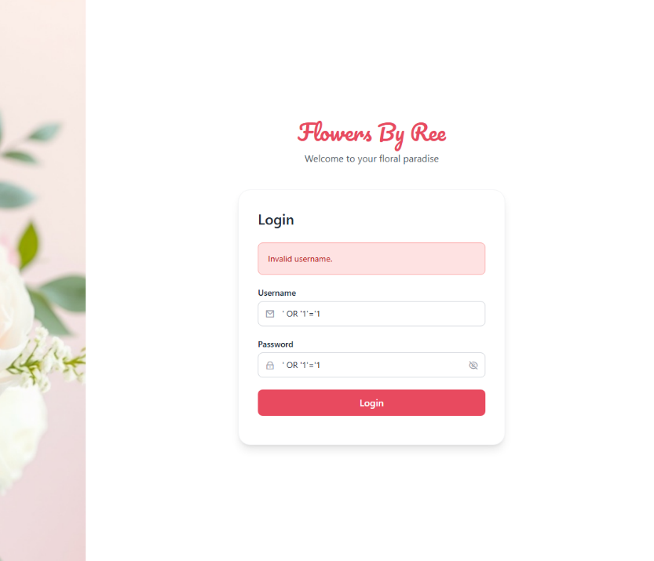
When creating secure login systems, I conducted thorough investigations to identify essential protective measures. The primary method of attacks comes from SQL injection attacks through user input which makes them established in a database breach.
The secure login system i developed involved the process of several vulnerability analysis of user input fields. These user input controls server as the main gateway for attack vendor across web application since login forms process user credential to allow attacker to steal database information and gain access. When proper securities measure is not implemented, input fields become a vulnerable to SQL injection attacks which allows attacker to alter queries to inject malicious code through form fields.
To attack this I decided to create prepared statements which help battle against this by separating the data used in a SQL command from the command itself [3]. A modern threat vector being OR '1'='1 into any username or password field to gain unauthorised database entry. This risk is raised as it this statement is always true ; this statement will return all records. However, for my own database driver website I decided to produce a prepared statement .
The prepared statements with bound parameter helped ensure user input are treated as data and not SQL executables. This ensured my login will not be vulnerable to SQL injection as the error log allowed the input of OR '1'='1 SQL query was returned as data.
Figure 1 - Secure Login Statement

2.2 | How to make Prepared Statements

The parameter query which I have researched from a fellow developer allowed me to gain an insight of developing it for my own website.
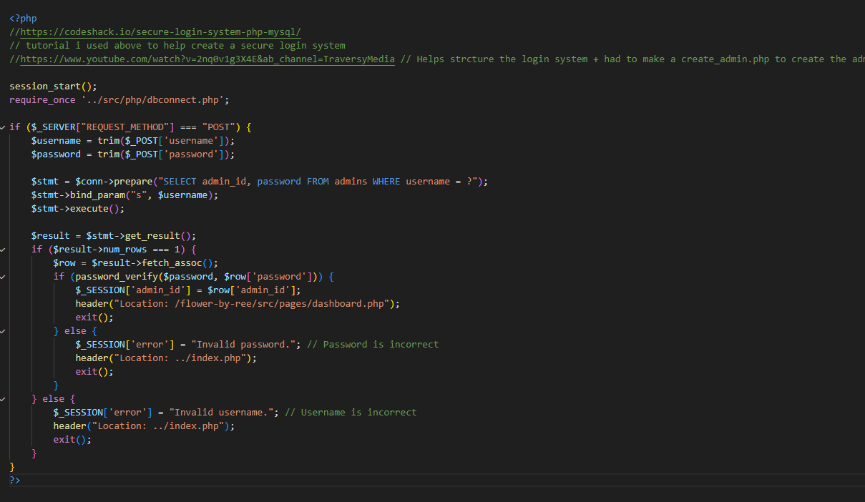
Figure 2 - Code shack Secure Login Example
This example allowed me to integrate to my own database driven website and ensure that I was allowed to input real data.
I managed to integrate this code into my database-driven website through analysis and adaptation which now provides secure handling of login credentials along with user-submitted data. Through this practical implementation, I developed better understanding of secure query execution and created an application that handles input data without exposing it to injection threats.

Conclusion

In conclusion , I believe that developer can use to protect input fields from SQL injection attacks. Prepared statements, parameterized queries, strict input validation and database user privilege limitations are technique that help safeguard sensitive data. Developers who implement these techniques can achieve substantial risk reduction for unauthorized access whilst ensuring safe data security.
Throughout the development of my website , I have constantly applied validation rules and principles to create a more secure login system and administrative interface to help prevent SQL injection in my database driven website. I also reviewed and tested my codebase for vulnerabilities, ensuring that common entry point such as login and search form is manipulated by simple SQL malicious queries. Ultimately , creating a safe database driven website which has been layered with many preventive techniques.

References

[1] | A. C, “ Advanced SQL Injection In SQL Server Applications,” in Next Generation Security Software, NA, n NGSSoftware Insight Security Research (NISR) Publication, 2002, p. 25.
[2] | B. Dickson, “The Daily Swig,” 04 01 2023. [Online]. Available: https://portswigger.net/daily-swig/car-companies-massively-exposed-to-web-vulnerabilities. [Accessed 28 04 2025].
[3] | J. Lengstorf, PHP for Absolute Beginners, Portland: Apress, 2009.

