
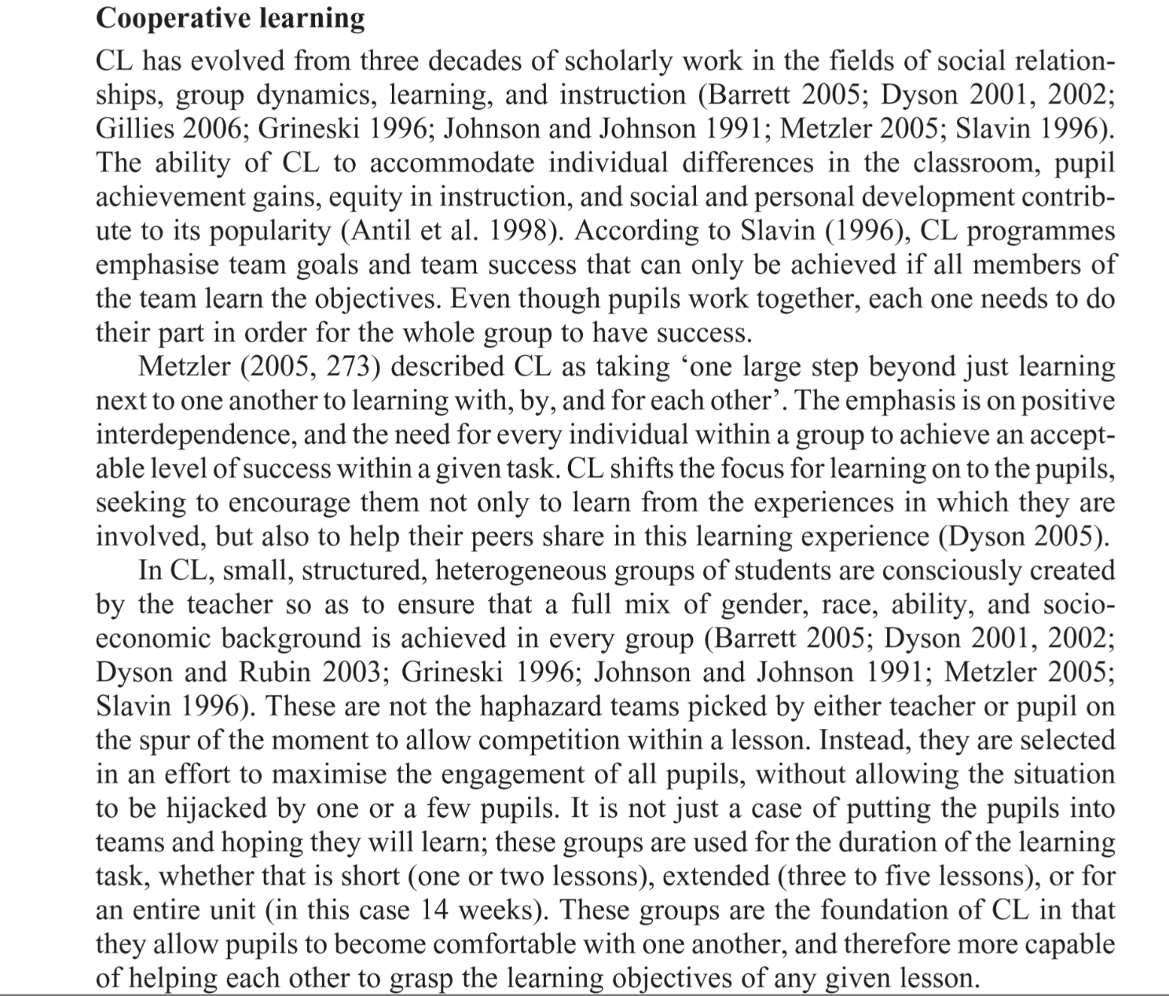
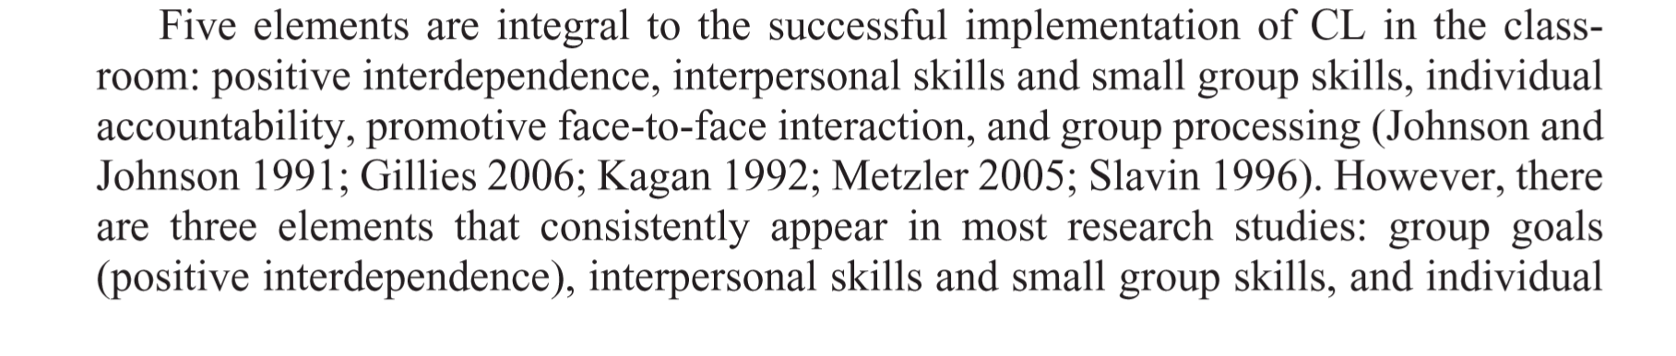
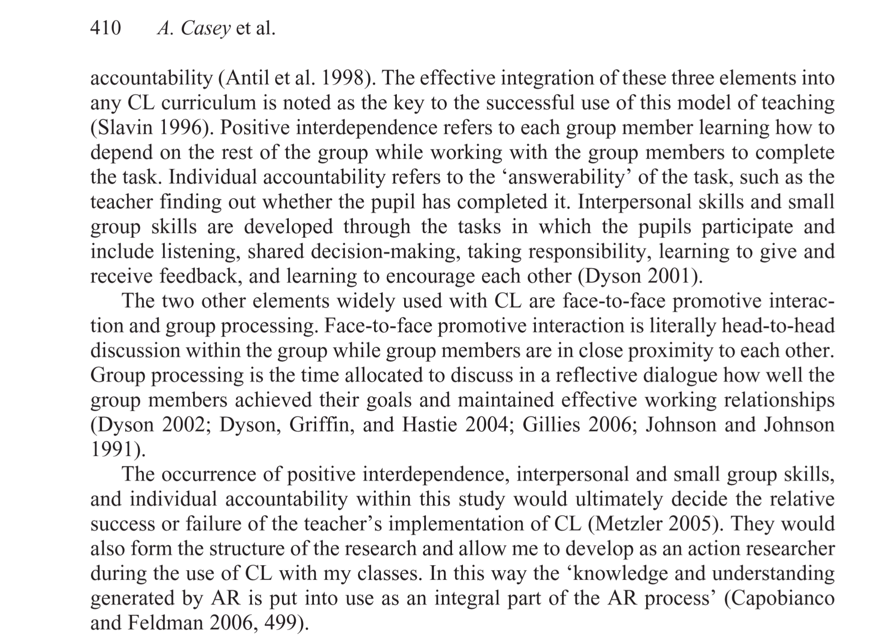
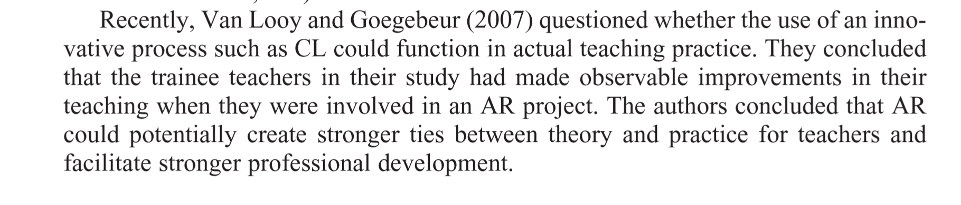

IEW Note Space and Places Lectures April/may 2019
Nodyn IEW Darlithoedd Lleoedd a Mannau Ebrill/Mai 2019

Features of co-operative learning - interdependence on each other / face to face interactions / doing your bit (taking responsibility) / interpersonal and group skills / team talk

Nodweddion o ddysgu cyd-weithredol – cyd-ddibyniaeth / rhyngweithiad wyneb i wyneb / gwneud eich rhan / sgiliau rhyngbersonol a grŵp / siarad tîm

