

Student Name: Daneil Nelson
Student Number: 2309115
Course Title: Managing Business Information
Module Code: 5004

MANAGING BUSINESS INFORMATION LCLM 5004
Table of Contents
1. Introduction 3
2. Evaluation of Existing Systems 3
3. Recommended Solution 5
4. Implementation Plan 8
5. Conclusion 10
References 11

1. Introduction
AKPerog Ltd. is a consumer electronics company with a flourishing growth rate and operates thirty brick-and-mortar stores as well as a growing online business (UK Government, 2018). The company has had a good sales growth over the last year and is in the process of expanding. Nevertheless, the organisation has been facing serious operational challenges since it is in a promising market position, which has started to affect its efficiency and customer satisfaction. The main source of these challenges is the old and isolated information systems that can no longer sustain the business size and complexity.
The biggest issue, which is critical, is that the company uses a manual system in tracking inventory, which has resulted in frequent stock variances between the physical stores and the online medium of sale. This issue leads to cancellations and refunds, as well as customer dissatisfaction. Also, there is a disorganised customer relationship management process and data is stored in various systems that are not connected. This results in challenges with maintaining a purchase history, personalising marketing efforts, and providing consistent support to staff.
No less troublesome is the use of manual reporting using spreadsheets that is slow, prone to errors and restricts the management from making real-time and evidence-based decisions. Additionally, the company faces the risk of breach and legal fines due to insufficient security protocols and a lack of adherence to data protection standards like the General Data Protection Regulation (GDPR). Lastly, the absence of integration between the sales, finance, and inventory systems would lead to time wastage, redundancy and a higher chance that a human error can occur. This report will examine these issues and propose a current information system solution that will optimise business processes, improve adherence, and customer experience to propel AKPerog Ltd. towards the high growth trajectory within its ambitious business strategy.

2. Evaluation of Existing Systems
The information systems used by AKPerog Ltd. are ineffective, outdated, and cannot support the growing operations of the company (Endole UK, 2024). The analysis of the current infrastructure reveals that there are some fundamental flaws in inventory management, customer relationship management, reporting and decision-making, data protection and interdepartmental integration.
Inventory Management
The organisation has an archaic method of tracking inventory, which comprises thirty retail outlets and its online shopping. There is a significant chance of inaccuracy with this method because online records do not always correlate with physical counts. This leads to a disparity that may ultimately be interpreted as overselling, order cancellations, and loss of money. (Manahov, 2020) Age of the operation, the store manager would not be able to exercise their stock visibility enough to effect their order fulfilment and demand forecasting efficiency.
Customer Relationship Management (CRM)
At this moment, customer records exist within individual systems resulting in organizational difficulties to construct one image of the customer (Massi et al. 2023). The marketing teams cannot easily segment their customers and create specific campaigns, and the service teams cannot see complete purchase histories. Ultimately, this equates to a lack of communication resulting in poor customer experience, resulting in a lack of long-term loyalty and retention.
Reporting and Decision-Making.
The management reporting is performed in the form of spreadsheets, which are manually compiled, which is rather time-consuming and may cause errors, as well as result in outdated information. The absence of automated reporting tools does not allow the leadership team to have access to real-time information and determine the new trends in sales (Habel et al., 2023). This leads to poor forecasting, slow forecasting and therefore missed opportunities and reactive decision-making.
Data Protection and Compliance.
The existing systems are not up to date with the modern standards of data protection. Cases of poor security measures and poorly maintained access control allow the possibility of unauthorised access. It is not only the violation of such rules as the General Data Protection Regulation (GDPR) that will subject the company to possible financial fines, but also undermine its reputation among the customers who anticipate its safety in processing their personal data (GDPR, 2024).
System Integration
Independent software solutions in departments like sales, finance and inventory have no form of interoperability (Khan and Abonyi, 2022). This isolated practice compels workers to exchange information between systems manually, wasting precious time and exposing them to the chances of human error. Lack of cohesive workflow also slows down the operations, and the business is not able to realise economies of scale.

3. Recommended Solution
To address the issues that AKPerog Ltd. faces, the best approach will be the implementation of a unified information system, which is a combination of enterprise resource planning (ERP), customer relationship management (CRM), business intelligence (BI), and analytics applications (Schwarz, 2024). All these solutions will make the company operations modern, decision-making better, compliance more efficient, and customer experience outstanding.
Enterprise Resource Planning (ERP) System.
The information infrastructure of AKPerog will be based on an ERP system. ERP is a system that incorporates the main business processes, finance, sales, supply chain, procurement, and human resources into a centralised system (Tarigan et al., 2021). ERP allows various departments to combine their data to create accuracy, consistency, and transparency in the organisation.
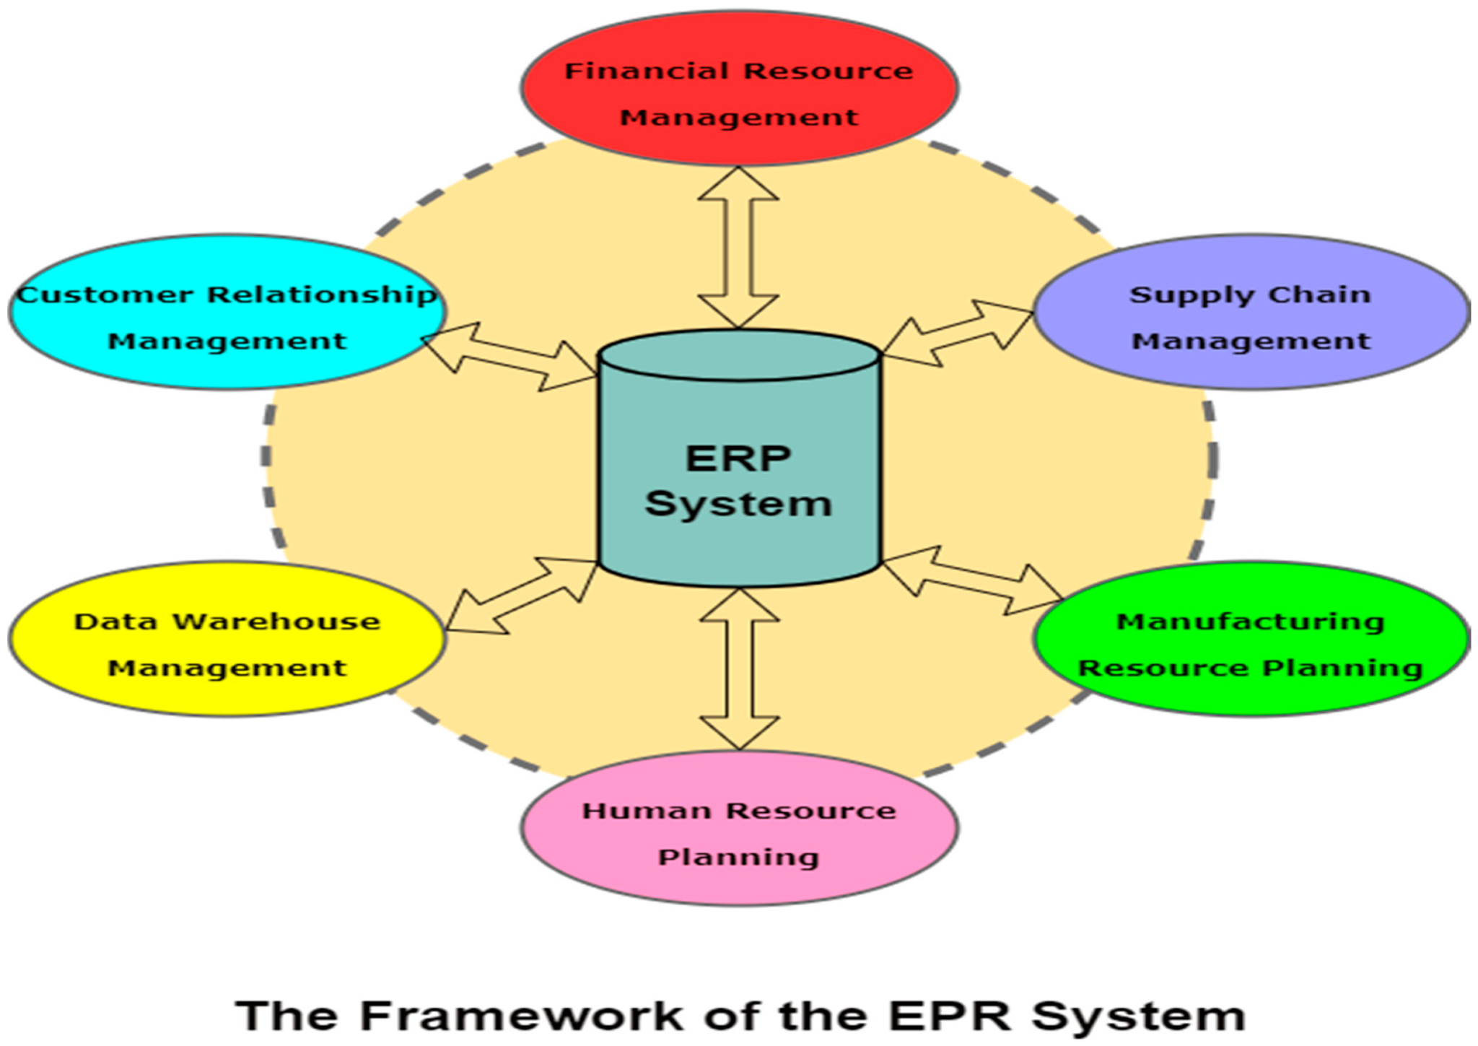
Figure 1: ERP system framework with data warehouse management
(Source: Kitsantas, 2022)
In the case of AKPerog, ERP will resolve the inventory issues by providing real-time inventory availability of all thirty stores and the virtual world (Kitsantas, 2022). The automated updates will eradicate inconsistencies between the physical and digital inventories, and no instances where customers buy products that are not available will be witnessed. The store managers would also be able to have precise knowledge of the stock levels, lowering overstocking and understocking. The procurement teams would be able to plan replenishment and reserve according to the actual demand trends. Specifically, cloud-based ERP systems include Microsoft Dynamics 365, Oracle NetSuite, or SAP S/4HANA (Schwarz, 2024). These solutions can be easily scaled as the business grows, financial resources on start-up are minimised, and most importantly, anywhere access is offered and is essential in businesses with stores geographically distributed.
Customer Relationship Management (CRM) System.
The current CRM system, based on an ERP platform, will establish an integrated customer profile by combining relationship data collected on sales, support and marketing channels (Hossain et al., 2025). Such a single source of truth allows interacting with customers more successfully and conducting marketing campaigns.
In the case of the marketing team, CRM enables segmentation in terms of purchase history, behaviour and preferences. This helps in personalised advanced promotions, enhances conversion rates, and creates customer loyalty (Ledro, Nosella and Vinelli, 2022). This will help the customer service representatives as they will be able to quickly and effectively resolve complaints through the immediate access to the histories of orders and communication records. Automation functions like campaign management, AI-based recommendations, and support for multi-channel communication can be offered through CRM solutions like Salesforce or CRM in Microsoft Dynamics 365 (Hossain et al., 2025). In the case of AKPerog, it would be a tremendous improvement over disjointed systems, and it would enhance the efficiency of operations and customer satisfaction.
Business Intelligence (BI) and Analytics
The implementation of the BI tools is key to addressing the existing reporting and decision-making inefficiency. Real-time dashboards, predictive analytics and automated reporting are offered through platforms like Tableau, Power BI, or the built-in analytics modules of ERP systems (Mohiuddin, Nur and Zamil, 2025). In the case of AKPerog, BI will help the management to track the trends of sales, discover the products which do not sell, and predict demand more precisely. The transition from manual spreadsheets to interactive dashboards will make sure that the decisions taken are based on the current error-free data. This will enhance strategic planning and responsiveness to market changes, as well as revenue opportunities.
Data Security and Privacy
The contemporary ERP and CRM systems are also compliant and secure in nature. Role-based access controls, encryption of data, and audit trails prevent violations of such rules as the GDPR (Belen-Saglam et al., 2023). The cloud providers are spending a lot on cybersecurity and have an extra layer of protection against the developing threats. These systems will assist AKPerog in reducing the risk of data theft, incurring expensive penalties, and facing negative publicity.
Justification for the Recommended Solution
The justification of the suggested system is as follows as it directly tackles the operational weaknesses of AKPerog Ltd. and supports its future development (UK Government, 2018). Automating inventory management, reporting, and marketing activities will help the company eliminate manual errors and enhance efficiency and provide a more fluid customer experience. The implementation will be a cost, but the long-term savings of the reduced refunds, the better forecasting and increased customer retention will be more than the cost, especially with the scalable cloud-based solutions which reduce the amount of infrastructure needed (Khedr and Sheeja, 2024). There is also the fact that the system can be expanded to meet the needs of increasing stores, products and more transactions without disturbing the entire system because it will support expansion (Belen-Saglam et al., 2023). Most significantly, it improves customer satisfaction through the availability of precise stock visibility, personalised promotions, and responsive customer service, all of which strengthen loyalty and competitiveness.
Expected Outcomes
Implementation of a combined ERP, CRM, and BI will change how AKPerog Ltd. operates since it will be more accurate in terms of taking orders and responding promptly in both the brick and mortar shops as well as the online platform. The personalised promotions with the help of unified customer data will help the marketing campaigns to be more effective, and the access to real-time dashboards and predictive analytics will enhance the power of the decision-making process (Visconti, Rambaud and Pascual, 2023). The enhanced security and compliance capabilities will minimise threats of data breach and regulatory fines, which will protect the reputation of the company as well as customer confidence.

4. Implementation Plan
Phase | Key Activities | Purpose/Expected Outcome
Needs Assessment & Vendor Selection | Analyse organisational requirements; evaluate ERP/CRM/BI vendors (e.g., Microsoft Dynamics 365, SAP S/4HANA, Oracle NetSuite). | Identify the most suitable solution that meets business needs, cost requirements, and scalability.
Infrastructure Setup | Configure cloud environment; establish cybersecurity protocols; prepare legacy systems for integration. | Create a secure, scalable foundation for the new system.
Data Migration | Cleanse, validate, and securely transfer inventory, sales, and customer records into the new system. | Ensure accurate and compliant centralised data while reducing errors and duplication.
System Integration | Connect ERP with finance and inventory, CRM with sales and support, and enable BI dashboards. | Establish real-time workflows and remove departmental silos.
Staff Training | Provide workshops, user manuals, and demonstrations for employees across departments. | Build user confidence, reduce resistance to change, and improve adoption.
Pilot Deployment | Implement system in a limited number of stores before company-wide rollout. | Test functionality, identify issues, and refine processes in a controlled environment.
Full Rollout | Gradual expansion to all thirty stores and the e-commerce platform. | Ensure smooth adoption across the entire organisation.
Continuous Monitoring & Improvement | Conduct post-implementation reviews, apply updates, monitor security, and gather staff feedback. | Maintain system effectiveness, security, and adaptability over time.
The stages of the plan are constructed one after the other to guarantee the reduction of risks and minimisation of disruptions. This incremental strategy will enable AKPerog Ltd. to pilot the system in a restricted setting and then extend it to all stores. Special attention is required for the data migration and integration because any errors at the given level may affect compliance and accuracy of operation (Rizvanović et al., 2023). Staff training is also necessary because the success of any system does not simply lie in the state of the technology but in the willingness and capability of the employees to make constructive use of it. AKPerog can guarantee that the system is updated with the technological requirements and regulations by introducing the element of constant supervision in the last stage of the operation (Kallmuenzer et al., 2024). This strategic roadmap will enable the firm to shift from the old systems to an integrated digital platform, which will facilitate its strategic development goals.

5. Conclusion
The current information systems are showing constraints in AKPerog Ltd. today since they are old and disjointed, affecting inventory control, customer relationship management, decision-making and compliance. It is not only that these challenges impede daily operations, but also the fact that they make the company unable to maintain its current growth and to be competitive in the consumer electronics industry. An integrated ERP, CRM, and BI solution is the solution that is suggested to address these concerns at a strategic level. It will be a centralised system that will take care of real-time management of inventory, which will ensure proper customer engagement and reliable information in order to make timely decisions. In addition, it will also improve the adherence to data protection requirements and minimise operational risks by providing secure access controls and process automation. Adhering to the phased implementation plan with the assistance of training, pilot deployment and constant monitoring,

References
Belen-Saglam, R., Altuncu, E., Lu, Y. and Li, S. (2023). A systematic literature review of the tension between the GDPR and public blockchain systems. Blockchain: Research and Applications, 4(2), p.100129. doi:https://doi.org/10.1016/j.bcra.2023.100129.
Endole UK (2024). Ak Oil & Gas Global Ltd - Company Profile - Endole. Endole.co.uk. Available at: https://open.endole.co.uk/insight/company/15772224-ak-oil-gas-global-ltd [Accessed 24 Sep. 2025].
GDPR (2024). General Data Protection Regulation (GDPR). General Data Protection Regulation (GDPR). Available at: https://gdpr-info.eu/issues/fines-penalties/ [Accessed 24 Sep. 2025].
Habel, J., Alavi, S. and Heinitz, N. (2023). A theory of predictive sales analytics adoption. AMS Review. doi:https://doi.org/10.1007/s13162-022-00252-0.
Hossain, M.Z., Sultana, S., Nahiduzzaman, A.K.M. and Jalil, M.A. (2025). Evaluating the Effectiveness of ERP and CRM Integration on Enhancing Customer Experience in the Digital Business Ecosystem. Pacific Journal of Business Innovation and Strategy, 2(2), pp.11–21. doi:https://doi.org/10.70818/pjbis.2025.v02i02.040.
Kallmuenzer, A., Mikhaylov, A., Chelaru, M. and Czakon, W. (2024). Adoption and performance outcome of digitalization in small and medium-sized enterprises. Review of Managerial Science. doi:https://doi.org/10.1007/s11846-024-00744-2.
Khan, A.A. and Abonyi, J. (2022). Information sharing in supply chains - Interoperability in an era of circular economy. Cleaner Logistics and Supply Chain, 5, p.100074. doi:https://doi.org/10.1016/j.clscn.2022.100074.
Khedr, A.M. and Sheeja , R.S. (2024). Enhancing Supply Chain Management with Deep Learning and Machine Learning Techniques: A Review. Journal of Open Innovation Technology Market and Complexity, 10(4), pp.100379–100379. doi:https://www.sciencedirect.com/science/article/pii/S2199853124001732.
Kitsantas, T. (2022). Exploring Blockchain Technology and Enterprise Resource Planning System: Business and Technical Aspects, Current Problems, and Future Perspectives. Sustainability, 14(13), p.7633. doi:https://doi.org/10.3390/su14137633.
Ledro, C., Nosella, A. and Vinelli, A. (2022). Artificial intelligence in customer relationship management: literature review and future research directions. Journal of Business & Industrial Marketing, 37(13), pp.48–63. doi:https://doi.org/10.1108/JBIM-07-2021-0332.
Manahov, V. (2020). High‐frequency trading order cancellations and market quality: Is stricter regulation the answer? International Journal of Finance & Economics. doi:https://doi.org/10.1002/ijfe.2071.
Massi, M., Piancatelli, C. and Vocino, A. (2023). Authentic omnichannel: Providing consumers with a seamless brand experience through authenticity. Psychology & Marketing, 40(7). doi:https://doi.org/10.1002/mar.21815.
Mohiuddin, M., Nur, M. and Zamil, M.H. (2025). BUSINESS INTELLIGENCE SYSTEMS IN FINANCE AND ACCOUNTING: a REVIEW OF REAL-TIME DASHBOARDING USING POWER BI & TABLEAU. SSRN Electronic Journal. doi:https://doi.org/10.2139/ssrn.5386522.
Rizvanović, B., Zutshi, A., Grilo, A. and Nodehi, T. (2023). Linking the Potentials of Extended Digital Marketing Impact and start-up growth: Developing a macro-dynamic Framework of start-up Growth Drivers Supported by Digital Marketing. Technological Forecasting and Social Change, 186(1), p.122128. doi:https://doi.org/10.1016/j.techfore.2022.122128.
Schwarz, L. (2024). ERP Software Comparison for 2024. Oracle NetSuite. Available at: https://www.netsuite.com/portal/resource/articles/erp/erp-comparison.shtml [Accessed 24 Sep. 2025].
Tarigan, Z.J.H., Siagian, H. and Jie, F. (2021). Impact of enhanced enterprise resource planning (ERP) on firm performance through green supply chain management. Sustainability, 13(8), p.4358. doi:https://doi.org/10.3390/su13084358.
UK Government (2018). AK PEROG GLOBAL KONSULT LTD overview - Find and update company information - GOV.UK. Service.gov.uk. Available at: https://find-and-update.company-information.service.gov.uk/company/11531154 [Accessed 24 Sep. 2025].
Visconti, R.M., Rambaud, S.C. and Pascual, J.L. (2023). Artificial intelligence-driven Scalability and Its Impact on the Sustainability and Valuation of Traditional Firms. Humanities and Social Sciences Communications, 10(1). doi:https://doi.org/10.1057/s41599-023-02214-8.

