SOFTWARE APPLICATIONS FOR BUSINESS

TABLE OF CONTENTS
INTRODUCTION 3
MAIN BODY 3
TASK 1 3
Analysing several contemporary E-Commerce website software solutions 3
TASK 2 4
Developing a mind map for contemporary software applications that are used to support day to day business functions 4
TASK 3 7
Analysing several contemporary office applications 7
TASK 4 13
Analysing the Key features of Contemporary digital dashboard 13
TASK 5 14
Analysing several contemporary communications, collaboration and project management applications 14
CONCLUSION 26
REFERENCES 27

INTRODUCTION
Software concerns with set of programs and instruction that is being used to operate computer system and implementing certain tasks. It not only keeps system to perform specific tasks but also helps in making business functions more effective. Therefore, right selection of software can also assist businesses in streamlining their working pattern so that they can be able to cater specific market requirements. Likewise, software application allows organisations to carry out their activities which shows creativity, improvises communication and ensures productivity in business tasks. Following report is based on increasing understanding in use of software in business as how it helps in managing workforce and business tasks. Therefore, it will be going to cover analysis over contemporary e commerce website software solution along with the creation of online-e portfolio. Illustration of mind map for software solution will also be found, while discussion of office applications and communication, collaboration applications will also be made.

MAIN BODY

TASK 1

Analysing several contemporary E-Commerce website software solutions
E-commerce software are the system which enables businesses to do business activities over online medium (Jenneboer, Herrando and Constantinides, 2022). This system encompasses various business tools like accounting and email marketing as well as involves techniques for inventory management. Furthermore, e commerce software solutions let businesses to list their products for sale and accept digital payments. Such software are as follows-
Shopify: It is considering as number one E commerce medium for all type of businesses, it generally doesn’t require extra efforts from the user side to begin showing products online. Shopify enables businesses to move their existing online business to this platform so that its businesses can experience its benefit. This platform also enables businesses to stay ahead from their competition and keep on developing their brands to greater level.
Wix: It is a robust website builder that provides cloud based web creation services, while it also lets user to design a HTML5 websites as well as mobile sets by the use of online drag and drop techniques (Typert-Morrison, 2022). Businesses can easily proceed to develop their online store irrespective of its niche, whether it’s a small or large store, it can allow to load a stuff with an easy to use Wix.
Squarespace online store builder: This is an all in one platform which is developed to allow users to introduce their own ecommerce website and helps in growing business online. Its essential features allow to show products and services seamlessly, while its versatile layouts also allow in presenting business with better visual appealing (Anderson, 2022). With the help of Squarespace, businesses can easily able to get their products catalog, merchandising and so on.
Weebly: It is a drag and drop website creation application that allows users to develop a professional website. It is considering as simplest platform for building a site as it also provides a free option as well as premium plan. With this editor user can easily proceed to involve creativity in their business as its core functions depends on online selling.
Likewise, these software solution, several other E commerce software solutions are also available that are Volusion, Big commerce, Elementor, Strikingly, Shift4Shop.

TASK 2

Developing a mind map for contemporary software applications that are used to support day to day business functions
Contemporary software application is used in business with the purpose of optimising day to day business activities (Babu and et.al., 2022). There are different software applications listed below which has been using in contemporary businesses-
Proof Hub: It is an all in one business software that assists firms in managing their work in an organised manner. This system is basically a centralised platform that enables teams to visualise their daily work seamlessly. It also reduces the possibility of other software’s need as its features are capable of providing collaboration and management support, while also lets user in sharing the updates so that task can be carried out accordingly.
Flodesk: It is rapidly growing application that provides email marketing services to small scale businesses. Focus of this system is on designing and allowing small firms to develop an efficient email and promote their brand.
Bit.AI: An interesting business management tool for every firm. Over this platform business can easily proceed to develop an interactive documents and can proceed to arrange an information in distinct workspaces (Hristov and Appolloni, 2022).
HubSpot CRM: All in one CRM solution that can be available for the small enterprises and for individuals as well. This system also provides a set of consumer services, sales and other operational tools through email workflows to a systematic website creation in managing entire business at central location.
Studio Cloud: It is a cloud business management tool that assures one stop solution for the firm, where it provides all features that is required for businesses in managing their core functions anytime and anywhere. Benefit of Studio cloud is that it enables businesses in managing their clients, suppliers and partners at one central place, while it also develops and forwards a professional invoice.
TimeCamp: It is a solution that have ability to provide better solution for the business management, it encompasses time tracker along with the system activities, attendance tracking and others (Chen and et.al., 2022). This software monitors time automatically that reduces the burden of tracking spending hours of workforce.

MIND MAP

TASK 3

Analysing several contemporary office applications
Office applications has been designed to assist in competing specific tasks on computer system, features in these can allows to develop and edit a documents that consists of visual paradigms and helps in developing presentation. There are some contemporary office applications which are listed below-
Word processing: A computer program which is designed to provide formatting, input, output and editing of the text. Common word processing applications involves Microsoft word, notepad as well as Corel Word perfect (Hart and Baruch, 2022). Microsoft word is an interactive word processor that is developed by Microsoft, it enables users to develop both easy and complex documents. Features of MS word allows to create a text files, also discover grammatical mistakes in text files, while also allows in formatting the existing document. Further, Notepad is another free processor that allows editing the text documents.

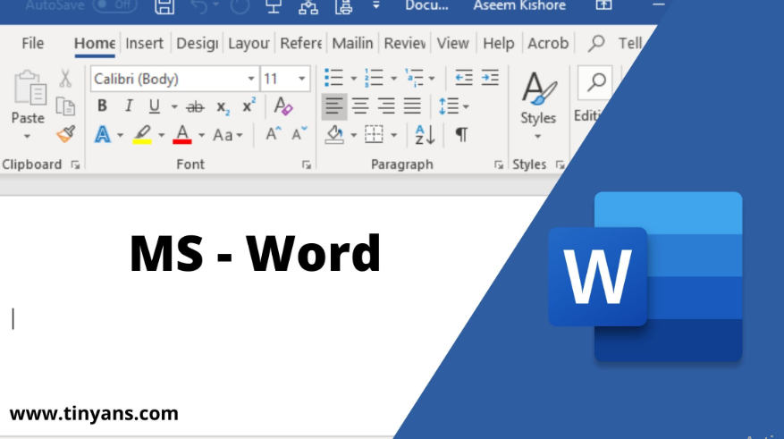
Figure 1MS Word, 2023

Spreadsheets: It is designed as computerised analogs, in this program performs on information entered into cells of table. Its features allow in manipulating and analysing the data. Google Sheets, Open Office, Microsoft excel are the finest example of this. Features of Google sheets allows in data visualisation, offline editing, formatting and editing etc. Further, Microsoft Excel is another spreadsheet that provides features like computation, pivot tables, graphing techniques also provides macro programming.

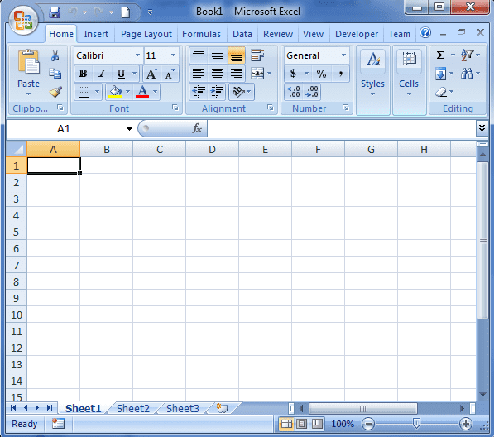
Figure 2Microsoft Excel, 2023

Databases: Microsoft access is a database management system that is developed by Microsoft, it utilises the Jet database engine (Winters, 2022). Its features allow to import data from other databases, while also helps in developing forms for viewing the data. Key functions also enables user to interact with the Access through SQL query language.

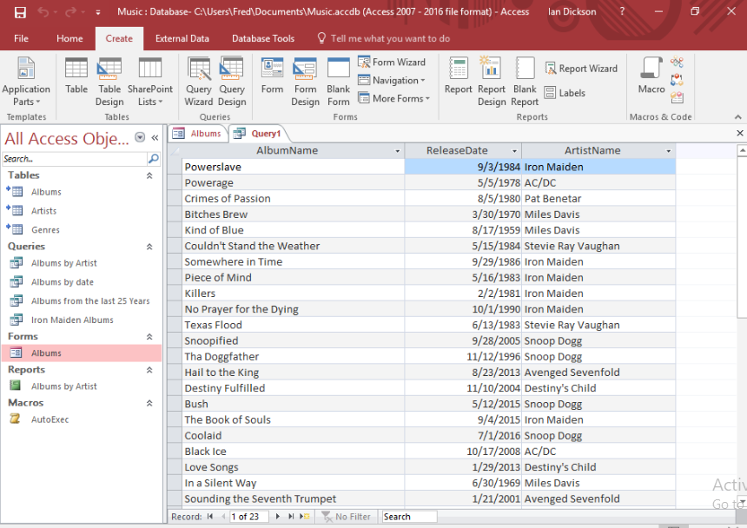
Figure 3Microsoft Access, 2023

Presentation: It helps in conveying information from speaker to other people. Different type of presentation software is available that is being used in businesses in communicating the ideas. Such software’s are Microsoft PowerPoint, Canva slides and Google slides. Features of Microsoft PowerPoint includes Audio features, collaboration, picture, print and design layout features, that helps in making presentation for both personal and professional purpose.

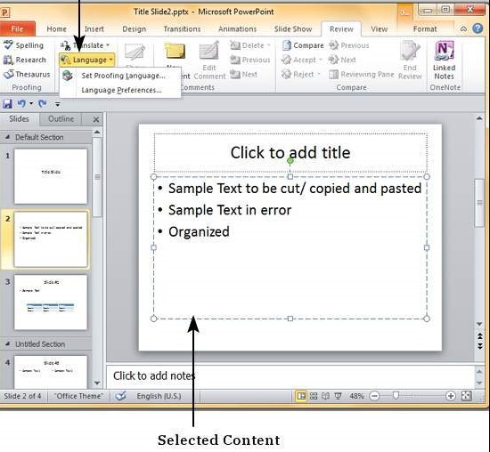
Figure 4Microsoft PowerPoint, 2023

OneDrive: It is another hosting services that allows registered users to synchronise their files (Myerson and Ross, 2022). Its features let users in saving their essential files, photos and documents.

Figure 5One drive, 2022

TASK 4

Analysing the Key features of Contemporary digital dashboard
Digital dashboard refers to the business intelligence which enables firms in monitoring, analysing and reporting on Metrics and suitable KPI’s (Corvello and et.al., 2022). Contemporary dashboards are designed to associate data from different and various sources in efficient manner while exploration and data analysation can be done directly on dashboard only. Better dashboard can allow information to being communicated rapidly, while also displays data clearly. Its key features are as follows:
Completely interactive: It leverages an analytics right from dashboard and helps in evaluating the data so that further decisions can be made.
All data sources at central point: Its functions allow in combining the data across the business so that management reports can be made.
Augmented analytics: Its strong AI application can help in providing specific approaches to perform and insights to extract from collected data.
Automated alerts: Businesses can proceed with setting their dashboard so that it will auto share the information with key stakeholders on a regular basis, while it also helps in sending alerts messages based on the metrics fluctuation.
Simple data preparation: Digital dashboard is associated with the contemporary data analytics that allows in preparing data in less time.

Dashboard for the marketing project
This dashboard is a visual showcase of the relevant information requires in tracking the key marketing metrics and to accomplish desired marketing goals (Becker and Pentland, 2022). Information present on this dashboard can allows in understanding the initiatives that has been made in accomplishing the desired goals of company. A digital marketing dashboard can assist in tracking essential marketing points, where it also separates the data from irrelevant data and essential numbers from Fluff (Marketing dashboard, 2023).

TASK 5

Analysing several contemporary communications, collaboration and project management applications
There are different contemporary communication applications which is Video and web conferencing, email, cell phones, smartphones etc. It helps in ensuring efficient communication so that information can be passed on real time in delivering task with greater efficiency. For example, key features of video conferencing include video recording, group video calls, screen sharing, end to end security as well as cross platform support (Shin and et.al., 2023). All these helps in making communication process more smooth. Likewise, there are some collaboration and project management tools which are as follows:
Zoom: It is a popular user friendly application that allows users to do video as well as audio conferencing with others, while it also supports sharing of information, personal chat all in one platform. Its feature also allows in recording meetings that can be reviewed later as well.


Figure 6Zoom, 2023

Slack: This software platform allows teams to stay systematic and connected. Its top features promote communication among team members, while separate room can allow member to share information about project and keep updated with latest information. In project management this software helps in making information more accessible and clear so that tasks can be carried out accordingly.

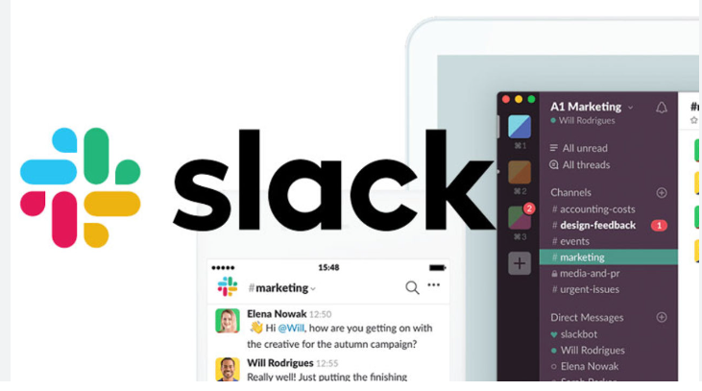
Figure 7Slack, 2023

Trello: This tool is specially designed for the project manager where it ensures greater customization in tasks and also promotes communication among project team members (Al-Rahmi and et.al., 2022). Its features include activity logs for every task so that teams can be informed with latest data; it also includes deadline for each task so that project team can work accordingly.

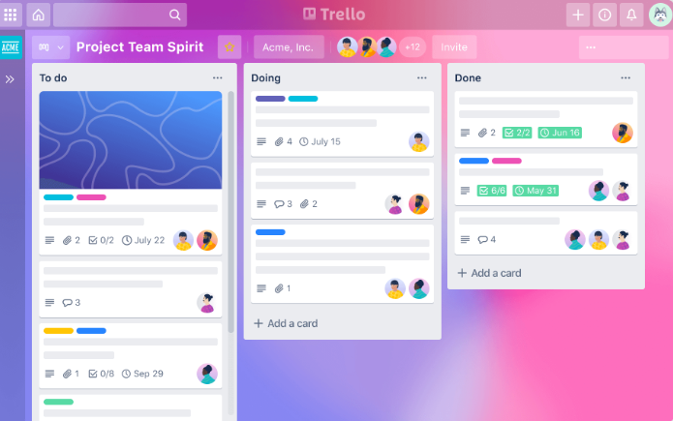
Figure 8Trello, 2023
Asana: A software which enables better collaboration on projects, by making all information available on central location. Its features include calendar views, file attachments as well as communication in real time. This software also integrates with the other collaboration tools so that better management of project can be found. Also its versatile application can help in managing large projects efficiently.

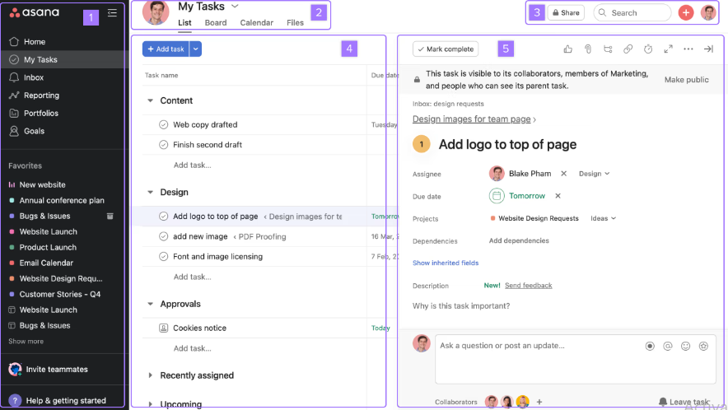
Figure 9Asana, 2023

Prezi: An cloud based software which assists in developing, editing and forwarding presentations (Fan Zheng, P. and Li, 2022). It consists of distinctive features that enables person to collaborate on tasks concerning with capability in creating, commenting on slides.

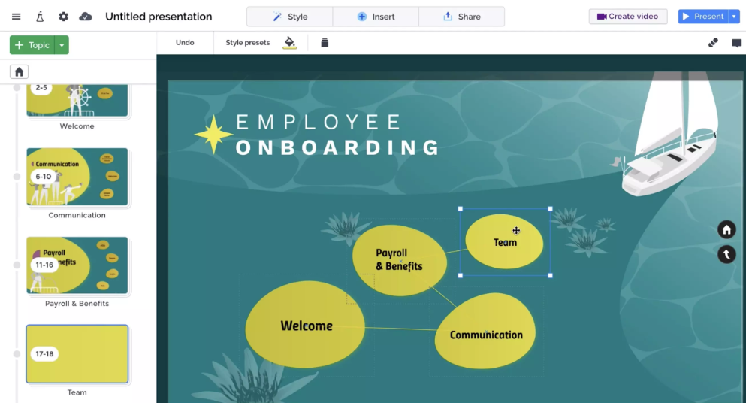
Figure 10Prezi, 2023

E-Portfolio Link

https://moshahidahmed1991.wixsite.com/software-solution

Screenshots from E portfolio

Welcome page
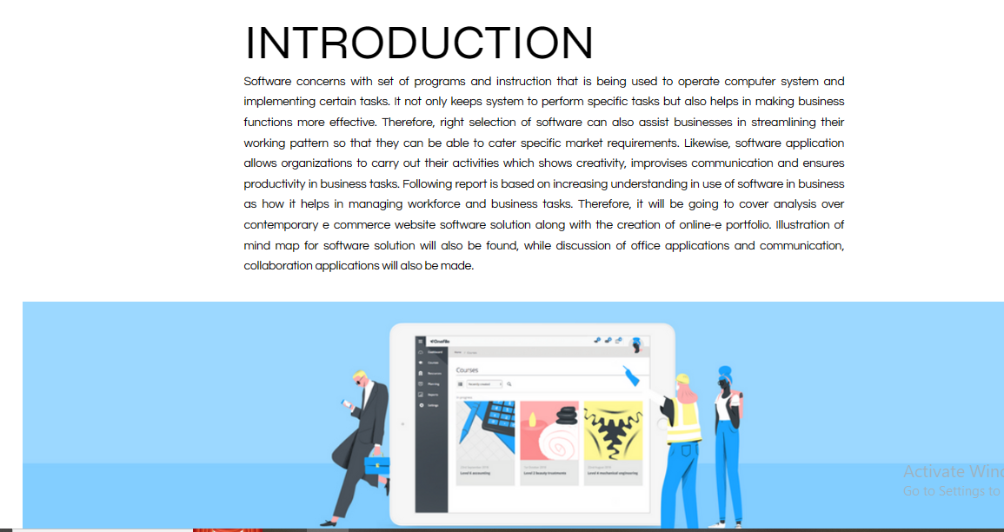

Task 1

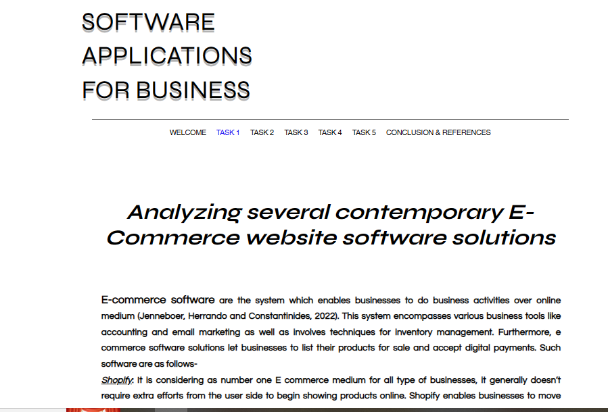

Task 2
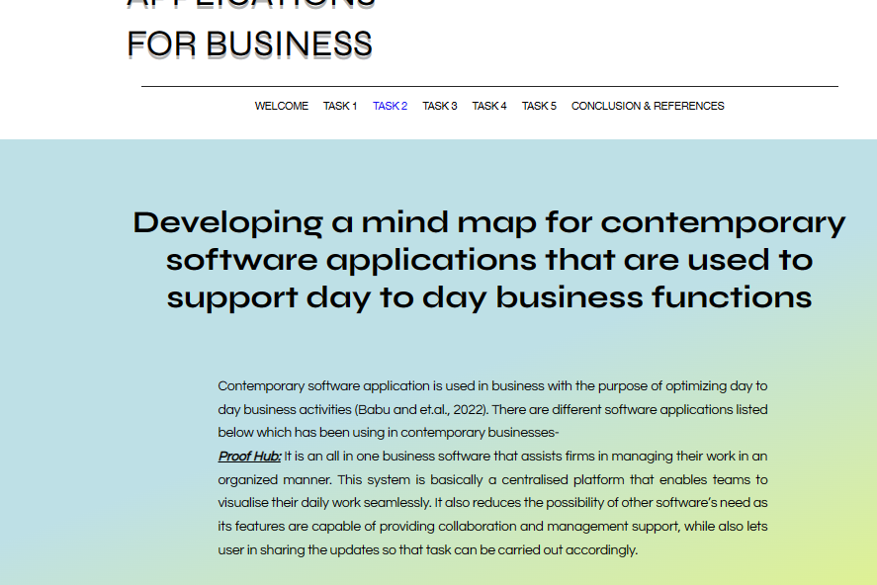

Task 3
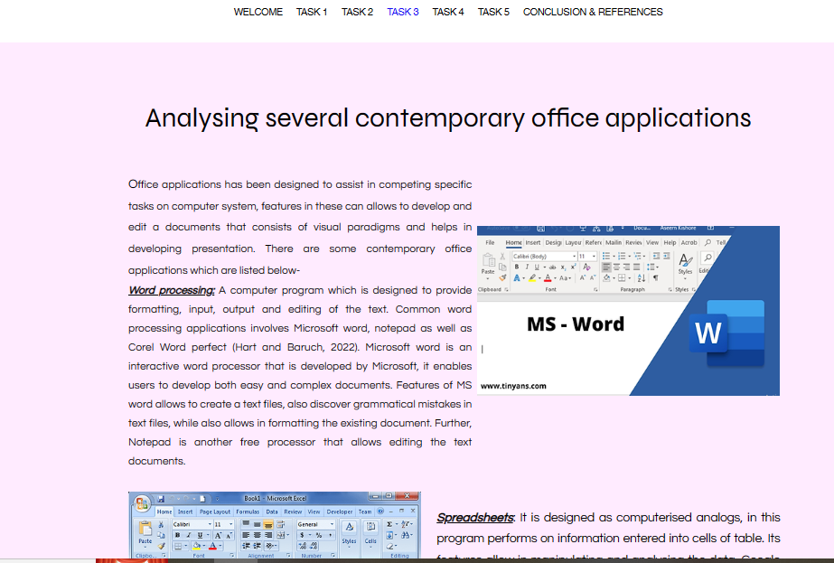

Task 4

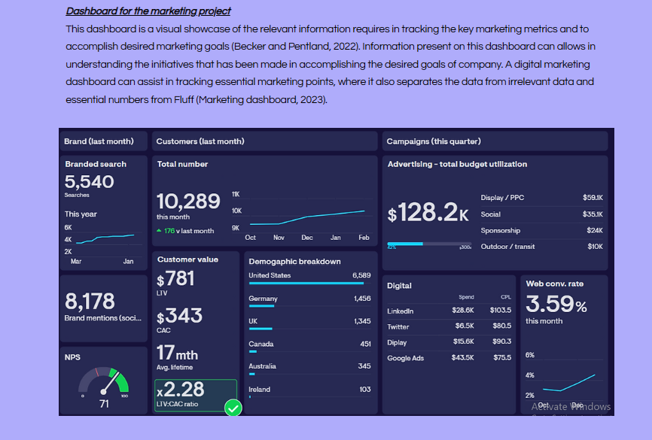

Task 5
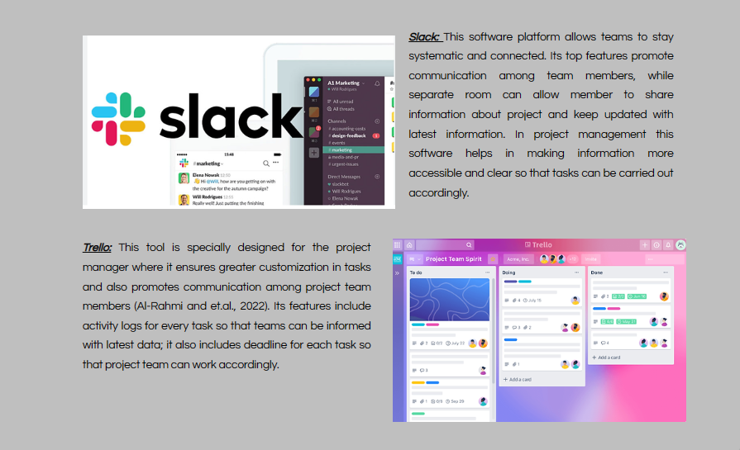

Conclusion and reference page
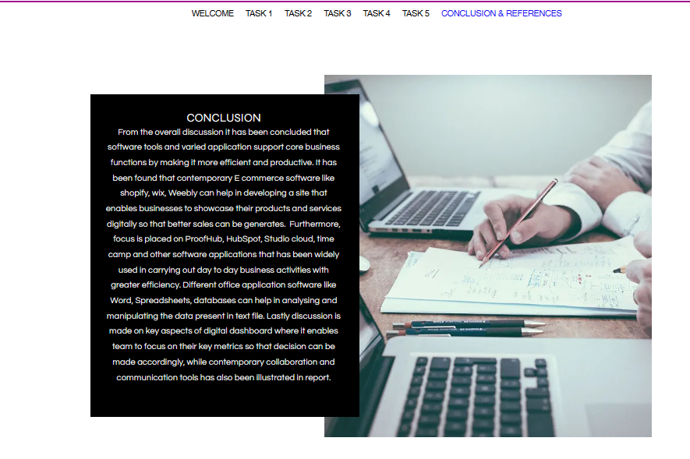

CONCLUSION
From the overall discussion it has been concluded that software tools and varied application support core business functions by making it more efficient and productive. It has been found that contemporary E commerce software like shopify, wix, Weebly can help in developing a site that enables businesses to showcase their products and services digitally so that better sales can be generates. Furthermore, focus is placed on ProofHub, HubSpot, Studio cloud, time camp and other software applications that has been widely used in carrying out day to day business activities with greater efficiency. Different office application software like Word, Spreadsheets, databases can help in analysing and manipulating the data present in text file. Lastly discussion is made on key aspects of digital dashboard where it enables team to focus on their key metrics so that decision can be made accordingly, while contemporary collaboration and communication tools has also been illustrated in report.

REFERENCES
Books and journals

Al-Rahmi, W.M. and et.al., 2022. Social media–based collaborative learning: The effect on learning success with the moderating role of cyberstalking and cyberbullying. Interactive Learning Environments. 30(8). pp.1434-1447.
Anderson, V., 2022. Crafting and Labor: An Investigation of the E-Commerce Giant, Etsy (Doctoral dissertation, New York University Tandon School of Engineering).
Babu, T. and et.al., 2022. Internet of things-based automation design and organizational innovation of manufacturing enterprises. Materials Today: Proceedings. 56. pp.1769-1775.
Becker, M.C. and Pentland, B.T., 2022, January. Digital twin of an organization: Are you serious?. In Business Process Management Workshops: BPM 2021 International Workshops, Rome, Italy, September 6–10, 2021, Revised Selected Papers (pp. 243-254). Cham: Springer International Publishing.
Chen, M. and et.al., 2022, April. Critical Challenges and Solutions for an Ultra-Large-Scale Enterprise DevOps Platform. In 2022 7th International Conference on Cloud Computing and Big Data Analytics (ICCCBDA) (pp. 167-171). IEEE.
Corvello, V. and et.al., 2022. The digital transformation of entrepreneurial work. International Journal of Entrepreneurial Behavior & Research. 28(5). pp.1167-1183.
Fan, J., Zheng, P. and Li, S., 2022. Vision-based holistic scene understanding towards proactive human–robot collaboration. Robotics and Computer-Integrated Manufacturing. 75. p.102304.
Hart, D. and Baruch, Y., 2022. The dynamics of diplomatic careers: The shift from traditional to contemporary careers. Human Resource Management. 61(2). pp.259-276.
Hristov, I. and Appolloni, A., 2022. Stakeholders' engagement in the business strategy as a key driver to increase companies' performance: Evidence from managerial and stakeholders' practices. Business Strategy and the Environment. 31(4). pp.1488-1503.
Jenneboer, L., Herrando, C. and Constantinides, E., 2022. The impact of chatbots on customer loyalty: A systematic literature review. Journal of theoretical and applied electronic commerce research. 17(1). pp.212-229.
Myerson, J. and Ross, P., 2022. Unworking: The Reinvention of the Modern Office. Reaktion Books.
Shin, J. and et.al., 2023, April. Integrating AI in Human-Human Collaborative Ideation. In CHI 2023-SIGCHI conference on Human Factors in computing systems (pp. 1-5). ACM.
Typert-Morrison, C., 2022. The Inaccessibility of Accessible Web Design: Bringing Web Content Accessibility Guidelines to Mainstream Audiences.
Winters, N.C., 2022. Autoimmunity and its expression in the analytic situation: A contemporary reflection on our inherent self-destructiveness. The International Journal of Psychoanalysis. 103(4). pp.558-580.

Online

Asana, 2023. [Online]. Accessed through<https://asana.com/guide/help/fundamentals/navigating-asana>
Marketing dashboard, 2023. [Online]. Accessed through< https://www.geckoboard.com/dashboard-examples/marketing/>
Microsoft Access, 2023. [Online]. Accessed through<https://www.quackit.com/microsoft_access/tutorial/>
Microsoft Excel, 2023. [Online]. Accessed through<https://www.spreadsheetsmadeeasy.com/an-introduction-to-microsoft-excel-2007/>
Microsoft PowerPoint, 2023. [Online]. Accessed through<https://www.tutorialspoint.com/powerpoint/powerpoint_setting_language_type.htm>
MS Word, 2023. [Online]. Accessed through<https://tinyans.com/ms-word/>
One Drive, 2022. [Online]. Accessed through<https://www.veryfi.com/connected-apps/microsoft-onedrive-one-place-storage/>
Prezi, 2023. [Online]. Accessed through<https://prezi.com/product/>
Slack, 2023. [Online]. Accessed through<https://www.uctoday.com/collaboration/slack-review/>
Trello, 2023. [Online]. Accessed through<https://trello.com/tour>
Zoom, 2023. [Online]. Accessed through<https://www.businessinsider.in/tech/apps/news/how-to-host-start-join-record-meeting-on-zoom-app-with-your-laptop-and-phone/articleshow/76999453.cms>

