Robyn Lewis 2309827
17th January 2025

m&e specification
ACBA5017 Building Services 2 – Integration

Contents
Table of Figures 2
Introduction 3
Mechanical Ventilation with Heat Recovery (MVHR) 3
Ventilation Rates 4
Whole-dwelling ventilation rate 4
Duct sizing 5
MVHR design 5
Heating 6
Radiator Schedule 6
Electricity and Lighting Layout 7
Lighting 7
Electricity 7
Sprinkler system 7
References 8
Appendices 10

Table of Figures
Figure 1- Building Regulations Approved Document F extraction rates (HM Government, n.d.) 3
Figure 2 - flow rates required for ductwork diameter 4
Figure 3 Boiler recommendation table (Vaillant, n.a) 5

Introduction
This report presents a set of M&E drawings for a proposed new build home in Wales. The plans are designed to provide a detailed representation of the systems necessary to meet the requirements of a modern, functional home, by adhering to best practice principles and current Building Regulations.

Mechanical Ventilation with Heat Recovery (MVHR)
MVHR is an advanced whole-home ventilation system that provides a supply of fresh air while recovering heat from the stale air being expelled. They are an excellent choice for domestic ventilation, particularly when focusing on energy efficiency, indoor air quality and sustainability while complying with current building regulations. The system is designed to improve indoor air quality and reduce energy consumption. (Clive Williamson, n.a ) Stale, moist air is extracted from kitchens, bathrooms, and utility rooms, as the stale air passes through the heat exchanger, the heat is transferred to the incoming fresh air. This fresh air is then supplied to living spaces in the home.
MVHR systems must be installed in compliance with Building Regulations Approved Document F (Ventilation) (HM Government , n.d.) and Part L (Conservation of Fuel). (Construction Infromation Services, 2022)
The MVHR system should be cited in an uninhabited but easily accessible space, such as utility spaces or hallways, to allow access for maintenance and reduce any noise disturbance. The airflow rates must be balanced to avoid over or under-ventilation.

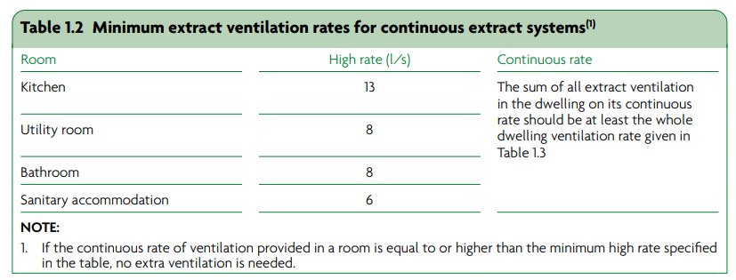
Ventilation Rates
Figure 1- Building Regulations Approved Document F extraction rates (HM Government , n.d.)

Building Regulations: Approved Document F (ADF) stipulates the minimum extraction rates (Figure 1); these rates are measured in litres/second; however, when calculating the appropriate extraction rates per room, we work in m3/h cubic meter per hour. The ventilation rate in Figure 1 will be multiplied by 3.6 to calculate the correct rates. When the total extract rate has been calculated, the rates need to be balanced.
Bedrooms require a supply rate 18m3/h per person per bedroom, in this instance the property has an occupancy of 4 people = 90m3/h.
The flow rate for the new build property in this design is calculated as follows;
Supply |  | Extract
Living Room | 18m3/h | Kitchen | 47 m3/h
Bed 1 | 36m3/h | Bathroom | 29 m3/h
Bed 2 (single occupancy) | 18m3/h | Linen cupboard | 14 m3/h
Bed 3 (single occupancy) | 18 m3/h
Total | 90 m3/h | Total | 90m3/h

Whole-dwelling ventilation rate
The dwellings area is 163m3, divided by the supply rate of 90m3/h provides us with an air change rate of 1.8. The hourly ventilation rate equates to approximately 0.5/h. The Government’s Standard Assessment Procedure (SAP) version 10.2 2021 recommends an effective air change rate of 0.5/h. (UK Government , 2021)

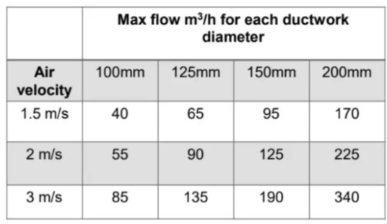
Duct sizing
Figure 2 - flow rates required for ductwork diameter
We are aiming for an air velocity rate of 1.5 m/s at the source. The highest airflow rate required in the property is in the kitchen; a ductwork diameter of 100mm would be suitable for the entire system; allowances for any additional noise can be made given that the kitchen is a non-habitable space.

MVHR design
An MVHR design plan is appended to this report. The system has been designed with the following considerations; -
The MVHR unit has been cited in a storage cupboard in the rear hallway.
The intake and extract ducts exit the property through the external wall. To ensure uninterrupted operation and future-proofing the property, the surrounding land is owned by the property, and citing on this wall has been considered to prevent potential future obstructions.
Extraction points are placed in the kitchen and bathroom to remove stale air, while all habitable rooms are equipped with fresh air supply.
Ducts will be routed through a service zone within a false ceiling for a concealed and efficient layout.
Attenuators are installed in each room to minimise sound transmissions through the duct systems.
An extraction valve has been placed in the linen cupboard as this space is utilised for drying clothes.
The supply valve in the living space is positioned at the furthest point to enable clean filtered air to flow naturally circulate downstairs and across the space into the kitchen.

Heating
Heating is provided by a 27kw gas combi boiler, as recommended by Vaillant (Figure 3) based on the property’s specifications, including the number of bedrooms and bathrooms.
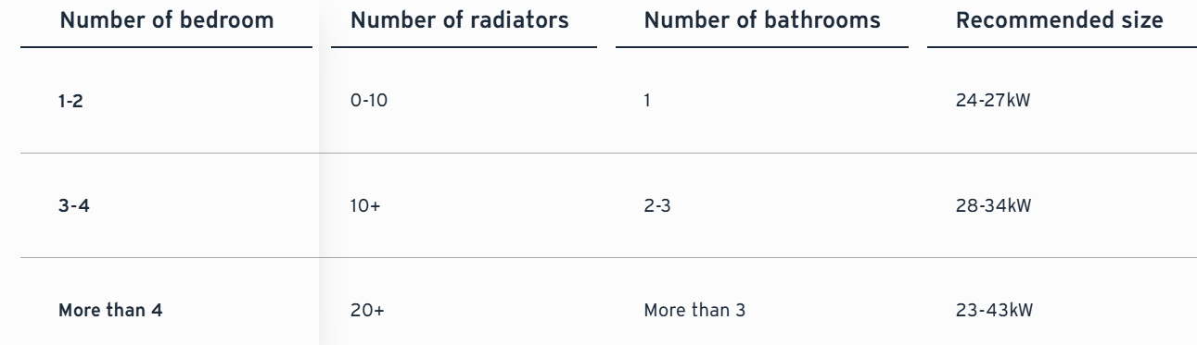
Figure 3 Boiler recommendation table (Vaillant, n.a)
To comply with Building Regulations Part L (Conservation of Fuel) the following will apply; -
- All exposed pipework will be insulated.
- Each radiator will have a Thermostatic Radiator Valve (TRV’).
- All radiators will be appropriately sized for the rooms. (Construction Infromation Services, 2022)

Radiator Schedule
British Thermal Units (BTU) have been calculated via Tool Station BTU Calculator. (Tool Station, n.s)
Radiator number | Required BTU for the room | Radiator Dimensions | BTU Output | TRV
1 | Combined total | 600mm x 1000mm | 3108 | Yes
2 | 5711 | 600mm x 1000mm | 3108 | Yes
3 | 4342 | 600mm x 1400mm | 4350 | Yes
4 | 3311 | 600mm x 1200mm | 3729 | Yes
5 | 2963 | 600mm x 1000mm | 3108 | Yes
6 | 2752 | 600mm x 1000mm | 3108 | Yes
7 | 2158 | 600mm x 800mm | 2487 | Yes
Radiators sourced from Henrad.com (henrad.com, n.d.)

Electricity and Lighting Layout

Lighting
Electrical lighting in domestic homes must comply with Part P of the Building Regulations (Welsh Government , 2010) ; these regulations govern electrical safety in dwellings and require electrical installations to be installed by a competent person and works should be certified by an NICEIC registered electrician. (NICEIC, n.a)
Building Regulations Approved Document L (Welsh Government, 2022)sets standards for the energy efficiency of lighting systems, mandating the use of energy-efficient light fittings.
Lights have been spaced to consider working planes, specifically the kitchen worktops, and evenly spaced throughout the house.
Each floor of the house has its own lighting circuit, ensuring better control and electrical loads.

Electricity
The electrical system is designed with a single-phase connection, suitable for a property under 100m2. The house utilises a ring circuit, which is a common choice for smaller properties. Spurs have been incorporated to supply sockets for kitchen appliances and the boiler.
Electrical installations comply with Part P of the Building regulations (Welsh Government , 2010) and also adhered to British Standards 7671, the UK’s national standard for electrical installation and safety of electrical wiring. (British Standards Institution , 2018)

Sprinkler system
The Sprinkler plan will comply with BSI British Standard 9251:2021 (British Standards Institue , 2021) and Approved Document Part B: Fire Safety (Welsh Government, 2020). Each room has a sprinkler serving the space; although the bathroom is less than 5m2, it hosts an electric shower, therefore a sprinkler is required as per regulations.

References
British Standards Institue , 2021. BS 9251:2021 Fire sprinkler systems for domestic. [Online]
Available at: https://products.ihserc.com/tmp_stamp/00151154826/BYHTSGAAAAAAAAAA.pdf?sess=00151154826&prod=CIS1
[Accessed 14 January 2025].
British Standards Institution , 2018. Requirements for Electrical Installations IET Wiring Regulations. [Online]
Available at: https://www.bsigroup.com/en-GB/products-and-services/standards/bs-7671-requirements-for-electrical-installations/#:~:text=BS%207671%20is%20the%20UK's,safety%20of%20electrical%20wiring%20systems.
[Accessed 2025 January 17].
Clive Williamson, H. L., n.a . Mechanical Heat Recovery Ventilation (MVHR). [Online]
Available at: https://www.cibse.org/media/nuapla4w/cibse-hfg-ventilation-debate-clive-williamson-july-2013.pdf
[Accessed 10 January 2025].
Construction Infromation Services, 2022. Building Regulations 2010: Approved Documents L Volume 2 Conservation of fuel and power. [Online]
Available at: https://cis.ihs.com/CIS/document/337814
[Accessed 10 January 2025].
henrad.com, n.d. [Online]
Available at: https://www.henrad.co.uk/home/plan/
[Accessed 2025 January 10].
HM Government , n.d. Ventilation: Approved Document F. [Online]
Available at: https://assets.publishing.service.gov.uk/media/61deba42d3bf7f054fcc243d/ADF1.pdf
[Accessed 13 January 2025].
LABC.com, n.a . Wales Approved Document Part B: Fire Safety. [Online]
Available at: https://www.labc.co.uk/sites/default/files/2021-08/building-regulations-guidance-part-b-fire-safety-volume-1-dwellinghouses.pdf
[Accessed 16 January 2025].
NICEIC, n.a. For Householders. [Online]
Available at: https://niceic.com/about-us/
[Accessed 17 January 2025].
Tool Station, n.s. BTU Calculator. [Online]
Available at: https://www.toolstation.com/help-and-advice/btu-calculator?gad_source=1&gclid=Cj0KCQiA-aK8BhCDARIsAL_-H9kLqwz1p7lxyBWCmtU4zZUzCfoFPLf-ib73e29gpBUSWjBkTGLMEFMaAsXFEALw_wcB
[Accessed 6 January 2025].
UK Government , 2021. The Government’s Standard Assessment. [Online]
Available at: https://files.bregroup.com/SAP/SAP%2010.2%20-%2017-12-2021.pdf
[Accessed 17 January 2025].
Vaillant, n.a. What size boiler do I need?. [Online]
Available at: https://www.vaillant.co.uk/advice/understanding-heating-technology/boilers/what-size-boiler-do-i-need/
[Accessed 16 January 2025].
Welsh Government , 2010. The Building Regulations 2010 Approved Document P Electrical Safety - Dwellings. [Online]
Available at: https://cis.ihs.com/CIS/document/317176?PreviousPage=search%3ff%3dAll%26t%3dbuilding%2bregulations%2bpart%2bp%26sqm%3dAllTerms
[Accessed 17 January 2025].
Welsh Government, 2020. Approved Document B Fire safety - Volume 1 Dwellinghouses. [Online]
Available at: https://cis.ihs.com/CIS/document/331141?PreviousPage=search%3ff%3dAll%26t%3dApproved%2bDocument%2bPart%2bB%253a%2bFire%2bSafety%26sqm%3dAllTerms
[Accessed 16 January 2025].
Welsh Government, 2022. The Building Regultions 2010 Approved Documents L Conservation of fuel and power. [Online]
Available at: https://cis.ihs.com/CIS/document/337814
[Accessed 17 January 17].

Appendices
Appendix 1 - MVHR Plan
Appendix 2 - Heating Plan
Appendix 3 - Electrical and Lighting Plan
Appendix 4 - Domestic Hot Water and Drainage Plan
Appendix 5 - Sprinkler Plan



