

Name: Netsanet Yadergal
Student ID: 24131569
Module Code: BMHP5016
Module: Principles of Health and Social Care Practice

Table of contents
1, Reflection on the Importance of Principles of Health and Social Care .......3
1.1.1., Definition of person-centred care, ........................................................3
1.1.2, Definition of partnership..........................................................................3
1.1.3, Definition of Ethics..................................................................................3
1.2.1, Care in the UK context............................................................................3
1.3.1, Theory of Maslow’s Hierarchy of Needs..................................................4
1.3.2, Theory Ethical principal...........................................................................4
1.3.3, Teamwork or communication theories....................................................5
2- Practical Examples of Concepts in Practice Purpose...................................6
2.1 person centre care......................................................................................6

2.2 partnership working ................................................................................... 6

2.3 Ethical Considerations................................................................................6

2.4 Conclusion...................................................................................................7
3: Self-Reflection as a Health and Social Care Professional ............................7
3.1. Introduction: My Role and Context..............................................................7
3. 2. Person-Centred Care: Practice and Reflection .........................................8
3. 3. Collaboration in Practice: Partnership Working .........................................8
3. 4. Ethics: Guiding Principles in Decision-Making ............................................9
3. 5. Strengths and Areas for Development.......................................................10
3. 6. Conclusion...................................................................................................11
Reference ...........................................................................................................12-13
🩺1 , Reflection on the Importance of Principles of Health and Social Care
1.1.1, Definition of person-centred care,

Person-centred care, often known as "patient-cantered" or "people-cantered," is a method of designing and delivering health and social services based on each person's particular preferences, values, needs and living circumstances. Person-centred care is an exciting approach to healthcare that puts individuals' unique needs, preferences, and values first (Quality Compliance Systems, 2024 & Local Government Association company, 2025). Treating illness or its symptoms is only one aspect of care; another is understanding and honouring the individual.

1.1.2, Definition of partnership
Partnership working in health and social care means professionals, organisations, service users, and families working together to plan and deliver care (Care Learning, 2024). It emphasises on shared accountability, open communication, and collaborative decision-making to address complex needs and develop health. This method is frequently used in childcare facilities, schools, hospitals, and assisted living facilities (Care Learning, 2024). Collaboration improves service coordination, clears up confusion and guarantees that the right people are providing the correct help to the right people. It prevents duplication.
1.1.3, Definition of Ethics
Ethics are the rules define what feels like right and wrong (Care Learning, 2024). Usually, a profession, society, or organisation shares these values. Professional codes of conduct and legislative frameworks are frequently the source of ethics in the health and social care sectors (World Health Organization, 2022). Ethics offer a framework for making decisions. They support team members in resolving conflicts, such as finding a balance between patient autonomy and safety (Care Learning, 2024).
1.2.1, Care in the UK context
Person-centred care is regarded as an important aspect of excellent health and social care services in the United Kingdom. Individual requirements and preferences should be considered in treatment and care (NICE, 2014). To provide high-quality care, individuals must be at the core of their care. “Person-centred practice” improves experiences, encourages better lifestyles, offers appropriate support, increases safety and effectiveness, and lessens the stress on healthcare assets and health gaps (NHS, 2022). When patients feel listened to and involved in their care, they’re more likely to take an active role, follow treatment plans, and manage their health leading to greater satisfaction and stronger engagement.
Working in partnerships is essential to UK policy and service frameworks. NHS England, foundation trusts, NHS trusts, and integrated care boards are all covered by this guideline. To enhance services and fulfil the legislative obligations for public engagement, it successfully encourages partnerships with individuals and communities (NHS England, 2022). Collaboration between professionals, organisations, and families ensures coordinated care, preventing gaps and helping individuals receive the right support when needed.
Among the fundamental UK ethical precepts are:
- Respecting people's freedom to make their own decisions is known as autonomy.
- Beneficence: Behaving in the best interests of others.
- Non-maleficence: Preventing injury to other people.
- Justice: Behaving justly and equally towards all.
(Care Learning, 2024)
1.3.1, Theory Maslow’s Hierarchy of Needs
In 1943, Abraham Maslow created his idea of the hierarchy of needs. Maslow's theory centers on the idea that satisfying five different kinds of wants in a certain order drives human behaviors, physiological, safety, love/belonging, esteem, and self-actualization (Verywell Health's, 2025). Health systems can identify and characterize resident needs and create care plans with the aid of needs assessment tools (NATs). By applying Maslow's model, carers may make sure that every facet of an individual's health is taken into consideration
.

1.3.2, Theory Ethical principal
To meet the growing complexity of ethical challenges that healthcare practitioners encounter, frameworks for ethical decision making in the field have been established (Georgieva, V., Andreevska, K. and Petkova, V. 2024). The definition and explanation of the four primary ethical concepts are provided: beneficence, nonmaleficence, autonomy, and justice (Varkey, 2021). Autonomy is the foundation for informed consent, truth-telling, and secrecy, all of which are covered (Varkey, 2021). Honoring a person's freedom to make their own choices Behaving in the individual's best interest Preventing damage Equitable and fair treatment.
1.3.3, Teamwork or communication theories
Effective collaboration models in health and social care settings emphasize several interconnected components that promote cooperative behavior and improved outcomes (Körner, M. et al.2016). A team development model created by Dr. Bruce Tuckman in 1965 updated in 1977 by Tuckman and Mary Ann Conover Jensen, has been used in healthcare environments to help teams go through different phases (Körner, M. et al.2016). Forming, storming, norming, performing, and adjourning are some of the stages that this model describes as team dynamics and performance change over time (Körner, M. et al.2016).
In health and social care, effective teamwork unites workers to address the emotional, physical, and social needs of persons, enhancing workplace support, safety, and outcomes (Care Learning, 2024). These included qualities of team members, shared responsibilities, communication, cooperation, coordination, accountability, involvement, and staff and client satisfaction (Körner, M. et al.2016).
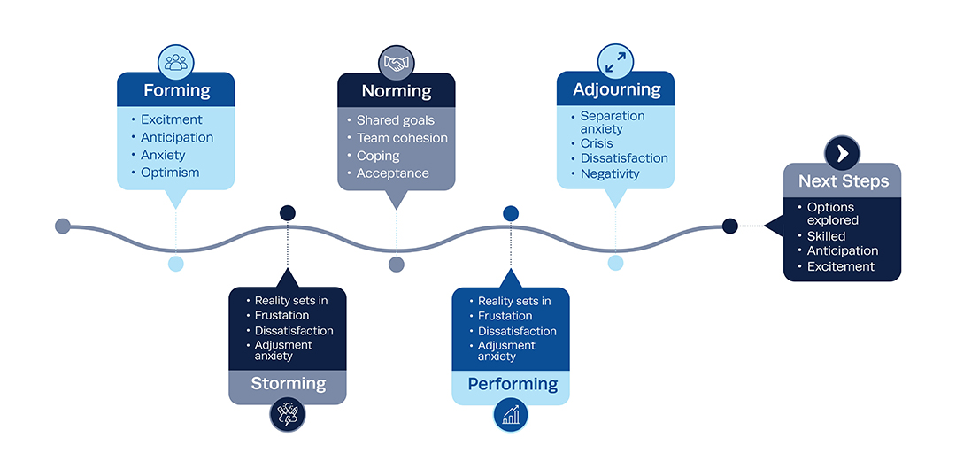
(Institute of Project Management., 2022)

🩺 2- Practical Examples of Concepts in Practice Purpose
During a placement at a residential care home in England, observation focused on a multidisciplinary team providing support for an elderly resident, Mrs. A, who had early-stage dementia and multiple physical health conditions. The team included care workers, a district nurse, a general practitioner (GP), and Mrs. A’s daughter. The primary issue involved effective management of medication while maintaining respect for Mrs. A’s autonomy and ensuring overall safety.
2.1, Person-Centered Care
Person-centered care was central to the team’s approach. Mrs. A expressed a strong preference to manage her own medication, as she had done independently before entering the care home. The care team respected this by developing a tailored care plan that allowed her to self-administer under supervision. Her room was equipped with a secure medication dispenser, and staff provided gentle reminders rather than direct administration. This upheld her dignity and independence, which emphasizes promoting individual well-being, choice, and control over care decisions (Gov.UK, 2014 & Department of Health & Social Care, 2025).
2.2, Partnership Working
Effective partnership working was evident in the collaboration between professionals and Mrs. A’s family. The district nurse coordinated with the GP to review her prescriptions, while care staff monitored her daily routines. Mrs. A’s daughter was actively involved in care planning meetings, offering insights into her mother’s habits and preferences. This collaborative approach ensured continuity of care and reduced the risk of medication errors (Department of Health & Social Care, 2025). Which promotes integrated care systems and joint decision-making across services to improve outcomes for service users (ligslation.gov.uk, 2022).
2.3, Ethical Considerations
Ethical principles guided every decision. Respect for autonomy was paramount—Mrs. A’s right to make decisions about her care was upheld, even when her cognitive decline posed challenges. The team conducted a Mental Capacity Act 2005 assessment to ensure she understood the risks and benefits of self-administering medication (GOV.UK, 2005). Informed consent was obtained, and confidentiality was maintained throughout. Staff were careful not to disclose sensitive health information during family visits unless Mrs. A agreed. Which stresses the importance of respecting and maintaining dignity, privacy, and informed choice in care delivery (Gov.UK, 2014).

2.4,Conclusion
This example demonstrates how person-centered care, partnership working, and ethical practice can significantly enhance outcomes in health and social care. By respecting Mrs. A’s preferences, involving her family, and adhering to legal and ethical standards, the team fostered a safe, empowering environment. Such practices not only improve individual experiences but also ensure compliance with UK legislation and professional guidelines, ultimately leading to better quality of care and service delivery.
🩺 3: Self-Reflection as a Health and Social Care Professional
3.1. Introduction: My Role and Context
As an aspiring health and social care professional currently undergoing academic and practical training, I am committed to developing the skills, values, and knowledge necessary to deliver safe, compassionate, and effective care. My experience as a domiciliary carer, where I have supported individuals with varying physical, emotional, and cognitive needs. This reflection explores how person-center care, partnership working, and ethical principles influence my practice and professional development.
To structure this reflection, I will use Gibbs’ Reflective Cycle (1988), which provides a systematic framework for learning from experience through six stages:
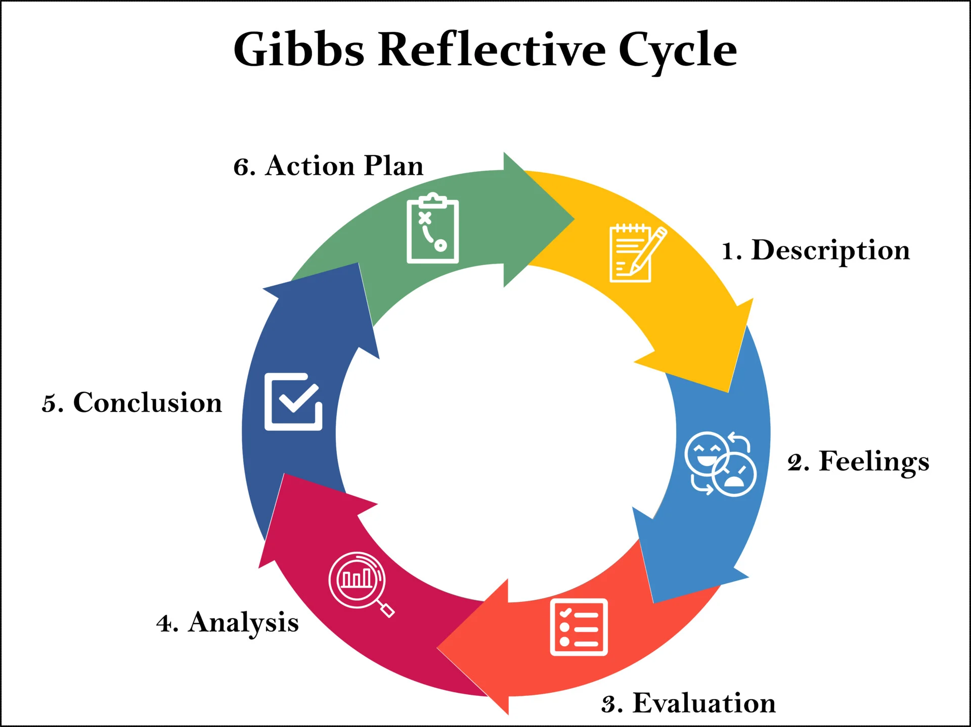(McLeod, 2025).
3.2. Person-Centred Care: Practice and Reflection
Description & Feelings:
I recently assisted an elderly dementia patient who refused to take a shower. At first, I was unsure of how to provide for her care requirements without upsetting her.
Evaluation and Analysis:
I spoke with her, found out about her preferences, and presented options by using person-center care concepts. A sponge wash with her favorite lavender taste worked well for her. This event made clear how important it is to respect each person's freedom of choice, understand their emotional requirements, and modify care to fit their values and history.
Conclusion & Action Plan:
I now appreciate how person-center care fosters trust and dignity. To improve, I plan to deepen my understanding of communication strategies for individuals with cognitive impairments and explore life history work to personalize care further.
Do the services offered provide flexibility, choice, and continuity of care, and do they represent the requirements of the people they serve (CQC, 2025).
The foundation of effective person-centred, community-focused health and care is laid out by these "six principles."
- Person-centred care and assistance are individualised, well-coordinated, and empowering.
- services are developed in collaboration with communities and citizens.
- The emphasis is on equality and reducing disparities.
- Carers are recognised, assisted, and involved.
- Important partners and enablers are the housing, community, social entrepreneurship, and nonprofit sectors.
- Social action and volunteerism are acknowledged as important facilitators.
(Person-centred care, 2017)

3.3. Collaboration in Practice: Partnership Working
Description & Emotions:
I witnessed nurses, social workers, and occupational therapists working together to create a care plan for a Debit 2 patient during a collaborative meeting. I contributed by providing observations from everyday activities, which were appreciated and recognised.
Analysis and Evaluation:
This experience showed the value of teamwork in providing comprehensive treatment. It empowered the patient and their family, decreased duplication, and enhanced continuity. I discovered that good communication, respect for one another, and common objectives are necessary for productive teamwork.
Conclusion & Action Plan:
Although I am comfortable participating in team conversations, I am aware that I need to strengthen my assertiveness and grasp of professional limits. I intend to research the functions of other health workers and go to training on communication between professions.
Raising awareness through team meetings and ensuring frequent two-way communication are two of the finest methods to help employees. It's a fantastic chance to consider what we do and how we provide care (HCPC, 2025). which call on professionals to collaborate with others and communicate clearly.
3.4. Ethics: Guiding Principles in Decision-Making
Description & Feelings:
I faced an ethical dilemma when a service user capacity refuses to have essential medication but asked me not to tell anyone. I felt torn between respecting confidentiality and ensuring their safety.
Evaluation & Analysis:
We followed to protecting procedures while preserving the person's dignity after speaking with my supervisor. Must document, discuss with colleagues, consider alternatives, and respect the person’s decision while ensuring they understand consequences. This affirmed the significance of expert advice and ethical reasoning. Maintaining confidentiality must be balanced with safeguarding obligations and the responsibility of care.

Conclusion & Action Plan:
I now see that practicing ethics calls for bravery, reflection and consultation. When presented with difficult choices, I'll keep researching ethical frameworks and look for guidance.
When ethics and morals clash and a decision must be taken that will affect everyone concerned, an ethical dilemma results. To improve their professional practice, employees must carefully consider their alternatives, employ suitable frameworks, and reflect on the process (Care Learning, 2024).
3.5. Strengths and Areas for Development
To support my development, I will engage in continuous professional learning, seek supervision, and reflect regularly using models like Gibbs and Johns (Johns, 2000).
Strengths:
- Empathy and active listening
- Commitment to person-centred values
- Willingness to learn from feedback
- Awareness of ethical responsibilities
Areas for Improvement:
- Assertiveness in team settings
- Confidence in handling ethical dilemmas
- Deeper understanding of legislation and safeguarding
- Enhancing cultural competence in diverse care environments
These frameworks reinforce the importance of accountability, evidence-based practice, and continuous improvement. Additionally, you could reflect how your day‑to‑day actions align with each of the five areas, for example:
Safe: I look for any dangers, follow safety protocols, and quickly report any accidents. Effective: I track results for the individuals I assist and employ evidence-based procedures.
Caring: I respect the dignity of service users, pay attention to their choices, and include them in decision-making.
Responsive: I adjust to changing conditions, respond to input, and customize help to meet the requirements of everyone.
Well-led: I participate in team communication, gain knowledge from audits, and support an improvement-oriented culture.
(CQC, 2022)
3.6. Conclusion
This reflection has deepened my understanding of how person-centred care, partnership working, and ethics shape my role in health and social care. By applying reflective models and aligning with professional standards, I am better equipped to navigate challenges and grow as a compassionate, competent practitioner. My journey is ongoing, and I am committed to learning, adapting, and advocating for the dignity and wellbeing of those I serve.

Reference
Bonebright, D.A. (2010) ‘40 years of storming: a historical review of Tuckman’s model of small group development’, Human resource development international, 13(1), pp. 111–120. Available at: https://doi.org/10.1080/13678861003589099.

Care Learning (2024). 2.1. Outline what partnership working means in health, social care and children’s and young people’s settings – Care Learning. [online] Care Learning. Available at: https://carelearning.org.uk/qualifications/level-1-award-hsc/pwcs-06-working/2-1-outline-what-partnership-working-means-in-health-social-care-and-childrens-and-young-peoples-settings [Accessed 22 Oct. 2025].
CQC (2022). The five key questions we ask - Care Quality Commission. [online] www.cqc.org.uk. Available at: https://www.cqc.org.uk/about-us/how-we-do-our-job/five-key-questions-we-ask.
Wahab, M. T., Lim, H. F. R., & Ng, Y. F. (2025). Unified Needs Assessments to Enable Systemic Healthcare Services Integration and Health System Transformation. International Journal of Integrated Care, 25, 277. https://doi.org/10.5334/ijic.ICIC24126

Körner, M. et al. (2016) ‘Interprofessional teamwork and team interventions in chronic care: A systematic review’, Journal of interprofessional care, 30(1), pp. 15–28. Available at: https://doi.org/10.3109/13561820.2015.1051616.

Institute of Project Management. (2022). The 5 Stages of Team Development: Tuckman’s Model | IPM. [online] Institute of Project Management. Available at: https://instituteprojectmanagement.com/blog/the-5-stages-of-team-development/#undefined.
Georgieva, V., Andreevska, K. and Petkova, V. (2024) ‘Models of Ethical Decision Making in the Field of Healthcare Services – A Literature Review’, Acta Medica Bulgarica, 51(s2), pp. 182–187. Available at: https://doi.org/10.2478/amb-2024-0068.

Department of Health & Social Care (2025). Care and Support Statutory Guidance. [online] GOV.UK. Available at: https://www.gov.uk/government/publications/care-act-statutory-guidance/care-and-support-statutory-guidance.
GOV.UK (2005). Mental Capacity Act 2005. [online] Legislation.gov.uk. Available at: https://www.legislation.gov.uk/ukpga/2005/9/contents.
HCPC (2025). Standards of proficiency |. [online] www.hcpc-uk.org. Available at: https://www.hcpc-uk.org/employers/using-our-standards/standards-of-proficiency/.

Care Learning (2024). 1.1. Define Ethics, Morals And Values - Care Learning. [online] Care Learning. Available at: https://carelearning.org.uk/qualifications/level-3-extended-hsc/hsc-dmo3-ethics/1-1-define-ethics-morals-and-values/.
Verywell Health's (2025). What Is the Hierarchy of Needs? [online] Verywell Health. Available at: https://www.verywellhealth.com/hierarchy-of-needs-maslow-s-five-categories-of-needs-5220468#citation-8.
legislation.gov.uk (2022). Health and Care Act 2022. [online] Legislation.gov.uk. Available at: https://www.legislation.gov.uk/ukpga/2022/31/part/1/crossheading/integrated-care-partnerships.
Person-centred care (2017). Person-centred care | NHS England | Workforce, training and education. [online] NHS England | Workforce, training and education. Available at: https://www.hee.nhs.uk/our-work/person-centred-care?utm_source.
NICE (2014). Person-centred care | Managing medicines in care homes | Guidance | NICE. [online] Nice.org.uk. Available at: https://www.nice.org.uk/guidance/sc1/chapter/person-centred-care?utm_source.
NHS England (2022). NHS England» Working in partnership with people and communities: statutory guidance. [online] www.england.nhs.uk. Available at: https://www.england.nhs.uk/publication/working-in-partnership-with-people-and-communities-statutory-guidance/.
NHS (2022). Person Centred Practice | NHS England | Workforce, training and education. [online] NHS England | Workforce, training and education. Available at: https://www.hee.nhs.uk/our-work/enhancing-generalist-skills/enhance-learning-resources/handbook/person-centred-practice?utm_source [Accessed 25 OQuality Compliance systems (2024). What is Person-Centred
are? | QCS. [online] QCS. Available at: https://www.qcs.co.uk/what-is-person-centred-care/ [Accessed 22 Oct. 2025].
Local Government Association company (2025). Person-centred care | Local Government Association. [online] www.local.gov.uk. Available at: https://www.local.gov.uk/person-centred-care.
World Health Organization (2022). Ethics and Health. [online] www.who.int. Available at: https://www.who.int/westernpacific/health-topics/ethics-and-health.

