

POSTER: element 1

Student Name: HIRABEN RAMA MODHVADIYA
Student ID: 2532030

Module Name: Marketing
Management
Module Code: LCMB7024

Programme: Master of Business Administration (MBA)
Lecturer’s Name: LAILA MAAZOUZ
University: University of Wales
Trinity Saint David

Term 1

Coca-Cola Energy+ Hydration: A Strategic Brand
Extension for the Functional Beverage Market

INTRODUCTION
This presentation will explore the brand extension strategy of Coca-Cola, which is an internationally recognised brand of drinks, which has a good brand image and emotional attachment of consumers. With its logical brand communication and innovation, Coca-Cola has preserved its relevance in the online age (Armutlu, 2023).

BRAND EXTENSION
The extension to be successful is Coca-Cola Energy+ Hydration, a functional drink, which has a combination of essential vitamins, natural caffeine and hydration. This extension is taking advantage of the brand equity of Coca-Cola to venture into the rising functional drinks market. Good brand extensions could empower consumer acceptance provided they are in line with the already established brand identity (Zhang, Guo and Qu, 2025).

BRAND EXTENSION
AND SUSTAINABILITY
Coca-Cola Energy+ Hydration is aimed at claims of sustainability due to the use of recyclable packaging, less sugar in it, and natural products. These activities relate to the sustainability objectives of Coca-Cola and build the brand image. Customers also trust and stay loyal to the sustainability driven strategies (Ling et al., 2023).

BRAND EXTENSION AND CURRENT TRENDS

This extension is a reaction to the growing demand among the consumers to buy health-conscious, low- sugary, and functional beverages. The consumers in modern days would be interested in products that have extra features like energy and wellness. Brand extensions that have a proper fit with the lifestyle of the consumer and trends greatly enhance purchase intention (He, Xiang and Wang, 2024).

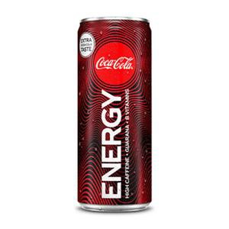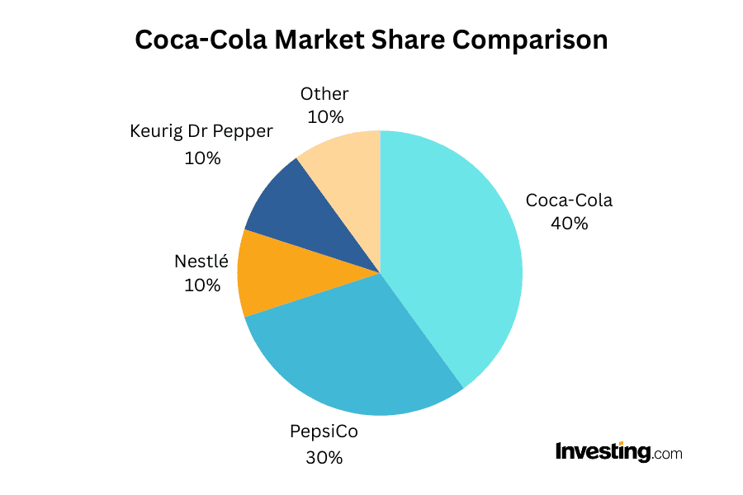CONCLUSION
Coca-Cola Energy+ Hydration Extension takes advantage of high brand equity that enables it to respond to changing customer demands. It follows the health trends, promotes sustainability, and improves long-term customer loyalty, which preconditions the future development of Coca-Cola.
References
Zhang, Y., Guo, X. and Qu, Y., 2025. Brand extension or co-branding: The consumer's attribution of responsibility to the crossover strategies of heritage brands. Journal of Retailing and Consumer Services, 82, p.104133.https://www.sciencedirect.com/science/article/pii/S0969698924004296
Armutlu, İ.İ., 2023. The Digital Era Effect on Brand Image and Brand Communication: The Coca-Cola Case Studies. In İletişim Bilimlerinde Son Yaklaşımlar (pp. 203-221). Özgür Yayın Dağıtım Ltd. Şti..https://avesis.erciyes.edu.tr/yayin/524ce06f-ab57- 4469-bc95-24957d67324c/medya-habercilik-alani-ve-sosyal-sermaye-iliskisi-tocqueville-putnam-ve-bourdieu-baglaminda- kuramsal-bir-inceleme/document.pdf#page=212
He, J., Xiang, J. and Wang, J., 2024. Extension of heritage brands and consumer purchase intention with the moderating role of pop culture involvement: an empirical analysis of time-honoured brands in China. Asia Pacific Journal of Marketing and Logistics, 36(5), pp.1131-1149.https://www.emerald.com/apjml/article/36/5/1131/1217283
Ling, G.Y., Yuang, G., Zhicheng, G., Xuan, G.T.X., Maharani, C.D., Genira, C.F., Tyagi, N. and Saidhanyakumar, M., 2023. Analysis of Factors Affecting Brand Loyalty: A Study of Coca-Cola. Asia Pacific Journal of Management and Education, 6(3), pp.16-29.https://pdfs.semanticscholar.org/b6fd/4bd3f3571308384c4f6e2a04212ef87d21d9.pdf

https://www.investing.com/academy/statistics/coca-cola-statistics/

