

ASSESSMENT COMPONENT 2: MARKETING PORTFOLIO
MODULE LECTURER: Dr Laila Maazouz
MODULE CODE: LCMB7024
STUDENT NAME: Amaan Allauddin Sayyed
STUDENT ID: 2437446
DATE OF SUBMISSION: 17.12.2025
Table of Contents
Element 1: STP Analysis 3
Overview of the New Brand Concept 3
Why This New Brand Appeals to Today’s Evolving Consumer Market 3
STP Analysis 4
Element 2: Marketing Mix 7P 5
Element 3: Marketing Strategy Pitch 9
Element 4: Reflection 9
Reference List 11

Element 1: STP Analysis

Overview of the New Brand Concept
BritFlix is promoted as a focused brand extension that Netflix uses to celebrate British storytelling by placing selected bundle of both modern and old UK content. It is at the forefront as an exclusive destination of British movies, series and documentaries, with everything wrapped in Netflix slick design with slight accents of Britishness. The brand is focused on cultural genuineness and regional variety and recent UK ability, with the aid of Netflix’s worldwide platform and exclusive originals. In general, BritFlix would be designed to promote the voices of Britain along with the bespoke, high-end viewing experience.

Why This New Brand Appeals to Today’s Evolving Consumer Market
BritFlix is well positioned to suit the changing consumer market today in that it is consistent with various high profile changes in viewing behaviour and cultural considerations. The new age consumers demand authentic and locally based content that acknowledges cultural diversity and local experiences (Pimentel et al., 2024). By highlighting the British storytelling experiences, both the classic and contemporary original, BritFlix promises to satisfy the increasing need of a culturally focused, place-based entertainment. This would be especially true because people have become increasingly interested in stories that are relatable, meaningful, and socially relevant.
The platform is also in alignment with the emergence of tailored, niche streaming experiences. With the audience becoming weary of the excessive content barns, they turn to specialized destinations that can find easily. The BritFlix group is a dedicated catalogue that makes use of Netflix personalization technology, allowing one to access personalized British content within and without issues (Bastavade et al., 2025). Also, the growing demand for international programming in the world makes BritFlix a radical product that will satisfy both the local and international customers as it will serve not only the British populace but also universal consumers who would embrace British humor, drama and documentary content (Michalis, 2022). The consumer behavior is also changing to patronizing local talent and creative industries. This trend is in line with BritFlix devotion of giving the emerging voices in the UK the boost they need, which makes it more attractive. All in all, the brand satisfies modern needs of authenticity, relevance, cultural diversity, and simplified viewing experiences.

STP Analysis
Segmentation
BritFlix divides the market by considering different motives and interests that define the new streaming culture. Demographically, it can target a large number of age groups that like watching British movies, classic series, local tales, and modern originals of the UK. Psychographically, it will target culturally interested viewers who appreciate authenticity, heritage and identity-driven stories (Cheng et al., 2021). On the behavioural level, it targets frequent streamers who usually enjoy curated and customised content as opposed to having to navigate wide and saturated libraries. Global audiences with affinities to British humour, drama, and documentary styles and domestic viewers with affinities to the familiar touchpoints of that culture are also captured in this segmentation (Mulla, 2022). The multi-dimensional segmentation strategy would enable BritFlix to determine overlapping population segments such as heritage-oriented audiences to globally curious content-discoverers to make sure that its product matches the changing views on entertainment.
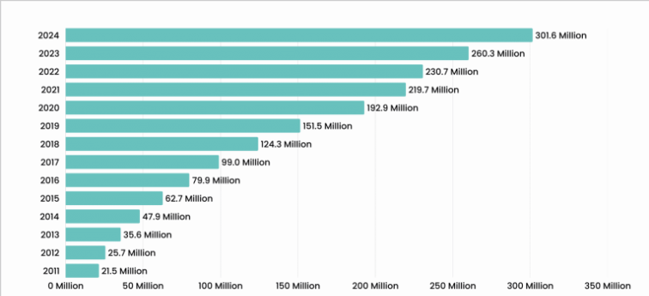
Figure 1: Netflix’s Subscriber Count over the Years
(Source: DemandSage, 2025)
Targeting
BritFlix also focuses on high-engagement consumer segments demonstrated to be interested in British storytelling, as well as niche culturally fueled streaming experiences. The core target audience consists of viewers located in the UK and requires a specific service that reflects their local identity and film culture (Makhlooq, and Al Mubarak, 2024). Another notable secondary audience is foreigners who are interested in British quality productions, story richness and artistic qualities that the UK has to offer them. BritFlix will also focus on younger digital natives, who focus on convenience, frictionless technology, and customised discovery capabilities, which match the strengths set by Netflix (Luo et al., 2025). It also targets globally minded consumer groups that pursue international content and therefore BritFlix is appealing to actors valuing originality, authenticity and cultural exploration. The focused strategy will help BritFlix to access consumers who have strong and long-term interest in the UK motivated entertainment.
Positioning
BritFlix is establishing itself as the leading British storytelling platform in the world with a curated library that produces a mix of cultural authenticity and state of the art streaming technology. Although it came at the expense of the strong brand and platform strengths of Netflix, BritFlix still has its distinct identity that is going to be supported by ingenuity, legacy, and local flavor. It is placed as a high quality service, one that is modern, culturally-based, and raising the voice of the UK due to bespoke originals and well-chosen classics (Nelsa et al., 2025). The brand does not focus on quantity but rather quality and it has a strong sense of making the content of British interests more accessible and special, so that a more valuable content is not readily available elsewhere. By marketing itself as the voice of authority on UK film and televisions, BritFlix will stand out in an oversaturated streaming sector and position itself to appeal to customers who want a deeper, personal, and cultural experience in their entertainment.

Element 2: Marketing Mix 7P
Product
BritFlix is a niche streaming service focused on the content of British film, television, and documentaries. As an ardent brand extension of the Netflix brand, it offers a carefully edited catalogue with classic cinema, recent dramas, comedies, documentaries, and regionally diverse output of the UK. The site puts the emphasis on cultural authenticity that manifests itself in the form of showing up and coming British talent and events that demonstrate the linguistic and geographic diversity of the country. Netflix boasts of good streaming features, availability options, and user-friendly interface to the benefit of the user (Hesmondhalgh et al., 2023). Individually tailored recommendations are narrowed down to British genres to allow viewers to easily discover new relevant material. The value is also added by exclusive UK originals, behind the scenes feature, and filmmaker spotlights which provide an immersion to the user. On the whole, BritFlix establishes itself as the ultimate source of British content online, with the focus on culture and high-quality streaming service.
Price
BritFlix will follow a similar pricing system used by Netflix that appears to be anchored in the premium-budget system with entry-level pricing. It can be accessed on regular and high-end Netflix subscriptions, and a BritFlix add-on is provided at a minor additional fee to appeal to enthusiasts of British productions. This format facilitates the development of value perceptions by playing off affordability and exclusivity to attract casual viewers and cultural lovers to subscribe (Lin et al., 2022). Customer appeal is strengthened by strategic price incentives, such as seasonal and student offers, and by promotional offers in cases of particular events such as the British Film Week or the BAFTAs. The framework is competitive compared to UK broadcasters and independent streaming formats, which makes it less difficult to adopt. The use of the BritFlix brand in the global pricing system at Netflix ensures consistency, promotes cross-platform usage, and has the highest revenue capacity without limiting the accessibility of British stories.
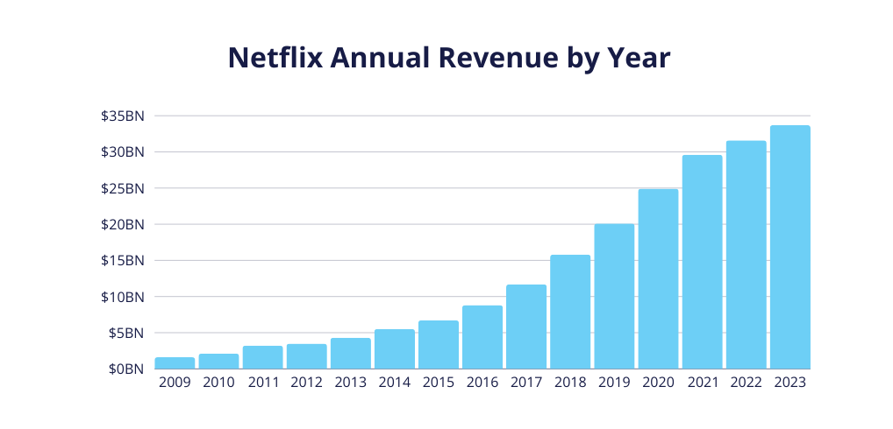
Figure 2: Netflix Annual Revenue by Year
(Source: TridensTechnology, 2025)
Place
BritFlix will be available fully online relying on the global streaming services provided by Netflix, which means that it will be available without any issues on smart TVs, mobile phones, laptops, tablets, gaming consoles, etc. This extensive multi-platform coverage not only makes the user feel needed, but it also expands and reaches even the international audiences who like British contents (Thete et al., 2025). The brand is presented as a dedicated page within the interface of Netflix, where the user can easily browse dedicated categories of British content, regionals, and new releases. Its distribution strategy is more focused on global access allowing British narration to extend to the diaspora and the culturally inquisitive communities globally (Gilsing et al., 2022). It is also expanded through partnerships with telecom providers, broadband connection, and university subscription plans. Being fully connected in the Netflix system, BritFlix eliminates logistic obstacles, improves scalability, and secures high service reliability on a wide variety of markets.
Promotion
BritFlix relies on a combination of digital advertising, social media campaigns, influencer and targeted content showcases as an integrated promotional strategy to drive awareness. The marketing communications focus on British identity, cultural diversity and exclusivity of new UK originals with the help of Netflix production capacity. Social media like Tik Tok, Instagram, YouTube and X feature cast interviews, behind-the-scenes video, and the interactivity to draw younger audiences. The collaboration with British actors, film-makers, universities, and cultural institutions increase the sense of honesty and credibility (Li et al., 2023). Shared information will target people with customised advertising so that the adverts can be related to the interest of the viewers (Munson et al., 2025). Further exposure comes when it participates in themed campaigns around the various major British cultural festivals such as the London film festival or the Edinburgh Fringe. Such a single promotional strategy also makes BritFlix unquestionably innovative as well as internationally recognizable.
People
BritFlix relies on the professional creative teams, operational and customer support personalities that define its identity and user experience. It will be based on the world-renowned workforce of Netflix and will incorporate high levels of UK representation, content curators, cultural advisors, directors, and production partners who will be recruited to make sure the story is a real one. Cultural awareness-trained customer support teams and digital service delivery assist in ensuring high levels of satisfaction (Fietkiewicz, 2020). BritFlix also seeks to develop new talent out of British writers, actors and producers as a way of building stronger relationships in the industry. Technical teams focus on user-friendly design and accessibility criteria and customised discoveries of tools that improve the overall experience. This creative and operational expertise is a mix which enables BritFlix to provide high quality services at all times and yet maintaining the cultural richness of the British storytelling.
Process
BritFlix also uses lean electronic procedures to provide content access and easy navigation as well as consistency in streaming capabilities. BritFlix can be accessed by using already existing Netflix accounts, negating any further user registration process. Improved algorithms are used to sort the British content and make recommendations to improve discoverability (de Araujo et al., 2021). The data-driven commissioning approach developed by Netflix allows BritFlix to track the viewer patterns and get involved in the highly-perspective British projects. Computerized procedures ensure quality management, generation of subtitles, and accessibility, which would be consistent throughout the standards of the service delivery (Huang et al., 2023). The customer service processes integrate AI with human interfaces to fix any problem at a rate. All these combined processes mean that BritFlix will be offering a hassle-free, user-friendly, and cultural oriented entertainment experience throughout all customer touch points.
Physical Evidence
Though BritFlix is an online store, the physical traces of visual branding, interface design, and promotion materials are delivered physically. The service has a clean look and a mix of Netflix minimalism with the nuances of Britishness, local imagery, curated works, and high-end colour styles. Minimum variations of layouts and user-friendly menus reinforce the brand familiarity and convenience (Rani et al., 2023). Presence is enhanced by the use of digital posters, billboards, social media graphics, and festival banners to build credibility. Thematically-based extraneous physical options, including efforts to interact with the British culture like themed merchandise or collaboration campaigns add to brand exposure and emotional bonding. The combination of these factors creates an image that can be identified as professional, culturally proud, and loyal to British creativity.

BRITFLIX

HOW THE BRAND ALIGNS WITH CUSTOMER TRENDS

BritFlix fits the pattern of a growing niche

and localised and authentic streaming

. The audience is requesting culturally

significant material, discoveries tailor Made

and depictions of the areas (de Araujo et al., 2021).

BritFlix is addressing such trends by presenting

to the world British talent, heritage and variety.

presenting to the world British talent,

heritage and variety of stories with such

a curated and easy sourced platform.

ABOUT MY BRAND
- BritFlix is a Netflix brand extension that builds up on the British stories.
- It offers a premium variety of classics, modern original and local UK fiction.
- It is a place that is giving a real live with cultures and quality viewing enriched.

MARKETING MIX
Product
Curated British films, series, documentaries, and new UK originals.
Enhanced by Netflix’s streaming quality, personalisation, and easy navigation.
Promotion
Digital advertising and strong social media presence.
Collaborations with influencers, British creators, and cultural events (Hesmondhalgh et al., 2023)..
Campaigns highlighting UK identity, talent, and exclusive content.

SEGMENTATION
Demographic: Targets broad age groups interested in British storytelling, from young adults to older heritage viewers.
Geographic: Focuses on UK audiences while appealing to international viewers who enjoy British culture and productions (Li, Larimo and Leonidou, 2023).
Psychographic: Attracts culturally curious, authenticity-seeking viewers who value heritage, creativity, and identity-driven narratives.
Behavioural: Appeals to frequent streamers who prefer curated libraries, personalised recommendations, and niche content over large, overwhelming catalogues (Nelsa et al., 2025).

REFERENCE LIST
de Araujo, L.M., Priadana, S., Paramarta, V. and Sunarsi, D., 2021. Digital leadership in business organizations. International Journal of Educational Administration, Management, and Leadership, pp.45-56.
Hesmondhalgh, D., Campos Valverde, R., Kaye, D. and Li, Z., 2023. The impact of algorithmically driven recommendation systems on music consumption and production: a literature review. UK Centre for Data Ethics and Innovation Reports.
Li, F., Larimo, J. and Leonidou, L.C., 2023. Social media in marketing research: Theoretical bases, methodological aspects, and thematic focus. Psychology & Marketing, 40(1), pp.124-145. Nelsa, P., Paradita, A.X., Hermawan, F.F., Ghifari, M.Y. and Lubis, M., 2025. Netflix's Digital Transformation Strategy: A Systematic Review of Challenges and Risk Mitigation Approaches. JIPI (Jurnal Ilmiah Penelitian dan Pembelajaran Informatika), 10(2),
CONCLUSION
BritFlix elevates British storytelling through a focused, culturally rich platform.
Aligned with modern trends and effective targeting, it delivers strong audience value.
The brand positions UK creativity globally, offering a unique and engaging streaming experience.

Element 3: Marketing Strategy Pitch
BritFlix is a groundbreaking move by Netflix to shape the future of the British storytelling through the establishment of a specific platform that reflects the diversity, richness, and cultural richness of UK cinema and TV. This is a new premium, selected brand that combines the world-class technology of Netflix and the strongly British sense of identity and one can find the classics that people have loved since ancient times, as well as disruptive original content. The BritFlix strategy is geared towards making it the world center of British content, and leveraging cultural relevance by promoting regional voices and new UK talent and then maximizing that through Netflix global reach as the amplifier of the story. In the case of customers, BritFlix offers the customized discovery, direct accessibility and originality of content that enhances attachment with the British creativity. To investors, it is a high-growth prospect on the basis of increasing demand of regional streaming centre, supported by the established infrastructure that Netflix provides and its marketing capabilities being data-driven. BritFlix is not just a grouping but a culture that is aimed at developing the British stories into universal experiences and making the UK one of the top creative forces of the streaming age.

Element 4: Reflection
My experience with working on the new brand concept and its marketing strategy creation was an exciting and very informative experience that enabled me to incorporate both creativity and strategic thinking. I needed to envision how Netflix would expand the global brand and develop a distinct platform where British stories are embraced both with traditional and modern versions. I have also taken into account the interests of different audiences such as people who are interested in real local content that is also highly marketable internationally. I understood that there must be a balance between heritage and innovation with the brand being the focus on quality rather than quantity (Trischler, and Li-Ying, 2023). I also visited STP analysis and that too made me realize the concept of segmentation, targeting and positioning on a global scale. I also liked the idea of the brand to appeal to domestic viewers who could relate to the UK culture as well as international viewers interested in British drama, comedy, and documentaries. I learned to take into account both cultural peculiarity and commercial viability, acquiring the skills necessary to conduct the research, analyze the market and translate the results into the actionable changes in the brand.
The development of my marketing mix enhanced my knowledge of integrated brand management. I aimed at product, price, place, promotion, people, process and physical evidence to have a unified brand experience. I designed a curated content offering to recognize British talent, regional variety, and exclusiveness with the help of personalization technology of Netflix (Selvakumar et al., 2025). I made pricing and subscription plans that are affordable at one end and high-end at the other end and I put into consideration the global digital distribution that would provide maximum coverage. I also created promotion plans that will use social media exposure, collaboration with influencers, and festivals to reach out to audiences. I also got to know the importance of harmonizing the processes of operations and technical arrangement with the expectations of customers that bring smooth experiences. I learned that enabling new talent and local voices can build not only more cultural authenticity to the brand; it could also create greater consumer loyalty and relevance over time in the streaming landscape on a global scale.
I found useful experience in putting together the marketing strategy pitch and presenting it. I needed to simplify intricate concepts into a concise, convincing story among prospective consumers and investors so that the brand purpose and strategic intent would be persuasive. I have gained the value of storytelling, foresight of questions, and evidence-based support of recommendations with maximization of creativity. I also understood that when bringing out the vision of a brand, there should be a balance between passion and commercial rationale. Another thing that I thought about is how to better my approach in future, including more quantitative data, experimenting with messaging with target audiences and refining thought processes iteratively. It reinforced my skills in strategic thinking, communication, and brand building and I am now more confident in the ability to turn creative ideas into effective action strategies that resonated with audiences on a deep level.

Reference List
Bastavade, A., Bhagwat, R., Battawar, C., Bhatkar, R. and Jadhav, P., 2025, August. Leveraging AI and Big Data in Cloud Computing: Case Study of Netflix. In 2025 12th International Conference on Emerging Trends in Engineering & Technology-Signal and Information Processing (ICETET-SIP) (pp. 1-6). IEEE.
de Araujo, L.M., Priadana, S., Paramarta, V. and Sunarsi, D., 2021. Digital leadership in business organizations. International Journal of Educational Administration, Management, and Leadership, pp.45-56.
DemandSage, 2025. Netflix Subscribers Statistics 2025 (Demographics & Users Count). Available at: https://www.demandsage.com/netflix-subscribers/ (Accessed: 28 November 2025).
Gilsing, R., Türetken, O., Grefen, P., Ozkan, B. and Adali, O.E., 2022. Business model evaluation: a systematic review of methods. Pacific Asia Journal of the Association of Information Systems, 14(4), pp.26-61.
Hesmondhalgh, D., Campos Valverde, R., Kaye, D. and Li, Z., 2023. The impact of algorithmically driven recommendation systems on music consumption and production: a literature review. UK Centre for Data Ethics and Innovation Reports.
Huang, W. and Ichikohji, T., 2023. A review and analysis of the business model innovation literature. Heliyon, 9(7).
Li, F., Larimo, J. and Leonidou, L.C., 2023. Social media in marketing research: Theoretical bases, methodological aspects, and thematic focus. Psychology & Marketing, 40(1), pp.124-145.
Lin, K., Fong, L.H.N. and Law, R., 2022. Live streaming in tourism and hospitality: A literature review. Asia Pacific Journal of Tourism Research, 27(3), pp.290-304.
Luo, X., Lim, W.M., Cheah, J.H., Lim, X.J. and Dwivedi, Y.K., 2025. Live streaming commerce: a review and research agenda. Journal of Computer Information Systems, 65(3), pp.376-399.
Makhlooq, A. and Al Mubarak, M., 2024. Artificial intelligence and marketing: Challenges and opportunities. Technological innovations for business, education and sustainability, pp.3-16.
Michalis, M., 2022. Trends and perspectives on digital platforms and digital television in Europe| public service broadcasting in the online television environment: The case for PSB VoD players and the role of policy focusing on the BBC iPlayer. International Journal of Communication, 16, p.20.
Mulla, T., 2022. Assessing the factors influencing the adoption of over-the-top streaming platforms: A literature review from 2007 to 2021. Telematics and Informatics, 69, p.101797.
Munson, J., Cummins, B. and Zosso, D., 2025. An introduction to collaborative filtering through the lens of the Netflix Prize. Knowledge and Information Systems, 67(4), pp.3049-3098.
Nelsa, P., Paradita, A.X., Hermawan, F.F., Ghifari, M.Y. and Lubis, M., 2025. Netflix's Digital Transformation Strategy: A Systematic Review of Challenges and Risk Mitigation Approaches. JIPI (Jurnal Ilmiah Penelitian dan Pembelajaran Informatika), 10(2), pp.1133-1143.
Pimentel, P.C., Bassi-Suter, M. and Didonet, S.R., 2024. Brand activism as a marketing strategy: an integrative framework and research agenda. Journal of Brand Management, 31(2), pp.212-234.
Rani, M., Singh, S., Tomar, S., Gupta, M. and Shyam, H.S., 2023. Content Generated by Netflix: Scoping Review and Analysis. Building AI Driven Marketing Capabilities: Understand Customer Needs and Deliver Value Through AI, pp.159-172.
Selvakumar, P., Shanthi, M., Pitchiah, R., Sharma, M., Dahake, P.S. and TC, M., 2025. The Role of Artificial Intelligence in Business Model Innovation: Overview of AI Technologies. AI-Driven Business Model Innovation, pp.219-246.
Thete, S.S., Jare, R.P., Jungare, M., Bhagat, G., Durgule, S. and Borate, V., 2025, March. Netflix Recommendation System by Genre Categories Using Machine Learning. In 2025 3rd International Conference on Device Intelligence, Computing and Communication Technologies (DICCT) (pp. 196-201). IEEE.
TridensTechnology, 2025. Netflix Subscribers Statistics Available at: https://tridenstechnology.com/netflix-subscribers-statistics/ (Accessed: 28 November 2025).
Trischler, M.F.G. and Li-Ying, J., 2023. Digital business model innovation: toward construct clarity and future research directions. Review of Managerial Science, 17(1), pp.3-32.
Fietkiewicz, K.J., 2020, July. The law of live streaming: A systematic literature review and analysis of German legal framework. In International Conference on Human-Computer Interaction (pp. 227-242). Cham: Springer International Publishing.
Cheng, T.G., Kamsin, I.F.B. and Zainal, N.K., 2021, September. A Review on Service Business Model Using IoT. In 3rd International Conference on Integrated Intelligent Computing Communication & Security (ICIIC 2021) (pp. 554-558). Atlantis Press.

