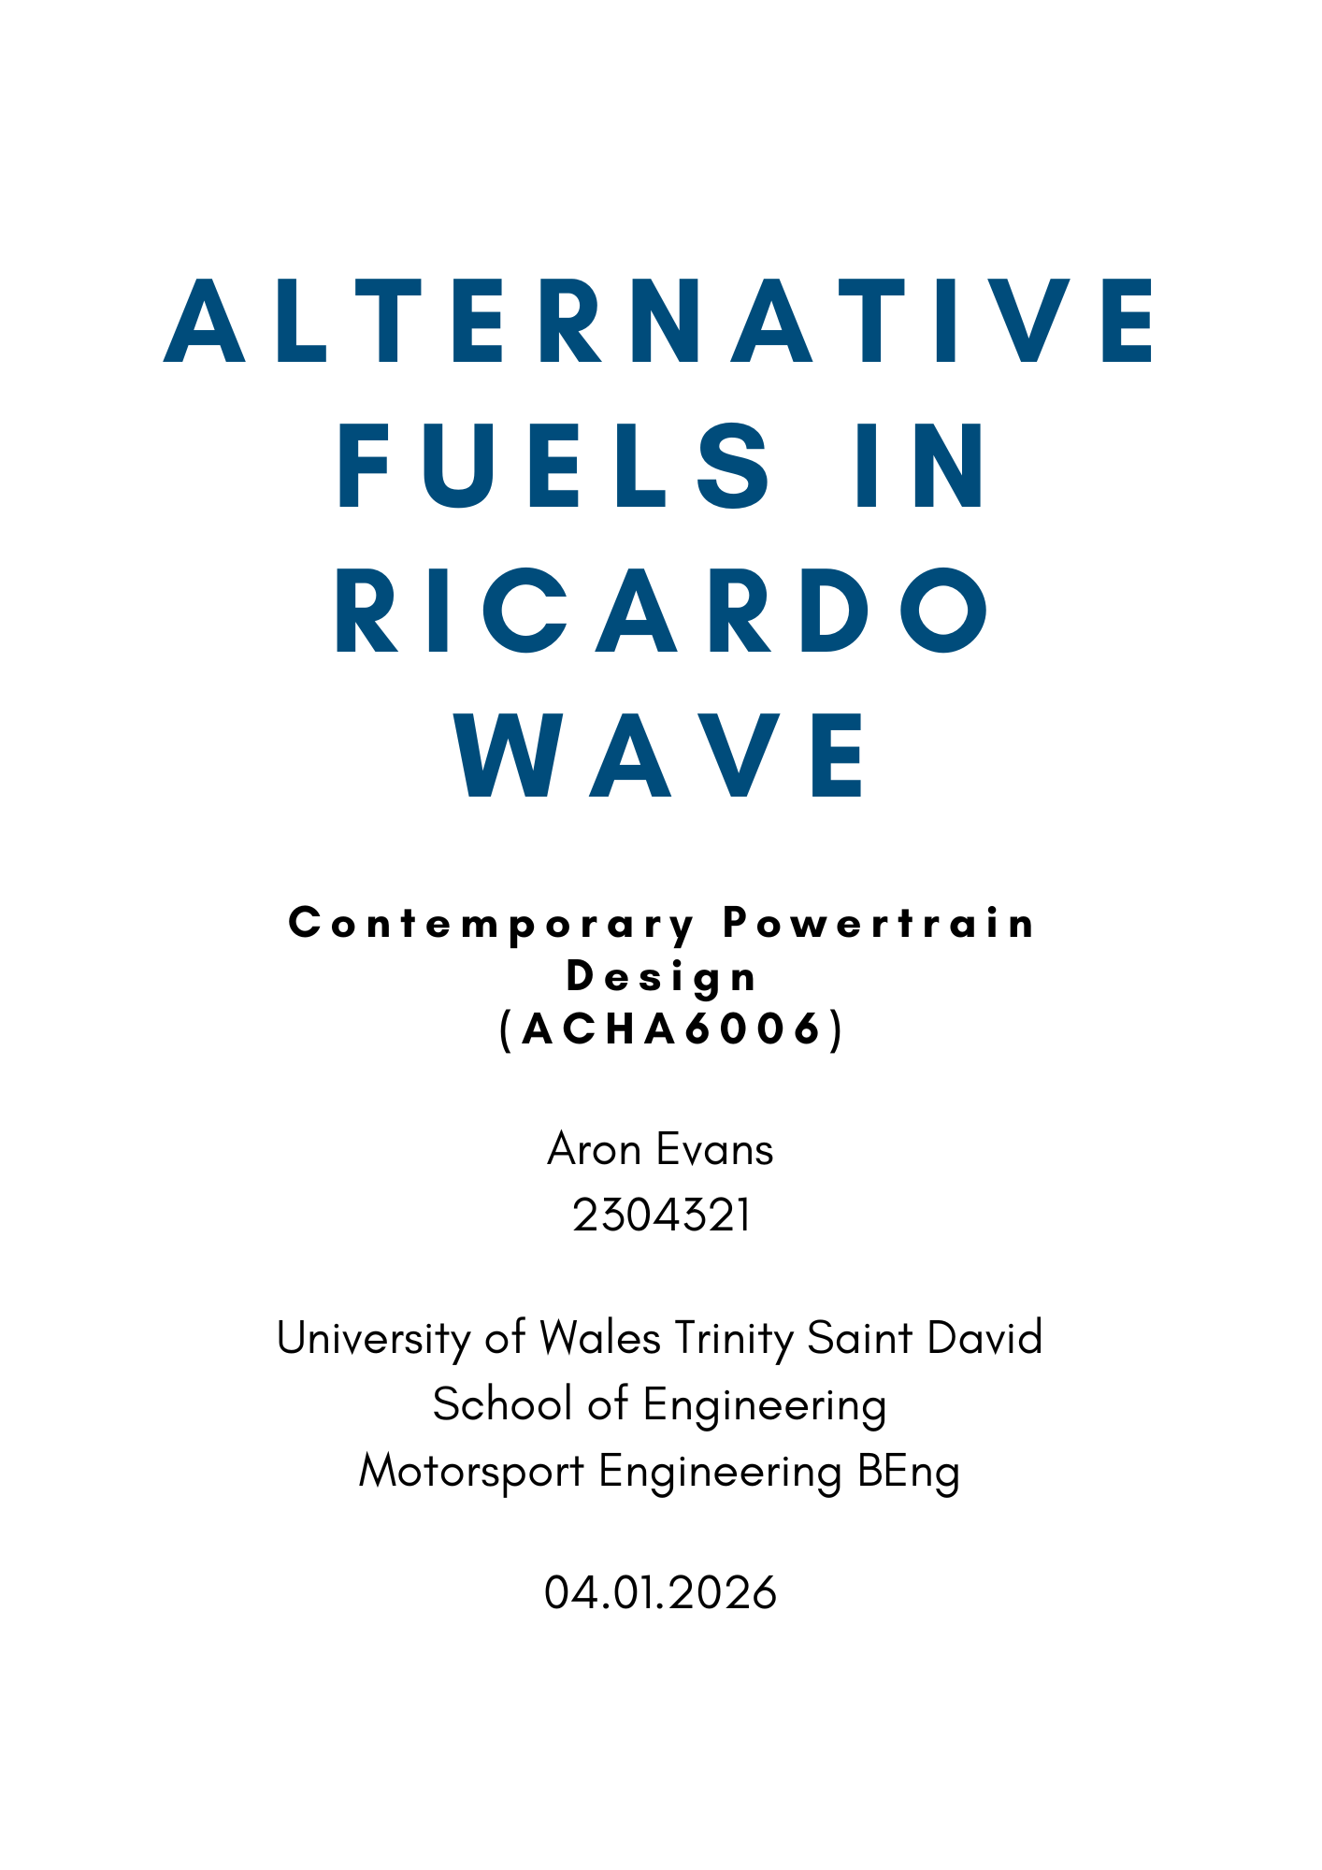
Contents
1. Introduction 3
2. Fuel Selection 3
2.1 E85 3
2.2 Ethanol 3
2.3 Methanol 3
3. WAVE Model Operating Conditions 3
4. Fuel Property Configuration 4
5. Performance Comparison 4
5.1 BMEP 4
5.2 BSFC 5
5.3 Peak Pressure 6
6. Comparison to Fuel Chemistry Expectations 6
7. Assumptions and Limitations of WAVE 7
8. Conclusion 7

Figure 1 - BMEP against RPM 4
Figure 2 - BSFC against RPM 5
Figure 3 - Peak Pressure against RPM 6

Table 1 - WAVE Fuel Property Values 4
Table 2 - Calculated Air/Fuel Ratio 6

Introduction
This report will select three alternative fuels with the intention to simulate their performance in comparison to a conventional fuel with the use of Ricardo WAVE. The results gathered from WAVE will then be validated using an air/fuel ratio calculator.

Fuel Selection
The first fuel to be used in this comparison is iso-octane, a petrol surrogate. The torque, BSFC, BMEP and pressure data for this fuel will then be used as a baseline to compare to three alternative fuels. These fuels are E85, ethanol and methanol and will be run through WAVE as well. These fuels have been selected to provide a range of alternative fuel options to petrol/iso-octane.

E85
Ethanol is currently blended with petrol in a 10/90 ratio (E10) in the UK to reduce the emissions of internal combustion engined vehicles. However, much higher percentages of ethanol are blended into petrol in other countries across the world. One more extreme example of these blends is E85 which will be run through WAVE.

Ethanol
To take things a step further, full ethanol will also be run through WAVE. Whilst this is achievable in reality, there are compromises such as combustion in low temperatures that have to be overcome before it becomes plausible on a large scale. Ethanol can, however, be run in WAVE for the sake of comparison to more conventional fuels.

Methanol
Methanol is even more oxygenated than ethanol and comfortably has the lowest air/fuel ratio and LHV of all the present fuels. This makes it an extreme example of deviating from conventional fuel characteristics.

WAVE Model Operating Conditions
The Morgan B48 WAVE model that all fuels were run through was provided and simulates a BMW B48 turbocharged engine which is present in Morgan vehicles.
The operating conditions are identical between fuels to ensure the only observed differences are as a result of the fuel properties. These operating conditions include an RPM sweep from 750rpm to 6500rpm and identical boundary conditions within the cylinders. The ambient temperature was also identical between the runs. The only settings changed between runs were the fuel properties (LHV, stoichiometric AFR and fuel density).

Fuel Property Configuration
Each of the fuels selected for this comparison were within the WAVE database and their values are listed below in table 1.
Table 1 - WAVE Fuel Property Values
WAVE Values
Fuel | AFRs | LHV (J/kg) | Fuel Density (kg/m^3)
Octane | 15.03 | 44430000 | 702.67
E85 | 9.79 | 29282500 | 773.53
Ethanol | 8.95 | 26830000 | 789.37
Methanol | 6.43 | 2011000 | 791.29

Performance Comparison
This section of the report will focus on the comparison of the performance of the alternative fuels in relation to the conventional iso-octane.

BMEP
BMEP is a measure of the average cylinder pressure required to produce the measured brake power of an engine. This measurement provides an idea of the engine load regardless of an engine’s displacement. What this means is this BMEP chart has identical trends to the torque plot as BMEP is directly proportional to torque. Therefore, this will be treated as a discussion of both BMEP and torque.

Figure 1 - BMEP against RPM
Figure 1 displays each fuel’s BMEP at a range of RPM. Octane rises to the engine’s performance ceiling the quickest with E85 and ethanol lagging behind. Methanol’s BMEP is substantially lower. This is because at low RPM, boost and airflow is limited meaning a high fuel flow is required for the alcohols. Methanol suffers from this the most as it has the lowest air/fuel ratio. Three of the fuels then converge at around 21 bar, most likely due to this being the engine’s efficiency limit and sufficient fuel being supplied foe E85 and ethanol to perform at the same level as iso-octane. Methanol however, continues to be compromised by its low air/fuel ratio demanding more fuel than is available. It also begins to suffer first from reducing volumetric efficiency at high RPM before being followed by the rest of the fuels. E85 is much closer to iso-octane than expected here given its high ethanol content.

BSFC
BSFC is a measure of how efficient an engine is based on the amount of fuel used for each unit of power. A lower BSFC equates to a more efficient engine/fuel as it requires less fuel per unit of power.

Figure 2 - BSFC against RPM
Figure 2 paints a similar picture to the BMEP plot. Methanol is the most inefficient fuel by a margin in comparison to the rest of the fuels. E85 sits the lowest and ethanol and Iso-Octane are slightly higher; they are so similar they overlap on this plot. In most cases, the observed order of the fuels mirrors their LHV values which denote fuel energy density. Methanol’s low LHV is reflected here with a high BSFC. An interesting thing to note is E85’s lower BSFC than iso-octane. I believe this to be a data extraction for iso-octane error given the identical trace to ethanol. The rise of every fuel as RPM increases is a result of friction and pumping losses combining with decreasing volumetric efficiency and reduced time for combustion reducing engine efficiency.

Peak Pressure

Figure 3 - Peak Pressure against RPM
Figure 3 displays the typical peak pressure trend for a turbocharged engine: very low peak pressures at low RPM are a result of insufficient flow for the turbo to operate properly. The spike observed at 2000-2500RPM is the turbo finally operating to its fullest. Peak pressure continues to increase until the engine begins to become inefficient at high RPM. Ethanol and iso-octane are once more identical suggesting iso-octane has been plotted twice. E85 is slightly lower at its peak due to its ethanol content; if ethanol were plotted it would be expected to be in a slightly lower than E85. Methanol struggles once more in comparison to its counterparts. This suggests that it’s suffering from the fact that the engine is identical. Methanol’s much lower air/fuel ratio and LHV mean it needs more fuel delivery; something it simply isn’t receiving due to the identical engine parameters. An engine catered to methanol would need larger injectors and a higher fuel pressure to accommodate methanol’s properties.

Comparison to Fuel Chemistry Expectations
Each fuel’s air/fuel ratio has ben calculated using the hydrocarbon fuel balance equation which concerns chemical composition. Each fuel’s calculated air/fuel ratio can be seen below in table 2. Iso-Octane, ethanol and methanol’s air/fuel ratios are identical to the values in WAVE whilst E85 has a deficit of 0.2; most likely due to its blended composition. This validates the accuracy of the calculated values.
Table 2 - Calculated Air/Fuel Ratio
Fuel | AFRs
IsoOctane | 15.03
E85 | 9.59
Ethanol | 8.95
Methanol | 6.43

The calculated air/fuel ratios display a gradual reduction from iso-octane down to methanol. This provided an estimate of the fuel flow for each fuel and what that would insinuate. Iso-octane’s high air/fuel ratio suggested the lowest fuel flow requirements of all the fuels and thus suggesting the best low RPM performance. Methanol on the other hand, could be assumed to have a very high fuel demand based on its low air/fuel ratio. This proved to be the case in the WAVE simulations.
The stoichiometric calculator will be submitted in addition to this report for viewing.

Assumptions and Limitations of WAVE
The single largest limitation of WAVE is that it assumes each fuel can be run with no changes to the engine. In reality, none of the selected alternative fuels would be able to run in a conventional petrol engine without modifications being made. The necessary modifications can be done and are present in flex-fuel vehicles which, as the name suggests, can run on both petrol and high blend ethanol fuels. This limitation has resulted in methanol being made to look like a very subpar alternative to iso-octane. Whilst methanol is the most extreme example, it sets the precedent that the same could be true to a lesser extent with ethanol and E85. This could be making iso-octane look artificially better than its counterparts.

Conclusion
To conclude, whilst WAVE can provide an idea of the performance of fuels, it allows fuels to be simulated within engines that are ill-suited to their properties. This can result to misleading characteristics if the observed trends are taken at face value.
It has also been discovered that the air to fuel ratio of fuels can be calculated to a very high level of accuracy using the hydrocarbon fuel equation thus allowing for confident predictions of fuel characteristics relating to the air/fuel ratio.

