Ieuan Vokes
Joyner P.A Cymru
Brynymor Road
Swansea
SA1 4JH

Neath, Port Talbot Council
The Quays
Brunnel Way
Neath
SA11 2GG

Project Number: 5010
Project Title: Ysgol Yr Afan. Port Talbot
Dear Sir/Madam,
Firstly, I would like to start by thanking you for choosing our company to design your new state of the art primary school located in Port talbot. We look forward to work collaboratively with Neath Port talbot council on this project. On review of the project, our teams understanding is that this project will be joint funded by you and the Welsh government under the sustainable communities for learning programme. Because of this we understand that the design of this project is required to meet the standards of BIM maturity. Our team and employees have prior experience of completing projects to these standards and meet the requirements set out by WAG.
I will firstly begin by giving a summary of what BIM is and then going into depth of what BIM maturity is and how we expect to meet these standards. I will also go into detail explaining and referencing the international standards of the BIM execution plan I will then go into depth explaining the level of development in BIM (LOD). Aswell as Level of information (LOI).
BIM stands for Building Information Modelling. BIM is a highly collaborate system that allows for people across the construction profession to communicate and collaborate on a single project. BIM allows you to account for planning across every single part of the construction process. This entire planning system is completed over one single 3D model. Using BIM allows for everyone within the planning project to commit their help onto the same model. “The components that make up a BIM model, are intelligent, have geometry, and store data. If any element is changed, BIM software updates the model to reflect that change. This allows the model to remain consistent and coordinated throughout the entire process so that the whole team including structural engineers, architects, MEP engineers, designers, project managers, and contractors can work in a more collaborative environment”. (Constructible , 2022)
When it comes to talking about BIM maturity, firstly you need to understand that it works through a system of levels. The levels start from level 0 and work there way up to level 3.
Level 0 of BIM maturity is where there is a very low to zero levels of collaboration. This is where a company would used simple paper based 2D CAD drawing and drafting techniques. The main goal is to generate production information in form of both paper and electronic prints. This is a very obsolete level that is rarely used by industry professionals. This is mainly due to the fact that BIM has come on a long way since this first level was used and there is now opportunities to make it a much more collaborative working environment.
Level 1 is where a small amount of collaboration is brought into the picture. This means that is incorporates both 3D CAD and 2D CAD drafting. 3D CAD in these stages is mostly used for concept works. 2D is use for creating approval documentation and production information. In this stage there also the beginning of data sharing that happens electronically using a common data environment. (CDE). This will be managed by the contractor in charge of the project. Even though there is data sharing at this level there is still a low level of collaboration between the different stakeholders as everyone creates and manages their own data.
Level 2 is mainly used within the public sector of projects. This level promotes collaborative working by giving each partner on the project their own 3D CAD model. The collaborative side of working is a distinguished part of this level, for it to work at its full potential it requires streamlined information exchanged related to the project as well as seem lined co-ordination between all the systems involved. Every sector within the project needs to have their own 3D model which is then exchanged through a common file format. For a system like this allows organizations to combine external data to the own model which can then be updated and changed to be able to progress with the project.
The final level (level 3) is often referred to as “open BIM”. Currently level 3 is still just an idea at this stage. However, its promises of deeper collaboration between all those included in the project. This is completed through a shared model that is then stored in a central repository. This level allows for all participants to work on the same model simultaneously which eliminates the chance of any two people working on the project adding in conflicting information to the project. Level 3 processes the use of an integrated solution built around open standards. Many of the firms are still thinking of transitioning from using level 2 to 3.
Now that I have explained to you what the different levels of BIM maturity. For this project to flow and be as collaborative as possible the level that I recommend we complete the project is at level 2. This is mainly because this is where the majority of all public sector projects are completed, and it meets with requirements of the funding from WAG. It also allows participation from everyone who is involved with the project meaning that the projects design and late construction stages are completed as smoothly as possible whilst containing sufficient data for the end users of the building to maintain the building throughout its lifecycle. (buildingSMART , 2023)
Based on our recommendation of using level 2 we now have the capabilities to work collaboratively to construct a BIM execution plan. (BEP). We will create the BEP from the outset meaning that we and provide you with a comprehensive document that clearly states each stakeholder, their role within the project and will detail our clear expectation of the outcome of the project. The BEP is an essential element to create before the beginning of a construction plan to ensure that all stakeholders have the plan to available and goals for the project are shared. The BEP will be especially important on this project due to the extremely complex requirements of the school and will include many collaborators. ( constructible , 2023 )
In reference to the above our team for the completion of the project are as follows:
Lead consultant: Joyner PA Cymru
Architect: A1 Architects
Structural engineer: Michael Dyson associates
MEP engineers: Heat Source
Project manager: Connor Lewis (employed by Joyner PA Cymru)
Contractors: Carter Lauren
All the above stakeholders have prior experience in delivering projects to the same requirements and quality expectations set up by Neath Port Talbots proposal.

Sincerely,
Ieuan Vokes, Managing director, 2203952@student.uwtsd.ac.uk

Appended onto this letter. I will now look to include some more information on building information modelling. I will look to explain to you what type levels of information you will need to use when talking about both an LOD and LOI format. I will also then look highlight the differences between these two formats throughout the RIBA stages of the project.
Firstly, I will begin by explaining what is meant by an LOD. LOD stands for ‘’Levels of Development’’ as well as ‘’Levels of Detail’’ with both having different meanings and purposes. Information for the way in which the model will actually work and amount of data would be information included within level of detail. To put this into an example for a building such as a primary school, a lot of data for a project like this would be using specific shapes and measurable locations of steel pipes in a model.
Secondly, I will now discuss the levels of development. Out of the two terms for LOD, ‘’Levels of Development’’ is more the more commonly used term within the construction industry. In modern day construction the level of detail is seen more as a criterion within the level of development. This is because the higher the level of development, the higher the amount of detail will be obtainable within the model. The level of development in terms of a BIM model is best described as the depth of thinking that was applied to the model. To better describe this is to say that it is talking about the reliability of the model itself. To give an example with reference to your project, if I was to ask yourself and the designers after looking at the model a question such as: Have the pipes been engineered and the permanence of their placement.
Below is an image detailing the different levels of LOD and how they work and interact when it comes to 3D modelling.
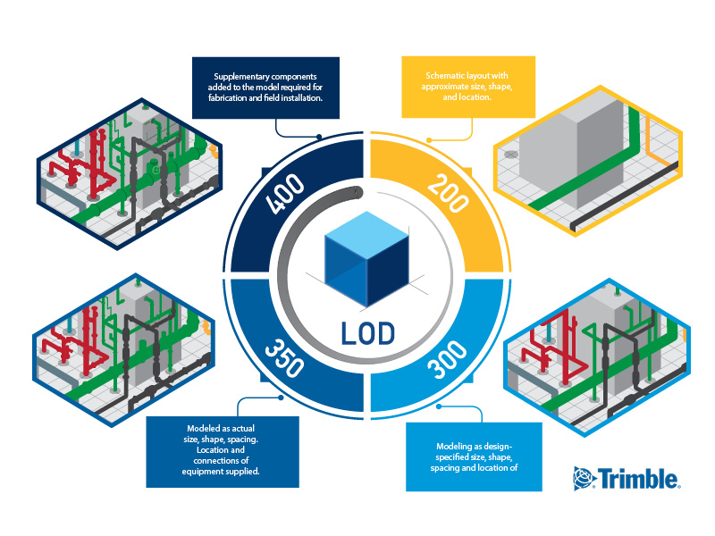
When it comes to looking into the different levels of development. As you can see above as the levels increase, the more developed they become as well as more detail being added.
Starting at Level 100. This is just the conceptual stage of the model where it is still in a very basic stage of its life. The model does allow for information to stand out and be diverse compared to the over simple details that can be found in the model.
Moving onto LOD 200. This is where a lot more development is brought into the model. Approximate sizing is begging to be used along with shape and the location of the project. This level is where the standard simple levels of 3D Modelling with relatively accurate information is being used. This is where the level of detailing starts to increase as the detail of the 3D model begins to show you planning images for the project.
Continuing onto level 300. The model begins to become a lot more detailed and accurate. This is done by using the measurements completed specifically to the design. As well as giving you an accurate shape, Spacing and the location of equipment. At this level this is where you are most likely to start bidding for the project. This is because at this level of development a quantity surveyor has all the information that they need to measure, Price, and decide whether the project would be profitable for them to complete.
After this there is then LOD 350. This level of development allows you as a user to see what the project will look like at its actual size. This is where the detail becomes very high, and you are able to get a real sense of what the final completed project is going to look like. By moving onto this level of development as a contractor you then have the opportunity to start to use virtual design construction which then means you can even move onto LOD 400.
When it comes to LOD 400, supplementary components are added into the model that are required for fabrication to be completed as well as field installation. This is where profitability really happens, this is because LOD 400 allows you to plan as well as practice virtually how to prefabricate using this software it also means that you are able to install each component. By using LOD 400. It allows everyone that is involved within the project to gain confidence in using prefabrication whilst also allowing you to track the project and make sure hit your target milestones.
However, for you to be able to date to achieve LOD 400 you need to make sure that you have the right skillset, software, and access to the right information. (The constructible , 2017)

After finally explaining how LOD works its now time to investigate LOI’s. LOI stands for level of information. This specifies the amount of non-geographical information can be attached to BIM elements. LOI is used to mainly help define the extent of which each element is described beyond its visual representation for example, Performance criteria, specifications, and maintenance information. These types of data allow you to ensure that all the project stakeholders have access to complete information.
This information can be used to complete informed decision making and because they have access to the information it means that their decision will be the perfect one for the project.
Just like LOD’s, LOI’s are set out extremely clearly to provide a full framework of sharing information. It all starts at LOI 100 where there is no information shared between stakeholders at all. Compared w=to when you rise the levels all the way to LOI 500 where every single piece of information is shared throughout all the stakeholders. Because everyone has the ability to access every single piece of information it means that their decision making has the ability to be precise as possible. By using a style of classification like this it means that it aids in streamlining communication, aligning expectations, and fostering collaboration. (Linkedin , 2023 )

After completing the research for this. Looking back onto it I now believe that I can give you a good understanding of what level of information you need to be at for both an LOD format as well as an LOI format.
Firstly, when it comes to a LOD format, I believe that the best level of development for this project is to be at Level 300. This is because at this level there is a large a amount of detail within the model. It also means that you can see very clear and a scaled version of the model. Havin this level of development will mean that you have the ability to sill send it out once designs are complete to allow for contractors to price the work and then bid on whether they want to win the project or not. After this you do then have the ability to enhance the level of development to LOD 350. Which then means you can achieve visual design construction.
In terms of LOI format. I believe that you should chose to allow for as much information as possible to be shared. Because of this I think that you need to use LOI 500. Doing this will mean that you have the ability to making important decisions streamlined as everyone that is supposed to have a say within the decisions of the project is allowed to have their input and because you would be using LOI 500 it means that the decisions made will be the most reliable because they hold the most information behind them.
References
About the Author Jim serves as Managing Director of SysQue and Building Data at Trimble. He maintains a strong customer focus on providing MEP contractors and engineers with managed data and business analytics for winning work et al. (2023) The lod on the lod, Constructible. Available at: https://constructible.trimble.com/construction-industry/the-lod-on-the-lod (Accessed: 15 January 2024).
Author Matt Ramage (2023) What is a BIM execution plan and what should it include?, Constructible. Available at: https://constructible.trimble.com/construction-industry/what-is-a-bim-execution-plan-and-what-should-it-include (Accessed: 11 January 2024).
Bim maturity assessment (2023) buildingSMART International. Available at: https://www.buildingsmart.org/users/services/bim-maturity-assessment/#:~:text=The%20BIM%20Maturity%20Measurement%20tool,how%20successful%20this%20has%20been. (Accessed: 14 January 2024).
Center, B.C.| T. (2023) Lod and Loi in bim, LinkedIn. Available at: https://www.linkedin.com/pulse/lod-loi-bim-bim-cafe (Accessed: 16 January 2024).
Lorek , S. (2022) What is BIM? Available at: https://constructible.trimble.com/construction-industry/what-is-bim-building-information-modeling (Accessed: 10 January 2024).

