Computational thinking test Name Bryn Sutton……………………………..
Student number 88924……... Degree HND……………………………………………………………..
Answer only the questions you can – if you cannot answer a question, move on to the next question. This test is not negatively marked, so you may wish to guess if unsure. Questions 1 and 2 to be answered on this paper, questions 3 and 4 to be answered using IDLE and saved.
- You have been selected to program a new robot intended to create hot drinks. The robot is capable of following simple, tea and coffee-oriented commands precisely, but has no understanding either of the process, or the fundamental principles which underpin it (e.g. that a kettle requires power). The robot has access to the following items:
- Kettle (initially unplugged)
- Tea bags
- Jar of ground instant coffee
- 1L carton of milk
- Unopened bag of sugar
- 1 metal tea spoon
- 1 large mug
- Access to a sink for water and an electrical socket for power
- You are required to give the robot the set of instructions (algorithm) necessary to successfully make a cup of milky coffee with 1 teaspoon of sugar. Each instruction should be on a new line. Ensure that your instructions are in a logical order and no steps are missed; while highly capable of following instructions, the robot cannot solve problems independently. (17)
Answer:
- Pick up kettle
- Take kettle to water source
- Turn on tap
- MUST Fill kettle to the ‘maximum fill’ line
- Return kettle to work surface
- MUST Plug kettle into power source
- MUST Turn power source on
- Acquire a large mug
- MUST Place mug on work surface
- MUST turn kettle on and allow to boil
- Acquire coffee jar
- Remove coffee jar lid (if required)
- Acquire metal spoon
- MUST fill spoon with at least one spoonful of coffee
- Empty spoon full of coffee into large cup
- Replace coffee jar on work surface
- Acquire bag of sugar
- MUST open bag of sugar
- Fill spoon with sugar
- MUST Empty spoon full of sugar into large cup
- Replace bag of sugar on work surface
- Replace spoon on work surface
- When water in kettle is boiled, pick up kettle
- MUST Pour water from kettle into large cup, measuring until cup is ¾ full
- Replace kettle on work surface
- Acquire milk carton
- Open milk carton (if required)
- MUST Pour milk into large cup until the cup is 9/10 full of liquid
- Replace milk carton on work surface
- Acquire spoon
- Place spoon in large cup
- MAY Move spoon in a clockwise motion five times
- Remove spoon
- Replace spoon on work surface

(PTO for more space)

- The robot is, of course, capable of making many variations of hot drink. The user must be permitted to give information about their drink preferences to the robot before it is created.
What are the pieces of information the robot must collect (requirements) before starting? (5)
Answer:
- Is coffee wanted?
- How much coffee is wanted?
- Is tea wanted?
- How long should the tea bag be left to brew?
- Is milk wanted?
- How much milk is wanted?
- How much water is wanted?
- Is sugar wanted?
- How much sugar is wanted?

c) If the instructions were converted to code, explain briefly how this data may be stored. What is the name given to a piece of data stored by a computer? (3)
Answer: If these instructions were to be converted into code, the data would be stored in a variable. A variable is an area of memory, which has been allocated an address by the program.

- We have been given the requirements for a program which:
- Says “Hello” to the user at the start.
- Reads a series of numbers from the user, adding them together.
- Stops when the user inputs -1 as a value.
- Once the user elects to stop inputting numbers, outputs the sum of the numbers input.
- Says “Goodbye” to the user.
For example, the program may run something like:
Hello
Enter number:
8
Enter number:
10
Enter number:
3
Enter number:
-1
Your total is 21.
Goodbye.

Of course, the user may enter any set of numbers and get a valid result:

Hello
Enter number:
9
Enter number:
-1
Your total is 9.
Goodbye.

Write the flowchart for this program (turn over for more space)

Answer: (On paper copy)
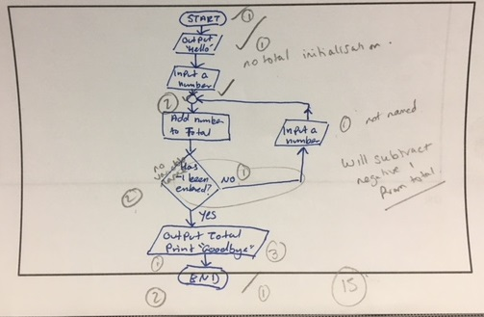

Question 2 continued:
(25)

- Now write the code for this program, using Python. This might give an output similar to:
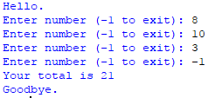
Answer:
print("hello")
total=0
num=int(input("Enter number (-1 to exit)"))
while num != -1:
total=total+num
num=int(input("Enter number (-1 to exit)"))
print("Your total is {0}".format(total))
print("Goodbye.")

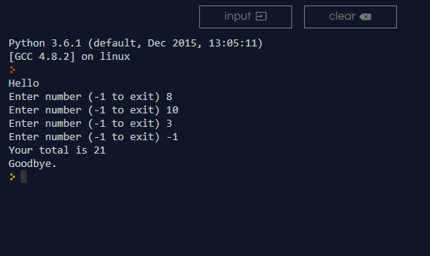

(15)
(Advanced) The program should additionally prevent the user from adding negative numbers (other than -1 to exit). For example:
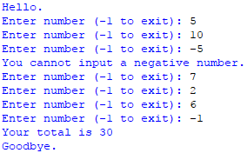

(10)

print("Hello")
total=0
num=int(input("Enter number (-1 to exit)"))
while num != -1:
if num >-1:
total=total+num
num=int(input("Enter number (-1 to exit)"))
else:
print("You canno input a negative number.")
num=0
print("Your total is {0}".format(total))
print("Goodbye.")

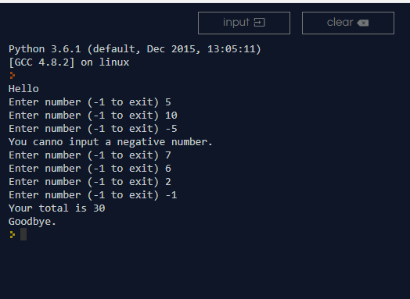

- Using Python with turtle, draw the following shapes:
- An oval. Remember that the code to draw a circle is:
import turtle

count = 0
while (count < 360):
turtle.forward(1)
turtle.right(1)
count = count + 1

You should start with this as a base, and modify it to form an oval similar to:
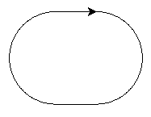
import turtle
t=turtle.Turtle()

count=0

while count<180:
t.forward(1)
t.right(1)
count=count+1
if count==180:
t.forward(100)
while count<360:
t.forward(1)
t.right(1)
count=count+1
if count==360:
t.forward(100)

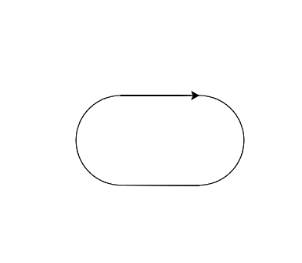

(7)
- A 5 point star. This can be achieved without lifting the pen. It should look similar to:
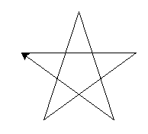
import turtle

t=turtle.Turtle()

count=0

while count<5:
t.forward(150)
t.right(144)
count=count+1
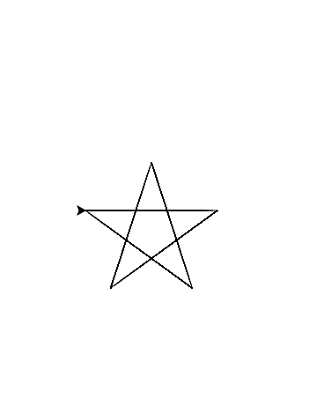
Hint: the angle of rotation at the end of each point is 144 degrees.
(8)
- A spiral. This may be a square spiral similar to:
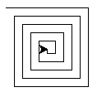
import turtle

t=turtle.Turtle()
length=20
count=0

while count<20:
t.forward(length)
t.right(90)
length=length+5
count=count+1

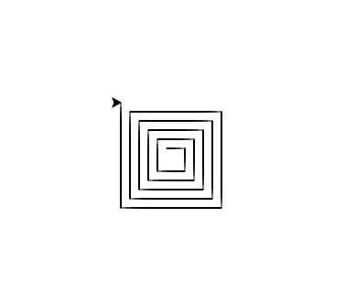

You should not equate each edge to a line of code. Instead consider what you can use to reduce the amount of code you are required to produce.
(10)

