A brief history of the Cornish language – David Trowt

Introduction:
The people we in the modern world know as Celts have been an enigma for centuries. There has been a plethora of research over the last few hundred years, however academia still isn’t united in exactly who or what the Celts were or are. This divide in opinion, mostly between linguists and archaeologists is discussed at length by Patrick Sims-Williams in his 1998 paper Celtomania and Celtoscepticism, however the language spoken by these ancient people, is generally accepted and recognised as Celtic.
The Celtic language enveloped a large swath of Europe and as identified by Edward Lhuyd (1660-1709) in his Archaeologia Britannica, Ancient Britain as well. Lluyd, according to John Collis, took the word Celtic as used by Pezron and ‘his use of it in an insular context is doubtless a tacit acceptance of the nomenclature of Pezron’. This Celtic language encompassed the many tribes that lived in Britain and over time has been reduced to just six remaining Celtic nations; Cornwall, Wales, Brittany, Isle of Man, Ireland and Scotland. The roots of the language they spoke or still speak, can be traced back to the Indo-European languages spoken throughout Europe and Asia and into the unattested Proto-Celtic which is the ‘reconstructed intermediate linguistic stage between Proto-Indo-European and the oldest attested individual Celtic languages’. The languages spoken by these six nations are split into two distinct groups, Goidelic for Irish, Manx (Isle of Man) and Scottish Gaelic and Brittonic for Cornish, Breton (Brittany) and Welsh. The Brittonic family, specifically Cornish will be traced from its roots to modern times, in the following paragraphs.

Early Celtic Language:
The Proto-Celtic language encompasses a large group of languages formed into what Collis, when discussing August Schleicher’s (1821-1864) theory of groups of languages being related to one another, describes thus:
The resulting concept is like a tree (hence, in German, the Stammbaumtheorie), in which the original Indo-European language is the trunk of the tree, the language groups form the branches (Slavic, Baltic, Germanic, Romance, Celtic, etc.), and the individual languages the twigs.

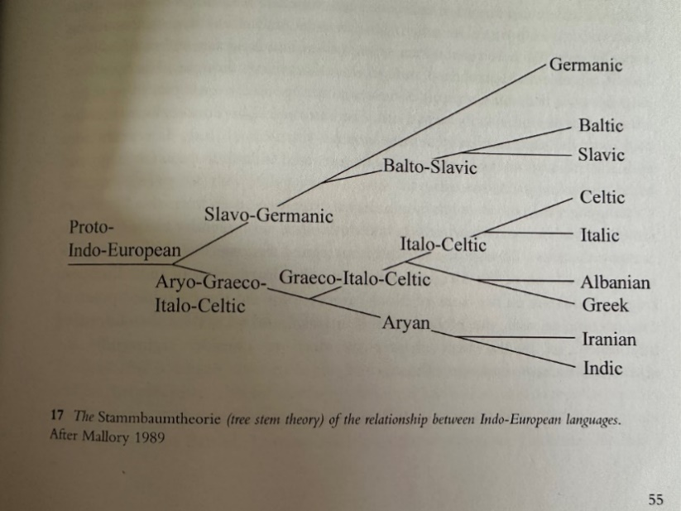
Collis uses a simple diagram (figure 1) to represent this concept and it can clearly be seen which languages Celtic shares its pathway with.
Celtic, in its broadest term, has been categorised into what is known as Continental Celtic and Insular Celtic. According to Paul Russell in his book An Introduction to the Celtic Languages, Continental Celtic represents the languages spoken throughout Gaul, Northern Italy and the Iberian Peninsula, whilst Insular Celtic represents the languages spoken within the British Isles. This is a very simplified explanation of the languages spoken, but in the case of Continental Celtic, evidence for it comes from inscriptions, such as the Botorrita Plaque, (figure 2 below), found in Spain or the Leptonic inscriptions found in Northern Italy, and the writings of classical authors such as Hecataeus of Miletus (550-475BCE), Pytheas of Massalia and later Julius Caesar (100-44BCE), all of whom wrote of the Celtic people in the Continental areas.
Figure 1
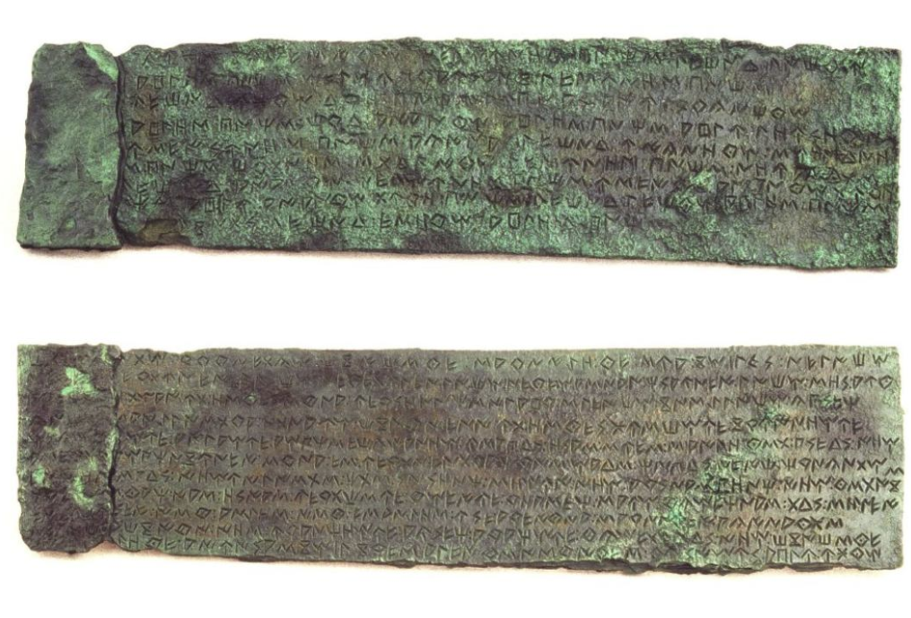
Figure 2
It is important to note that evidence from Classical authors alone cannot be relied upon when determining who actually spoke a Celtic language, Russell states in his book:
Their testimony can be misleading; use of the generic term Keltoi in Greek or Celtae in Latin does not necessarily refer to speakers of a Celtic language unless decisive personal names or local names are present. Much of our knowledge of Continental Celtic depends precisely on such evidence.
The evidence of Insular Celtic is derived from the languages that are or were spoken within the British Isles and of the various texts and inscriptions found over the centuries. Both Insular Celtic and Continental Celtic are further categorised as two distinct language groups, Goidelic (Q-Celtic) and Brittonic (P-Celtic); John Koch describes P-Celtic as a ‘subgroup of the Celtic languages within which the Proto-Celtic consonant (Kw, ) came to be pronounced as ‘P’. Q-Celtic is the contrasting term for the subgroup in which this change did not occur’, and is the older form. Notable Q-Celtic languages are Celtiberian and Goidelic and P-Celtic, Leptonic, Gaulish, Brittonic and Galatian.
Gaulish, as mentioned above, is a P-Celtic language, but also has Q-Celtic aspects as well. Koch gives an example of this stating that the Celtic horse goddess Epona, shows clear P-Celtic (the use of the letter ‘P’), however the Coligny Calendar, found with other artifacts in Coligny, France in 1897 and dated to the first century BCE, shows a month called Equos relating to the month of the ‘horse’, utilising the letter ‘Q’. A Gaulish tribe, the Sequai, were referenced by Caesar in his book on the Gallic war This shows at least some Q-Celtic use and evidence that Gaulish likely descended from the more archaic Proto-Celtic of earlier times, a point made by D. B. Gregor who echo’s Koch’s opinion on Epona above. An important note on the relationship between Insular and Continental Celtic; Russell feels that this is one of a ‘geographical convenience’ and is not related to the genetics of the tribes living in either area, evidencing how Gaulish can be both P-Celtic and Continental Celtic.

In relation to the language spoken by the Britons prior to the Anglo-Saxon invasion, Koch refers to it as British. From here, this term will be used to relate to ‘the oldest attested stage of the Celtic speech of Britain’, as opposed to the wider Brittonic group which includes Gaulish, Leptonic and Galatian.
The early British language was a relatively ‘untouched’ language in terms of how it had changed over the years. There is, however, some evidence of Latin words being ‘borrowed’ and used in the British language, something the Britons did with words unknown to them. An example of this is the Welsh word for ‘bridge’ which is pont, the Latin word being pons; ‘legion’ in Welsh is lleng and in Latin legio. The evidence for a change in the British language in the time between the Romans leaving Britain and the separation of Wales from south-west Britian (Dumnonii tribe) in around 577CE at the Battle of Deorham, is in the opinion of Koch, scarce. However, this separation of the British tribes caused by the Anglo-Saxon incursion did have an effect on diverging the British language, which separately became known as Welsh, Cornish and Breton.

Cornish as a language:
The earliest known stage of Cornish is commonly known as Primitive Cornish 600-800CE, however due to the scarcity of evidence of the language during this period, an opinion shared by Koch above, little can be said concerning the evolution of Cornish at this stage.
Old Cornish 800-1200CE denotes the next stage of Cornish and does have some evidence as a written language such as place names and personal names as written in the Bodmin Gospels which, whilst written and produced in Brittany in the 9th Century CE, were brought to the priory of St Petroc by the early 940s CE. In her article for the British Library, Claire Breay describes how different scribes used the margins and blank pages within the Gospel book to record the names of slaves freed in Cornwall during the 10th and 11th Centuries CE; these entries, known as manumissions, are written in Cornish.

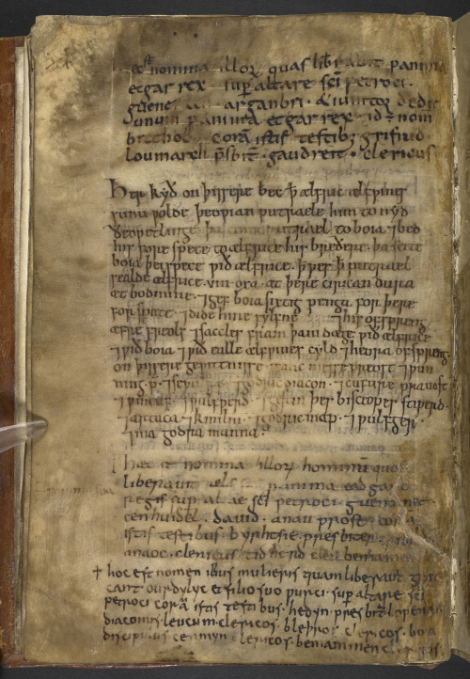
The below (figure 3) shows the one of the pages of the added manumission documents.
Figure 3

Another known document written around 1200CE is the Vocabularium Cornicum or Old Cornish Vocabulary, which is a glossary of Latin-Old Cornish vocabulary. Within the text of this document is some evidence for the usage of ‘d’ and ‘t’ as word endings, prior to the change to ‘s’ in Middle Cornish. An example is the word durat, meaning ‘door’ which changes to duras in Middle Cornish or rid, meaning ‘ford’, which changes to rys. Koch also gives an example of this ‘hard ending to consonants’. He describes the Old Cornish name of Gerent becoming a softer Gerens in Middle Cornish, showing the -nt becoming an -ns. O.J Padel describes the name Antun becoming Ansun as an example of this happening in the middle of a world, although he says that this was rare.

Middle Cornish 1200-1575CE has more examples of Cornish language in documents and manuscripts found. One such document was found St Stephen in Brannel in 1340CE and is known as the Charter Endorsement. These forty-one lines of Cornish text were found written on the rear of a land charter and appear to be related to the marriage of a couple; it is not known exactly what it pertains too.
Another Cornish literature example is The Passion of our Lord (Passhyon Agan Arloedh), a retelling of the Passion of Christ written around 1375CE. Sandercock gives an example from this poem to show the difference in how sounds were written at the time, compared with modern Cornish:
Manuscript - Modern Cornish - English
ze wolsowas y basconn. – dhe woslowes y Basshyon. – to listen to His Passion.

He states, ‘Z’ was an attempt to represent a voiced ‘Th’ as in the sound of an English word ‘The’, represented in Cornish writing since Lluyd introduced it in the 1700’s as ‘Dh’.
The Ordinalia, written by the clerics of Glasney College in Penryn, are three plays retelling the stories of The Beginning of the World (Origo Mundi), The Passion of Christ (Passio Christi) and The Resurrection (Resurrexio Domini), with a ‘resolutely Cornish treatment’, are well known pieces of literature written in the late 14th Century CE. As above, Sandercock uses some text from the play to demonstrate the changing usage of sound in written form:
Manuscript - Modern Cornish - English
thyvgh lauara ow dyskyblyon – Dhywgh lavarav, ow dyskyblon – To you I say, my disciples

As above, the writers in Middle Cornish have attempted to represent the voiced ‘Th’ sound, this time by using ‘Th’. Both of these pieces were written in the late 14th Century CE yet have different representations of how ‘Th’ is written. Russel states that due to Middle and Late Cornish being written using contemporary English orthography but at the time there was no set standard for English, thus there was likely none for Cornish either.
Late Cornish 1600-1800CE ultimately saw the decline of the Cornish language as less and less people spoke it fluently and even fewer documents were produced in the Cornish language. The last known sermon preached in Cornish was at St Wynwallow Church in Landewednack in 1678, which given The Book of Common Prayer and all church services were, by law, to be conducted in English, is perhaps an example of ‘some’ Cornish resilience to this decline? Sandercock writes of Richard Carew who in his book Survey of Cornwall (1602), makes comment that the language was “spoken in only the outermost skirts of the shire’. Craig Weatherhill in his book talks of the population of Cornwall, and that by 1500CE around 69,000 people lived in Cornwall and around half (34,500) spoke Cornish. As Cornish was pushed westwards in favour of the English language, the number of native speakers dropped and the last recorded monoglot native speaker, Dolly Pentreath passed away in 1777.

Revival:
Did people stop speaking Cornish, the simple answer is no. Following Dolly’s death, John Nancarrow of Marazion was recorded in 1790 as being ‘a fluent speaker of Cornish’. In 1936 in an interview given to J. Arthur Rablen, a retired Policeman named William Botheras told how, around 1875 as a youth, he spent considerable time with local Newlyn fisherman and witnessed them conversing in Cornish ‘for up to ten minutes at a time’.
Henry Jenner (1848-1934), sometimes referred to as the ‘instigator of the revival’, in 1904 published his A Handbook of the Cornish language which was written to help people understand and learn the Cornish Language. This encouraged others to learn and the ‘revival’ was born.
In present day the Cornish Language Board was set up in 1967 to specially promote Cornish as a language and continues to work with schools and other institutions offering a variety of educational material. After a study in 2018 it was found that approximately 3000 people living in Cornwall and the Isle of Scilly spoke Cornish to some degree, with roughly 500 speaking fluently. In 2010 UNESCO’s Atlas of World Languages showed Cornish listed as ‘critically endangered’ as opposed to ‘extinct’ as it was before; it is as of today, listed as ‘endangered’.

Conclusion:
As can be seen throughout the essay, the Cornish language has a long history, with its roots dating back into the Proto-Celtic era. Whilst it was not spoken widely, nor is it heavily attested, what is known is of acceptable quality and demonstrates some evidence of how the language developed over the centuries from it’s root up until it’s ‘death’ in the late eighteenth century.
To the question of it’s revival, the evidence above shows a concerted and successful effort by different people and organisations to not only revive the language, but also the result of that effort in its now official status as ‘endangered’. The growth of the Cornish language continues and as such, in this author’s opinion, it can be said to be ‘revived’.

Bibliography:
BBC, ‘Cornish Language No Longer Extinct’, Says UN, https://www.bbc.co.uk/news/uk-england-cornwall-11935464 [accessed 8th March 2025].
Breay, Claire, ‘Treasures On Tour In Cornwall’, Medieval Manuscripts Blog, 21 October 2021. https://blogs.bl.uk/digitisedmanuscripts/2021/10/treasures-on-tour-in-cornwall.html [accessed 6th March 2025].
Celtiberia Historica, ‘Contrebia Belaiska (Botorrita)’, (date unknown) https://celtiberiahistorica.es/en/exposicion-viva/contrebia-belaiska-botorrita [accessed 1st March 2025].
Collis, John, The Celts – Origins, Myths & Interventions, (Gloucestershire: Tempus Publishing Ltd, 2003).
Cunliffe, Barry, ‘The Ancient Celts’ (Oxford: Oxford University Press, 2018).
Davies, Janet, The Welsh Language: A History, (Cardiff: University Of Wales Press, 2014).
Ellis, Peter Beresford, The Story Of The Cornish Language, (Redruth: Tor Mark Press, 1998).
Ferdinand, Siarl, ‘The Promotion of Cornish in Cornwall and the Isles of Scilly: Attitudes towards the Language and Recommendations for Policy’, Studia Celtica Fennica, 1 March 2020. https://journal.fi/scf/article/view/79496/53340 [accessed 8th March 2025].
Gregor, D. B, Celtic: A Comparative Study, (Cambridge: The Oleander Press, 1980).
Kesva, Who Are We, (2025) https://www.kesva.org/who-we-are [accessed 8th March 2025].
Koch, John T, Celtic Culture: A Historical Encyclopedia, (Santa Barbara: ABC-Clio, 2006).
Padel, O. J, A Popular Dictionary Of Cornish Place-Names, (Penzance: Alison Hodge, 1988).
Russell, Paul, An Introduction To The Celtic Languages, (Oxon: Routledge, 2013).
Sandercock, Graham, A Very Brief History Of The Cornish Language, (Hayle: The Cornish Language Board, 1996).
Sims-Williams, Patrick, ‘Celtomania And Celtoscepticism’, HPCS4003, The Early Celts, 2023. UWTSD Moodle.
UNESCO, Cornish In United Kingdom Of Great Britain And Northen Ireland, https://en.wal.unesco.org/countries/united-kingdom-great-britain-and-northern-ireland/languages/cornish [accessed 8th March 2025].
Weatherhill, Craig, Cornish Place Names & Language, (Wilmslow: Sigma Leisure, 1995).
Williams, Jennifer, ‘Social Consequences Of The 1549 Prayerbook Rebellion Under Edward VI’, The Historian Magazine (undated). https://thehistoriansmagazine.com/social-consequencs-of-the-1549-prayerbook-rebellion-under-edward-vi/ [accessed 9th March 2025].
Williamson, Forschungsmitarbeiter Mitch, ‘The Battle Of Deorham, A.D. 57’, 14 December 2024. https://warhistory.org/@msw/article/the-battle-of-deorham-a-d-577 [accessed 6th March 2025].

This term in its context today, was first coined by Paul-Yves Pezron in 1703 when he linked his native language of Breton to that of Welsh and modern (at the time) Greek, German and Latin.
John Collis, The Celts – Origins, Myths & Interventions, (Gloucestershire: Tempus Publishing Ltd, 2003), p. 49-50.
John T, Koch, Celtic Culture: A Historical Encyclopedia, (Santa Barabara: ABC-Clio, 2006), p. 1464.
Historically sometimes written as Brythonic, but for this essay the spelling ‘Brittonic’ will be used, unless by way of quote.
Collis, The Celts – Origins, Myths & Interventions, p. 55.
Ibid., p.55.
Barry Cunliffe, The Ancient Celts (Oxford: Oxford University Press, 2018), p.81.
Celtiberia Historica, ‘Contrebia Belaiska (Botorrita)’, (date unknown) https://celtiberiahistorica.es/en/exposicion-viva/contrebia-belaiska-botorrita [accessed 1st March 2025].
Cunliffe, The Ancient Celts, p.89.
Paul Russell, An Introduction To The Celtic Languages, (Oxon: Routledge, 2013), p.3.
Koch, Celtic Culture: A Historical Encyclopedia, p. 1413.
Ibid., p. 1473.
Cunliffe, The Ancient Celts, p. 279.
D. B. Gregor, Celtic: A Comparative Study, (Cambridge: The Oleander Press, 1980), p. 22.
Ibid., p. 22.
Ibid., p. 18.
Koch, Celtic Culture: A Historical Encyclopedia, p. 290.
Ibid., p 290.
Gregor, Celtic: A Comparative Study, p. 30.
Janet Davies, The Welsh Language: A History, (Cardiff: University Of Wales Press, 2014), p. 7.
Ibid., p. 7.
Gregor, Celtic: A Comparative Study, p. 48.
Forschungsmitarbeiter Mitch, Williamson, ‘The Battle Of Deorham, A.D. 577’, 14 December 2024. https://warhistory.org/@msw/article/the-battle-of-deorham-a-d-577 [accessed 6th March 2025].
Koch, Celtic Culture: A Historical Encyclopedia, p. 488.
Claire Breay, ‘Treasures On Tour In Cornwall’, Medieval Manuscripts Blog, 21 October 2021. https://blogs.bl.uk/digitisedmanuscripts/2021/10/treasures-on-tour-in-cornwall.html [accessed 6th March 2025].
Ibid.
Graham Sandercock, A Very Brief History Of The Cornish Language, (Hayle: The Cornish Language Board, 1996), p. 6.
Koch, Celtic Culture: A Historical Encyclopedia, p. 488.
O. J, Padel, A Popular Dictionary Of Cornish Place-Names, (Penzance: Alison Hodge, 1988), p. 29.
Ibid., p. 490.
Sandercock, A Very Brief History Of The Cornish Language, p. 8.
Ibid.
Koch, Celtic Culture: A Historical Encyclopedia, p. 490.
Russell, An Introduction To The Celtic Languages, p. 222.
Peter Beresford, Ellis, The Story Of The Cornish Language, (Redruth: Tor Mark Press, 1998), p. 17.
Craig Weatherhill, Cornish Place Names & Language, (Wilmslow: Sigma Leisure, 1995), p. 10.
Jennifer Williams, ‘Social Consequences Of The 1549 Prayerbook Rebellion Under Edward VI’, The Historian Magazine (undated). https://thehistoriansmagazine.com/social-consequencs-of-the-1549-prayerbook-rebellion-under-edward-vi/ [accessed 9th March 2025].
Sandercock, A Very Brief History Of The Cornish Language, p. 11.
Weatherhill, Cornish Place Names & Language, p. 10.
A topic for another essay so referred to here in only broad terms.
Monoglot means ‘using or speaking only one language’, so Dolly was the last recorded person to speak ‘only’ Cornish.
Gregor, Celtic: A Comparative Study, p. 347.
Weatherhill, Cornish Place Names & Language, p. 148.
Ibid., p. 10.
Kesva, Who Are We, (2025) https://www.kesva.org/who-we-are [accessed 8th March 2025].
Siarl Ferdinand, ‘The Promotion of Cornish in Cornwall and the Isles of Scilly: Attitudes towards the Language and Recommendations for Policy’, Studia Celtica Fennica, 1 March 2020. https://journal.fi/scf/article/view/79496/53340 [accessed 8th March 2025], p 3 (109).
BBC, ‘Cornish language No Longer Extinct, Says UN’, https://www.bbc.co.uk/news/uk-england-cornwall-11935464 [accessed 8th March 2025].
UNESCO, Cornish In United Kingdom Of Great Britain And Northern Ireland, https://en.wal.unesco.org/countries/united-kingdom-great-britain-and-northern-ireland/languages/cornish [accessed 8th March 2025].

