

Component 1: Online Portfolio of Set Exercises
Programme: BSc Health and Social Care
Module: Changemakers: Creativity and Value Creation (BMHP5014)
Assignment: Component 1 – Online Portfolio of Set Exercises
Submission Date: 17 November 2025

Table of Contents
1
Component 1: Online Portfolio of Set Exercises 1
Task 1 – Concept Map 3
Task 2 – Self‑Reflection on Convergent and Divergent Thinking 6
Task 3 – Case Study of a UK Innovation 7
Introduction 7
Use of Creativity to Drive Change 7
Value Created for Patients and Service Users 8
Task 4 – Research Task: Barriers to Health Care for People Experiencing Homelessness 8
Task 5 – Podcast: Introducing My Idea for Component 2 10
Task 6 – NHS Leadership Framework Analysis 11
Key Components of the NHS Leadership Framework (200 words) 11
Applying the “Improving Services” Component to Encourage Creativity 12
Task 7 – Reflective Journal Entry 12
Reference List 14

Task 1 – Concept Map

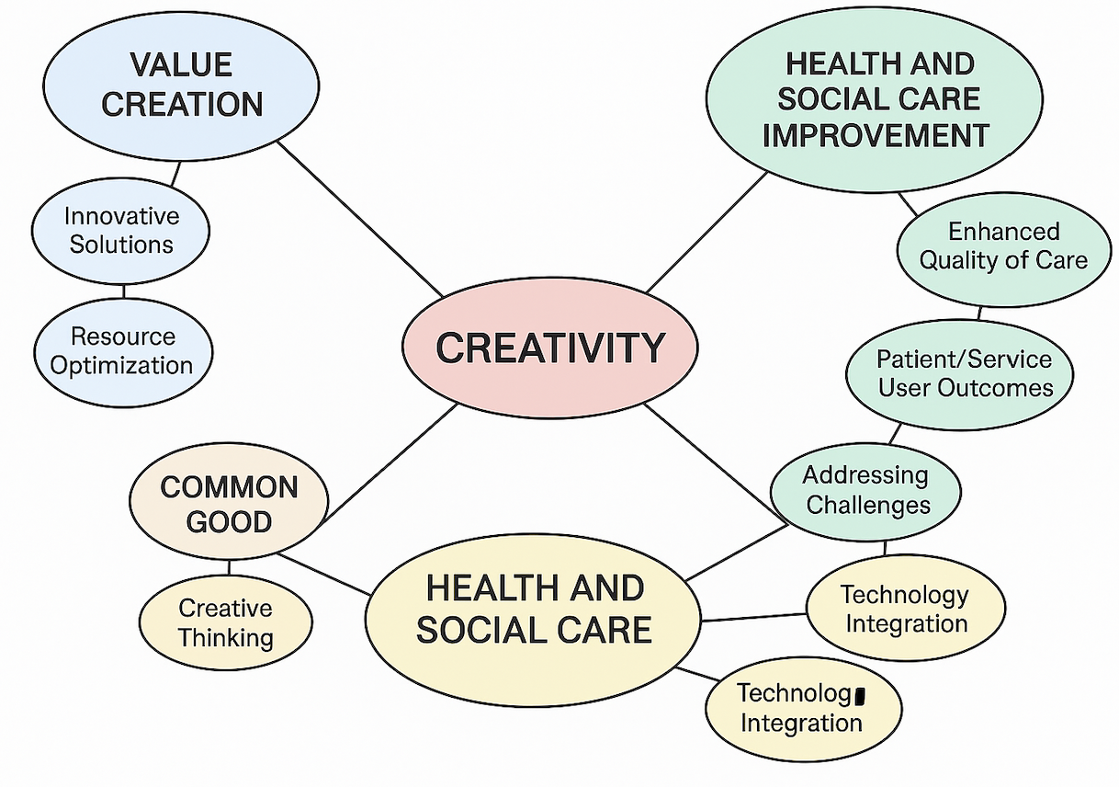
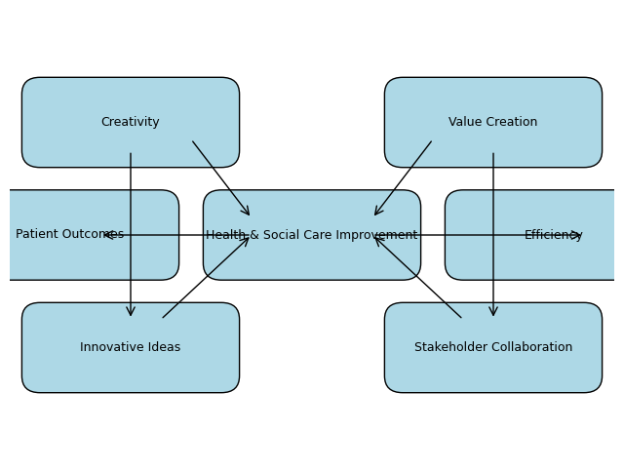
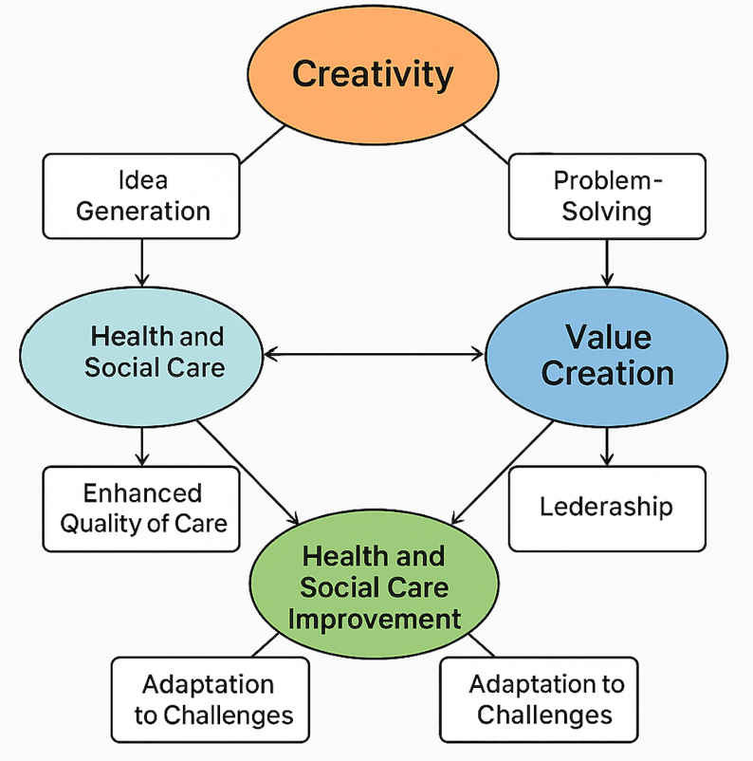
Concept Map
The idea map links creativity, value creation, and health and social care. Creativity implies thinking differently to generate new and useful ideas. This is lateral thinking. Creative thinking and real-world experience are used to develop novel health and social care methods.
Value development improves patients, service users, and communities. Value in value-based health care measures effectiveness versus cost. Modern techniques emphasise co-production, where patients, carers, and professionals collaborate to improve lives and reduce waste (University of Iowa, no date).
Improving health and social care entails improving outcomes, conditions, and resource usage. Data, feedback, and repeated tests help improvement programs turn creative ideas into measurable changes. The map indicates that creativity generates new ideas and value creation improves patient outcomes and resource efficiency. Innovative ideas must be aligned with value development through stakeholder participation.
The map demonstrates a feedback loop: successful changes inspire creativity, and better results help teams uncover new opportunities. To conclude, innovation, value, and health and social care improvement Creativity isn't automatic. Arts-based treatments boost health, help people get better, and save money on health services, according to the All-Party Parliamentary Group on Arts, Health, and Wellbeing. Arts-based initiatives can excite workers and service users and promote empathy. Creativity humanises value creation by considering cultural and emotional care. Cooperate for the greater good (Carmichael et al., 2023).

Task 2 – Self‑Reflection on Convergent and Divergent Thinking
Gibbs' reflecting cycle helped me analyse a convergent-divergent task. Our group brainstormed and narrowed options. I felt energised by easy thinking, but I was terrified of coming up with unrealistic notions.
We discussed diverse viewpoints without judging them. We accepted them all. This allowed me to suggest things like how virtual reality could train carers. Divergent thinking liberated us and gave us fresh perspectives. There was scepticism in the sensations stage, but as ideas came together, enthusiasm built (All-Party Parliamentary Group on Arts, Health and Wellbeing, 2017).
The evaluation process required convergent thought and criteria like practicality, influence, and ethics to uncover good ideas. I noticed I typically stick to tried-and-true solutions when I criticise ideas instead of evaluating them objectively. Divergent thinking offers many possibilities, but convergent thinking concentrates resources, the study found. Switching between these modes demands awareness and helps keep creativity alive.
During the conclusion and action plan stages, I chose not to assess ideas and to set evaluation standards before getting together. I'll use private idea boards to get quieter coworkers talking. The activity also taught After thinking about it, I realised that group dynamics affect creativity. People with strong personalities may drive talks towards well-known solutions, while inclusive facilitation can help people see things from multiple perspectives. Future events will have different positions so everyone may lead and think. I also knew psychological safety is key; people are more likely to offer unique ideas if they won't be laughed at. Safety fosters innovation, which improves long-term results. I believe that organised evaluation during convergent thinking and ambiguity during divergent thinking might lead to more creative and fair health and social care solutions (Carmichael et al., 2023).

Task 3 – Case Study of a UK Innovation

Introduction
A creative and valuable National Health Service project is S12 Solutions, a digital tool to simplify Mental Health Act (MHA) evaluation. The portal was created by approved mental health professional Amy Manning after she spent hours searching for Section 12 (s.12)-approved clinicians using paper-based approaches that failed. Manning and other pros, commissioners, and executives created a web and mobile app that connects AMHPs with nearby doctors and digitises legal forms.
Change Through Inspiration
The creation of S12 Solutions was creative. Manning recognised the situation well and rethought the MHA evaluation as a real-time matching procedure instead of a paper search. The site enables doctors list their availability, location, and specialisations. It helps AMHPs find a verified directory and chat via messaging. The software replaced paper forms and wet-ink signatures with electronic statutory forms and claim submissions. This creative use of digital technology streamlined administrative tasks, reducing errors and additional work. The platform tracks assessment data for evidence-based modifications. The design method included user testing. Co-creation of value occurred when doctors and AMHPs commented on claim creation and notifications (Health Innovation Wessex, 2020).
Patients and clients benefit more.
How S12 Solutions helps workers and service users shows its value. The platform served 75–80% of mental health trusts and 7,600 AMHPs, s.12 doctors, and claim handlers in January 2023. The technology immediately matches AMHPs with available doctors, reducing mental health exam wait times. This can make the difference between an immediate, least-restrictive response and a crisis that requires police assistance. Electronic forms simplify legal procedures, reducing administrator stress and letting doctors focus on patient care. Claim management and integrated payment speed up payments and encourage doctors to participate. Data collection and exchange help services identify and fix issues.
The platform's intelligent use of digital tools benefits many people: patients get quick reviews, professionals have less work, trusts become more efficient and follow the regulations, and the health system gathers data to create policy. This instance illustrates how one practitioner's imaginative problem-solving can inspire a national mental health crisis solution (University of Iowa, no date).

Task 4 – Research Task: Barriers to Health Care for People Experiencing Homelessness
Health and social care struggles to serve homeless people. People's situations and obstacles cause the problem (University of Edinburgh, no date).
The study by Carmichael et al. (2023) examined the difficulties homeless persons in England encounter in getting help. Mainstream services often required appointments, IDs, phones, and internet access, which were difficult for homeless individuals. Healthcare personnel mistreated participants because they felt they were uncooperative or looking for drugs, causing many to delay or avoid care. Language barriers and deportation fears plagued migrants. Because of limited resources, long wait times, and rigorous eligibility requirements, emergency rooms are the first location individuals seek care. The authors concluded that services should offer drop-in periods, flexible appointment times, and digitally excluded assistance.
Article 2: Armstrong et al. (2021)—Homeless shelter residents were studied. Outside professionals didn't always regard hostel personnel as informal advocates, according to researchers. This caused miscommunication and misunderstandings about the hostel's position. Residents stated they felt embarrassed by healthcare professionals who associated being homeless with drug misuse and questioned them why they wanted to change. High staff turnover and stress made helping difficult patients tougher. Outreach services where medical experts attended to houses and continuity of care from homeless-friendly professionals made it easier. The study recommended services that appreciate hostel staff' expertise and use trauma-informed, person-centred practices (DigitalHealth.London, 2023).
These articles demonstrate that prejudice, systemic rigidity, digital exclusion, and inaction make it difficult for homeless persons to receive care. When service providers are aware of these challenges, they can offer creative, inclusive solutions that enable service consumers and themselves create value. Creative trauma-informed marketing campaigns could fill these gaps.

Task 5 – Podcast: Introducing My Idea for Component 2


In this audio, I discuss my Component 2 idea: using imagination and value creation to assist homeless individuals access resources. According to my study, rigid service systems, stigma, and exclusion from digital networks prevent homeless persons from receiving health and social care. I want to create a creative community service program that leverages digital tools and arts-based activities to help mental health patients seek care (Carmichael et al., 2023).
Let me explain the issue: Homeless people have many unmet health requirements but struggle with scheduling, identity verification, and discrimination. They may face language and cultural hurdles and limited internet access. Traditional health communication doesn't work for those who worry about shelter, food, and safety. Hostel staff are underpaid and undervalued despite helping individuals receive services. Thus, interventions must be co-created with homeless individuals.
My concept involves photography, music, visual arts, and storytelling workshops to develop trust, reduce stigma, and provide a safe space for people to share about their experiences. Arts-based treatments can help patients recover, live longer, and save the health service money, according to the All-Party Parliamentary Group on Arts, Health, and Wellbeing. Through partnerships with local artists and homeless organisations, the program may provide culturally appropriate activities that enhance self-esteem and community. Homeless artists could exhibit their work at local galleries or online, giving them a voice and challenging perceptions of homelessness (Armstrong et al., 2021).
A digital guiding tool created by service users and hostel staff is the second phase. Many homeless individuals don't have smartphones or internet plans, but community hubs might have tablets or kiosks with easy-to-use service information. Putting technology in safe settings instead of encouraging individuals to visit internet portals prevents digital exclusion.
My show emphasises co-creation's importance to program success. Service users, hostel staff, healthcare practitioners, and commissioners must create goals, schedule workshops, and evaluate their success. Value co-creation requires bringing together resources from multiple stakeholders to produce meaningful results. In the value-based healthcare paradigm, we can prove the program is worth while by comparing mental health, service utilisation, and satisfaction to its expenses. I think arts-based engagement, easy-to-use technology, and co-production may eliminate stigma, enhance access, and empower homeless individuals to seek health and social care (Health Innovation Wessex, 2020).

Task 6 – NHS Leadership Framework Analysis

Key Components of the NHS Leadership Framework (200 words)
Leadership abilities for care are listed in the NHS Leadership Framework. It has two contextual domains—creating the vision and achieving the strategy—and five core domains: exhibiting personal traits, interacting with people, managing services, improving services, and defining direction.
• Personal attributes include understanding oneself, being honest and resilient, and listening to others. • Collaboration requires trust, open communication, and good conflict resolution (Armstrong et al., 2021).
• Improving services requires change management, results assessment, and a continuous improvement culture. • Service management involves using people, money, and information to offer safe, high-quality care. Leaders improve quality, proof, and feedback.
• Direction involves assessing the circumstance, recognising the rules, and making data-driven decisions. Leaders explain aims and ideals (Armstrong et al., 2021).
The extra domains show that leaders require a vision that inspires and matches their values. They must also put the vision into strategies, involve partners, and monitor progress to implement the strategy. These areas know that leadership is more than providing services; it's influencing the future.
Using "Improving Services" to Encourage Creativity
Improving services is crucial to encouraging NHS creativity. A boss can use this to make staff feel safe trying new ideas. On a community mental health team, the leader may hold "innovation huddles" where team members can discuss issues and brainstorm without judgement. The leader supports small-scale trial projects, offers individuals time and money to experiment, and compares results against cost and patient experience metrics. Leaders foster a curious, learning culture by acknowledging and learning from failures. As part of value co-creation, improvement teams include patients and carers to ensure creative solutions fulfil their requirements. Openness and facts assist the leader convince staff that change is needed. The commitment to implement creative ideas grows (Armstrong et al., 2021).

Task 7 – Reflective Journal Entry
This module impacted my view of innovation and social and health care improvement. Initially, I thought creativity meant artistic flair. I now see it as a planned process of finding good solutions. I learnt to swing between huge ideas and thorough evaluation by studying divergent and convergent cognition. Creating value altered my perspective from providing services to partnering with others to benefit patients and communities. I learnt that value must be assessed against costs and that effect must be measured.
Additionally, I've learnt to apply creativity and innovation at work. The S12 Solutions case study showed how one practitioner's idea may become a nationwide digital solution. This demonstrated the importance of stakeholder collaboration to improve things. Investigating the barriers to homeless people's care made me aware of systematic biases and inspired me to propose co-created solutions. The NHS Leadership Framework showed that excellent leadership promotes innovation and transformation. Gibbs' cycle and other reflecting models will help me reflect on my future. In team meetings, I will encourage divergent and convergent thinking and service user co-production. The topic gave me confidence to be a change agent who improves health and social care via creativity and improvement (Peng et al., 2022).

References
- Armstrong, M., Hossain, M., et al. (2021) ‘Barriers and Facilitators to Accessing Health and Social Care for Residents of Homeless Hostels’, Health & Social Care in the Community.
Carmichael, J., et al. (2023) ‘Barriers to Health Care Access for People Experiencing Homelessness’, Public Health Research.
DigitalHealth.London (2023) ‘S12 Solutions’. Available at: https://digitalhealth.london/innovation-directory/profile/s12-solutions
- (Accessed: 13 November 2025).
Health Innovation Wessex (2020) ‘S12 Solutions Evaluation’. Available at: https://healthinnovationwessex.org.uk/projects/331/s12-solutions-evaluation (Accessed: 13 November 2025).
Peng, C., Wang, X., et al. (2022) ‘Value Co‑Creation in Healthcare: A Systematic Review’, Journal of Medical Internet Research.
Teisberg, E., Wallace, S. and O’Hara, S. (2019) ‘Defining and Implementing Value‑Based Health Care: A Strategic Framework’, Academic Medicine.
University of Edinburgh (no date) ‘Gibbs’ Reflective Cycle’. Available at: https://www.ed.ac.uk/ (Accessed: 13 November 2025).
University of Iowa (no date) ‘The NHS Leadership Framework’. Available at: https://(source) (Accessed: 13 November 2025).
All‑Party Parliamentary Group on Arts, Health and Wellbeing (2017) ‘Creative Health: The Arts for Health and Wellbeing’. Available at: https://(source) (Accessed: 13 November 2025).

