Discuss the challenge of conserving the heritage value of the Cofiwch Dryweryn graffiti as a piece of built heritage.

The Cofiwch Dryweryn (Remember Tryweryn) graffiti is a memorial to the drowning of the village of Tryweryn, near Bala, for the creation of a reservoir to supply water to Liverpool. The graffiti is situated on the wall of a ruined building just off the A487 between Llanrhystud and Aberystwyth, Ceredigion (Figure 1). The graffiti was the subject of some media attention in February 2019 after it was vandalised, and subsequently restored. There had been previous calls for the wall and its graffiti to be offered legal protection, which were repeated after the latest vandalism, but have been dismissed as the structure does not qualify as a listed building. This essay will explore the history and significance of the Cofiwch Dryweryn graffiti and the possibilities and challenges that are posed by its conservation.
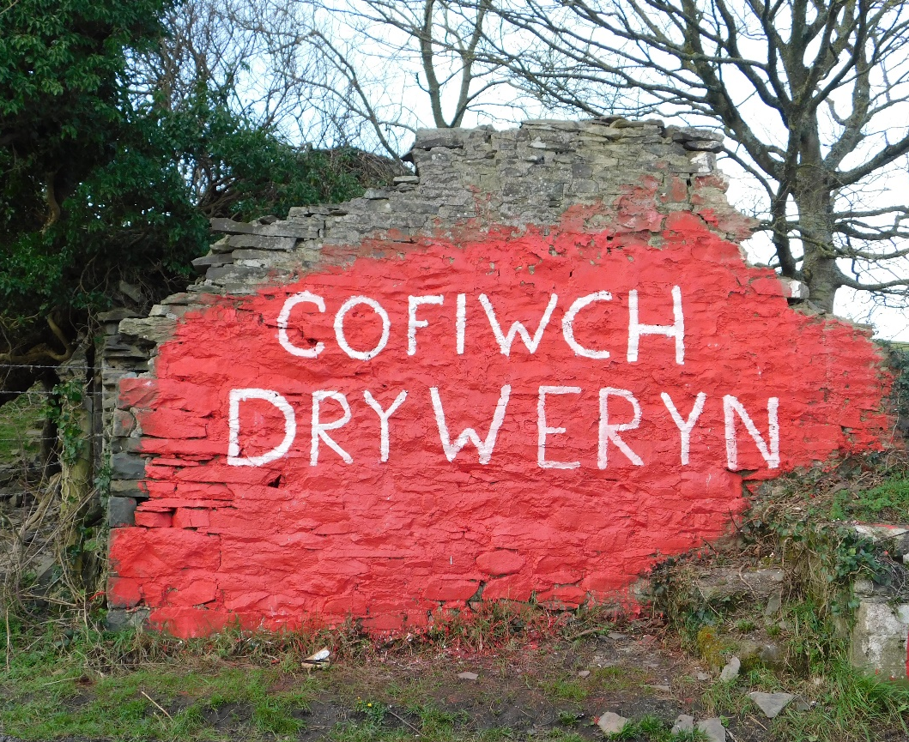
Figure 1 The Cofiwch Dryweryn graffiti in February 2019 having recently been repainted after being vandalised. Credit: Catriona Price.
In the mid-1950s Liverpool feared a shortage of water and proposed several sites to be flooded to make a new reservoir to supply water to the city. The site that was eventually settled upon was the Afon Tryweryn valley, encompassing the community of Capel Celyn, near Bala in North Wales. Despite initial opposition from the majority of Welsh MPs at the time of first proposal, the valley was eventually flooded to create the Llyn Celyn reservoir in 1965 (Cunningham 2007).
The creation of the Llyn Celyn reservoir was an emotive and complicated process. Capel Celyn was a Welsh speaking community, well established with many resident there for several generations (Cunningham 2007). At the time of the proposal there was no Welsh Devolution or even a Welsh Office, and the proposed flooding of a Welsh speaking settlement to provide water for England sparked a rise in Welsh Nationalism (Cunningham 2007, Johnes 2012: 212-3). Opposition was not universal however, with some Welsh MPs no longer opposing the plan and some locals even offering support for the flooding. One resident of the area at the time described the decline of the village, with a reduction in pupils at the school, from fifty to just nine, and the fact that many houses had become unfit for habitation. At the time of eviction Capel Celyn and the surrounding community was home to forty people, a school of nine pupils, a chapel and burial ground and six farms, with land being lost from another ten farms (Johnes 2012: 212-215).
The flooding of the Tryweryn valley directly affected only a very few people but it had much wider implications associated with the rise of Welsh nationalism. A Welsh speaking settlement was to be destroyed to provide water for England, and it became a symbol to rally around. During construction between 1962 and 1963 the site was attacked three times (Cunningham 2007). The Minister for Welsh affairs, Welsh speaking son of David Lloyd George, Gwilym Lloyd George was branded by some a traitor for allowing the flooding (Johnes 2012: 113). Cymdeithas yr Iaith Gymraeg (the Welsh Language Society) was founded in 1962 to promote the use of the Welsh Language, partly as a response to the planned flooding of Tryweryn (Griffiths 2014). Tryweryn had not been the first example of Welsh valleys being flooded to give England water, but its unique combination of culture and landscape meant Capel Celyn took on a symbolic meaning – the flooding of a nation (Griffiths 2014). It is this context that the Cofiwch Dryweryn graffiti was first daubed on the end of a ruined building off the A487 between Llanrhystud and Aberystwyth.
The original Cofiwch Dryweryn graffiti at Llanrhystud first appeared in the 1960s and was painted by academic and writer Meic Stephens to:
‘remind the people of Wales of the treachery and suffering, the anger, the agony and the disruption that took place when Liverpool Corporation were given the go-ahead – against public opinion in Wales – to drown Tryweryn, without paying a penny for it’ (Owens 2019).
The Llanrhystud Cofiwch Dryweryn graffiti was not the only one to be painted around the time of the flooding of Capel Celyn, but it was the only one to survive – being repainted by successive generations over the years (Owens 2019, Griffiths 2014). Over time the graffiti has taken on a greater meaning, becoming an iconic, if unofficial, landmark of the region, and a symbol of Welsh Nationalism. The Cofiwch Dryweryn graffiti has become a memorial, something which has a greater meaning than may be obvious on first inspection.
The Cofiwch Dryweryn graffiti has gained some media attention over the years, having been vandalised several times, painted over with other words or images, only to be restored and repainted with the original slogan. Most recently in February 2019 the graffiti was covered by the word ‘Elvis’ only to be repainted days later by a group of local students (Owens 2019, Walford 2019). Previous vandalism in recent years had occurred in 2014 and 2010 (Morgan 2014). After each incident the act of vandalism has been condemned and cries have gone out to officially protect the monument. Speaking in 2014, then Ceredigion MP Mark Williams commented on the lack of protection to the site offered by the Welsh Assembly Government (Morgan 2014). After the 2019 attack calls for protection of the wall have come from current Ceredigion MP Ben Lake, Llanrhystud Councillor Rowland Rees-Evans, Bala Councillor Dilwyn Morgan and Assembly Member Bethan Sayed (Betteley 2019, Shaw 2019, BBC 2019a). A recent petition to the Welsh Assembly calling for the Cofiwch Dryweryn graffiti to be designated a Welsh Landmark gained 1016 signatories before it closed (Figure 2) (National Assembly for Wales 2019). Speaking in February 2019 a spokesperson for the Welsh Government stated it ‘would be willing to engage in talks with the Llanrhystud Community Council and interested parties on better interpretation and protection of the site’ adding ‘The ‘Cofiwch Dryweryn' memorial is not a listed structure, although Cadw is always prepared to reconsider a request for listing if there is new evidence’ (BBC 2019b). At the same time Councillor Rees-Evans of Llanrhystud had been in talks with the National Trust to bring the wall into their care to secure its protection (Bettely 2019).

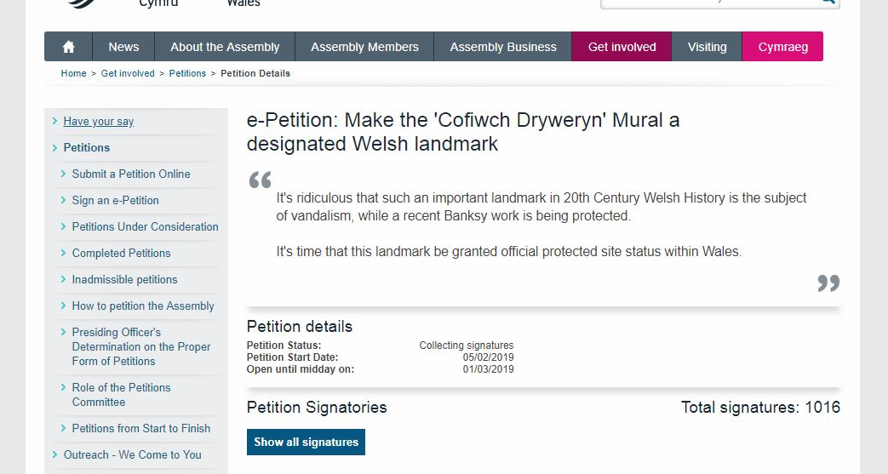
Figure 2 A recent petition submitted to the Welsh Assembly gained 1016 signatures. Credit: National Assembly for Wales.
These attempts at protection however are not the first. In 2006 Llanrhystud County Council announced plans to raise funds to repair the wall with permission from the landowner at a cost of £1000. At the time Cadw stated that the graffiti was not eligible for a maintenance grant as it was not a scheduled monument or listed building (BBC 2006). After an incident where the wall was defaced in 2008 Cymdeithas yr Iaith Gymraeg planned to raise funds to repair and maintain the monument, appealing to local Assembly member Elin Jones for help (BBC 2008a, BBC 2008b). In 2009 Cadw pledged £30,000 towards the appeal to secure the long term future of the graffiti, but estimated costs to gain ownership, preserve and maintain the wall totalled £80,000 (BBC 2009). This campaign continued into 2010, with an agreement being set that the National Trust would eventually take control of the site. These attempts at securing funding failed, something that Councillor Rees-Evans put down to the impacts of the 2008 banking crisis (Betteley 2019).
While there is local public and political support to conserve the heritage value of the Cofiwch Dryweryn graffiti, it is potentially a difficult task. While the memorial appears on the National Monuments Record for Wales website Coflein as a Historic Asset, no formal protection has been offered to the monument (Coflein 2019). The graffiti is located on the end of a ruined cottage, but due to the deteriorated and, apart from the graffiti, unremarkable nature of the cottage the building is ineligible to be listed. One option that could possibly be used to protect the graffiti is to designate the site as a Scheduled Ancient Monument. Under the Ancient Monuments and Archaeological Areas Act 1979, which has been amended and updated by the Historic Environment (Wales) Act 2016, the Welsh Assembly is able to designate a site as a Scheduled Ancient Monument (SAM). A Scheduled site is legally protected from deliberate damage and deterioration over time. The Landowner is responsible for the upkeep of the monument where necessary and grants are available to help with the cost of this (Cadw 2002, 2016). The land on which a SAM is located is still able to be bought and sold, so in the case of the Cofiwch Dryweryn graffiti the current land owner still has the option to sell the land to an individual or organisation prepared to provide the upkeep of the site if desired. Even without legal protection the graffiti site could be sold to someone willing to organise and pay for the upkeep of the site. As already noted, talks have been held with the National Trust to take over the site, but the money to enable this has not been forthcoming. Even if finance were available the site would still not have legal protection even if in the ownership of a heritage organisation. A further option would be for an individual or individuals to raise the money needed to maintain the site. This could be used to keep the site in good condition and allow for the instillation of interpretation at the site or even security measures such as CCTV.
While it may be possible with public or charitable support to raise enough money for the upkeep of the Cofiwch Dryweryn site, this would not offer legal protection from acts of deliberate damage such as vandalism. The scheduling option discussed above would be the only option to provide legal protection, but in order to be scheduled a site must meet certain requirements. Cadw guidelines for the selection of sites include the criteria that a site must be of national importance, and take into account factors such as: rarity, documentation – the existence of previous investigations or contemporary written accounts, any associated monuments, condition and survival of potential, fragility or vulnerability, diversity – either a combination of factors or one important attribute, and potential of significance – usually confined to archaeological sites rather than monuments (Cadw 2002). The Cofiwch Dryweryn graffiti certainly meets a number of the factors that are required to be considered for scheduling. It is a unique example with a known creator who has spoken about it; the monument is also vulnerable. However Cofiwch Dryweryn may not meet the important criteria that a monument must be of national importance. While the site may have a few vocal supporters insisting on its protection, it is unclear what is required for a site to be of national importance.
One issue that arises with the protection of the Cofiwch Dryweryn graffiti is the actual nature of the heritage value that is being conserved. The ruined cottage that the graffiti is painted on is in itself of little heritage value. The one wall of the building on which the words are daubed has only become a heritage asset because of those words painted upon it, and even these have been painted, changed and repainted many times over the years. It could be argued that the built aspect, or even the painted words have little value as a piece of built heritage, but rather have a community and memory value instead. Cofiwch Dryweryn may even be considered a form of intangible heritage - a representation of an idea, of a sense of identity, or of a collective memory. West and Ndlovu (2010) describe collective memory as the acts of remembering and reiterating narratives of the past and that new members can gain their own memories and narratives associated with an event or place. An example they use is that of the Angel of the North, Antony Gormley’s sculpture outside Gateshead, which has been adopted by locals as a part of their identity. Much of the desire to protect the Cofiwch Dryweryn graffiti has come from people living in the local area. It may be that the memorial holds only local or communal value rather than a greater national importance. Communal value relies on the meanings that people make or hold in relation to a place or object, communal values have associative aspects between a place and a sense of identity or emotion. Unlike the assessment of value of a nationally important historic site, the assessment of value for a site of communal value comes from the feelings and opinions of the public rather than the assessment by professionals according to a set criteria. (Benton and Cecil 2010).
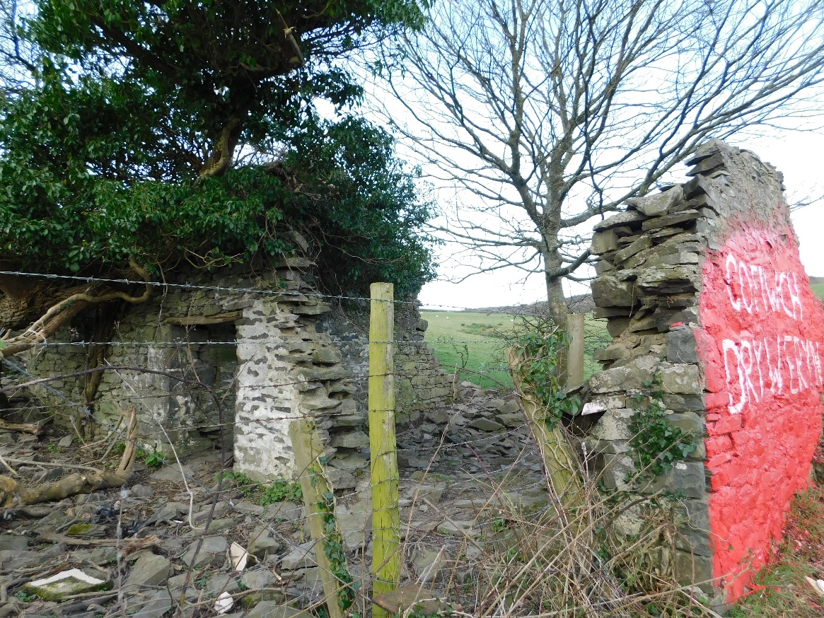
Figure 3 The ruined cottage the Cofiwch Dryweryn graffiti is situated on is of little heritage value in itself. Credit: Catriona Price.
It may also be argued that the Cofiwch Dryweryn graffiti has heritage value as a piece of art, rather than a built structure. Writing in PN Review in 2016 Sam Adams described the Cofiwch Dryweryn Memorial as having ‘achieved iconic status surpassing any effort by Banksy.’ This comparison was presumably originally intended just to highlight the significance of one piece of graffiti compared to another but has, since the time of initial comparison, gained even more relevance. After the most recent attack on the graffiti a Welsh AM Bethan Sayed called for the Welsh Government to contribute to the future of the site, as they had offered to do so for the Banksy Mural that appeared in Port Talbot in December 2018 (BBC 2019a). Before being sold to an Essex based gallery, Neath Port Talbot Council had offered to meet the cost of loaning the work to the public on a permanent basis. Until this sale had been agreed security and protection costs for the Banksy came from a variety of sources including the Welsh Government, local businesses, and Welsh Actor Michael Sheen (Fyfe 2019, BBC 2019c). In this case it was the artwork, rather than the built object it was applied to that people were trying to protect. While Adams may feel that the Cofiwch Dryweryn graffiti may rival a Banksy, recent events have proven that while there is public support for the preservation of the memorial it is nothing compared to the public interest in the Port Talbot Banksy.
Several options exist for the preservation of the heritage value of the Cofiwch Dryweryn graffiti as a piece of built heritage, all with pros and cons associated with them. Protecting the monument by designating it a scheduled monument would offer the most comprehensive preservation by providing both legal protection and a possible source of funding. The issue with scheduling however, is whether the graffiti would meet all of the criteria necessary for designation – in particular the clause that a site must be of national importance. Bringing the site under the protection of an organisation such as the National Trust or campaigning locally to raise funds could be an option to finance the interpretation, repair and restoration of the memorial but would offer no legal protection to the site. This latter option has also been attempted in the past and been unsuccessful. Much of the difficulty in protecting the heritage value of the Cofiwch Dryweryn graffiti is due to the uncertain nature of that heritage value, and whether it is a site of national importance – representing the rise of Welsh Nationalism, or a piece of intangible heritage representing community and memory, or even perhaps a piece of art that is being constantly changed and updated by the people who take value from it. It may be necessary to fully understand the nature of the Cofiwch Dryweryn site and its value to the local and wider community before a protection plan can be implemented to protect the graffiti.

References
Adams, S. (2016) ‘A Letter from Wales’, PN Review, 42(4) pp. 9-10. Available from: https://search-proquest-com.ezproxy.uwtsd.ac.uk/docview/1780542339/fulltext/48693FCF65454E22PQ/1?accountid=130472 [Accessed 31st March 2019].
BBC. (2006) ‘Damn graffiti wall set to be saved’, BBC News, 17th October. Available from: http://news.bbc.co.uk/1/hi/wales/mid/6056566.stm [Accessed 31st March 2019].
BBC. (2008a) ‘Anger over memorial wall attack’, BBC News, 13th May. Available from: http://news.bbc.co.uk/1/hi/wales/mid/7396410.stm [Accessed 31st March 2019].
BBC. (2008b) ‘Damn memorial’s slogan repainted’, BBC News, 13th May. Available from: http://news.bbc.co.uk/1/hi/wales/mid/7398081.stm [Accessed 31st March 2019].
BBC. (2009) ‘Plea for £50,000 to save graffiti’, BBC News, 1st August. Available from: http://news.bbc.co.uk/1/hi/wales/mid/8179016.stm [Accessed 31st March 2019].
BBC. (2010) ‘“National Landmark” Cofiwch Dryweryn is defaced’, BBC News, 29th April 2010. Available from: http://news.bbc.co.uk/1/hi/wales/mid/8652096.stm [Accessed 31st March 2019].
BBC. (2019a) ‘Drowned Tryweryn village slogan replaced by Elvis’, BBC News, 3rd February. Available from: https://www.bbc.co.uk/news/uk-wales-47110347 [Accessed 31st March 2019].
BBC. (2019b) ‘Drowned Tryweryn village slogan vandalism repainted’, BBC News, 4th February. Available from: https://www.bbc.co.uk/news/uk-wales-47116149 [Accessed 31st March 2019].
BBC. (2019c) ‘Port Talbot Banksy art could be moved, says council’, BBC News, 8th January. Available from: https://www.bbc.co.uk/news/uk-wales-46793598 [Accessed 31st March 2019].
Benton, T and Cecil, C. (2010) ‘Heritage and Public Memory’, in Benton, T (ed.) Understanding Heritage and Memory. Milton Keynes. The Open University. 7-43.
Betteley, C. (2019) ‘Calls for money to be raised to protect Cofiwch Dryweryn memorial’, Cambrian News, 15th February. Available from: http://www.cambrian-news.co.uk/article.cfm?id=127398&headline=Calls%20for%20money%20to%20be%20raised%20to%20protect%20Cofiwch%20Dryweryn%20memorial&sectionIs=news&searchyear=2019 [Accessed 31st March 2019].
Cadw. (2002) What is Scheduling? Cardiff. Cadw. Available from: https://cadw.gov.wales/docs/cadw/publications/What_is_Scheduling_EN.pdf [Accessed 31st March 2019].
Cadw. (2016) Scheduled Monuments. Available from: https://cadw.gov.wales/historicenvironment/protection/monuments/?lang=en [Accessed 31st March 2019].
Coflein. (2019) The online catalogue of archaeology, buildings, industrial and maritime heritage in Wales. Available from: https://www.coflein.gov.uk/ [Accessed 31st March 2019].
Cunningham, M. (2007) ‘Public Policy and Normative Language: Utility, Community and Nation in the Debate over the Construction of Tryweryn Reservoir’, Parliamentary Affairs, 60(4), pp 625-636. https://doi-org.ezproxy.uwtsd.ac.uk/10.1093/pa/gsm037
Fyfe, W. (2019) ‘Banksy artwork in Port Talbot sold for “six-figure sum”’, BBC Wales News, 18th January. Available from: https://www.bbc.co.uk/news/uk-wales-46910294 [Accessed 31st March 2019].
Griffiths, H, M, (2014) ‘Water under the bridge? Nature, memory and hydropolitics’ Cultural Geographies, 21(3), pp 449-474. DOI: 10.1177/1474474013510109
Johnes, M. (2012) Wales Since 1939. Manchester. Manchester University Press.
Morgan, S. (2010) Bid to protect the iconic “Cofiwch Dryweryn” wall’, Wales Online, 13th October. Available from: https://www.walesonline.co.uk/news/wales-news/bid-preserve-iconic-cofiwch-dryweryn-1891109 [Accessed 31st March 2019].
Morgan, S. (2014) ‘Vandals deface famous Cofiwch Dryweryn memorial’, Wales Online, 24th February. Available from: https://www.walesonline.co.uk/news/wales-news/vandals-deface-famous-cofiwch-dryweryn-6740008 [Accessed 31st March 2019].
National Assembly for Wales. (2019) e-Petition: Make the 'Cofiwch Dryweryn' Mural a designated Welsh landmark. Available from: https://www.assembly.wales/en/gethome/e-petitions/Pages/petitiondetail.aspx?PetitionID=1476 [Accessed 31st March 2019].
Owens, D. (2019) ‘Famous monument to flooded village vandalised and replaced with “Elvis”’, Wales Online, 3rd February. Available from: https://www.walesonline.co.uk/news/wales-news/famous-monument-flooded-village-vandalised-15775059 [Accessed 31st March 2019].
Shaw, A. (2019) ‘Anger after vandals daub “Elvis” graffiti over monument to flooded Welsh village’, North Wales Live, 3rd February. Available from: https://www.dailypost.co.uk/news/anger-after-vandals-daub-elvis-15774885 [Accessed 31st March 2019].
Walford, J (2019) ‘Famous monument to flooded village is repainted after it was vandalised’, Wales Online, 4th February. Available from: https://www.walesonline.co.uk/news/wales-news/famous-monument-flooded-village-repainted-15780486 [Accessed 31st March 2019].
West, S. and Ndlovu, S. (2010) ‘Heritage, Landscape and memory’, in Benton, T. (ed.) Understanding Heritage and Memory. Milton Keynes. The Open University. 202-237

