Restaurant concept & Menue Design

Assignment 2

Module title: Food & Beverage Operations
Module code : BMIH4002
Student Name : Rasel Ahmed
Student Id : 2233498
Lecturer’s Name : Ffion Cumbertatch
Word count 400

Part 1: Restaurant Concept

This restaurant will offer a great indoor environment and top-class facilities to local and international consumers. The location of the Trinity restaurant will be near Lampeter City. As per the plan, this restaurant usually targets all types of local and international customers. So this restaurant will provide UK’s popular starters, main dishes, and beverages. So, traditional and international cuisines are the preferred menu for this restaurant (Mathayomchan et al. 2020). The atmosphere is a very crucial factor in the opening of new restaurants. The Trinity restaurant has a big plan to decorate the surrounding environment with the touching of indoor plants and an ambient lighting system. Also, it will be decorated with exceptional furniture. The menu theme will be closely linked with the indoor atmosphere of the restaurant.
Customer targeting is the crucial point of a restaurant business. Trinity will target a variety of customers group. Local and young customers are the main target of the Trinity restaurant (Sarkar et al., 2015). This customer group is usually related to education and job sectors. Most of the customer's age will be between 20-35 years old. Foreigners are also in the targeting range that’s why added some international cuisine to the Trinity restaurant menus. Foreign students and different levels of workers are within the target range. The income of this category's customers is average to below average (Chen et al. 2019). According to the income level food products and recipes are also customised and able to attract all economic levels of customers.
In terms of marketing of Trinity restaurant, social media marketing is the suitable choice and identified as a main marketing tool (Bradshaw et al., 2019). Also, the will be used a traditional marketing strategy with banners, features, and posters. The main marketing target is to achieve positive word of mouth by providing quality food and services.
The first positive thing about the Trinity restaurant is the uniqueness of the infrastructure and surrounding environment (Oliveira et al. 2017). Secondly, highly attractive interior decoration and lighting Will attract customers. Also, it offers both local and international cuisine that will make it different from the competitors.
The menu is designed with priorities of local cuisine (GÜLER et al., 2016). Also, it includes the most popular starter, beverages, main dishes, and dessert items. For example, chicken wings, calamari, chicken tikka masala, cottage pie, chips, and so on. All of the menus are identified and listed to cover both national and international customers.

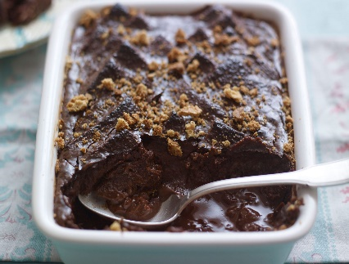
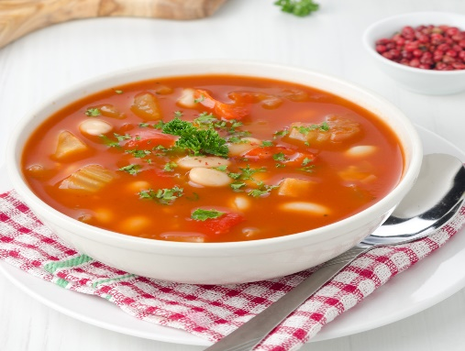
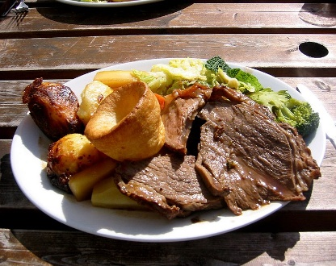
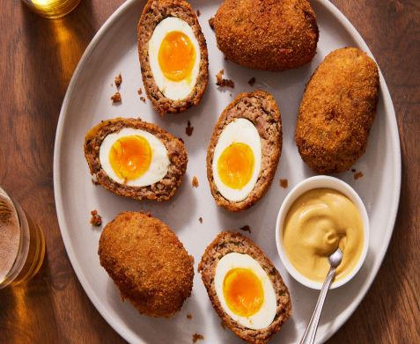
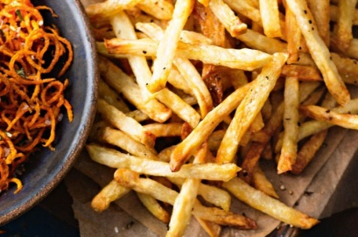
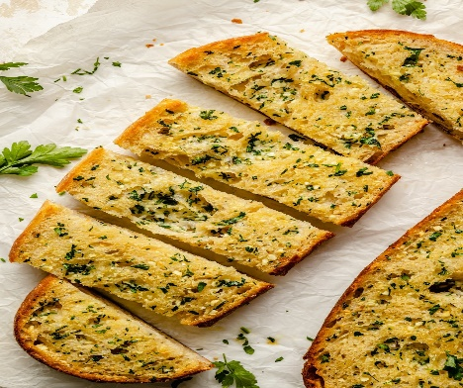
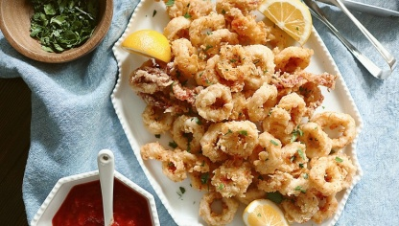
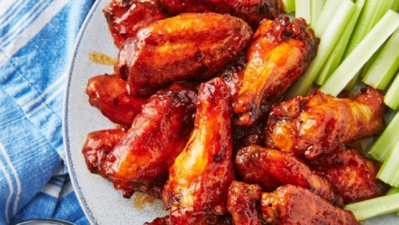
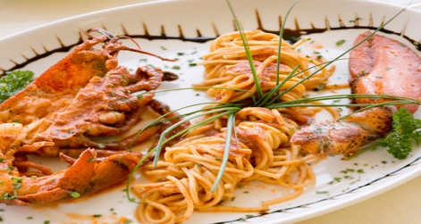
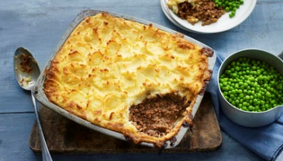
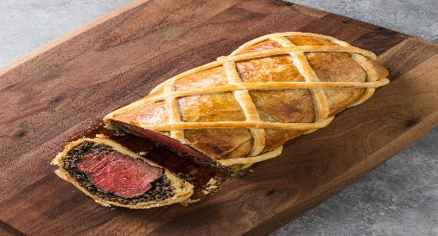
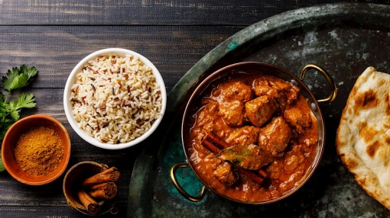
Chocolate, bread, butter, milk, egg
Bread and butte pudding - £ 7
Onion, gloves, garlic, chicken, vegetables, oil
Soup of the day £6
Egg, breadcrumbs, corn flower, sausage meat, flour, vegetables oil
Scotch egg £6
Sunday Roast £ 7
Beef, olive oil, potato, carrot, parsnips
Garlic, Bread, butter, parsley, salt
Garlic bread £11
The ingredients used to make Calamari are whole milk, sage leaves, smoked paprika, squid, lemon, vegetable oil, black paper and cayenne pepper. Calamari is a popular and delicious restaurant dish.
Calamari £ 18
Starter
Trinity restaurant
Lobster, noodles, linguine pasta, butter, cream, oil
CHICKEN wings £ 20
Chicken wings are a popular English dish which is made using butter, chicken wingettes, flour, garlic powder and black paper.
Lobster Linguine £30
Beef, pastry, garlic, butter, olive oil, cooked ham, mushrooms
Beef Wellington £35
Products served with Cottage Pie are Red Wine, Potatoes, Tomato, Beef Mince and beef bouillon cube.
Cottage pie £20
Chicken Tikka Masala is a Pakistani delicacy that is very popular in the UK. The products served with Chicken Tikka Masala are Pakistani bread, chicken and rice.

Chicken Tikka Masala £30
Mains
The delicious chips available here are Bean Chips, Corn Chips, Pita Chips, Steak Fries, Potato Wedges, Sweet Potato Fries and Tortilla Chips.
Chips £18
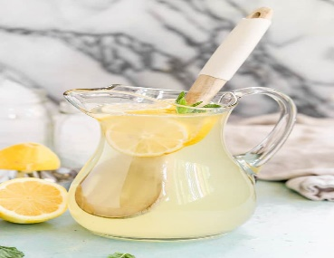

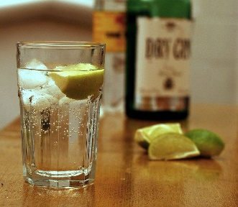
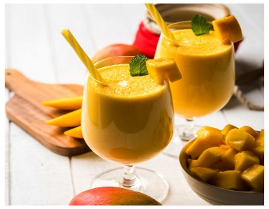
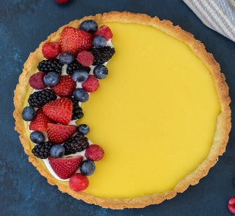
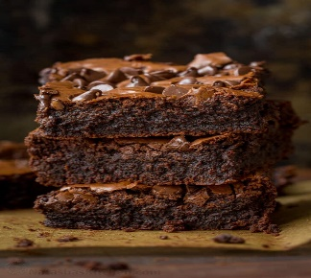
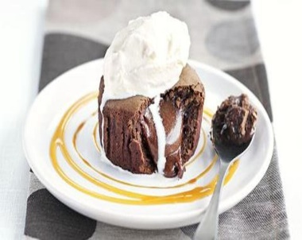
Lemon, sugar, mint
Lemonade £4
Chocolate, sugar, caramel
Hot Chocolate £5
Gin and tonic £6
Mango, Mint, sugar, water
Mango Mint LASSI £5
Trinity restaurant
Lemon juice, sugar, strawberry
Lemon tart £10
Chocolate
Chocolate brownie £8 .
Chocolate, sugar, cream
Chocolate fondant £9
Chocolate, bread, butter, milk, egg
Bread and butte pudding - £ 7
Mains
Deserts
Beverages

Deserts
Beverages

References
Bradshaw, C., Dodds, K., Crumbley, J., Sutherland, M. and Shaw, A., (2019). Social Media in the SME Business to Business Environment and Toolkit.
Chen, W., Tajeddini, K., Ratten, V. and Tabari, S., (2019). Educational immigrants: Evidence from Chinese young entrepreneurs in the UK. Journal of enterprising communities: People and places in the global economy.
Cleave, P., (2020). Food as a leisure pursuit, a United Kingdom perspective. Annals of Leisure Research, 23(4), pp.474-491.
Filimonau, V. and Krivcova, M., (2017). Restaurant menu design and more responsible consumer food choice: An exploratory study of managerial perceptions. Journal of cleaner production, 143, pp.516-527.
GÜLER, O., BENLİ, S., AKDAĞ, G. and ÇAKICI, A.C., (2016). What is your favorite local food menu? Application of conjoint analysis on The Eastern Mediterranean cuisine of Turkey. Journal of Tourism & Gastronomy Studies, 4(3), pp.38-52.
Lai, H.B.J., Karim, S., Krauss, S.E. and Ishak, F.A., (2019). Can restaurant revenue management work with menu analysis?. Journal of Revenue and Pricing Management, 18, pp.204-212.
Mathayomchan, B. and Taecharungroj, V., (2020). “How was your meal?” Examining customer experience using Google maps reviews. International Journal of Hospitality Management, 90, p.102641.
Nguyen, Q., Nisar, T.M., Knox, D. and Prabhakar, G.P., (2018). Understanding customer satisfaction in the UK quick service restaurant industry: The influence of the tangible attributes of perceived service quality. British Food Journal, 120(6), pp.1207-1222.
Oliveira, R.C.D., Fernandes, A.C., Proença, R.P.D.C., Hartwell, H., Rodrigues, V.M. and Fiates, G.M.R., (2017). Preferences for menu labelling formats of young adults in Brazil and in the United Kingdom. Revista de Nutrição, 30, pp.321-332.
Sarkar, J.G., Sarkar, A. and Ponnam, A., (2015). Exploration of brand sacralization among the young adult consumers in the context of emerging Asian market. Young Consumers.
Soon, J.M., (2020). ‘Food allergy? Ask before you eat’: Current food allergy training and future training needs in food services. Food Control, 112, p.107129.
Spence, C., (2016). Gastrodiplomacy: Assessing the role of food in decision-making. Flavour, 5(1), pp.1-16.

