The Global Business Environment
-
Assignment 1
-
Environmental Analysis of Automobile Industry
Table of Contents
Introduction 2
1.0 PESTLE Analysis 2
2.0 Porter’s Diamond Model 5
3.0 Porter’s Five Forces Analysis 6
4.0 SWOT Analysis 7
5.0 Porter’s Value Chain Analysis 9
Conclusion 10
References 11

Introduction
The automobile industry is an important part of the UK economy. This report evaluates the internal and external business environments of one of the leading global car brands based in the UK, the Aston Martin. Aston Martin was founded in 1913 in London by Lionel Martin and Robert Bamford (Aston Martin, 2021). It has evolved since then into an internationally admired luxury car brand. Aston Martin cars are sought by people for their beautiful design and style, high performance and excellent craftsmanship. It is a leader in the high luxury sports car market (HLS). Aston Martin bought the Lagonda marque in 1947 and since then The Aston Martin Lagonda Global Holdings PLC manages the operations of both the brands (Aston Martin Global Holdings PLC, 2021). The headquarters are there in Gaydon, Warwick, England and there are dealers in over 53 countries at more than 160 locations.

PESTLE Analysis
Macro environmental forces are various factors external to a business over which the business can have no or minimal control (MacKay, et al., 2020). In case of Aston Martin, it needs to understand all the external challenges it is likely to encounter in the various markets it sells its products. The PESTLE Analysis tool can help it to understand these challenges.
Political
Though Brexit has happened, there are several uncertainties in trading laws between the European Union (EU) and the UK. While goods will be free from tariffs and quotas, goods moving between the UK and the EU will be subject to customs and therefore extra paperwork (SMMT, 2021).
Economic
Mutual recognition of professional qualifications across the EU and the UK is not as easy in post-Brexit scenario leading to lack of skills in various industries. Global rise in income levels has created strong demand for automobiles from countries like China, India and other developing economies. Luxury vehicles with great interiors, comfort and performance are being preferred by people in these countries (Valuates, 2021).
Socio-cultural
A cultural shift has been observed among the UK people who used to believe that real drivers do not drive automatic cars. However, now automatic cars are gaining popularity as manually shifting gears are considered as an inferior option (U.S.News, 2021). Owners of luxury vehicles tend to upgrade to enhanced models within one to two years thereby creating additionally demand for used luxury cars (Valuates, 2021).
Customers across the world are preferring all industries to ensure transparent, ethical and responsible management. Automobile recalls are becoming increasingly common across the world due to safety issues and customers prefer brands which are transparent about them (BBC, 2018).
Customers are ready to migrate from established car brands to other brands which offer hybrid and pure electric products. Some customers are even contemplating giving up owned vehicles and using public transport instead to do their bit for the environment (World Economic Forum, 2021).
More Chinese customers are adventurous and willing to buy car online in comparison to European and US customers.
Technological
Automatic cars which require lesser effort to drive are becoming more popular than traditional manual geared cars (U.S.News, 2021).
Advances in technology has increased competition in automobile industry to build connected and autonomous vehicles (SMMT, 2020). Features like driver assistance systems, autonomous emergency breaking, adaptive cruise control, collision avoiding, self-activating safety systems and sensors are no longer good to have, but should-have features in cars.
Self-driving autonomous cars are being built using the automated lane-keeping system which allows cars to stay automatically on the lane and at a safe distance from other vehicles.
Legal
The UK government is the first country in the world which has announced that soon self-driving cars will be allowed at slow speeds on motorways when traffic is less (The Guardian, 2021). The most common standards which automobile industries across the globe have to follow include IATF 16949, ISO 9001, ISO 14001 and ISO 45001 (Neves, et al., 2018).
Environmental
The UK government has announced that petrol and diesel cars will be phased out by 2040 to reduce the greenhouse gas emissions and is giving financial support to the automobile industry to help cars transit smoothly to electric (The Guardian, 2021). Globally too the trend of electrification is on the rise due to emission concerns as well as dynamic fuel prices (Valuates, 2021).

2.0 Porter’s Diamond Model
The UK’s attractiveness in the automobile industry can be analysed using the Porter’s diamond model. According to this model, there are four key elements which foster domestic competitiveness which in turn is the breeding ground for international success. The company’s strategy, structure, rivalry, factor conditions, demand conditions and supporting industries determines the superiority of a country (Kamran, 2020). A weakness in any one of these factors can limit the potential of the given sector and successful interaction of these factors can nourish each other. The relationship between the four factors is illustrated in the figure.
Porter’s diamond model

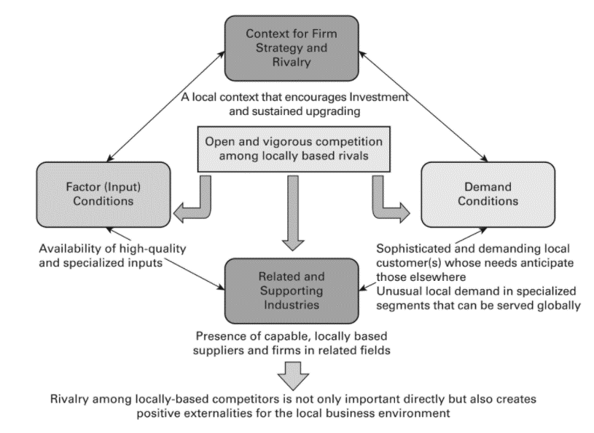
Fig. No 1 Source: Kamran (2020)
The UK automobile industry is a crucial part of the UK economy with a turnover of £82 billion in 2019 (SMMT, 2020). It has added £18.6 billion in value to the UK economy and accounts for 13% of the total goods exported by the UK. 8 out of 10 cars made in the UK are exported and the export market consist of over 150 countries across the world. This shows that cars manufactured in the UK have a global demand. The automobile manufacturing industry in the UK had invested £3.3 billion net capital and £3.75 billion in R&D which has made the UK as the fourth largest car manufactured in Europe. There are over 30 car manufacturers present in the UK building more than 70 different models with the help of many skilled engineers. There are over 2400 automotive suppliers in the UK and 20 of the global leaders in automotive supplies have a presence in the UK indicating the attractiveness of the UK for automotive manufactures. Ford, Volkswagen, Nissan, Mercedes, Kia, Vauxhall were some of the leading sellers in 2019 in the UK.

3.0 Porter’s Five Forces Analysis
Porter’s Five Forces model is yet another simple model which can help Aston Martin to determine the attractiveness of the automobile industry and decide if it is possible to sustain its competitive advantage among its different competitors (Hole, et al., 2019).
Porter’s Five Forces Model
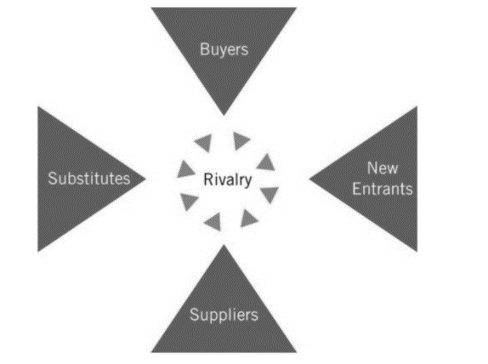
Fig. No 2 Source: Clegg, et al., (2019)
Each of the four forces shown outside in the figure above influences the level of competition in the industry and influences the power to make a profit (Clegg, et al., 2019). Since Aston Martin operates in the high-end luxury sports car market, this analysis keeps that in mind.
Bargaining power of customers – Customers of high-end luxury cars look for comfort and style and niche products find takers among the elite who wish to flaunt the cars as symbols of luxury (Yahoo Finance, 2021). Hence bargaining power of customers is less.
Bargaining power of suppliers – Globalisation has helped automobile makers to reach out to suppliers all over the world to continue production undisrupted (Financial Times, 2018). However, car parts require expertise and hence quality of suppliers too matter. Hence bargaining power of suppliers is low to medium.
Threat of substitutes – During times of recession, customers can easily substitute personal cars with public transportation thereby triggering a decline in demand (The Guardian, 2021).
Threat from new entrants – The automobile industry is a highly regulated industry with global laws on emission, safety and quality (SMMT, 2021). Hence initial investment costs are high thereby making it difficult for new entrants in the business. Hence this is a low force.
Intensity of competitive rivalry – The global automobile industry is dominated by certain key players and the competition is intense (Financial Times, 2018). Each of the big players have made heavy investment into technology over the years thereby forcing all brands to be extremely aware of the customer taste changes and market changes. This is the biggest force shaping the global automobile industry.

4.0 SWOT Analysis
SWOT Analysis is one of the most widely used analysis tool which helps a firm to decide which can be the best strategies through which it can exploit its strengths and opportunities and also ensure that it eliminates the weaknesses it may have and identify and avoid the threats facing it (Fisher, et al., 2020).
SWOT Analysis of Aston Martin
Strengths  - Talent in creating high-performance luxury cars  - Internationally recognized global brand famous for its beautiful designs  - Strong marketing strategy by appearing in international cinemas for over 50 years, most famous collaboration being with James Bond movies  - Consistently strong market demand in the United States and Canada  - Classic models of Aston Martin continue to be in high demand in auctions | Weaknesses  - Dependency on small suppliers for parts has prevented Aston Martin from meeting its output targets due to their inability to scale up with the increasing demand forcing the company to turn to foreign suppliers  - The company is heavy in debt due to an expensive refinancing undertaken in October 2020  - The company has gone bankrupt seven times and somehow managed to survive
Opportunities  - The automobile industry is helping the UK to reach its emission targets and manufacturers have invested heavily in technologies to help the UK to transition to zero emission in road transport marking the rise of electric vehicle market  - Connected autonomous cars are becoming popular | Threats  - Post Brexit, there is pressure from the UK government to source parts domestically to qualify for various trade deals by applying the “rules of origin”. Aston Martin imports many parts including gearbox and engines from different countries unlike its competitors like McLaren which has ramped up sourcing from the UK  - Global shortage of semiconductors is affecting production capacity across the automobile industry
Table No.1 Source: Adapted from Manufacturing (2021), Financial Times (2018), Yahoo Finance (2021), Aston Martin Global Holdings PLC (2021), BBC (2020)

5.0 Porter’s Value Chain Analysis
According to Porter’s value chain model, a company can gain competitive advantage by doing important activities either cheaply or better than its competitors (Johnson, et al., 2019). The model classifies the various activities done by a firm into nine value-creating activities (five of which are primary and four are supporting). In totality these activities produce the product as a value to the customer. These activities need not be carried out by the company alone but by all the members in the entire supply chain as they also form a part of the value chain.
Porter’s value-chain model

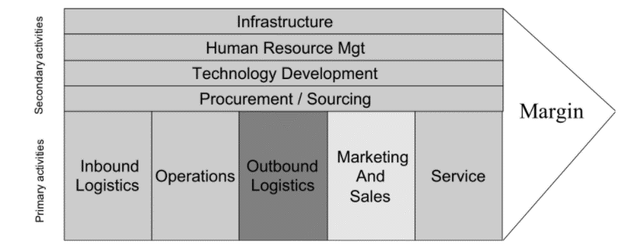
Fig. No 2 Source: Leeman (2020)
Aston Martin’s value chain can be analysed using this value chain to understand what is it that makes Aston Martin different from its competitors.
Operations- This has always been the strongest points of Aston Martin as its focus has always been on creating beautiful awe-inspiring cars for its luxury sports car loving customer segment. It thus does not mass-produce cars using economies of scale, but creates cars symbolising elegance and power. The cars are handcrafted and have limited distinctive models. Its production systems are adapting to modern digitalisation to save over 30% operational costs per year (Aston Martin Global Holdings PLC, 2021). It has strategically patterned with Mercedes-Benz AG and Red Bull Advanced Technologies to continue to innovate design and performance of its cars.

Procuring and Sourcing -
Sustainability forms a key part in the entire supply chain. Aston Martin follows a strict procurement guide and expects its suppliers and sub-suppliers to follow the same ethical rules and regulations laid down by the guide (Aston Martin Global Holdings PLC, 2021).
Marketing and Sales – Aston Martin uses the differentiation strategy to create high luxury sports cars and markets them consistently using the movies. Formula One has also been a consistent marketing strategy which has helped to increase the brand desirability due to the viewership reaching 85 million a race (Aston Martin Global Holdings PLC, 2021). Continuous participation in F1 has kept Aston Martin in people’s mind always. At the same time, it has a wide dealer network globally which ensures smooth purchase of the car across the globe. Its use of digital marketing through use of contemporary social media, implementation of cloud-based Salesforce systems has helped it to scale up based on customer and business data (Aston Martin, 2021). An Aston Martin is seen by many as an investment due to the brand name associated with it. Aston Martin encourages customization of its cars as per customer needs as it targets upper income class customer segment who will not think twice before buying an expensive car. The company also targets the super-rich by making and selling limited versions of extreme high-performance cars thereby creating a lucrative side-business.

Conclusion
Aston Martin has never been a mass producer of cars. It has distinguished itself as a creator of beautiful high luxury sports cars. Global trends indicate an inclination towards rise in demand of electric cars and vehicles equipped with latest technologies to make driving easy and safe. Aston Martin’s brand name and ability to grasp viewer attention are its biggest strengths. It needs to capitalise on the opportunities and leverage its strengths to maintain its competitive advantage in the high luxury sports vehicle segment.

References

Aston Martin Global Holdings PLC, 2021. Aston Martin Lagonda. [Online]
Available at: https://www.astonmartinlagonda.com/
[Accessed December 2021].
Aston Martin, 2021. Aston Martin. [Online]
Available at: https://www.astonmartin.com/en/
[Accessed December 2021].
BBC, 2018. Volvo recalls 70,000 cars in the UK over fire risk. [Online]
Available at: https://www.bbc.com/news/business-49068627
[Accessed December 2021].
BBC, 2020. Aston Martin chief leaves after 94% share price collapse. [Online]
Available at: https://www.bbc.com/news/business-52804705
[Accessed December 2021].
Clegg, S. R., Schweitzer, J., Whittle, A. & Pitelis, C., 2019. Strategy: Theory and Practice. London: Sage.
Financial Times, 2018. Aston Martin turns to foreign suppliers to drive growth. [Online]
Available at: https://www.ft.com/content/1e83fe3a-e98d-11e8-885c-e64da4c0f981
[Accessed December 2021].
Fisher, G., Wisneski, J. & Bakker, R., 2020. Strategy In 3D: Essential Tools to Diagnose, Decide, and Deliver. Oxford: Oxford University Press.
Hole, D. Y., Pawar, S. & Bhaska, D. M. P., 2019. Porter's Five Forces Model: Gives You A Competitive Advantage. Journal of Advanced Research in Dynamical & Control Systems, 11(04), pp. 1436-1448.
Johnson, G., Scholes, ‎. & Whittington, ‎., 2019. Exploring Strategy, Text and Cases. London: Pearson Education.
Kamran, Q., 2020. Strategic Value Chain Management: Models for Competitive Advantage. London: Kogan Page Publishers.
Leeman, J. J., 2020. End-to-End Supply Chain Management - 2nd edition -: Fast, flexible Supply Chains in Manufacturing and Retailing. Düsseldorf : Institute for Business Process Management.
MacKay, B., Arevuo, M., Meadows, M. & Mackay, D., 2020. Strategy: Theory, Practice, Implementation. Oxford: Oxford University Press.
Manufacturing, 2021. Who is Luxury Sports Car Manufacturer Aston Martin?. [Online]
Available at: https://manufacturingglobal.com/smart-manufacturing/who-luxury-sports-car-manufacturer-aston-martin
[Accessed December 2021].
Neves, F. d. O. et al., 2018. Analysis of the quality management system for automotive industry- ISO/TS 16949 in the world. Total Quality Management and Business Excellence.
SMMT, 2020. SMMT MOTOR INDUSTRY FACTS 2020, London: SMMT.
SMMT, 2021. UK Automotive Priorities for International Trade. [Online]
Available at: https://www.smmt.co.uk/industry-topics/europe-and-international-trade/
[Accessed December 2021].
The Guardian, 2021. Car industry lobbied UK government to delay ban on petrol and diesel cars. [Online]
Available at: https://www.theguardian.com/business/2021/mar/15/car-industry-lobbied-uk-government-delay-ban-petrol-diesel-cars
[Accessed December 2021].
The Guardian, 2021. Self-driving’ cars could get green light for use on UK motorways this year. [Online]
Available at: https://www.theguardian.com/technology/2021/apr/28/self-driving-cars-could-get-green-light-for-use-on-uk-motorways-this-year
[Accessed December 2021].
U.S.News, 2021. U.K. Motorists Shift Gears to Automatic Vehicles. [Online]
Available at: https://www.usnews.com/news/best-countries/articles/2021-06-09/british-motorists-move-away-from-manual-transmission-vehicles
[Accessed December 2021].
Valuates, 2021. Global Luxury Vehicles Market Size, Manufacturers, Supply Chain, Sales Channel and Clients, 2021-2027, Bengaluru: Valuates.
World Economic Forum, 2021. The automotive market is changing. Can China show us the future?. [Online]
Available at: https://www.weforum.org/agenda/2021/07/future-automative-market-china/
[Accessed December 2021].
Yahoo Finance, 2021. Aston Martin drives higher amid SUV demand. [Online]
Available at: https://uk.finance.yahoo.com/news/luxury-carmarker-aston-martin-drives-higher-amid-suv-demand-144649012.html
[Accessed December 2021].

