Student Name: Jahanara Begum
ID: 1813593
Module Name: Problem Solving and Decision making
Code: BMSK4004

Table of Content
Title | Page Number
1.1 Introduction | 03
2.1 Workplace problem and its scope and impact | 04
3.1 Analyze information on identified problem to help decision making process | 05
Propose a range of alternative solution | 08
Evaluate range of alternative solution to determine the most appropriate option | 09
Objective setting in relation to problem | 10
Communicate plan with stakeholders | 12
Assess appropriate monitoring review technique to ensure successful implementation of the solution | 13
Conclusion | 14
References | 15

“Introduction”
Dementia is a kind of disease. In this disease the victim does not able to memories his or her past. They become forget everything, they are losing their time schedules, and they cannot memories their familiar places. The patient cannot control and cannot complete his or her daily activities due to fade his or her memory. This is the most common disease in all over the world. Many organizations or institutes have provided care to dementia patients. Dementia is actually a brain diseases called as brain disorder. It means the decay of the brain of the patients. For these diseases patients start to loss their memories slowly. They cannot control and maintain their daily activates. Their daily needs cannot proper fulfill. The dementia patients are losing their independency. They are losing their basic rights. They are being excluded from the society. In one word the dementia patients have some massive disabilities. But dementia is a curable disease. Through proper care the patients who are suffering from dementia can get well. For that there are many organizations and institutes are work for giving health care to the dementia patients. The organizations and institutes are called the dementia care institutes.

“Workplace problem and its scope and impact”
According to Brooker, (2006) for preventing the dementia, some institutes and organizations are taking some several steps and give the proper care to the patients. Giving dementia preventing health care is not an easy task. It is very challenging task for the institutes. People of all ages can be a victim of dementia. Mainly the old ages people are the main victim of dementia. The main intentions of the care institute to give the proper medication of the people who is the victim of dementia. Different types of challenges are faced by the institutions during providing health medication to the victims as well as the patients. Here mentioned some main problems that are faced by the care in state during giving the medication to the patients below:
Patience: patience is a most common problem of the care institutions. Here care institutions give some care workers to look after the patients. Here the dementia patients do not able to maintain his daily work activities. They cannot maintain their time schedules. They forget everything. So the care worker has to take a look after to the patient’s daily activities and maintain the schedule of the patients. So here patience is a big factor for the care worker. If the care worker loss his patience he cannot able to give the proper medication to the patient.
Discipline: disciple is a big problem for the care worker who is work under a care institute. The patients are admitting into the care organization to prevent their disease. The patient cannot maintain their schedules for suffering from the dementia disease. The care worker has to maintain the discipline of the daily activities of the patient’s. But it is very hard for the care worker to bring another person under a discipline.
Lack of knowledge of maintaining technologies: Technology is a big component of any organizations development. But maintaining the technology is very tough. For maintaining the technology here need huge knowledge of it. Otherwise it is very difficult for any organization to maintain the technology. So every care worker of any dementia care organizations has to know the proper knowledge to handle the technological accessories. Many care workers of organizations have no proper knowledge on the technological side.
Proper knowledge on medicine: here care workers need to have proper knowledge on medicine. If any care worker has no knowledge on medicine he cannot give the proper medication to the patients.
Love and affection: dementia patients are suffering from their losing memories. They cannot memories their past, they cannot maintain their daily activities properly. They need help to finish their daily activities. They need company to feel well. Here dementia care institute fixed some care worker with the patients individually. They are fixed for maintaining the patients daily needs and give the proper medication to the patients with love and sincerely. But there are a great lack of love and affection in the care workers. So it is a big problem for the care institutes.

“Analyze information on identified problem to help decision making process”
Patience
According to Manthrope (2003) patience is one of the main problems in the dementia care institutes. Here care worker of any dementia care organization must contain the patience. Patience is a most essential attributes of any dementia care worker. In dementia care organizations there are many patients are admitting for seeking proper medication. Dementia patients are very sensitive as they forget their memories (Innes and McCabe, 2007). Because of dementia they cannot memories anything. They cannot maintain their daily time schedule. So they admit into a dementia care institute. The care organization provide care worker with them to ensure proper medication. The care worker looks after the patients. They maintain the time schedule of the patients’. They give the medicine to the patient in right time. They help for memorizing the memories of the patients’ past. As the patients are very sensitive, the care worker should maintain the medication system with very carefully. Sometimes the care worker loses their patience. It is very harmful for the dementia care organizations. For losing the patience they cannot give proper medicine to the patients. The care worker cannot maintain the dose time for losing the patience. It is very harmful for the dementia patient. To get well dementia patient have to maintain their doses properly in time. The care worker can make a schedule for the patient’s daily activities. The care worker can list the doses in a work sheet. From the sheet the care worker can maintain the doses time. Here the care worker must be flexible for giving the medication to the patients. They have to behave with the patients friendly. They can make a shift system among all the care workers of the institutions. By creating shift system, they can easily handle all the patients of the dementia care organizations. By one care worker it is not possible to look after the patients all activities. So if they maintain the shift system they can easily handle all the schedule of the patients. For that they cannot lose their patience. For that the patients become happy for the medication system that is given by the care worker as well as the car organizations.
Discipline
According toAdams, (2003) discipline is one of the most common problem of the care workers. Care workers must have to maintain the discipline for giving the proper medication to the patients (Innes and McCabe, 2007). It is very hard for the care workers to maintain the discipline. They have to prescribe the discipline to the patients. The dementia patients do not maintain the discipline in their activities. They cannot remember the sequence of their activities. They are unable to do their regular job because their memories have been faded away. They do not know which medicine is to take in which time. So the care organization gives a care worker to fix the problems of the patients. Here the care worker gets confusion to fix the discipline problem of the patients. The care worker must be known about the medication system. For knowing the medication system properly, they can easily maintain the medicine doses schedule properly. If the care worker does not maintain discipline in their work the dementia patient cannot attain the proper medication from the care organization and they cannot get well properly. The care worker can make a chart of their daily service. They can maintain their job according to the chart. Once the care workers can able to assure the discipline in their job they patient can able to get proper care.
Lack of knowledge of maintaining technologies
According to Rabins(2006) lack of knowledge about maintaining technologies is another great problem of the dementia care institutes. Here in present era there are huge change are coming in the medication system for bless of technology. Here technology is creating the medication system easier and comfortable. Here technology makes the medication system easier for the care providers and makes medication system comfortable for the patients. But it is necessary to know how to use the technology in the medication system for the care workers. To look after the patient’s daily activities, the care workers can fit a CC TV camera in the patient’s rooms and can control all the patients at a time. But if the workers do not know the operation system of the CCTV camera, it becomes difficult for the care workers to give concentration to the patients. They cannot maintain the time schedule of the patient’s activities. For patient’s recreation they can provide TV system in the room of the patients’. So it is very essential for the all care workers to know the operation of the technological instruments. If the care workers have not any knowledge about the technology so it becomes very difficult to give the proper medication to the dementia patients. The care workers can attain the knowledge about technology by receiving some training.
Proper knowledge on medicine
According to Constantine, (2006) attaining the knowledge about the medicines that are given to the patients who are come to the care institution for receiving the medication. Here dementia patients are too much sensitive, so they should handle with great care. The dementia patients need proper medicine to get well. Like maintain the discipline of the patients’ daily activities giving proper medicine to the patients is very essential. Here care workers should know the knowledge about the medicine. They have to gain proper medicine knowledge. Here medicine is a great fact for a dementia patients cure all. The care worker can gain the knowledge about the medicine by some effective training.
Love and affection
According to Lyketsos(2006) love and affection is a necessary need for a dementia patient. A dementia patient cannot memories his or her memories because his or her memories have been faded away. He or she cannot maintain his or her daily work perfectly. He or she cannot maintain his or her daily activities accurately. They are generally worried about their memories. Their minds are always covered with gloom. They always try to memories their faded memories but they cannot memories their memory. The care organization give some care worker for entertain the patients. They are appointed for look after the dementia patients. The care worker has to handle the patients with love and affections. If the care worker gives medication to the dementia patients with love the patient can easily share their problems with the care workers. if the care workers behave with the patients friendly the patients do not deem that they are in a care organization for receiving medication. So the care worker should behave with the patients friendly. If the patients are take the care workers friendly the care workers can provide their medication perfectly and the care workers can provide perfect discipline chart for the patients.

Using problem solving tools
According to Waal (2013) problem solving tools are very helpful way to solving the healthcare related problems. Those using problem solving tools provide some easier way to solve problems. Here given some problem solving methods as well as some problem solving tools.
SWOT analysis: According to, Lyketsos (2006) SWOT analysis is a simple but very effective and powerful tools that helps the healthcare organizations about solving the problems. It helps to find out the strength and weakness of the organization.
Figure 01: SWOT
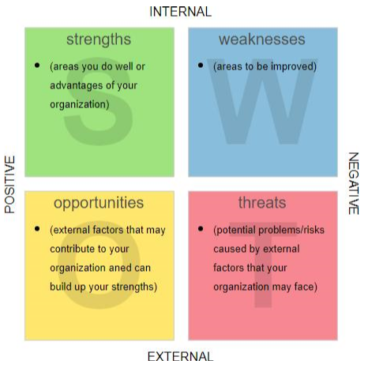
Source: (Lyketsos, 2006)
By analyzing the SWOT organization can fix their healthcare related errors and give the proper medication to the patients as well as the service users. Using the SWOT analysis any organization can take initial approaches about upcoming threats. The SWOT analysis gives the epidemic knowledge about the upcoming threats. In dementia care hospital there need to implement the SWOT analysis. The weakness of the dementia care organization is to look after the patients all time and to give the patients medication treatment in just time. By using SWOT analysis the managing body can fix the problem by recruit some car workers and using technological features like CC TV camera.
PESTILE analysis: According to Povey(2010) PESTILE analysis is another important thing that helps to solve the problem of the healthcare service system.
Figure 02: PESTLE
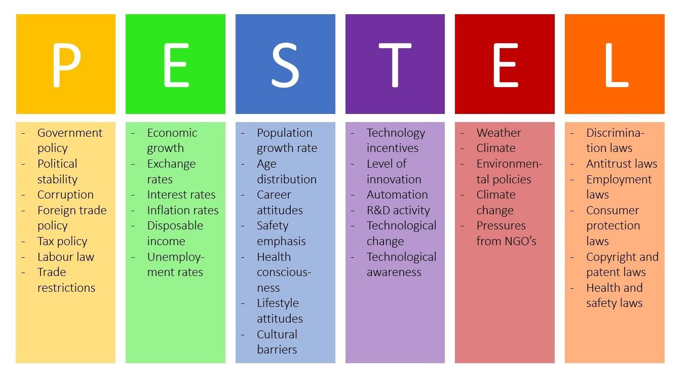
Source: (Povey, 2010)
The PESTILE analysis works with five factors. Mainly the PESTILE analysis looks after the Environmental side of the healthcare service. Most of the problems and threats come from the environment. The PESTILE analysis shows the problems and gives the ways about solving the problems to the healthcare organizations. Here in dementia care organizations there need to entertain the patients and make their mind cheerful. But it is not possible for creating these types of environment by the organization every time. It becomes a problem. The PESTEL analysis solve the problem here the organization find an idea from PESTEL analysis. The organization authority arranges television set in every room for entertaining the patients.
The fishbone diagram: According toKovach (1997) the Fishbone diagram tool use for measuring the effects of the diseases.
Figure 03: fishbone diagram
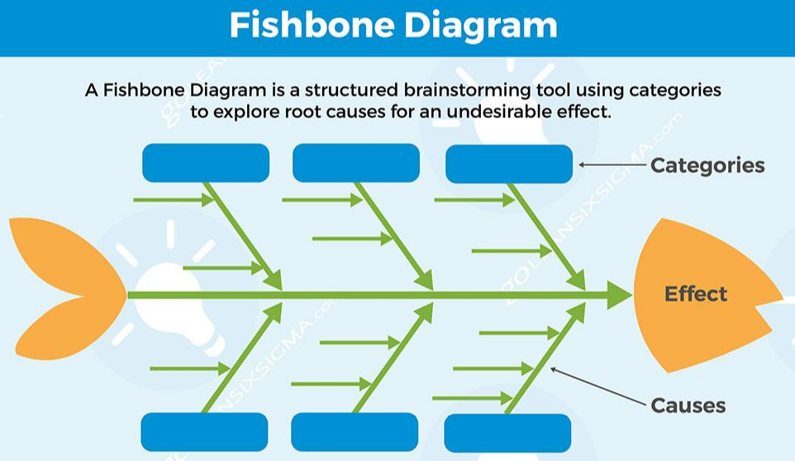
Source: (Kovach, 1997)
This tool shows the causes that are occurred for the diseases to the healthcare organizations. The fishbone diagram gives some knowledge about the diseases by giving the diagram. The fishbone diagram classified the diseases according to their natures. It is very important tools that are very effective for the healthcare organization for solving the problems. Here in dementia care hospital the main problem is the patients who are suffering from dementia cannot take care of themselves. So they need someone beside them for take care of them. It is a problem. The fishbone diagram shows that the problem and the problem causes. Here the problem is occurring from suffering dementia. Fishbone diagram also shows the effects that can happen for this disease. Here living alone is very harmful for the dementia patients. So there need to have someone for looking after the dementia patients.
These tools are used for solving the problems that are related with the healthcare service. Those problems are solved by the healthcare organizations. The tools give the right way to the healthcare organizations for solving the problems and ensuring the proper healthcare service to the healthcare service users.

“Propose a range of alternative solution”
Here dementia care institutions can sign contract with newly recruited care workers for the dementia care organizations. If the numbers of care workers are too much the service which is given to the patients is easier for the organizations. The organizations can provide more workers with the patients. So the organization can ensure the proper medication to the patients.
Here the organization can make a schedule for the care workers duty. The organization can select the perfect care worker in the perfect shift. The organization can increase their care worker’s ability of giving medication by appointing them on their duty according to their ability and performance (Hayes and Povey, 2010). Organization can make some legislation for the care workers for providing the medication to the patients. For that the care workers cannot bank their work, and give their service perfectly.
The dementia care organizations can give briefing to the care workers about dementia. So they can able to understand how dangerous the disease it is. They can understand the stages of the dementia easily. They can able to identify the symptoms of the dementia. They can able to understand the needs of the patients. They can easily solve the problems of the patients.
The organization can develop the time management skill of the care workers by giving them some training. For that they can attain the discipline in their work. They can able to make actual schedule for the dementia patient according to their stages and they can able to give medicines according to patient’s dementia stages. Short trainings are very effective for the dementia care institutes.
The organizations can increase decision making ability by giving some briefing and by some effective training. This ability can teach the care worker that how to give proper medication to the dementia patient. And also teach the care worker that how to handle the dementia patients properly.

“Evaluate range of alternative solution to determine the most appropriate option”
There are some different options to prevent those problems that are faced by the dementia care institutions when they give the medication to the dementia victim peoples.
Newly recruited employees are more effective because they are well trained and they can give the more care and medication to the patients (Waal, et al., 2013). Here organization needs to give better medication to the patients. So they have to solve the problems of the organizations. Dementia patients are very sensitive. So they are always needed to handle with care. Here to handling the patients there need skilled and trained worker. The skilled and trained worker can know the bad side of the disease. They know the proper medication of the dementia disease according to the stages. Here if the organization recruited some skilled and trained workers they can handle the care seeker as well as the dementia patients. They can able to understand the problems of the dementia patients. The skilled worker knows the proper medicine according to the stage of the dementia disease. The trained worker can give training to the other workers. The skilled worker can work potentially. They handle the dementia patient with great care and love. So the patient can cure all very fast.
According to McCabe, (2006) discipline is the main key of any work. Here in dementia care organization discipline is the important things. Dementia victim does not able to memories his or her past. They become forget everything, they are losing their time schedules, and they cannot memories their familiar places. The patient cannot control and cannot complete his or her daily activities due to fade his or her memory. So to maintain their daily activities the care worker should make a schedule for completing the daily activities of the care seeker as well as the dementia patients. If the care workers have not any scene of discipline they cannot make the proper schedule of the patient. Here dementia patients are more sensitive so the need the proper medication under a proper schedule. So the organization needs to invent some legislation for making discipline to the care workers duty. The organization can make some effective schedule of the work of the care worker so that they can do their duty correctly. The organization can make the schedule according their workers ability and effectiveness. This schedule can help the care worker to give the patient proper medicines.
The organization need to make time management skill in their care workers who are appointed to look after the dementia patients. The time management skill can be upgraded by giving some training to their care worker. The time management skill helps the worker to maintain the timing in making schedule for the patient daily activities. it is very effective. Here another effective initiative is to upgrade the decision making ability to the care workers. For decision making ability the care worker can take decision in some serious moments while they are giving the medication to the dementia patients. This ability can be increased by some training that are providing by the organizations.
Organizations can give some brief about dementia to the care workers. This briefing helps the care workers to understand the pain of the dementia patients. So they become start to handle the patients with love. They become more serious about the dementia victims as well as the dementia patients so that the dementia patients can get the proper medications.

Objective setting in relation to problem
Here have some objectives that are setting in relation to problems. Accomplishing these objectives, the care workers can give the medication to the patients and can attain potentiality in their work. They can take proper care of the patient effectively. Here given the objectives through a smart tabular form below:
Table 01: Plan for reduce challenging issues of dementia care workers
Objective | Action that needs to perform | Time duration to achieve objective | Understand the achievement of objective | Support for achievement | Barriers for achievement
Need to increase discipline | Giving some short briefing and invented some rules and regulations | Twice in a year | They can able to maintain the patients medication schedule | Need support from the organizations authorities | Time management  barriers
Need to increase time management skill | Training courses about time management skills | 3 months  01/03/2019  -  01/06/2019 | The care worker can able to make accurate schedule for the patient and can able to maintain their work according the schedule | Need support from the trainers | Time management  barriers
Need to improve decision making skills | Training courses about decision making skills | 2 months  01/03/2019  _  01/05/2019 | They can able to make decision in any occurred and emergency situations | Need help from the trainers | Time management  barriers
Upgrading knowledge to give proper medicine | Give briefing about medicine and give a training about medicine | 2 months  01/03/2019  _  01/05/2019 | They can able to give proper medicine to the dementia patients according to their stages | Need help from the organizations authorities and from the trainers | Time management  barriers
Achieving knowledge about technology | Need training about technology operating | 3 months  01/03/2019  -  01/06/2019 | They can able to handle technological instruments that are used in the organizations | Need help from the organizations authorities | Limitation of their economics situations.

These objectives can help to the dementia care workers about their work. After completing these objectives, they can able to give proper medication to the dementia patients properly. They can be fastest in their work place. For maintain IT site they can reduce their time and can easily look after all the patient who are admitted into the dementia care center at a time. The time management skill can help the dementia care worker to maintain their work time properly. By using time management skill, they can make a suitable and appropriate schedule for daily activities for the dementia patients. For using IT knowledge, they can use all the instruments of the organizations which are related to the technology. They can record all the data of the dementia patient’s conditions. By receiving medicine knowledge, they can give proper medicine to the dementia patients. So the patients can have the proper medication.

Communicate plan with stakeholders
According to Kovach (1997) communicate plan with stake holder is very important for the dementia care workers. The care workers have to communicate with the stakeholders for their wellbeing. They can register themselves into the register of the outside agencies. They can hire or recruited by renowned organizations. They can improve their time management skill and they can give advertisement for them through some newspapers and some TV channels. As the newspapers and the TV channels are also in the stakeholder. The dementia care worker easily communicates with the dementia patients. They can easily grab them. They can improve their decision making skills. For that they can get great rating from the stakeholders so that they can hire by higher reputed originations or any higher reputed patients. If they can attain the technological knowledge so they can achieve extra ability. So they can hire by some reputed care organizations which are advertise by the stakeholders. Their time schedule is very strong and acceptable which are needed for the dementia people so that the dementia patient’srelatives want to higher them if the care worker mentions his or her ability to the stakeholders.

“Assess appropriate monitoring review technique to ensure successful implementation of the solution”
Undertaken strategies | Stakeholders | Outcomes | Required time | Evaluation
Completing the communicating skills | The agencies and the relatives of the dementia patients | They can properly communicate with the patients and their relatives. | Approximately 3 months | They will guide by their tutor
Completing the discipline maintenance skill | The agencies and the organizations | They can do their job with proper discipline. | Approximately 2 months | They will guide by their tutor
Attaining rules and regulation knowledge | The agencies and the organizations | They can maintain the medication system according to the medicine act | Approximately 4 months | They will guide by their tutor
Attaining time management skills | The patients and the organizations | They can able to maintain their work according to their time schedule | Approximately 2 moths | They will guide by their tutor
Ability to maintain Technological system and tools | The organizations | They can able to handle the technological instrument easily | Approximately 6 months | Assess from the organizations
Ability to decision making skills | The agencies | They can take any kind of decisions in any kind of situations | Approximately 3 month | They will guide by their tutor

Here that development plan is very initiative for improving the skills and development the medication giving system of the dementia care workers. Dementia is a kind of disease where people cannot remember their memories. This dementia occurs in many stages. In the first stage people start to fade away their memories. They cannot remember their known memories and cannot identify their known place. They cannot maintain their daily work activities without help of others. So they need the dementia care worker to look after them. They cannot maintain the time schedule of their own activities. So they go to the care organizations to get cure all. The care organizations provide care workers to look after the dementia patients. If the care workers complete the entire development plan they can show the potentiality in their work. They can accurately and perfectly look after and taking care the patient. The relatives can also get confidence to hand over their patient under the care worker. So this development plan is more essential for a care worker that must be completed for their wellbeing.

Conclusion
It is not very easy to control a dementia patient for a care worker. It is very hard work. Because for dementia a patient loser his or her all memory. He or she cannot memories anything. He or she cannot maintain his or her medicine doses timely. His or her mind always covers with gloom. So it is very harmful for a dementia patient to live alone. So they need to give themselves under a dementia care worker or any dementia care organization. If they get admit into a care organization, the organization provides him with a care worker. So a care worker has to show his or her potentiality in his or her work. The care worker has to obtain all the qualities that are needed. The care worker must improve the time management skills of his own. For this the care worker can make an appropriate time schedule for the patient daily activities. The dementia patients are suffering from their losing memories. They cannot memories their past, they cannot maintain their daily activities properly. They need help to finish their daily activities. They need company to feel well. So the care worker must maintain the good behavior with the dementia patients. The dementia care worker must handle the dementia patient with great care and love. Having proper medication and great care a dementia patient can fully get well. So a dementia care worker’s main purpose is to give right medication to the patients.

References
Adams, T, Manthrope, J. (2003). Dementia Care: An Evidence Based Textbook. London. CRC press.
Brooker, D (2006). Person-Centred Dementia Care: Making Services Better. London: Jessica Kingsley Publishers
Hayes, J., Povey, S., (2010). The Creative Arts in Dementia Care: Practical Person-centred Approaches and Ideas, London: Jessica Kingsley Publishers
Innes, A, McCabe, L (2006). Promoting Person Centred Care at the Front Line, London: Jessica Kingsley Publishers
Innes, A., McCabe, L., (2007). Evaluation in Dementia Care, London: Jessica Kingsley Publishers
Kovach, R, C (1997). Abridged Index Medicus, Volume 28, Issue 12
Keady, J., Clarke, C., Page, S., (2007). Partnerships in Community Mental Health Nursing and Dementia Care: Practice Perspectives, London: McGraw-Hill Education
Rabins, P. V., Lyketsos, C. G., Steele, C. D., (2006). Practical Dementia Care (2 ed.) London. oxford university press.
Waal, H., Lyketsos, C., Ames, D., O'Brien, J., (2013). Designing and Delivering Dementia Services, London: John Wiley & Sons

