5CO02 Evidence Based Practice
Name - Sarah Waters
Student number – 2240422
Overall word count –4157
Introduction
This report will outline what Evidence Practice (EBP) is and how it can be used as robust and credible evidence justification for decision making on people practice. Elder & Nikodem (2023) advise there has been a concern over the perceived lack of strategic judgement and business acumen involved in HR practices and EBP helps to overcome this. It will help demonstrate the value EBP can add to your overall organisational performance. It is the role of HR to be the custodian of making the right decision and facilitating decision making the best way possible.
The CIPD’s Profession Map captures the knowledge and behaviours needed to learn, progress, and make an impact at work and it was designed to contribute to the purpose of HR profession, which the CIPD believes to be ‘to champion better work and working lives’ (CIPD 2023). One of the three values it references is being evidence based, this goes alongside principles led and outcomes driven.
This report will explain decision making tools and principles as well as touch on the ethics involved here. Using organisational data and will end with practical recommendations of how EBP can work in this company, weighing up the benefits, risks, and financial implications of implementing such recommendations. Gifford (2023) believes that EBP will help us to be more systematic, able to critique evidence and will be replicable in different situations which is valuable.
What is Evidence Based Practice (AC 1.1)
The CIPD (2023) defines Evidence Based Practice (EBP) as organisations making better, more effective decisions by choosing reliable, trustworthy solutions and being less reliant on outdated received wisdom, fads, or superficial quick fixes. Supported by Elder & Nikodem (2023) who state a key element of EBP is recognising the ‘’weaknesses of relying on single-source evidence and/or personal judgement, a wider evidence base is deemed to result in better-quality decisions, strengthening solutions and in turn strategic success’’.
The basic idea of Evidence Based Management is that good quality decisions require both critical thinking and analysis of the best available evidence (Barends & Rousseau 2018). A company needs to use more than professional expertise, which is prone to opinion, assumption and biases when lacking evidence.
Barends & Rousseau (2018) advise that using the below six steps is likely to increase the likelihood of a favourable outcome. The CIPD (2023) outline these steps in Figure 1 below.
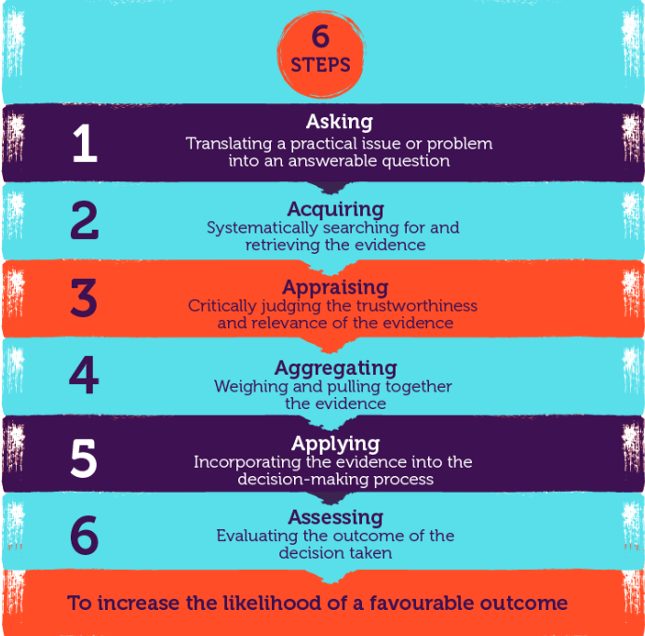
Figure 1
Gifford (2023) advises that less than 30% of people use EBP in people management although he believes using EBP is more likely to create favourable outcomes as it critiques more than one source objectively when it comes to making effective decisions. Supported by Rousseau (2020) who states decision success is more likely when alternatives are considered simultaneously.
Gifford (2023) states sources can be.
- Professional expertise, provided by HR experience.
- Scientific literature, collected from the CIPD website and other sources.
- Organisational data analysed to provide recommendations at the end of the report.
- Stakeholder views from the senior management team during consultation meetings.
Rousseau (2020) states that organisations often make decisions based on well – established research or on cognitive biases, for example seeking information to confirm existing beliefs. However, they believe that EBP can improve decision bias, reduce errors in judgment, improve the quality, relevance and understanding of the information considered. Organisations cannot afford to waste effort and resources on practices that may not work; instead, practices must be strongly rooted in evidence on what works best (Elder & Nikodem 2023)
Implementing evidence-based practice requires three things; a reasonably evidential base, tools, and techniques to implement widely and the motivation to apply knowledge and logical though to decision making (Barends & Rousseau 2018). CIPD (2023) states that when using EBP it’s essential to determine which evidence is the best or most trustworthy to be able to prioritise recommendations. The well-established HR topics i.e., health and wellbeing in the workplace, good working lives including work-life balance and performance management are likely to have plentiful research, whereas EBP may lack here.
Analysis tools (AC 1.2)
PESTLE (an acronym) described below is a working management tool for strategy and making decisions. The CIPD (2023) states a PESTLE analysis study the key external factors that influence an organisation.
- Political (Industry regulations and legislation)
- Economic (Growth/decline, inflation, cost of living)
- Sociological (Demographic trends, cultural norms, work life balance
- Technological (Huge growth in this area including automation of processes, data storage and AI)
- Legal (Employment law and tribunal outcomes)
- Environmental (Social responsibility to the environment including being sustainable and recycling)
Due to it being a simple framework to understand it is favoured though there must be a commitment to repeat the process to review success as outlined above, evaluating decision making is essential. Care must be taken to ensure the most relevant stakeholders are included not to overwhelm the process with too much input. Training of managers in how to use EBP is going to be crucial to success, this is often a barrier along with the quality of the available organisational data.
Similarly to this, Porter's Five Forces model is a strategic framework that helps to identify and analyse five forces that affect a company’s profitability in any given industry;
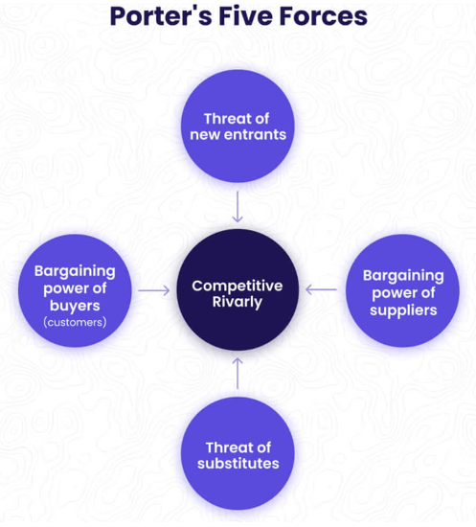
Figure 2 taken from Alonso (2023) article on Cascade website.
Alonso (2023) advises that Porter’s Five Forces Model helps take a step back, analyse and fully understand the competitive environment before making any strategic decisions. This would be applicable to the company as it is consistent across any organisational size and helps to give a complete picture and demonstrates which force is in control at any one time. Though there can be a lack of focus on the ‘why’ the forces are at play and critics say the model gives a snapshot of competitive forces at a single point in time and can quickly be out of date.
There are other analysis methods to recognise and diagnose issues, challenges, and opportunities. Employment Consultative Group (ECG) meetings is a collective voice tool implemented by Admiral Group PLC, involving quarterly meetings with agenda points collected from representatives around the business. This promotes a culture of continuous listening and has a great buy-in from employees.
Critical thinking (AC 1.3)
Asking good questions of sources and validity of evidence is a central skill in EBP (Barends & Rousseau 2018). Adair & Jaeger (2016) advise strong critical thinking skills are needed deal with a world of increasingly rapid change and complexity, applicable to businesses decision making. It covers elements such as reviewing relevant information and feasible options and then evaluating decisions made a result.
Critical thinking goes beyond thinking clearly or logically and looks in depth at various relevant concepts by exploring such things as underlying issues, loosely connected issues, or seemingly unconnected issues (Adair & Jaeger 2016) It is systematic and well thought out and can go some way to preventing any stakeholder personal agendas or bias based on their personal factors. Garland (2019) lists getting to the root of the problem, seeing things from a neutral position and never assuming as key critical thinking components.
There are several forms of bias that need to be considered to assist with objectivity. These include unconscious bias which is defined by Imperial College London (2023) as the associations people hold, outside conscious awareness and control. This can influence decision making in the workplace as managers can be influenced by factors such as background, demographics, and personal experiences. There is also confirmation bias which occurs a decision or opinion is made people tend to look for further information that confirms this and supports their view. This can result in interpreting information in a certain way or ignoring anything that contradicts our thought process which can lead to errors and misjudgement (Imperial College London 2023).
CMI website (2015) also call out some ‘common psychological traps that can impair our decision making’ i.e., tunnel vision which is failing to see the ‘big picture’ while focusing on the detail and loss aversion which avoids possible losses over pursuing possible gains.
Biases are often made automatically and instantly which means when using EBP as a more rounded and rational form of decision making, it is driving a change to inherent behaviour in decision making.
Decision making processes (AC 1.4)
Decision making processes help to use different perspectives to consider all areas of a decision.
De Bono’s 6 hats are a popular choice here. This decision-making process was constructed by Edward De Bono in 1985 and The de Bono Group (2019) demonstrates how each colour hat is labelled with a role i.e., green hat for creativity and yellow hat for benefits. By doing so you are asking each person or group to consider different elements essential to decision making. This will give rich qualitative data although it can be time-consuming exercise as stakeholders can have opinions on other hats to their own which needs to be considered and there needs to be time allocated to complete this process which has cost implications.
Stakeholder analysis is a tool to identify and understand the needs of major interests and expectations of those involved in the decision making and who needs to be communicated with as part of the process. Smith (2000) defines a stakeholder as individuals, groups or organisations that have an interest in the project or decision and can affect its outcome in some way. Stakeholder analysis is often considered the first step in strategic planning activities as this involves considering who should be involved and the needs of all parties which gives a well-rounded view from those who it most affects. Though too many stakeholders can be detrimental to moving forward as some may have concerns and have their own interests at the heart of their contribution.
There are some ‘quick win’ decision making tools such as the PMI (plus/minus/interesting) process. Which the CMI website (2015) define as a ‘pros and cons’ list used to make yes/no decisions, where you also record any implications of the decision that do not clearly fit into the ‘plus’ or ‘minus’ columns. Though since this will only work in binary, a choice between two options, decision making, it clearly has drawbacks in a people setting as these are rarely so black and white but worth baring in mind if time is short. Similarly, benchmarking is a quick source of decision making as it examines what other organisations are doing and taking on board their ‘best practices’ when decision making and adding value. However, doing so without critically evaluating whether these practices are effective and replicable in other contexts and organisations is a risk to using this method (Barends & Rousseau 2018).

Ethical dimension to People Management (AC 1.5)
CIPD (2023) states ‘’Ethics are at the heart of professionalism’’. There is a belief that a company should take the right course of action in terms of its practices and act with integrity which lends itself to being a business case for acting ethically in decision making as it will help feed a company’s positive reputation as an employer and means potential customers maybe more likely to use the services, therefore boosting profitability as a result.
There are many theories surrounding ethics in HR practices. Deontological theory focusses on the moral obligation and responsibilities of individuals to do the right thing and treating people with dignity and respect. It involves being right or wrong e.g., having rules and laws. Utilitarianism theories talk of consequences with a shared interests between employers and employees and suggests that the most ethical choice is the one that will produce the greatest good for the greatest number of people.
Equity in the workplace refers to fair treatment in access, opportunity, and advancement for all individuals. Work in this area includes identifying and working to eliminate barriers to fair treatment (SHRM 2017). This isn’t to say everyone must be treated the same, people may need different things to help them reach the same end goal but is about making this fair.
Eight Ethical Lenses (CIPD 2015) aims to aid ethical decision-making by describing the possible ways of thinking about work as offered by philosophical ethics. It identifies eight lenses none of which are ‘‘right’ or ‘wrong’’ ways of decision-making in the workplace but instead offer different perspectives. It includes lenses such as fairness, democracy, and wellbeing. It makes decision makers answer ethical questions when navigating workplace dilemmas. These lenses occasionally contradict each other i.e., the wellbeing lens states that the goal of workplace design should be to promote ‘good’ work which conflicts with the Rights and Duties Lens, which suggests that individuals’ interests shouldn’t be used as means to the ends of others.
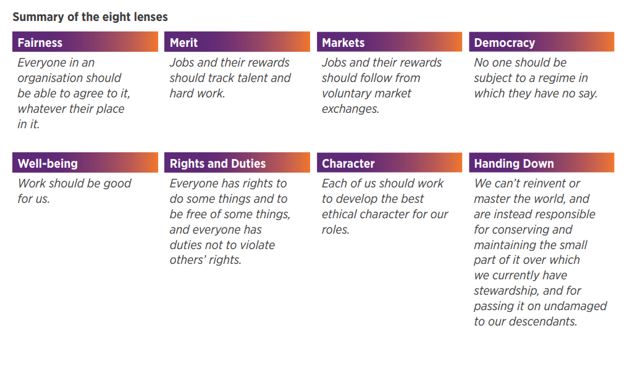
Figure 3 taken from CIPD Research Report (2015)
Financial and non-financial performance measures (AC 3.1)
When using EBP, tracking improvements in performance as an appraising measure of success is crucial. Admiral Group PLC is an insurance company within the financial sector and customer retention was paramount to overall business performance and profitability and was a major financial Key Performance Indicator (KPI). Organisational data such as reporting on absence and attrition as well as positioning in the Great Places to Work survey were also key, using trust index to track improvements on the previous year on employee satisfaction.
Financial measures can be tracked and reported on with more ease due to being numerical and consistent in display i.e., gross, and net profit. This can be offset against non-financial measures such as employee satisfaction and employee wellbeing, this tends to be more qualitive and descriptive but gives more in-depth feedback that can be improved upon. However, this takes more time and can be harder to analyse.
There is also an amalgamation of the above which is known as a balanced scorecard. Kaplan & Norton (1992) define this as a set of measures that gives a fast but comprehensive view of the business.

The Balanced Scorecard will give us information from four different perspectives.
- How do customers see us? (Customer perspective)
- What must we excel at? (Internal perspective)
- Can we continue to improve and create value? (Innovation and learning perspective)
- How do we look to shareholders? (Financial perspective)

The balanced scorecard includes financial measures and it complements this with operational measures on customer satisfaction, internal processes, and the organisation’s innovation and improvement activities when tracking success of the business (Kaplan & Norton 1992).

Methods to measure adding value (AC 3.2)
HR can have a significant and measurable impact on a company (Hults 2011). This can be in terms of the maintenance transactional activities i.e., payroll and absence record keeping but also ensuring employees are working towards delivering on business objectives to achieve organisational success. Hults (2011) advises people need to be supported, trained, and equipped to fulfil the strategic vision of a company. The main issue is how to measure and report on this value.
Customer and employee satisfaction surveys are an effective measurement of how HR are adding value, and these can sit both privately in terms of employee satisfaction surveys and public, in terms of customer service feedback and testimonials on advertising and scoring. As previously mentioned, Admiral Group PLC attributes a lot of its measurement of success around retention of business and should be reviewed similarly as a Key Performance Indicator (KPI). If each year a company retains more return custom than the year before then it is showing the value of its practices which can demonstrate these improvements to both stakeholders and customers, further boosting reputation.
Cost benefit analysis (CBA) is one well socialised evaluation tool to compare the costs and effects of a decision. The Gov website (2020) advises after using CBA for a review of health practices, if the intervention costs less than the value of the gains in monetary terms, then it clearly provides good value for money and is a good decision to make. CBA allow decisions to be clearer and more evident as it will go with the option with the biggest overall benefit.

2668
Equality, Diversity, and Inclusion Salary Data Analysis (AC 2.1)
A quantitative review of data collected from employees.
Gender

The chart below demonstrates the split of employee’s gender in the company, demonstrating a similar split between traditional gender’s however lacking diversity here.

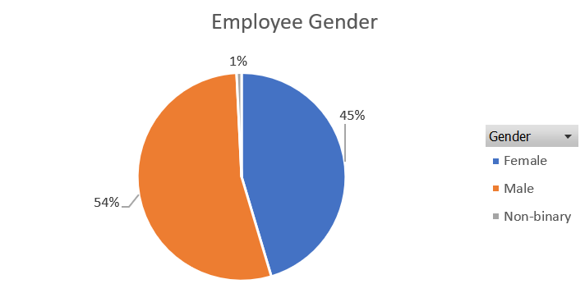

Ethnicity

A full overview of ethnic diversity around the company.

Key takeaways.

- 8 out of 18 teams have little ethnic diversity including business services, marketing, and lettings.
- The ethnicity of white is broken down to region i.e., White Irish, White British, White Other however it remains the overall the highest ethnic classification across the company.
- The Community Engagement and Partnerships team demonstrates the most diversity within the team, though is a small sample size.

Disability by team and organisation

Disability is a protected characteristic of the Equality Act (2010). It is important to monitor this in terms of support available and policies and procedures of the company.

Broken down by team.

Overall, there is 8% of the company with a disability as per below.

Gender and salary

Due to having over 250 employees the gender pay gap is reportable therefore it is important this is reviewed regularly (ACAS 2022).

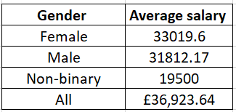

Key takeaways.

- There is little difference between male and female salaries, with female salaries coming in higher based on the Chief Executive being female with the relevant inflated remuneration package.
- Non-binary members of staff are paid considerably less which should be reviewed in terms of the roles they occupy, is progression accessible for this cohort.
- There is consistency with the salaries paid within team, incremental increases for management positions.
- The overall average salary for the organisation is £36,923.64.

Feedback scores from a recent employee survey on hybrid working practices (AC 2.2)

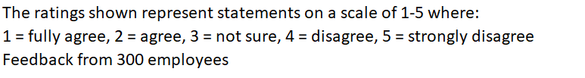

Key takeaways.

- 82.3% of employees scored 1 or 2 for agreeing work practices support their work-life balance and well-being (with 53.6% of employees fully agreeing)
- 250 (83.3%) strongly disagree that they feel less stressed when away from the office meaning recommendations should focus around managing stress when working from home.
- It is an even split between responses for people receiving adequate recognition when WFH vs the office, 46.4% vs 53.6% but improvements could be made here.
- 83% of employees disagree or strongly disagree that they miss engaging with colleagues in the workplace which is positive though 59.6% disagreed or strongly that WFH does not affect cross functional communication and collaboration with their team.
- 62% of employees feel more connected to the company’s culture since WFH and 82.3% of employees agree or strongly agree that the hybrid working practices support work-life balance demonstrating the company’s flexibility is aiding our company culture and values successfully.
- 66.3% of employees feel WFH allows them to meet their targets, so this must be an immediate area of focus.
- There is no free type option for the survey, this would have helped us obtain more quantitative detailed information to help us understand why employees scored the way they did.

Recommendations (AC 2.3)

It is worth acknowledging here that if a recommendation is based on evidence from multiple high-quality sources such as a systematic review and controlled organisational data, it should be rated as high-quality (Barends & Rousseau 2018).
Dixon-Fyle, Dolan, Hunt & Prince (2020) advise in a report that there are three indicators of inclusion; quality, openness, and belonging and ensuring policies and procedures give way to these principles is a good idea. The report states there are challenges in creating an environment of inclusive leadership, equality, and fairness of opportunity and open and freedom from bias and discrimination which is where advocating the use of EBP for the company helps to form a well-rounded perspective.
- Ethnicity/Race and Disability are two of the protected characteristics outlined in the Equality Act (2010). To be an employer of choice to all Diversity and Inclusion should be promoted through all its policies and procedures including advertising of Recruitment strategies, perhaps with testimonials from the current workforce of ethnic minorities and those with disabilities of their positive experiences of working within the company. There should be a focus on the support provided in reasonable adjustments etc… since this is a legal requirement (ACAS 2022).

There are significant positives to the testimonials, diversity can lead to profitability; the most diverse companies are now more likely than ever to outperform less diverse peers on profitability Dixon-Fyle, Dolan, Hunt & Prince (2020). The benefit of this is laid out above in more diverse pool of potential applications however it has little financial implication as no loss of working time or direct costs other than the time taken to interview staff. There is more of a financial implication with the reasonable adjustments as the equipment needed can be expensive though the larger the company the larger a tribunal would expect to be provided (ACAS 2022).

- The Learning and Development (L&D) team should develop some training courses focussed on managing stress when working remotely. The NHS website gives guidance on how to be productive, motivated whilst protecting mental health while working from home. These include having a dedicated workspace, a set routine including breaks where possible with time spent outdoors or doing something employees enjoy and staying connected with team members via video calls/meetings. This would benefit employees by providing them a tool kit to improve their stress whilst WFH and has very little by way of risk or financial implication as this could be done via a brief online training session so not affecting productivity or losing much working time from staff though it will take the L&D team time to create.

- Recognition is a cost-effective method of reward as per the CIPD website (2023), pay is discussed above however there should be a focus on recognising the hard work of employees to aid job satisfaction and culture. An employee of the month initiative whereby staff members vote for their colleagues would help here. Nominations can be submitted via a Teams form; the winner is then selected by the management team demonstrating and highlighting awareness of the work staff are producing. This is a benefit it terms of improving how valued employees feel, has little risk and little cost as it would be utilising tools such as our intranet and emails to staff, although it would need to be discussed monthly in a meeting meaning time taken here from stakeholder working days to attend this. This would go a step further into Star of the Quarter and offer a cash prize for one employee every quarter, the nominees for this would be made up of the previous employee of the month winners. The same benefit and risk apply here but would require a financial contribution as a direct cost to make this more attractive to staff. Return on investment (ROI) would need to be considered here as it would need to show the job satisfaction and culture scores were improving in the next survey.

- There needs to be an immediate review of pay to non-binary members of staff to ensure this cohort are competitive with the other gender options. As well as this it would seem males are paid more in our entry level roles, and this should be reviewed by Recruitment immediately to avoid any potential discrimination. The ACAS website (2022) states equal pay law is covered by the Equality Act 2010 and the Equality and Human Rights Commission (EHRC) statutory code of practice on equal pay. This will be a benefit as it will be more attractive to potential employees due to demonstrating fair practices however will cost more from the Recruitment budget in these roles which will impact business profit, this is a costly implication but necessary based on the potential for discrimination here.

- 66.3% of employees feel WFH allows them to meet their targets, so performance management needs to be built into working practices more effectively. CIPD website (2022) summarises the main tools used in performance management are objective setting, performance ratings, appraisals, feedback, amongst others. Admiral Group PLC hold team days in office where face to face 121’s, appraisals, coaching, and training time are prioritised, and this should be replicated within the company. The benefit of this was boosted performance as desk side coaching and training is more effective in improving performance than being conducted remotely and it removes any potential communication barrier. This would also SMART and meaningful objectives being set with understanding on both management and employees’ side, for which refresher training is likely needed. This will again take L&D time to create and time for managers to attend.

This recommendation would have a dual benefit of increasing face to face interaction and collaboration amongst employees. Although this may mean we see a dip in productivity on these days as a potential financial implication. We would need to bolster cover with other teams to prevent this which is a direct cost, though I feel the benefit of this recommendation across areas of concern would out way the costs incurred in the ROI in improvements here.

1489
References
ACAS website (2022) Equal pay and the law - Acas Accessed 3rd November 2023
ACAS website (2022) What reasonable adjustments are - Reasonable adjustments at work - Acas Accessed 18th November 2023
Adair, D & Jaeger, M (2016) https://www.researchgate.net/publication/292190233_Incorporating_Critical_Thinking_into_an_Engineering_Undergraduate_Learning_Environment Accessed 18th October 2023
Alonso, T (2023) Porter's Five Forces (2023): The Definitive Overview (+ Examples) (cascade.app) Accessed 3rd November 2023
Barends, E & Rousseau, D M (2018) Evidence based management – how to use evidence to make better organisational decisions, 1st Edition, Kogan Page
CIPD research report (2015) Ethical decision making: eight perspectives on workplace dilemmas, https://www.cipd.org/globalassets/media/knowledge/knowledge-hub/reports/ethical-decision-making-2015-eight-perspectives-on-workplace-dilemmas_tcm18-9564.pdf Accessed 18th October 2023 and 8th November 2023
CIPD (August 2022) Performance Management | Factsheets | CIPD Available at: Performance Management | Factsheets | CIPD Accessed 15th November 2023
CIPD website (November 2022) Equality, diversity and inclusion in the Workplace | Factsheets | CIPD Accessed 15th November 2023
CIPD website (March 2023) https://www.cipd.org/uk/knowledge/factsheets/pestle-analysis-factsheet/ Accessed 12th October 2023
CIPD website (April 2023) Evidence-based HR: Make better decisions and step up your influence | CIPD Accessed 18th October 2023
CIPD website (May 2023) Reward | Factsheets | CIPD Accessed 15th November 2023
CIPD website (July 2023) https://www.cipd.org/uk/knowledge/factsheets/evidence-based-practice-factsheet/ Accessed 11th October 2023
CIPD website (July 2023) SWOT Analysis | Factsheets | CIPD Accessed 15th November 2023
CIPD website (July 2023) Evidence-based practice for effective decision-making | Factsheets | CIPD Accessed 15th November 2023
CIPD website (August 2023) Ethical Practice and the Role of People Professionals | Factsheets | CIPD Accessed 15th November 2023
CIPD website (October 2023) Pay Fairness & Pay Reporting | Factsheets | CIPD Accessed 13th November 2023
CIPD website(November 2023) https://www.cipd.org/uk/the-people-profession/the-profession-map/explore-the-profession-map/ Accessed 11th October 2023
CMI website (2015) CHK-277_Developing_decision_making_skills.pdf (managers.org.uk) Accessed 18th November 2023
Dixon-Fyle, S, Dolan, K, Hunt, V & Prince, S (2020), How diversity, equity, and inclusion (DE&I) matter | McKinsey Accessed 8th November 2023
Equality Act (2010) Equality Act 2010 (legislation.gov.uk) Accessed 15th November 2023

Elder, S R & Nikodem, M (2023) Considering the application and relevance of evidence-based HR, Considering the application and relevance of evidence-based HR (peoplemanagement.co.uk), Accessed on 15th November 2023

Garland P. Brackins (2019), Critical Thinking Skills: 11 Proven Strategies To Improve Decision Making And Problem Solving Skills, Bluesource and friends
Gifford, J (2023) Evidence – based HR, making better decisions, Attended 27th September 2023
Gov website (2020) Cost benefit analysis: health economic studies - GOV.UK (www.gov.uk) Accessed on 16th November 2023
Hults, B (2011) Why HR Really Does Add Value (hbr.org) Accessed 22nd November 2023
Imperial College London (2023) https://www.imperial.ac.uk/equality/resources/unconscious-bias/ Accessed 25th October 2023

Kaplan, R S & Norton, D P (1992) The Balanced Scorecard—Measures that Drive Performance (hbr.org) Accessed 7th November 2023

NHS website 6 simple tips to tackle working from home - Every Mind Matters - NHS (www.nhs.uk) Accessed 15th November 2023

Rousseau, D M (2020) Making evidence based-decisions in an uncertain world, Organisational Dynamics, January-March, Vol 49, No 1, https://www.sciencedirect.com/science/article/pii/S0090261620300085 Accessed 11th October 2023
SHRM website (2017) https://www.shrm.org/resourcesandtools/tools-and-samples/toolkits/pages/introdiversity.aspx#:~:text=Equity%20in%20the%20workplace%20refers,changes%20in%20organizations%20and%20industries. Accessed 18th October 2023
Smith, L. W. (2000) Stakeholder analysis (pmi.org) Paper presented at Project Management Institute Annual Seminars & Symposium, Houston, TX. Accessed 19th November 2023
Tayler, S & Woodhams, C (2022) Studying Human Resource Management: A guide to the study, context and practice of HR, Third Edition, Kogan Page
The de Bono Group website (2019) Six Thinking Hats – De Bono Group Accessed 3rd November 2023

