James Dunhill
DR Carlene Campbell / UWTSD
WIRELESS nETWORK & sIMULATIONS

Abstract
This report will talk about different modulations that are used in communication systems, it will briefly explain how motivation works and how data is sent and received. There will also be a comparison between the two distinct types of testing: communication systems and computer simulations and how they differ in comparison.
There is also a research report based on how wireless systems can benefit agricultural farms that deal with criminals active during the night with different types of wireless technology and how smart cities could reduce crime rate in built-up areas. There are also two designs created to illustrate the layout to create a solution, with a conclusion to sum the best way to fix the issues.

Introduction
Communication systems have grown over the years by getting better at longer distances communication with better capacity and efficiency. Unique types of technologies that can harness this and use it for communication, Wireless networks, mobile networks, Bluetooth, and satellites are some types of Communications that have been developed. These are based on types of frequencies and how they are modulated depending on how they perform.
Over the years there have been lots of different standards created in wireless technology The IEEE is the most popularly used standard for Wi-Fi. Overtime different letters and combination starting to make calling the standards in Wi-Fi confusing so a system of brandy each Wi-Fi generation with a number to represent what generation they are on, the current generation is Wi-Fi 6 which offers and Max output of 10 gigabits per second and it uses less power than its predecessors but also supporting backwards compatibility and better security. They achieve this through using the frequencies mentioned before this will be mentioned throughout this report.
Overtime software created simulations of networks and communication systems, opportunities for network engineers and architects to design and implement wireless networks in buildings before they build them or redesigning existing networks with newer Technologies. The opportunity that this can offer allows for trialling new updated wireless systems with simulations of interference built-in to allow the engine to gather and understand and tough problems that may be a head of them while rolling out the real Wi-Fi network.

Abstract 1
Introduction 1
Chapter 1 - QAM 3
Section 1.1 3
Section 1.2 3
Section 1.3 3
QAM bits per symbol 3
QAM noise margin 3
Advantages of QAM 3
Disadvantages of QAM 4
Examples of QAM 4
Section 1.4 4
Chapter 3 - Wireless Sensor Network Design & Critical review 5
Section 3.1 - The Problem 5
Farms 5
Towns & Cities 5
Useful Knowledge 5
Section 3.2 - Research 5
Section 3.3 - Design 6
Farm Design 6
Smart City Design 7
Section 3.4 - Evaluate and critique 7
Chapter 4 - Conclusion 8
Table of Figures 8
References 8
Appendix 0

Chapter 1 - QAM

Section 1.1
Modulation is used to allow for sending a signal over long or short frequency range. Allowing for multiply frequency range (like radio stations) allows for multiple signals simultaneously over a single channel. A big reason they do this is to keep the size of the antenna down, they can find these in phones and tablets [1,2].
But there are unique types of modulation
- Amplitude modulation (AM)
- Frequency modulation (FM)
- Phase modulation (PM)
Depending on the modulation Or depend on the frequency that is used if the frequency is short but that means the capacity will be bigger and allow for more data to travel through it but if the frequency is a long wave, it means that the data will be in transfer speed [12].

Section 1.2
Computer network simulations are done through using special bespoke software that is specially designed to emulate new designs or to recreate existing networks designs. When simulations are created, they are used to emulate devices and simulate communication systems. These are done in actual time, and I have the option of modifying the settings to create realistic environmental destruction or create perfect factory settings with no interference.

The way these are largely as it stimulates exactly how communication systems work down to a very fine point, expensive and specialised the software emulation is the more realistic and closer this will achieve to real-life communication systems.

Section 1.3
QAM Stands for Quadrature Amplitude Modulation. QAM is one of the top modulation techniques around, it is widely popular and used all over the world in many places. A popular reason they use QAM is for its design to utilise both amplitude and phase components, this then gives out modulation able to provide high spectrum usage of efficiency.
They build QAM signals with two carriers, these both operate at the same frequency but they give the signals names to Identify each carrier I & Q, once transmitted the singles are combined at the start and once the single has been received it is then separated, by extracting the data from each of the singles. This then leaves the data to be sorted and combined into the modulating information.
Using the equation, you can see that I & Q are being represented.
I=Acos(Ψ) and Q=Asin(Ψ)

QAM bits per symbol
QAM uses a top order of modulation, this has a very positive effect allowing to carry more bits of information per symbol.
16QAM will send 4 bits per symbol, 64QAM will send 6 bits per symbol and this process will keep repeating, each combination is assigned a 2-bit digital pattern. This is done to create groups of 2-bit digital patterns, these are then able to be mapped to the corresponding symbols.

QAM noise margin
Noise is the downside to having higher order modulation rates, it increases the data rate speed and allows for the higher level of efficiency from the spectral. This is because the higher order of modulations is considerably susceptible to noise and interference.

Advantages of QAM
QAM modulation's prime benefit is down to can represent a bigger number of bits per carrier, this allows for higher data rates (Bandwidth).

Disadvantages of QAM
With all positives are some are some negatives and one of the biggest problems that QAM deals with is the noise, this is because the states are closer. This makes the QAM receiver more complex compared to other receivers of different modulation [5].
Another problem that affects QAM is that it uses an amplitude component, this is used to represent binary data. The downside to this is linear amplifiers are less efficient and consume more power.

Examples of QAM
An example of QAM would be how it works: 16QAM is used to map 4 bits per carrier, 64QAM is used to map 6 bits per carrier, 256QAM is used to map 8 bits per carrier, 1024QAM, and this keeps ongoing.
This constellation diagram here shows the progression in unique positions for states within grows, the number of points in the diagram also grows too.
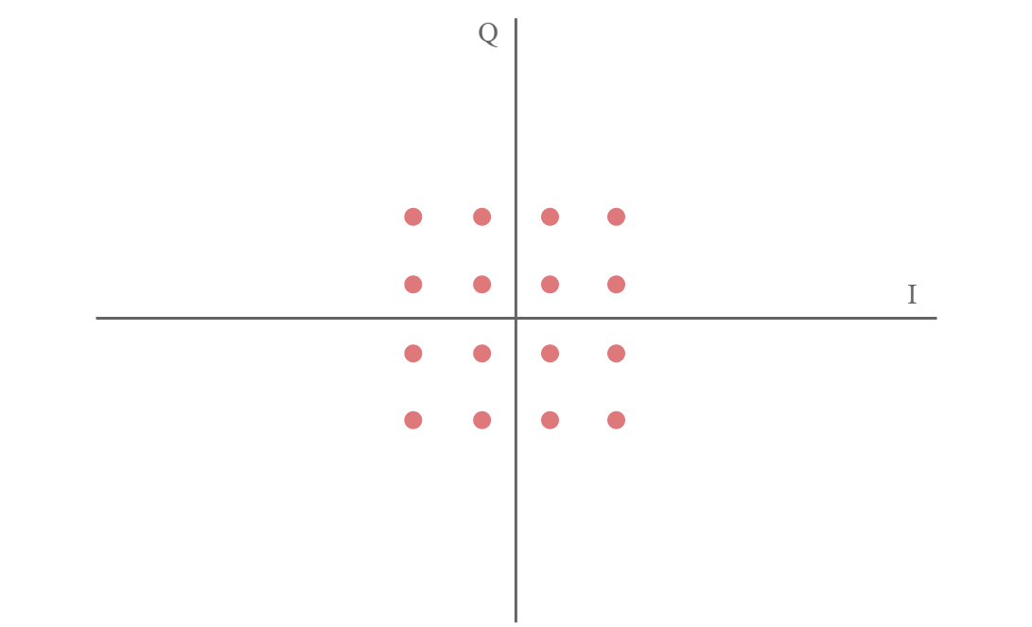
Figure 1 1-1 - (16QAM) electronics-notes.com
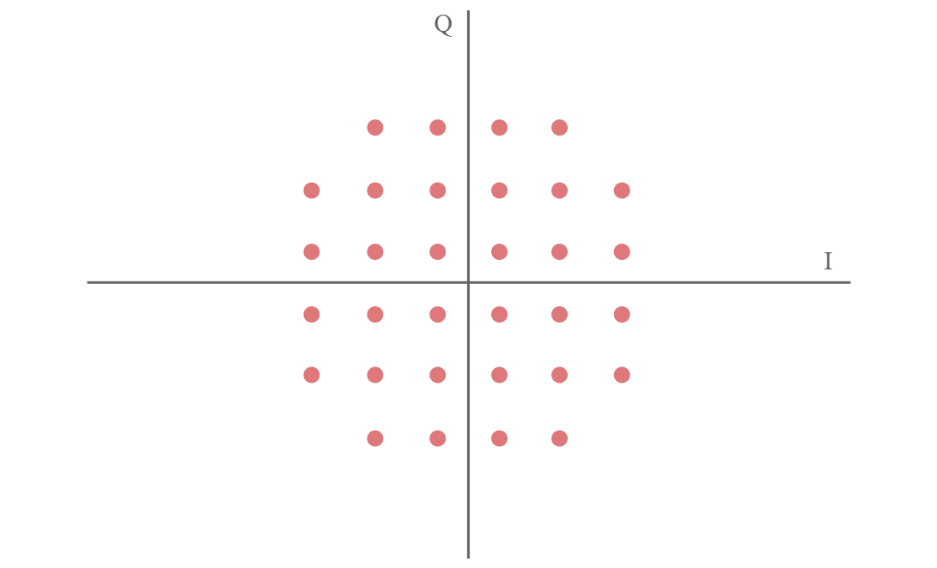
Figure 2 1-2 (32QAM) electronics-notes.com
(32QAM)
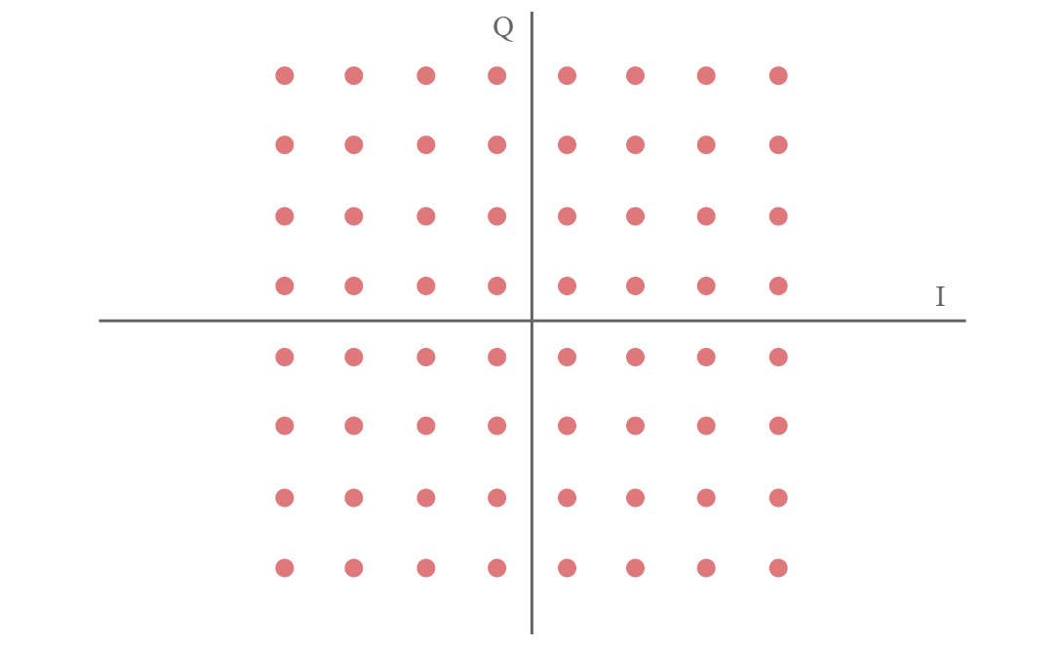
Figure 3 1-3 (64QAM) electronics-notes.com
The larger the modulation grows the less space is between each of the points of the constellation an insignificant amount of noise cause problems.
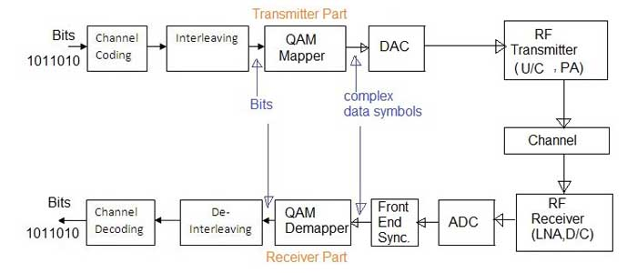
Figure 4 3-4 (64QAM Quadrature Amplitude Modulation) electronics-notes.com
The diagram above is showing the flow of data of how QAM is processed though.

Section 1.4
Some pros and cons to using computer simulations over a testbed can be very deepening in the tests that are completed.

Computer simulation, the use of a computer to represent the dynamic responses of one system by the behaviour of another system modelled after it. A simulation uses a mathematical description, or model, of an actual system in the form of a computer program.
An environment that is created for testing where a test bed may refer to software only or to both hardware and software.

Chapter 3 - Wireless Sensor Network Design & Critical review

Section 3.1 - The Problem

Farms
Across the Caribbean multiple farms are reporting thefts of agricultural produce being stolen during the nights, the thieves are stealing livestock and fully grown crops just before the sale. A lot of damage to the Farmers profits and overall yearly earnings, therefore they have invested into a new wireless sensor network that would allow for them to track and monitor their land from anywhere to put in better security to keep their stock safe from theft.
There have been several attempts or controlling the growth of the problem and with minor success in catching the culprits has led to having fresh ideas brought in to help solve the problem.

Towns & Cities
Also another major concern on the island is the increase in robberies within the cities and towns, That have been reported as of robberies across the town and the cities creating an unsafe environment for people to be in, some crimes have been committed on public transport as where criminals are using concealed weapons such as knives and guns to commit crimes like robberies and other such transgression.

Useful Knowledge
Taking pre-existing knowledge that the farms used to help get a better idea of what needs to be done to create a solution for this problem. Some forms are highly fenced, and some other farms are not fenced at all, this has not posed any difficulty. Limitations on the culprits could still access the farm's crops.
They raided most farms at night allowing for the culprits to use the darkness to mask their appearance and make it hard for them to be seen. On top of this some locations on the island where the farms are based are in a Valley have hilly terrain with deep slopes and lots of forests surrounding them, some troublesome problems in finding a solution for preventing theft.

Section 3.2 - Research
This section will primarily look at research of unique types of technology that could help bring a better stance of security to the towns and to the farmers.
Different types of technologies that are used in smart cities to detect crimes before they are taken one of these is using AI and the other is using micro Miller wave scanners.
Millimetre wave scanners scan the whole body in search for concealed items underneath clothing that the individual may be holding, electromagnetic Radiation is used to detect these items.
Smart AI that is designed to track body movement and body language, this watches public places for any unusual activity and records the movements and sends it to local authorities. This is not perfect and does have its flaws by pulling up people who have a bad leg or bad back.

Section 3.3 - Design

Farm Design
The design that has been chosen allows for the farmers to easily operate from a single point to watch over their premises in the diagram displayed (Check Appendix - Figure 3-1).
In the Rural parts of the island there is no mobile network carrier that can bring a cellular network for Communications, this creates problems for the Farmers trying to keep communications open to outside of their premises but also makes it difficult in creating a network that is connected to the internet. Therefore, the designer has proposed using satellites to beam the internet down to the premises [18,19].
With the newly connected sensors that are placed around the premises these are connected to a wireless access point, this allows for them to have Direct access to the internet via satellite, update notifications sent to the farmers phone and also other devices that can receive notifications if a sensor has been triggered. They set these sensors up to operate during certain times of the day, depending on how the farmers want them to operate they can be operational during certain times.
The sensor uses infrared light; this is electromagnetic radiation with wavelengths, these are invisible to light. These are used to create a circuit, once the connection has been broken by intercepting the light then it will send a signal that somebody has entered the premises [20].
On the doors to each other buildings there are rfe chips that I used to allow the Farmer and staff access into the buildings by using a key card, this allows for a much more secure and better way of monitoring access of who is going in and out of the buildings as well as putting security on the doors in general.
Also based on the local wireless network that would be created would have smart LED light operate in certain areas, light sensors would automatically turn on if it sees movement. This comes with benefits allowing the farmer to have an easier operational time not having to turn lights on and off, This will save money, also alerting any of the farm staff if there are intruders walking around certain areas as light will start turning on when movement is detected giving away intruders location [21].
Using surveillance cameras on a local network will allow for the premises to be securely recorded during day and night, play some cameras in locations where areas are most likely to be targeted or have been targeted would be a good place to start. These locations will have wireless camera setup to stream 24/7 to a secure storage centre somewhere on site if a crime is taken place then the cameras should be able to record and catch the culprits having the cameras using infrared will allow him to see in the night of the perpetrators. Depending on the bandwidth and the resolution that is chosen will be sent and stored at optimal 1080p he would be the best resolution to use as it offers high pixel count and is reasonably fast to transfer over a wireless network that supports gigabit streaming (802.11ac) [17].
50% of the network that is built uses cables that go from the house to storage buildings and the other half that's in the fields and livestock are I using wireless transmitters and repeaters to extend the connections the repeaters extend the connections further by boosting the signal to get more distance, the payoff to using this technology is that the signal stay stronger but the capacity gets smaller as a percentage of it drops off after an amount of time.
With the satellite data this can then be uploaded with a communication connection to the nearest police station in the area, response to any crime that is committed within minutes of the technology sensing criminal activity. The downside to using this technology is the latency from satellites is very slow and can take time to send information, depending on what information is being sent to the police will depend on how fast they can respond. If video footage is being sent, this could take longer than just simple readings off a sensor.

Smart City Design
The crime rates on the increase in the towns and cities on the island technology is being introduced to slow down the crime rate in these areas. The designs that have been created I'll meet to illustrate how an effective system could be introduced with certain types of technology to reduce crime rates across the cities (Check Appendix - Figure 3-2).
In the town centres developing a system that uses short-range frequencies that are using low power how to create a Wi-Fi network this would be a WLAN. This would give good opportunity to allow fast and reliable communications across the towns easily monitoring the cities and the towns would be linked up to the local police stations using this technology, monitoring the areas from the nearest police stations.
There are two types of technology that is growing very quickly that allow smart city to be more secure in real time, The first technology has been around for a long time and is used at airports mostly before boarding a plane millimetre wave to scan the body for anything that may be hidden on the person i.e. knives or weapons. Taking this type of technology and moving into cities or creating better structural security, for example placing it on buses or shop doorways, this would instantly scan for anything that may be unusual or deemed a risk to the public.
The other technology is using Smart AI to predict unnatural human movement, this will pick out people that are taking unusual roots or trying to conceal something under their clothes with body language too.
If any of these two technologies to text me saying they will send information directly to the local and nearest police station to alert suspicious activity in the towns allowing for police to turn up or be within the premises before any drastic action needs to be taken.

Section 3.4 - Evaluate and critique
Looking at the design and the areas that were developed on the farm could do with an expansion and redevelop for better and newer technology.
Implementing sensors allows for quick and easy notifications depending on the type of sensors used. The sensors that were used were infrareds that allowed for detecting intruders when a circuit is broken. Installation of the sensors are very quick and easy allowing for replacements or new sensors to be installed with ease.
All senses are built to brave all types of weather, in the Caribbean the weather is mostly warm and sunny meaning that the cameras and sensors don't have to deal with different types of extreme weather conditions leaving them only to be prepared for heat. There is also a security element to not be able to see the infrared light, making it difficult for intruders to see any cameras.
Looking at the design and how it was built and made a lot of areas of faults that can be changed with very new technology that would benefit more than current suggested technology. Using new and smarter cameras with thermal technology would be better as infrared can break by anything blocking for sensors where thermal will only detect heat off of living animals, In the camera settings it would be able to allow for certain changes to be detected stopping foxes and other small animals triggering the systems.
The livestock putting tags that uses GPS triangulation would be an interesting way to track live animals around the farm without having to worry about them leaving the premises, if a live animal left the premises it would then instantly track and follow where the car is going allowing for an extra layer of security to find animals once they have gone from the property.

Chapter 4 - Conclusion
This report offers a lot of knowledge about the different types of modulations and techniques that are used within wireless communications.
Some recommendations would be researching more about the different types of wireless technology that can be used for short range and how that could be used better, also understanding how boosters could carry signals across much more thicker and Ben's areas in farmland. to work would be looking into more GPS based technology on Farm but also using this inside of smart cities.
Simple recommendations from the research would show that infrared technology is very powerful and very useful with qualms architecture and how performance can be used, and harvest would make very reliable systems.
In the future when designing wireless systems, taking advantage of Simulation to create the first test network with interference built-in gives a good understanding of what needs to be sorted out before starting. QAM is a very powerful and useful modulation that is used for communication. This more in-depth would give a better understanding of creating a better network and design.

Table of Figures
Figure 1 / 1-1 - (16QAM) electronics-notes.com 4
Figure 2 / 1-2 (32QAM) electronics-notes.com 4
Figure 3/ 1-3 (64QAM) electronics-notes.com 4
Figure 4 / 3-4 (64QAM Quadrature Amplitude Modulation) electronics-notes.com 4

References
[1]electronics notes, “What Is QAM: Quadrature Amplitude Modulation » Electronics Notes,” Electronics-notes.com, 2020. [Online]. Available: https://www.electronics-notes.com/articles/radio/modulation/quadrature-amplitude-modulation-what-is-qam-basics.php. [Accessed: 19-Apr-2020].
[2]“Quadrature Amplitude Modulation - an Overview | ScienceDirect Topics,” Sciencedirect.com, 2013. [Online]. Available: https://www.sciencedirect.com/topics/engineering/quadrature-amplitude-modulation. [Accessed: 19-Apr-2020].
[3]“Fundamentals of Quadrature Amplitude Modulation,” Communication System Design Using DSP Algorithms with Laboratory Experiments for the TMS320C6713TM DSK, pp. 215–228, 2008.
[4]M. Rouse, “QAM (quadrature amplitude modulation),” SearchNetworking, 2017. [Online]. Available: https://searchnetworking.techtarget.com/definition/QAM. [Accessed: 19-Apr-2020].
[5]“Advantages of QAM | Disadvantages of QAM | 16QAM,64QAM,256QAM,” Rfwireless-world.com, 2012. [Online]. Available: https://www.rfwireless-world.com/Terminology/Advantages-and-Disadvantages-of-QAM-types.html. [Accessed: 19-Apr-2020].
[6]“Quadrature Amplitude Modulation (QAM) - National Instruments,” Ni.com, 2019. [Online]. Available: https://www.ni.com/en-gb/innovations/white-papers/06/quadrature-amplitude-modulation--qam-.html#section-489076841. [Accessed: 21-Apr-2020].
[7]L. M. Devi and A. Dinamani Singh, “Bit Error Rate of R-QAM Signalling in Generalized K-Fading Channels,” SSRN Electronic Journal, 2020.
[8]Y. Li, “A Construction of General QAM Golay Complementary Sequences,” IEEE Transactions on Information Theory, vol. 56, no. 11, pp. 5765–5771, Nov. 2010.
[9]L. L. Hanzo, S. X. Ng, T. Keller, and W. Webb, “QAM Basics,” in QAM Basics, Wiley-IEEE Press, 2004, pp. 1–1.
[10]“Different Types of Modulation Techniques in Communication Systems,” ElProCus - Electronic Projects for Engineering Students, 20-Mar-2014. [Online]. Available: https://www.elprocus.com/different-types-of-modulation-techniques-in-communication-systems/. [Accessed: 21-Apr-2020].
[11]Elsevier, Modeling and Simulation of Computer Networks and Systems. 2015.
[12]“How does modulation work?,” Tait Radio Academy, 2020. [Online]. Available: https://www.taitradioacademy.com/topic/how-does-modulation-work-1-1/. [Accessed: 21-Apr-2020].
[13]S. Rampfl Betreuer, F. Wohlfart, and D. Raumer, “Network Simulation and its Limitations.”
[14]“WiFi used to detect weapons and explosives - Smart Cities - Osborne Clarke,” Smart Cities - Osborne Clarke, 28-Aug-2018. [Online]. Available: https://smartcities.osborneclarke.com/general/wifi-used-detect-weapons-explosives/. [Accessed: 23-Apr-2020].
[15]B. Buntz, “How smart building technology could address mass shootings,” IoT World Today, 2020. [Online]. Available: https://www.iotworldtoday.com/2017/10/04/how-smart-building-technology-could-address-mass-shootings/. [Accessed: 23-Apr-2020].
[16]“AI makes smart-city software smarter - Smart Cities - Osborne Clarke,” Smart Cities - Osborne Clarke, 08-Apr-2020. [Online]. Available: https://smartcities.osborneclarke.com/general/ai-makes-smart-city-software-smarter/. [Accessed: 23-Apr-2020].
[17]B. Mitchell, “802.11 Standards Explained: 802.11ax, 802.11ac, 802.11b/g/n, 802.11a,” Lifewire, 10-Aug-2003. [Online]. Available: https://www.lifewire.com/wireless-standards-802-11a-802-11b-g-n-and-802-11ac-816553. [Accessed: 01-May-2020].
[18]“What is Satellite Internet - Pros & Cons,” Plugthingsin.com, 2020. [Online]. Available: http://www.plugthingsin.com/internet/satellite/. [Accessed: 01-May-2020].
[19]“Accessing Satellite Data - Satellite Applications Catapult,” Satellite Applications Catapult, 13-Dec-2018. [Online]. Available: https://sa.catapult.org.uk/work-with-us/our-capabilities/accessing-satellite-data/. [Accessed: 01-May-2020].
[20]J. Lucas, “What Is Infrared?,” livescience.com, 27-Feb-2019. [Online]. Available: https://www.livescience.com/50260-infrared-radiation.html. [Accessed: 01-May-2020].
[21]M. Brown, “Philips Hue Outdoor Motion Sensor review: A must-have accessory for Hue smart lighting owners,” TechHive, 01-Mar-2019. [Online]. Available: https://www.techhive.com/article/3346228/philips-hue-outdoor-motion-sensor-review.html. [Accessed: 01-May-2020].
[22]M. Baba, V. Gui, C. Cernazanu, and D. Pescaru, “A Sensor Network Approach for Violence Detection in Smart Cities Using Deep Learning,” Sensors, vol. 19, no. 7, p. 1676, Apr. 2019.
[23]E. N. Grossman and A. J. Miller, “Active millimeter-wave imaging for concealed weapons detection,” Passive Millimeter-Wave Imaging Technology VI and Radar Sensor Technology VII, Aug. 2003.

Appendix
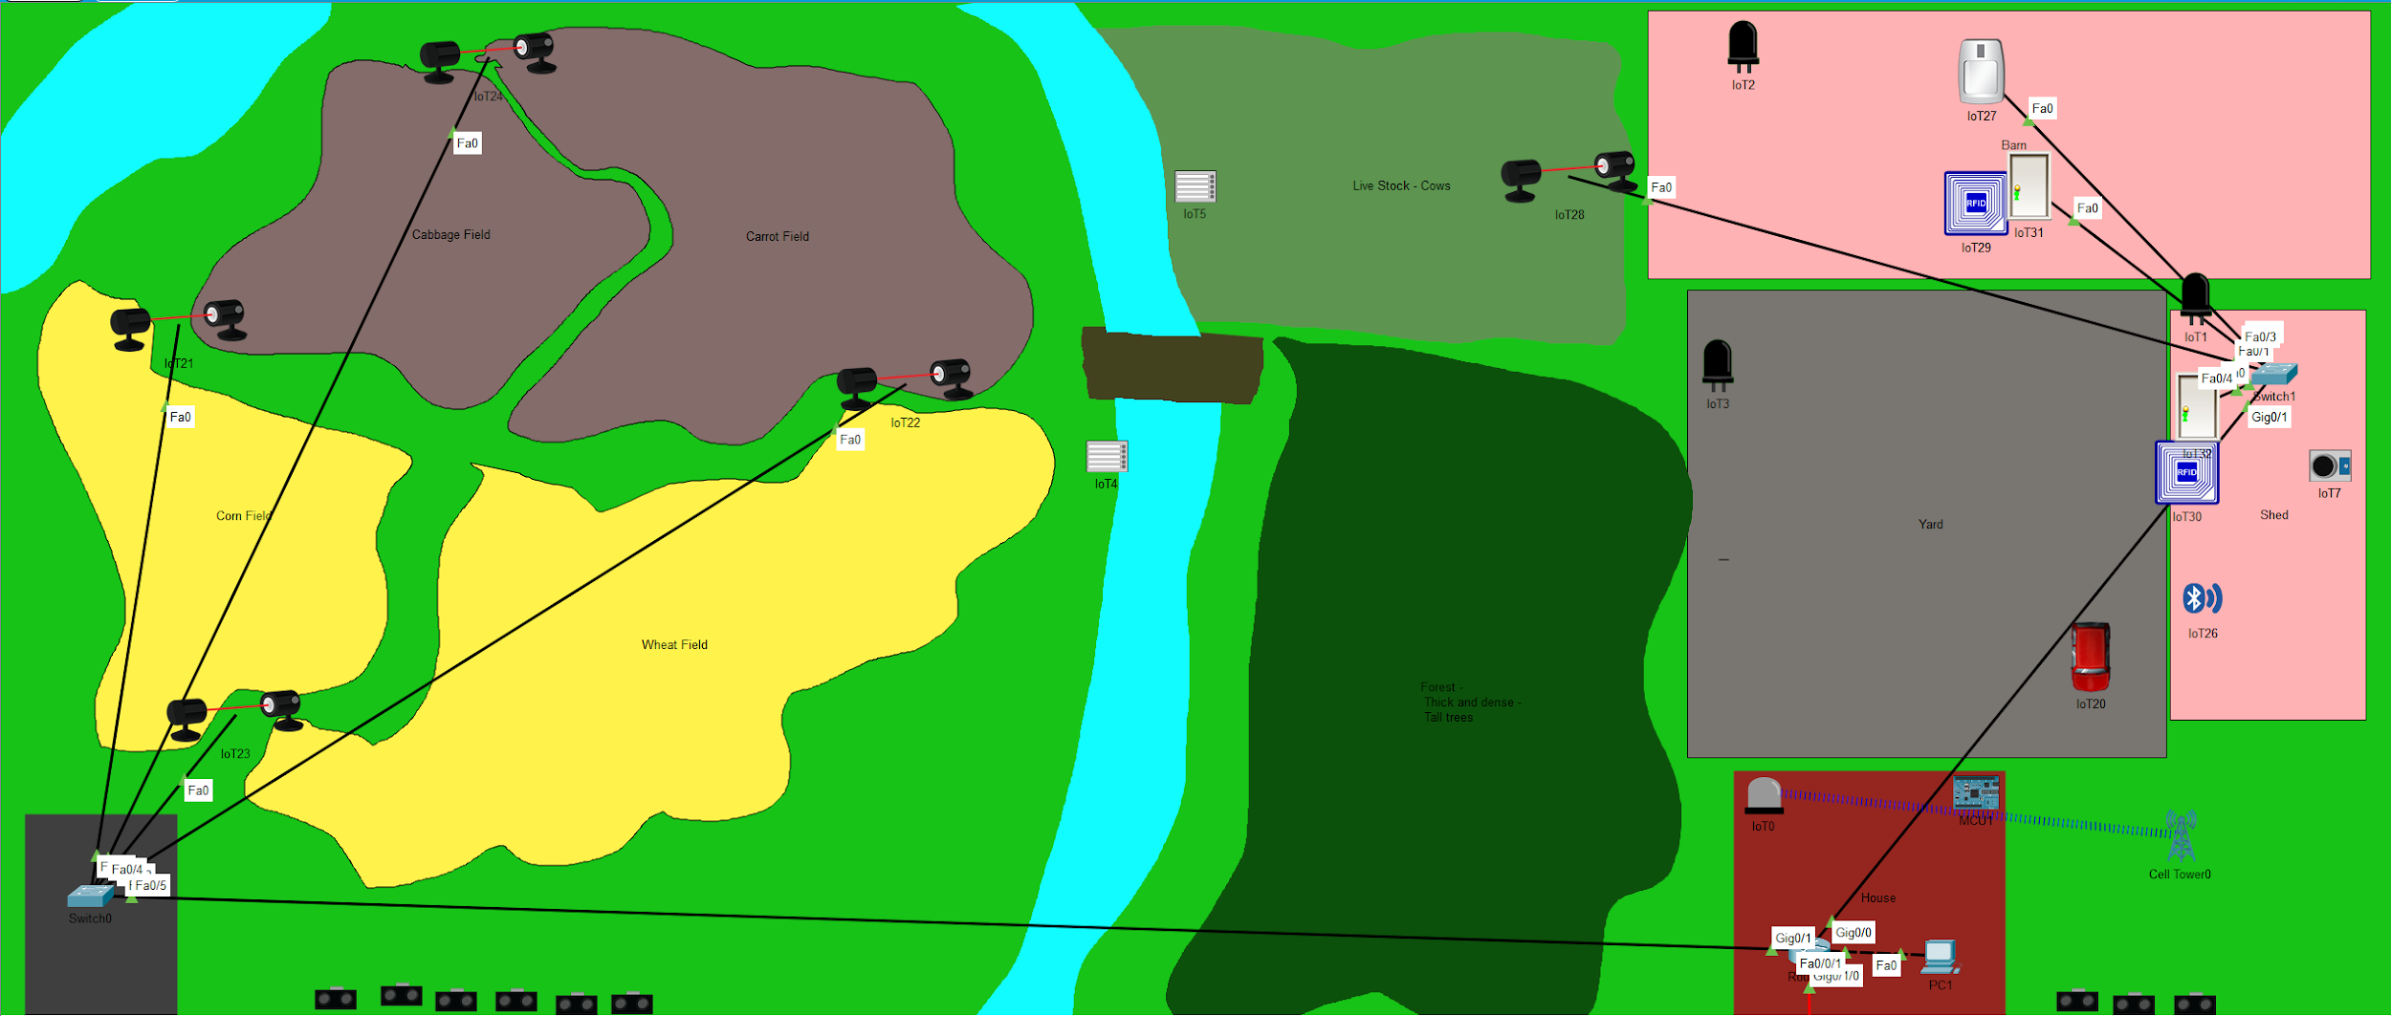
Farm Design
Smart City Design
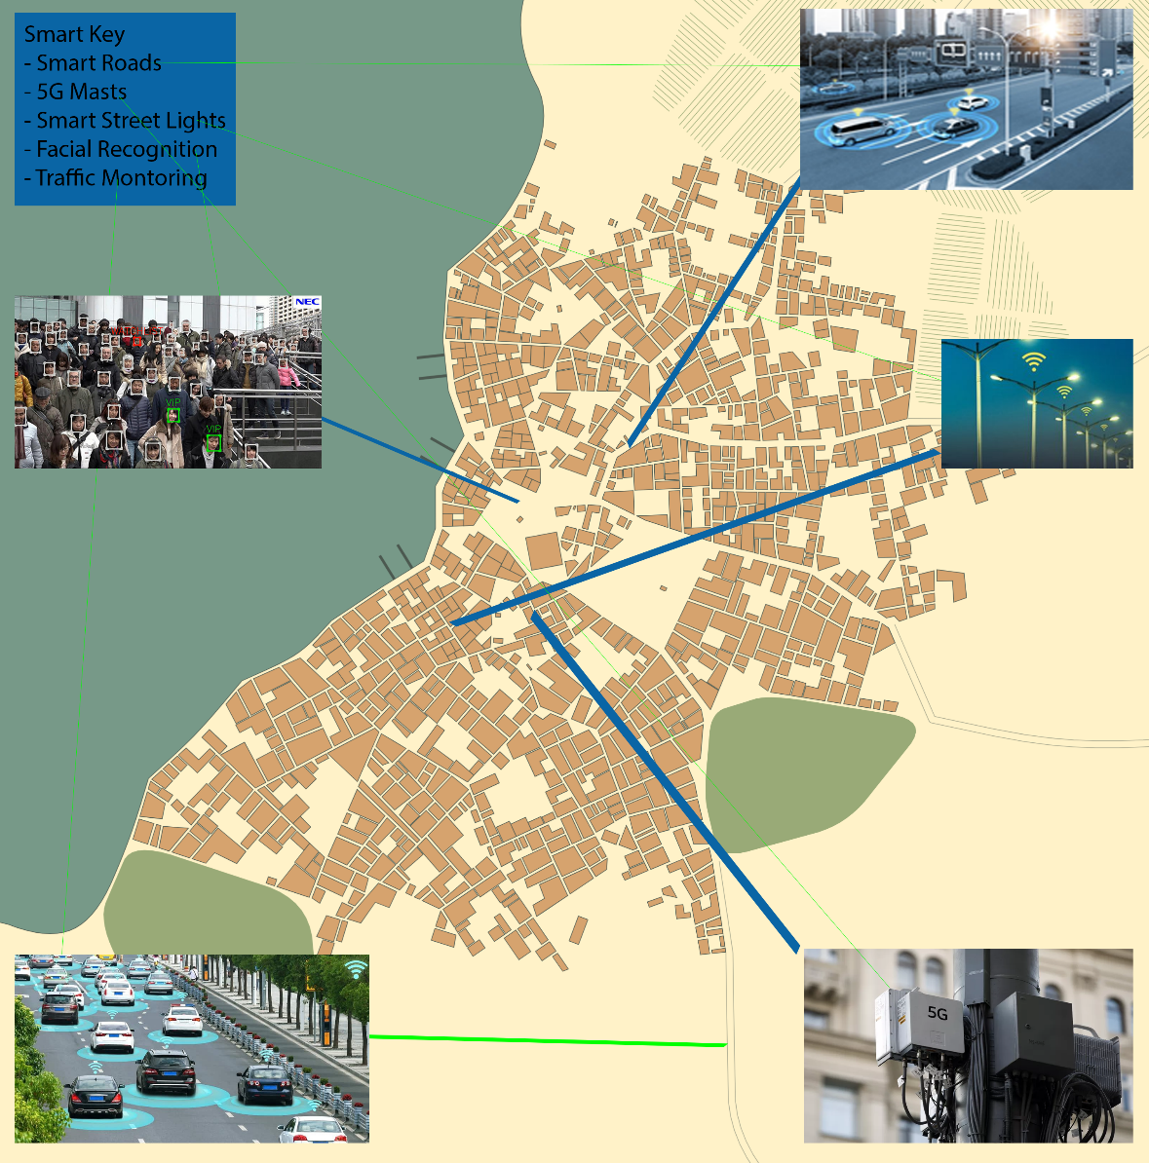
Images used:
Website | Name
https://www.theverge.com/2020/4/4/21207927/5g-towers-burning-uk-coronavirus-conspiracy-theory-link | 5G Tower | 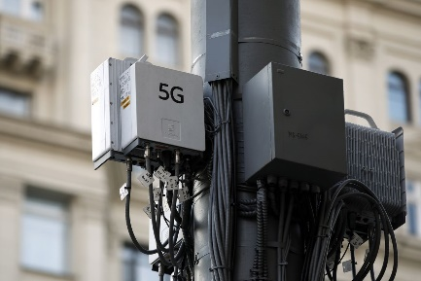
https://www.forbes.com/sites/omribarzilay/2018/01/24/the-road-to-the-autonomous-age-will-be-paved-by-smart-cities/ | Smart Roads | 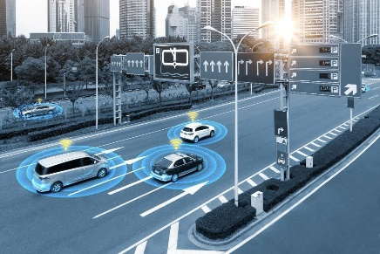
https://www.transportadvancement.com/articles/advanced-road-traffic-management-system-for-smart-cities/ | Smart Traffic Management | 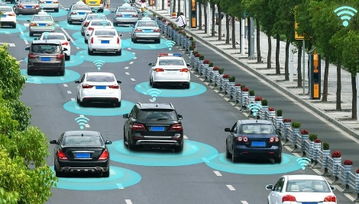
http://blog.co-star.co.uk/tag/smart-street-lighting/ | Smart Street Lights | 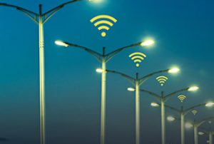
https://www.zdnet.com/article/please-run-australias-facial-recognition-surveillance-system-on-the-ato-san/ | Facial recognition | 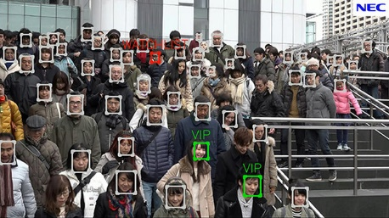

‌

marking criteria and Student FEEDBACK

This section details the assessment criteria. The extent to which these are demonstrated by you determines your mark. The marks available for each criterion are shown. Lecturers will use the space provided to comment on the achievement of the task(s), including those areas in which you have performed well and areas that would benefit from development/improvement.

Common Assessment Criteria Applied (Assignment 1) | Marks available | Marks  awarded
1. Engagement with Literature Skills
Extent of research and/or own reading, selection of credible sources, application of appropriate referencing conventions.
You have discuss key concepts, appropriately summarised your research content and use the appropriate referencing convention. You have engaged well with peer review articles. Note, that websites require careful consideration. (Grade mark: 80.00%) | 15 | 12
2. Knowledge and Understanding Skills
Extent of knowledge and understanding of concepts and underlying principles associated with the discipline.
You have demonstrated excellent knowledge and understanding. You have used the IEEE report formatting. (Grade mark: 80.00%) | 15 | 12
3. Cognitive and Intellectual Skills
Analysis, evaluation and synthesis; logic, argument and judgement; analytical reflection; organisation of ideas and evidence
Very good background introduction and you have discussed very good on QAM. There was not a Simulink module created. A Simulink model wasn’t explained or discussed. You were required to do a Simulink creation of a modulation technique. Task 1 was not completed due to the missing Simulink creation of a modulation technique. This was covered in the tutorial by Paul with e.g. of QPSK and QAM 64, along with SNR and aWGN. These were carried out in tutorial by students along with excel line graph. Your task 2 was discussed and explained in an excellent manner. (Grade mark: 80.00%) | 30 | 24
4. Practical Application Skills
Deployment of methods, materials, tools and techniques; application of concepts; formulation of innovative and creative solutions to solve problems.
Your design was explained, discussed and evaluated. However the diagrams in the Appendix could be bigger, each on a separate with annotation. (Grade mark: 85.71%) | 35 | 30
5. Transferable Skills for Life and Professional Practice
Attributes in professional practice: individual and collaborative working; deployment of appropriate media; presentation and organisation.
Professionally done. Written and flow excellently with little or no grammatical errors. (Grade mark: 80.00%) | 5 | 4

Assignment Mark (Assessment marks are subject to ratification at the Exam Board. These comments and marks are to give feedback on module work and are for guidance only until they are confirmed. ) | Late Submission Penalties (tick if appropriate) |  | 82%
 | Up to four weeks late |  | 82%
 | First Attempt? |  | 82%

