Bristol Marriott Hotel: City Centre
Expert: Andreia Stefana Dumitrascu,
Representant of: International Hotelier Support Agency
Student Code: 1905740
Module Name: Organizational Consultancy
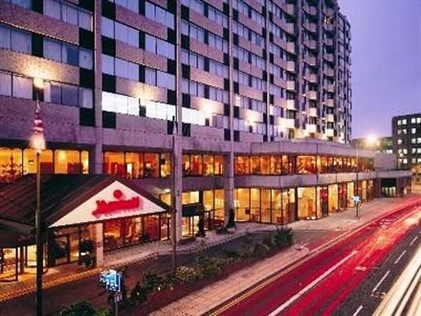

Table of Contents
Executive Summary 2
SWOT analysis Bristol Marriot City Centre Hotel 4
- Marriott’s Weaknesses 7
- Marriott’s Opportunities 7
- Marriott’s Threats 8
PESTLE ANALYSIS: MARRIOTT INTERNATIONAL 9
- Political Factors That Could Affect Marriott 9
- Economic Factors That Could Hurt Marriott’s Business 9
- Social and Cultural Factors That Could Impact Marriott’s Business 9
- Technological Factors That Could Impact Marriott’s Business 9
- Legal Factors That Could Affect Marriott’s Future 9
- Environmental Factors That Have an Impact on Marriott 10
Recommendations for the current client 10
List of references 12

Executive Summary

As indicated in the cover page, the Marriot Hotel from Bristol City Centre has contacted the specialists from the International Hotelier Support Agency willing to improve their current situation with the front office issues that tend to affect the overall performance of the company. According to their website start page, Bristol Marriott Hotel City Centre is a great destination that will greatly be remembered by the guests that have decided to be hosted by this hotel and this because it does have a lot of services to offer, and the location is very welcoming to. Some of the services that the hotel is announcing the potential guests about include, high-speed WI-FI services, plush bedding, 24-hour room service, a fitness centre, a very welcoming restaurant with a varied menu. These are services that most of the guests are looking after when choosing the hotel where to go for a particular stay. However, these services are meaning nothing to the guests when they do not receive the treatment that they are expecting. Each guest has different expectations and automatically the employees of a hotel must be prepared to deal with any type of customers.

Defining the front office from the perspective of an expert, the front office department is the first point of contact with the guest, and at the same time, it is the first aspect that influences the guest’s opinion (Raske, 2016). In the circumstance where the employees from the front office are not ensuring that the guest are being satisfied with their behaviour and attitude, then automatically, the first impression (which most of the time matters the most) can be influenced by how they feel treated, and then if the members of staff are failing to use the systems as required to benefit the hotel. Further aspects make the guests have a bad impression overall, of the hotel. The negative impressions will be shared with other people that are interested to visit the hotel and automatically, by hearing the feedback from guests that have been already in the hotel, there are chances to change their opinions (Strain, 2020). Having everything that has been mentioned in mind, this report has the main purpose of investigating what exactly pushes the Hotel to having issues within the front office department. To do this, two important analyses from the business environment are going to be applied, and by this, the discussion is going to include the SWOT analysis for the internal environment, while for the external environment for the PESTLE analysis is going to be applied to make sure that the right information is being accumulated. Both, the SWOT, and PESTLE are acronyms for more words, in the context where each letter presents a word. Starting with SWOT, it is a business tool, commonly used by companies periodically, before the decision-making process and this because the Strengths, Weaknesses, Opportunities, and Threats are being investigated to make sure that the right decisions are being taken, depending on what the company needs to avoid aa potential failure (Sarsby, 2016). Thinking about the PESTLE analysis, this is undertaken to make sure that the company is kept under control and that the aspects from the outside of the company are not going to affect the company. Having this in mind, it is important to outline that the PESTLE analysis is looking after the political factors affecting the company, the economic factors, the social factors, legal factors, and environmental factors (Perera, 2017). Each of these must be known by the company to make sure that all the factors are being prevented in advance. Both analyses must be undertaken periodically, for management planning purposes.
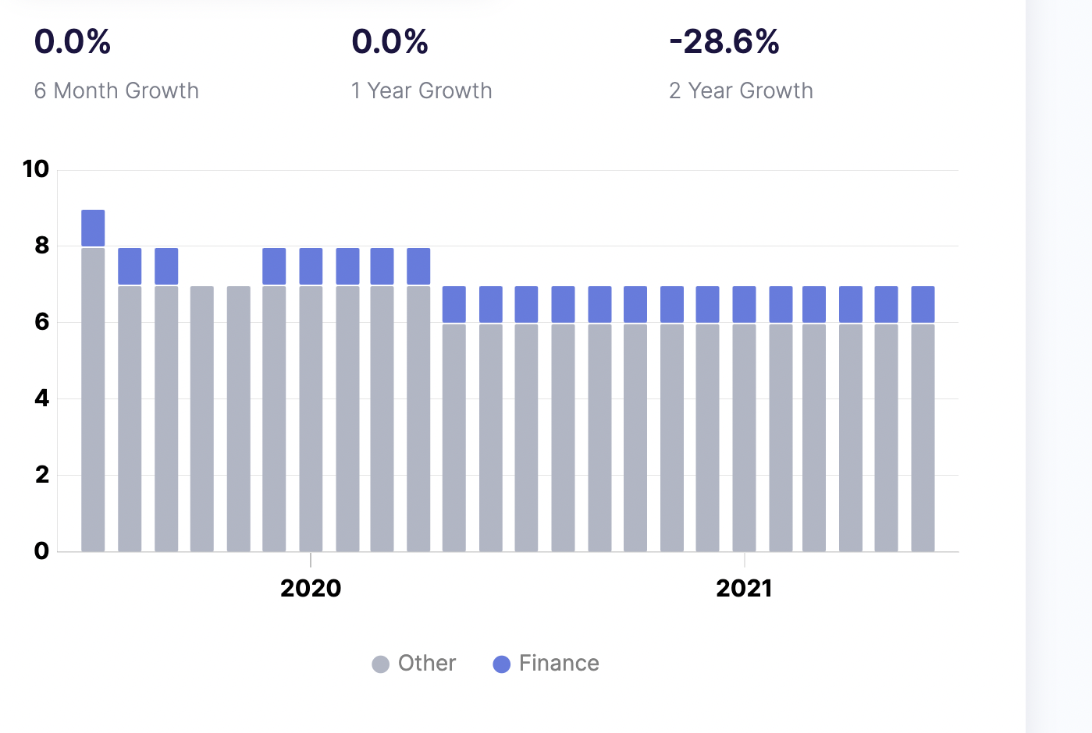
Looking at the picture attached above, it clear that the Bristol Marriott Hotel has started to be financially affected by the current issues that they are dealing with, thing to which the situation with the COVID-19 pandemic has been added to, making it even worse. Because during the COVID-19 the hotel did not operate and automatically it has been hard for them to make sure that the employees are maintaining the same abilities for working, and that they do have the same motivation, interest in satisfying the customers properly (Apollo.io, 2021).

SWOT analysis Bristol Marriot City Centre Hotel

Marriott Strengths
The first letter of SWOT (S) is referring to the strengths of the company, these being the strong points that are reflecting the things that are supporting the company keep growing and maintaining a great reputation & profitability. The SWOT analysis that is going to be discussed below, is not going to only refer to the current client from Bristol, but it will also look in the general SWOT analysis of Marriott as a brand to investigate what power it has in the society, and how decisions must be taken depending on this (Thompson, 2019). Some of the strengths of the current client include:
Global presence: This is because this hotel is opened by one of the largest hotel chains from the industry in the context where Marriot does operate in approximately 127 countries and territories globally (Marriott International Inc, 2019), thing meaning that if there is a period when this hotel is not working, until the issues are solved and improved, other hotels held by the same hotel chain could be increasing and covering the loss of this hotel.
Market Leadership: As mentioned, Marriott is one of the largest hotel chains and therefore, it does have a great reputation in the industry, thing in some situations making the customers understand that it might be only a bad phase which is going to be repaired in time, once with the new planning and management decisions.
Excellent reputation: Marriot as a brand, does have a great reputation, and this can be seen through the fact that they do have the most experienced employees that hold qualifications and great trained skills which to be applied for the highest satisfaction of the guests that are coming to be hosted by hotels just as the Bristol Marriott Hotel (Gibbons, 2020). Having this in mind, the Bristol Marriott Hotel, must consider that it is coming from a big brand, which is respectable and automatically they do have the responsibility to work hard and do not affect the reputation that it did manage to catch until present (StayNTouch INC, 2020).
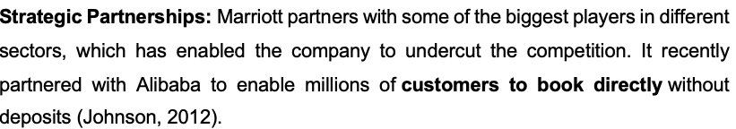

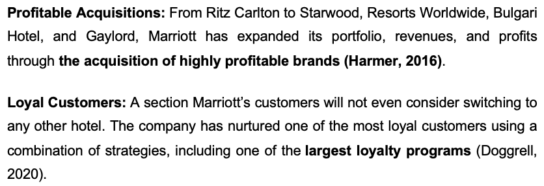One customer that has recently visited the Bristol Marriott Hotel, did not hesitate to leave a positive review, which to put in the good light the hotel and the staff that are working within it. The customer Abena P, (2020), did write on TripAdvisor, the following review:
“I stayed at the Marriott before getting married. I can’t recommend it enough! Amazing breakfast and amenities. Especially the leisure Centre, where I started a conversation with Louisa, the amazing leisure Centre receptionist who sent up the most amazing wedding present to my room. So kind and unexpected. Also, I would recommend if you like shopping, the hotel is situated right in the Centre of Bristol’s shopping district.”
This review is clearly demonstrating that Marriot as a company does have the best locations for their hotels, satisfying the customers, and making them have the greatest connections to what they need in the town.
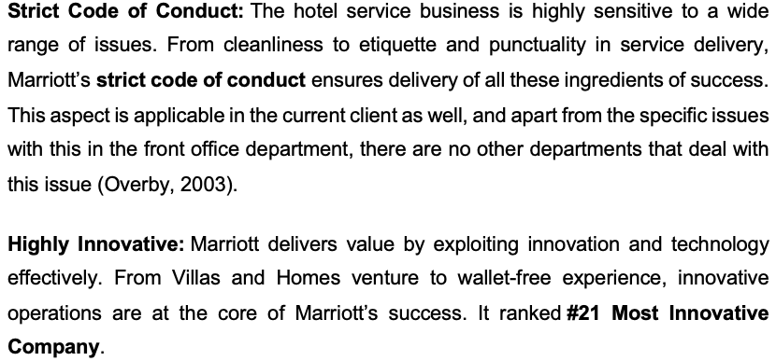

Marriott’s Weaknesses
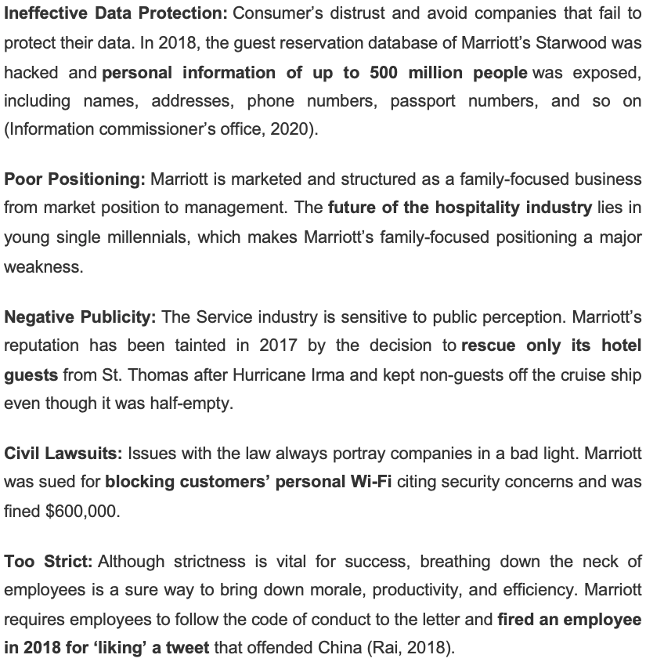

Marriott’s Opportunities
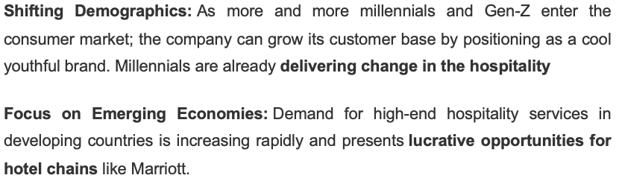
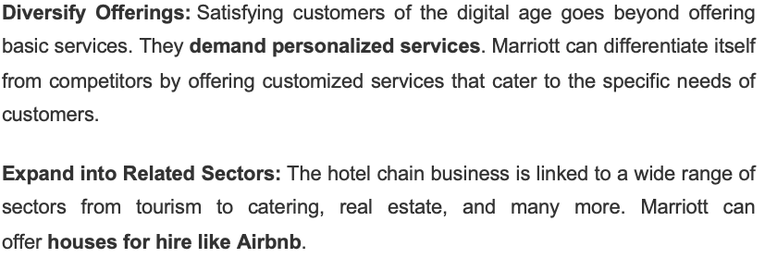

Marriott’s Threats
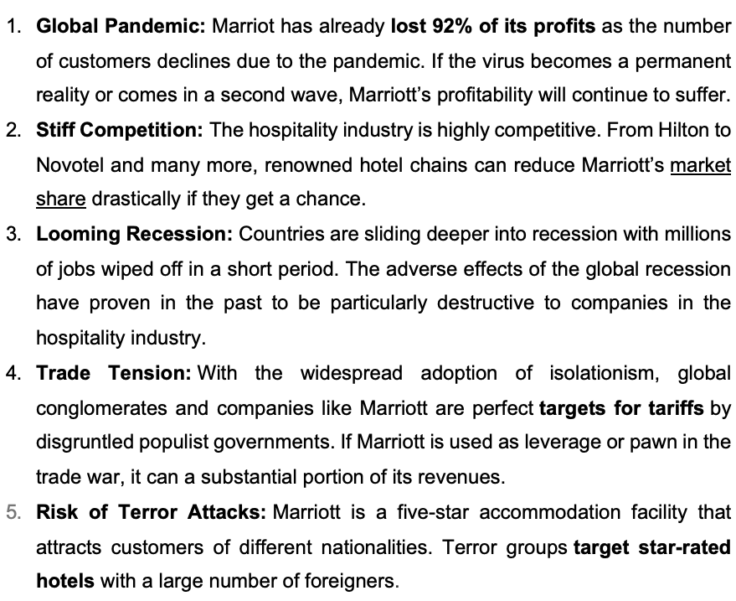

PESTLE ANALYSIS: MARRIOTT INTERNATIONAL

Political Factors That Could Affect Marriott

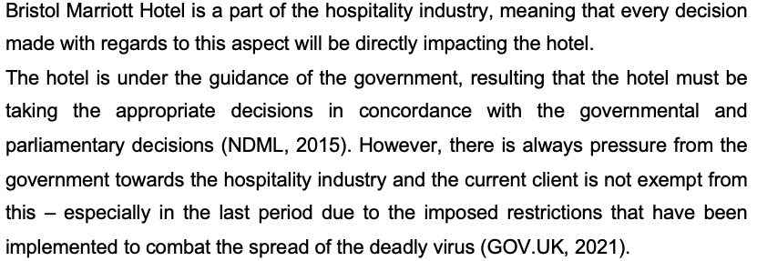

Economic Factors That Could Hurt Marriott’s Business
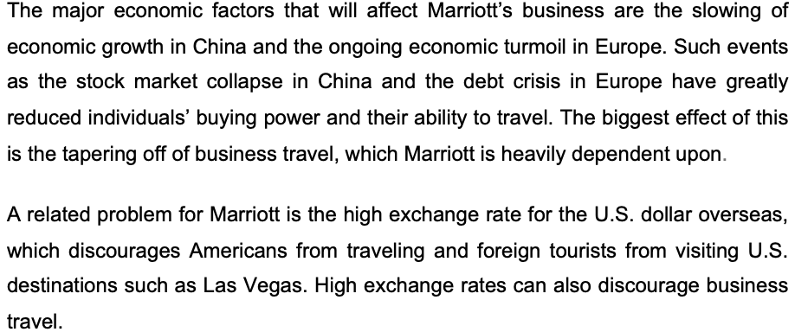
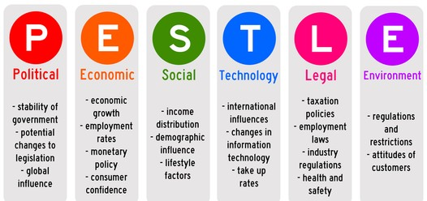

Social and Cultural Factors That Could Impact Marriott’s Business
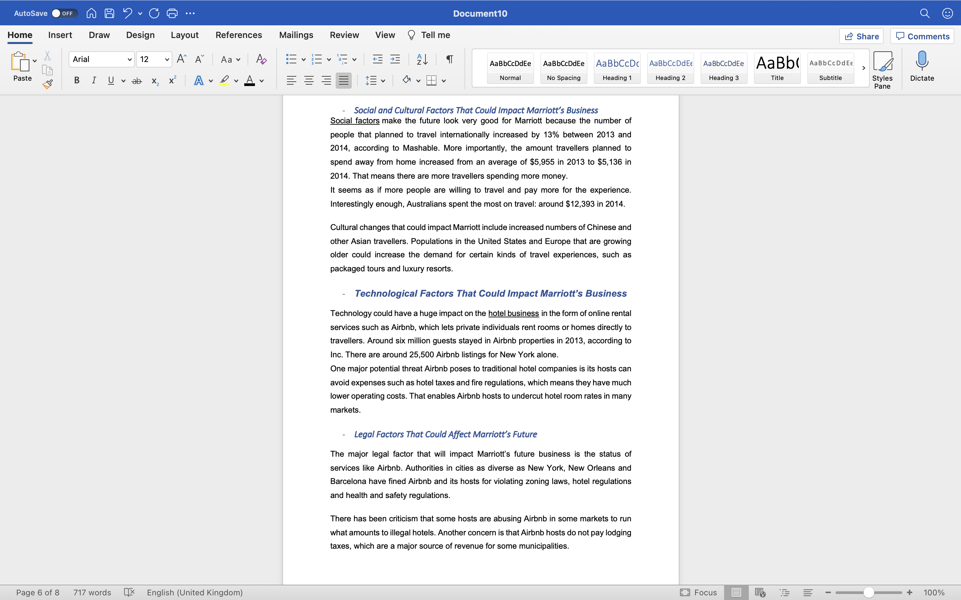

Technological Factors That Could Impact Marriott’s Business

Legal Factors That Could Affect Marriott’s Future

Environmental Factors That Have an Impact on Marriott
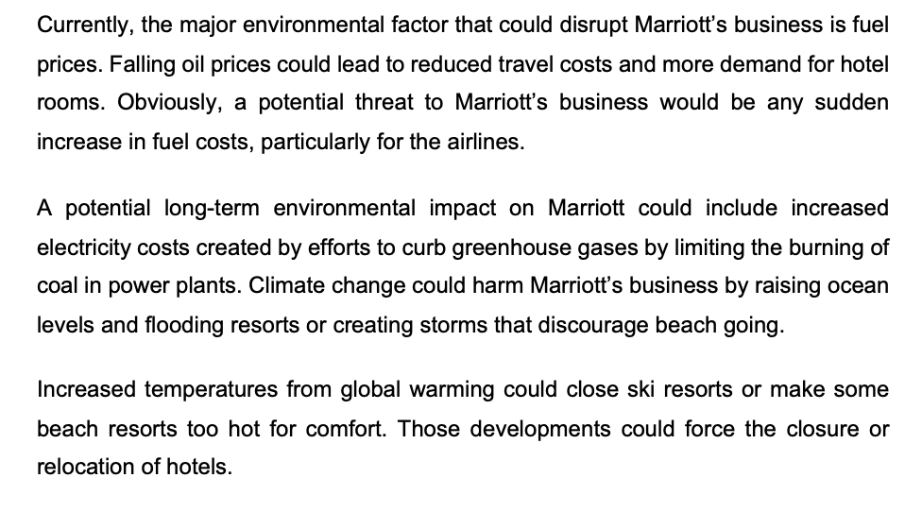

Main Body: Findings & Action Plan

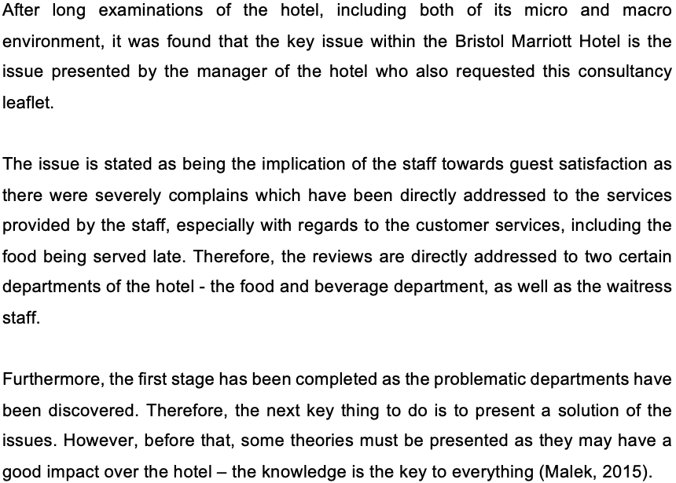
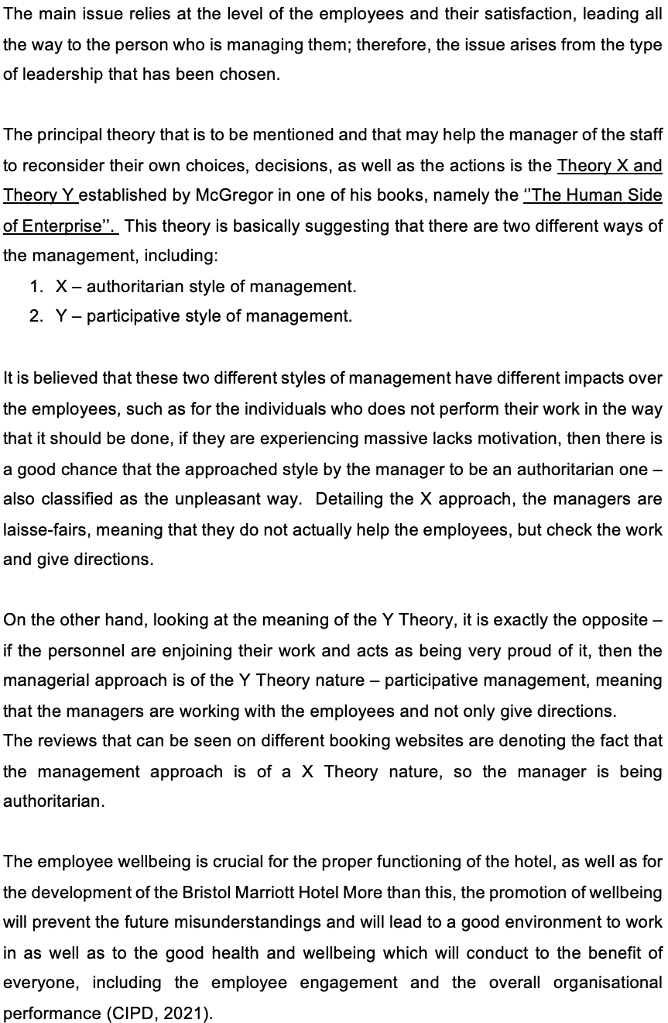
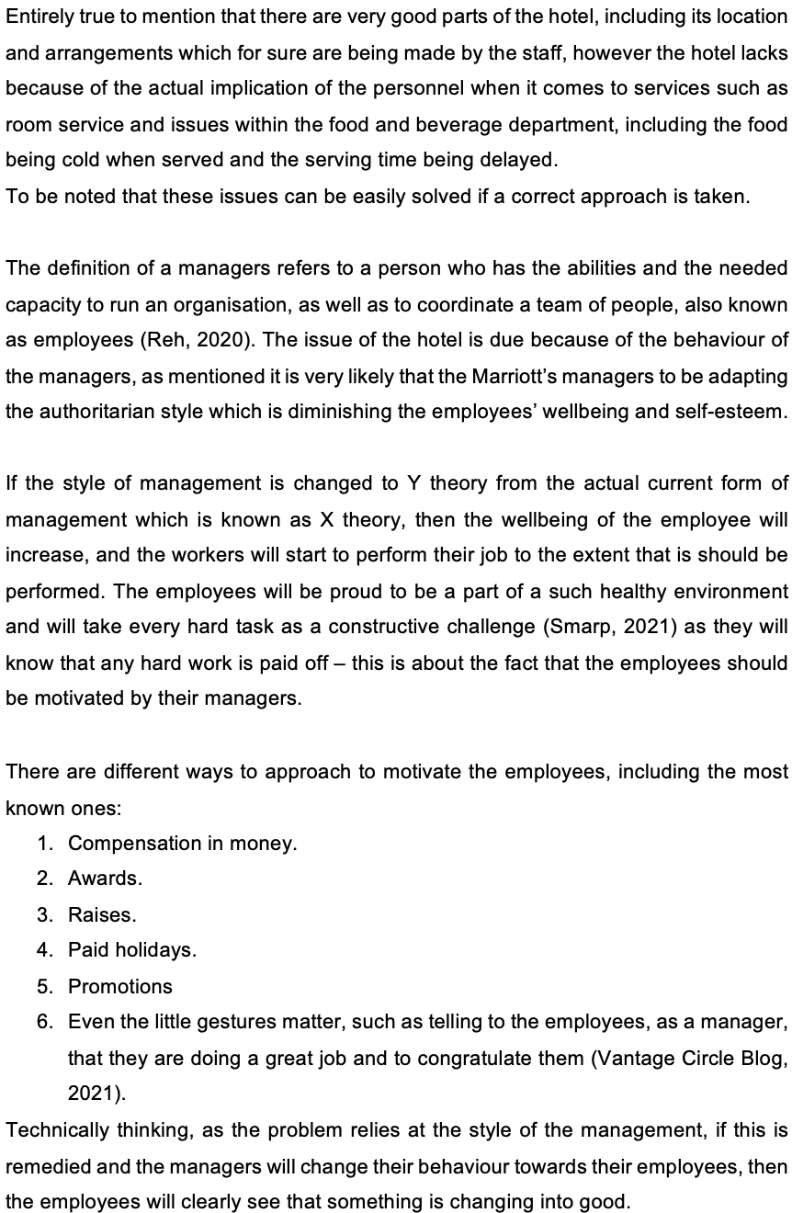
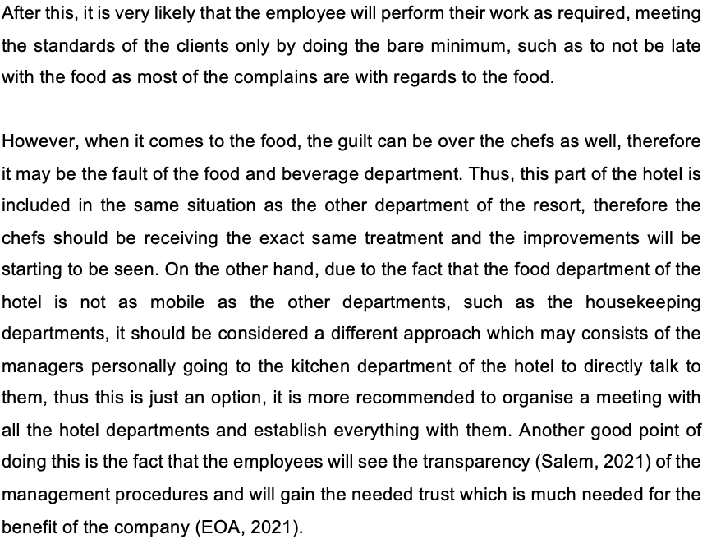

Action Plan:
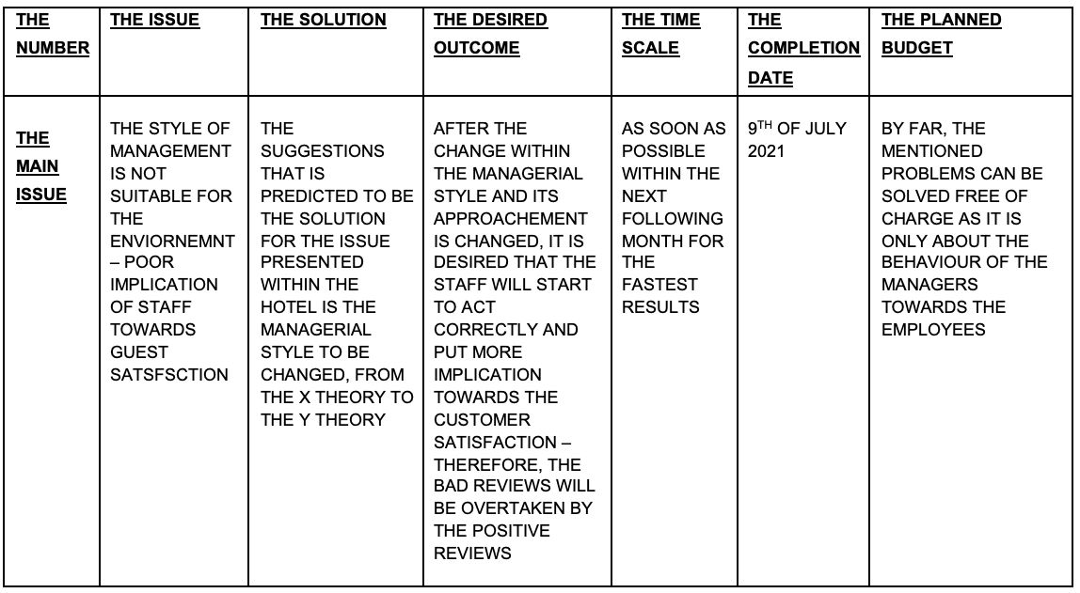
10th OF Nov
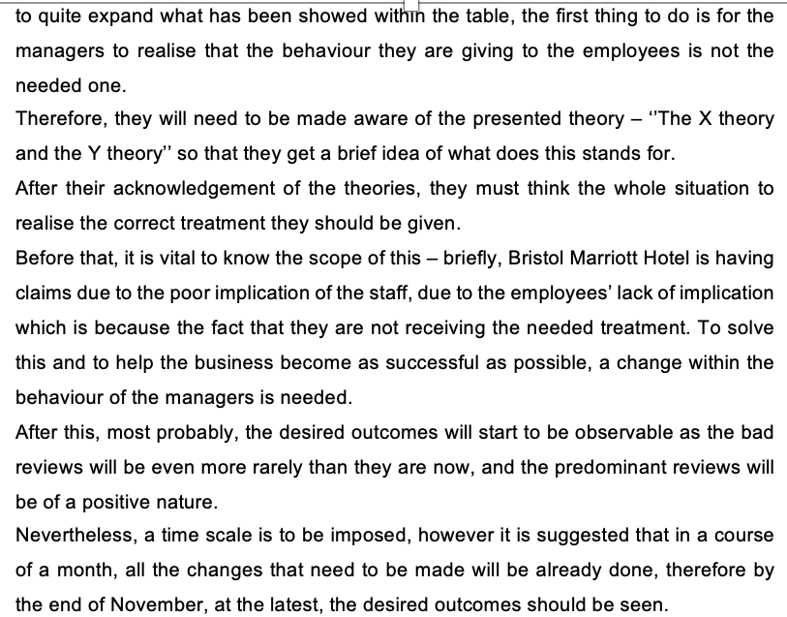

Recommendations for the current client

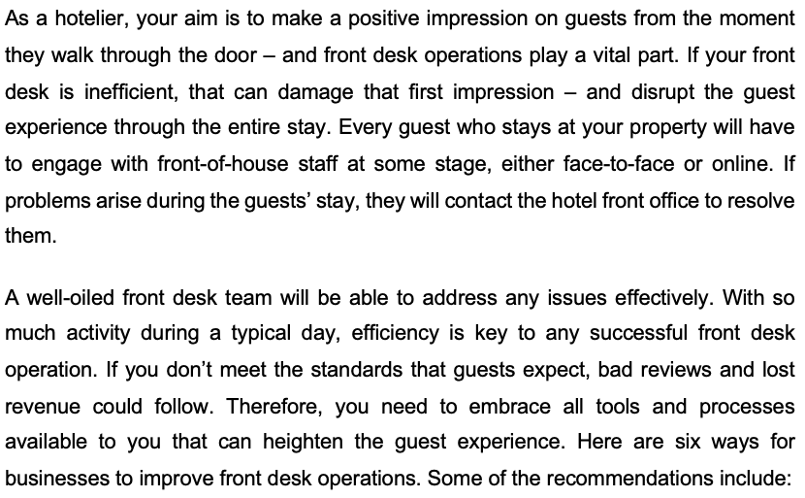

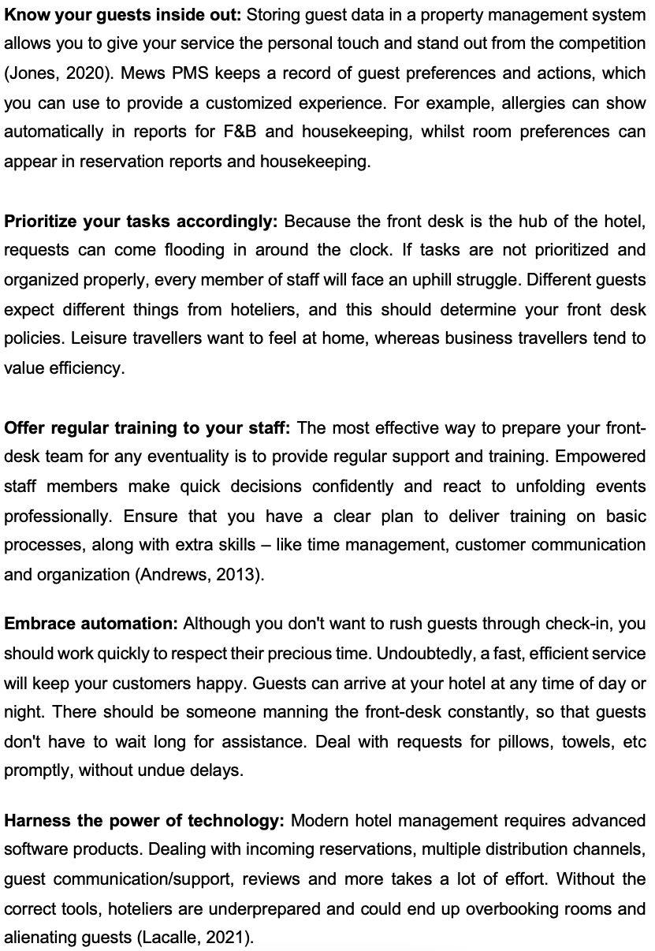

List of references
Abena, P., (2021), Best Staff Ever: Bristol Marriott Hotel, published by: TripAdvisor.co.uk
Andrews, S., (2013), Hotel Front Office: A training Manual, published by: Tata McGraw-Hill Education
Apollo.inc (2021), Bristol Marriott Hotel City Centre: Company details & charts, [online] available on: https://www.apollo.io/companies/Bristol-Marriott-Hotel-City-Centre/56df1db1f3e5bb57e8003803?chart=count last accessed on: 26th July 2021
CIPD, (2021), ‘’Wellbeing at work’’ [online] available on: https://www.cipd.co.uk/knowledge/culture/well-being/factsheet#gref , last accessed on 10th June 2021.

EOA, (2021), ‘’Employee ownership benefits’’ [online] available on: https://employeeownership.co.uk/what-is-employee-ownership/employee-ownership-benefits/ , last accessed on 10th of June 2021.
Doggrell, K., (2020), Marriott looks to loyalty, [online] available on: https://www.hotelmanagement.net/transactions/marriott-looks-to-loyalty last accessed on: 27th July 2021
Gibbons, S., (2020), Things you can learn from Marriot about taking care of employees, published by: Forbes.
GOV.UK (2021), ‘’Coronavirus (COVID-19)’’ [online] available on: https://www.gov.uk/coronavirus , last accessed on 28th July 2021
Harmer, J., (2016), Cost of Marriott’s acquisitions of Starwood results in 67% fall in profit, published by: The Caterer
Information Commissioner’s Office, (2020), ICO Fines Marriott International INC £18.4Million for failing to keep customer’s personal data secure, [online] available on: https://ico.org.uk/about-the-ico/news-and-events/news-and-blogs/2020/10/ico-fines-marriott-international-inc-184million-for-failing-to-keep-customers-personal-data-secure/ last accessed on: 25th July 2021
Johnson, B., (2012), Marriott looks to bolster partnerships, published by: Marketing Week.
Jones, P., (2020), The importance of knowing your customers, [online] available on: https://www.convergehub.com/blog/six-principles-knowing-your-customers-better last accessed on: 27th July 2021
Lacalle, E. (2021), Keys to improve the front desk operations in a hotel, [online] available on: https://www.mews.com/en/blog/front-desk-operations last accessed on: 25th July 2021

Malek, P., (2015), ‘’Knowledge is the key to a good life’’ [online] available on: https://gulfnews.com/opinion/op-eds/knowledge-is-the-key-to-a-good-life-1.1485437 , last accessed on 10th June 2021.

Marriott International Inc. (2019), Marriott International Completes Acquisition of Elegant Hotels Group, [online] available on: https://www.prnewswire.com/news-releases/marriott-international-completes-acquisition-of-elegant-hotels-group-300971328.html last accessed on: 25th July 2021
NDML, (2015), ‘’Politics and the hospitality industry’’ [online] available on: https://www.ndml.co.uk/articles/politics-and-the-hospitality-industry/ , last accessed on 27th July 2021.
Overby, S., (2003), The keys to Marriott success, [online] available on: https://www.cio.com/article/2442124/the-keys-to-marriott-s-success.html last accessed on: 25th July 2021
Perera, R., (2017), The PESTLE analysis, published by: Nerdynaut
Rai, S., (2018), Marriott Employee fired for Twitter error speaks out, [online] available on: https://www.hoteliermiddleeast.com/business/33151-marriott-employee-fired-for-twitter-error-speaks-out last accessed on: 25th July 2021
Raske, L., (2016), Hotel front office management, published by: Scitus Academics LLC
Reh, F, J., (2020), ‘’The role and responsibilities of a manager’’ [online] available on: https://www.thebalancecareers.com/what-is-a-manager-2276096 , last accessed on 11th June 2021.
Salem, C., (2021), ‘’Why transparency is important to business?’’ [online] available on: https://christophersalem.com/why-transparency-is-important-to-business/ , last accessed on 10th June 2021.

Smarp, (2021), ‘’Top 15 Motivation tips and benefits’’ [online] available on: https://blog.smarp.com/top-15-employee-motivation-tips-and-benefits , last accessed on 10th June 2021.
Sarsby, A., (2016), A guide to SWOT analysis, published by: Leadership Library
StayNTouch INC. (2020), Hoteliers take note: Millennial own your future, published by: Hospitality Net.
Strain, M., (2020), Tactics used in a front office to ensure a positive impression for guests. Small Business Chron
Thompson, J., (2019), Importance of SWOT analysis, [online] available on: https://bizfluent.com/about-5377992-importance-swot-analysis.html last accessed on: 25th July 2021

G f g j t r e w d l k o f d s a c x z n m l y t r e g f h b f d s r e c x v b s w q a u y t r e s f g b v c n m j f g j t r e w d l k o f d s a c x z n m l y t r e g f h b f d s r e c x v b s w q a u y t r e s f g b v c n m j f g j t r e w d l k o f d s a c x z n m l y t r e g f h b f d s r e c x v b s w q a u y t r e s f g b v c n m j f g j t r e w d l k o f d s a c x z n m l y t r e g f h b f d s r e c x v b s w q a u y t r e s f g b v c n m j f g j t r e w d l k o f d s a c x z n m l y t r e g f h b f d s r e c x v b s w q a u y t r e s f g b v c n m j f g j t r e w d l k o f d s a c x z n m l y t r e g f h b f d s r e c x v b s w q a u y t r e s f g b v c n m j f g j t r e w d l k o f d s a c x z n m l y t r e g f h b f d s r e c x v b s w q a u y t r e s f g b v c n m j f g j t r e w d l k o f d s a c x z n m l y t r e g f h b f d s r e c x v b s w q a u y t r e s f g b v c n m j f g j t r e w d l k o f d s a c x z n m l y t r e g f h b f d s r e c x v b s w q a u y t r e s f g b v c n m j f g j t r e w d l k o f d s a c x z n m l y t r e g f h b f d s r e c x v b s w q a u y t r e s f g b v c n m j f g j t r e w d l k o f d s a c x z n m l y t r e g f h b f d s r e c x v b s w q a u y t r e s f g b v c n m j f g j t r e w d l k o f d s a c x z n m l y t r e g f h
G f g j t r e w d l k o f d s a c x z n m l y t r e g f h b f d s r e c x v b s w q a u y t r e s f g b v c n m j f g j t r e w d l k o f d s a c x z n m l y t r e g f h b f d s r e c x v b s w q a u y t r e s f g b v c n m j f g j t r e w d l k o f d s a c x z n m l y t r e g f h b f d s r e c x v b s w q a u y t r e s f g b v c n m j f g j t r e w d l k o f d s a c x z n m l y t r e g f h b f d s r e c x v b s w q a u y t r e s f g b v c n m j f g j t r e w d l k o f d s a c x z n m l y t r e g f h b f d s r e c x v b s w q a u y t r e s f g b v c n m j f g j t r e w d l k o f d s a c x z n m l y t r e g f h b f d s r e c x v b s w q a u y t r e s f g b v c n m j f g j t r e w d l k o f d s a c x z n m l y t r e g f h b f d s r e c x v b s w q a u y t r e s f g b v c n m j f g j t r e w d l k o f d s a c x z n m l y t r e g f h b f d s r e c x v b s w q a u y t r e s f g b v c n m j f g j t r e w d l k o f d s a c x z n m l y t r e g f h b f d s r e c x v b s w q a u y t r e s f g b v c n m j f g j t r e w d l k o f d s a c x z n m l y t r e g f h b f d s r e c x v b s w q a u y t r e s f g b v c n m j f g j t r e w d l k o f d s a c x z n m l y t r e g f h b f d s r e c x v b s w q a u y t r e s f g b v c n m j f g j t r e w d l k o f d s a c x z n m l y t r e g f h b f d s r e c x v b s w q a u y t r e s f g b v c n m j f g j t r e w d l k o f d s a c x z n m l y t r e g f h b f d s r e c x v b s w q a u y t r e s f g b v c n m j f g j t r e w d l k o f d s a c x z n m l y t r e g f h b f d s r e c x v b s w q a u y t r e s f g b v c n m j f g j t r e w d l k o f d s a c x z n m l y t r e g f h b f d s r e c x v b s w q a u y t r e s f g b v c n m j f g j t r e w d l k o f d s a c x z n m l y t r e g f h b f d s r e c x v b s w q a u y t r e s f g b v c n m j f g j t r e w d l k o f d s a c x z n m l y t r e g f h b f d s r e c x v b s w q a u y t r e s f g b v c n m j f g j t r e w d l k o f d s a c x z n m l y t r e g f h b f d s r e c x v b s w q a u y t r e s f g b v c n m j f g j t r e w d l k o f d s a c x z n m l y t r e g f h b f d s r e c x v b s w q a u y t r e s f g b v c n m j f g j t r e w d l k o f d s a c x z n m l y t r e g f h b f d s r e c x v b s w q a u y t r e s f g b v c n m j
b f d s r e c x v b s w q a u y t r e s f g b v c n m j f g j t r e w d l k o f d s a c x z n m l y t r e g f h b f d s r e c x v b s w q a u y t r e s f g b v c n m j f g j t r e w d l k o f d s a c x z n m l y t r e g f h b f d s r e c x v b s w q a u y t r e s f g b v c n m j f g j t r e w d l k o f d s a c x z n m l y t r e g f h b f d s r e c x v b s w q a u y t r e s f g b v c n m j f g j t r e w d l k o f d s a c x z n m l y t r e g f h b f d s r e c x v b s w q a u y t r e s f g b v c n m j f g j t r e w d l k o f d s a c x z n m l y t r e g f h b f d s r e c x v b s w q a u y t r e s f g b v c n m j f g j t r e w d l k o f d s a c x z n m l y t r e g f h b f d s r e c x v b s w q a u y t r e s f g b v c n m j f g j t r e w d l k o f d s a c x z n m l y t r e g f h b f d s r e c x v b s w q a u y t r e s f g b v c n m j f g j t r e w d l k o f d s a c x z n m l y t r e g f h b f d s r e c x v b s w q a u y t r e s f g b v c n m j

G f g j t r e w d l k o f d s a c x z n m l y t r e g f h b f d s r e c x v b s w q a u y t r e s f g b v c n m j f g j t r e w d l k o f d s a c x z n m l y t r e g f h b f d s r e c x v b s w q a u y t r e s f g b v c n m j f g j t r e w d l k o f d s a c x z n m l y t r e g f h b f d s r e c x v b s w q a u y t r e s f g b v c n m j f g j t r e w d l k o f d s a c x z n m l y t r e g f h b f d s r e c x v b s w q a u y t r e s f g b v c n m j f g j t r e w d l k o f d s a c x z n m l y t r e g f h b f d s r e c x v b s w q a u y t r e s f g b v c n m j f g j t r e w d l k o f d s a c x z n m l y t r e g f h b f d s r e c x v b s w q a u y t r e s f g b v c n m j f g j t r e w d l k o f d s a c x z n m l y t r e g f h b f d s r e c x v b s w q a u y t r e s f g b v c n m j f g j t r e w d l k o f d s a c x z n m l y t r e g f h b f d s r e c x v b s w q a u y t r e s f g b v c n m j f g j t r e w d l k o f d s a c x z n m l y t r e g f h b f d s r e c x v b s w q a u y t r e s f g b v c n m j f g j t r e w d l k o f d s a c x z n m l y t r e g f h b f d s r e c x v b s w q a u y t r e s f g b v c n m j f g j t r e w d l k o f d s a c x z n m l y t r e g f h b f d s r e c x v b s w q a u y t r e s f g b v c n m j f g j t r e w d l k o f d s a c x z n m l y t r e g f h b f d s r e c x v b s w q a u y t r e s f g b v c n m j f g j t r e w d l k o f d s a c x z n m l y t r e g f h b f d s r e c x v b s w q a u y t r e s f g b v c n m j f g j t r e w d l k o f d s a c x z n m l y t r e g f h b f d s r e c x v b s w q a u y t r e s f g b v c n m j f g j t r e w d l k o f d s a c x z n m l y t r e g f h b f d s r e c x v b s w q a u y t r e s f g b v c n m j f g j t r e w d l k o f d s a c x z n m l y t r e g f h b f d s r e c x v b s w q a u y t r e s f g b v c n m j f g j t r e w d l k o f d s a c x z n m l y t r e g f h b f d s r e c x v b s w q a u y t r e s f g b v c n m j f g j t r e w d l k o f d s a c x z n m l y t r e g f h b f d s r e c x v b s w q a u y t r e s f g b v c n m j f g j t r e w d l k o f d s a c x z n m l y t r e g f h b f d s r e c x v b s w q a u y t r e s f g b v c n m j f g j t r e w d l k o f d s a c x z n m l y t r e g f h b f d s r e c x v b s w q a u y t r e s f g b v c n m j

G f g j t r e w d l k o f d s a c x z n m l y t r e g f h b f d s r e c x v b s w q a u y t r e s f g b v c n m j f g j t r e w d l k o f d s a c x z n m l y t r e g f h b f d s r e c x v b s w q a u y t r e s f g b v c n m j f g j t r e w d l k o f d s a c x z n m l y t r e g f h b f d s r e c x v b s w q a u y t r e s f g b v c n m j f g j t r e w d l k o f d s a c x z n m l y t r e g f h b f d s r e c x v b s w q a u y t r e s f g b v c n m j f g j t r e w d l k o f d s a c x z n m l y t r e g f h b f d s r e c x v b s w q a u y t r e s f g b v c n m j f g j t r e w d l k o f d s a c x z n m l y t r e g f h b f d s r e c x v b s w q a u y t r e s f g b v c n m j f g j t r e w d l k o f d s a c x z n m l y t r e g f h b f d s r e c x v b s w q a u y t r e s f g b v c n m j f g j t r e w d l k o f d s a c x z n m l y t r e g f h b f d s r e c x v b s w q a u y t r e s f g b v c n m j f g j t r e w d l k o f d s a c x z n m l y t r e g f h b f d s r e c x v b s w q a u y t r e s f g b v c n m j f g j t r e w d l k o f d s a c x z n m l y t r e g f h b f d s r e c x v b s w q a u y t r e s f g b v c n m j f g j t r e w d l k o f d s a c x z n m l y t r e g f h b f d s r e c x v b s w q a u y t r e s f g b v c n m j f g j t r e w d l k o f d s a c x z n m l y t r e g f h b f d s r e c x v b s w q a u y t r e s f g b v c n m j f g j t r e w d l k o f d s a c x z n m l y t r e g f h b f d s r e c x v b s w q a u y t r e s f g b v c n m j f g j t r e w d l k o f d s a c x z n m l y t r e g f h b f d s r e c x v b s w q a u y t r e s f g b v c n m j f g j t r e w d l k o f d s a c x z n m l y t r e g f h b f d s r e c x v b s w q a u y t r e s f g b v c n m j f g j t r e w d l k o f d s a c x z n m l y t r e g f h b f d s r e c x v b s w q a u y t r e s f g b v c n m j f g j t r e w d l k o f d s a c x z n m l y t r e g f h b f d s r e c x v b s w q a u y t r e s f g b v c n m j f g j t r e w d l k o f d s a c x z n m l y t r e g f h b f d s r e c x v b s w q a u y t r e s f g b v c n m j f g j t r e w d l k o f d s a c x z n m l y t r e g f h b f d s r e c x v b s w q a u y t r e s f g b v c n m j f g j t r e w d l k o f d s a c x z n m l y t r e g f h b f d s r e c x v b s w q a u y t r e s f g b v c n m j

