Assignment Title: Intercultural Competence Report

Student name:Anca Roxana Iclanzean

Student id:2207144

Module lead:Lisa Bassler

Module code: BMIH5003

Word count: 1089

Executive Summary
The primary objective of this report is to analyse the intercultural obstacles encountered by the esteemed five-star Diversity Hotel and Spa London throughout its expansion process into India. Understanding and bridging the cultural divides between England and India is of ulmost importance in my role as general manager leading the staff training for the newly opened branch. This report will discuss intercultural competence and the significance of cultural awareness. This report will also analyse and demonstrate the two countries' major cultural and behavioural differences,analysing the scores of few dimensions ,and also include a list of recomendations
Table of Contents
Executive Summary 1
Introduction 3
Cultural overview 3
Importance of cultural understanding in a global marketplace 4
Analysis of culture of England and India 5
Conclusion 6
Recommendations 6
References 7
Appendices 9
Appendix – 1: Global Study Result of England 9
Appendix – 2: Global Study Result of India 10

Introduction
Intercultural competence is the capability to perceive and recognise cultural differences and revere all people by overcoming cultural obstacles (Deresky, 2017). Diversity Hotel and Spa London is a renowned five-star hotel in London, and they have exclusive spa services for the guests. The hotel has exquisite value in culture, and they have operated in other European countries as well. As a general manager, the duty is to train the staff of a newly opened branch in India.

Cultural overview
A culture encircles a group of people or community where a distinct feature comprising values, norms and beliefs is built. One culture is different from another with some distinguished characteristics (Maheshkar and Sharma, 2018). While planning for expanding business in a new region, the culture of the respective region must be analysed and perceived first. Major cultural overviews and differences are discussed here.
The culture of London is highly influenced by the culture of Great Britain. This culture is the essence of multifarious age-old historical events. British was ahead of all contemporary races concerning literature, sports, technology etc. As the capital city of England, London is full of diverse people from all over the world. The per capita income and standard of living of the British is higher than the Indians.

On the contrary, India is the largest country in South Asia with people of different cultures and religions (Shah, 2015). Once Indian subcontinent was the colony of England for about two hundred years. Consequently, the culture, norms, education, and laws of India were substantially predisposed by the British. India is a popular marketplace for international business and foreign direct investment for its large population (Gupta et al., 2023). As India is a developing country, the standard of living of Indians is getting high and people are spending more on travelling and entertainment (Asher and Talbot, 2023).

Importance of cultural understanding in a global marketplace
The value of learning about other cultures is obvious. No company can succeed on a global scale without first researching and understanding the market it intends to enter.
Effective communication: A communication gap arises while interacting with people of different cultures (Maheshkar and Sharma, 2018). To minimise the gap, cultural awareness is required. For example, when the Diversity Hotel and Spa London authority has a good perception of the culture of India, they can effectively communicate with them and gather the necessary information they need.
Reducing cultural barriers: Cultural barriers concerning language, habit, and mentality can be overcome with cultural awareness (Deresky, 2017). For example, the Diversity Hotel and Spa London can customise its service offerings according to the lifestyles and choices of Indian people.
Effective decision-making: Cultural understanding allows a global company to make effective decisions in international business. Analysing the environment and culture they can decide whether they should expand their business in that particular market (Christiansen et al., 2020). For example, considering India's large customer base and growing income, the management of Diversity Hotel and Spa London decided to roll out operations in this market.

Analysis of culture of England and India
A comparison between the cultures of England and India is given below:
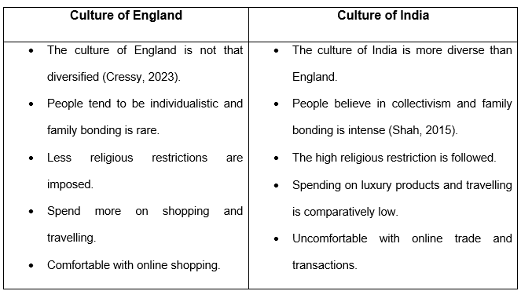
Demonstrating a critical understanding of key cultural differences, customs, and behaviour between England and India.
Major cultural, behavioural, and traditional differences between England and India are presented below:
Performance orientation: The British are more aware of the monetary and social benefits of business (Cressy, 2023). Indian businessmen are also profit-oriented which demonstrates the performance orientation index of global project results to be almost similar (Score – 4) (Globe Project, 2023a; Globe Project, 2023b). But they emphasise building relationships. Mutual trust is prominent here in terms of business deeds and contracts. Usury is prevalent in India while less popular in England (Hoffmann et al., 2021).
Human orientation Based on the humane orientation index of Global Project score, Indian people are more social and religious (Score – 5) than the British (score – 4) (Globe Project, 2023a; Globe Project, 2023b). The rate of divorce and suicide is higher in London than in India. However, in terms of purchasing or availing a service British focus on quality. Conversely, Indians underscore the price over quality (Basha and Lal, 2019). Children of England are more independent than the children and teenagers of India.

Uncertainty avoidance: The people of England are more sincere about time and words. Indians are somewhat indifferent about time and words (Gupta et al., 2023). This is demonstrated in the future orientation dimension of England which is relatively higher than that of India. The uncertainty avoidance index in England is higher (5) than in India (4) (Globe Project, 2023a; Globe Project, 2023b). Therefore, British people are risk-takers and have a spending tendency. However, Indians try to save money and bypass risks. Indians are critically resolute in negotiations while the British are comparatively flexible in negotiation.
Individualism: Individualism is a dimension with a big scores bewtween this countries because England is 76 and they are classed as individualist society acording to (Hofstede 2023) and India score low in dimension because is classed as a country who is collectivistic and individualist society (Hofstede 2023)

Conclusion
Despite some cultural barriers, India is a potentially profitable business ground for the Diversity Hotel and Spa London. As the economy and standard of living of Indians are improving and they have an influential tourism sector, the Diversity Hotel and Spa London authority can leverage this advantage by removing barriers through market and cultural awareness.

Recommendations
Analysing all perspectives discussed above, some recommendations for facilitating the expansion of the Hotel, and avoiding any cultural misunderstanding, are given below:
- The administration of the Diversity Hotel and Spa London must thoroughly identify the cultural differences between England and India and build good cultural awareness. Understanding the cultural aspects of the local country where the company will expand its business will enable the company to provide culture-friendly services to the customers and avoid any cultural misunderstanding.
- The management of the hotel can employ local employees who have better knowledge and understanding of the local culture. Local employees are more likely to offer better services in terms of cultural aspects to the customers.
- The company should also organise appropriate training programs so that the company culture and values can be sustained along with the culture and customs of the local culture. This will enable the company to maintain the company value and mission and hence stick to the long-term goal of the organisation as well.
Above mentioned are the recommendations for the better cultural and awareness development of the hotel.

References
Asher, C.B. and Talbot, C. (2022) India Before Europe. Cambridge University Press.
Basha, M.B. and Lal, D. (2019) ‘Indian consumers' attitudes towards purchasing organically produced foods: An empirical study’, Journal of cleaner production, 215, pp.99-111. https://doi.org/10.1016/j.jclepro.2018.12.098
Christiansen, B., Branch, J.D. and Karmowska, J. (2020) Cultural Factors and Performance in 21st Century Businesses. IGI Global.
Cressy, D. (2023) Society and culture in early modern England. Taylor & Francis.
Deresky, H. (2017) International management: Managing across borders and cultures. Pearson Education India.
Globe Project (2023a) Results - England GLOBE Project. [online] www.globeproject.com. Available at: https://globeproject.com/results/countries/GBR?menu=list#country [Accessed 10 Nov. 2023].
Globe Project (2023b) Results - India GLOBE Project. [online] www.globeproject.com. Available at: https://globeproject.com/results/countries/IND?menu=list#country [Accessed 10 Nov. 2023].
Gupta, V., Cahyanto, I., Sajnani, M. and Shah, C. (2023) ‘Changing dynamics and travel evading: a case of Indian tourists amidst the COVID 19 pandemic’,Journal of Tourism Futures, 9(1), pp.84-100. http://dx.doi.org/10.1108/JTF-04-2020-0061
Hoffmann, V., Rao, V., Surendra, V. and Datta, U. (2021) ‘Relief from usury: Impact of a self-help group lending program in rural India’, Journal of Development Economics, 148, p.102567. https://doi.org/10.1016/j.jdeveco.2020.102567
Hofstede 2023 ComparasationTool: Available at https://www.hofstede-insights.com/country-comparison-tool?countries=india%2Cunited+kingdom (Accessed 10 Nov 2023)
Maheshkar, C. and Sharma, V. ( 2018) Handbook of research on cross-cultural business education. IGI Global.
Shah, S.S. (2015) ‘Perception & Cultural Awareness of International College students about India: A cross-cultural study’, Journal of Media and Mass Communication, 1(1), pp. 69–75. doi:10.12720/jmmc.1.2.69-75.

Appendices

Appendix – 1: Global Study Result of England
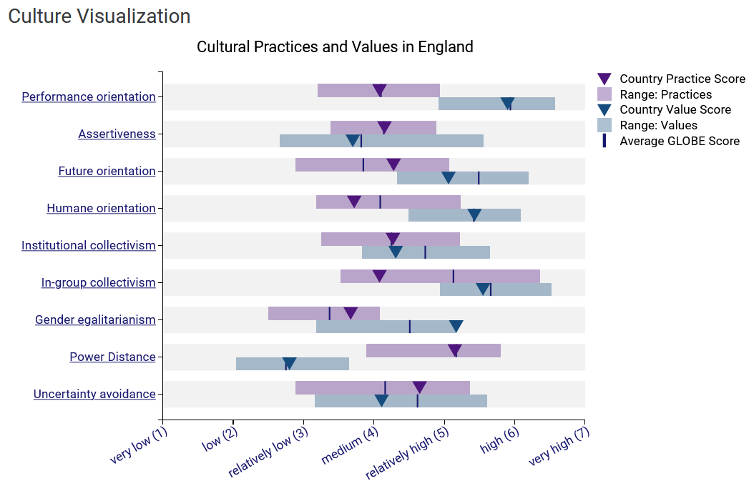
Source: (Globe Project, 2023a)

Appendix – 2: Global Study Result of India
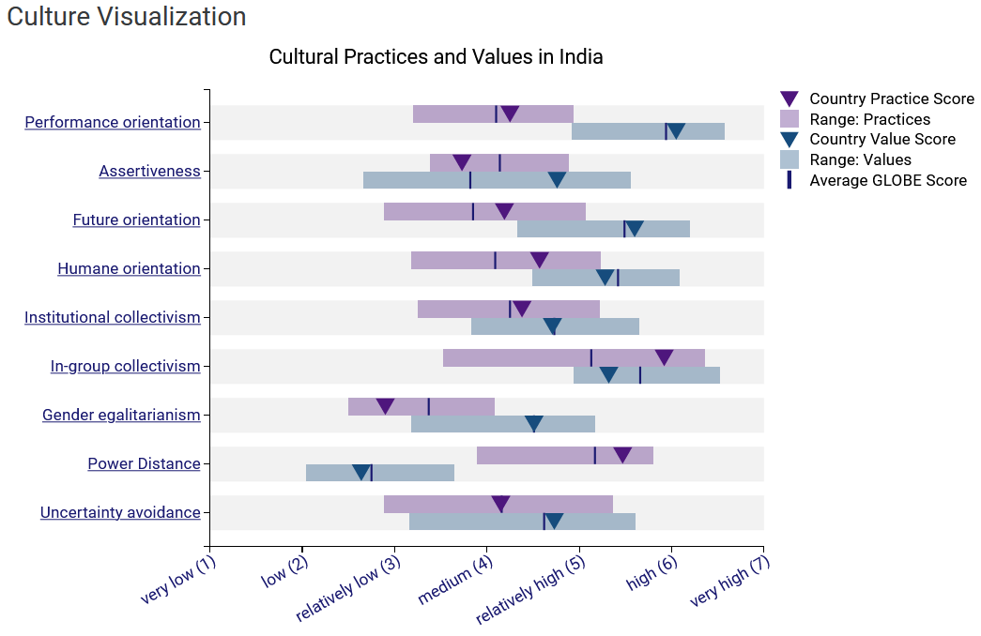
Source: (Globe Project, 2023b)

