

Module Name: Learning In the Digital Era
Module Code: ACCA4026

Student Name: Lizandro Roberto Mata Hugo
Student ID: 2533010
Group: 1

Lecturer’s Name: Koushik Modak

University of Wales Trinity Saint David
London campus

Assignment 1
E-portfolio Link: https://2533010.wixsite.com/learning-in-the-digi

Table of Contents
Introduction 2
Main Body 3
Task 1: Essential Academic and Employment Skills for the future career Path 3
Task 1 (a): Report on Essential Academic and Employment Skills 3
Task 1 (b): Evaluation of Task 1 (a) based on Similarity report 4
Task 2: Collaborative Mind Map and Individual Poster 6
Mind Map (Collaborative) 6
Poster (Individual) 7
Task 3: Virtual Collaboration and RefWorks 8
Report on Virtual Collaboration 9
Step-by-step process of using RefWorks with visuals 10
Task 4: E-Portfolio Creation and Evaluation 18
Task 4 (a): E-Portfolio Creation 18
Task 4 (b): Illustrative Review of E-Portfolio tool Selection 21
Conclusion Error! Bookmark not defined.
References 23
Task 1 References: 23
Task 3 References: 24

Introduction

As far we can observe daily, in everyone’s life, Digital Era is very important and indispensable for our day-to-day life. It has transformed almost everything in our modern life, for instance; at work, for student, and so many more roles in our environment. However, having in consideration that it gives unnumerable benefits, on the other hand it is challenging because we can get distracted very easy. In conclusion Digital Era is gives as the opportunity to be flexible in our daily life, we have more opportunities to study if our life is too busy or the hours at work are not fix, and we can communicate with anyone around the planet.

Main Body

Task 1: Essential Academic and Employment Skills for the future career Path

Task 1 (a): Report on Essential Academic and Employment Skills
By the journal Article , Employment Skills for 21st Century Workplace, we can see that we share the opinion that Education is the key to develop skills and knowledge to compete for a better employment opportunity to get a higher Wedges and also to enrich ourself for a new types of dialogues for a futures discussions in our Day to Day Life [1].

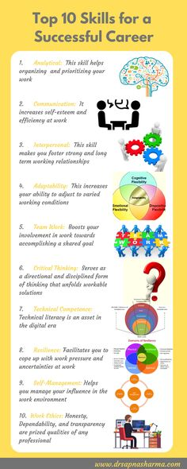
Figure 1: Top 10 skills for a successful career [2]
By R&E Source in the Open Journal for Research and Education, we can observe that the importance for a foreign person when we move to another country with a completely different language, for example in here in the UK, “English”, I could see that the importance of the Academic Skills such as; Reading, Writing, Listening, and speaking, which are necessary to access a better opportunities at work and also to be able to get access to a hight educations [3].
By Hammill Institute, in in the article; What Skills Are Really Valued? We can get a different perspective, and we can see that skills like: Punctuality, Be Polite, Respect the others, etc. These perceived skills have seemed more important that other that we frequently taught [4]. In the article made by Joseph F. Coates, we can get another different perspective, in here we think more about the future skills for our future generations. What is really the right skills that they will need? What will be the best career for Employment? We can see here that we are already thinking about their future to encourage them on the right direction to get the knowledge and skills for the job or career that we think is the best for them. But, under my point of view, this is not completely good idea, it is maybe 50% Right because they need to choose and get what is best for them. I agree with the idea to teach and to train them but never choose for them [5]

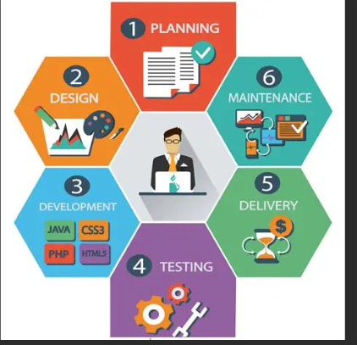
Figure 2: essential skills for employment [6].
Task 1(b): Evaluation of Task 1 (a) based on Similarity report

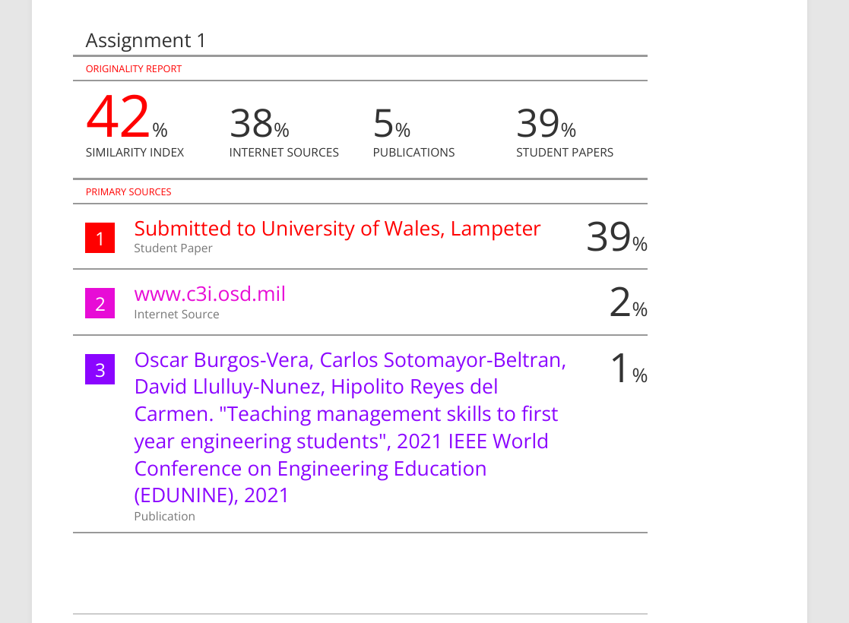

As we can analyse this report, we can observe that we have in total 42% of Similarity Index which was fractionated by the following aspects: 1% obtain by the references, which is normal when we do this Assignments. 2% by Internet sources, in this case is also normal to get that percentage, because of the sources we choose from Internet. And 39% was by student paper, this is also normal because we all use the same template. By now it shows that the Assignment was done 100% by research.
Personally, I would like to evaluate myself with 90% because of the effort and hard work I have done. On the other hand, I would explain why I have chosen 90% of 100%. It is because of the structure of the Assignment, which is the biggest weakness for me, owing to the lack of experience making this kind of academic assignments. But that is why we are here to Learn and Develop our Skills.

Task 2: Collaborative Mind Map and Individual Poster

Mind Map

Mind Map link: https://mm.tt/map/3952545974?t=eS3T7N52z4

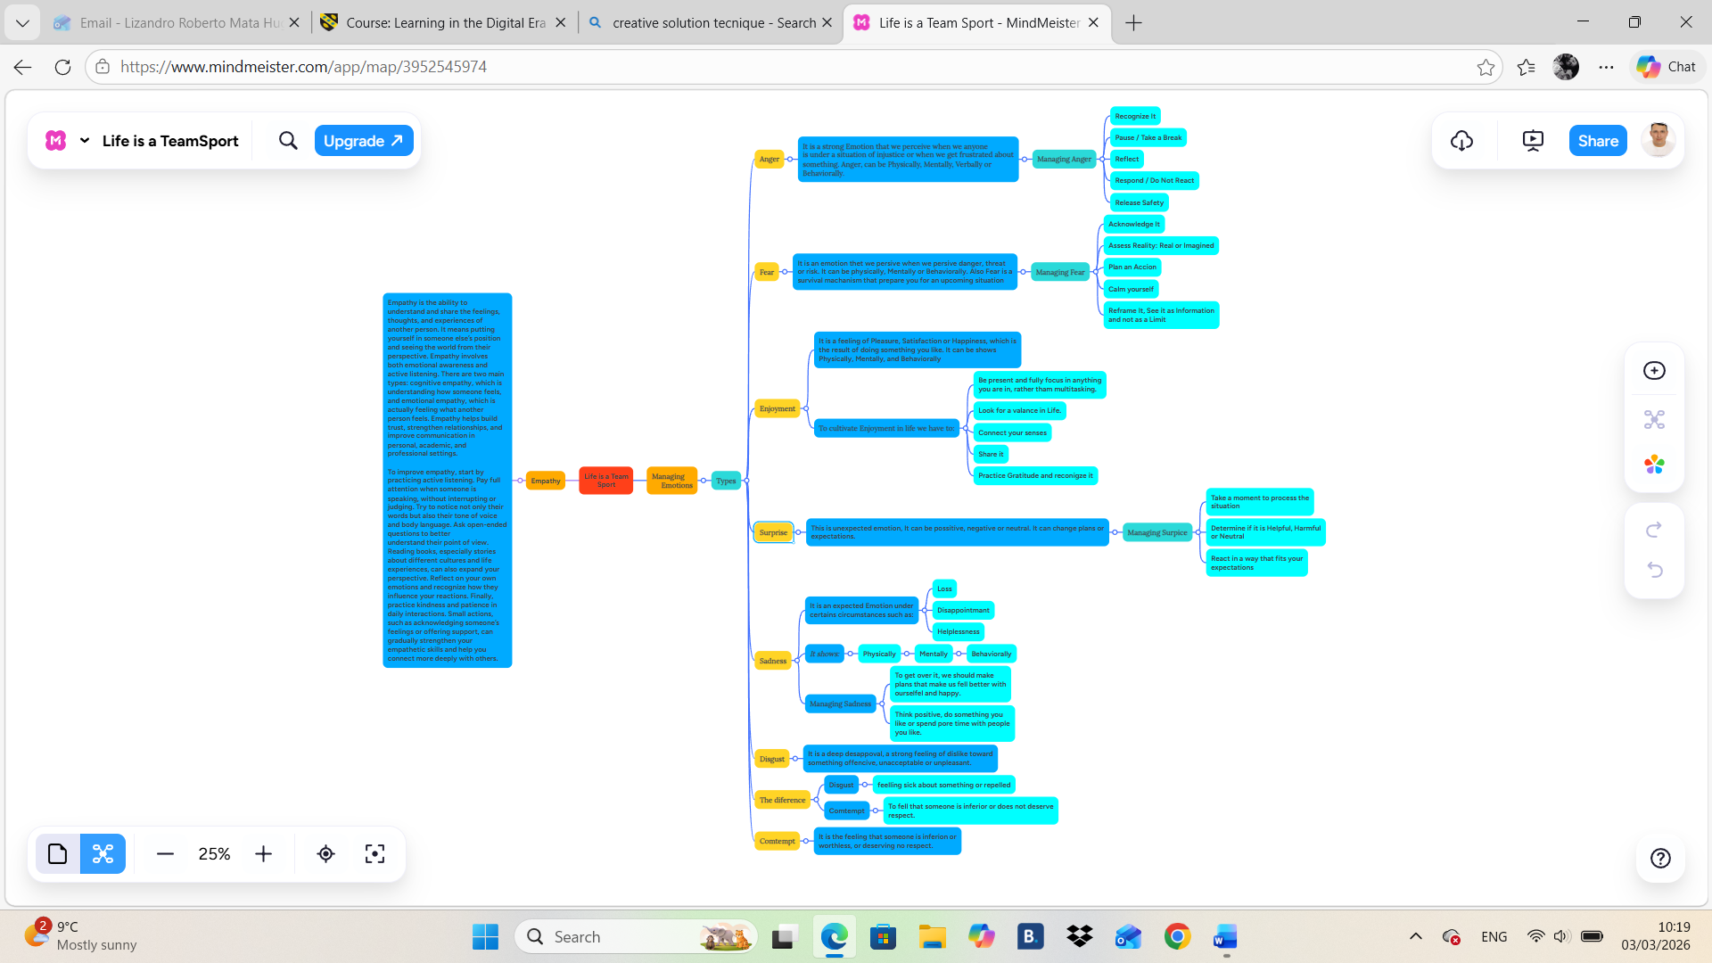

Poster (Individual)

Poster Link: https://www.canva.com/design/DAHDcWWaAkc/3_hbUi6o7LQbUKgMW2_R3w/edit?utm_content=DAHDcWWaAkc&utm_campaign=designshare&utm_medium=link2&utm_source=sharebutton
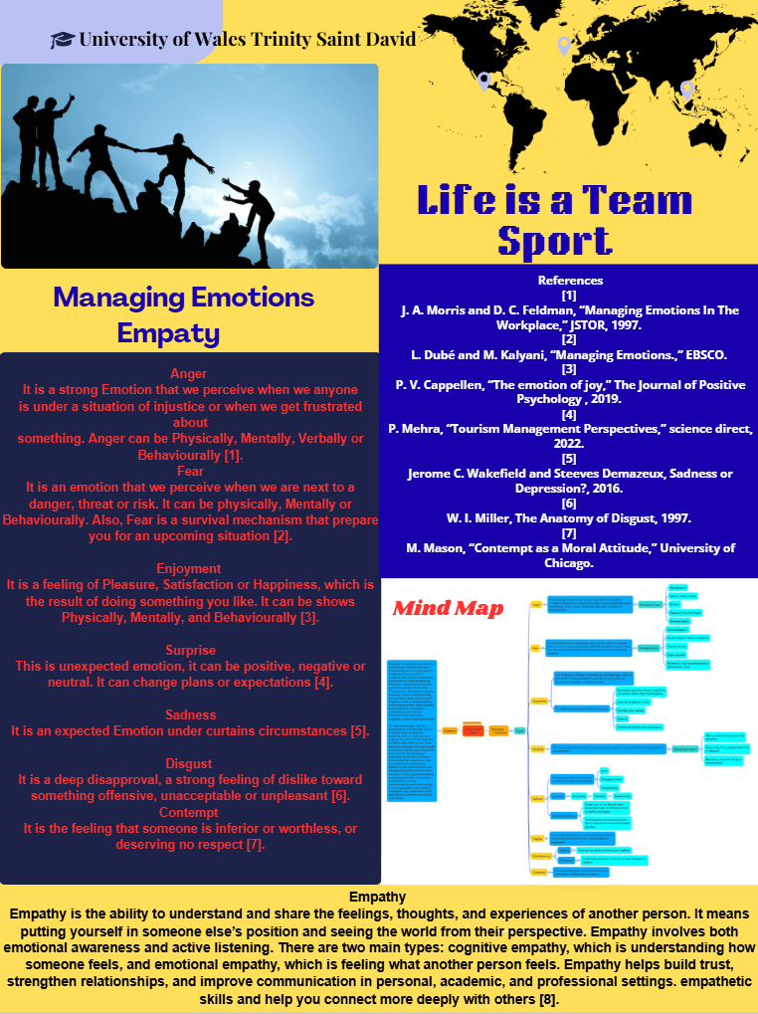

Task 3: Virtual Collaboration and RefWorks

By the following articles we can see that we both agree sharing that we all have the opportunity to experience a virtual collaboration, where we will learn how to communicate across cultural and organizational boundaries using technology.to address this need, instructors incorporate virtual learning in the workplace also it is important for an student to have an authentic experiences while they are studying. This will be beneficial to develop the skills needed or expected for futures employers [7].
On the other side, RefWorks is a web-based reference management tool. It is designed for use by students and faculty to manage references in their research process and to insert in-text citations and create bibliographies when writing papers. There are legacy RefWorks and new RefWorks which was rolled out in the early 2016. Adding references to RefWorks is easy to learn, User can add references by using the following methods: * Exporting directly, user can collect references by directly exporting selected search results into their RefWorks database. *Using saves to RefWorks add-on, it is available to capture web resources into RefWorks, however, sometimes it does not take enough information. *Dragging and dropping, is where we can drop PDF or Worl files into RefWorks database. *Searching Directly, we can search directly from database and various online catalogues. *Manual entering, it must be done when none of the other methods are applicable. *Transporting, references from other reference managers can be transported to RefWorks and vice versa [8].

Report on Virtual Collaboration
Topic 1
Forming a Team
A leader must first understand and learn the nature of the groups, so we can work with, rather than against it. To understand the phenomenon of groups we shall draw largely upon the tradition Known as group Dynamic. A crucial factor in group or team formation is the amount of time that has been spent together. It takes time for a group or team to take shape; it does not work quickly. To build a team is essential that we work together and hold it over a significant period [1].
Team building gives to each person and teams physical, social and emotional challenges. People who are in a team must work together to develop and include a strategy for achieving their objective. In addition, it provides a better environment. It addressed several specific skills such as: Problem Solving, Appropriate risk taking, building working relationships, Cooperation, Leadership and communication, Creative thinking, building trust, making decisions, Setting goals, etc[2].
Virtual team dynamic is a term used to describe behaviours, this is like Truckman’s Stage which original’s model comprised four stages: forming, storming, norming, performing, and adjourning. Build trust in the team is very important for a team to perform productively, also the failure or success is based on the relationship with each member or the team. Always be authentic and transparent, it helps to build deep connection. Going back to virtual relationship, people often think they cannot be themselves [3].
Everyone is a unique and has different sets of individual achievements and characteristic, it proposed effective student teams based on psychological trait rather than academic qualifications, this combines multiples techniques like; Psycholical profiling, Text analysing, Latent Semantic Analysis and Collaborative filtering. After an experimental study with the University students, there was an excellent results and positives feedback, also, this shows that the approach can improve the team balance and performance[4].
Forming a group from different departments or areas of responsibility, working together and exchanging information is call multifunctional team. It is becoming crucial because organizations always require group cooperation. Teams is one of the keys performing business activities and problem solving[5].

Step-by-step process of using RefWorks with visuals

- Search for the RefWorks web page.
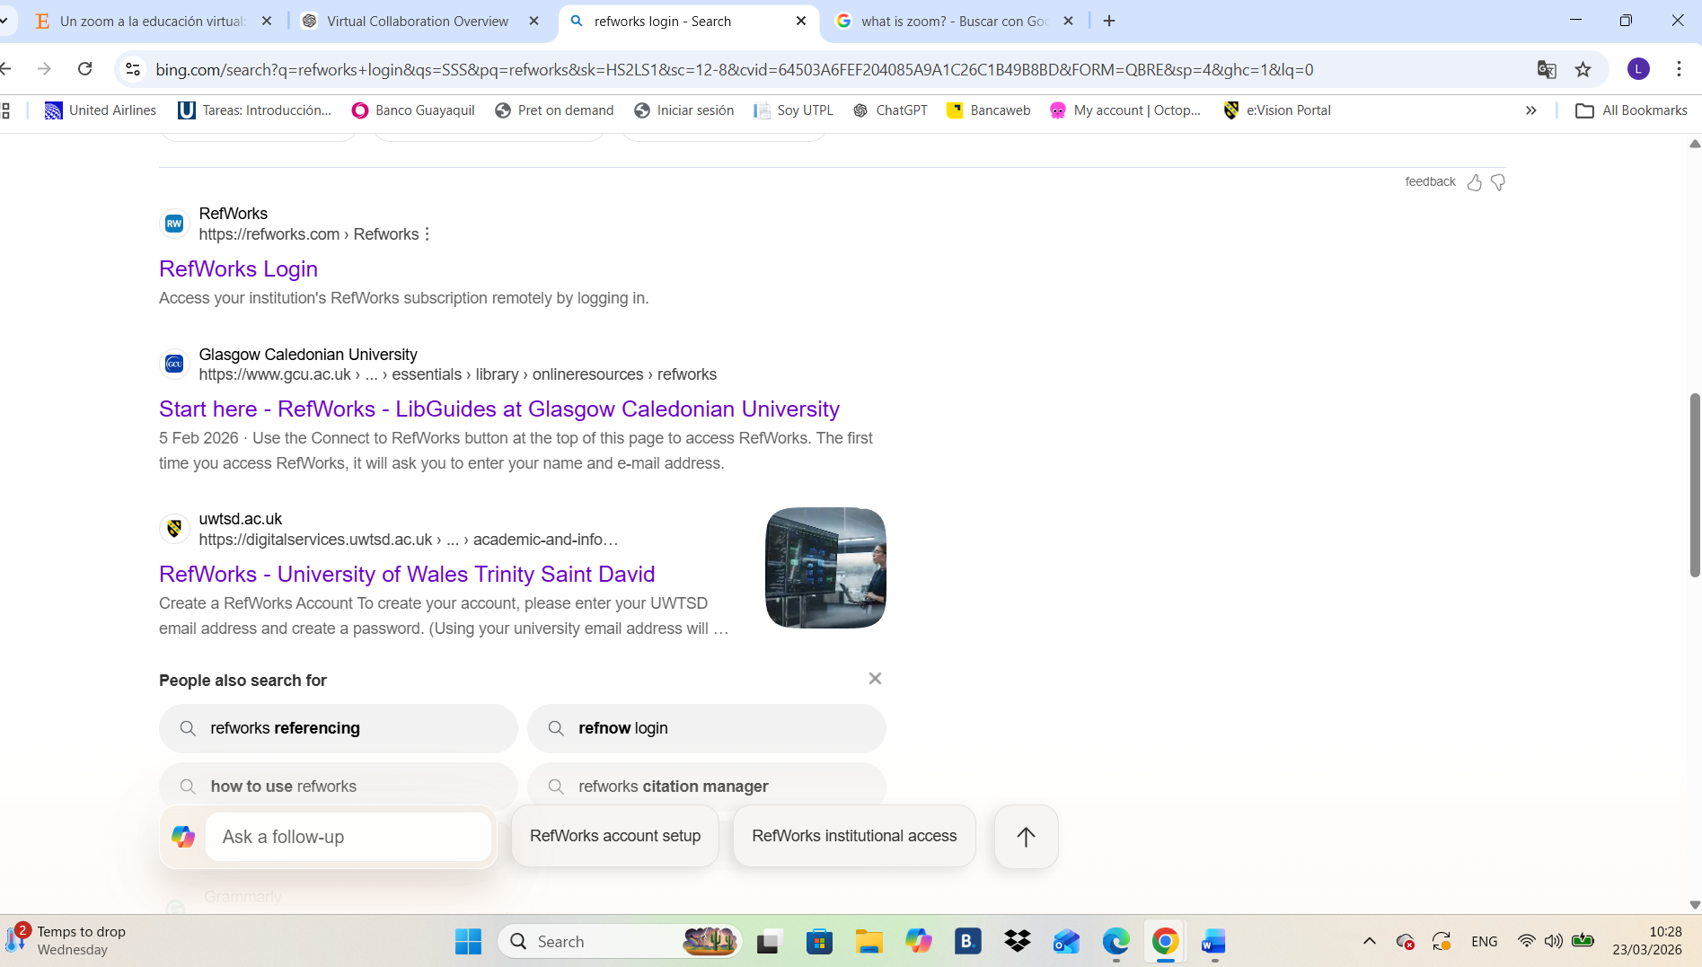

2-Create an account using our student email.
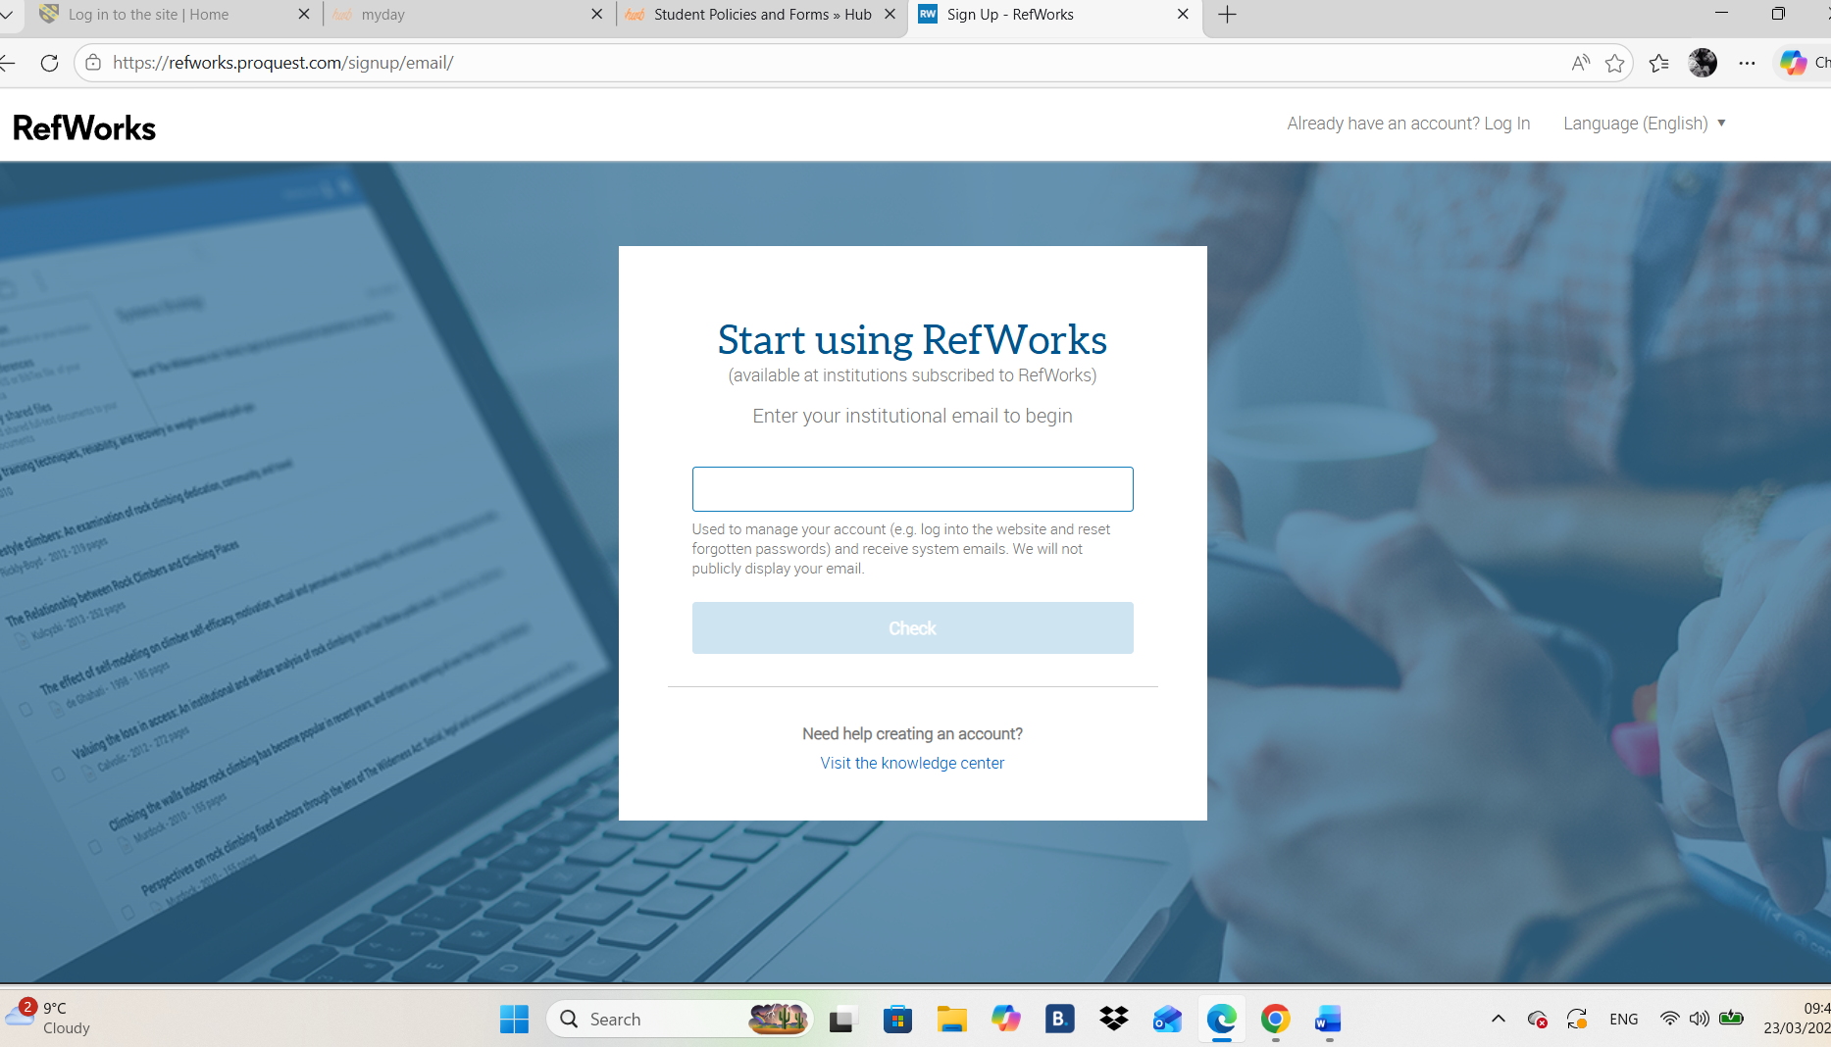

3-Once you have set up an account, we will have access to the main page.
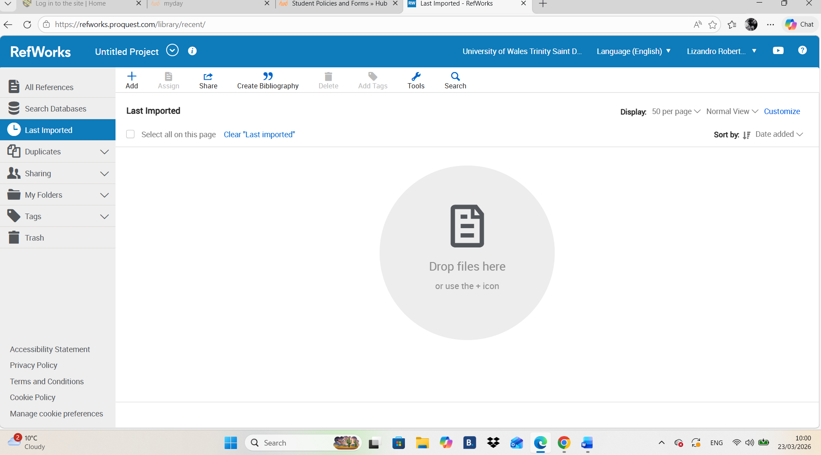

4- Create a folder in RefWorks where we want to add the search that we will do in the following steps
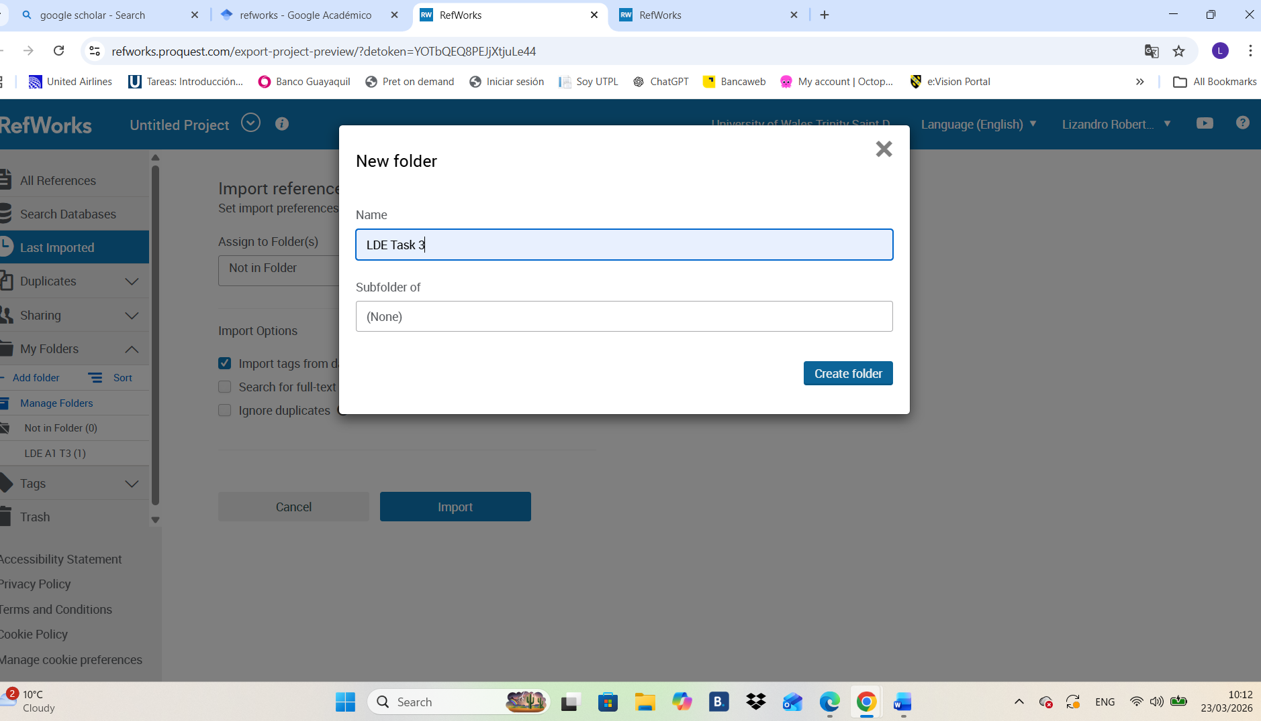
5- The next step is to go to Google Scholar and search about the topic you would like.
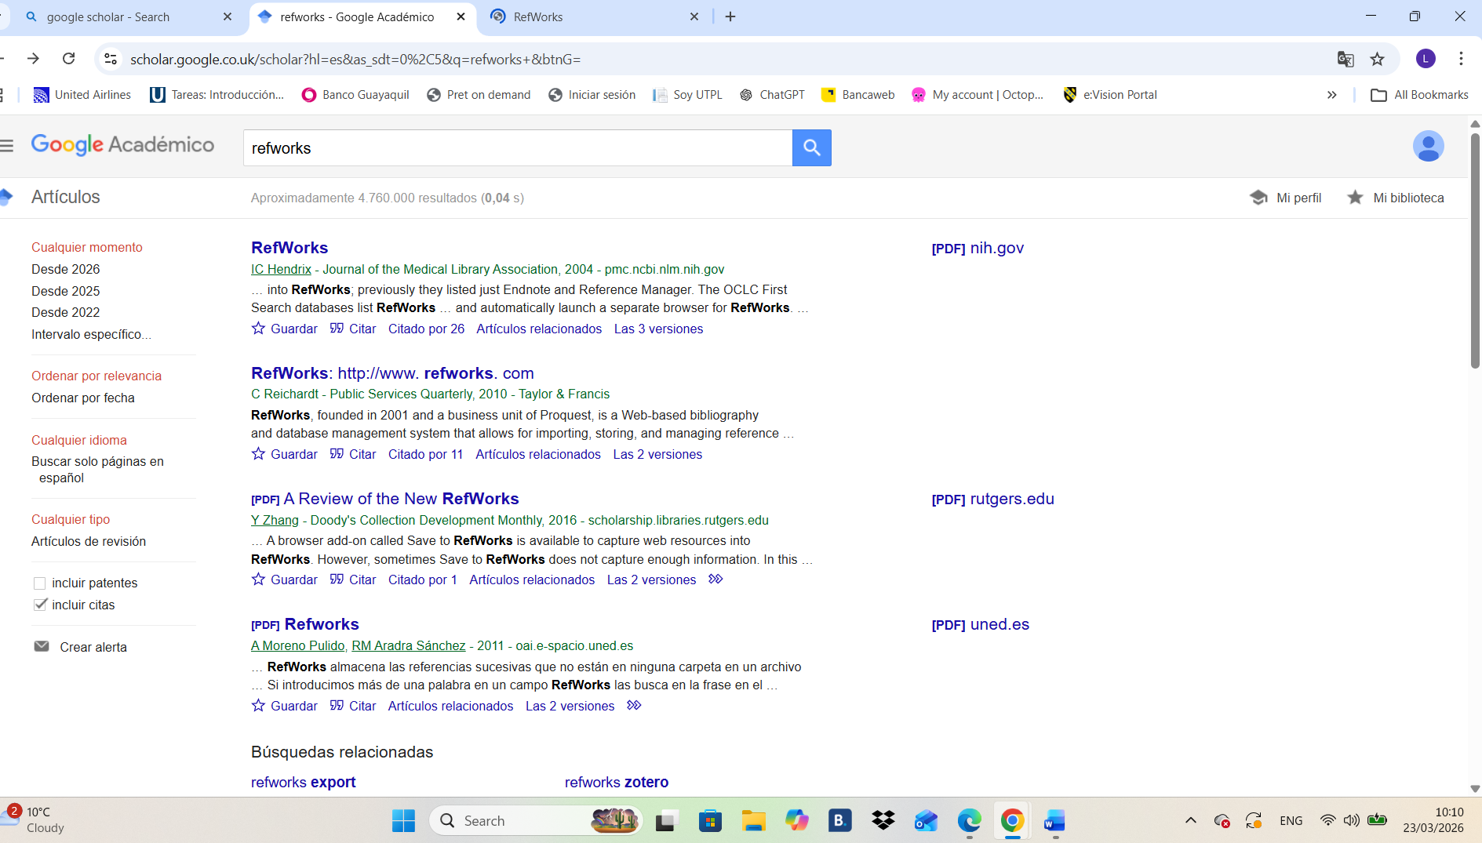

6- In the page selected, we must clip on the bottom of the link where it says “Cite”. After we click cite, it will come at the bottom of the message the option RefWorks, which we have to click on it.
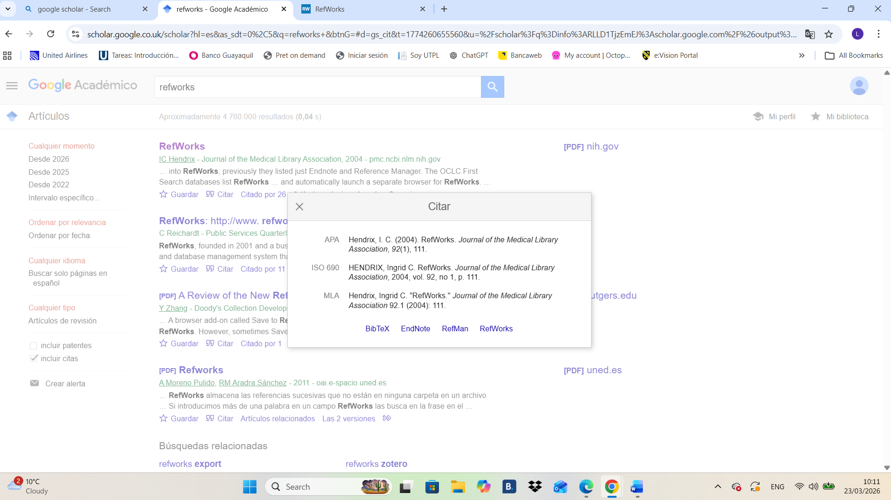
7- Once we press on the option RefWorks will appear the following RefWorks page. In this page we will have to select the Folder where we want to insert the citation we chose from the web page in the last step. Once it is the folder selected, we must press the option “IMPORT”
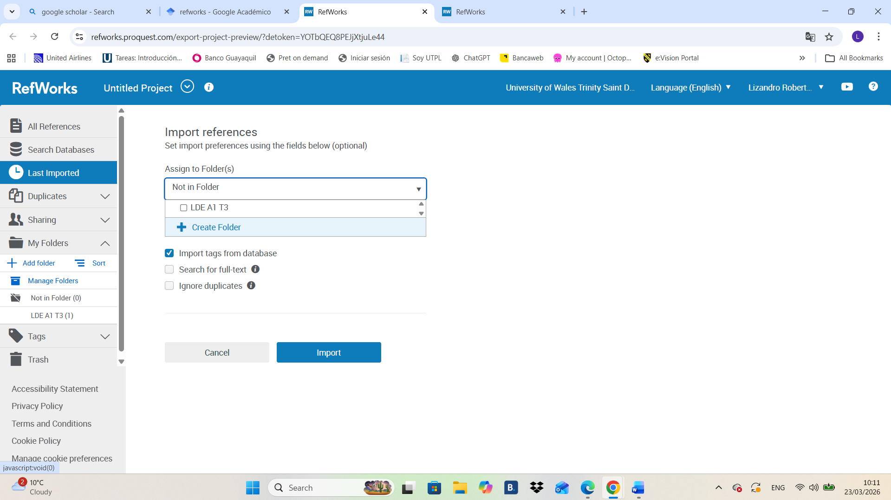

8-After we press import, it will be shown in the screen a message that it says that the import is successfully complete
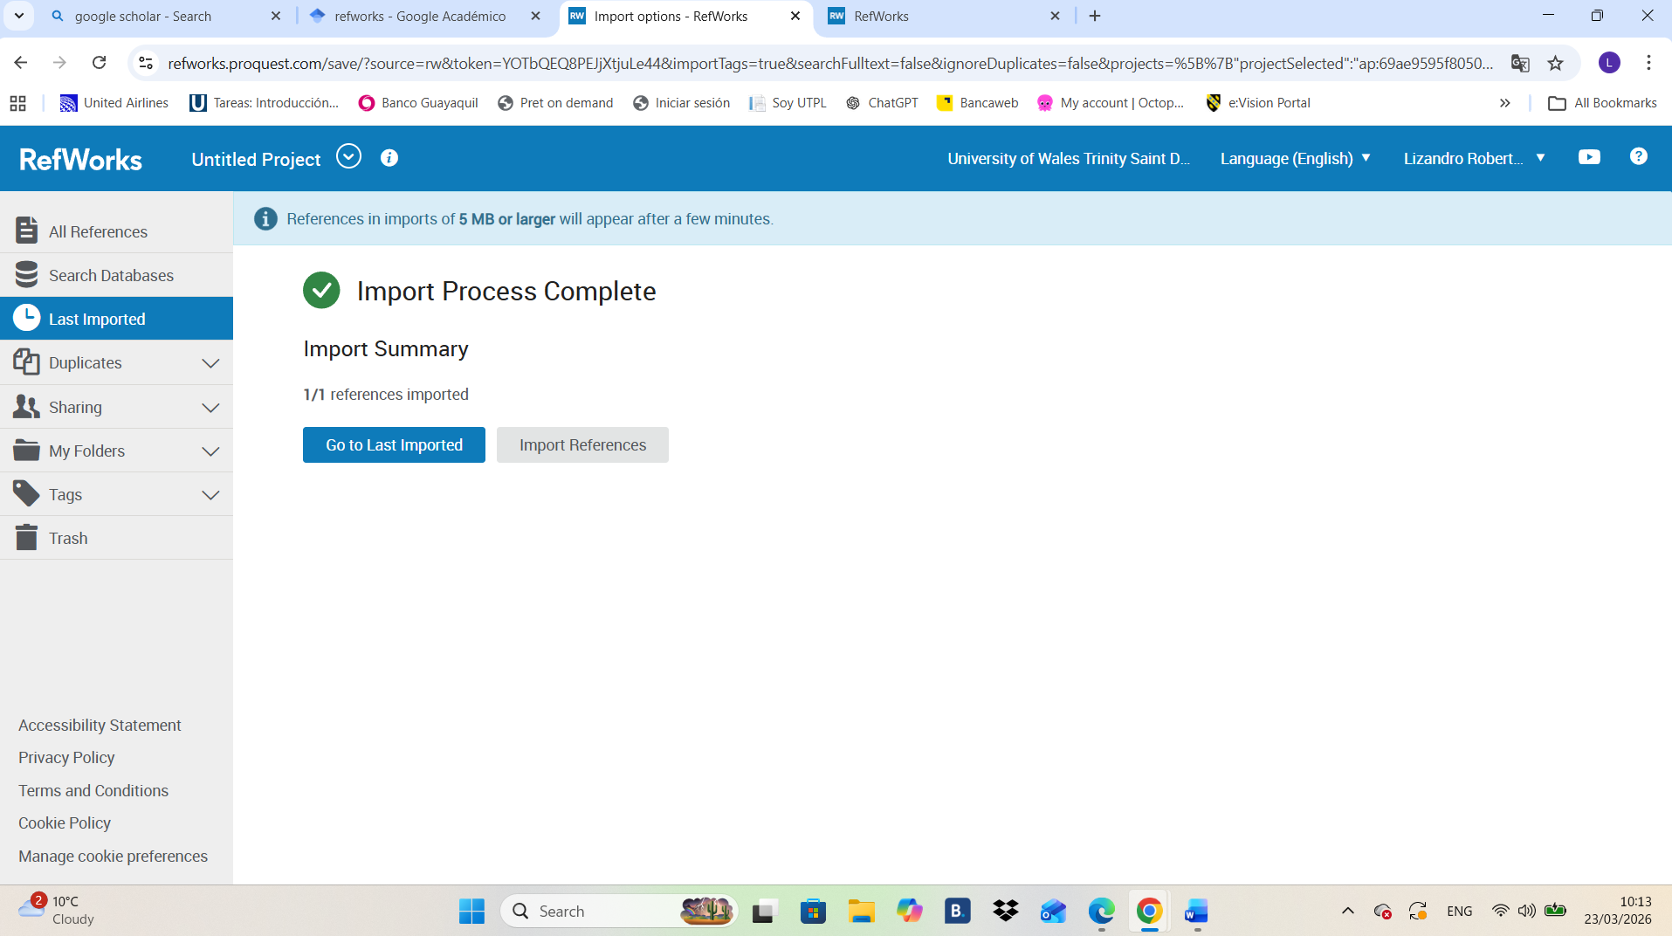
9-after that message appear, we go to my folder, and we can see all imported on the RefWorks web site.
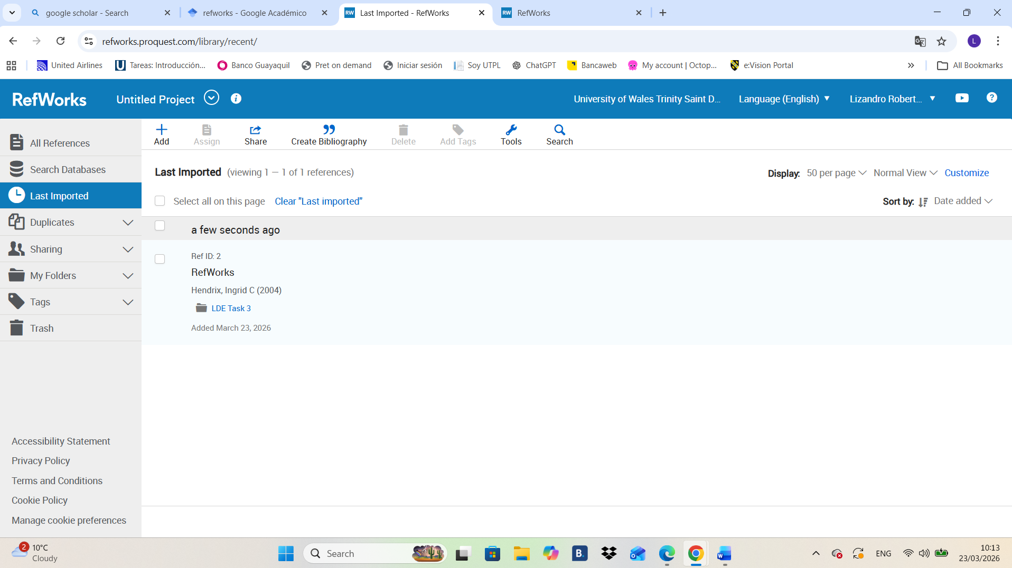

10-Now we must create a new blank page in Microsoft Word to insert citation and bibliography from RefWorks.
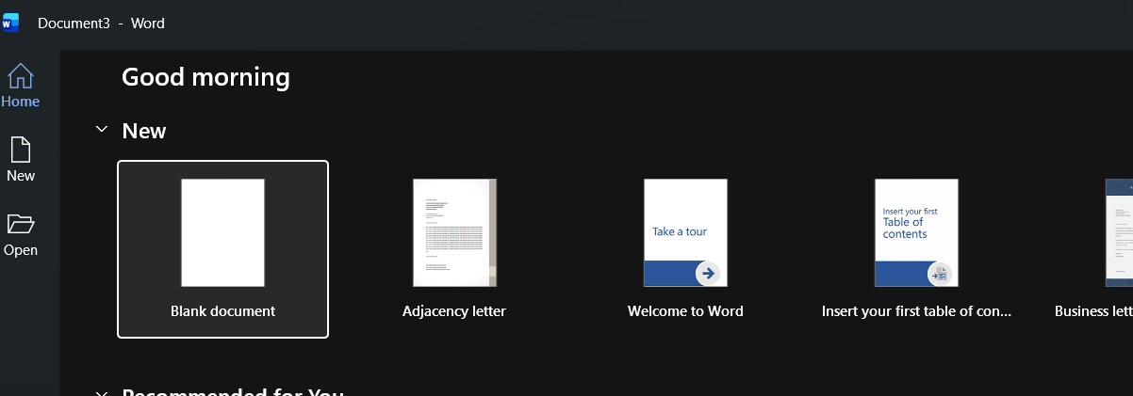

11-Once we have a new blank page, we have to go “HOME” and in the home page we must go to the top right and press “ADD-INS” in where, once we press add-ins, it will show as few options from where we have to find RefWorks and after we find it we have to choose it .
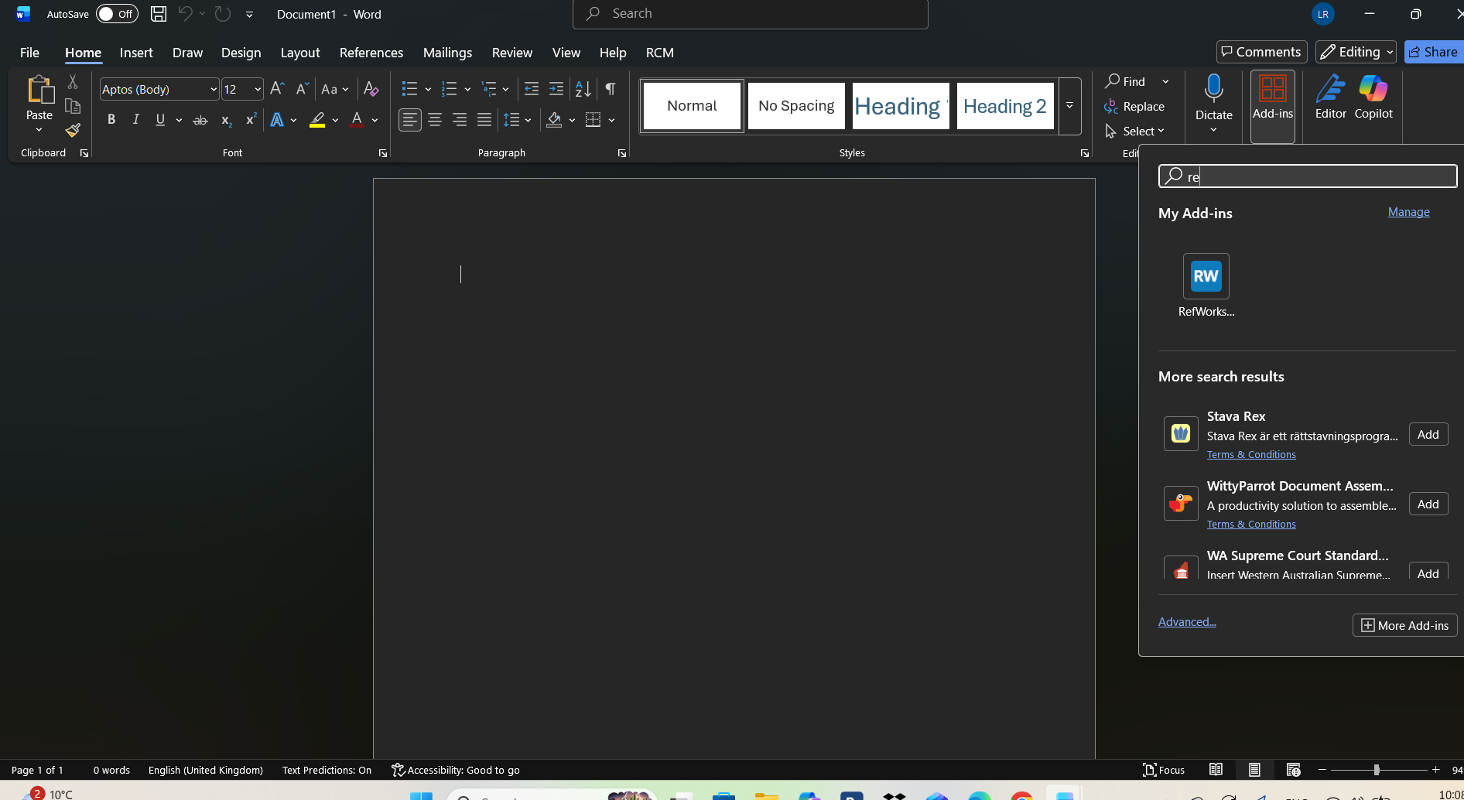

12- After we select the option RefWorks, in the last step, we will have on the right site of the blank page a RefWorks menu from where we can add our citation previously saved in RefWorks.
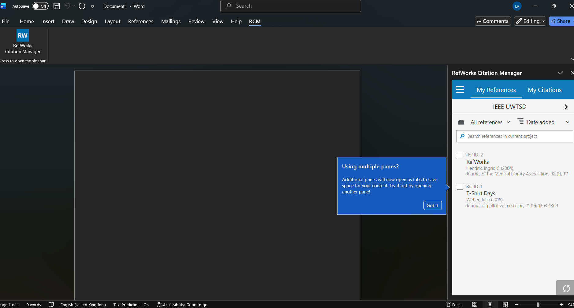

13-Now we must write the text of our research and add the automatic citation from RefWorks, which will appear at the end of the paragraph as it shown.
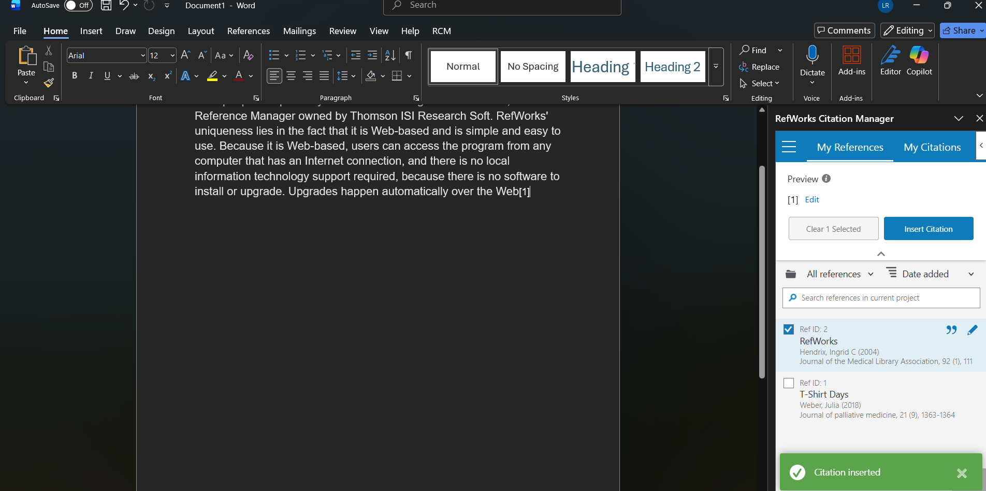

14-Now we will add reference from RefWorks
We must go back to the RefWorks web page, them go to the top side where it says “CREATE BIBLIOGRAFY” and press on it. After that we will have different options from where we must choose create bibliography.
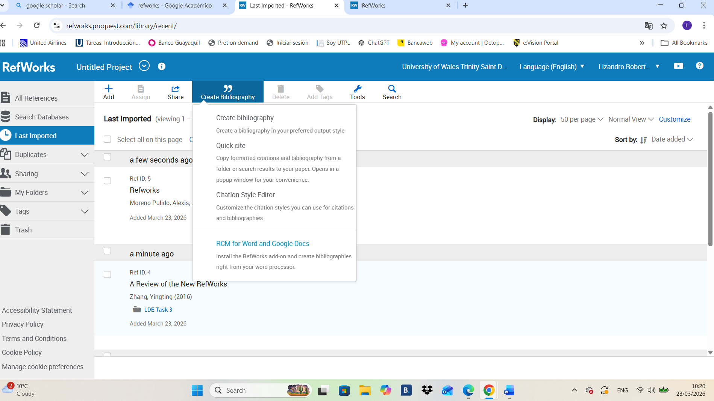
15- Once you have pressed Create Bibliography in the last step, we will have the following page where we must go to the right side of the page in the middle where it says, “COPY TO CLIPBOARD” and select it and go to the following step in the word blank page we have created before.
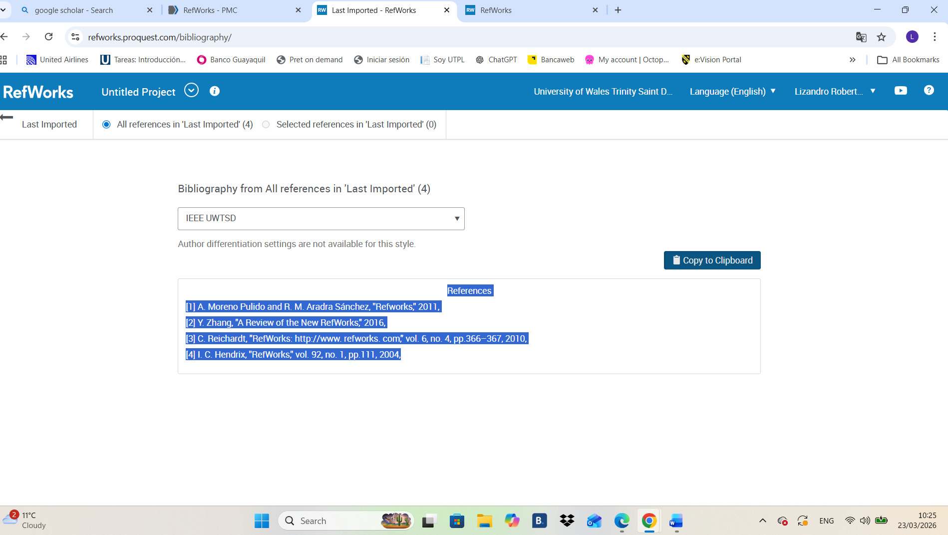

16-After we have selected in the last step, we came to the word page and paste it on it.
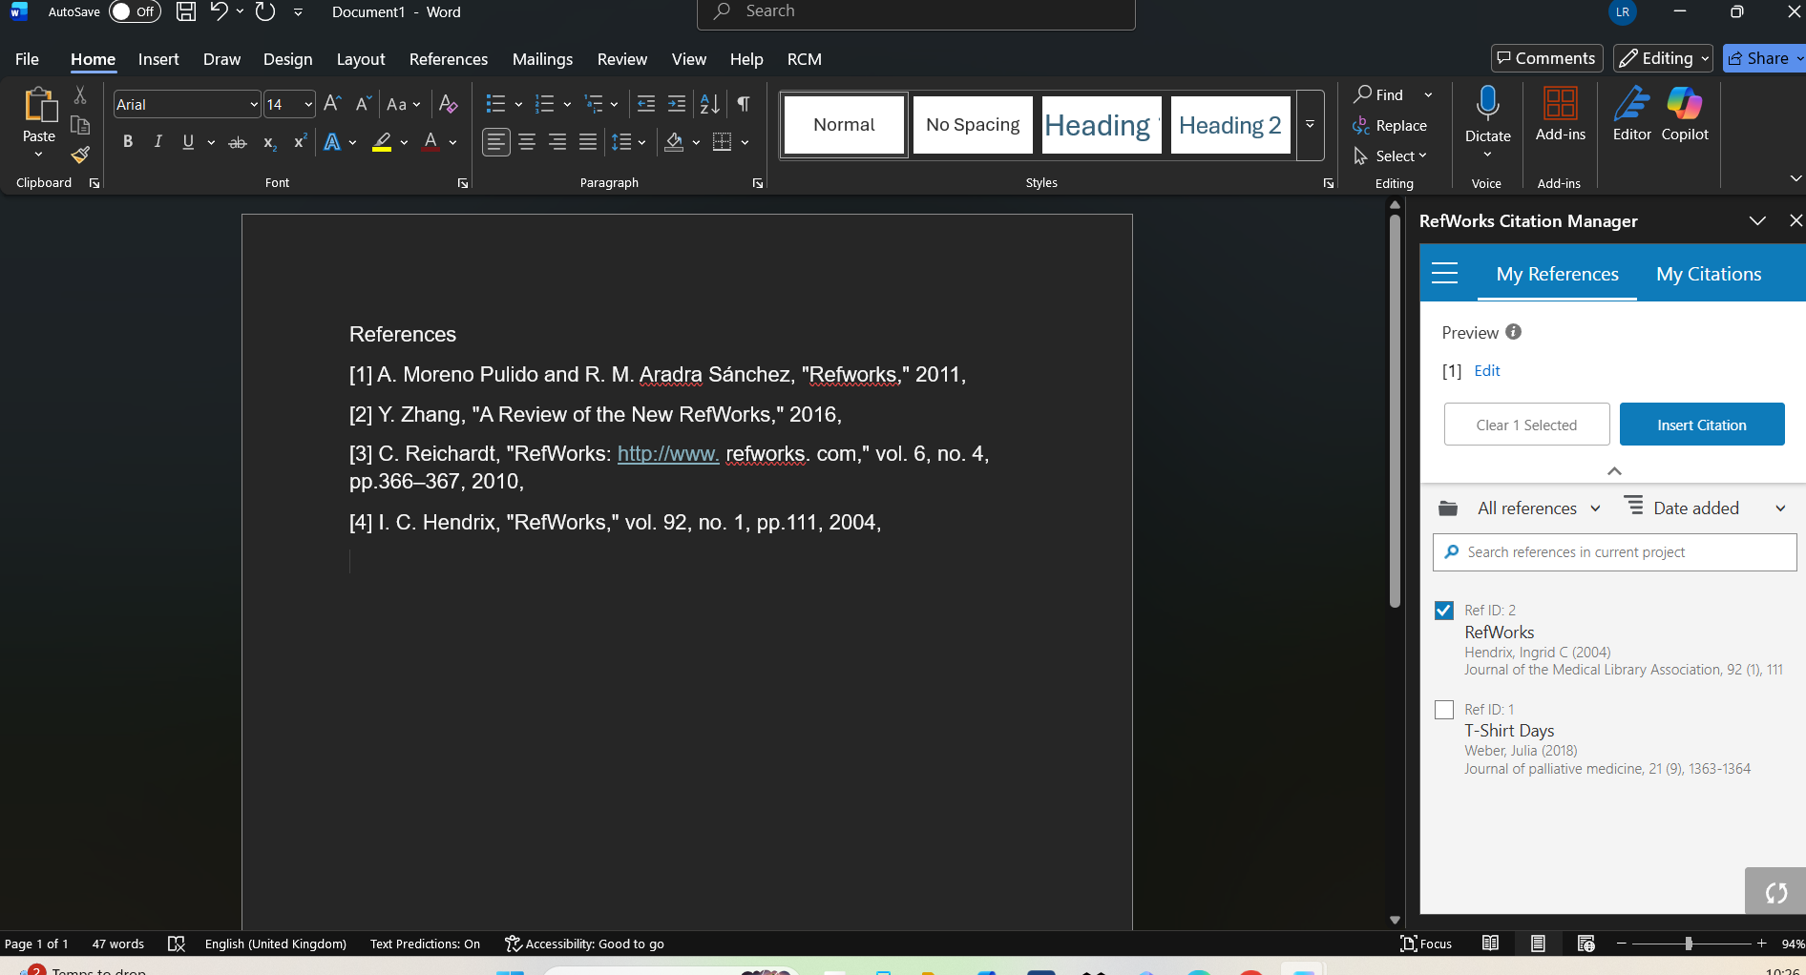

Task 4: E-Portfolio Creation and Evaluation

Task 4 (a): E-Portfolio Creation
E-portfolio Link: https://2533010.wixsite.com/learning-in-the-digi
1.- We can see here the welcome page with the respective links.
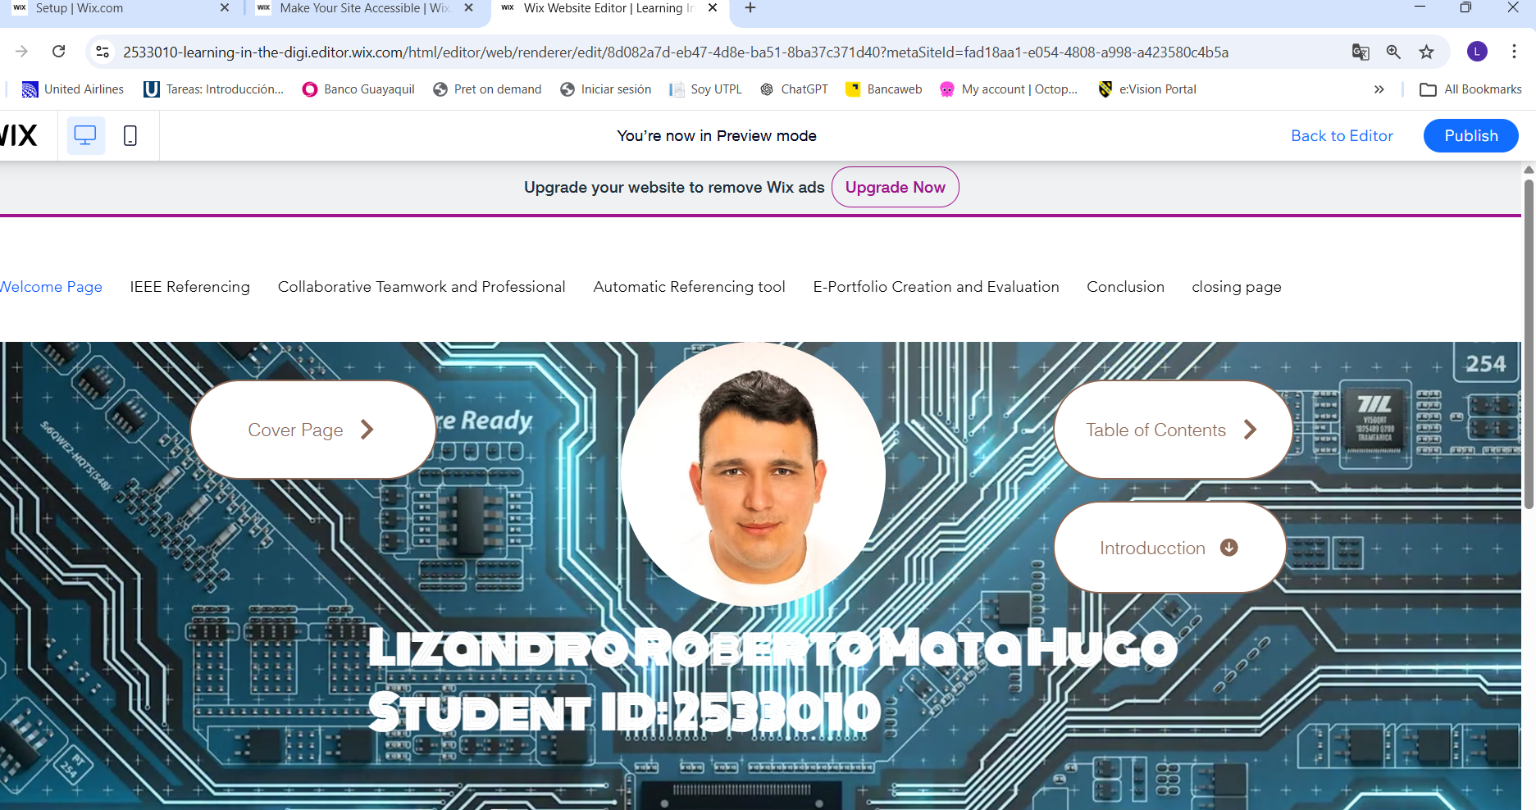

2.- here we can appreciate task 1 Essential academic and employment skills for the future career path.
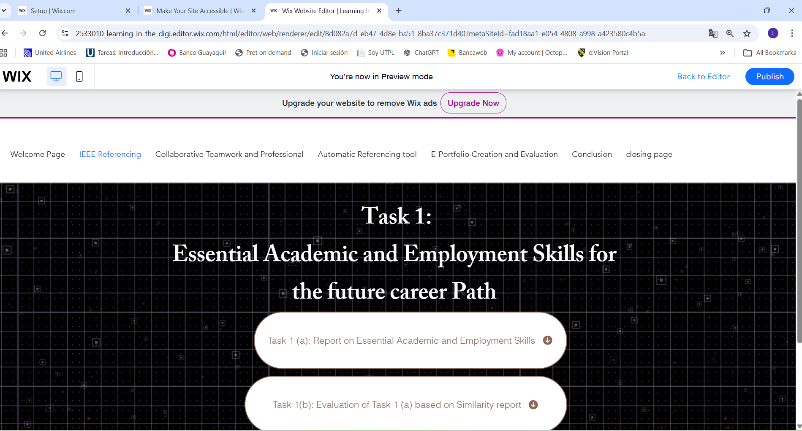
3.- This is task 2 Collaborative mind map and individual poster.

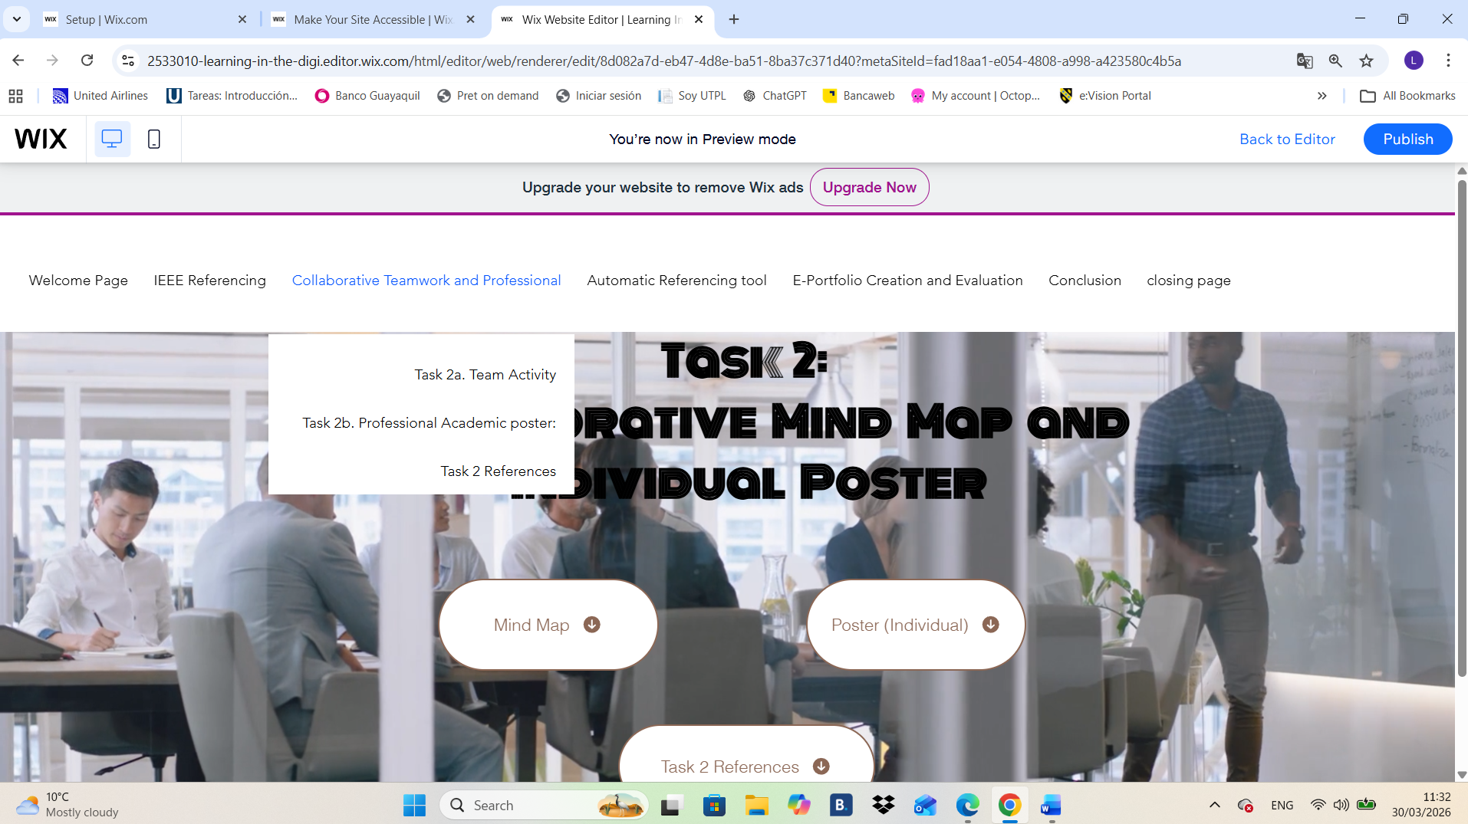

4.- In here we can see Task 3 which is about virtual Collaboration and RefWorks.
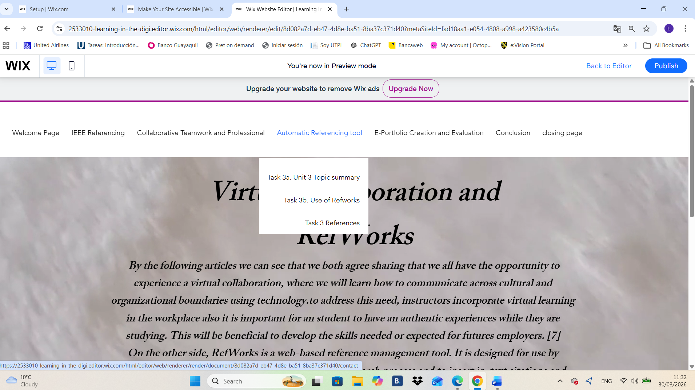
5.- Task 4 is about creating an E-portfolio and Evaluation.

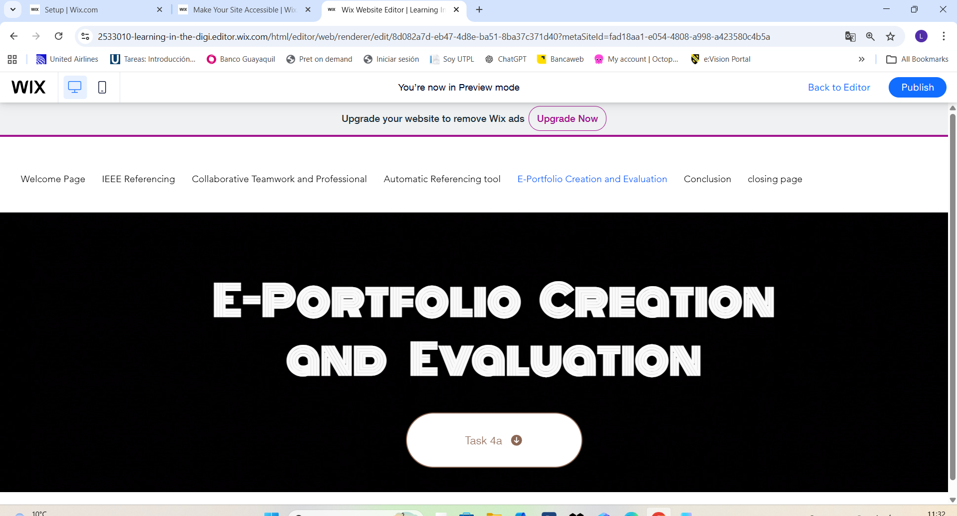

6.- here we have a short conclusion.

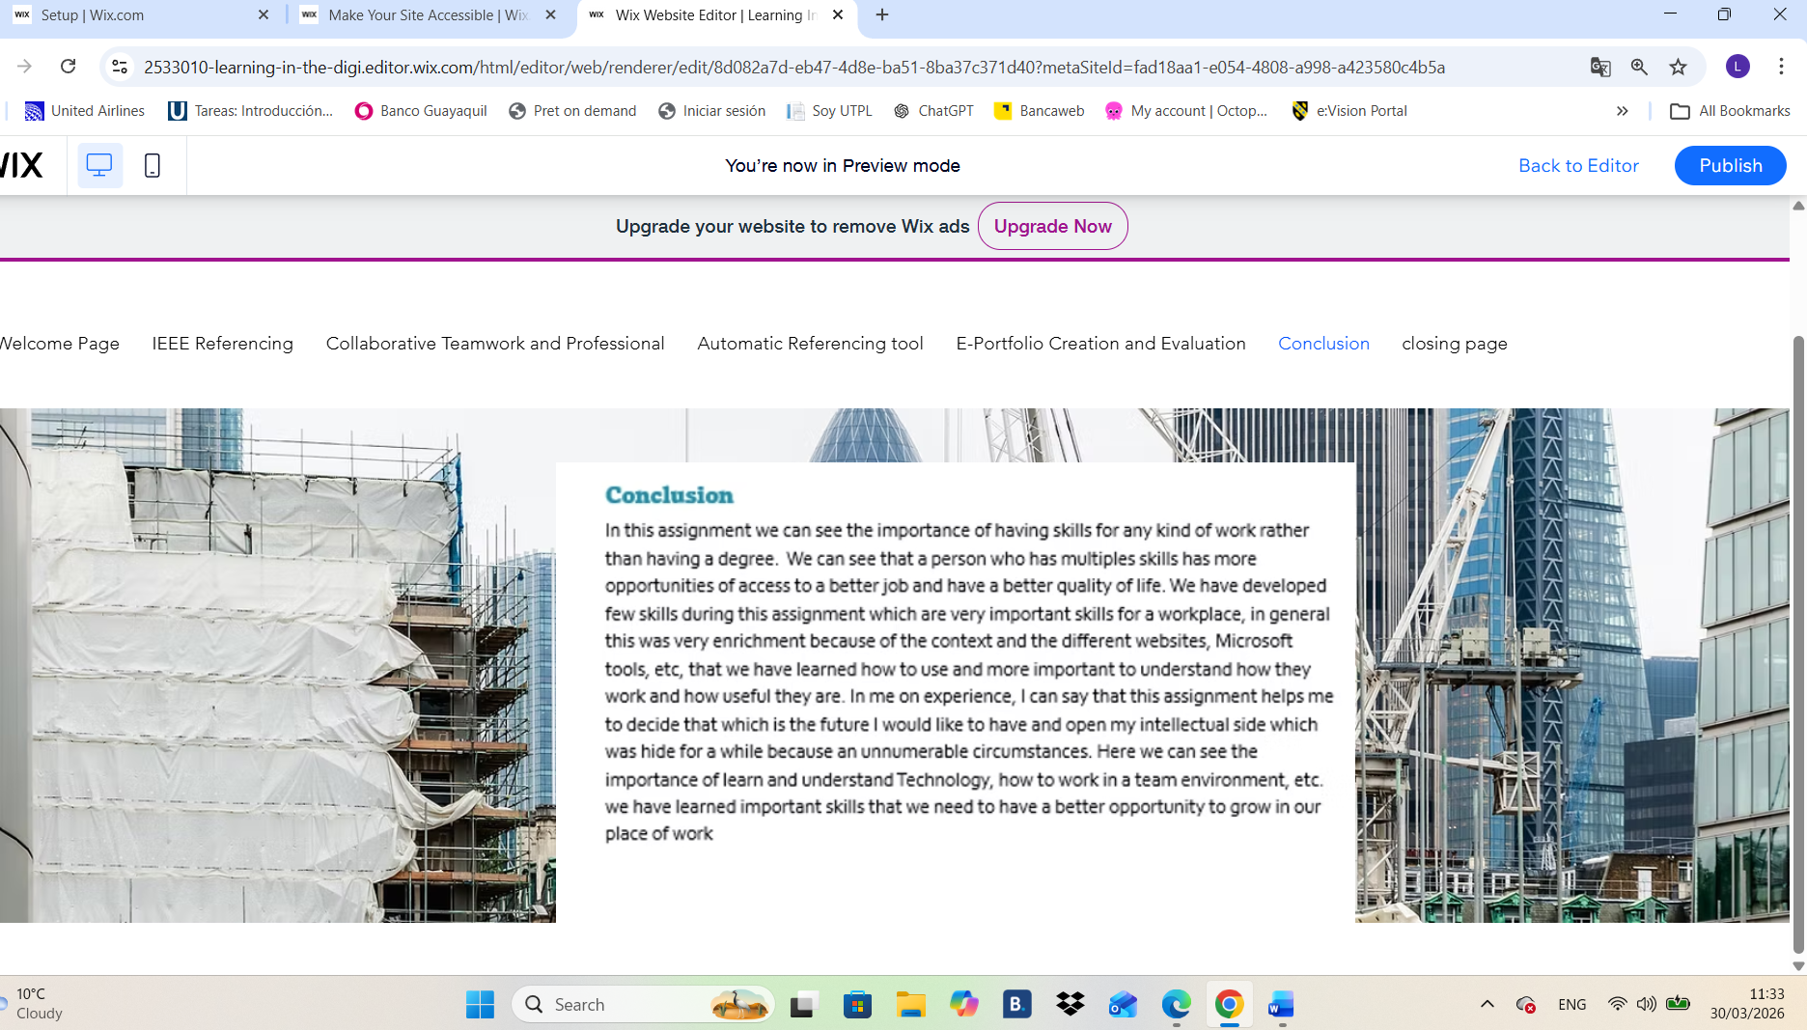
7.- And to close it, I have created a closing page.
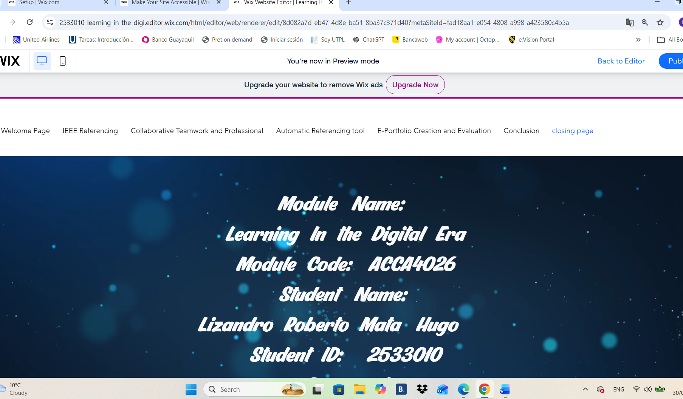

Task 4 (b): Illustrative Review of E-Portfolio tool Selection
As a personal experience, I can say that any that Wix was the best option for me to create the E-portfolio because after a short time searching and going around it, I have a lot More knowledge that when I start it with a very basic knowledge about it. Know I can say that I am not a master on it but, I will be able to make anything for a future assignment. It really helps me a lot and I am certainly sure that I will apply this at work or it will help me now to compete for a better opportunity now to access a new job.

conclusión
In this assignment we can see the importance of having skills for any kind of work rather than having a degree. We can see that a person who has multiples skills has more opportunities of access to a better job and have a better quality of life. We have developed few skills during this assignment which are very important skills for a workplace, in general this was very enrichment because of the context and the different websites, Microsoft tools, etc, that we have learned how to use and more important to understand how they work and how useful they are. In me on experience, I can say that this assignment helps me to decide that which is the future I would like to have and open my intellectual side which was hide for a while because an unnumerable circumstances. Here we can see the importance of learn and understand Technology, how to work in a team environment, etc. we have learned important skills that we need to have a better opportunity to grow in our place of work.

References

Task 1 References:

References

[1] | K. A. Hodge and J. L. Lear, “Employment Skills for 21st Century Workplace,” Journal of carrier and Technical Education, p. 28, 2011.
[2] | printerest, “21st century Carear Skills,” [Online].
[3] | G. Chmelikova, “Doctoral Student and Necessary Academic Skills,” Journal for Research and Education, 2015.
[4] | H. Institute, “Employment Social Skills,” Employment Social Skills: What Skills Are Really Valued?, 2014.
[5] | J. F. Coates, “Skills required for twenty-first Century employment,” Skills Required For Twenty-First Century Employment, 1995.
[6] | w. y. ball, “Yellow Ball,” [Online].

Task 2 References:

References

[1] J. A. Morris and D. C. Feldman, “Managing Emotions In The Workplace,” JSTOR, 1997.

[2] L. Dubé and M. Kalyani, “Managing Emotions.,” EBSCO.

[3] P. V. Capellen, “The emotion of joy,” The Journal of Positive Psychology , 2019.

[4] P. Mehra, “Tourism Management Perspectives,” science direct, 2022.

[5] Jerome C. Wakefield and Steeves Demadex, Sadness or Depression?, 2016.

[6] W. I. Miller, The Anatomy of Disgust, 1997.

[7] M. Mason, “Contempt as a Moral Attitude,” University of Chicago.

Task 3 References:

References

[1] | J. Adair, “Effective Team builging,” in how to make a wining team, 2009.
[2] | D. Midura and D. Glover, Essencials of team building, 2005.
[3] | uwtsd, “formig a team,” 2026. [Online].
[4] | C. Ciubuc, Mihai Dascalu, Stefan Trausan-Matu and Ana-Maria Marhan, “Forming Teams by Psychological Traits,” An Effective Method of Developing Groups in an Educational Environment , 2013.
[5] | scienceDirect, “Novel approach to multi-functional project team formation,” international jpournal of proyect management, 2004.

