
The Impact Of The Virtual Learning Environment (VLE) On The Students' Learning Experience At UWTSD London Campus

STUDENT NAME: JOSE MANUEL JALO
STUDENT ID: 1921659
MODULE CODE: BMSW4003 DIGITAL SKILLS AND RESEARCH METHODS GROUP: 2
LECTURER : Modak Koushik

Table of Contents

- Introduction ………………………….. 3
- Objectives……………………………... 3
- Literature Review ……………………. 4
- Research Methods …………………… 4
- Population, Sample And Sample Size .. 5
- Sample Size…………………………….5
- Data and data collection Process…….. 6
- Analyses And Discussions……….7 - 14
- Conclusion/Recommendation…… 15
- Reference………………………… 16

Introduction
In this report I am going to talk about the impact of the virtual learning environment (VLE) on the students' learning experience at UWTSD London campus. Due to the pandemic that we are going through, making it impossible to have face-to-face classes.
At the UWTSD they came up with the idea of introducing virtual learning (Moodle), which is an online platform used for educational purposes (Building a Modern Virtual Learning Environment (VLE) 2020 {1})

To create this report, I had to develop a questionnaire in word and then I did an online survey with my colleagues using the UWTSD emails and WhatsApp group. I used Primary and secondary data.
Rationale

The report is structured to draw out the evidence of what UWTSD students at the London Campus think about the virtual learning environment.
Also, with this research I can help the UWTSD London Campus make Virtual Learning more effective and efficient.

Objectives

- Improve the UWTSD Students at London Campus experience of using VLE
- Give the University the feedback of how they can improve the Moodle Service

Literature Review

The literature review helps you understand the background and development of VLE. I will start by describing my literature review topic, explain how the report was made, and conclude by analyzing what was achieved during the review.

The survey was made to find out the impact of VLE in UWTSD at London campus, it was based on 3 report questions: the use of Moodle helped the student motivation, how the student felt using this online platform idea. And what impact that VLE had on the independent student learning. The feedback will help the University to improve the VLE to become more efficient and work effectively. Also, the lectures will get feedback on how they can make the classes more enjoyable.

Research Methods
Research methodology is the specific procedures or techniques used to identify, select, process, and analyze information about a topic. In a research paper, the methodology section allows the reader to critically evaluate a study’s overall validity and reliability. The methodology section answers two main questions: How was the data collected or generated? How was it analyzed? ( Practical Research by Paul D. Leedy, 2000)
There are a lot of research methods that can be used, below I will give some examples and define quantitative, qualitative and mixed.
According to Pritha Bhandari 2020

Quantitative: It's a process of collecting and analyzing numerical data. It can be used to find patterns and averages, make predictions, test causal relationships, and generalize results to wider populations.
Involves collecting and analyzing numerical data for statistical analysis..
Is used widely in the natural and social sciences: biology, chemistry, psychology, economics, sociology, marketing, etc.

Qualitative: Is the opposite of quantitative, involves collecting and analyzing non-numerical data (e.g., text, video, or audio) to understand concepts, opinions, or experiences. It can be used to gather in-depth insights into a problem or generate new ideas for research.
Is used in the humanities and social sciences, in subjects such as anthropology, sociology,education, health sciences, history, etc.
Mix Method: Is the type of research in which a researcher or team of researchers combines elements of qualitative and quantitative research approaches (e. g., use of qualitative and quantitative viewpoints, data collection, analysis, inference techniques) for the broad purposes of breadth and depth of understanding and corroboration. (Creswell JW)

I will define some commonly used terms in research. Namely Population, Sample and Sample size.
Population, Sample And Sample Size
A population is the entire group that you want to draw conclusions about.
A sample is the specific group that you will collect data from. The size of the sample is always less than the total size of the population.
In research, a population doesn’t always refer to people. It can mean a group containing elements of anything you want to study, such as objects, events, organizations, countries, species, organisms, etc.
Sample Size

Sample size refers to the number of participants or observations included in a study. This number is usually represented by n. The size of a sample influences two statistical properties: 1) the precision of our estimates and 2) the power of the study to draw conclusions.

For this report, my population was all the students at UWTSD London Campus about more than 2000 students. Due the pandemic my sample was 20 students and due the unresponsiveness of some of the students my sample size was 15 students.

Data and data collection Process

Data collection is the process of gathering and measuring information on variables of interest, the process will involve the generation of large amounts of data. In addition to the variety of study methodologies available, there are also different ways of making a record of what is said and done during an interview or focus group, such as taking handwritten notes or video-recording.( Most, . M.M., Craddick, S., Crawford, S., Redican, S., Rhodes, D., Rukenbrod, F., Laws, R. (2003))
These two types of data, when considered for research, is a double-edged sword because it can equally make a research project as well as it can mar it.
Primary data and secondary data both have their advantages and disadvantages. Therefore, when carrying out research, it is left for the researcher to weigh these factors and choose the better one.It is therefore important for one to study the similarities and differences between these data types so as to make proper decisions when choosing a better data type for research work.

Primary Data
Primary data is the kind of data that is collected directly from the data source without going through any existing sources. It is mostly collected specially for a research project and may be shared publicly to be used for other research
Primary data is often reliable, authentic, and objective in as much as it was collected with the purpose of addressing a particular research problem. It is noteworthy that primary data is not commonly collected because of the high cost of implementation.

Secondary Data
Secondary data is the data that has been collected in the past by someone else but made available for others to use. They are usually once primary data but become secondary when used by a third party.
Secondary data are usually easily accessible to researchers and individuals because they are mostly shared publicly. This, however, means that the data are usually general and not tailored specifically to meet the researcher's needs as primary data does.

Analyses And Discussions

At this stage I will show some graphics and I will analyse them as my visual representation of my data

Question 1: How do you feel overall about Virtual Learning at University of Wales (London Campus)?
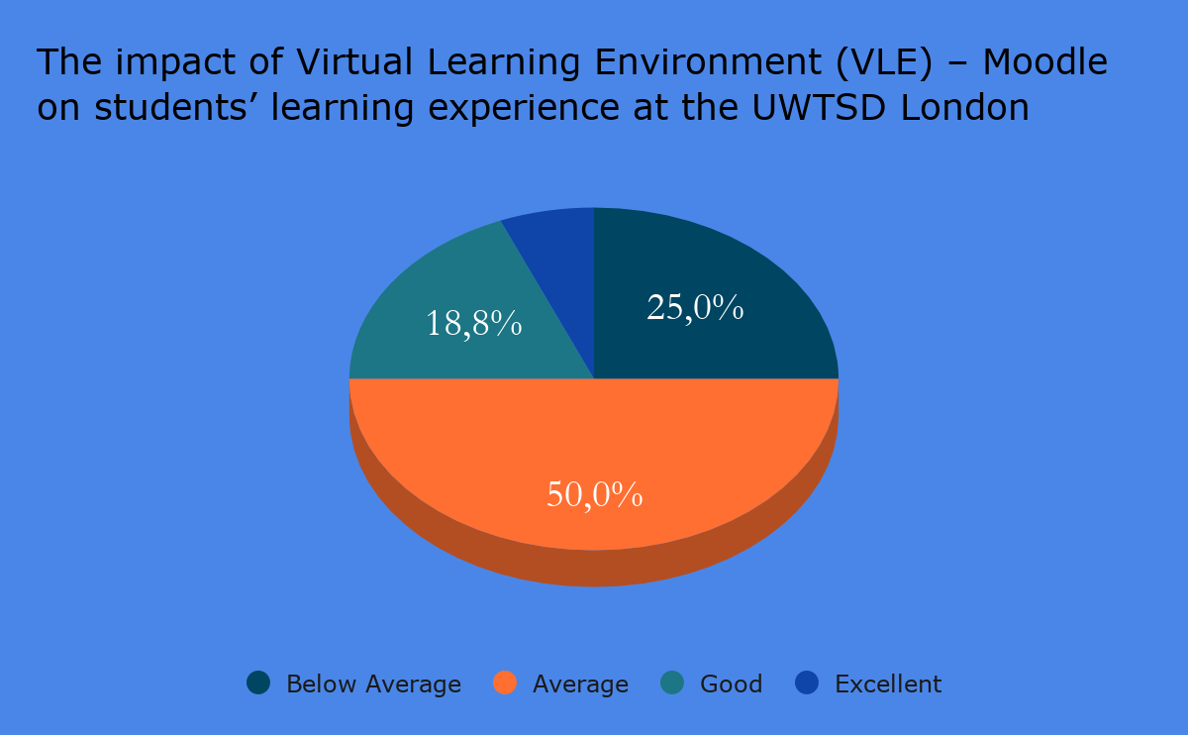

Poor
Below Average - 4
Average - 8
Good - 3
Excellent - 1

Analysis of the data
Most of the students surveyed thought their learning at UWTSD London campus was between average and excellent with no one saying it was poor. The students felt their expectations were being met.

Question 2: Do you have access to a device for a virtual learning environment?

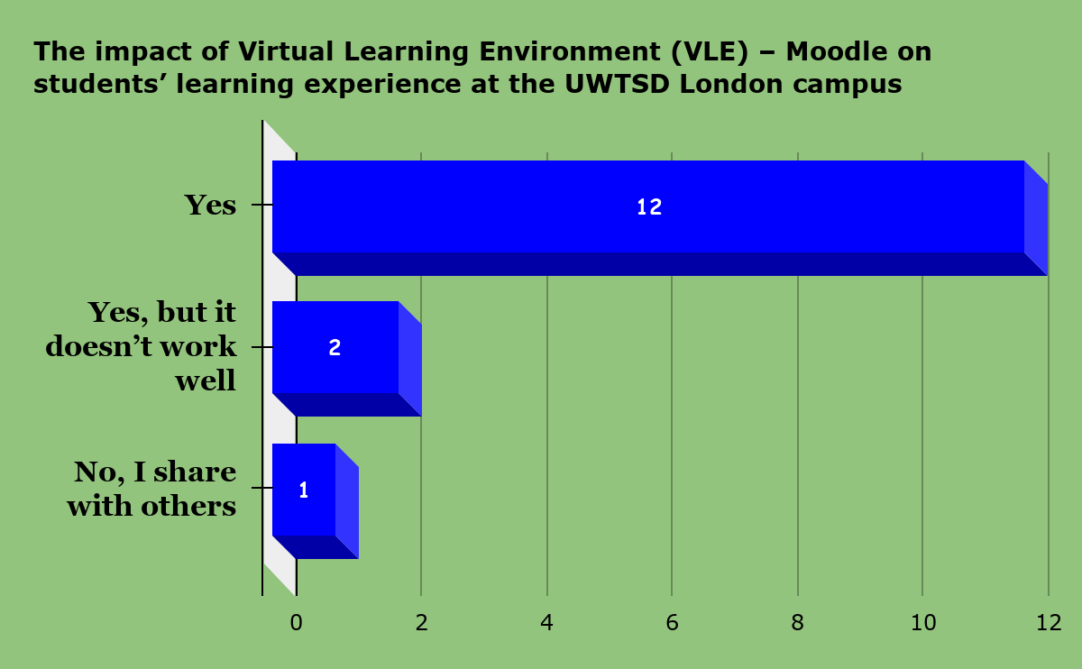

Yes - 12
Yes, but it doesn’t work well - 2
No, I share with others - 1

Analysis of the data
In terms of access to devices like laptops for virtual learning, of the fifteen students surveyed, most of the students stated they had access to a device, although some reported the device did not work well and one reported having shared access to a device. in order for them to fully participate in their studies at UWTSD they need to be able to access devices so this was a positive outcome.

Question 3: What device do you use for distance learning?

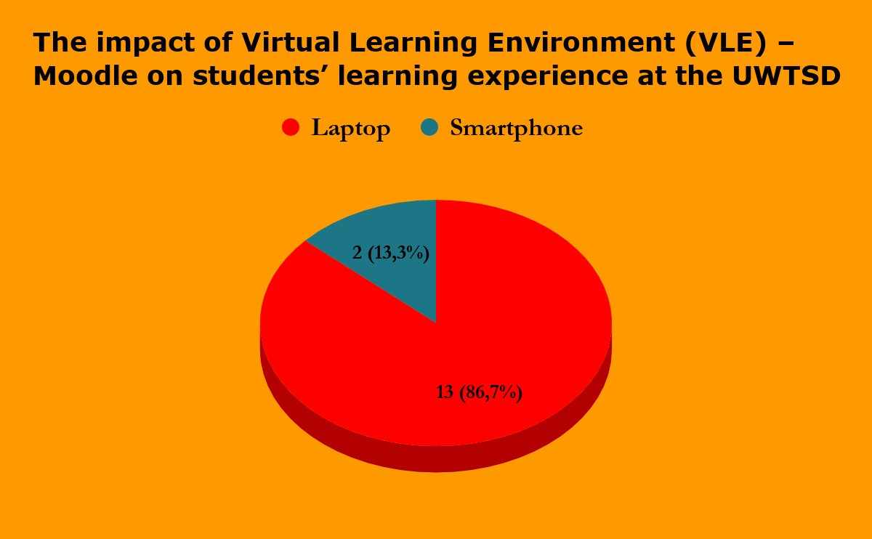

Laptop - 13
Desktop - 0
Tablet - 0
Smartphone- 2

Analysis of the data
Students were asked what device they use for their learning and fourteen of the fifteen surveyed reported they used a laptop with one reporting they were using a smartphone for their studies. it seems the students are well equipped to successfully engage in their work judging from the response obtained.

Question 4: How much time do you spend weekly on an average on virtual learning?

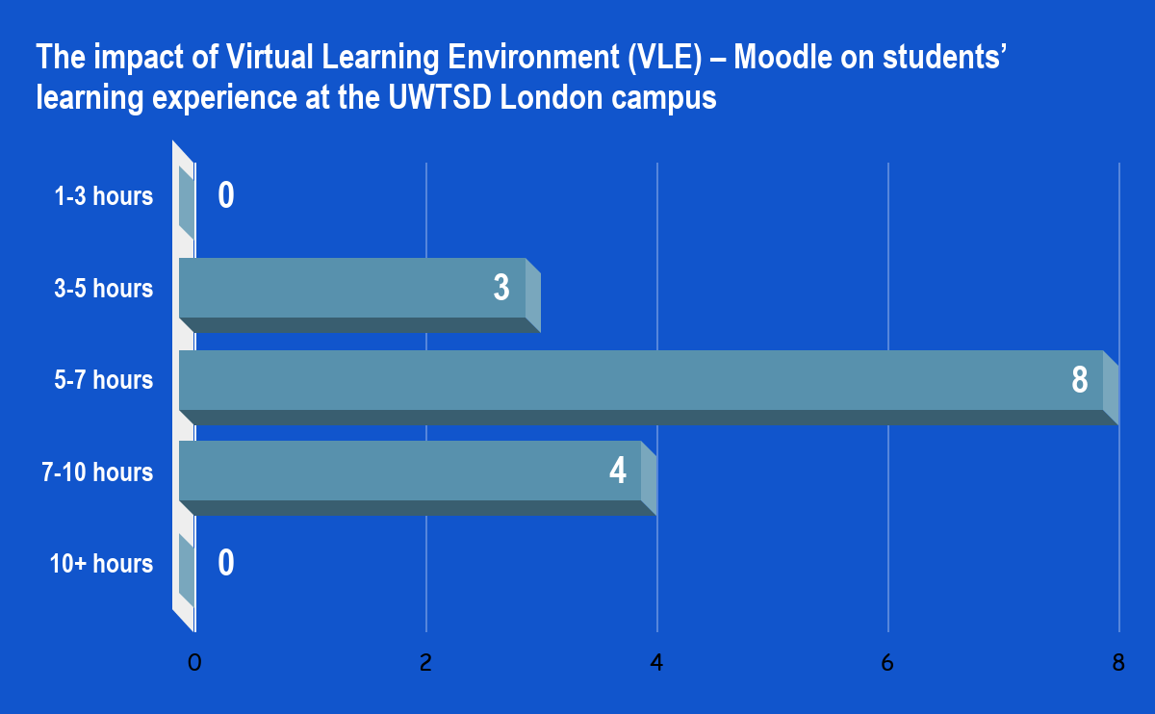

1-3 hours - 0
3-5 hours - 3
5-7 hours - 8
7-10 hours - 4
10+ hours - 0

Analysis of the data
In terms of time students reported that they spent between 3 and 10 hours per week studying virtually, with a majority of 8 students reporting they spent five to seven hours a week on their studies. None of the students spent less than three hours or more than ten hours on their studies.

Question 5: How helpful are your teachers while studying online?

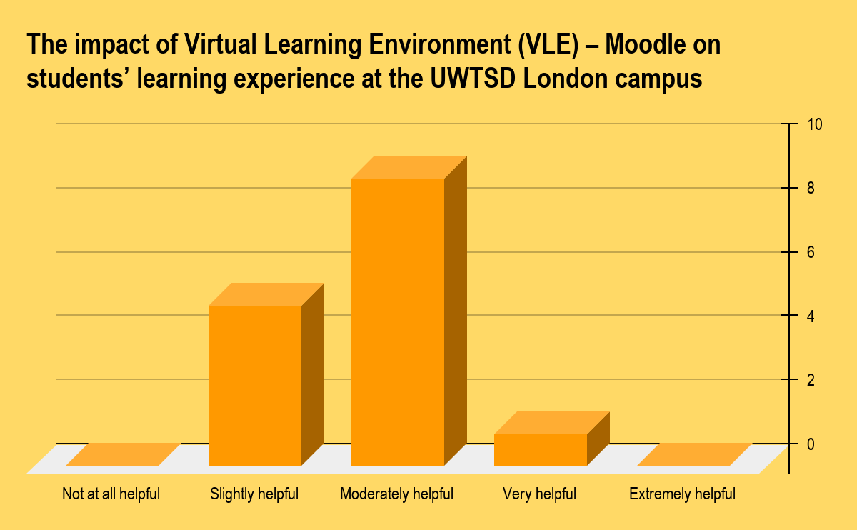

Not at all helpful
Slightly helpful - 5
Moderately helpful - 9
Very helpful - 1
Extremely helpful - 0

Analysis of the data
The teachers were reported to be helpful by the participants of the survey. With a majority of the students saying the teachers were moderately helpful. The second response given by 5 of the fifteen surveyed students was that the teachers were slightly helpful.

Question 6: Are you satisfied with the technology and software you are using for online learning?

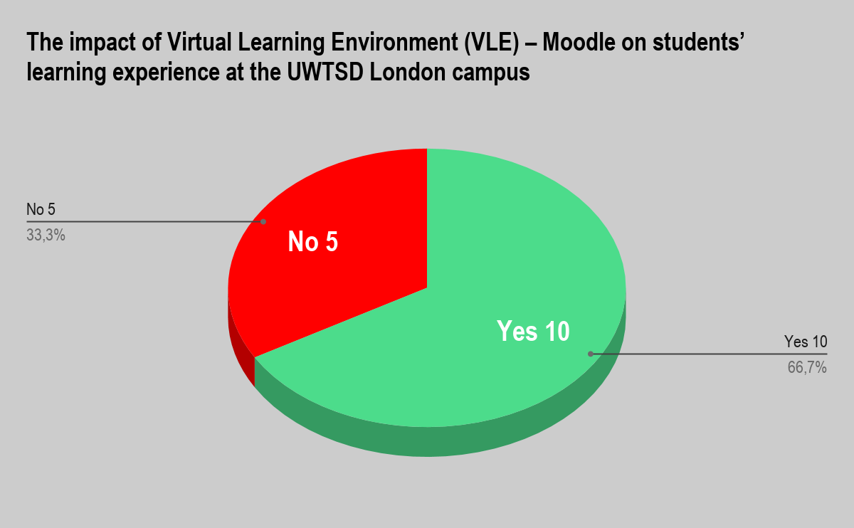

Yes - 10
No - 5
Why? ________

Analysis of the data

Ten of the surveyed students reported they were happy with the technology and software they were using for online learning. This included the virtual classrooms they were attending. Anyone was able to give a reasonable answer of why.

Question 7: How helpful the University has been in offering you the resources to learn from home?

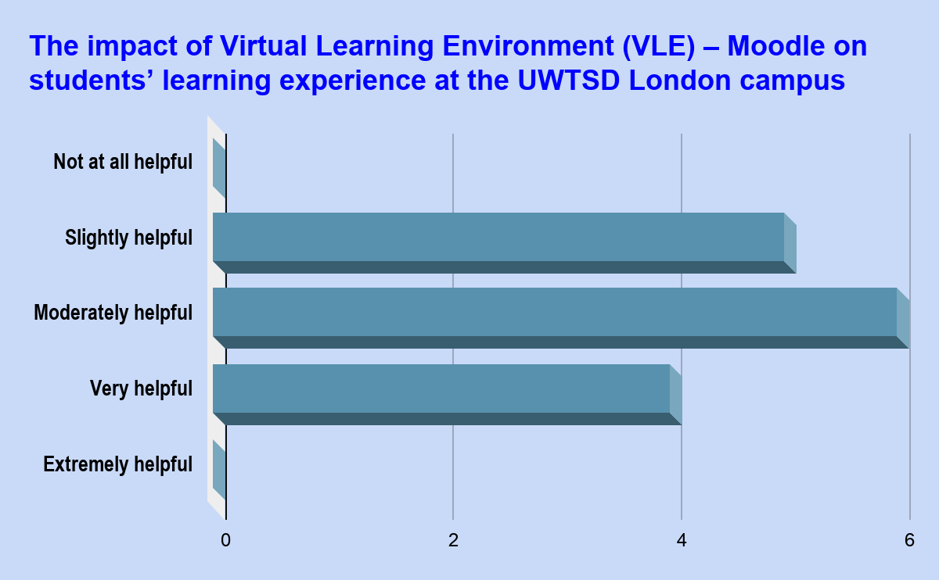

Not at all helpful - 0
Slightly helpful - 5
Moderately helpful - 6
Very helpful - 4
Extremely helpful - 0

Analysis of the data
In this questions the fifteen students was divided between three choices, moderate helpful (6) slightly helpful (5) and very helpful (4)

Question 8: How much effort are you putting into your classes right now? Rate using the grade (1Very Low to 5 High)

1 (0) | 2 (0) | 3 (5) | 4 (8) | 5 (2)

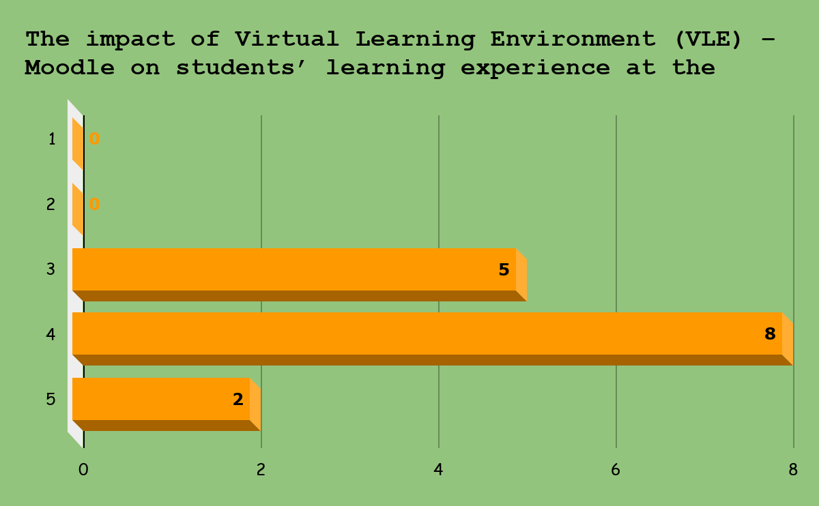

Analysis of the data
The students reported they were putting a great deal of effort in their studies and 70 percent reported they were putting in high levels of effort rated at 4 and 5 out of a possible maximum of 5.

Conclusion/Recommendation

In conclusion this report has looked at the impact of Virtual Learning for the students at UWTSD. We started by collecting data from surveys and students, analyzing this information, using quantitative and qualitative research methods and we analyzed the data we received. The overwhelming evidence indicated that the VLE was positive for students as was evidenced by the results of the data we analyzed and published in this report.

Reference

eThinkMarch 10, (2020),”Building a Modern Virtual Learning Environment (VLE)”, https://ethinkeducation.com/blog/building-a-modern-virtual-learning-environment-vle/
Accessed On : 05/01/2021

Pritha Bhandari (2020),”An introduction to quantitative research”
https://www.scribbr.com/category/methodology/
Published on June 12, 2020. Revised on November 27, 2020
Accessed On : 05/01/2021

Most, . M.M., Craddick, S., Crawford, S., Redican, S., Rhodes, D., Rukenbrod, F., Laws, R. (2003). Dietary quality assurance processes of the DASH-Sodium controlled diet study. Journal of the American Dietetic Association, 103(10): 1339-1346.
Accessed On : 05/01/2021

Creswell JW, Plano Clark VL. Designing and conducting mixed methods research. 2. Los Angeles: SAGE; 2011. [Google Scholar]
Accessed On : 05/01/2021

