STUDENT: Sadeka Khatun (1920267)
University of wales | Trinity saint david
Psychology in Health and Social Care
Module NUMBER: BMHP4019 Component 2 – Written ASSIGNMENT Lecturer: Rebecca Kavanagh

Contents
Introduction 2
Some statistical facts and figures to consider… 3
Social identity Theory (SIT) 4
Theory of Planned Behaviour (TPB) 5
Frustration Aggression Hypothesis (FAH) 6
Conclusion 7
Reference List 8

Introduction

Mr Mason Kabee known to friends as family as Mason may be experiencing more than one or even two or more possible theories for his current behaviour. Taking into consideration his charges for re offending and a custodial sentence that he has already served, in this report are possible theories that have been identified to highlight the potential causes as to why Mason could be demonstrating the behaviour which has been identified by the Youth Offending Team. The intention Mason did show before his release was of a positive engagement and a committed individual which showed an intention to want to progress and achieve a qualification via the apprenticeship that he signed up for. This again showed his positive attitude that he wanted to make a change in his circumstances to better his future.
We will further explore the possible causes of Mason’s recent outbursts, studying the theories mentioned in this report more in detail. Consider that it may be possible to identify the unnoticed causes and possible reasons for Mason’s behaviour and attitude and how he is feeling currently. Analysing and investigating the possibilities that the below points can relate to the various aspects of Mason’s current situation.
- Social Identity Theory (SIT)
- Theory of Planned Behaviour (TPB)
- Frustration Aggression Hypothesis (FAH)

Some statistical facts and figures to consider…

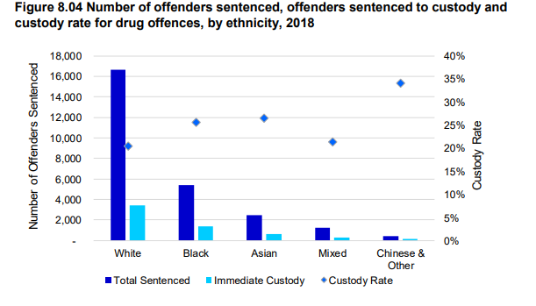
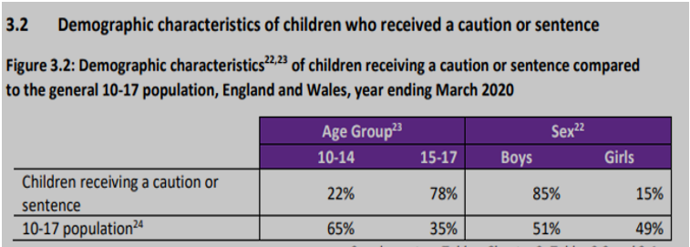
(Ministry of Justice, 2021)

According to Youth Justice Statistics in March 2020 last year research shows teen-agers made up 51% of the general 10-17 population in England and Wales. 85% of the total number received a caution or a prison term. (Ministry of Justice 2021). This percentage has steadily been on the rise over the last ten years. 78% of Most children who received a caution or sentence were aged 15 to 17 Years of age.

Social identity Theory (SIT)

What is Social Identity Theory? This theory was introduced originally in the 1970s by Henri Tajfel and over the decades developed into other sub-theories but mostly this theory gives us an understanding of how individuals can feel and behave due to other social influences. The theory explains how social groups and social beliefs and styles also play a huge factor towards one’s behaviour. As we discover that social identity is a form of Self-concept and how it does relate to individual traits. The way individuals behave. act’s and portrays themselves as to who they are. However, when we start to consider that social influences from others around us can also influence how an individual can behave will cause self-conflict. “Influence from others can create uncertainty”. (Hogg, 2016, pp. 3-17).
Could it be that Mason is being influenced by a social group or some sort of social belief and understandings taking these factors into consideration this report can help aid the Youth Offending Team further to recognise the root causes of his behavioural way’s. This theory considers the emotion’s, feelings, and behaviour that others around can influence another individual be it good or bad. It would be fair to consider group influence that needs to be addressed and highlighted as a danger area in terms of how Mason is demonstrating via his recent action’s.
What also could be considered is that social factors can determine an individual’s behaviour in specific circumstances. Individuals sometimes can be blinded or under false pretences and lack their own judgement call. People influenced by a social factor can act more like most of their social group which would generally conflict with their own individual beliefs and acts if they were not influenced. (Tajfel, 1982, pp. 45-46).

Theory of Planned Behaviour (TPB)

As observed in this case study, Mason has served time in offenders for re offending so has previous charges relating to the same offence. Theory of planned behaviour has been examined whereby it has been identified that individuals with a previous offence is likely to commit the same again, therefore theory describes how the attitude of someone contributes significantly towards a specific act. If a goal should be turned into an action this would adjusts on motivation and how much energy the individual is willing to spend. “True fact re offending have been and will in some respect remain unknowable” (Muncie, 2015, pp. 1-20).
Whether an individual can think in a particular behavioural way be it good or bad in nature, this would mean that the person acting out a particular behaviour expect a particular desired outcome therefore based on their attitude and intentions upfront will go ahead and act this out as they believe this to be the right actions. This is where the support team may also need to rethink how Mason time spent in the youth offender’s establishment has affected him. Agreed that a positive attitude changed into a negative for Mason or was this intended as he always had a planned desired goal regardless of him showing a positive attitude on his release. Let us consider that due to other unfortunate circumstances his intentions due to pressure always was intended to be positive to a certain point in time. Therefore, the Youth Offending Team had this perception of him to be positive and want to progress for the better. However, it is further possible that Mason gave that impression by being on his best behaviour enrolling onto the apprenticeship was his way of agreeing by presenting himself under false pretences and not really having that true intention to want to better himself. Taking all these possible assumption’s into planning the next course of action for him will now need to be investigated analysed further in depth. This would be in the best interest of Mason.
Further findings around planned behaviour will allow us to examine and consider why Mason is potentially expressing his recent change in behaviour. This theory also introduces the idea that there is a ‘motivational’ aspect of an individual’s behaviour. We can also discover through published information that the effect of cognitive influences, so how our beliefs and feelings towards a preferred object can influence us. (Greg, 2009, p. 90). but is there an element of persuasion, all these factors need to be weighed up this way of understanding will further broaden the possibilities there are various aspects to consider in this case.

Frustration Aggression Hypothesis (FAH)

Frustration–aggression theory, as well as recognized as the frustration–aggression hypothesis, was created in the 1930’s. It a theory is most used in Psychology, and commonly used in criminology there are many more other fields that this theory has been introduced to and relates to. However, “It’s understood that frustration is expressed based on an event rather than feelings” (Breuer and Elson, 2017). Many researchers find evidence that frustration aggression is part of the nature and nurture debate. Social psychological justifications which believe aggression is due to nurture. “Frustration in the environment” or a “Struggle Between Life and Death”. (Brown, 2006, p. 98). Those who are in position of control to the individual such as mediators, or support or community workers that involve themselves to help in mediation. Usually experience first-hand the frustration aggression.
The unexpected outburst by Mason due to frustration could explain why a member of the Youth Offending Team received unacceptable behaviour.
FAH would explain why the outburst from Mason happened when confronted, however we still need to understand and explore the possibilities that the frustration has been building up over a period of sometime, this as a root cause has not yet been identified, but we could relate this also under the assumption that there is more complexity in the reasons why Mason is feeling such emotions.
There is a 3-part component model of attitude the most popular which measures in three parts which is Thoughts = Cognitive, Feelings = Affective, and Action = Behavioural. (Breckler, 1984, p. 5). Mason’s Behavioural aspect could be what he believes as his actions are the subjective norm which could again explain that it's his lifestyles that will need positive changes. Also, to add that we note down that the development in adolescent and the transition to adulthood would be another factor to also consider in Mason’s case. Teenager like Mason will encounter many obstacles, causing frustration and anger which hinders the way they develop into adulthood the transition will involve…
- Hormonal Changes
- Brain Development
- Personal differences due to Pubertal growth. (Berk, 2017, pp. 1375 -1377).
Other frustrations can also be addressed such as the financial difficulties he may be facing, causing him to feel stressed and anxious about a particular event.

Conclusion
Prevention Programme’ These are services available that would retain young individuals away from crime or any form of law breaking. Youths are introduced to these programmes If they have been in trouble with the police and have previous charges or if they are at risk of being in trouble with the police again, or if individuals are believed to be involved in anti-social behaviour. (Gov. UK, 2021)
Taking all these findings and all the theories stated we can start to build a theory around what Mason is experiencing either from a social identity perspective, then possible theory of planned behaviour and then emphasising on the theory based around frustration aggression. What we begin to see is that from social aspect to his own frustrations the pressure is now overwhelming him in a way anger is being shown in his attitude. The choices Mason needs to make is to ensure he has corrected guidance and support to help improve his circumstances. The Youth Offending Team to take into consideration all aspects of what has been stated and highlighted in this report.
To conclude on this report with best regards to the Team for a successful outcome, and hope that the best decision for the utmost best resolution and changes for Mason’s future can be achieved and to maintain support for him throughout.

Reference List

- Berk, E. L. (2017) Development Through the Lifespan. 7th edn. Boston: Pearson Education.
- Breckler, J. S. (1984) “Empirical Validation of Affect, Behaviour, and Cognition as Distinct Components of Attitude”. Journal of Personality and Social Psychology. 47(6) pp. 1192-1196
- Breuer, J. and Elson, M. (2017) “Frustration-Aggression Theory”. The Wiley Handbook of Violence and Aggression. pp. 1-12.
- Brown, C. (2006) Social Psychology. London: SAGE Publications Ltd.
- GOV.UK, (2021) Youth crime prevention programmes. Available at: https://www.gov.uk/youth-crime-prevention-programmes (Accessed: 20 March 2021).
- Greg, M. (2009) The Psychology of attitudes and attitude change. Los Angeles [Calif]: SAGE Publications.
- Hogg, M.A. (2016) Understanding Peace and Conflict Through Social Identity Theory. USA: Claremont Graduate University.
- Ministry of Justice, (2021) Youth Justice Statistics [Image] Available at: https://assets.publishing.service.gov.uk/government/uploads/system/uploads/attachment_data/file/956621/youth-justice-statistics-2019-2020.pdf (Accessed: 20 March 2021).
- Muncie, J. (2015) Youth and Crime. 4th edn. London: SAGE
- Tajfel, H. (1982) Social Identity and Intergroup Relations. Cambridge: Cambridge University Press.

