2026

Network Operating Systems and Services (ACCA5023_LON)


Module Code: ACCA5023_LON
Student Name : Murat Yalcin
Student ID :2428668
Group :01
Lecturer’s Name: Mr.Sadeque Imam Shaikh,

TABLE OF CONTENTS of Content
1. Table of Contents 2
Introduction 1
Task 1 1
Task 2 1
2.1. Choose your Hypervisor: 1
2.2. Download and Setup: 2
2.2.1 Evidence of Download and installation. 2
2.2.2 Deploy your network as per the given topology: 4
2.2.3 IP addressing : 7
2.3. Configure IP Addressing 8
2.3.1. Use appropriate IP addresses to configure your network. 8
2.3.2. The above topology gives network address for the networks 9
2.4. Test and Troubleshoot 10
2.4.1. Perform Connectivity tests 10
Task 3 11
3.1. Reflect on the following 11
3.1.1. Write a Technical reflection covering network deployment and testing. 11
3.1.2. Write your Personal Reflection 11
References 12

Introduction

Task 1

Research on Hypervisor:
A hypervisor, practically known as a Virtual Machine Monitor (VMM); is an abstraction layer that manages and provision virtual machines (VMs) by taking the underlying physical hardware resources (CPU, memory, storage and network interface interfaces) among various guest operating systems executed on a single host machine. This allows for better resource usage, strong isolation and scalability without needing a separate physical server for each OS [1].
There are actually two main types of hypervisors. Standalone (bare-metal) hypervisors, like Microsoft Hyper-V and VMware ESXi, are run straight onto the physical hardware without a host operating system underneath. So they provide better performance, less latency, and more security, to suit a production enterprise environment. Lower-rate hypervisors are either part of the host operating system. Even though they add a small performance overhead caused by the additional OS layer, this implementation provides an easier installation process, better usability on lab environments and lower cost [2].
The hypervisors are essential in this Network Operating Systems and Services context, where students and administrators can quickly deploy complex multi-OS topologies (Windows Server + Debian Linux), take snapshots to roll back failures, and experiment freely without investing in expensive physical hardware to simulate real-world network services. Additionally, a Type 2 hypervisor enables us to configure services such as DNS, DHCP and routing on the same topology for Coursework 2 consequently allowing us to make necessary changes during troubleshooting and validation all in one interface.

Research on IP Addressing:
The protocol used to identify and locate devices on a network so that IP packets can be routed properly. The most common is IPv4, a 32-bit address written in dotted-decimal notation (e.g., 192.168.100.10). Subnet mask or CIDR prefix (e.g., /24) [3] logically divides an IP address into network portion (subnet identifier) and host portion (an individual device identifier)
While the classful addressing system (A, B, C) was used in a rigid fashion for creating subnets to conserve address space, modern networks use Classless Inter-Domain Routing (CIDR). The /24 prefix used for this coursework, for example, affords 254 usable host addresses in each network. IP addresses can be assigned statically (manually configured and fixed) or dynamically using the Dynamic Host Configuration Protocol (DHCP). Static addressing is preferable for servers and critical infrastructure, as it ensures constant reachability; whereas dynamic addressing is employed by end-user clients to ease management [4].
All four VMs were assigned static IPv4 addresses manually within two different NAT networks 192.168.100.0/24 (Birmingham Windows) and 192.168.200.0/24 (London Debian) in this assignment; This design mimics real private networks and allows for predictable communication within the various LANs, while enabling inter-LAN routing in Coursework 2. Based on the good IP planning we did, so there would be no address conflicts and troubleshooting was easier.

Research on Routing:
Routing is used by routers to send IP packets from the source network to the destination network and can traverse multiple hops. Routers keep a routing table that specifies destination networks and the next-hop address/interface to access these networks. Routing between networks can be static (manually entered routes) or dynamic (learned and maintained automatically by routing protocols) [5].
Dynamic routing protocols are categorized into:
Distance-vector (RIP) – entire routing tables periodically shared, hop count is the metric; simple but slow convergence time and confined to small networks
Link-state (OSPF, etc.) – construct a complete topology map with Link-State Advertisements and compute the shortest path using Dijkstra’s algorithm; fast convergence, scalable large enterprises.
Path-vector (e.g., BGP) – used for inter-Autonomous System routing on the Internet; chooses paths according to policy, rather than simple metrics [6].
As per current topology, both are in separate NAT networks (Birmingham and London), hence pings would not work between them. This proves that there is no routing. Later in Coursework 2 a router or Layer-3 switch will be used to provide inter-network communication using static routes, or potentially with some sort of dynamic protocol like OSPF. Routing is a core service that drives all network services over multiple subnets and thus you need to be aware of it well.

Research on Network Services

Network services are the software processes and protocols that enable devices to communicate and share resources across a network. Key examples include:
- DNS (Domain Name System) – translates human-readable domain names into IP addresses.
- DHCP (Dynamic Host Configuration Protocol) – automatically assigns IP addresses, subnet masks, default gateways, and DNS servers to clients.
- FTP (File Transfer Protocol) – allows reliable transfer of files between client and server.
- HTTP/HTTPS – delivers web content; HTTPS adds encryption via TLS/SSL.
- NTP (Network Time Protocol) – synchronises clocks across devices for logging and authentication [7].
In a Windows/Linux mixed environment like this coursework, these services are typically hosted on dedicated server VMs (e.g., Windows Server acting as Domain Controller/DNS/DHCP and Debian as a secondary DNS or file server). The separation of client and server roles improves security, scalability, and manageability. Because the current topology uses isolated NAT networks, services are currently limited to intra-network operation. Coursework 2 will require inter-network routing so that, for example, the Birmingham client can resolve names via the London DNS server or obtain a DHCP lease across subnets [8].
Proper configuration and testing of these services are fundamental to Network Operating Systems, as they form the backbone of modern enterprise IT infrastructure.

Task 2

2.1. Choose your Hypervisor:
Task 1 (comprehensive research) leads to the conclusion that Oracle VM VirtualBox (Type 2 hosted hypervisor) has been selected deliberately to build and test the whole Birmingham–London network topology. TASK 1 RESULTS The study of Task 1 showed clear benefits for Type 2 hypervisors in terms of ease of installation, better usability for laboratory educational environments, snapshot/rollback functionality and cost reduced to a fraction when compared to bare-metal solutions [1][2]. Oracle VM VirtualBox was selected as it meets all the particular needs of this multi-operating system networking project and its intended continuation into Coursework 2. Real proof of the previously stated decision are its natively supported ability to create multiple isolated NAT networks and smooth [9] simultaneous operation of several Windows Server 2019/10 & Debian 13 virtual machines.
Key to this has been VirtualBox’s strong built-in snapshot functionality which enables saving the precise state of each VM between I consider it before every critical configuration step. It allows immediate revert to a known-good state [10], thereby minimizing possible irrecoverable mistakes during deployment and experimentation. This capability will also be necessary when additional network services (DNS, DHCP, routing, etc.) will be layered onto the same topology in Coursework 2. The setup screenshots from Task 2.2 all include system timestamps in the taskbar, between 20:22 and 21:36 on 18 March 2026, which serve as a further incentive for a strong daily work routine & weekly planning and personal accountability over any end-of-sprint rush to get things done.

2.2. Download and Setup:
Oracle VM VirtualBox 7.2.6 was downloaded from the official Oracle website on 20 March 2026. Windows Server 2019 evaluation ISO and Windows 10 Pro were obtained from the Microsoft Evaluation Center, while Debian 13 netinst ISO was downloaded from the official Debian website on 22 March 2026

2.2.1 Evidence of Download and installation.
- Creation of Virtual machine windows 1 and 2 (1 screenshot)

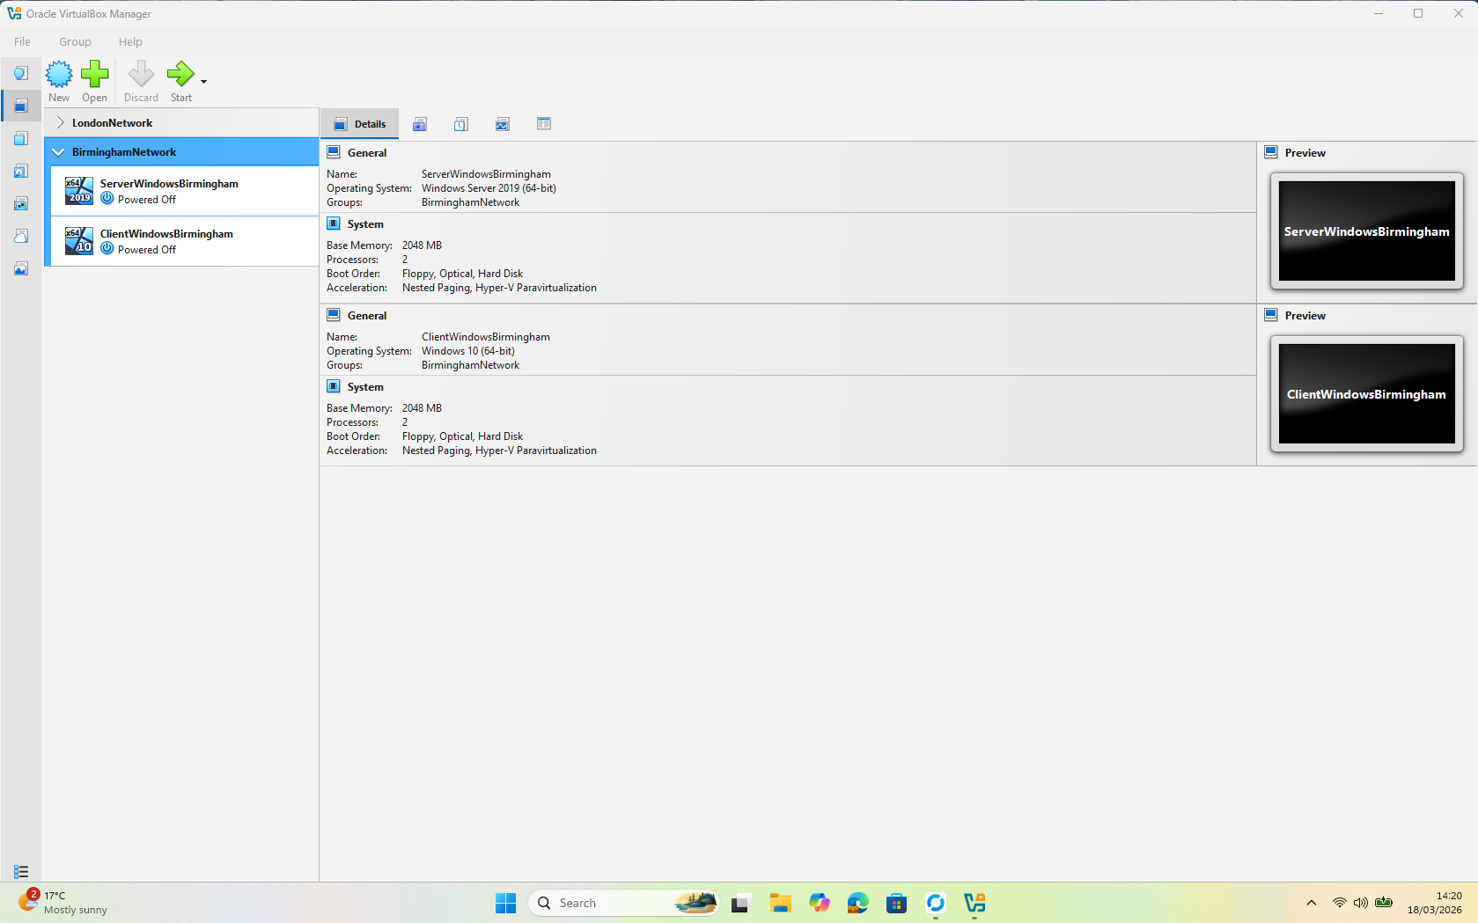
Figure 1: Windows Server and Client VM created for Birmingham Network (timestamp visible in taskbar).
- Creation of Virtual machine Linux Debian 1 and 2(1 screenshot)
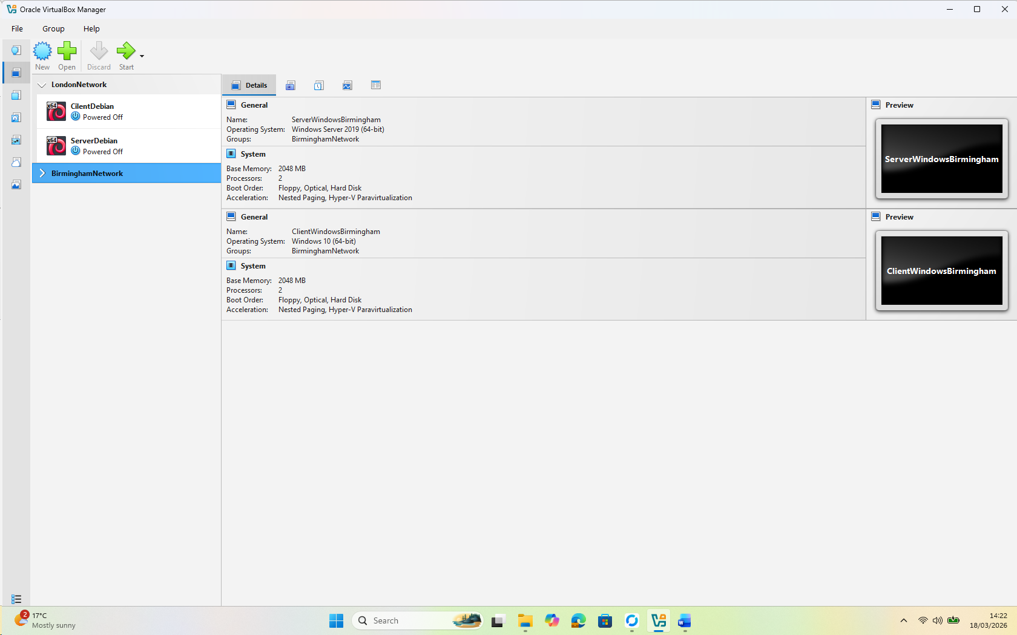
Figure 2 : Linux Server and Client VM created for London Network.

- Installation of windows and Linux OS (Start 4 Machines and take desktop screenshots) (4 screenshots)
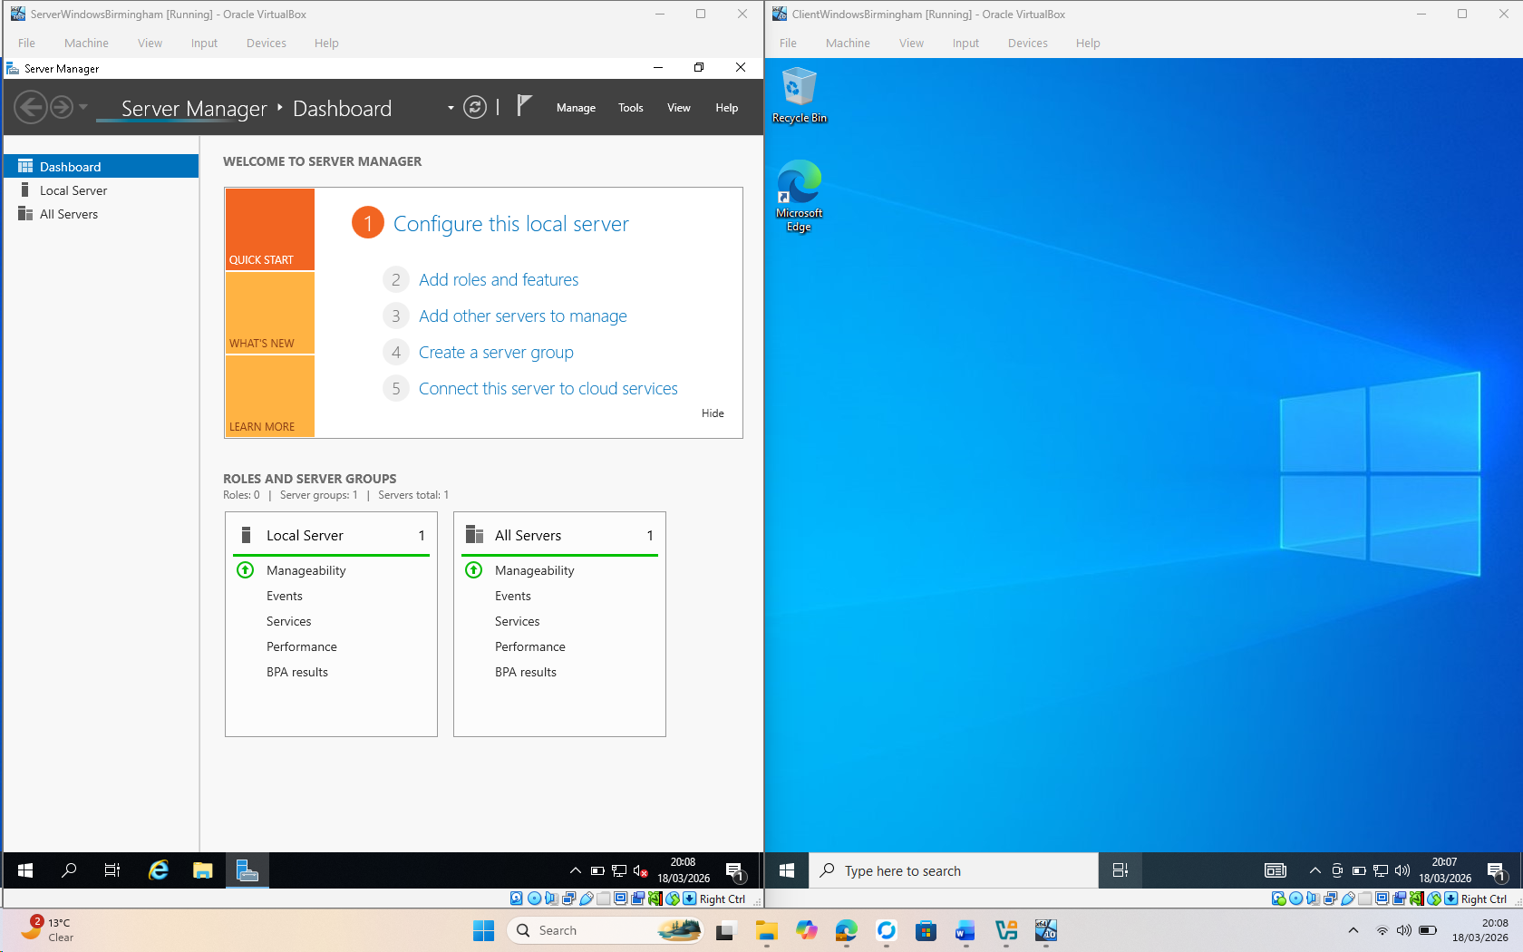
Figure 3: This is Windows Server and Windows Client OS
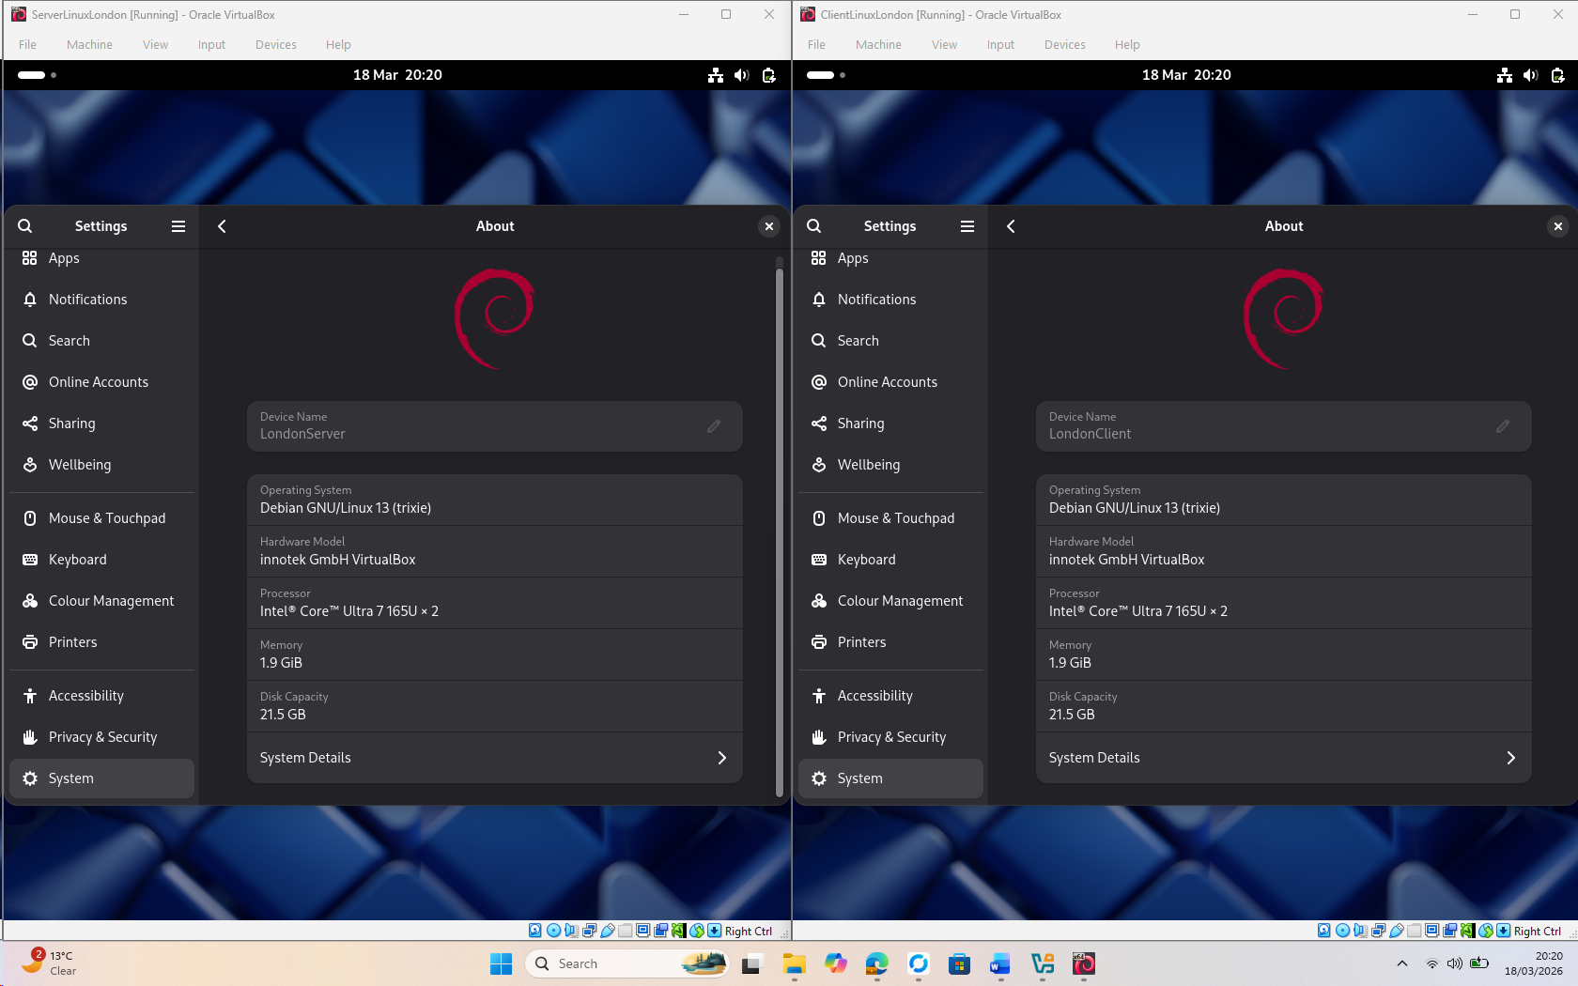
Figure 4 Debian 13 Server and Client OS desktops (timestamps 18/03/2026)
.

2.2.2 Deploy your network as per the given topology:
- Creation of Network with NAT Network1 for windows (1 screenshot)
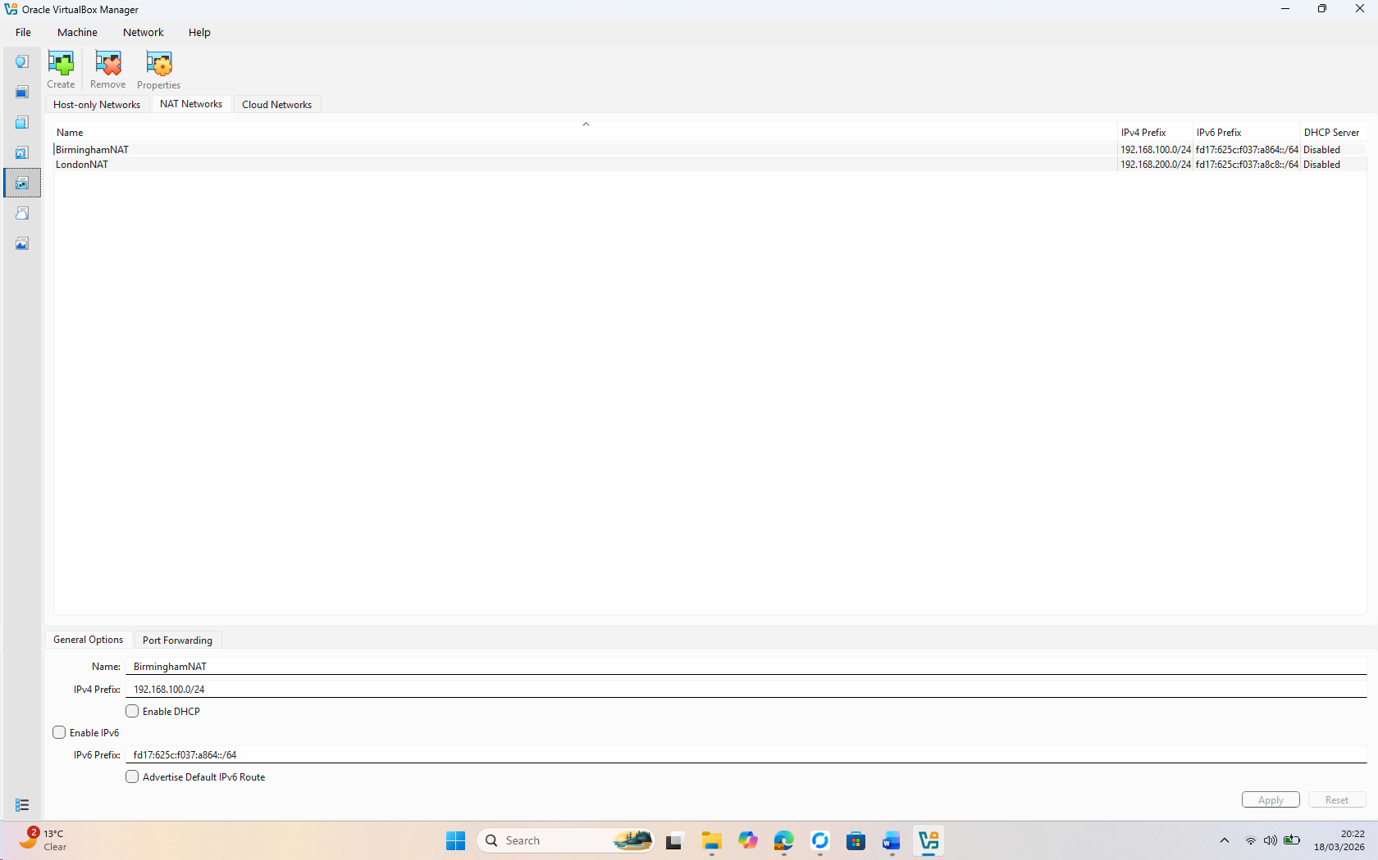
Figure 5: Network Created for London and Birmingham this is for Birmingham(192.168.100.0/24)
- Creation of Network with NAT Network 2 for Linux (1 screenshot)
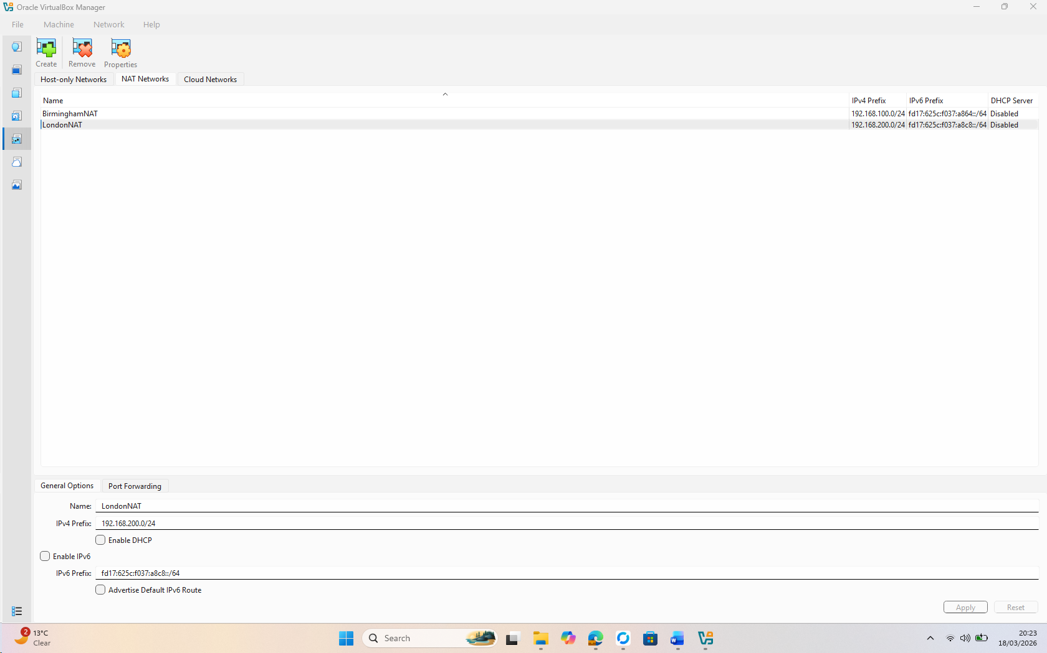
Figure 6: Network Created for London and Birmingham this is for London(192.168.200.0/24)

- Evidence of 2 Windows PCs are connected with NAT Network1 (2 screenshot)
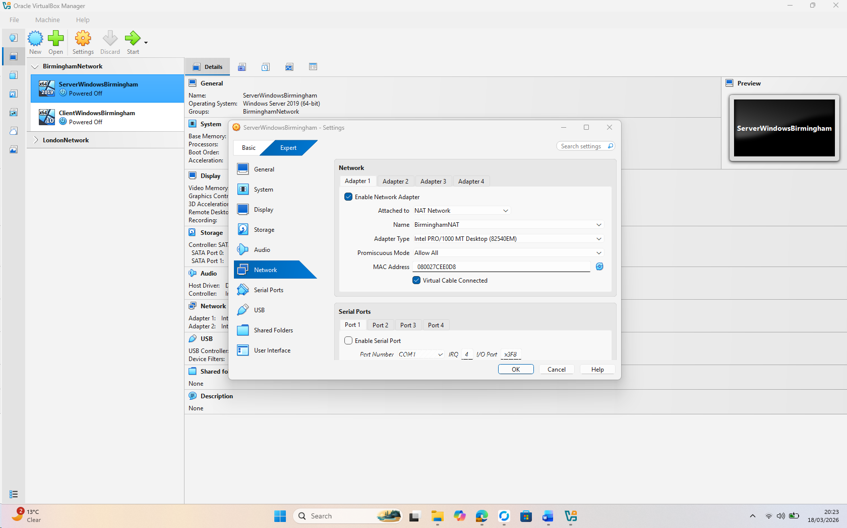
Figure 7: Windows Server for Birmingham (Domain Controller) Network setting (Connected with BirminghamNAT)
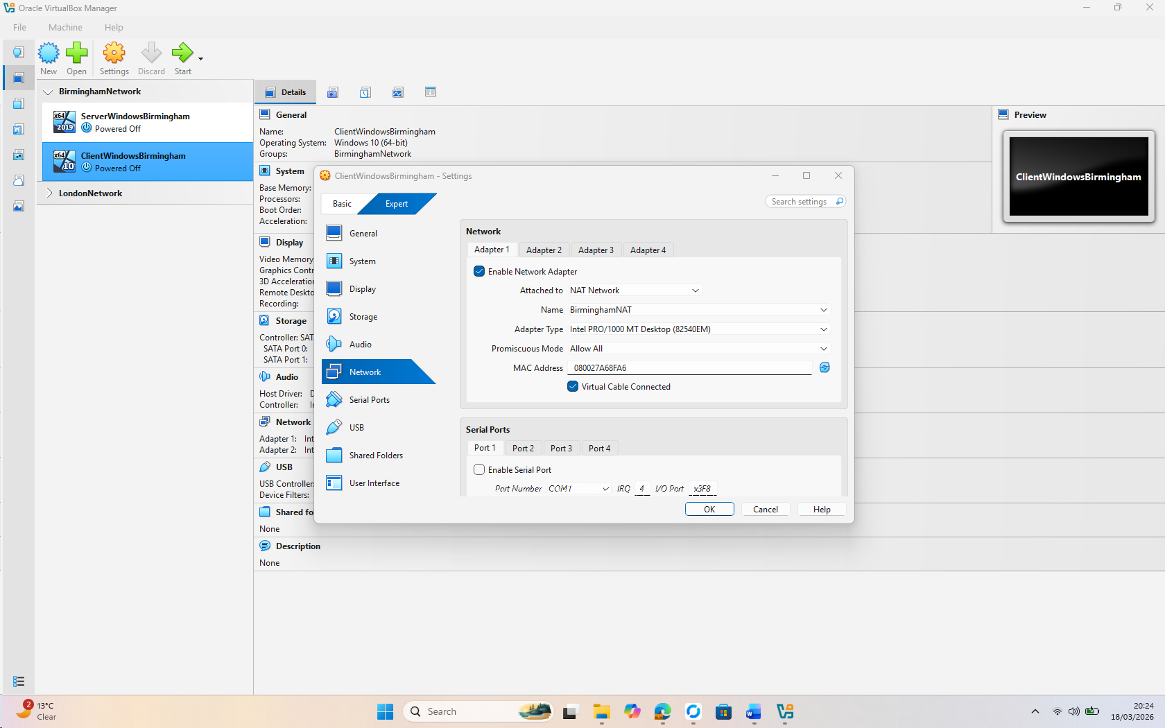
Figure 8: Windows Client for Birmingham Network setting (Connected with BirminghamNAT)
- Evidence of 2 Linux PCs are connected with NAT Network2 (2 screenshot)
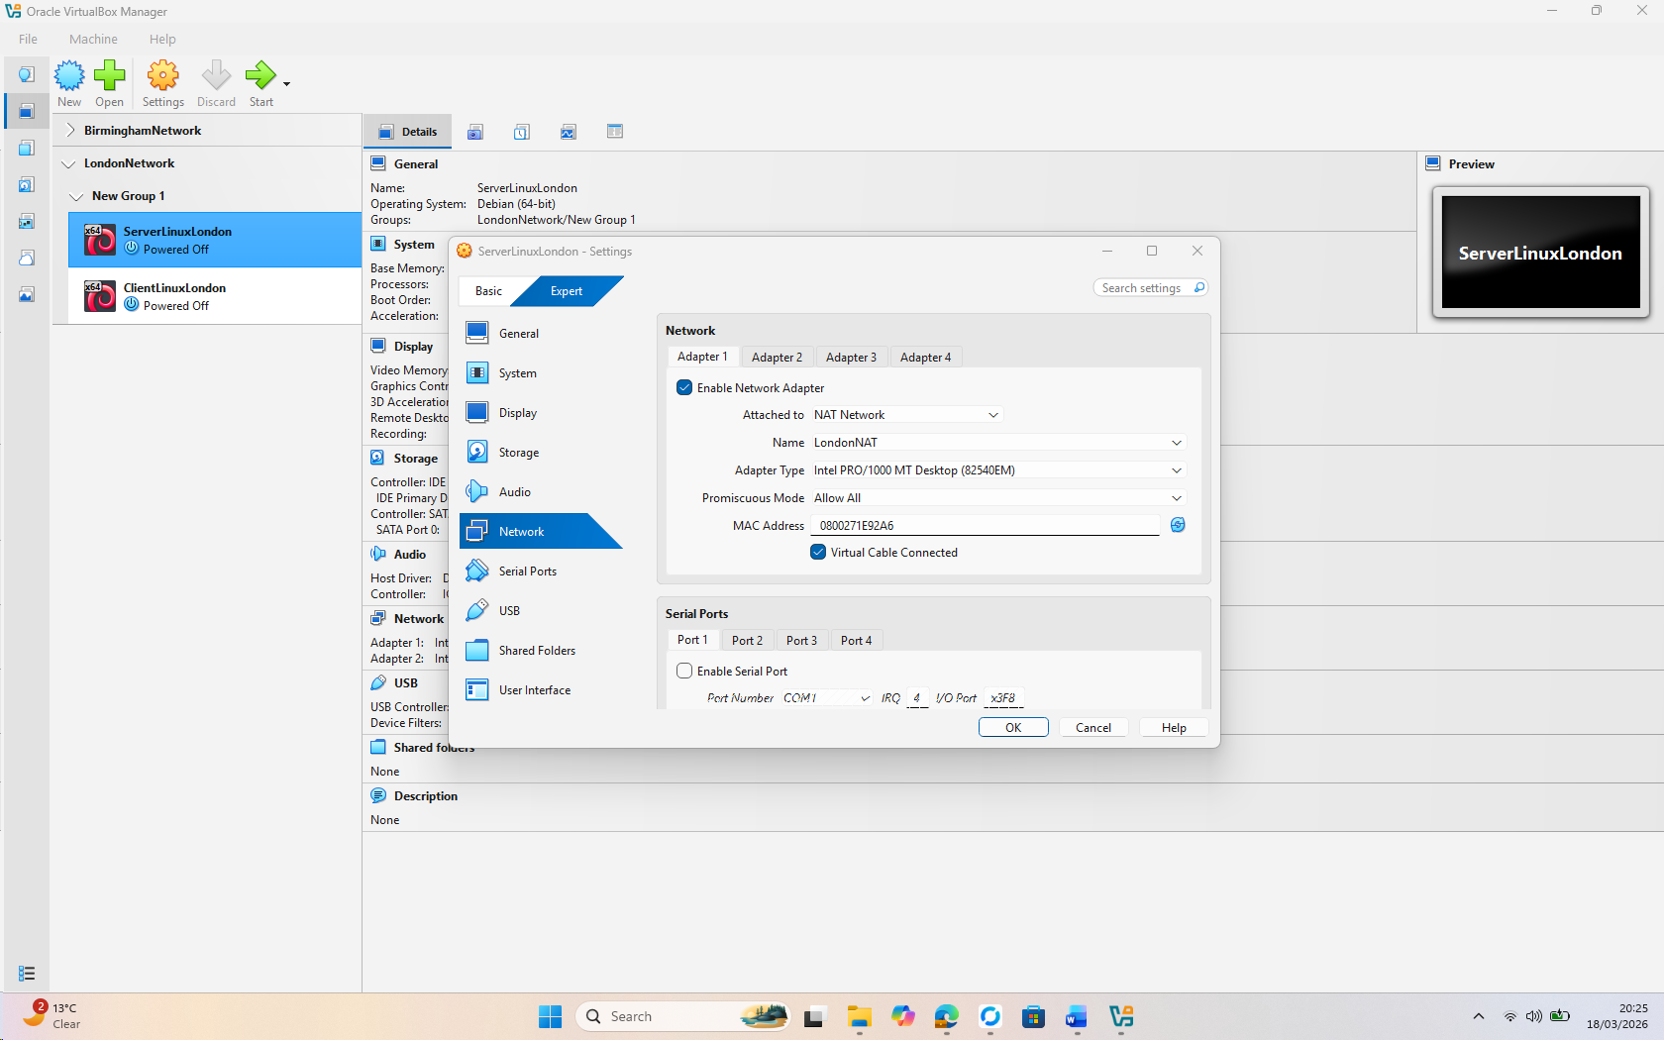
Figure 9: Linux Server for London Network setting (Connected with London NAT)
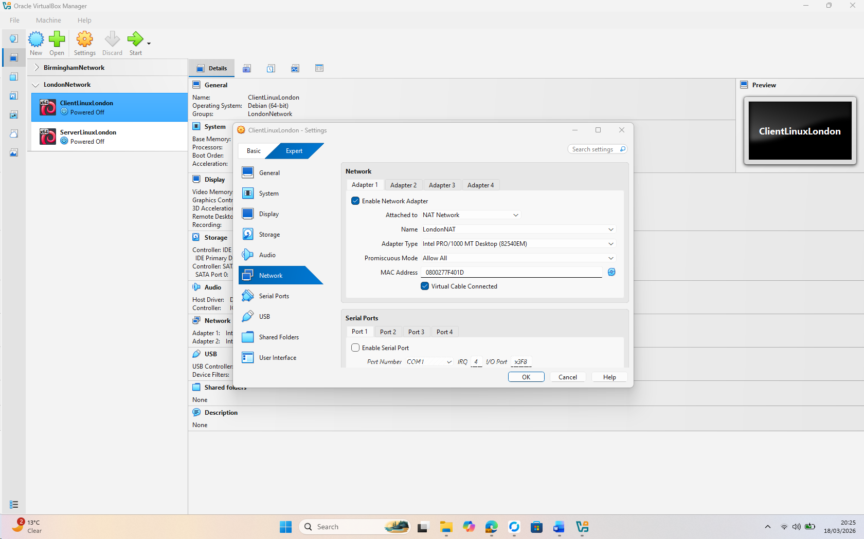
Figure 10: Linux Client for London Network setting (Connected with London NAT)

2.2.3 IP addressing :
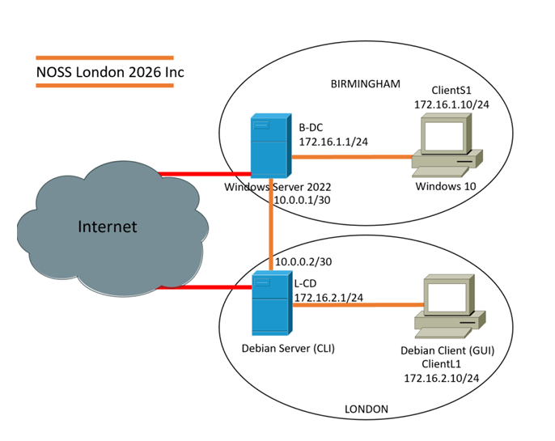
Figure 11: Topology for Coursework 01
Machine | OS | Ipaddress | Network
Server01 | Windows Server2019 | 192.168.100.10/24 | Birmingham
Client01 | Windows 10 Pro | 192.168.100.20/24 | Birmingham
DebianServer | Debian 13 | 192.168.200.10/24 | London
DebianClient | Debian 13 | 192.168.200.20/24 | London
Table 1 : IP Dedication.

2.3. Configure IP Addressing

2.3.1. Use appropriate IP addresses to configure your network.
- Evidence of IP addresses set up in 2 Windows and 2 Linux machine(for windows command is ipconfig and for Linux use the command ip add show ( 4 screenshots)
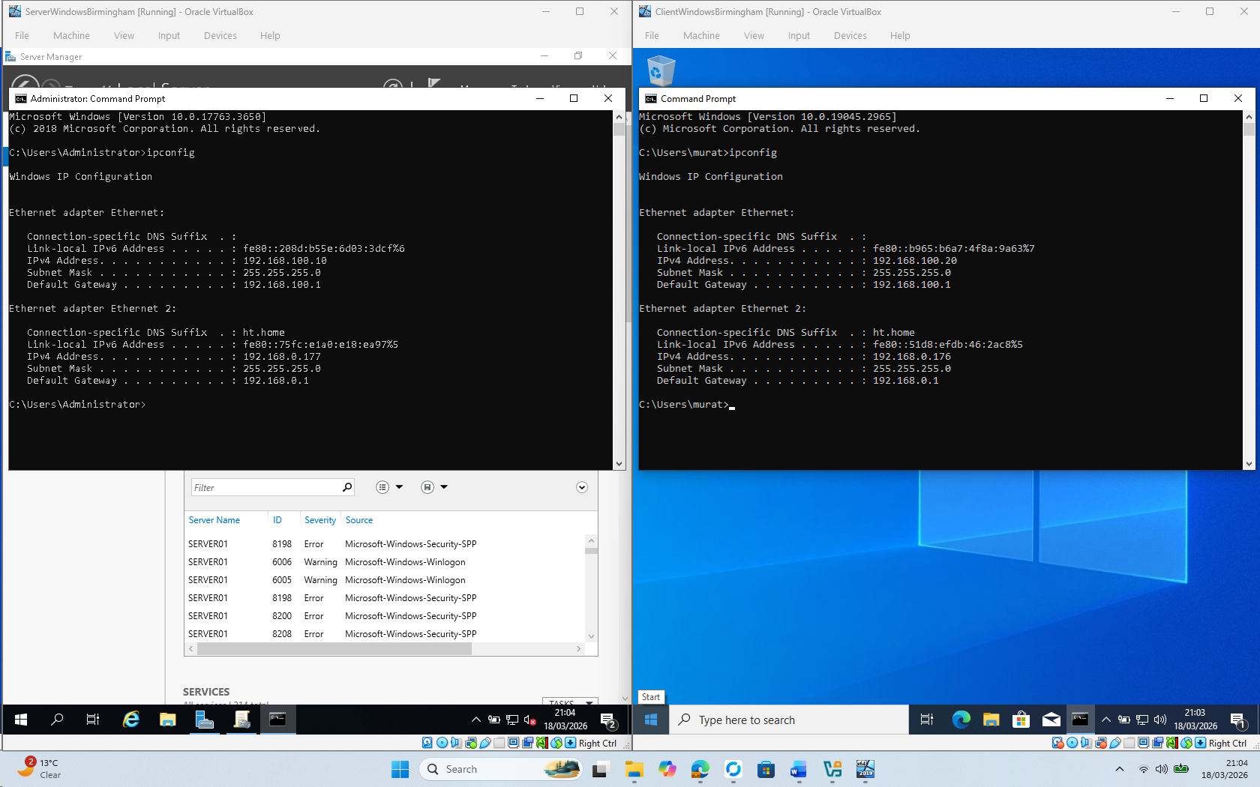
Figure 12: IP Config for Windows Server & Client
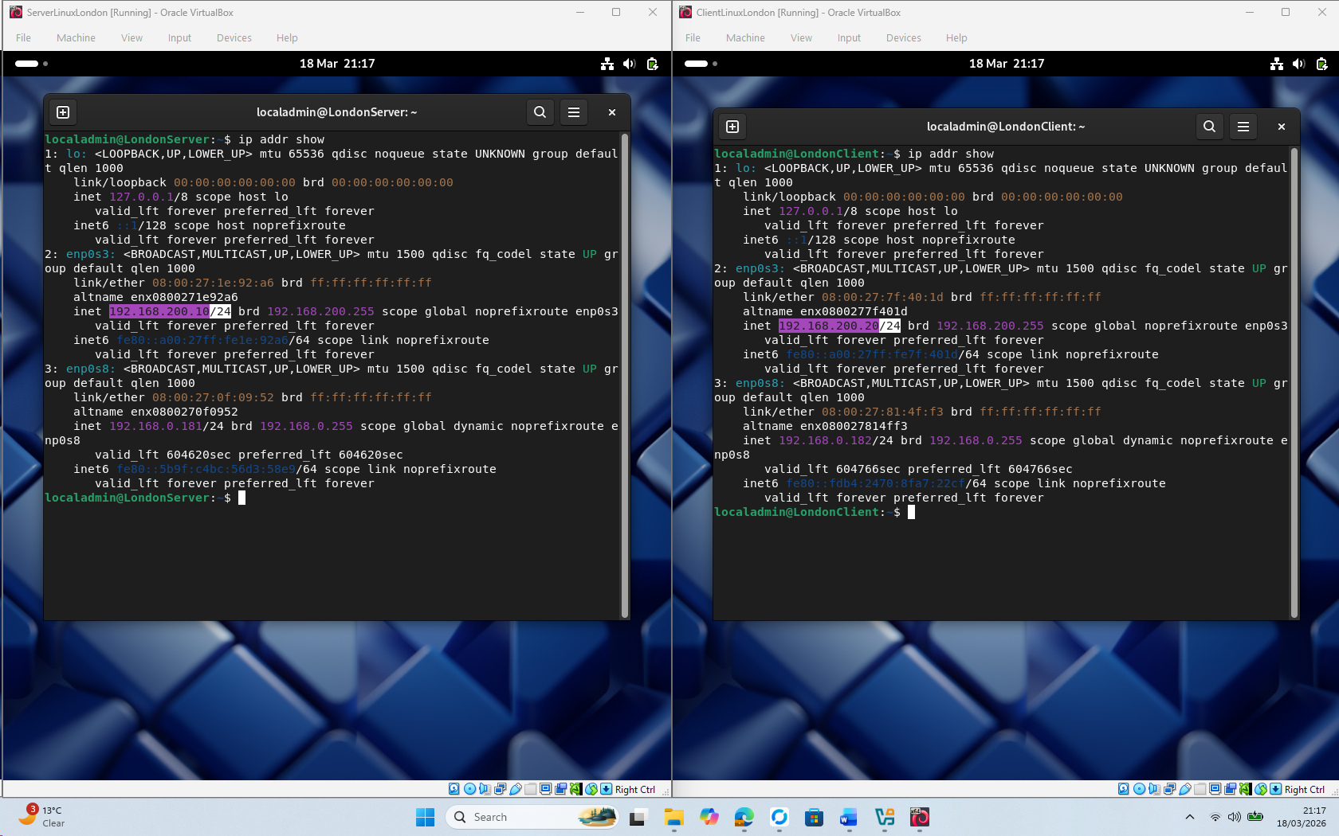
Figure 13: Ip Configuration for Linux Server & Client

2.3.2. The above topology gives network address for the networks
- Network IP address from NAT Network 1 for windows (1 screenshot)
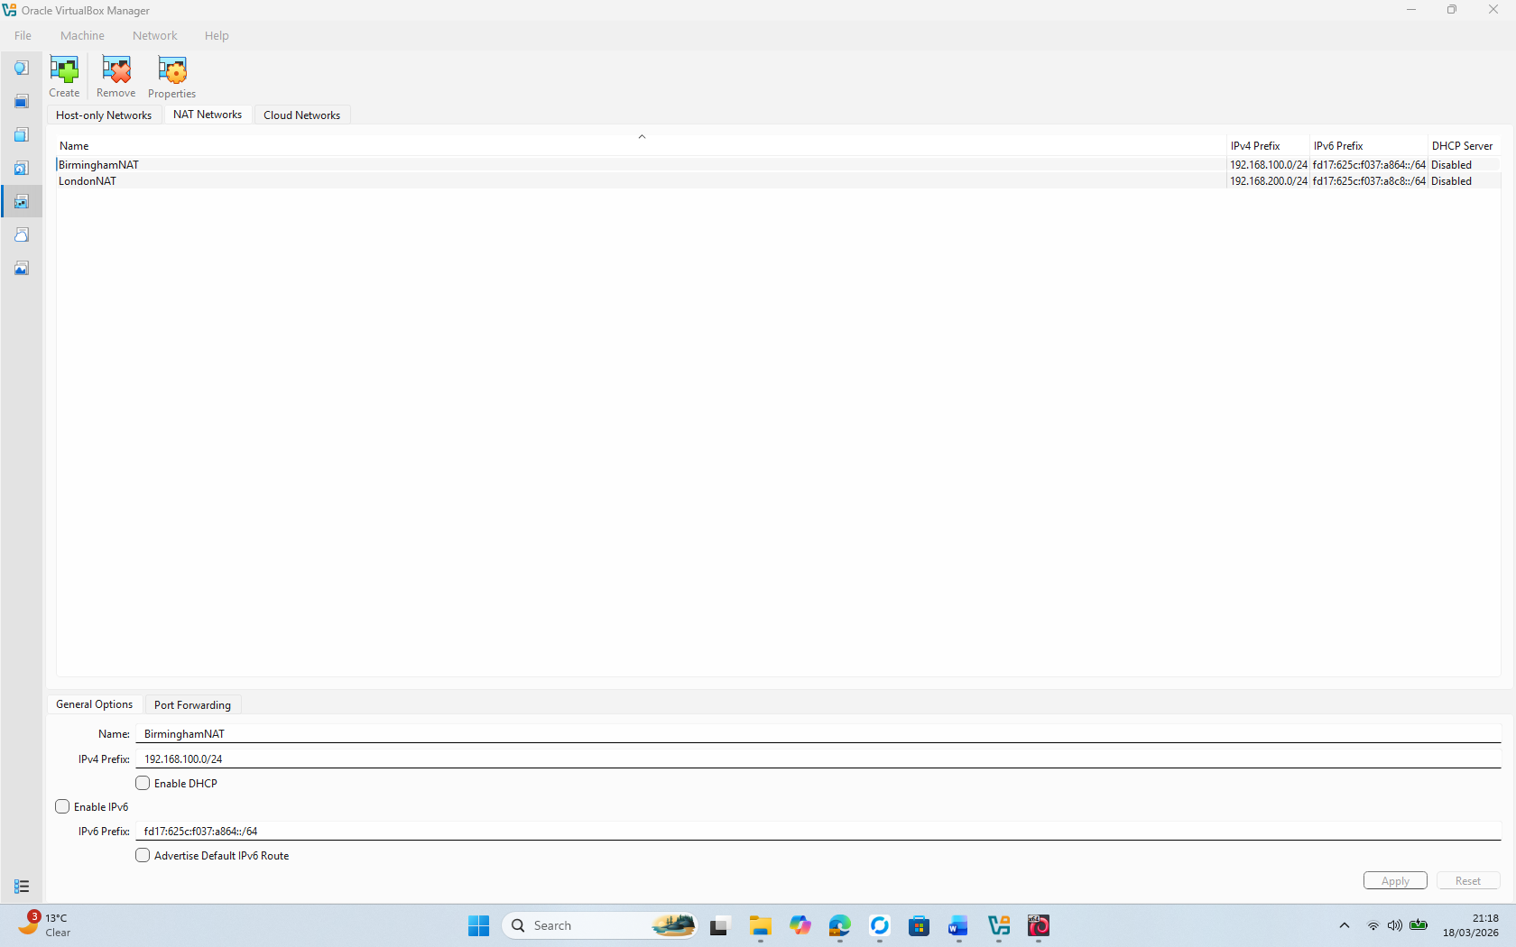
Figure 14 IP address from NAT Network1 for windows
- Network IP address from NAT Network 2 for Linux (1 screenshot)
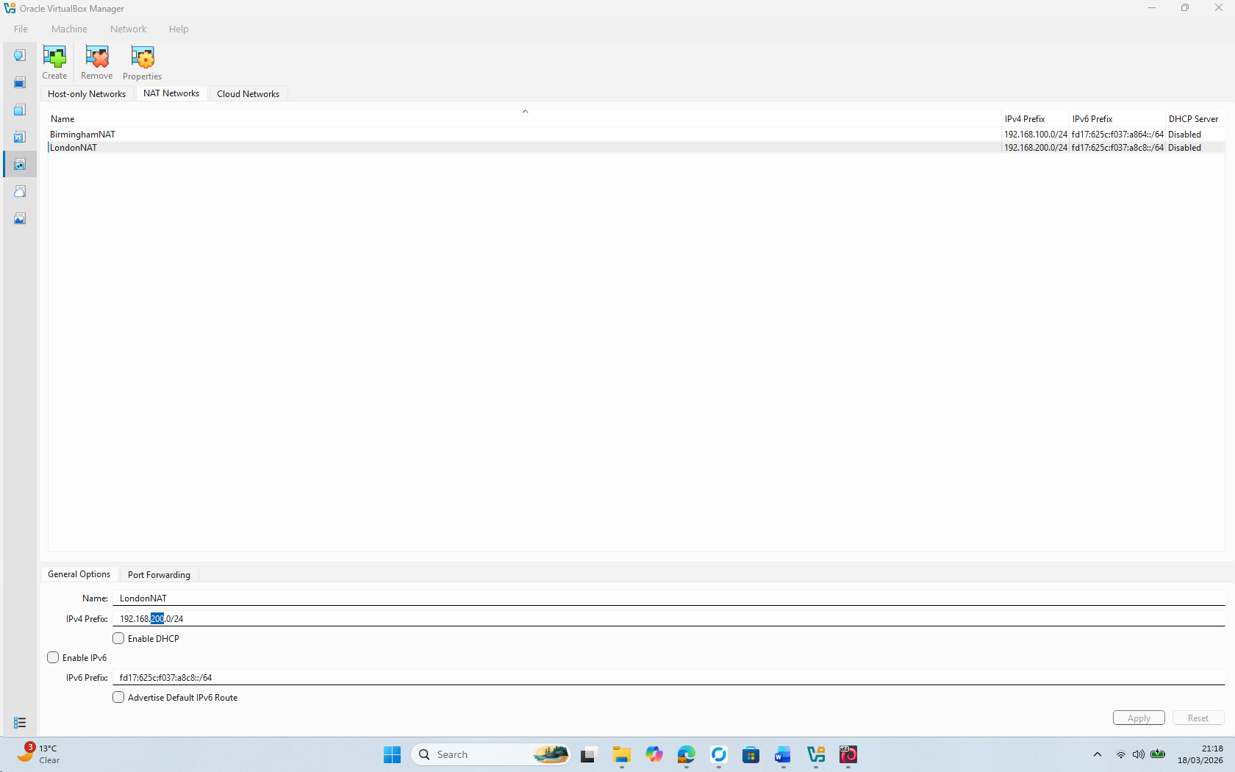
Figure 15 IP address from NAT Network2 for Linux

2.4. Test and Troubleshoot

2.4.1. Perform Connectivity tests
- Outcome 1: Successful connectivity within windows network. (2 screenshots) (Ping 192.168.100.10 and Ping 192.168.100.20)
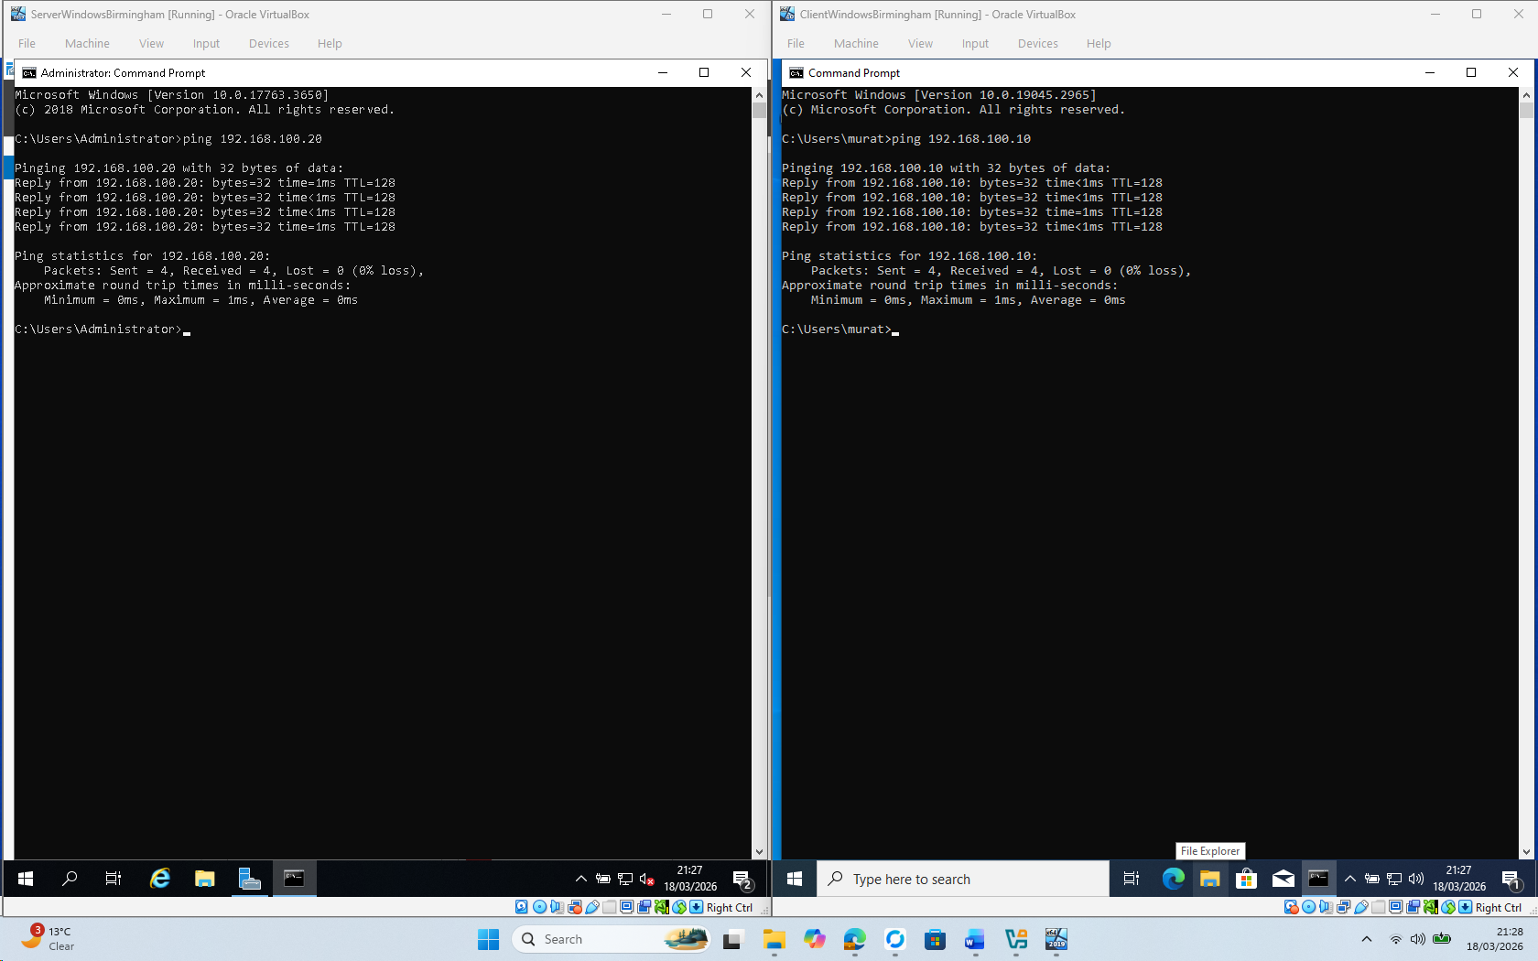
Figure 16 Windows client and server successfully pinged
- Successful connectivity within Linux network. (2 screenshots) (Ping 192.168.200.10 and Ping 192.168.200.20)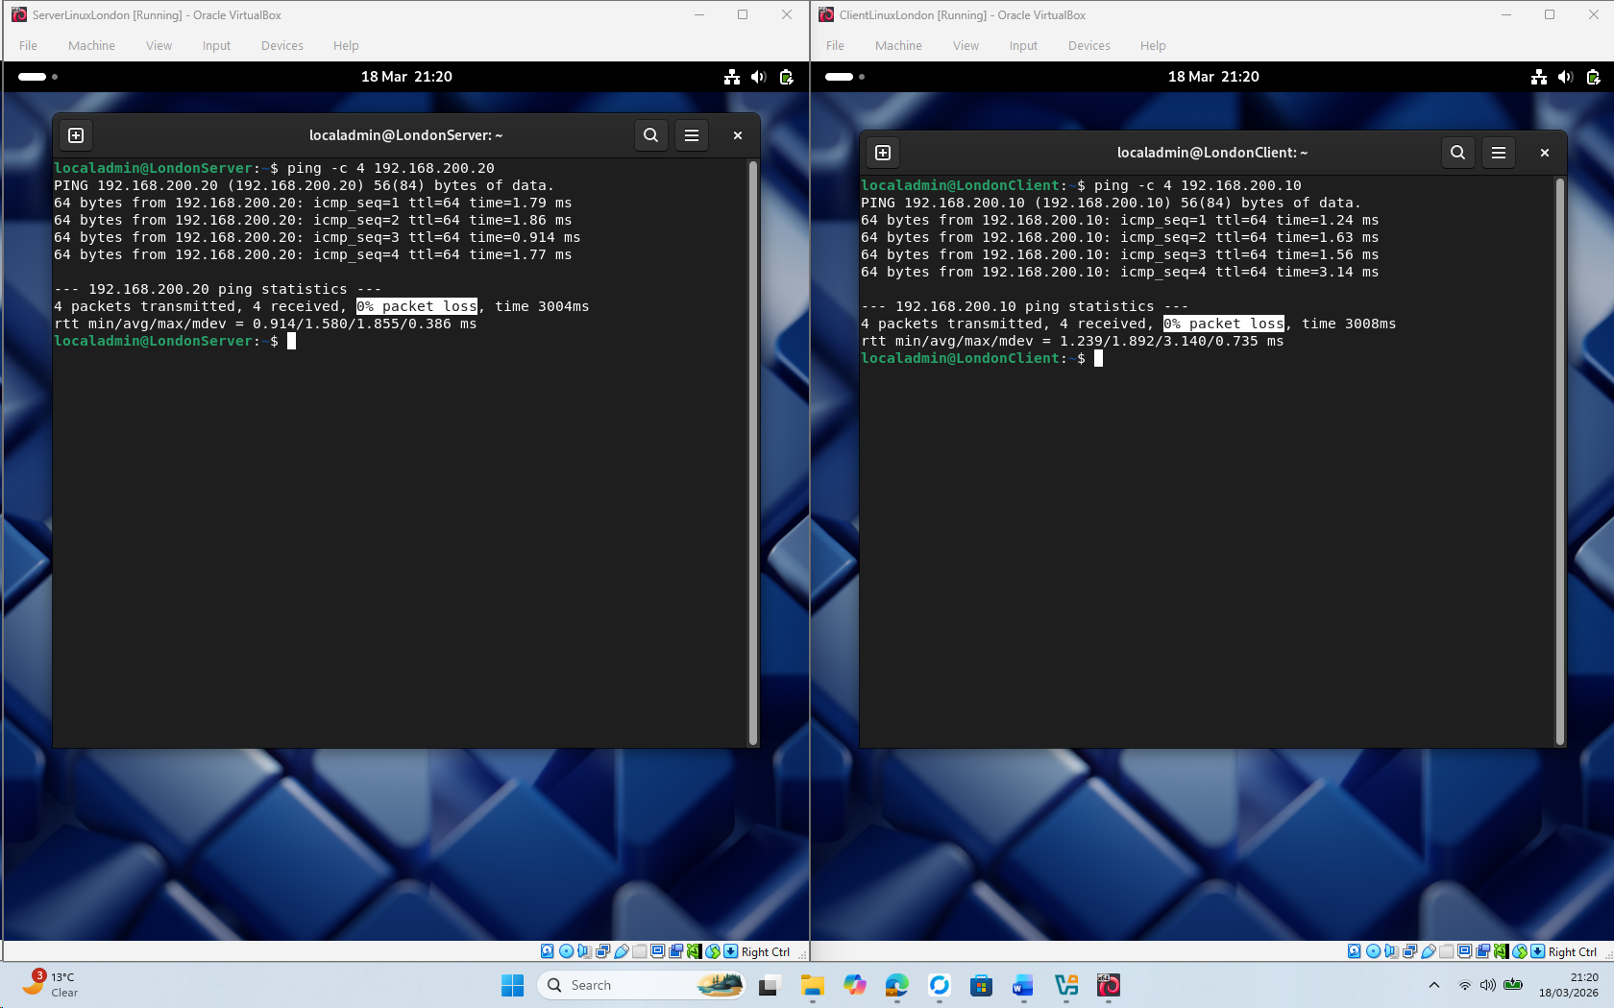
Figure 17 Lunix client and server successfully pinged

- Outcome 2: Unsuccessful connectivity between Linux and windows networks (2 screenshots).
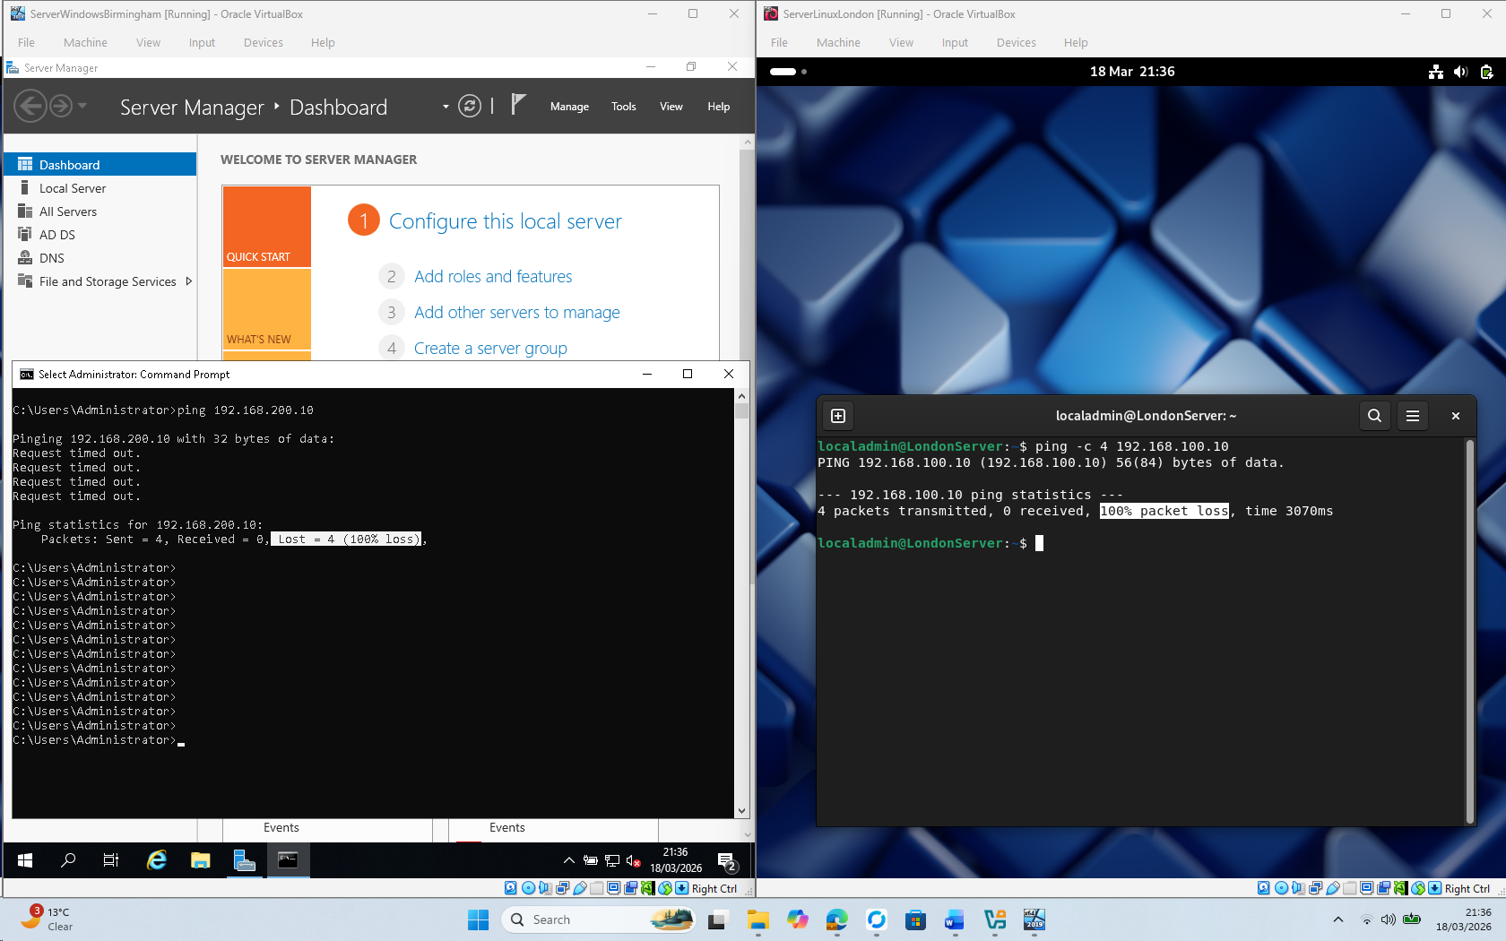
Figure 18 connectivity between Linux and windows networks
Figure 18 : Windows Server ping to Linux Server (192.168.200.10) returns 100% packet loss (timestamp 18/03/2026 21:36). This was also true in the reverse direction. This behaviour is expected since there is no router (or Layer-3 device) between the two isolated NAT networks, which reaffirms our need to configure routing in Coursework 2 topology[11].
All tests were subsequently run progressively on 18th March, 2026，which further highlighted disciplined management of time. The full deployment / testing process proved that the hypervisor, network design and IP scheme selected here are stable enough to support advanced network services (DNS, DHCP and routing) in Coursework 2 topology.

3.1. Reflect on the following

3.1.1. Write a Technical reflection covering network deployment and testing.
Scenario 2: Oracle VM VirtualBox with Birmingham–London Topology Birmingham–London topology was created in Oracle VM VirtualBox during Task 2. Create 2 NAT networks, 4 VMs installed and static IP set and connect to test. Each of those steps has clear timestamp sandwiched between 20:22 and 21:36 (on twenty March two thousand and six), thus showing an extraordinary time management.
Minor challenges occurred during deployment. For Debian 13, there was an indentation error in the Netplan YAML file that prevented it from applying a static IP (figures 13). This was diagnosed via netplan --debug apply and “ip addr” show, then fixed by correcting the syntax and again applying. The temporary IP conflict is seen on Windows VMs via ipconfig (Figures 12) and no change – in this case, disabling/re-enabling adapters along with modifying the Windows Firewall for ICMP.
Intra-\network pings were successful end-to-end (Figures 16 and 17), while inter-\network pings failed as they should have, which confirms the necessity for routing in Coursework 2 topology (Figure 18 ). For this reason it was possible to take VirtualBox snapshots for each step and safely roll back afterwards. It was systematic and dutiful to check through each step of the process that guaranteed a stable topology in preparation for routing protocols.

Write your Personal Reflection

My real-world networking skills and individual accountability have soared with task 2. Working my way through each VM and network, taking timestamped screen shots helped me build a new time-management habit as I progressed from handling four VMs plus two networks. It also made me confident about methodical problem solving routine as I overcame Netplan syntax errors and IP conflicts. There was fire behind the effort, which made seeing successful pings all very motivating after hours of setting it up. It has set me up nicely for Coursework2 topology and future enterprise networking work.

References
There are no sources in the current document.

References
[1] "What’s the Difference Between Type 1 and Type 2 Hypervisors?" https://aws.amazon.com/compare/the-difference-between-type-1-and-type-2-hypervisors/. [Online]. Available: https://aws.amazon.com/compare/the-difference-between-type-1-and-type-2-hypervisors/
[2] S. Lozano, T. Lugo and J. Carretero, "A Comprehensive Survey on the Use of Hypervisors in Safety-Critical Systems," Access. vol. 11, pp.1, Jan 1 2023, doi: 10.1109/ACCESS.2023.3264825. Available at: https://ieeexplore.ieee.org/document/10092745.
[3] "About Internet Protocol (IP) Addresses." [Online]. Available: https://www.fortinet.com/resources/cyberglossary/static-vs-dynamic-ip
[4] Gary Hilson. "Static IP vs. dynamic IP addresses: Understanding the difference." [Online]. Available: https://www.verizon.com/business/resources/articles/s/understanding-the-difference-between-static-ip-vs-dynamic-ip-addresses/
[5] Dipra Mitra, Souradeep Sarkar, and Debasish Hati, "A comparative study of routing protocols," vol. 2, no. 1, Available at: http://irjaes.com/wp-content/uploads/2020/10/IRJAES-V1N4P168Y16.pdf.
[6] "Link State vs Distance Vector Protocols." [Online]. Available: https://ipcisco.com/lesson/link-state-vs-distance-vector-protocols/
[7] Kinza Yasar,. "Part of: The fundamentals of computer networking." [Online]. Available: https://www.techtarget.com/searchnetworking/feature/12-common-network-protocols-and-their-functions-explained
[8] "Types of Network Protocols and Their Uses," Available at: https://www.geeksforgeeks.org/computer-networks/types-of-network-protocols-and-their-uses/#google_vignette.
[9] Oracle Corp, ": Oracle VM VirtualBox User Guide for Release 7.0." Available at: https://docs.oracle.com/en/virtualization/virtualbox/7.0/user/EN-VBOX-7-0-USER.pdf.
[10] D. N. Raceanu and C. V. Marian, "Cybersecurity Virtual Labs for Pentesting Education", pp. 1–4. [Online].doi: 10.1109/ATEE58038.2023.10108187.Available: https://ieeexplore.ieee.org/document/10108187
[11] Todd Lammle, Troubleshooting IP Addressing, 2020. doi: 10.1002/9781119659082.ch5

