WORKPLACE CULTURE
AND ITS IMPACT ON ORGANISATIONAL EFFICIENCY 2019

PRESENTATION NOTES

By Louise Westcott
Student I.D 1705358

Host – Julie Thomas
Organisation - UWTSD

Publication Date 06/03/2019

THE IKEA FAMILY
Ingvar Kamprad Elmtaryd Agunnaryd (derived from founder's initials and hometown)

IKEA is a Swedish company, founded by Ingvar Kamprad, in 1943. Then aged just seventeen, he began peddling “useful items such as pens, wallets, picture frames, table runners, watches, jewellery and nylon stockings to his neighbours” in Elmtaryd Agunnaryd, on his bicycle. (IKEA foundation, 2019). From such humble beginnings, Ingvar grew his company by “advertising in local newspapers and operating a makeshift mail-order service”. (IKEA.com). The first bricks and mortar furniture store was opened in Älmhult, Sweden in 1953.
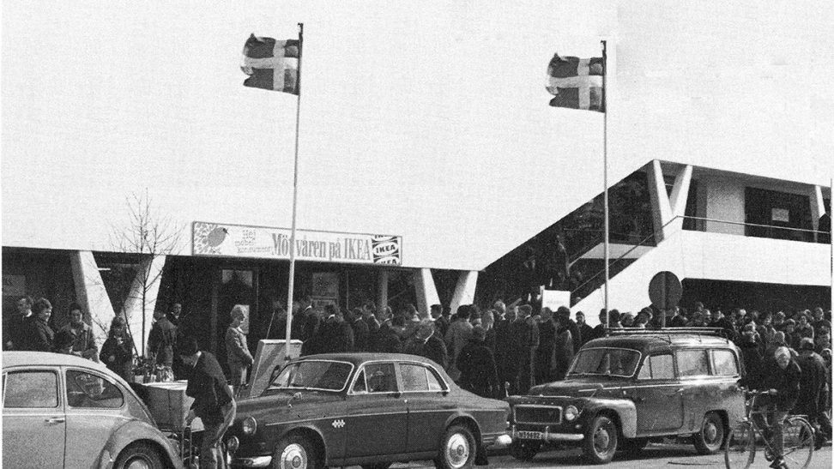
In 1982, the IKEA Foundation was founded, and over the years, IKEA became an activist against child labour and partnered with other large organisations to promote children’s rights and the right to an education.
Today the IKEA Foundation, along with its partners, strives to achieve large-scale results in four fundamental areas of a child’s life:
- A place to call home
- A healthy start in life
- A quality education
- A sustainable family income

Page 1
WHAT IS WORKPLACE CULTURE

Culture can be described simply as an environment in which behaviours are demanded/encouraged – or not tolerated/discouraged. “It is the result of a group’s values, beliefs, traditions, taboos”. They can come in the form of written or unwritten rules, policies or procedures, and unspoken rules of behaviour or social norms. They can arise for religious, cultural, political or nationalistic reasons, and they exist everywhere where people come together to form a group, be it within a family, a sports team, a friendship group, or in the workplace. (O’Shea, V. 2018).

WHY POSITIVE WORKPLACE CULTURE IS IMPORTANT

Culture – or more precisely, positive culture is hugely important to every organisation because;
- It attracts better candidates. “A strong, positive, clearly defined and well-communicated culture attracts talent that fits”.
- Better engagement and retention. Culture impacts how employees feel about working within the organisation. Employees are more likely to work well and want to remain in the organisation.
- Impact on mental health and job satisfaction. “Research shows that employee happiness and satisfaction are linked to strong workplace culture”.
- Performance. Organisations with positive cultures “outperform their competitors financially and are generally more successful”. (ERC, 2019).

In (Laurie, J. Mullins, 2013) Book entitled Management and Organizational Behavior, he mentions that “In recent years increasing attention has been given to positive psychology which is defined broadly as the scientific study of what makes life worth living”. Since we spend the majority of our lives in some form of setting where culture plays a part, be it at work, at home with our families or with friends, having positive cultural environments are of utmost importance to our physical, mental and emotional wellbeing as individuals.

Page 2


THE IKEA CULTURE

IKEA has retained its Swedish roots despite its worldwide expanse of stores and sectors. “Swedish society is known for being open, innovative, caring and authentic.” IKEA’s culture is quoted as being “hard to describe but easy to embrace. It’s a culture of enthusiasm, togetherness and willpower, born from our roots in southern Sweden and inspired by the IKEA founder, Ingvar Kamprad.” (IKEA systems, 2017).
As a result of IKEA’s wide range of activities - a furniture store, with a restaurant, its charitable organisation sector, and others, there are several different roles one could have working under the IKEA umbrella, in over 170,000 positions. However, we shall focus on the retail side for the presentation.
In 2017, Cosmopolitan magazine interviewed some employees to find out what it’s like to work at IKEA. They found some very good pros and some cons;
PROS
- Days/Nights out
A former IKEA chef explained, "IKEA is great to work for - They always reward staff with department days/nights out to ensure team balance is good.”
- Christmas perks
“You always get a great Christmas presents from Santa, a free lunch and a party!”
- Life insurance, interest free-loans, annual bonuses
IKEA offers all staff good motivators, such as “life insurance, interest-free loans and the chance to earn an annual bonus. The culture and values within the company are strong." The chance to earn annual bonuses are also a good motivator offered by the company.
Page 3
- Gifts of holidays

- 6 weeks paid holidays per year

- Free or discounted meals

CONS
- Difficulty in getting a promotion

- No regular shift patterns and long shifts

- Monotonous work, which quickly becomes boring

THE HANDY MODEL
Charles Handy, a leading authority on organisational culture, defined four different kinds of culture: Power, Role, Task and Person:
Power culture - A small number of individuals dominate the organisation – It is thought of as a strong culture, however not necessarily a positive one. The influence of the people at the top spreads throughout the organisation. Few people make decisions – so the decision-making process is usually fast.
Role culture – Based on an individual’s role. Power is determined by your role. Typically long chains of command, so decisions can be slow, and less likely to be innovative, and not seen as good places to work.
Task culture – Task = Teams are formed to work on tasks or projects usually a more dynamic culture, especially with the correct mix of skills and abilities within the team (Matrix structure).
Person culture – All about the individual – organisation really just exists for people to work. Not common today. (Tutor 2u, 2018).

Page 4
RECOMMENDATIONS
IKEA seems like a Power culture, which through having such a strong ethic, is working well for the organisation.
Though there are con’s in every line of work, regardless of how hard management try to minimise these, I believe that iKEA overall is a very good place to work and that the Pro’s related to working for IKEA by far outweighs the cons.
Management could try to elevate some of the boredom staff feel by offering the opportunity to switch roles among staff members if they wish too, this would cost the company more money in training, however, in the long run, it is always helpful to have multiple staff trained in multiple roles in case of staff shortage, holidays, sick leave etc.
Management could also look for ways to make promotion more obtainable. However, this may be caused by members of staff staying with the company for longer because of the pros of the job. Staff may not feel so disheartened by lack of promotional opportunities if they are offered opportunity’s to change roles, and/or have regular pay increases.
In comparison, IKEA seems to stand way above other similar stores in terms of pros. For example, while Argos rated quite highly as a good place to work, and did offer more opportunities for promotion – however, staff discounts are small, bonuses and rewards are non-existent, and Argo’s staff report feeling overworked, underpaid and un-appreciated. For these reasons I feel IKEA is a hard organization to beat, or even make recommendations for improvement for – as management already seem to be doing their utmost to keep employee’s happy. (Adzuna, 2019).

Page 5
REFERENCES
Books;
O’Shea, V. (2018). Shaping your Workplace Culture, a practical guide. London: Culture shapers publications.
Mullins, L.J. (2013). 10th Edition. Management and Organizational Behavior. United Kingdom; Pearson Education LTD.

Websites;
Adzuna.com (2019). Argos Reviews. [Online]. Available; https://www.adzuna.co.uk/jobs/company/argos/reviews [Accessed 2019, March 1st].
Cosmopolitan Magazine Online (2017). What’s it really like to work at IKEA? [Online]. Available; https://www.cosmopolitan.com/uk/worklife/a12808032/what-its-like-to-work-at-ikea/ [Accessed 2019, March 1st].
ERC (2019). Workplace Culture: What It Is, Why It Matters, and How to Define It. [Online]. Available; https://www.yourerc.com/blog/post/workplace-culture-what-it-is-why-it-matters-how-to-define-it [Accessed 2019, February 3rd].
IKEA.com (2014.) This is IKEA. [Online]. Available; https://www.ikea.com/ms/fr_MA/about_ikea/the_ikea_way/history/1940_1950.html [Accessed 2019, February 1st].
IKEA.com (2019). Welcome inside our company. [Online]. Available; https://www.ikea.com/ms/en_KR/about-the-ikea-group/company-information/index.html [Accessed 2019, February 15th].
IKEA foundation (2017). Fighting child labour and promoting education. [Online]. Available; https://www.ikeafoundation.org/about-us-ikea-foundation/history/ [Accessed 2019, February 12th].
Inter IKEA systems B (2017). Typically Swedish. [Online]. Available; http://franchisor.ikea.com/typically-swedish/ [Accessed 2019, February 20th].
Tools hero (2018). Cultural Web Analysis. [Online]. Available; https://www.toolshero.com/management/cultural-web-analysis/ [Accessed 2019, February 13th].
Tutor 2u.com (2017). Handy's Model of Organisational Culture. [Online]. Available; https://www.tutor2u.net/business/reference/models-of-organisational-culture-handy [Accessed 2019, February 20th].

Page 6

