MARKETING FUNDAMENTALS ANALYSIS AND EVALUATION

Executive summary
The report based on the car manufacturing company and it shows how the organisation comes back after the pandemic situation. The report deals with the marketing strategy which has been followed by the different automobile industry. The report faced some interrelated issue while discussing about the details structure of the organisation. The company has established the customer safety, which is the essential part of the report. At the end of the discussion, it shall be recommended that the organization must consider there proving strategy to the ultimate strategy.
Table of Contents
1. Introduction 4
2. Impact of Covid-19 on the organization 4
A. Inter-related issues navigated by the leaders 4
(i) Customer safety and employee safety 4
(ii) Shoring up cash and liquidity 5
(iii) Corporate Governance 5
B. Micro and macro Internal analysis of the company (SWOT) 6
Analysis 8
C. External analysis of the company (PEST) 8
D. Principle of marketing 9
E. Marketing strategy of the company 9
(i) Product strategy 10
(ii) Pricing strategy 10
(iii) Place strategy 10
(iv) Promotion strategy 10
(v) People strategy 11
(vi) Process strategy 11
(vii) Physical evidence strategy 12
Discussion of HR, finance and product price 12
Discussion on the financial practice of Mercedes 13
Conclusion 14
Reference list 16

1. Introduction
The global pandemic has had a hugely adverse effect on business worldwide. In this report, challenges for marketing will be discussed thoroughly within the Mercedes Company. All the factors that this company has gone through during the opening will be enlightened significantly. Along with that, the business concepts that this company uses will be elaborated. Micro and macro analysis of the internal environment would be discussed effectively and political, social, demographic understanding will be comprehended as well.
Ola Källenius is the Chairman of Marcedes Benz, UK. This company has around 173,000 employees worldwide. The marketing strategy of the company and research options of the company their information during this time of Covid will be elaborated. Product segmentation process of this company and targeting their customers while having a proper promotional program will be understood from this report. HR strategies and strategies for the finance department would be extendedly discussed, and the product price strategies that will benefit making the company better will further be discussed. Price skimming, strategies for penetration to the market and strategies for global expansion will also be elaborated along with a brief description of mixed element marketing. The competitive advantages and disadvantages for this Covid situation within this company will be discussed too.
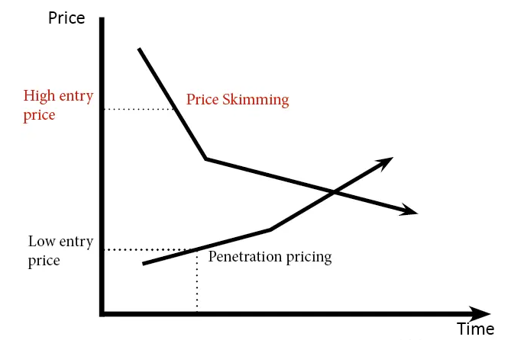
Figure 1: Price skimming strategy
(Source: economicshelp.org, 2021)

2. Impact of Covid-19 on the organization
Covid-19 has affected the perspective of business, and the operating system has been changed worldwide, which will have effects in the end. In Mercedes Company, the impact of Covid will be discussed below-

A. Inter-related issues navigated by the leaders
Leaders are currently navigating a large range of interrelated issues for coping up with the current situation and for enhancing the brand value of this company. Leaders have prioritized the safety of their employees and their customers. Operations have been re-oriented by them, and theories for cash liquidity have been taken into a higher range of consideration for having effective improvement. They have been focused on the Government support program too, and this has been considered as an advantage within this company. Strategies have always evolved according to the need of the circumstances within this organization.
Impact of COVID 19
Due to Covid 19 pandemic, sales of the company have been decreased significantly. Company has faced some major supply chain issues. In 2020, sales have dropped to 7893, which is 42.7% lower than the previous year. However, the company has taken some major steps to manage the situation. The company has prioritized the requirements of the customers. In this process, the safety of the customers is considered more. Hence, it is expected that, Mercedes will recover this sales within 2022. Along with customers, the company is looking after the safety aspects of the employees too. According to Sabri, Wijekoon and Rahim (2020), “Enhancing trend of better financial management practices is essential, especially for working employees due to the increased levels of existing personal indebtedness, and increasing focus on personal responsibility for financial planning among them”. Cost management strategies have been applied by the company. In this process, they are headed to own the whole inventory for the manufacturing. This will help to reduce the cost of outsourcing.

(i) Customer safety and employee safety
Mercedes has incorporated cleaning crews and they are constantly disinfecting the dealership programs multiple times within a day. Service technicians are working to ensure safety. Throughout the dealership, sanitization has been kept as the topmost priority. Doorknobs, countertops are being focused on this sanitization process significantly. From June 1, 2021, the company is maintaining CDC’s new guidelines (mercedesbenzatlantasouth.com, 2021). The company has been welcoming fully vaccinated customers and business partners into their retail stores without masks. Along with that, online purchasing has been allowed for the customers who are not comfortable within the stores. Vehicles are being delivered to a home, parts are being shipped to the delivery location, and the company has introduced test drives in customers' homes.
High tech industrial cars manufactured by this organization offer best in class customer safety. After the development of technologies, the safety of customers has become the essential thing in this organization. Better seating position at times of deriving and safety of airbags are there like any other car-manufacturing organization in the market. On the other hand, the smart sensing technologies of this car brand are most effective in the development of customer safety in this organization.

(ii) Shoring up cash and liquidity
Solution of the problems regarding lack of cash does not occur within the company, the leaders are taking effective prevention measures. Risks have been managed as coronavirus has had an impact on liquidity (Azman, 2019). Quality and performance have been maintained within the company in this tough time of covid as well, as they never compromised with the quality. Funding problems for the future have been asserted by the leaders beforehand. The leaders have effectively estimated future cash flow for avoiding risks and for keeping sufficient liquidity.

(iii) Corporate Governance
The company has ensured that healthy corporate Governance has been taking practical steps even during the crisis of covid-19. The accurate strategies of leaders have maintained the organization's mission, vision and relationship with the stakeholders. Economic stability has been gained within the company with proper maintenance of Corporate Governance (Kiradoo, 2019). Designation and responsibilities of different employees have been well calculated, and in this way, the company is earning a decent amount of economic profit.

B. Micro and macro Internal analysis of the company (SWOT)
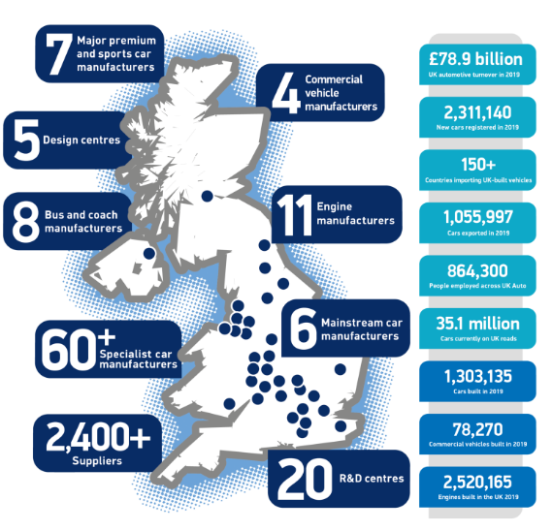
Figure 2- Facts for UK automotive
(Source- Smmt.co.uk, 2021).

Strength | Weakness
- As a highly developed market is already there in the UK and 78.9 billion turnovers have been observed by 2500 component providers with the world's most capable engineers, it is easy for this company to operate in the country (smmt.co.uk, 2021).  - The brand image is qualitatively high that makes an advantage for this company even in this Covid crisis.  - The company sponsors many global brands such as New York Fashion Week.  - The company has been consistent about its innovation about technical advancement.  - Financial stability has been observed in the company throughout  - In developing countries, they tend to have a powerful hold and the company has prioritized being the pioneer  - A broad portfolio has been observed as well and their products range from SUVs to Sedans. | - The distribution of their products are very exclusive and hence the development is very slow.  - They are not able to maintain their supply and brand equity can not be managed.  - Objectives within the company are conflicting and hence employees are unable to understand the company’s vision and mission (Zhao et al. 2020).  - Servicing cost is higher and hence it is tough to afford the products for people coming from the lower-income group.  - Maintenance cost is higher as well and it affects the ratio of sales for this company.  - Other rivals in the same market offer the same service at a lower cost.
Opportunity | Threats
- The demands of luxury transport have been increasing  - According to figure 1, the UK market has more than 2400 suppliers, which makes the company operate easily (smmt.co.uk, 2021).  - The Collaborative nature of the company has been noticed and the strategies are aligned with the motifs.  - The automotive industry has been growing and more employment has been observed as well.  - With the innovation and technical advancement, the growth opportunities have been expanded too. | - Competition has been intensified within the market  - Fuel prices have been observed to fluctuate constantly in the UK, and growth has been stagnant.  - The price of raw materials has been increased within the market (Zhao et al. 2020).  - For global warming, the Government has discouraged the usage of private cars which affects sales.

Analysis
The automobile market in the UK is effective enough to kick start a new business. Opportunities that were discovered from SWOT analysis, present that each of the opportunities in the market can be Utilized by Mercedes for overcoming the issues that can start a new business. Threat of raw materials in the market can be developed

C. External analysis of the company (PEST)

Factors | Analysis
Political | - The taxation rate has been increased within the country with an excessive rate.
Economical | - Economical crisis across the globe has contributed towards the fall of sales in the luxury car
Social | - Mercedes has been able to draw the attention of both female and male customers across the globe. On the other hand, Aston Martin is reported to be more popular with male customers and BMW has been reported to be more popular among female customers (Chernysh and Chelembiienko, 2019)
Technological | - By introducing more technical factors, the company has focused more on the environment and reduction of the harmful gas has been observed as well and has been counted as a potential opportunity.

D. Principle of marketing
The principle of marketing majorly deals with 4P and 7P strategies. Mercedes uses the 7p marketing strategy and this global pandemic has not made an exception for the company to take this principle into the higher range of consideration.

E. Marketing strategy of the company
Mercedes has always been open and flexible for the innovation that provides a safe and pleasant ride for their customers. Along with that, the company has taken their marketing strategy into the higher range of consideration. For future growth, the company has focused on digital transformation. The company has dealt with future mobility and the current trends have been focused on. Potential growth has been observed with these four trends that concern ‘connectedness, autonomous, shared service and electrics’. The company has aligned their mission and vision with their marketing principle. Focusing on the customer’s experience through ‘amazing delivery’ has been considered as their principle while determining marketing strategies. The company invests a lot of amount in high-cost materials. The company has used 7p strategy for sustaining this global crisis. Mercedes has used it significantly for making higher brand value and for reaching to global customers. The sales of a vehicle from 2005 to 2020 has been observed and in 2020, a decrease in sales has also been observed as shown in figure 2 (statista.com, 2021).
.

(i) Product strategy
The company offers light commercial passenger cars and vehicles with heavy equipment. The company has considered a marketing mix product strategy. In the segments of a luxury car, it has Sedans, SUVs and sports cars as well (Themba et al. 2019). Along with the technical advancement, it has focused on the design. With offering a wide range of new cars, the company has focused on the portfolios of pre-owned Mercedes. By the end of 2022, the company has decided to invest 11 billion dollars in electric and hybrid cars in the market.

(ii) Pricing strategy
The company has prioritized quality in a more focused way. As there is no compromise over the quality, hence the price range has been higher significantly. A huge variety is also available within their offered service (Helmold, 2020). The price for their products ranges from $30,000 to $100,000. Premium pricing has been offered that gives benefit for the competition. Apart from that, premium features have also been offered.

(iii) Place strategy
The company has chosen their place for operation quite significantly. The company has chosen a wide number of countries for their operation. Their dealership and service station varies across the world. The primary markets of the operation are Europe, North America, Germany and many more (Wu, 2021). The number of dealerships varies globally across the major metro cities. Factories for manufacturing are widely ranged across the globe as well. In this area, developing and developed countries bothy are there.

(iv) Promotion strategy
The company has decided their marketing strategy with an aggressive nature. The company has been used all the advertisement platforms, including television, sponsoring award shows, digital media, etc. The company does not concentrate upon the traditional advertisement methods as they only focus on the higher income group, and they have prioritized hence luxury. The company has focused more on customer-centric approaches to deal with this Covid crisis and the economic hazards (Fischer, 2019). In this way, brand awareness has been improved among the existing customers and new potential customers have been drawn into this company. The company concentrates upon organizing International Golf Tournament where golfers join across the world. The winners get a chance to drive the cars in challenging situations. However, in the global pandemic, it was not possible to organize this, still, they were connected to their customers with technologies.

(v) People strategy
For determining the strategy regarding people, the company mainly focuses on the employees and the customers and their safety has been prioritized, especially in the time of the global Coivid 19 pandemic. Providing extraordinary customer support expands the brand loyalty and brand image and customers have a positive experience for using their service and products (Saritas and Penez, 2017). Recruiting the correct people and giving necessary training to them has also been noticed within the company that adds more competitive advantage than the rival companies do. The sanitization process has been prioritized for the well-being of the staff and the customers.

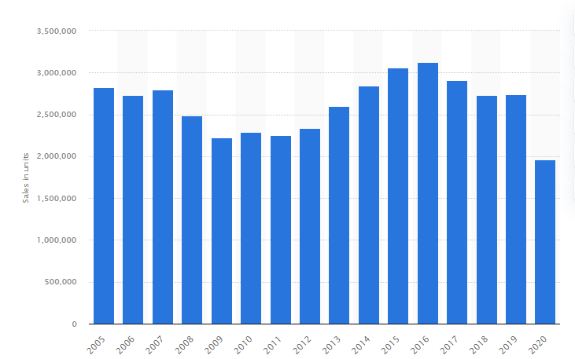
Figure 3- vehicles sales in the UK from 2005 to 2019
(Source- statista.com, 2021)

(vi) Process strategy
The company has initiated to deliver their products with different modifications and it shall be considered to be easy to access for the propels. The previous examples of the organisation only deal with the high range of cars. The company has always tried to do something different. The company has initiated their place and distribution strategy and is has maintained their process of manufacturing of products which has focused on the differentiation focusing strategy (Lee and Lim, 2017).

(vii) Physical evidence strategy
The company handles the physical evidence strategy dealing with different physical evidence of the organisation. The company focuses on the interior design of, it has developed their products with more luxury, and on the other hand, it deals with more spacing. The company focuses on masking a brand image, which helps to increase its marketing strategy.

Discussion of HR, finance and product price
The HR practice in the organisation Mercedes has determined to maintain their considerable and formal structure that become attractive for maintaining the hiring strategy. The company has discussed the different HR practices for the development of the organisation. In the present situation, there are different competitors who are discussed in the external analysis of the company. The formatted HR practice of the company shall increase its sustainability and encouragement, which is reliable to control the competitive advantage of the company. The company has initiated the different strategies of human resource practice to maintain their employees. The company has considered several HR practices such as
- Providing security to their employees: The Company Mercedes has provided their employees with john security along with that the company provides different kinds of security to their employees such as health security, financial security and others. The company provides different opportunities for their employees (Bernstrøm et al. 2018). Insurance security along with the security of their job is also recommended for the HR practice for the industry. During the 1980s, there were different consolidations in personal management and it dealt with the strategy of administration and handling the HR. the economical profitability of the employees are optimised with the development of the production system of the industry.
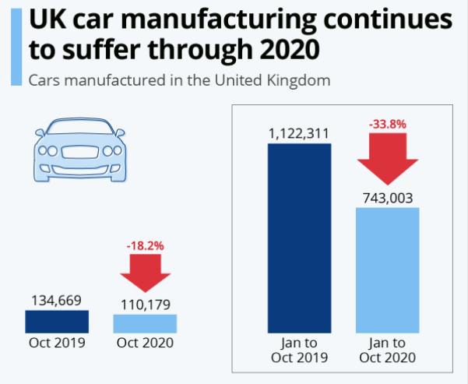
Figure 4: Impact of pandemic in UK automobile industry
(Source: statista.com, 2021)
- Hiring the right people: An organisation maintains the HR practice for increment of employee satisfaction and development The company Mercedes has introduced the recruitment and selection procedure for the organisation (Dattner et al. 2018). In the present day, there are numerous examples of employees engaged in the industry. In this organisation, the human resource department has discussed seven basic HR practices and recruitment is one of the important formalities of the industry.
- Performance management: The organisation has considered the performance management system as an essential role for HR practice of the industry. The company monitors the performance in the industry. In HR practice, performance management comes with the second essential formation of the industry. The employees of the organisations are responsible for their certain dust and they are considered to meet them.
- Human resource information system: The human resource information system is also managed by HR professionals. For information management, the information tracking system is used for the development of the organisation. In most of the automobile industry, the information tracking process is used with the innovation of a self-service employee portal where the employees can solve their problems.
- Learning and development: the human resource team of the company deals with the engagement of employees through their learning and development. The development of the organisation has taught the employees with the change of process, technology and leg shifts of the organisation. Information that this organisation collects from the market helps it to develop effective technologies that come in the welfare of customers.

Discussion on the financial practice of Mercedes
The automotive industry has established its financial practice with their development of economical establishment and the company has taken different initiatives for establishing financial availability (Sabri et al. 2020). The automobile industry is an example of an oligopoly market structure. The UK automotive industry is a vital part of the UK economy and it deals with more than 78.9 billion Euros. During the pandemic situation, there are different issues that are considered in the automobile industry. For the company, Mercedes is also dealt with such difficulties; in the oligopoly, market competition the company has confessed the collusive oligopoly market.
According to the NADA, there is 37% of dealer’s gross profit in the automobile industry. The industry focuses on the higher-class society but after the Covid pandemic, the company has overcome with the impressive combination of the economical executive cars that are fuel-efficient. The company Mercedes has introduced the sedan with their considerable rating of 24 mpg in the city on the other hand it has maintained the 38 mpg on the highway. The formal takeover of the organisation shall be the cheapest, which has launched in the year 2020. Which only costs $33,795? The company focuses on the luxurious interior and most probably produces the most luxurious car in the world (Parkers.co.uk, 2021).

Conclusion
It can be concluded that the company has gathered the preference of ordinary people rather than compiling their products with the rest of the companies. The company has initiated their luxury products but after the pandemic situation and instability of the financial condition of the society made the organisation compiled to the manufacturer on budget-friendly. The company initiates their product according to their research and development. All the different factors of the company have initiated to maintain their new opening that has been enlightened significantly. The organisation has suffered a difficult situation while the pandemic situation of COVID 19. During this situation, the company has dealt with the consumer safety and health of the consumer. The company has determined the health corporate governance and that has become the mission and vision of the organisation. In this report, the company has been analysed by SWOT and PEST analysis and deals with the 7p’s marketing strategy, which conforms to the political-economical or other details of the company. The company follows the marketing strategy, which is also considered in this report.

Reference list
Azman, N.K., 2019. Corporate Governance and Liquidity Risk of Mercedes-Benz. Available at SSRN 3498613. Viewed from https://papers.ssrn.com/sol3/papers.cfm?abstract_id=3498613 [accessed on 8.11.21]
Bernstrøm, V.H., Drange, I. and Mamelund, S.E., 2018. Employability as an alternative to job security. Personnel Review. Viewed from https://oda.oslomet.no/oda-xmlui/bitstream/handle/10642/6279/PDF_Proof_last+revisions+after+acceptance+4th+June+2018.pdf?sequence=4 [accessed on 11.11.2021].
Chernysh, I. and Chelembiienko, K., 2019. Planning and Implementation of a Startup in a Modern Business Environment. ЕКОНОМІКА І РЕГІОН, (2 (73)), pp.41-49. Viewed from http://journals.nupp.edu.ua/eir/article/download/1625/1322 [accessed on 8.11.21]
Dattner, B., Chamorro-Premuzic, T., Buchband, R. and Schettler, L., 2019. The legal and ethical implications of using AI in hiring. Harvard Business Review, 25. Viewed from https://egn.com/dk/wp-content/uploads/sites/3/2020/06/The-legal-and-ethical-implications-of-using-AI-in-Hiring.pdf [accessed on 11.11.2021].
economicshelp.org (2021). Price skimming. Available at: https://www.economicshelp.org/blog/147806/economics/price-skimming/ [Accessed on: 19th November 2021]
Fischer, M., 2019. Practice prize paper–managing advertising campaigns for new product launches: an application at mercedes-benz. Marketing Science, 38(2), pp.343-359. Viewed from https://pubsonline.informs.org/doi/abs/10.1287/mksc.2018.1136 [accessed on 8.11.21]
Helmold, M., 2020. Pricing in the Automotive Industry. In Total Revenue Management (TRM) (pp. 107-113). Springer, Cham. Viewed from https://link.springer.com/chapter/10.1007/978-3-030-46985-6_11 [accessed on 8.11.21]
Kiradoo, G., 2019. Impact of Corporate Governance on the Profitability and the Financial Performance of the Organization. Journal of Management (JOM), 6(3), pp.192-16. Viewed from https://www.academia.edu/download/62304981/JOM_06_03_02220200307-95013-8a8rfg.pdf [accessed on 8.11.21]
Lee, S. and Lim, T.S., 2017. Retailer's innovative differentiation method based on customer experience: focusing mediating effect of omni-channel shopper type. Quality Innovation Prosperity, 21(2), pp.37-51. Viewed from https://qip-journal.eu/index.php/QIP/article/download/864/803 [accessed on 11.11.2021].
Mercedesbenzatlantasouth.com, 2021 Covid-19 Customer Message viewed from https://www.mercedesbenzatlantasouth.com/covid-19-customer-message/ [accessed on 8.11.21]
Parkers.co.uk, 2021, Mercedes-Benz A-Class running costs and mpg, Viewed from https://www.parkers.co.uk/mercedes-benz/a-class/review/mpg-running-costs/ [accessed on 11.11.2021].
Sabri, M., Wijekoon, R. and Rahim, H., 2020. The influence of money attitude, financial practices, self-efficacy and emotion coping on employees’ financial well-being. Management Science Letters, 10(4), pp.889-900. Viewed from http://growingscience.com/msl/Vol10/msl_2019_290.pdf[accessed on 11.11.2021].
smmt.co.uk, 2021 UK Automotive viewed from https://www.smmt.co.uk/industry-topics/uk-automotive/#:~:text=The%20UK%20automotive%20industry%20is,value%20to%20the%20UK%20economy.&text=Over%201.3%20million%20cars%20%2C%2078%2C270,in%20the%20UK%20in%202019 [accessed on 8.11.21]
statista.com (2021). UK car manufacturing continues to suffer through 2020. Available at: https://www.statista.com/chart/21570/uk-car-manufacturing-coronavirus-effect/[Accessed on: 19th November 2021]
statista.com, 2021 Vehicle sales in the UK from 2005 to 2020 viewed from https://www.statista.com/statistics/265959/vehicle-sales-in-the-uk/ [accessed on 8.11.21]
Themba, O.S., Razak, N. and Sjahruddin, H., 2019. Increasing customers’ loyalty. The contribution of marketing strategy, service quality and customer satisfaction. Archives of Business Research, 7(2). Viewed from https://www.researchgate.net/profile/Herman-Sjahruddin/publication/331135754_Increasing_customers'_loyalty_The_contribution_of_marketing_strategy_service_quality_and_customer_satisfaction/links/5c985c2092851cf0ae95ef6e/Increasing-customers-loyalty-The-contribution-of-marketing-strategy-service-quality-and-customer-satisfaction.pdf [accessed on 8.11.21]
Wu, H., 2021, March. Comparison of Marketing Strategies Between Emerging and Legacy Companies. In 6th International Conference on Financial Innovation and Economic Development (ICFIED 2021) (pp. 195-198). Atlantis Press. Viewed from https://www.atlantis-press.com/article/125954365.pdf [accessed on 8.11.21]
Zhao, F., Tan, H. and Liu, Z., 2020. Analysis of the Business Models of the Intelligent and Connected Vehicle Industry. In MATEC Web of Conferences (Vol. 325, p. 04002). EDP Sciences. Viewed from https://www.matec-conferences.org/articles/matecconf/pdf/2020/21/matecconf_ictle2020_04002.pdf [accessed on 8.11.21]

