7 Real-life Examples of Job Descriptions That Stand Out

Stephanie Bevegni

June 14, 2016

When done right, job descriptions do more than just communicate an opening at your company. They attract the right candidates to apply, position your company as a great place to work, and ultimately help you recruit talent more efficiently.
To aid you in writing powerful job descriptions, here are seven real-world examples from small to mid-sized companies. By spending a little time on thinking through your job post, it can help you attract the best possible candidates.
We put together a Killer Job Description Checklist as well as some examples of how other companies are getting it right. Take a look at each of these tips as well as the examples from companies, see what makes them great, and get inspiration for your future job descriptions.

1. This website company keeps the job title straightforward and keyword-driven
You don’t always need to get overly creative in the job description. Instead, accurately describe the role and make sure job-seekers searching for a job can actually find it.
Take the posting by the website-building company Weebly, which asks for a “Senior Android Engineer.” The description could’ve been a bit less precise by asking for a Senior Software Engineer, for example. Instead, Weebly’s making the specific ask for an Android developer. This eliminates a lot of candidates who don’t want to work on Android software.
What else do we love about this job description?
- It focuses on fit. The post describes where the job fits on the company’s totem pole (something that should be included whenever possible). As a result, candidates can actually know if they will potentially qualify for the job.
- Plus, the description is straightforward as opposed to overly exaggerated. If you’re looking for a new Senior Customer Service Rep, go with that, rather than a Customer Support Guru, which could entail a variety of tasks. This also helps make your job post is search engine optimized, meaning that people looking for that type of role will be more likely to find it while searching on Google.

2. Connect with candidates on an emotional level like TransferWise
You’ll also want to keep the job description concise and focus on illustrating the role’s benefits and opportunities (e.g., for growth, collaboration, leadership) first. Later in the post, you can go into the requirements of the position later in the post.
There are two key components to include in your job description, which TransferWise does a good job of including:
First, your company’s unique culture and team dynamics. Here’s how TransferWise does this in the description for a Lead Designer:
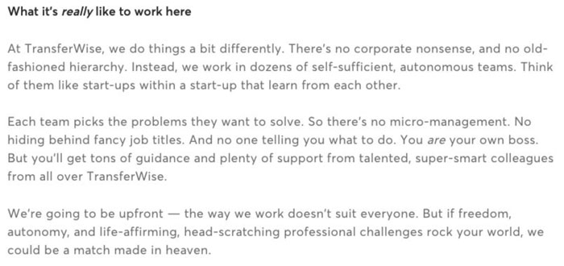
What else do we love about this job description?
- We’re painted a powerful picture of what it’s like to actually work at the company. For example, we learn that it’s a small team and you can problem-solve independently. The post explicitly states that there’s no micro-management at the company, which can draw in possible applicants dealing with that issue at their current job.
- You also get a sense of the company’s culture because of the language used. The job description is blunt at the end, saying that not everyone will necessarily want to work at the company. That honesty can be appreciated by candidates looking for a change.

3. Grab the attention of prospects like Buzzfeed
Job descriptions are a chance to describe your ideal candidate. First off, what traits would this person have? By giving them a clear picture of what the job entails, they’ll be able to figure out if it’s a good fit. Note that, according to recruiting pro Lou Adler, it’s best to describe the job as a series of critical performance objectives (and not a laundry list of skills).
Take BuzzFeed’s search for a VP of IT, as an example:
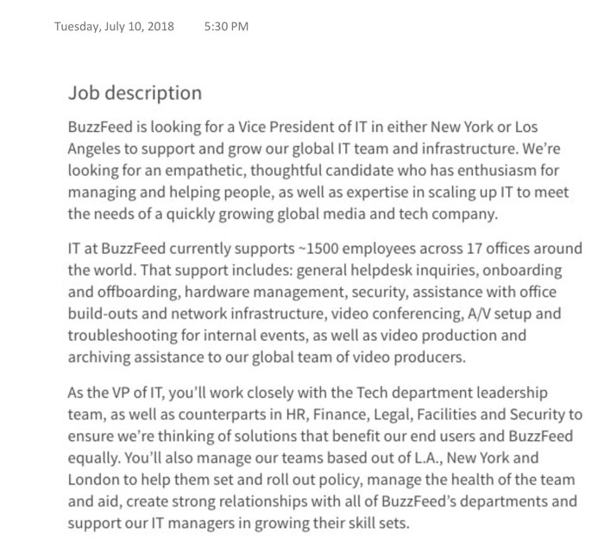
What else do we love about this job description?
- The company makes it clear from the start what kind of soft and hard skills you should possess. By discussing these skills, a person can decide whether or not they actually have what’s required to be successful in this role.
- The posting also explicitly states what teams the role will work with on a day-to-day basis. This helps show that Buzzfeed is an organization that values collaboration, for example.

4. Describe the impact like Dropbox: the job’s influence, day-to-day experience, and opportunities
Express the position’s value within the company. You want to describe the role—where they fit in the company and what the daily responsibilities are like. It’s also important to work closely with the hiring manager to develop an employee value proposition (EVP) on why the spot is a better job for someone who already has a good job doing similar work.
Make the impact of each task clear with an action verb in the present tense. Dropbox, for example, was looking for a Software Engineer and their recruiters chose to frame the position’s impact like this:
“The New York City office has a small, talented team that works on impactful projects that are essential to Dropbox’s success. As an early member of Dropbox NYC Engineering, you’ll have the unique opportunity to build critical product features and infrastructure while shaping the direction of the team and the office.”
Nailed it.
What do we love about this job description?
- You know how big your team is, that your input will be valued because it’s a team that’s recently gotten started, and the impact (written with active verbs) your work will have: the opportunity to build critical product features and shape the direction of your team.
- The description is also successful because it fully discloses any potential drawbacks of the job instead of hiding them with clever language. This will weed out any candidates who dislike traveling, or say, having to work independently for long periods of time.

5. Gaming startup keeps it conversational and mobile friendly
Parisian gaming company, Pretty Simple, has to hire creative artists and designers. When they write job descriptions, they make sure that their style appeals to their target audience. They keep it conversational, light-hearted, and highlight the company culture.
- 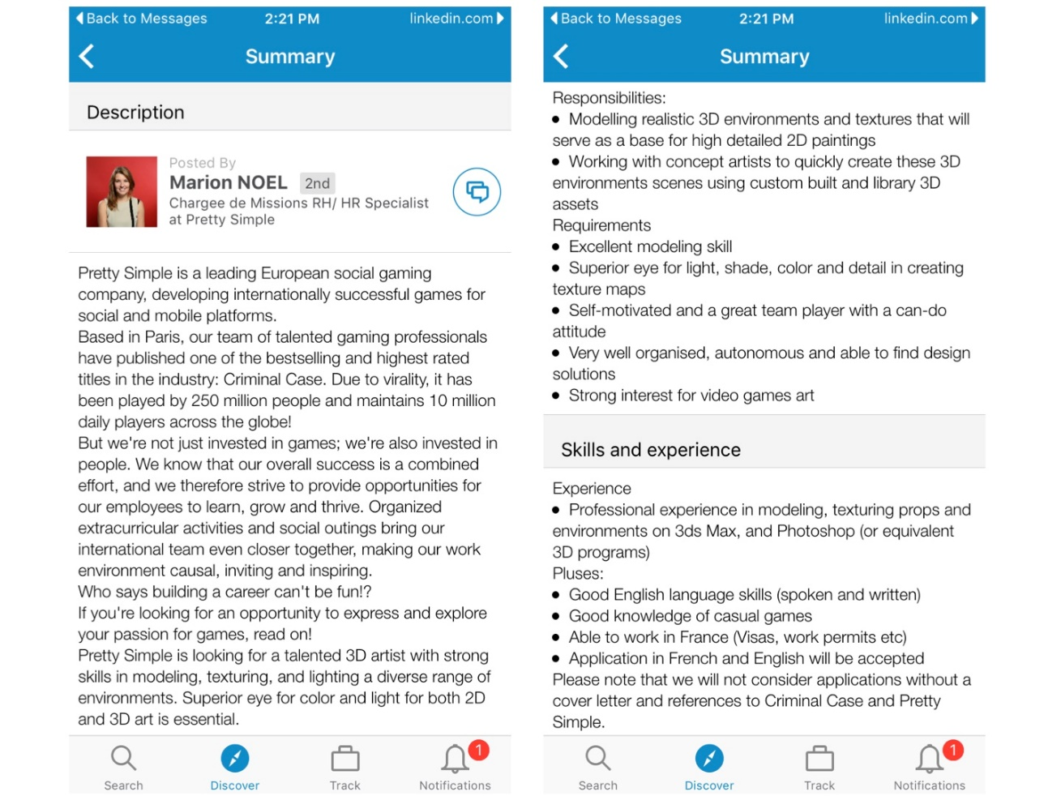
In this job description, Pretty Simple uses casual copy to grab and keep the reader’s attention. From phrases like, “Who says building a career can’t be fun?” and “Read on!”, the recruiters write with excitement that also reflect the company atmosphere. The hiring team also knows that their mobile-focused audience will likely see this on the go, so they keep the length as short as possible.
What else do we love about this job description?
- The recruiter uses bullet points, short sentences and white space to make this job description easy to read. It clearly communicates duties and what a successful candidate looks like, without pouring on the copy. They even separate nice-to-have qualities with a “Pluses” section.
- This is *hands-down* the best two sentences in the entire job description: “But we're not just invested in games; we're also invested in people. We know that our overall success is a combined effort, and we therefore strive to provide opportunities for our employees to learn, grow and thrive.” Candidates want to know that the company will invest in them, and give them opportunities to make an impact. This statement not only reinforces that working at a gaming company is fun, but also assures that new hires will be challenged and will grow their skillsets.
- The Pretty Simple recruiting team knows the audience they are trying to reach, so this short and nicely formatted job description is optimized for mobile. You can read the entire post in two scrolls!

6. Wrike adds attention-grabbing video overviews to each job description
Wrike, a fast-growing project management software company with 300 employees, includes a one minute video with every job description on their website. They’ve used this approach over the past two years, and have inspired quality candidate to apply. “Even to this day, recruiters get three emails a week that reference the job description video,” says Spencer Mellon, Talent Acquisition Program Manager at Wrike.
In the video, the hiring manager introduces himself, highlights the position’s importance in the company, and explains who the candidate will be working with. There are a myriad of skills and experiences required for the job, but the he focuses on the soft skills and top requirements, which makes it easy for candidates to determine if they’re qualified.
What else do we love about this job description?
- The delightful video makes the text-heavy job post more engaging. It’s long enough to add more color to the description without boring the viewer. It’s also short enough to capture their attention and make them want to know more.
- The hiring manager brings a personal touch to the job description. It helps the candidate watching the video visualize this person as their future boss. In this example, the Chief Revenue Officer is the hiring manager, which gives a candidate exposure to an exec. The CRO speaking to this opp is also a testament to his investment in the hiring process and the person they hire.
- The format is so simple and easy to do, that anyone in the office can point, shoot, edit and post. There’s no need to hire an outside video company, making it budget-friendly for small businesses.

7. The Siegfried Group leads with what’s in it for the candidates
National CPA firm The Siegfried Group needs to hire more accounting and finance professionals to serve their high profile clients. With 350 employees across 18 offices, they need to search far and wide for quality candidates. While this job description is more on the lengthy side, the white space formatting and benefit-first messaging makes it easier on the eyes.
- 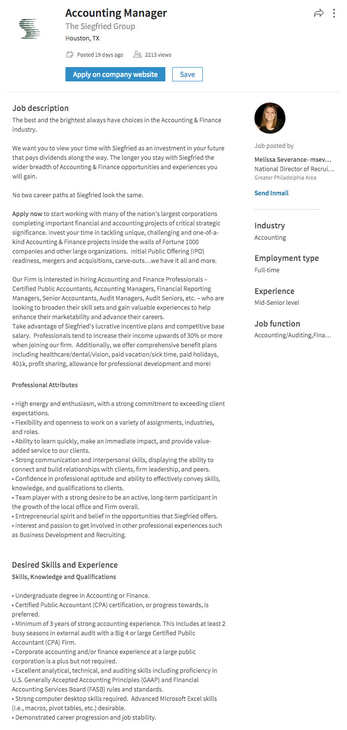
Talk about a powerful introduction! The aspirational hook reels the candidates, and the long-term benefits keeps them reading. The Siegfried Group focuses on what the company can do for the candidate, not what the candidate can do for the company. This approach not only gets candidates to apply, it helps them visualize the bright career possibilities ahead.
What else do we love about this job description?
- The recruiter clearly explains the types of companies the new hire will work with, and the types of projects the person will take on. The description also emphasizes importance of the hire, and the impact they will have at the organization.
- With phrases like “exceed client expectations” and “flexibility to work on a variety of assignments”, the job description defines what success looks like in the role. They also target hungry professionals eager to learn and grow and develop by defining the soft skills that make up a top performer.
- While the description requires some industry terms, this overview nicely balances financial lingo with conversational words and phrases, such as "No two career paths at Siegfried look the same" and “we have it all and more.”
So what makes a killer job description? A beautiful format that is easy to read, a conversational tone, and powerful statements that clearly explain the opportunity. For more job description inspiration, download our free tipsheet: 7 Tricks for an Irresistible Job Description.

