
Programme: Master of Business Administration
Module- Marketing management
Module code - LCMB7024
Title- Marketing portfolio

Word count – 2750
Lecture –Dian Mayasari
Student name – Sneha Sajanbhai Khunti
Student ID – 2504970
Submission date - 19th of November 2025

Table of Contents
Introduction 4
Concept Behind the New Brand 5
Segmentation Analysis 6
Targeting Strategy 7
Differentiation Strategy 8
Positioning Strategy 9
Conclusion 10
Introduction 12
Product Strategy 13
Price Strategy 14
Place (Distribution) Strategy 15
Promotion Strategy 16
Conclusion 17
Introduction 19
The Problem 20
The solution 21
Value Proposition 22
Marketing Strategy 23
Conclusion 24
Reflection 26
References 28
Appendix 31

Element 1: Choose a company and develop a Segmentation, Targeting, Differentiation, and
Positioning (STDP) Analysis for a New Brand Concept

Introduction
Tesco is the biggest supermarket chain in the UK in the competitive retail sector, which has a good reputation with affordability, convenience and innovativeness (Tesco PLC, 2025). To meet the emerging environmental and ethical consumer preferences and tastes, Tesco has introduced Tesco ECO+, its own sustainable sub-brand, which delivers environmentally aware and ethically responsible household items and grocery products at affordable prices. This emerging brand shares the desire of Tesco to be responsible in retailing and changing consumer demands. This report will critically analyse how the Tesco ECO+ brand is further segmented and targeted, which is the subject of the following segmentation, Targeting, Differentiation, and Positioning (STDP) analysis.

Concept Behind the New Brand
Tesco ECO+ is based on the vision of achieving a sustainable way of life at a low cost and mainstream way. Its mission is to offer eco-friendly products, e.g. biodegradable packaging, plant-based groceries that can help customers reduce their environmental footprint without compromising value or quality (Hamdi, 2024). The increasing consumer demand for ethical consumption, environmental innovation, and disclosure contributes to the relevance of ECO+. Its value chain is based on competitiveness, affordability and environmental friendliness, and the convenient technology-driven shopping experience for a new generation of conscious and data-driven customers.

Segmentation Analysis
- Demographic: It targets young adults and families who are between 18-40 years in the middle-income groups and are interested in product offerings that are affordable and also sustainable.
- Psychographic: Appeals to the consumer based on their eco-conscious and ethical mind, and health-focused lifestyles.
- Behavioural: Tesco targets common buyers who are interested in recyclable product options, plant-based products, and product options that do not impact the environment and are increasingly brand-loyal (Ciobotaru et al., 2024).
- Geographic: Focuses on urban and suburban regions in the UK- especially on eco-conscious cities like London, Manchester and Bristol.
- Attractive Segment: Gen Z and Millennials are the most strategic target segment as more than 70% of them are interested in sustainability-oriented brands, which Tesco ECO+ can serve with an ethical vision (Deloitte, 2025).

Targeting Strategy
- Primary Audience: Environmentally minded Millennials and Gen Z buyers between 18-40 years who value sustainability, affordability, and convenience.
- Characteristics & Values: Online active, eco-conscious, and customer-driven by ethical purchasing and environmentalism.
- Targeting Approach: Tesco incorporates a differentiation marketing strategy, selling ECO+ products and promotions to groups of buyers who have a strong commitment to sustainability (Wu, 2025).
- Brand Alignment: The target will be seen as an extension of Tesco's strengths of being affordable, accessible and large-scale in its retail affairs.
- Data-Driven Targeting: With the help of Clubcard, AI analytics, and purchase data, Tesco can individualise the recommendations, predict the demand for eco-products, and be more effective in marketing the ECO+ brand (Wolniak et al., 2024).

Differentiation Strategy
Tesco ECO+ competes with low-cost sustainability by providing affordable and low-carbon, and recyclable products without charging a higher price. Through its rivalry with such brands as Sainsbury’s SO Organic, Aldi’s Nature Pick, and Waitrose’s Duchy Organic, ECO+ takes advantage of the strong supply chain and technology-centred businesses of Tesco to guarantee affordability and accessibility. ECO+ is unique in its differentiation levels by using innovative products, smooth service through the online platform of Tesco, effective distribution channels, advocacy of trained staff, and excellent eco-friendly brand image (Igwe, 2025).

Positioning Strategy
Positioning Statement: In the case of eco-conscious families and younger adults, Tesco ECO+ is the place with affordable, environmentally-friendly daily products, which is a blend of quality and Tesco’s trusted sustainability on a large scale.
Perceptual Map
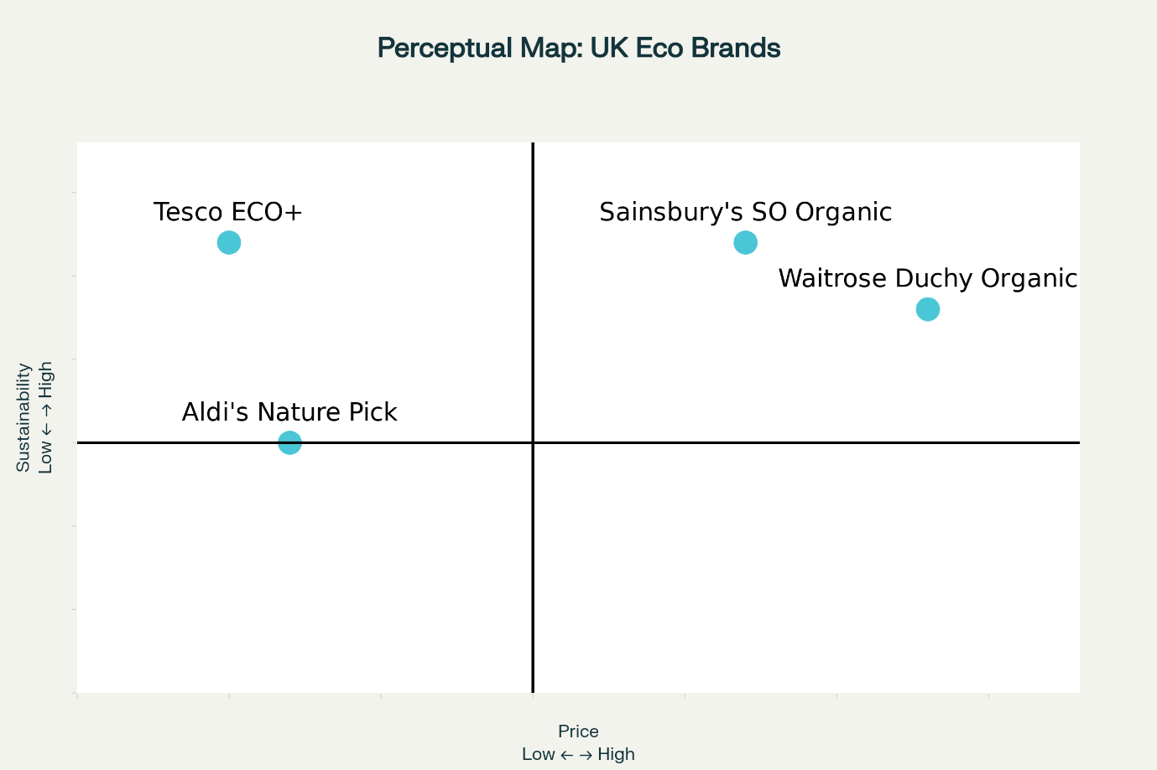
Figure 1: Perceptual Map
(Source: Self-Generated)
ECO+ is meant to be a premium but affordable brand, a space between organic products of higher quality and cheaper brands. It is a product that will capture the consumer's attention and incorporate the elements of trust, goal and convenience so that the customers can make responsible decisions without compromising their financial capability. The marketing mix of Tesco will support this stance by using packaging that raises environmental awareness, online advertising that focuses on the ecological benefits of saving carbon, and reward loyalty based on sustainable buying, which will further strengthen the ECO+ brand as the preferred brand to buy when looking at environmentally friendly and affordable living (Prathapkumar, 2024).

Conclusion
In conclusion, the market analysis in terms of STDP indicates that Tesco ECO+ has a high market potential since there is a rising need for affordability in sustainability. Moreover, by appealing to environmentally aware Millennials and Gen Z customers, the brand attains a definite differentiation and a progressive stance. ECO+ helps Tesco engage in long-term innovation efforts, inclusiveness, and environmental responsiveness within the changing retail sector.

Element 2: Marketing Mix (4Ps)

Introduction
A new sub-brand of Tesco, known as Tesco ECO+, is aimed at supporting the principles of sustainability and affordability in daily shopping. It presents the Tesco strategic vision of ensuring that eco-friendly living is affordable to all consumers, despite income of the customers (Tesco PLC, 2025). This initiative reinforces the wider brand strategy at Tesco, of providing value, innovation, and responsibility and as such, adjusting to the changing consumer preference towards ethical and environmentally conscious products. This part will implement the 4Ps marketing mix: Product, Price, Place, and Promotion to illustrate how Tesco ECO+ will realise its brand goals, customer retention, and further consolidate Tesco as one of the pioneers in sustainable retailing.

Product Strategy
Tesco ECO+ aims to offer sustainable and economical grocery and household products. The primary product will give customers the ability to make ethical decisions in their daily lives by providing a variety of more environmentally friendly choices, like biodegradable packaging, alternatives that are plant-based, and household items that can be used and reused.
The original product is presented by the Tesco ECO+ brand name, with the help of basic and easy-to-recycle packaging with eco-labels and a carbon footprint index to increase transparency. Although Tesco upholds its reputable quality products, all products are responsibly sourced following fair trade and low-emission production conditions. The product portfolio consists of cleaning necessities, organic food products, and personal care products that match the expectations of consumers in terms of quality and value.
Being an augmented product, Tesco offers added value in the form of rewards in the form of Clubcard in addition to eco-discounts in order to facilitate purchase returns and loyalty (Meng, 2024). Online eco-shopping guides and sustainability tips are also part of the brand and allow customers to make well-informed and responsible decisions.

Price Strategy
Tesco ECO+ pricing strategy aims to bring sustainable living closer to people and become inclusive, so that even consumers with low income can afford environmentally friendly products (Shams et al., 2025). The most important pricing goal is to provide value, but without damaging the environment; this would assist Tesco in achieving its mission of combining quality and affordability.
ECO+ applies the value-based pricing strategy whereby the products are priced according to the perceived benefits of sustainability to the consumers, as opposed to the cost of production. Tesco employs a penetration pricing strategy to motivate adoption and establish a sizeable market share within a short period of time - at the initial stage, Tesco offers lower prices to target customers conscious about eco-friendly customer behaviour as well as to position ECO+ on the same level with such competitors as Aldi, Lidl, and Sainsbury SO Organic (Imran et al., 2025).
The given strategy is based on reality in the present-day UK market; consumers in this segment demand sustainable products, but cannot afford to pay a top-price premium (Shilling, 2024). Balanced price and purpose, ECO+ provides an attractive value point in both the price and purpose, which is of interest to ethical and funds-sensitive customers.
The price promotion also increases affordability with Clubcard discounts and preparation of special plans. Gradual premiumisation of some ECO+ products is to be imposed gradually by Tesco over time as brand familiarity and brand loyalty are introduced. This is a long-term strategy that will make Tesco's sustainability both achievable and aspirational, and build on its sustainability in ethical retail innovation.

Place (Distribution) Strategy
Tesco ECO+ products will be distributed through the Tesco historical retail network with multichannel distribution to reach a greater number of customers and make their shop convenient. The brand will be found in Tesco Superstores, Tesco Express, and Tesco Online, which will all offer the same access to sustainable products. In-store will have dedicated special aisles named ECO+ Sustainable Living, to provide a better display and ease of shopping for eco-friendly products. By being able to integrate with Tesco.com and the Tesco app, customers are able to easily browse and buy ECO+ products, which tends to augment the sense of convenience and digital engagement.
To meet various shopping choices, an omnichannel strategy provides a flexible process towards Click-and-Collect features and home delivery (Wang et al., 2024). Tesco will also partner with Deliveroo and other companies of this type to deliver groceries and other essentials within a short time through a professional delivery service.

Promotion Strategy
The Tesco ECO+ promotion strategy will concentrate on creating brand awareness and influencing the perception of consumers and gaining long-term loyalty to the brand, as Tesco ECO+ will be promoted as the sustainable, but cost-effective, option. The key goals include exposure of the brand to a big audience, product testing and creating loyalty to the purchases among people who are environmentally sensitive (Salesforce, 2025).
With the help of an Integrated Marketing Communication (IMC) approach, Tesco will be moving towards a digital-first approach with social media campaigns like the one Tesco will use to encourage more people to be eco-friendly and environmentally responsible: the #EcoForEveryone (Samadzadeh, 2024). Emotive storytelling will be applied in television and print advertisements to show how small decisions in day-to-day life can have a significant impact. The store shelves, end-of-aisle displays, QR codes with links to sustainability stories, and easy-to-read eco-labels will be more interactive and transparent.
Personalised promotions will be based on Clubcard-driven digital personalisation of promotions according to the individual shopping patterns, and push notifications will notify customers about eco-product offers via the Tesco app.
PR will help Tesco to cooperate with environmental NGOs and influencers to enhance credibility and report on sustainability targets (McClain, 2025). Awareness and engagement will be enhanced further through sales promotions, such as opening events, product sampling and interactive "Sustainability Challenges" on social media.

Conclusion
In conclusion, Tesco ECO + marketing mix can be seen as a unified approach towards the relevant mission of the brand to make sustainability affordable and accessible. The Product range fosters environmental friendliness, the Price strategy guarantees value without sacrificing morality, the Place strategy makes use of the omnichannel accessibility of Tesco, and the Promotion plan creates awareness by way of genuine information-driven interaction. The combination of these factors ensures sustainability, accessibility and profitability, which may contribute to the long-term goals of Tesco, which are to lead in ecology, win the affections of their customers and innovate their retail processes. This integrated marketing mix will enable ECO+ to emerge as the most affordable sustainability brand in the UK, increasing consumer behaviour in a positive way.

Element 3: Marketing Strategy Pitch

Introduction
With sustainability being one of the requirements, Tesco launches ECO+, a new sub-brand aimed at ensuring every household can afford, access, and live an eco-friendly lifestyle with ease (Hossain et al., 2024).

The Problem
Consumers in the UK desire to spend sustainably; however, with scarce selection and confusion in labelling, many consumers encounter obstacles on the road to living a greener life (Nichifor et al., 2025).

The solution
Tesco ECO+ provides recyclable, carbon-neutral logistics and economical green alternatives for groceries and household products, making sustainability effortless, clear, and cost-efficient (Olarewaju et al., 2024).

Value Proposition
“Sustainability for Everyone.”
Tesco ECO+ combines reliability with innovation and the eco-consciousness of Tesco, allowing customers to go green while shopping at the same time without losing out on quality, value of price, and convenience of everyday shopping (Hasan and Kulsum, 2025).

Marketing Strategy
- Introduce through Clubcard eco-rewards and campaign on social media #EcoPlusLiving.
- Collaborate with the local sustainability impactors (Tyni and Järvelä, 2024).
- Create in-store areas and online filters for ECO+.
- Work with communities in terms of recycling activities and community education.

Conclusion
In conclusion, Tesco ECO+ makes Tesco a sustainability pioneer; customer loyalty and good environmental effect are the outcomes that make Tesco redefine responsible retailing in the contemporary and eco-conscious consumer world.

Element 4: Reflection

Reflection
Designing the new brand concept of Tesco ECO+ and creating the strategy of marketing has resulted to be an informative and growth-encouraging experience. When starting the project, I wanted to design a brand that focused on modern demand on consumers, especially with the increased interest in sustainability at a cheaper price. The conceptualisation of ECO+ required the application of a creative thinking approach, but at the same time, integration of the brand into the existing values and positioning of Tesco. Such a cooperation between innovation and practicality improved my perception of strategic brand improvement and the importance of basing new concepts on real-life market problems and customer behaviour (Sharabati et al., 2024).
The process of carrying out the situational and market analysis, i.e. STDP, SWOT, value proposition development and perceptual mapping, allowed me to have theoretical models put into practice. I gained the knowledge of the role of each framework in developing a consistent brand identity that identifies the needs of customers, threats of competitors, and differentiators. As an example, the formation of the value proposition “Sustainability for Everyone” made me consider my emotional, functional and economic benefits of ECO+ that are to be conveyed, more critically. This boosted my strategic thinking and made me more resourceful in defining brand value in a clear and persuasive manner.
Another critical aspect of the learning process was to prepare and pitch the marketing strategy. This helped me to create a short and appealing presentation that allowed me to compile all the amount of information into meaningful and persuasive key messages. This helped me in developing my skills of communication and narration- especially the skills to combine information in a well-organised, interesting and engaging presentation (Romero Vallejo, 2024). This helped in developing and strengthening my confidence, clarity and engagement of the audience.
Some of the major skills acquired by me during the process were analytical, creative, teamwork, visual communication and time management. The repetitive quality of the work to generate ideas and focus on them, and create images, showed me the fact that feedback loops and revision are crucial in marketing undertakings. I also learned to appreciate the importance of making a decision related to branding that is consistent throughout all aspects of design, messages, prices, and customer experience.
To improve my practice in such future projects, there are a number of ways in which I could improve my approach. To begin with, I would pay close attention to conducting more extensive consumer research in order to reinforce the strategic decisions. Greater amounts of data-driven information would enable me to be more likely to validate suggestions. Second, I would dedicate more time to practising pitch delivery, practising transitions, timing and pacing in order to have a full impact.

References
Ciobotaru, R., Tas, A.A. and Khan, T.A. (2024) Healthiness of meat-based products in comparison to their plant-based alternatives in the UK market: a packaging evaluation. Foods, 13(21), p.3346. Available at: https://www.mdpi.com/2304-8158/13/21/3346
Deloitte (2025) Deloitte Global Gen Z and Millennial Survey 2025 Available at (Online) <https://www.deloitte.com/global/en/issues/work/genz-millennial-survey.html> (Accessed on 11 November 2025).
Hamdi, M. (2024) Sustainable packaging trends in the consumer packaged goods market. Harvard University. Available at: https://www.researchgate.net/profile/Mourad-Hamdi/publication/383608198_Sustainable_Packaging_Trends_in_the_Consumer_Packaged_Goods_Market/links/66d36b5a2390e50b2c228da9/Sustainable-Packaging-Trends-in-the-Consumer-Packaged-Goods-Market.pdf
Hasan, M.I.M. and Kulsum, M.U. (2025) Sustainability practices and consumer behavior in food delivery services: a case study.’ Available at: https://www.theseus.fi/bitstream/handle/10024/887855/Hasan_Kulsum.pdf?sequence=2
Hossain, M.I., Akter, N. and Muzareba, A.M. (2024) Product and Packaging Decisions. In Marketing in a Transition Economy: New Realities, Challenges, and Prospects (pp. 155-190). Singapore: Springer Nature Singapore. Available at: https://link.springer.com/chapter/10.1007/978-981-97-3553-2_5
Igwe, C.O. (2025) Management and Green Marketing: Aligning Workforce. Regulatory Frameworks and Digital Compliance in Green Marketing, p.209. Available at: https://books.google.com/books?hl=en&lr=&id=V2lfEQAAQBAJ&oi=fnd&pg=PA209&dq=Igwe,+C.O.+(2025)+Management+and+Green+Marketing:+Aligning+Workforce.+Regulatory+Frameworks+and+Digital+Compliance+in+Green+Marketing&ots=JpOSulr1Eo&sig=6VY_y93TRLojDbF1t--uYUs8UHw
Imran, N., Kumar, M., Jagtap, S., Trollman, H., Gupta, S. and Garcia-Garcia, G. (2025) Exploring consumer behaviour on carbon labelled food products: evidence from a survey on the case of sandwich production and consumption in UK. Journal of Agriculture and Food Research, p.101937. Available at: https://www.sciencedirect.com/science/article/pii/S2666154325003084
McClain, N. (2025) Public Relations as an Approach for SMEs to Improve Business Sustainability (Doctoral dissertation, Walden University). Available at: https://scholarworks.waldenu.edu/cgi/viewcontent.cgi?article=19547&context=dissertations
Meng, S. (2024) Operation Management of Grocery Retailer in the UK: A Case of Tesco. Pacific International Journal, 7(2), pp.136-142. Available at: https://rclss.com/pij/article/download/586/391
Nichifor, B., Zait, L. and Timiras, L. (2025) Drivers, barriers, and innovations in sustainable food consumption: A systematic literature review. Sustainability, 17(5), p.2233. Available at: https://www.mdpi.com/2071-1050/17/5/2233
Olarewaju, T., Dani, S., Obeng-Fosu, C., Olarewaju, T. and Jabbar, A. (2024) The Impact of Climate Action on the Financial Performance of Food, Grocery, and Supermarket Retailers in the UK. Sustainability, 16(5), p.1785. Available at: https://www.mdpi.com/2071-1050/16/5/1785
Prathapkumar, K.S., KS, S.K. and HN, M.S. (2024) GREEN MARKETING IN THE DIGITAL AGE: EXPLORING SUSTAINABLE PRACTICES AND CONSUMER BEHAVIOUR. International Journal of Exclusive Management Research. Available at: https://ijemr.in/wp-content/uploads/2024/06/IJEMR-Final.pdf#page=93
Romero Vallejo, Y. (2024) Unit of work: the art of storytelling (Master's thesis, Universidad de Granada). Available at: https://digibug.ugr.es/bitstream/handle/10481/104156/Romero_Vallejo_Yolanda_DIR_Pearse.pdf?sequence=4&isAllowed=y
Salesforce (2025) What is the Marketing Mix & the 4 Ps of Marketing? | Salesforce Available (Online) <https://www.salesforce.com/in/marketing/mix/> (Accessed on 11 November 2025).
Samadzadeh, M. (2024) Investigating Successful E-Commerce and Digital Marketing Strategies for Major Supermarkets in the UK. Available at: https://www.researchgate.net/profile/Mohammadreza-Samadzadeh-3/publication/387491235_Investigating_Successful_E-Commerce_and_Digital_Marketing_Strategies_for_Major_Supermarkets_in_the_UK/links/67703cf8117f340ec3e067af/Investigating-Successful-E-Commerce-and-Digital-Marketing-Strategies-for-Major-Supermarkets-in-the-UK.pdf
Shams, S.R., Brown, D.M. and Hardcastle, K. (2025) Pricing Strategy for People, Planet, and Profit. In Sustainable Marketing: Strategic Marketing for People, Planet and Profit (pp. 169-225). Cham: Springer Nature Switzerland. Available at: https://link.springer.com/chapter/10.1007/978-3-031-79130-7_3
Sharabati, A.A.A., Ali, A.A.A., Allahham, M.I., Hussein, A.A., Alheet, A.F. and Mohammad, A.S. (2024) The impact of digital marketing on the performance of SMEs: An analytical study in light of modern digital transformations. Sustainability, 16(19), p.8667. Available at: https://www.mdpi.com/2071-1050/16/19/8667
Shilling I. (2025) UK Sustainability in Food Market Report 2024 | Mintel Store Available (Online) <https://store.mintel.com/report/uk-sustainability-in-food-market-report-2024> (Accessed on 11 November 2025).
Tyni, S. and Järvelä, M.L. (2024) International conference promoted the agri-food and forestry sectors. Available at: https://www.theseus.fi/bitstream/handle/10024/866625/Oamk_Journal_88_2024.pdf?sequence=1
Wang, X., Wong, Y.D., Shi, W. and Yuen, K.F. (2024) An investigation on consumers' preferences for parcel deliveries: applying consumer logistics in omni-channel shopping. The International Journal of Logistics Management, 35(2), pp.557-576. Available at: https://www.emerald.com/insight/content/doi/10.1108/ijlm-07-2022-0288/full/html
Wolniak, R., Stecuła, K. and Aydın, B. (2024) Digital transformation of grocery in-store shopping-scanners, artificial intelligence, augmented reality and beyond: A review. Foods, 13(18), p.2948. Available at: https://www.mdpi.com/2304-8158/13/18/2948
Wu, X. (2025) An analysis of the international differentiated marketing strategy pattern of multinational supermarket brands: A case study of Aldi. In Global Dialogue on Media Dynamics, Trends and Perspectives on Public Relations and Communication (pp. 540-546). CRC Press. Available at: https://www.taylorfrancis.com/chapters/edit/10.1201/9781003564966-82/analysis-international-differentiated-marketing-strategy-pattern-multinational-supermarket-brands-case-study-aldi-xinqi-wu

Appendix
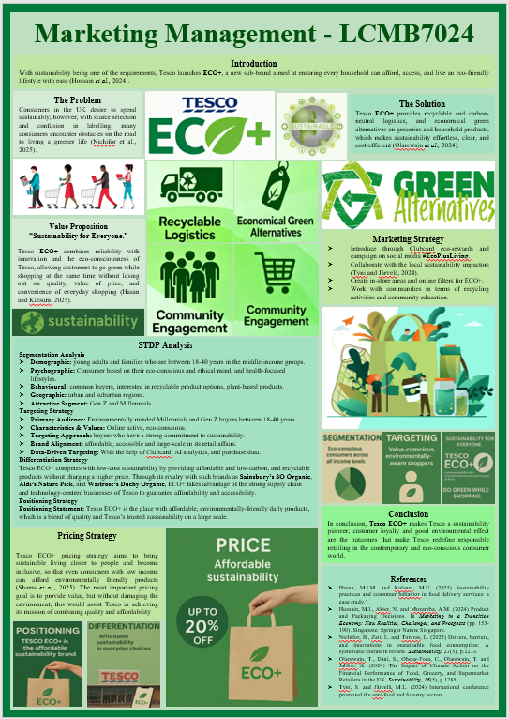
Figure 2: Poster
(Source: Self-Generated)

