lewis Richards 1800497

Stop and search

Stop and search is the power given to the police in England and Wales to search a person or vehicle that they suspect under “reasonable grounds” if that person is carrying; illegal drugs, a weapon, stolen goods, or something else that could be used to commit a crime for example a crowbar. Police officers are not permitted to stop a person on grounds of their gender, race or previous criminal record. The stop and search must purely be done on an assessment based on current intelligence or on behaviour that might be classed as suspicious. A suspect who is stopped and searched must comply with the police, they must be told why they are being stopped and for what reason. They must be informed of what the police are looking for, for example drugs or a weapon. The police officer must show them their warrant card which is proof they are permitted to carry out the search. The police officer must also tell the suspect that they can obtain a copy of the search following the search and how to get it. Most police officers now wear body cameras which will record the search, the public are also permitted to record the search. (BBC) 2020).
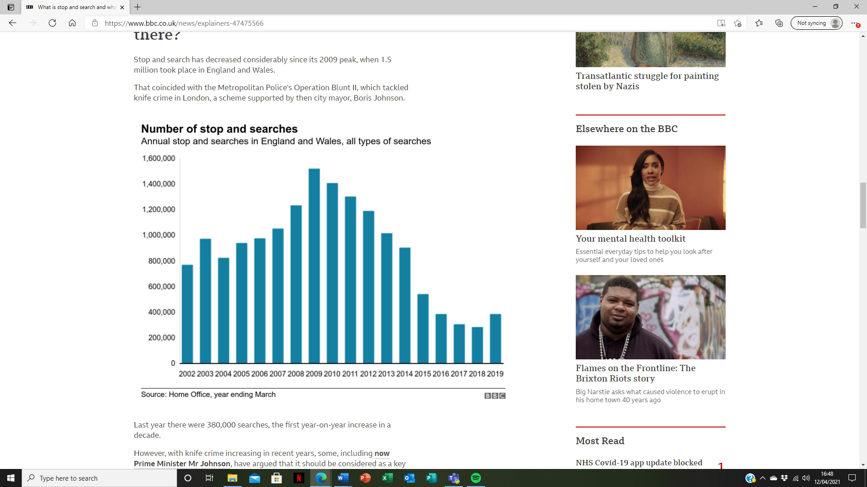
Above is the annual number of stop and searches for England and Wales.
According to the BBC (2020), a black person is 9 times more likely to be stopped and searched compared to a white person. Following on from the Stephen Lawrence murder recordings of stop and search have improved.
The way a police officer interacts during a stop and search must be professional and this is imperative when trying to gain the public’s trust and confidence. The public say they are more likely to be satisfied with stop and search if they feel they are not unfairly stopped and if they are given a credible reason for being stopped. If they are respected and treated with respect and if the whole encounter is time worthy. Stop and search powers should only be used in a purpose that minimises dissatisfaction and does not encourage community resentment. Police fairness in stop and search ensures legitimacy and this will involve officers adopting a professional and unbiased approach that complies with standards of conduct and the code of ethics as well as excellent communicative skills and treating individuals with dignity and respect. (College of Policing) 2016).
During stop and search officers need to think about how they come across to the public. An officer needs to be aware of what they say, how they say it and how they hold themselves – their body language, stance, expression and gestures. It is good to start a stop by firstly gaining the suspects cooperation, putting them at ease, maintaining cooperation and de-escalating any conflict. Threatening behaviour by the police can encourage the suspect to become defensive, evasive and hostile. This would make the search harder, more challenging and could lead to the officer or suspect gaining an injury. Good communication and active listening skills by the officer is paramount. When a challenging situation arises, it is important for the officer to remain professional. Officers must give explanations, avoid police jargon and check to see the person has understood. (College of Policing) 2016).
GOWISELY is an acronym and serves as a reminder to a police officer of the information they must give a member of the public when they carry out a stop and search.
G - grounds for the search.
O – object the officer is searching for.
W – warrant card – proof of who they are.
I – identification shows the suspect that the officer is an officer.
S – station to which the officer is attached.
E – entitlement to see copies of paperwork.
L – legislation, the legal power giving the right to stop and search.
Y – you, why you are being detained and the nature and reason for the search.
This information is given to ensure that the stop and search is conducted lawfully. GOWISLEY acts as a reminder to the public and to officers of the need for explanation and accountability. The information is also important if needed later in a court of law for evidence. (Shoutout) 2013).
The police and criminal evidence act 1984 says that an officer may carry out stop and search in any place with public access or in any other place to which people have ready access. A constable may search a person or vehicle and anything that is in or on the vehicle and that they may detain a person or vehicle for the duration of the search. (Gov.uk).
The police and criminal evidence act 1984 (PACE) was made to maintain the correct balance between the powers of the police and the rights and freedoms of the public. The PACE codes of practice cover stop and search. (Gov.uk) 2020).
A police officer must have either a belief as a suspicion that an offence has already been committed in order to conduct a stop and search. Police officers have said that stop and search is a valuable tool and that in 1998/1999 12% of stop and searches resulted in an arrest and that the power of stop and search indirectly helped the detention and prevention of crime through the intelligence the searches gathered. However, since the Stephan Lawrence report, the number of stop and search in London has halved. The reason for this crucial reduction is said to be because officers were worried about accusations of racism so avoided using such powers. (BBC) 2000).
The public need to be able to trust and have confidence in the police and that is why the police need to be transparent. The public need to see how and why the search powers are used as what impact the search might have. Media statistics are not always formed from a result of deliberate or intentional police behaviour. The police have the potential to improve their perception by the public by encouraging the publics understanding of police practice, by being open about when things go wrong and how things are done to rectify mistakes. By being transparent it shows the public that there is genuine responsibility and accountability for police actions. Data requires a good quality, and this also needs to be transparent and easy to read. Transparency needs to be shown at all levels. Officers’ recordings need to be in good detail so they can be easily reviewed. Stop and search must be monitored by supervisors to ensure any issues are identified and addressed. Senior officers must make sure data is analysed and acted upon and police forces must promote and support fair and effective use of stop and search powers and facilitate public security of their use. Public and supervisory scrutiny of recordings is important, and this is why a recording is made of every stop and search encounter. Details of where the person is detained is also documented. A new record must be made for each person and or vehicle searched. There are mandatory details which must be included, and these are the ethnicity of the suspect, the date, time and place of the search, the object of the search – what was being searched for, an explanation of the reasonable grounds plus the constable’s identification details. The record must also state if anything was found and if so, was it was linked to the original reason for the stop and search and what the outcome was. The reasons a suspect is stopped must be because of reasonable suspicion, the officer involved must have proof of a particular source of intelligence or information. There must be specific behaviour suspicious to the officer by the suspect. The answers asked by the officer to the suspect must be suspicious, plus any other relevant information. The report does not need to be lengthy, but it must be concise and accurate. An officer must ensure enough detail has been given and it is easy to understand, and that the information given is detailed enough for someone else to judge whether a reasonable person would also have suspected that individual in the same situation. (College of Policing) 2020).
Equality and Human Rights (2010), commission wrote a critical review on the use of stop and search in England and Wales, it discovered that since 1995 the statistics show that the Asian community has been stopped twice the amount of times compared to its white community and the numbers for the black community were between 4 and 8 times greater. These statistics are obviously going to impact Asian and black people’s experiences with the police. Despite years of debate and discussion along with new initiatives to tackle the issue, the problem is still huge, and the police have not made any significant improvement in the record on race disproportionality in stop and search.
The European Court of Human Rights ruled in 2010 that certain searches undertaken under section 44 of the Terrorism Act 2000 were not lawful because they were not found to be on “reasonable suspicion” grounds. The majority of searches in England and Wales were conducted following PACE. The Equality and Human Rights commission believe that PACE is also used in a more disproportionately way against black people than those conducted under the Terrorism Act. Therefore, the commission believe that the use of PACE holds great significance in terms of the way it impacts relations within its community. There have been a few explanations to why black people are stopped more frequently than white, and these are; data is inaccurate, black people also commit more crimes or that they are more “available” on the streets to be stopped and searched than white people. The critical review agrees that for the police, stop and search gives them the power, if they suspect a person of being involved in a crime, to confirm or diminish suspicion without exercising powers of arrest. When used correctly, appropriately and proportionately it can improve and increase police confidence, trust and respect in communities. (Equality and Human Rights) 2010).
Since the Stephen Lawrence injury in 1999, it concluded that stop and search should continue but it put safeguarding recommendations in place to ensure consistent and proper use. Recommendation 61 stated that a full written report must be made after each stop and search. These were to be completed and handed to the person involved at the time of the search. However, since 2001 and due to time constraints and paperwork overload, the recording requirements have been reduced and now, only a numbered receipt is given and the person who was searched can now go to the station afterwards and ask for a full record. This in itself could prevent people claiming their records because the station could be too far away or not easily accessible and it could cause fear of being labelled as a potential complainant. (Equality and Human Rights) 2010).
There is legislation in place governing the polices use of stop and search. These are PACE – Police and Criminal Evidence Act 1984, Misuse of Drugs Act 1971 and Firearms Act 1968. The police must have reasonable suspicion to stop and search and that the individual must be in possession of stolen or prohibited items. The Road Traffic Act 1968 says that under section 163, a person must stop their vehicle or cycle when requested to do so by a constable. Section 4 of PACE then allows the officer to search the vehicle – when the officer has reasonable suspicion that the vehicle is carrying a person who is about to commit or has already committed a crime. The Criminal Justice and Public Order Act 1994 states that under section 60 they do not require reasonable suspicion. But instead, they can be authorised by a senior police officer where there is a belief that incidents involving serious violence may occur or that people are carrying weapons in a certain locality. The above power is mainly used at large events such as football matches. (Equality and Human Rights) 2010).
The Terrorism Act 2000 also allows the police to stop and search without reasonable suspicion and this must too be authorised by a senior officer. This was until it was ruled unlawful in 2010. Under PACE Code A, it states what constitutes “reasonable suspicion” it says that there must be an objective basis for the suspicion. There must be facts, information or intelligence that is relevant to an officer finding an offending article. (Equality and Human Rights) 2010).
Personal factors can never be used as reasonable suspicion without supporting and reliable sources of information being given. An example of this would be a person who is know for a previous conviction being stopped again without reason and supporting intelligence. Neither can reasonable suspicion be used based on stereotypical images or generalisations of certain groups or people who are more likely to be involved in a criminal action. Stop and search purely on race has always been prohibited. (Equality and Human Rights) 2010).
In the Human Rights Act 1998, it states everyone has a right to liberty and privacy so again the use of stop and search power must be legal, non-discriminatory and proportionate. For example, using power to disperse a group of young adults based on collected intelligence is unlawful. (Equality and Human Rights) 2010). Under the Race Relations Act 2000 it is unlawful for police to directly or indirectly discriminate against a person due to their race. If a person believes they have been discriminated against they can complain to the Race Relations commission. The police have a duty to pay regard to the elimination of discrimination and to promote steps by the police should made in order to achieve better equality outcomes.
Ken Hinds, a black man growing up in north London was regularly stopped and searched by the police and often assumed to be a criminal, he was stopped an average 5 – 6 times a year. He was stopped in shops, on trains, in his car and even as he stepped out his own house. In May 2004, Hinds witnessed a young black man being stopped and searched, the police arrested Hinds and charged him with threatening and abusive behaviour. After his charges were dismissed in court, Hinds pursued the officers involved for an apology. He got one, along with £22,000 compensation. Hinds now works as a youth worker and conflict engagement specialist in high-risk areas with gangs in north London. He also works as a gang mediator with the police, he recently received a commendation from the Metropolitan police for his courage, tenacity and dedication in tackling knife crime. Hinds recalls his bad memories of the encounters he had whilst growing up in London as a black man and says the police were his enemy, he would not call them and if in trouble he would tackle things himself. Hinds believes strongly that the police often “add fuel to the fire” instead of tackling crime in the black community strategically. He goes on to say that engagement and accessibility is paramount to successful policing. (Equality and Human Rights) 2010).
Responsibility for developing practice in stop and search changed hands and in 2007 it became the job of National Policing Improvement Agency and they put together a next steps initiative. The initiative is designed to deliver focus, intelligence-based practice that is under pinned by support and community confidence. It also gives officers new roles, it measures to combat non-recording of stop and search, it reinforces officer training and is set to be rolled out amongst all forces. The initiative will target stop and search in areas where crime is low, it will target where areas are high disproportionality and suggest powers are being unfairly used, wasting money and not being effective. Guidance is called for on reasonable suspicion in specific circumstances and the descriptions of suspects are more detailed to ensure racial profiling is not happening. The next steps initiative also recommends a range of managerial responses including the police being more proactive through neighbourhood policing initiatives. Proactivity is also needed when delivering the marketing of know your rights leaflets. (Equality and Human Rights) 2010).
To drive through policing practice the values should be that of fairness, equality, protection of human rights and effectively keeping communities safe. The commission believes that positive engagement with communities is key. Building confidence and trust can be done by the police using their powers in a non-discriminating manner and in a way that protects human rights. (Equality and Human Rights) 2010).
So where do we go now? Derbyshire constabulary are following positive practice with their stop and search monitoring. People who are stopped and searched are asked for their email address, this is to allow the police to send them a link to access their stop and search report. There is also a link to an online survey where people can share their experiences and offer their feedback. If the person does not want to give an email address, then they are given a card with details of how to fill the survey in via the force’s website. This feedback monitors the process and allows for improvement of the practice. West Midlands Police also use their body worn video footage to identify examples of good practice which could enlighten areas for development. This is known as reflective learning. (HMICFRS) 2021).
Another example of positive practice is in Avon and Somerset Police force, panel members are called to review body camera footage and give feedback, recommendations are published. Panel members are also involved in the police apprentice curriculum which helps build relationships with harder to reach communities. (HMICFRS) 2021).
The PEEL programme continues to monitor and inspect disproportionality in certain areas of policing. It will act on recruitment to create a workforce that better reflects its communities. It will endeavour to treat people fairly. Raining will be looked at to ensure faire behaviour. Officers need to be more equipped with better communicative skills to deescalate situations to avoid confrontation. Forces will be helped to understand data on stop and search and to help maximise their use of body worn video footage to improve procedures and behaviours. (HMICFRS) 2021).

BBC, 2020. (what is stop and search and what are my rights?). Accessed 8th April 2021. Available from What is stop and search and what are my rights? - BBC News
BBC, 2000. (The power to stop and search). Accessed 8th April 2021. Available from BBC News | UK | The power to stop and search
College of policing, 2020. (stop and search). Accessed 8th April 2021. Available from Transparent (college.police.uk)
College of policing, 2016. (stop and search). Accessed 8th April 2021. Available from Professional (college.police.uk)
Equality and Human Rights Commission, 2010. (stop and think). Accessed 8th April 2021. Available from ehrc_stop_and_search_report.pdf (equalityhumanrights.com)
GOV.UK, 2020. (Police and criminal evidence act 1984 (PACE) codes of practice). Accessed 8th April 2021. Available from Police and Criminal Evidence Act 1984 (PACE) codes of practice - GOV.UK (www.gov.uk)
HMICFRS, 2021. (Disproportionate use of police powers). Accessed 8th April 2021. Available from Disproportionate use of police powers: A spotlight on stop and search and the use of force (justiceinspectorates.gov.uk)
Legislation.GOV.UK. (Police and criminal evidence act 1984). Accessed 8th April 2021. Available from Police and Criminal Evidence Act 1984 (legislation.gov.uk)
Shoutout, 2013. (GOWISELY). College of policing, 2016. (stop and search). Accessed 8th April 2021. Available from GOWISELY! | Shout Out UK

