ABC ASA
Strategic Review of Sustainability Vision and Future

1 Introduction and Purpose 4
1.1 ABC ASA Vision, Mission Statement and Strategic Objectives 5
1.1.1 Strategic Objectives 7
2 Evaluation Methodology 8
2.1 SWOT Analysis 9
2.2 Key Stakeholders 9
2.3 Material Issues associated with sustainability 9
3 Evaluation of Sustainability Strategy 11
3.1 Governance Material Issues 12
3.2 Environmental Material Issues 15
3.3 Social Material Issues 18
4 Business Case for Workshop Recommendations 21
Appendix A: Stakeholder Analysis 22
Appendix B: Materiality Assessment 25
Appendix C: SWOT Analysis on Strategic Objectives 26
Appendix D: References 29

Introduction and Purpose
The purpose of this Report is two-fold:
The initial sections shall outline the methodology used to evaluate ABC ASA's existing Vision, Mission Statement and Strategic Objectives (cumulatively referred to as 'Strategic Objectives'). The critical analysis will determine the extent ABC ASA material issues are addressed by Strategic Objectives and their comprehensiveness in setting a sustainability-based corporate direction.
Later sections shall formulate recommendations to strengthen value creation potential by encapsulating more sustainability principles in Strategic Objectives. The Report shall do this by considering stakeholder interests, SWOT Analysis, and Material Assessment outcomes to balance internal and external considerations.
This Report has been prepared to engage the below internal stakeholders in the next periodic review of the ABC ASA 2021 – 2023 Business and Strategy Plan.
- Chairman of the Board;
- Chief Sustainability Officer;
- Board Members;
- Chief Financial Officer;
- Chief Executive Officer.

Recommendations are made for an internal workshop comprised of representatives from the ABC ASA Sustainability Committee.

ABC ASA Vision, Mission Statement and Strategic Objectives
The disruptive nature of COVID-19 and the OPEX+ discount price war between Russia and Saudi Arabia was significant in a very volatile year for the Oil and Gas industry (Blackmon, 2020). Internally and pre-pandemic, ABC had already identified changing market conditions. The Chief Executive Officer's Management Letter in the 2019 and 2020 Annual Report highlighted new and vital stakeholder interests in the Organisation, such as;
- "…greater accountability and transparency in our actions to reduce Climate Change" (ABC ASA, 2019);

- "…focus on climate action and expectations of Global Citizenship" (ABC ASA, 2019).

- "Challenging market conditions' (ABC ASA, 2020);

- "…great uncertainty with regards to the demand for oil and oil related products" (ABC ASA, 2020);
The sentiment of unsettled market conditions and evolution in stakeholder expectations resulted in a holistic review of ABC ASA's previously shareholder orientated Vision and Mission Statements.
In October 2020, revised Strategic Objectives and a 3-year Improvement plan were approved by the Board of Directors.
The new Vision and Mission Statements are as show in Figure 1 and 2 below.
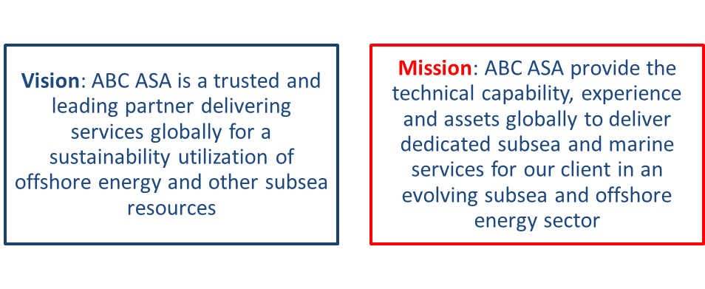
Figure 1 ABC ASA Vision Figure 2 ABC ASA Mission

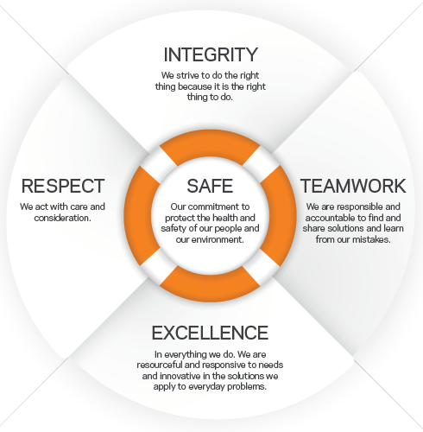
Figure 3 ABC ASA Values
In addition to Corporate Vision and Mission Statements, ABC has five organisational values, as shown in Figure 3. ABC has been reporting under the Carbon Disclosure Project (CDP) using these five values and global reporting initiative criteria for seven years.

Strategic Objectives
Figure 4 presents ABC ASA's Strategic Objectives, including Mission Statement, Values and outlined objectives within the latest Annual Report (ABC ASA, 2020).
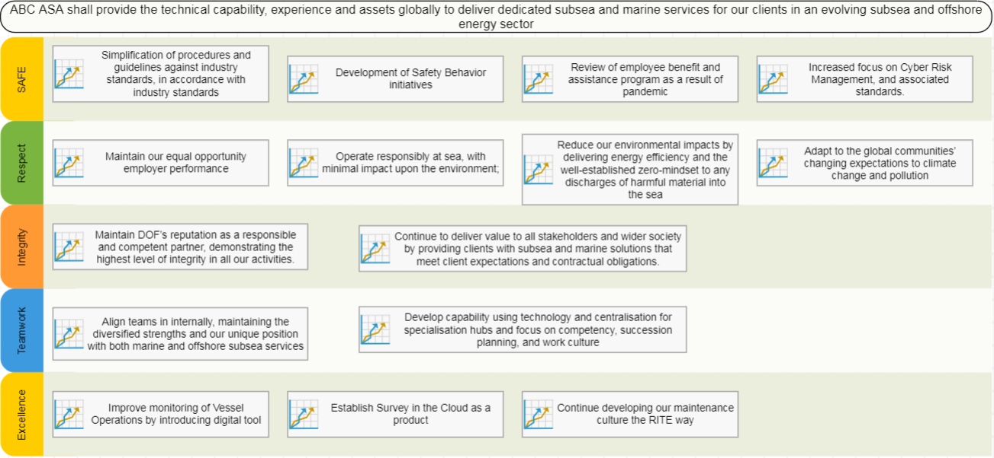
Figure 4 ABC ASA Disclosure of Strategy

Evaluation Methodology
The below outlines the methodology used in this Report to appraise ABC's existing Strategic Objectives;
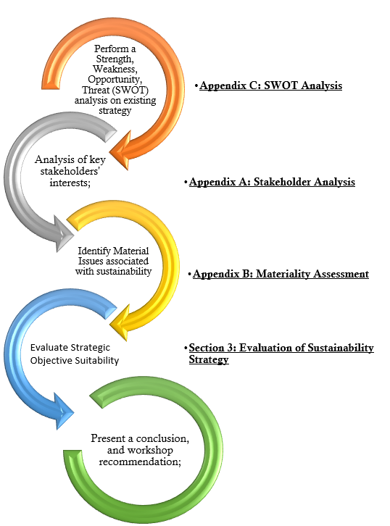
Figure 5 Methodology for Evaluation

SWOT Analysis
The SWOT Analysis (Appendix C) has been utilised as a situation analysis, identifying organisational and environmental factors that influence favourability in achieving predetermined strategic objectives (Gurel & Tat, 2017). Factors identified within the SWOT Analysis have been used in this Report to highlight departure points from its existing corporate strategy (Houben, et al., 1999). Combined with Stakeholder Analysis and Material Issues, SWOT Analysis provides a valuable interactional analysis technique allowing this Report to make recommendations accountable to many internal and external considerations.

Key Stakeholders
Key stakeholders to ABC have been identified as part of the 2019 Sustainability Report (Appendix A).
The Stakeholder Identification exercise involved consultation and engagement with interested parties via;
- Workshop sessions;
- Dialogue through existing communication channels;
- Advisory panels;
- Public meetings;
- Forums;
- Focus groups; and
- Surveys
This endeavour provides insight into attributes, interrelationships and interfaces amongst advocates and opponents of ABC's activities (Smith, 2000). In addition to being an essential consideration of current and future strategy formation, identifying stakeholders' interests is an input to Material Assessment.

Material Issues associated with sustainability
Since 2014, ABC has adopted the Global Reporting Initiative (GRI) framework to guide the Economic, Environmental and Social (ESG) domains reported through the Carbon Disclosure Project. Using the two GRI planes below, this Report can also divulge ESG issues that are sufficiently important that they should inform current and future strategic objectives in sustainability;
- Degree of Stakeholder interest;
- Importance of the issue in terms of business continuity
(Calabrese, et al., 2019), (Global Reporting Initiative, 2019)
This technique will help assess connectivity between ESG topics most material to stakeholders and the comprehensiveness of existing or future value creation strategies in addressing risks and opportunities.
ABC's Materiality Assessment is presented below in Figure 6;
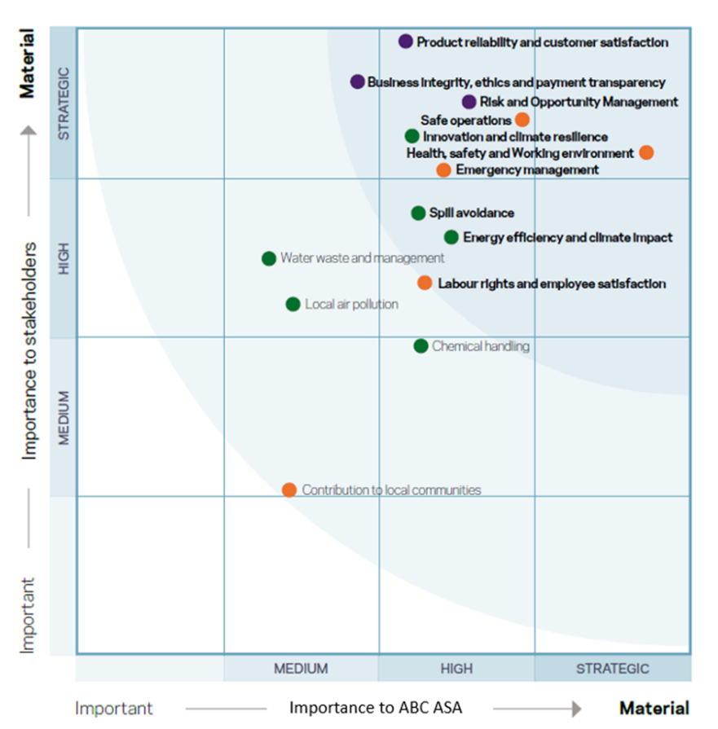
Figure 6 ABC ASA Material Assessment

Evaluation of Sustainability Strategy
This section of the Report shall draw upon the outlined methodology to evaluate how strategic objectives treat identified material issues and determine the Strategic Objectives adequacy in Value Creation.

Governance Material Issues
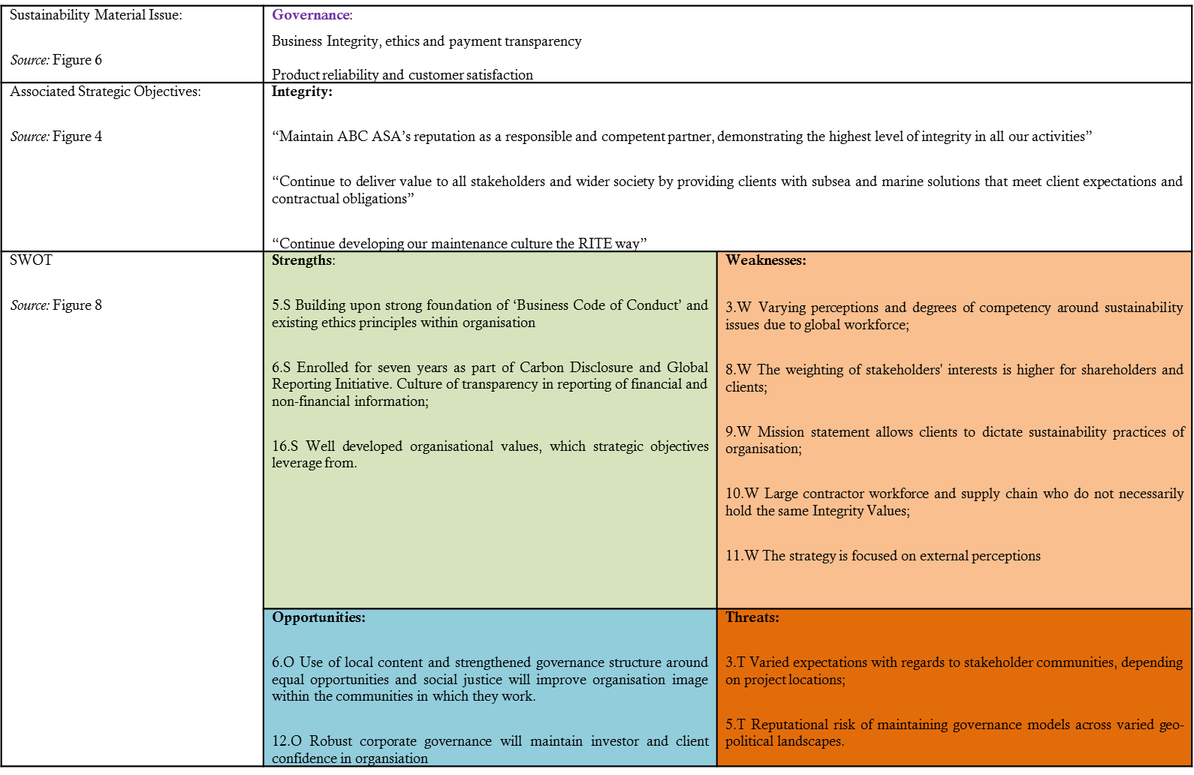

Strategic Objective: Assessment of suitability
- Both the Value and Strategic Objective combine a requirement to comply with the law and emphasise individual duty. In doing so, an implied behaviour is imposed upon individuals involving moral thought, action, and self-governance. A personal commitment and self-governance model is a robust measure for those whose integrity may be challenged by day-to-day dealings (Paine, 1994) across the geopolitical spectrum of ABC's operations.

- Figure 7 is specific in its application across 'all our activities'. This elicit scope setting addresses the fundamental 'Threat' of 'Governance' levels becoming dictated by the geopolitical environment. Applying a consistent expectation, regardless of location or task, is a critical aspect of protecting business continuity and ensuring stakeholder needs are consistently met;

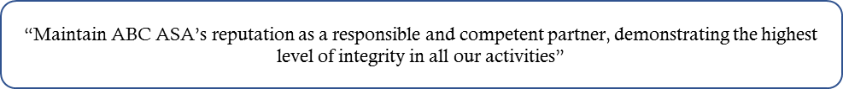
Figure 7 Governance: Integrity Objective
- There is an assumption in Figure 8 that value creation for clients is mutually beneficial for all ABC's stakeholders. This objective overlooks the fact that stakeholders have conflicting interests.
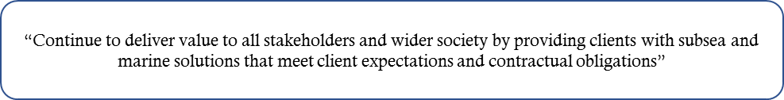
Figure 8 Governance: Delivering stakeholder value
- ABC's Governance performance in financial and non-financial areas is transparent and has been publicly disclosed as part of their GRI involvement. The current rating of 'A-'under CDP gives credibility to governance and transparency measures. The following areas are disclosed related to this material issue;
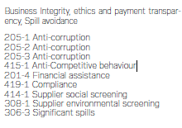
Figure 9 GRI Reporting: Integrity
- Specific leading and lagging indicators and performance standards associated with Governance strategic objectives are not disclosed within the 2020 Annual Report. Despite this, ABC's 'Code of Business Conduct' unpins Figure 7 and Figure 8 Objectives with specific behaviours and actions. The 'Code of Business Conduct' is a publicly available document that also forms part of suppliers' terms and conditions.

Recommendations and Conclusion
Within ABC, there is a robust Governance model around business ethics, integrity and transparency. The Governance model is supported by a framework of mature documents and internal processes;
- Business Code of Conduct;
- Annual disclosure into CDP, using the GRI framework;
- Corporate Audits;
- Ethical Hotlines;
- Bribery Act and Modern Slavery annual assessments;
- Transparent tax strategy;
- Due diligence within the supply chain.
ABC could benefit from integrating the abovementioned framework of activities and performance standards into a 'Balanced Scorecard'. The above recommendation shall increase transparency between the operational measures reported through GRI/CDP and offer further insight towards how the material issue of 'Business Integrity, ethics and payment transparency' is being addressed. A Balanced Scorecard will also assist the Organisation in establishing criteria for their own governance standards, rather than allowing external parties to impose inconsistent or ambiguous governance ideals as implied by Figure 8.
The Strategic Objective shown in Figure 8 should be reconsidered. Compliance with this objective does not necessarily correlate to corporate governance levels expected by the entire range of stakeholders or the Code of Business Conduct document.
Strategic Objectives in this area are considered 'Conservative'. The Organisation displays maturity and commitment towards its internal processes, but it does not consider its full range of stakeholders in value creation. Value propositions are orientated around cost efficiency and demonstrating performance to external parties (Baumgartner, 2010).
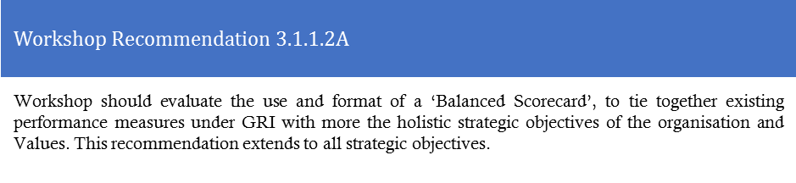
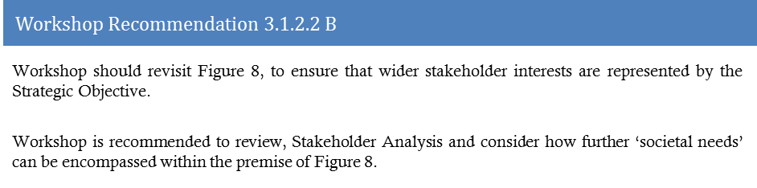

Environmental Material Issues
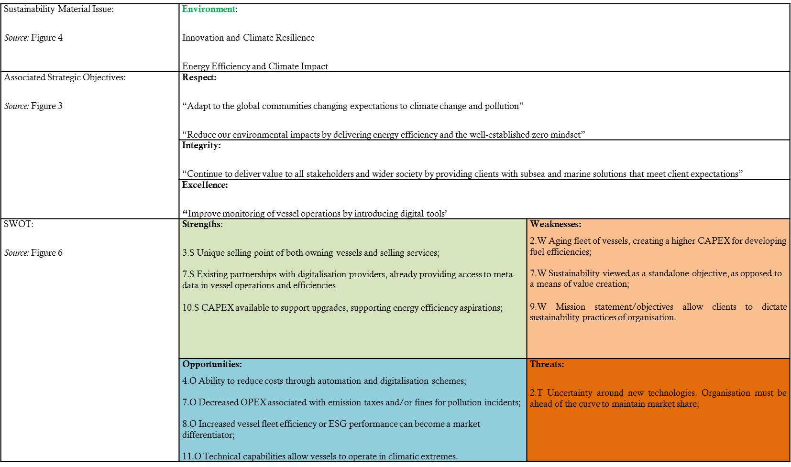

Strategic Objective: Assessment of Suitability
- Strategies Objectives above align well with Mission and Vision statements, emphasising an evolution of existing services through increasing capabilities, adjusting to clients' needs and protecting natural capital.

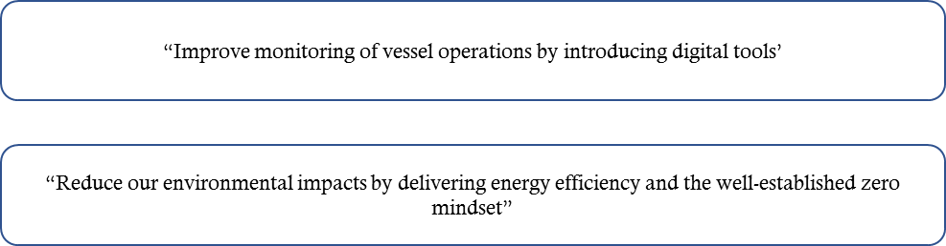
Figure 10 Environmental; Innovation Objectives

- The strategic objectives (Figure 10) related to 'innovation' material issues are focused on developing vessel fuel-efficiency technology and digitalisation. As a strategic area for sustainability, this will provide greater access to vessel metadata, introducing new products and services, facilitating improved environmental decision-making, and decreasing operational expenditure. The 'innovation' strategic objectives are sustainable as they create internal and external Value.
  - ABC have two unique selling points that further increase their ability to 'innovate' and provide more sustainable services;
    - Assets are owned and operated by the Organisation. Where competitors charter vessels, ABC has an ownership structure of both the product and client-facing service. This allows the decision to upgrade asset hardware, innovative or provide digitalisation solutions to be made internally. The value proposition allied with innovative practices can be realised directly from within the Organisation and used as a market differentiator via client-facing services;
    - Whilst' Aging Fleet' is identified as a Weakness, ABC operates a relatively modern fleet of vessels compared to competitors. Although the Capital Expenditure (CAPEX) required for improving fuel efficiency remains high, ABC is at an advantage over its peers who have older and less compatible assets for technological and digitalisation upgrades. The Organisation has already entered a partnership for these services, ensuring Value Constellation (Normann & Ramirez, 1993) ahead of the market.

- The term 'climate resilience' is ambiguous as a material issue. The wording of the strategic goals associated with climate resilience emphasises the need to 'meet client expectations' or 'adapt' to changing expectations externally. Similar to criticisms raised in Section 3.1, ABC allows external stakeholders to dictate the performance level of 'climate resilience', introducing regional variability and ambiguity. For clear performance standards and leading/lagging indicators to be established, the Organisation needs to define these 'expectations' internally and seek greater clarity from stakeholders.

- Within the strategic objective, ABC makes little reference to working with its supply chain to meet mutual targets around 'climate impact', 'innovation' or 'energy efficiency'. As per the 2020 Annual report, many partnerships and joint ventures have already been established in this area.

Recommendation and Conclusions
Like Section 3.1, strategic environmental objectives are lacking normative and operational performance standards. Despite this, they consider the industry's external contextual factors and stakeholders (even if they are not well defined in objectives). Strategic Objectives also exploit ABC's internal unique selling points, providing legitimacy as a value proposition.
The recognised need to innovate in technology and digitalisation is synonymous with a 'conservative' corporate strategy approach. The Organisation is correlating these measures to internal improvements associated with cost efficiency and competitiveness in the market (Baumgartner, 2010). If ABC fully commits to technological and digitalisation endeavours, the strategy could become transformative by interacting with the market and providing value propositions others cannot. This opportunity is more significant when considering that the differentiating product is owned and operated by ABC, meaning all competitive advantages are realised directly by the Organisation.
The material issue of 'Climate resilience' does not appear to be satisfied through the strategic objectives. Climatic impacts that may alter ABC's industry have not been defined clearly or the Organisation's adaptive measures. This oversight is missing a unique selling point in the fleets existing technical capability to deal with climatic extremes.
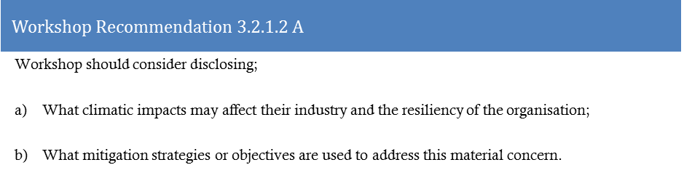
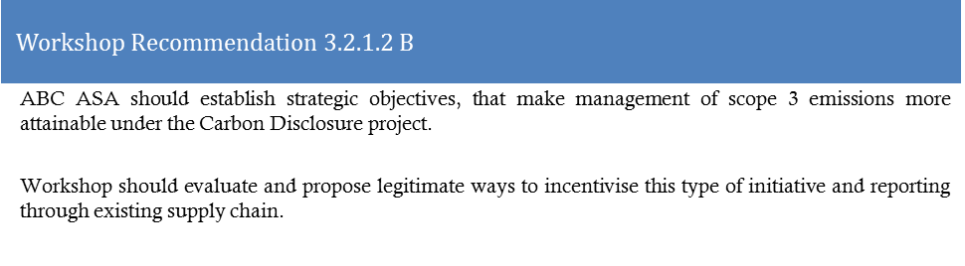
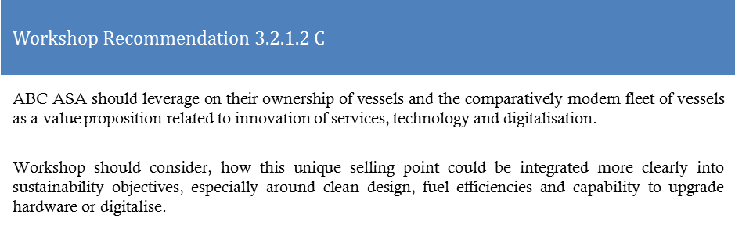

Social Material Issues
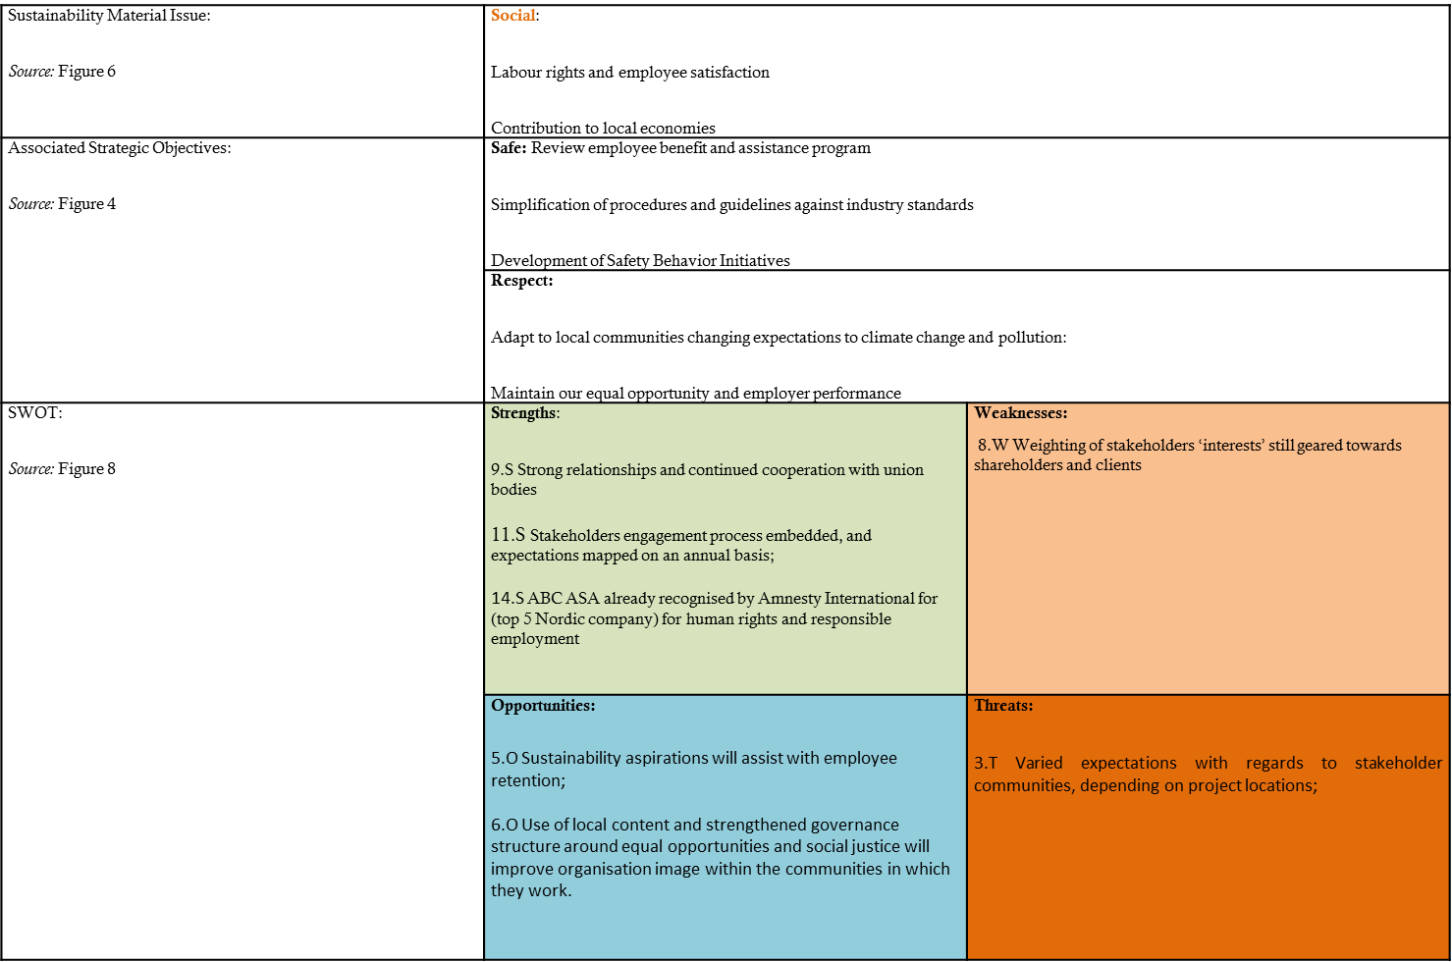

Strategic Objectives: Assessment of suitability
- The material issue of 'Contribution to local economies' ranked low in the Materiality Analysis (Figure 6). As such, strategic objectives have not substantially addressed this material issue. This Report considers contributing to local economies as a crucial component of developing and maintaining social capital. ABC needs to be actively involved in local economies to ensure the continuation of relationship-building strategies (De Chiara, 2016), their social license to operate, and the ability to attract and retain local content employees.

- Despite external recognition in social performance, the strategic objective style is 'Introverted' (Baumgartner, 2010). The strategic objectives are associated with risk and liability mitigation instead of developing external relationships and being transformative. For example, Figure 11 indicates that ABC has no further aspirations for improvement and does not see further value creation potential in this area.


Figure 11 Social: Equal Opportunity Performance
- ABC has identified the interconnectedness of Safety with sustainability. Safety performance is necessary to preserve the workforce from unnecessary workplace injuries, protect their well-being, and improve employee engagement. At a macro level, employees can continue to function as productive participants within their communities. ABC's safety objectives reflect a robust commitment and culture to employees, indicating a behavioural culture of compliance and responsibility (Lee, 2018) to stakeholders. Strong safety culture in hazard planning and control has also been correlated with an increased organisational capacity to manage environmental risks and sustainability interests (Lee, 2018).

Conclusion and Recommendations
Within ABC's Annual Report, there are numerous examples of Extroverted Strategies that differentiate the Organisation from its competitors;
- Donation to schools / educational programs;
- Development of training and career paths for underprivileged communities;
- Cadetships;
- A high degree of transparency across human capital reporting and anti-discrimination performance;
- Safety Culture and performance
The fact that social sustainability performance has been ranked 'Top-5 in Nordic Countries' by Amnesty international (ABC ASA, 2020) is a testament to the above measures' legitimacy.
Despite transformative social development examples, strategic objectives are mainly compliance-based with a weak association to potential value-building propositions such as;
- Building stronger relationships with local communities, clients and supply chains;
- Accessing, attracting and retaining local workforces;
- The Commercial and Business Acquisition benefits of using local content within projects (as opposed to ex-pat crews);
- Cooperation and Sharing of natural systems and resources such as ports, fishing zones;
- Mutual trust amongst statutory and governance organisations.
Appendix A identifies a broad remit of stakeholders, whilst the Materiality Assessment places a disproportionate weighting towards client and shareholder interests. Subsequently, the societal interests of all stakeholders are not adequately addressed in strategic objectives.
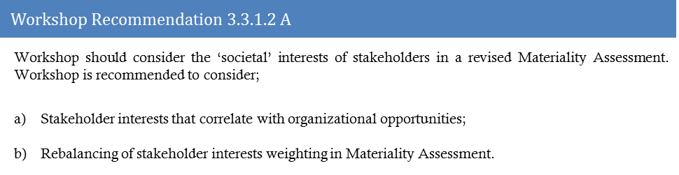
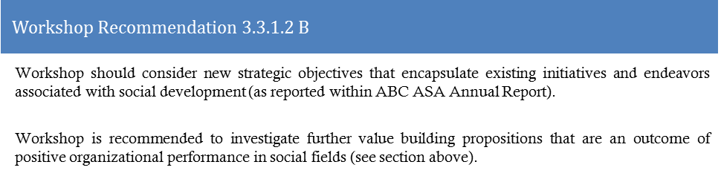

Business Case for Workshop Recommendations
This Report finds ABC has a 'Market Based’/’Conservative' approach. The Vision, Mission statement and Strategic Objectives seek to optimise organisational resource efficiency through sustainability measures;
- Innovation and digitalisation; focus upon fuel efficiency technologies, digitalising solutions, working remotely;
- Collaboration: Cooperation with stakeholders' interests;
- Knowledge Management: Centralisation of the value chain, utilising digitalised data/metadata; succession planning;
- Sustainability Reporting: Annual disclosure and increased transparency of non-financial performance.
This current approach serves ABC well for value creation. The competitive cost-based sustainability strategies differentiate the Organisation by focusing on the firm's attributes; ownership of vessels, asset capability (and modernity), and existing competency areas. Leveraging against these strategic action areas, ABC can decrease the average cost of operation and work at a higher margin (Lloret, 2016). The recommendations provided in this Report develop upon the existing 'Conservative' and Market-based approach to sustainability by increasing synergies between sustainability action and corporate competitive strategies.
Areas of attention to achieve the above are set out in the recommendations and summarised below;
- The requirement to increase alignment between strategic objectives and operational performance standards in areas of sustainability through a Balanced Scorecard;

- Internally developing ESG levels of performance, instead of aligning with external parties' expectations;

- Increased weighting and prioritisation of non-client stakeholder interests in Materiality Assessments to ensure strategic objectives and reporting represent all concerned parties.
Continuation of a 'Conservative' approach is recommended in acknowledgement of current uncertainty and volatility in the industry. Over the medium term, management should be cognisant that Conservative strategies should be focused on maintaining economic success, not only considered if it demonstrates short-term financial results (Baumgartner, 2010). In the long-term, once the 'energy market' is better understood, ABC is recommended to adapt their strategies towards a more Transformative approach.
Focus on the abovementioned sustainability areas of innovation, collaboration, knowledge management, and reporting will ensure that ABC remains malleable to the unknowns of the energy transition, can legitimise operations and differentiate itself through eco-efficient assets and superior ESG performance.

Appendix A: Stakeholder Analysis

 | Stakeholder |  | Channel of Engagement |  | Key interests, concerns or expectations
Investors, shareholders and partners;  ABC ASA is a publicly listed company with many shareholders. ABC ASA also has many joint venture partners and bondholders in which we represent. |  | - Board Meetings;  - Investor conferences  - Individual meetings  - Website  - Annual reports  - Site visits  - Results reporting presentations |  | - Impact of coronavirus on sales, project backlog, forecasting;  - Management of costs and industry trends;  - Environmental, Social and Governance issues;  - Shareholder returns/dividends;  - Alignment with 3-year improvement plan;
Employees;  ABC ASA has approximately 3,500 employees. They are the backbone of our Organisation and a natural choice as a critical stakeholder group. Engagement with employees is conducted through studies of feedback from numerous employee committees, working environment surveys and separate dialogue with individuals. |  | - Ongoing dialogue through established channels  - Operational leadership teams  - Safe the RITE Way  - Managers/team dialogues –  - Employee engagement surveys (Great Place to work?)  - Focus groups  - Company intranet and newsletters  - Electronic notice boards/public |  | - Conditions of employment  - Wages and benefit  - ESG profile of Organisation  - Health and Safety performance  - Strategic direction  - Social justice  - Ethical responsibilities
Unions:
Local Communities:  The group has its primary operations offshore and is not visible in the local community, aside from office buildings, a few warehouses and shore bases. However, in some communities, ABC ASA is a significant employer. This means there are expectations for the Company as regards contributing to the local community.  ABC ASA also considers itself to have accountability towards the stewardship of natural capital, such as the ocean. As Local communities are also a stakeholder of this type of natural capital, there is a responsibility for ABC ASA to understand the interests of this group for sustainable management, beyond legal compliance. |  | - Ethics hotline;  - Website, LinkedIn, Social Media;  - Stakeholder engagement workshops;  - Vessel visit days;  - Local media coverage;  - Annual reports;  - Interactions with employees within the community;  - Visual / noise intrusions. |  | - Localised procurement;  - Employment opportunities;  - Community investment opportunities;  - Environmental performance and interactions of ABC ASA Group operations;  - Provision of energy mix;  - Education; cadetships, graduate programs;  - Meaningful and transparency of engagement structures;
Statutory Bodies;  National departments for Health & Safety, industrial relations, environmental affairs, indigenous affairs, Trades and Customs, Visa and immigration; |  | - Vessel or site visits;  - Stakeholder days;  - Seminars or workshops;  - Meetings;  - Presentations;  - Safety Cases or similar statutory documentation;  - Press releases;  - Annual Reports;  - Websites;  - Regulatory visits/inspections;  - Incident Investigations;  - Local economic development forums;  - Applications / documentation e.g. visas, customs |  | - Legal compliance, across Environmental, Social and Governance spectrums of Organisation;  - Community development, and progress or alignment within social and labour plans;  - Quality of applications / licensing;  - Sustained contribution to national tax base;  - Contribution to the national or local energy mix and sustainability aspirations;  - Responsible governance practices and respect for human rights;  - Timely reporting and resolution of non-compliance, e.g. tax issues, incident investigations
Suppliers |  | - Supplier engagement through projects;  - Annual Reports;  - Shared worksites;  - Audits and pre-qualification processes |  | - Opportunities to work with the Organisation;  - Contracts and terms and conditions;  - Procurement strategies;  - Safety performance offshore;  - Quality control and maintenance of hired equipment;  - Payment terms;
Media |  | - Holding; statement;  - Press releases;  - Interviews;  - Annual Reports;  - High profile incidents. |  | - Company ESG performance;  - Financial performance;  - New project awards;  - Strategic direction;  - Labour relations  - Markets and productions
Non-governmental Organisations (NGOs) |  | - Press releases;  - Interviews;  - Annual Reports;  - High profile incidents. |  | - Community engagements / social development;  - Collaboration on projects;  - Corporate Governance;  - Transparency on disclosures  - Environmental stewardship

Appendix B: Materiality Assessment 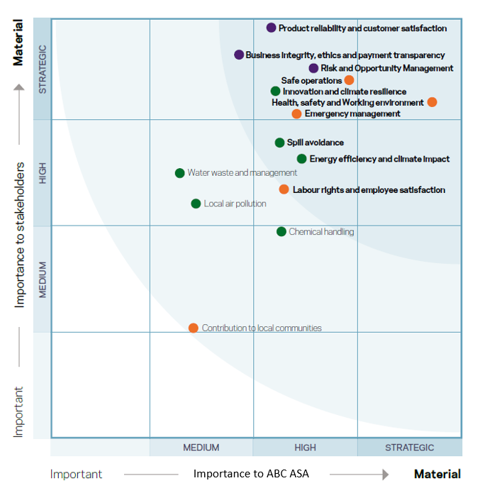

Appendix C: SWOT Analysis on Strategic Objectives
Organisational Strengths; Which elements or characteristics give ABC ASA an advantage over others?
- Large existing market share, with assets capable of catering for new segments within the offshore industry;  - High level of competence within conventional subsea and marine industries;  - The unique selling point of both owning vessels and selling services;  - Networks of local content and providers of local content workforces across the globe.  - Building upon a strong foundation of 'Business Code of Conduct and ethical principles; | - Enrolled for seven years as part of the Carbon Disclosure and Global Reporting Initiative. Culture of transparency in reporting sustainability issues;  - Existing partnerships with digitalisation providers, already providing access to meta-data in vessel operations and efficiencies;  - Organisational measures and Sustainable Development Goals are already linked within annual disclosure documents.  - Strong relationships and continued cooperation with union bodies  - Established and recognised frameworks around behavioural-based Safety; |  | - CAPEX available to support upgrades, supporting energy efficiency aspirations;  - Stakeholders engagement process embedded, and expectations mapped on an annual basis;  - Organisational structure and global footprint allow experience transfer and utilisation of best practices;  - Organisational involvement in key industry bodies that define environmental or sustainability approach within the industry sector.  - ABC ASA already recognised by Amnesty International (top 5 Nordic company) for human rights and responsible employment.  - Well developed organisational values, which strategic objectives are leverage from.
ABC ASA Organisational Weaknesses: Which elements or characteristics give ABC ASA a disadvantage over others?
- Limited levels of competency or track record within new or less conventional areas of 'energy' sectors;  - An ageing fleet of vessels, creating a higher CAPEX for developing fuel efficiencies; | - Varying perceptions and degrees of competency around sustainability issues due to global workforce;  - New Mission and Vision statement, relatively unknown within the Organisation at the time of writing;  - The connection between Company Values and strategic measures remain somewhat disconnected  - Leading and lagging indicators associated with sustainability aspirations lacking, especially within publicly disclosed reports. |  | - Sustainability viewed as a standalone objective, as opposed to a means of value creation;  - The weighting of stakeholders' interests' still geared towards shareholders and clients;  - Mission statement allows clients to dictate the sustainability practices of the Organisation.  - Large contractor workforce and supply chain who do not necessarily hold the same Integrity Values  - The strategy is focused on external perceptions as opposed to internal drivers
ABC ASA External Opportunities: External elements that give benefit to ABC ASA
- Expanding population and globalisation increases the global demand for 'energy';  - Changes in the energy mix, create opportunities for new products and services;  - Market consolidation  - Ability to reduce costs through automation and digitalisation schemes; | - Sustainability aspirations will assist with employee retention;  - The use of local content and strengthened governance structure around equal opportunities and social justice will improve organisation image within the communities in which they work.  - Decreased OPEX associated with emission taxes and fines for pollution incidents;  - Increased vessel fleet efficiency or ESG performance can become a market differentiator; |  | - Diversification across multiple sectors of the energy sector reduces exposure'  - Decreased exposure to gradual price reduction in global oil prices.  - Technical capabilities allow vessels to operate in climatic extremes.  - Robust corporate governance will maintain investor and client confidence in organsiation
ABC ASA External Threats: External elements that could provide issue for ABC ASA
- Uncertainty political-legal forces around energy policy and maritime requirements;  - Uncertainty around new technologies. The Organisation must be ahead of the curve to maintain market share; |  | - Varied expectations with regards to stakeholder communities, depending on project locations;  - Continued exposure to conventional energy markets (oil and gas);  - Reputational risk of maintaining governance models across varied geopolitical landscapes.
Figure SWOT Analysis ABC ASA

Appendix D: References

ABC ASA, 2019. 2019 Sustainability Report, Bergen: ABC ASA.
ABC ASA, 2020. 2020 Integrated Annual Report, Bergen: ABC ASA.
ABC ASA, 2020. Annual Report 2019, Bergen: ABC ASA.
ABC ASA, 2021. ABC 3-yr Business and Strategy Plan 2021 - 2023, Bergen: ABC ASA.
Baumgartner, R. J., 2010. Corporate Sustainability Strategies: Sustainability Profiles and Maturity Levels. Sustainable Development, 18(2), pp. 76-89.
Blackmon, D., 2020. Forbes. [Online]
Available at: https://www.forbes.com/sites/davidblackmon/2020/12/17/2020-in-review-one-of-the-oil-and-gas-industrys-worst-years-approaches-a-merciful-end/?sh=7fca5a597bed
[Accessed 13 March 2021].
Calabrese, A., Costa, R., Levialdi Ghiron, N. & Menichini, T., 2019. MATERIALITY ANALYSIS IN SUSTAINABILITY REPORTING:A TOOL FOR DIRECTING CORPORATE SUSTAINABILITY TOWARDS EMERGING ECONOMIC, ENVIRONMENTAL AND SOCIAL OPPORTUNITIES. Technological and Economic Development of Economy, pp. 1-23.
De Chiara, A., 2016. Social Capital and Sustainability Strategies. In: Implementing Sustainability Strategies in Networks and Clusters. s.l.:Springer, pp. 25-72.
Global Reporting Initiative, 2019. Has materiality changed in the Standards. [Online]
Available at: https://www.globalreporting.org/how-to-use-the-gri-standards/questions-and-answers/materiality-and-topic-boundary/
[Accessed 18 March 2021].
Gurel, E. & Tat, M., 2017. SWOT ANALYSIS: A THEORETICAL REVIEW. The Journal of International Social Research, 10(51).
Houben, G., Lenie, K. & Vanhood, K., 1999. A knowledge-based SWOT-analysis system as an instrument for strategic planning in small and medium sized enterprises. Decision Support Systems, Volume 26, pp. 125 - 135.
Lee, D., 2018. The Effect of Safety Management and Sustainable Activities on Sustainable Performance: Focussing on Supplers. Sustainability, Volume 10, p. 4796.
Lloret, A., 2016. Modeling corporate sustainability strategy. Journal of Business Research, Issue 69, pp. 418-425.
Mannino, S., 2020. Why Every Brand Needs A Mission Statement. [Online]
Available at: https://www.forbes.com/sites/forbesbusinesscouncil/2020/08/26/why-every-brand-needs-a-mission-statement/?sh=2324d151eb37
[Accessed 13 Marhc 2021].
Normann, R. & Ramirez, R., 1993. From value chain to value constellation: designing interactive strategy. Havard Business Review, 4(71), pp. 65-77.
Paine, L. S., 1994. Managing for Organizational Integrity. [Online]
Available at: https://hbr.org/1994/03/managing-for-organizational-integrity
[Accessed 19 March 2021].
Smith, L. W., 2000. Stakeholder analysis: a pivotal practice of successful projects. [Online]
Available at: https://www.pmi.org/learning/library/stakeholder-analysis-pivotal-practice-projects-8905
[Accessed 26 March 2021].

